  External and Internal Envelope Report  Date: 7th January 2026 | Visual Survey  41 Salem Road Llanelli, Felinfoel  Francis Barcelo 2401983@student.uwtsd.ac.uk  Retrofit Coordination and Management (ACBA 5026)

Table of Contents
2 Introduction 2
3 Report Summary 2
4 Scope 3
4.1 Methodology of data collection 3
5 Limitation of Inspection 3
6 Method 4
7 About the Property 4
8 Construction 5
9 External Survey 6
9.1 Main Roof 6
9.2 Kitchen/outrigger roof 7
9.3 Rainwater Goods 9
9.4 Eaves: Soffits and Fascia 10
9.5 Windows and Doors 11
9.6 Walls 13
10 Internal Survey 15
10.1 Upstairs (First Floor) 16
10.1.1 Loft 16
10.1.2 Windows 18
10.1.3 Walls 20
10.2 Downstairs (Ground Floor) 22
10.2.1 Kitchen Roof Compartment 22
10.2.2 Windows 24
10.2.3 Walls 26
10.2.4 Floor 28
11 Deep Retrofit Recommendation 29
12 Reference List 34

Introduction
This report contains information regarding the overall condition of the property being inspected by visual inspection. With information gathered during the survey recommendations are provided to ensure what’s the best viable solution to the problem found. The main aim of this survey is to identify any potential problems and provide a recommendation of how a deep retrofit is feasible and beneficial to fix the problems.

Report Summary
This survey main aim is to provide a visual interpretation of the condition of the existing external and internal envelope of the property and to provide any retrofit recommendations. This survey is taken prior to any remedial works completed. This survey is done with the use of arial photos from sources such as google maps and Digi maps, along with photos taken during the survey and a subjective comparison on the information gathered. Throughout the report the property is compared to existing data before the property was renovated before being sold to the current homeowners.
Photos and information gathered from the survey and shown in the report indicates that some areas of the property may require immediate works. It is recommended that the present of damp and moisture are taken into consideration when planning to maintain the building, as they can cause problems both internally and externally and may pose as a health hazard to the occupants living in there. The use of old building plans helps highlight various areas of the building that may need to have further works to further improve the well-being of everyone who uses the property.
Results from the survey have been used to provide various recommendations when it comes to recommended retrofit works to the house. Where areas where damp and moisture are presents, it shows a potential lost in efficiency and an overall increase in heat lost. Just from an in-person inspection it can be identified that some rooms have a worse thermal performance indicating a lack of insulation present when previous renovation was completed. A deep retrofit is feasible and in some areas is recommended to improve energy performance, comfort of the residence, maintenance, and compliance with regulations.
Despite the issues mentioned above, it is generally considered that the property is in a good condition. There are no urgent structural issues identified, and no major urgent works needed to be undertaken.

Scope
Both the survey and the report combine images together captured by visual inspection and the use of background study to find old structural photos/plans. Both provide an overview of the general conditions of the roof, external and internal walls, and windows and doors. When comparing old data from data collected from the survey, it should be taken into consideration that certain possible problems could exist and is to be taken as an assumption.

Methodology of data collection
- The survey is a combination of general scanning and the use of captured images that best represent the situation.
- Any problems found to be noted on the image or as a note
- Provide a brief narrative of potential recommendations on the images used.
- There should be enough images provided to allow a competent third party to replicate any findings found in the report.
- Provide sufficient data that supports the recommendations of having a deep retrofit when it comes to improving well-being and energy efficiency.

Limitation of Inspection
The house being inspected is currently occupied and is fully furnished and all occupants were present during the survey. The inspection is done by visual inspection when looking at both the external and internal envelope. This inspection was done to identify any obvious problems found during the survey. The inspection is non-invasive, meaning while the survey was being conducted no action were taken to expose certain areas of the property. This also means that no sections of the property were damaged to view non-visible structural components of the property. This report will only cover the visually exposed area available. No special equipment’s are used so visual inspection is limited.
It is best to note that this report does not provide an estimate on the cost of any works or defects identified during the survey. There are also no comments on how maintenance should be carried out but suggestions on what may be needed.

Method
The survey would only be taken in one session where data obtained shows visual image of both the internal and external envelope of the property. This is a basic survey, and it is done at daytime to provide a good visual representation of the structure when looking at the roof and external walls. The images captured is at high resolution to provide the best visual representation to allow identification and to allow reference of comments talked about in the report.

About the Property

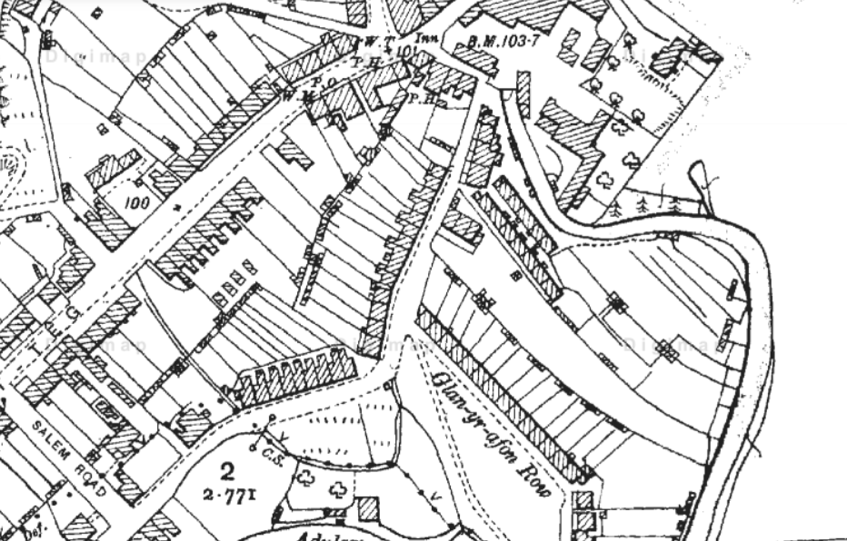
(Digimaps, 1900)
With the use of archival study, historical maps shows that the house was originally built around the 1900’s where it indicates that its most likely a Victorian type of Building. The property is a mid-terraced house and is two stories that has 3 main upstairs bedrooms. Structures found in the property’s boundaries are not part of the survey and is not found in this report.
This house is in a flat area surrounded by residential buildings. The area of the property is approximately 80 square metres.

Construction
Old House Plan | New House Plan
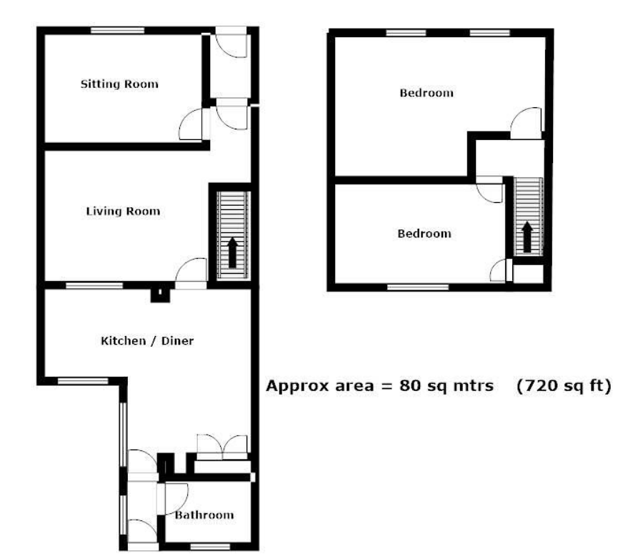 | 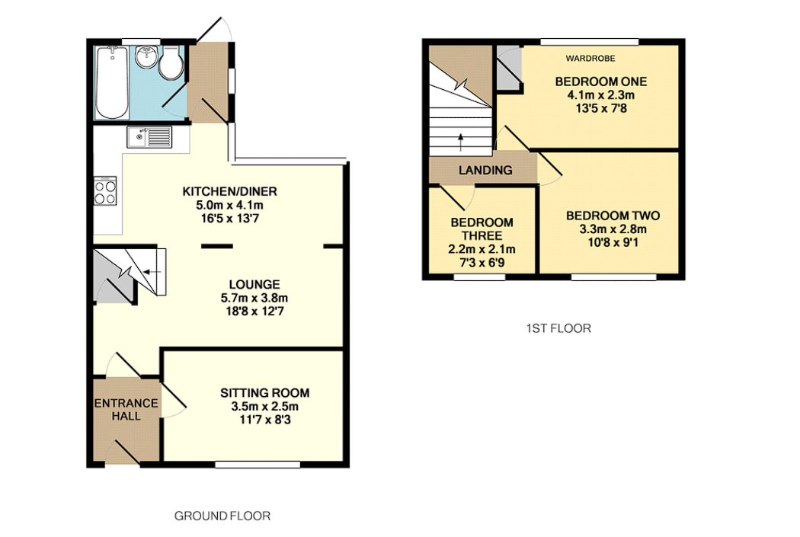

An EPC certificate was issued in 2014 with a rating of F, and an EPC certificate hasn’t been issued ever since. In 2014 the certificate concludes that the wall is built up of, Granite or whinstone, solid Brick, and a cavity wall where it is assumed that it has no insulation. The roof was assumed pitched with no insulation and where the rafters were the only place to be insulated. The house used to have a chimney and has now been removed. Part of the roof of the house is made of polycarbonate roof panels with a timber frame. The house has a Fully Double-Glazed Window. The floor of the house is confirmed to have solid concrete.

External Survey
It is best to note that special equipment’s such as drones were not used to perform the external inspection of the property. Images captured are taken from the visual inspection performed and data from resources such as Google Earth.

Main Roof
Description:  The main roof is covered in slates, and it is a traditional timber pitched and cut roof. An air vent is installed where the previous chimney used to be (see image above).  Condition:  The roof is generally in good condition with only minor plant growth found on some slates. Some slates observed has shown minor cracks. Air vent from observation at ground level seems to be at a good condition  Cause/defect:  Crack slates have been likely caused by its age and the presence of moisture and being exposed to freeze-thaw weathering especially in the winter. Small plant growth on the roof can be a concern, but at a small quantity is not usually a cause of concern.  Recommendation:  All growth found should be removed to prevent any moisture being absorbed and being present on the roof. Any damaged slates should be replaced, and another survey where equipment’s such as drone and thermography are available should be done to fully analyse the condition of the air vent, the entire roof, and check its thermal efficiency. | 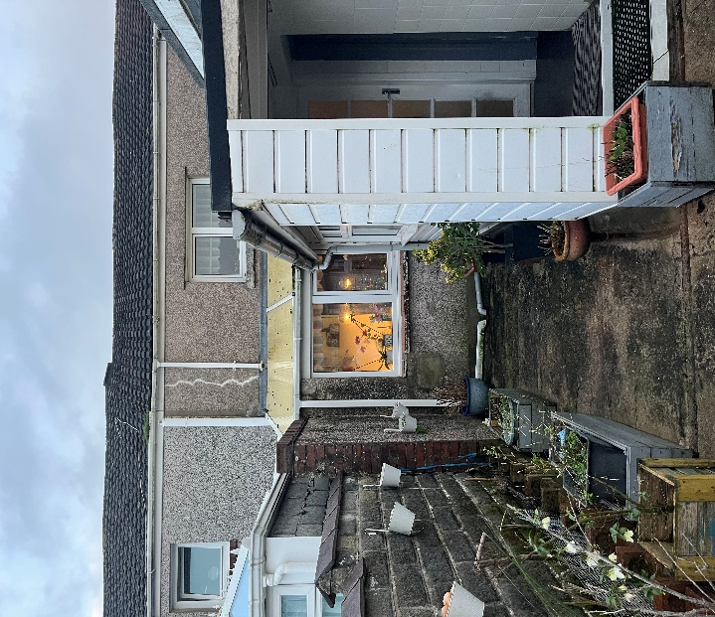  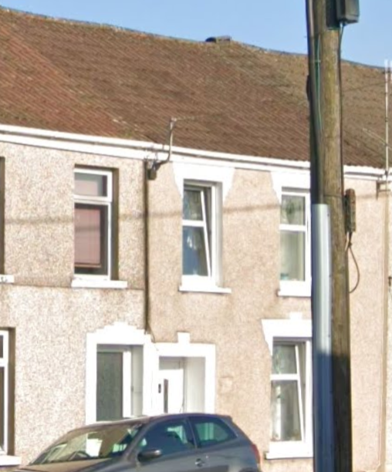  (Google Earth, 2025)

Kitchen/outrigger roof
Description:  This part of the roof the house is made up various materials. It consists of timber pitched roof covered in slates, a flat roof, and a plastic roof which is likely made up of polycarbonate. It also consists of a chimney  Condition:  The roof is in good condition with small mosses and plant growth observed. Chimney is in good condition with no defects observed. Polycarbonate roof has been discoloured.  Cause/Defects:  Discolouration is caused by the exposure to UV light and weathering which can cause brittleness and cracking overtime leading to a structural problem and can influence thermal performance. Small plant growth on the roof can be a concern, but at a small quantity is not usually a cause of concern.  Recommendation:  All growth found should be removed to prevent any moisture being absorbed and being present on the roof. Any damaged slates should be replaced. Polycarbonate roof should be replaced overtime but poses no danger to the occupants for now. | 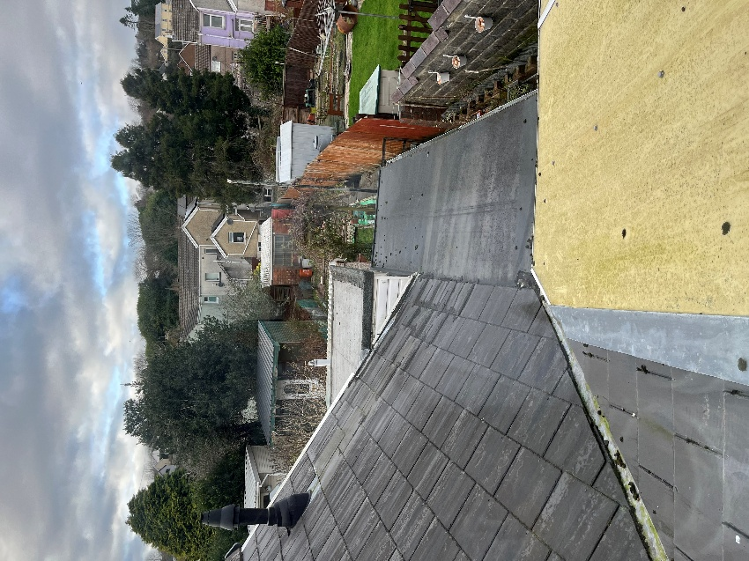  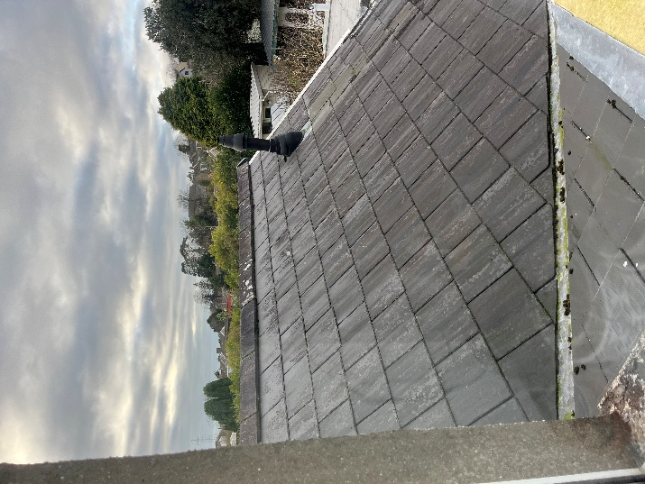  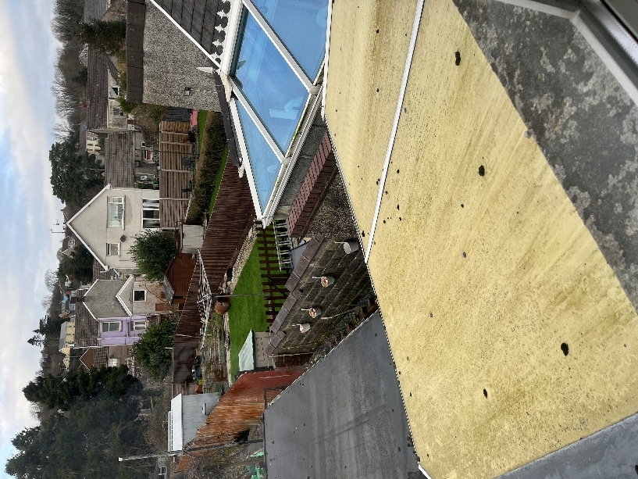

Rainwater Goods
Description:  All gutters inspected are made up of uPVC some half-round and some square gutters. They vary in diameter. Downpipes are also made up of uPVC.  Condition:  All gutters and downpipes are in good condition. Some have been damaged/chipped on their sides. Growth on the sides and in the gutters, itself have been observed during the inspection. During the survey some clips are seen damaged, junctions are in good conditions apart from some growth on the sides.  Cause/defects:  Age and weathering are the massive contributors to its current condition. Lack of maintenance have contributed to the growth to occur.  Recommendations:  Remove all growth in the gutters itself to prevent blockages. Any damaged clips should be replaced. Basic maintenance and cleanliness should be done to maximise its life span. | 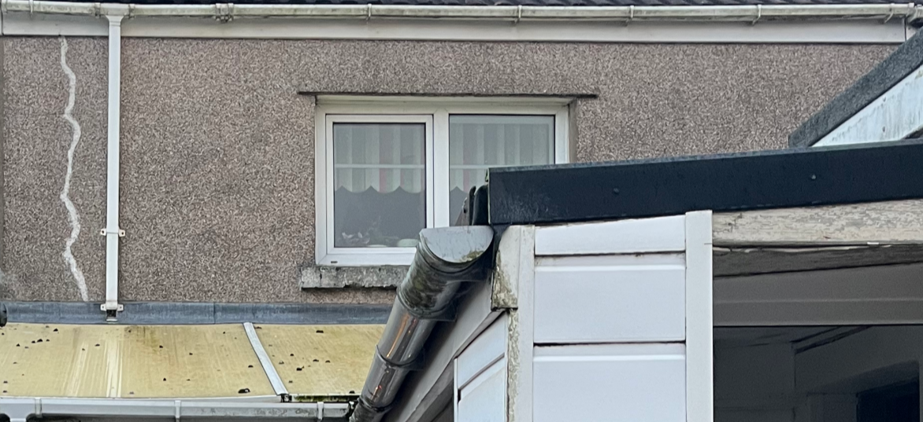  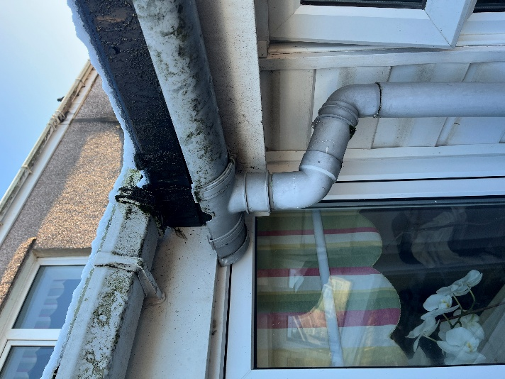  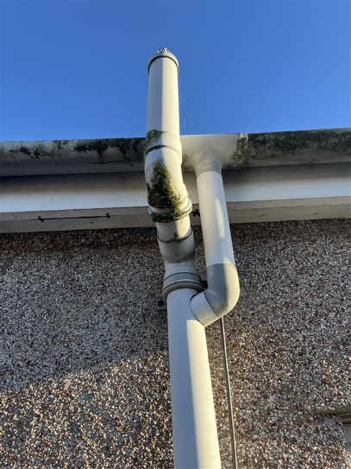

Eaves: Soffits and Fascia
Description:  Soffits and Fascia of the property are a mix of uPVC and timber. The survey only covers the kitchen/outrigger roof soffits and Fascia.  Condition:  The soffits and Fascia made of uPVC are in good condition. The areas made up of wood are in poor condition where rot can be seen and paint is peeling off (see image across).  Cause and Defect:  Main factor affecting the timber soffits and fascia is the age and exposure to weathering and the lack of maintenance.  Recommendation:  Any sign of rot or damage should be fixed and replaced with hardwood timber or a uPVCu alternative to enable proper ventilation and enhance the effectiveness of insulation. Basic maintenance should be done like painting and cleaning | 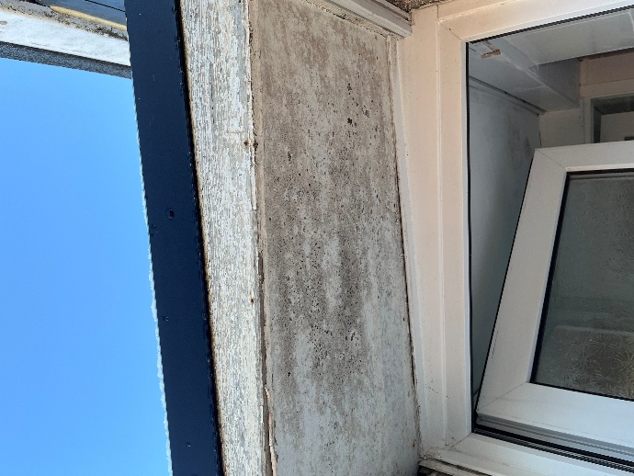  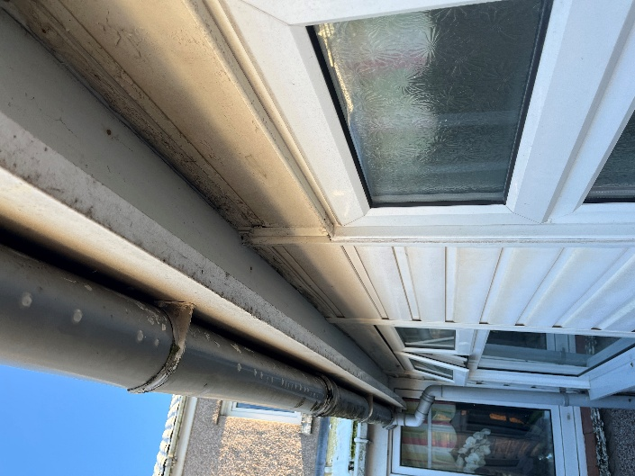  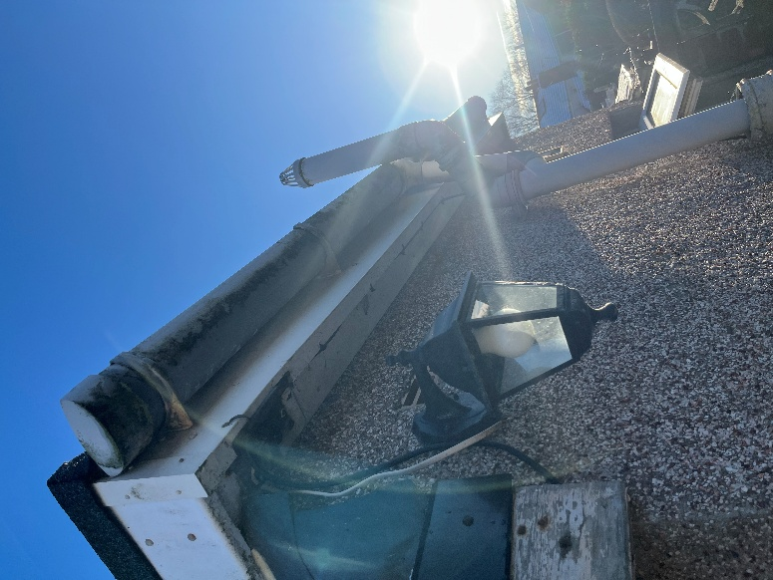

Windows and Doors
Description:  All windows and doors observed in the external survey are all uPVC. Windows on the first floors is a Tilt and Turn window with a concrete sill. On the ground level most are casement windows with a variety of hinged on the side and top, one window at the front of the house is a Tilt and Turn. The sill of the windows on the Ground level varies from concrete, brick, and uPVC. Both external doors and all windows are double glazed.  Condition:  All windows and doors appear to be in good condition. With some windows containing a stained-glass design and previous records such as an EPC certificate recorded in the past the windows are potentially outdated and inefficient. This leads to heat escaping and the formation of condensation leading to moulds and causing health problems. The sills of some of the windows displace growth. Some can be observed to be broken due to past works done.  Cause/Defect:  The sill of windows needs regular basic maintenance due to the exposure of weathering. Main problem is the age of some of the windows which is affecting the thermal performance of the property.  Recommendation:  Basic Maintenance like cleaning the sill is recommended. Broken sills should be fixed and replaced to prevent water damaged to the surrounding area of the window. To prevent condensation replacing the older windows may benefit the occupants. Additional airtight layers at junctions around the windows can help improve thermal efficiency. | 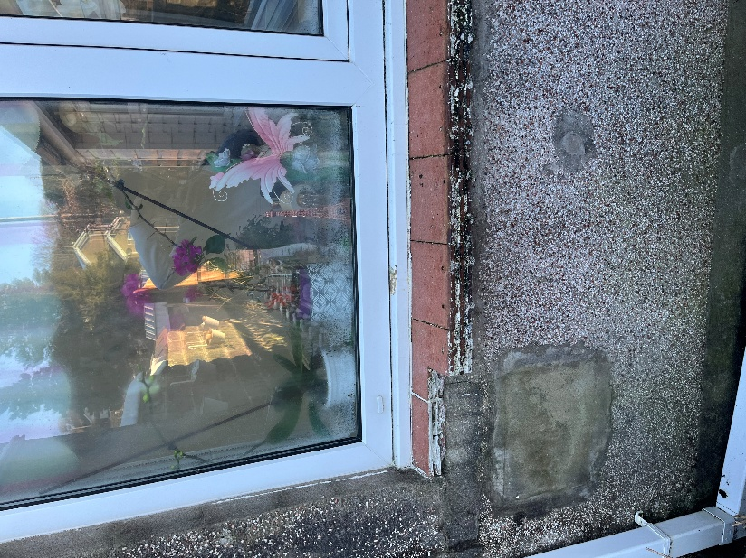  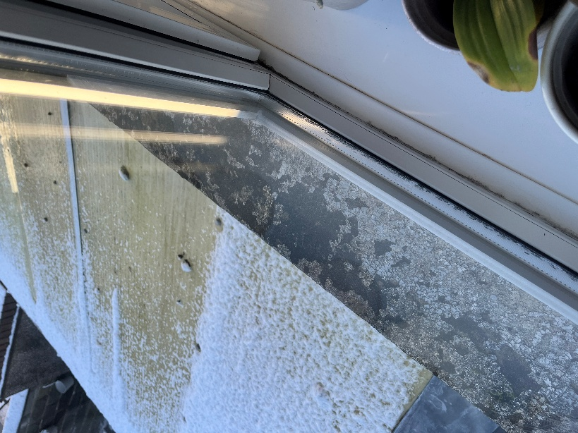  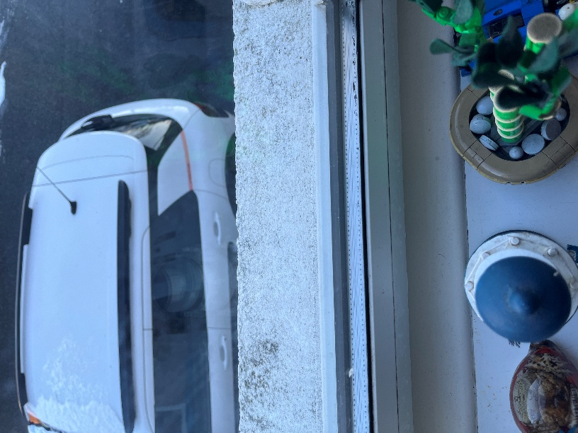

Walls
Description:  Walls consist of a mix of pebbledash walls and uPCV weatherboard cladding. A Past EPC certificates assumes that due to the age of the house a solid brick with no insulation was used when built. Some sections of the property are built recently with the potential of having cavity wall which was also assumed in the EPC certificate. Sills are made up of a mix of concrete, brick and uPVC.  Condition:  The exterior render of the house is in good condition. Some areas of the render can be seen to have been removed/damaged (see image across). Some growths and discolouration have been observing on the pebbledash render. Some areas have metal and uPVC pipes coming out of the wall.  Cause/Defect:  Age of the render and lack of regular maintenance have contributed to the growth and discolouration of the pebbledash render. Recent works to remove pre-existing components can be seen on parts of the walls where the render has been damaged/removed. Some metal pipes are no longer in use.  Recommendation:  Regular maintenance should be done to remove growth and discolouration in the render. Areas in the pebbledash wall that has been damaged should be fixed to maximise weather-resistant, hide cracks, and provides insulation.  Removing unused metal pipes is key to prevent thermal bridging. The wall should be filled and finished with the same render. It is also good practice to install thermal break and a continuous insulation to any pipes penetrating the exterior wall.  With data collected from both the survey and the EPC certificate it should be considered that external wall insulation is a viable solution to maximise the thermal efficiency of the house. | 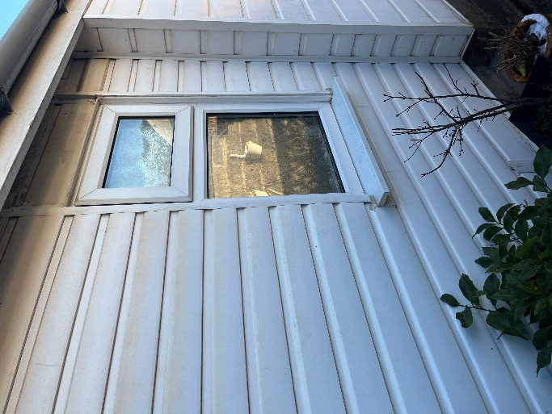  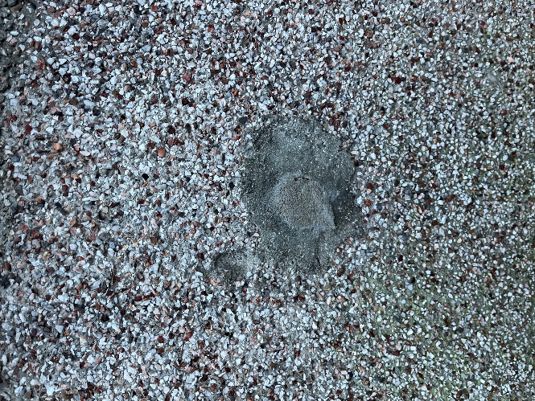  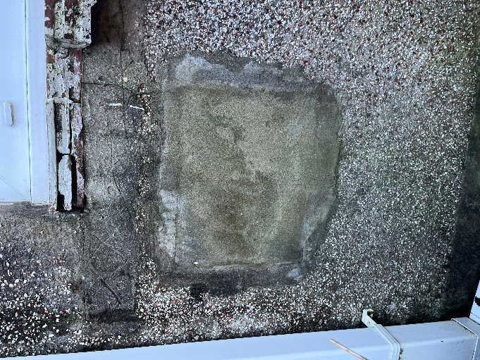  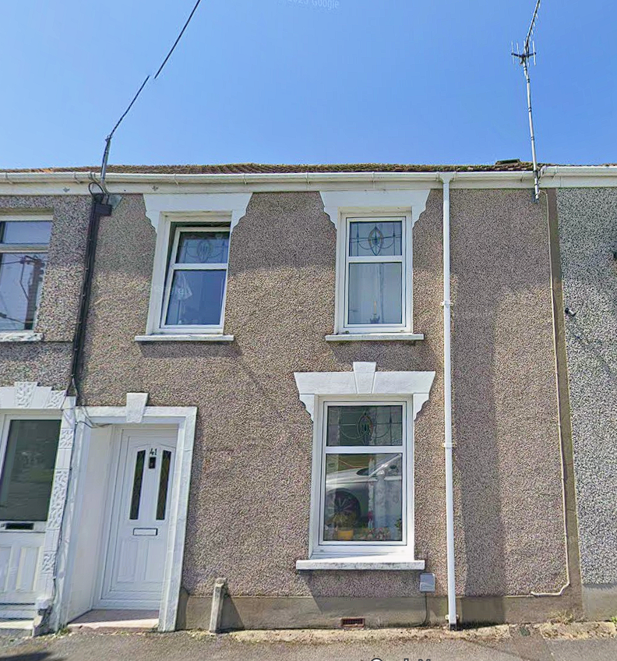  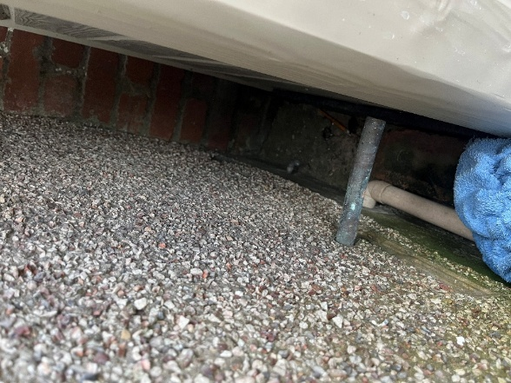  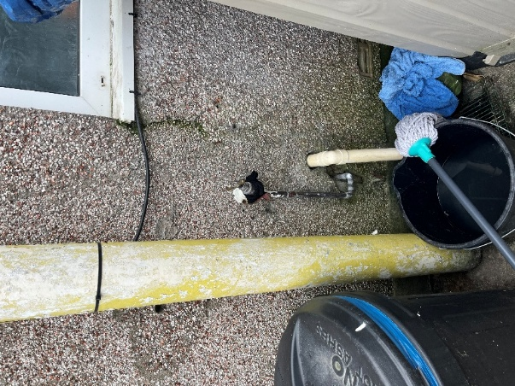

Internal Survey
(Zoopla, 2016)
Names of each room inspected would be referred to the names given on the House Plan (see image above).

Upstairs (First Floor)

Loft
Description:  Traditional timber pitch and cut, black felt and batten. Insulated at rafters.  Condition:  The timber structure of the roof is in good condition with no deflection or cuts observed. However, insulation is in poor condition and not up to current building regulations. Water marks suggest that moisture and condensation have occurred.  Cause/Defect:  Insulation has deteriorated over time, and the roof covering have failed on the junctions and valleys.  Recommendation:  Works on the roof is highly recommended. A full inspection with the necessary equipment’s need to be done to fully inspect the timber elements and the roof overall structural condition. Insulation should be replaced and is increased to recommended thickness.  Good opportunity to explore other ways to improve thermal efficiency such as airtight layer. Insulation on the loft hatch is recommended to further improve thermal performance. | 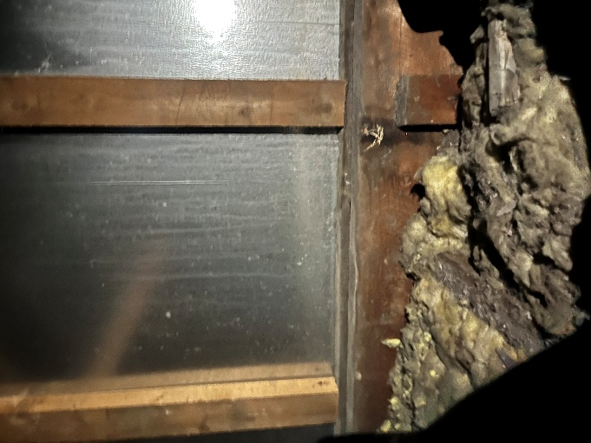  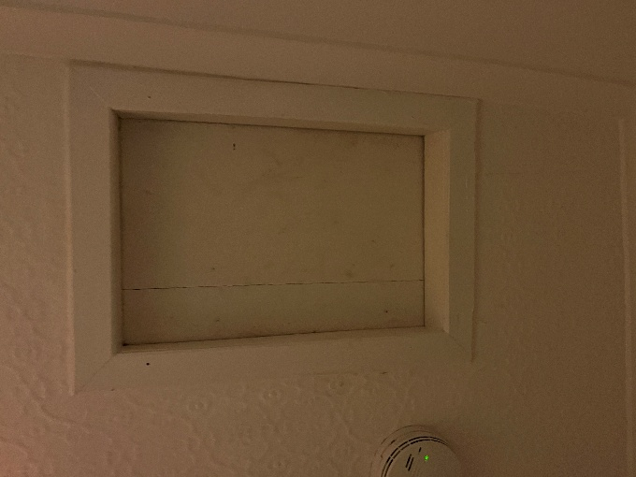  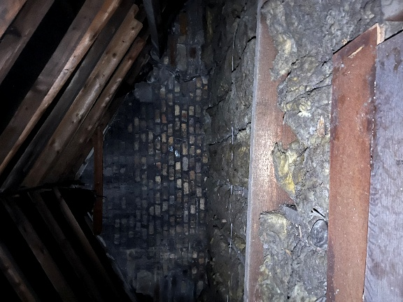  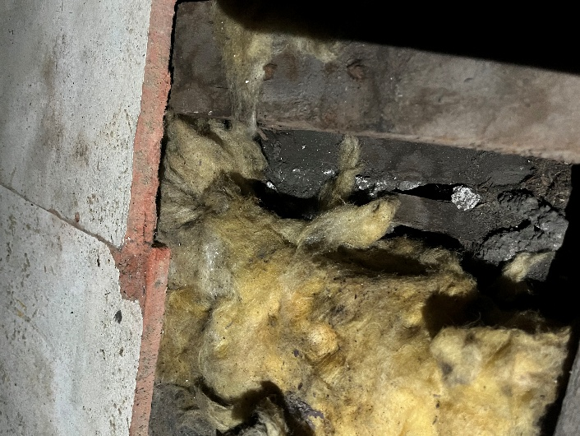  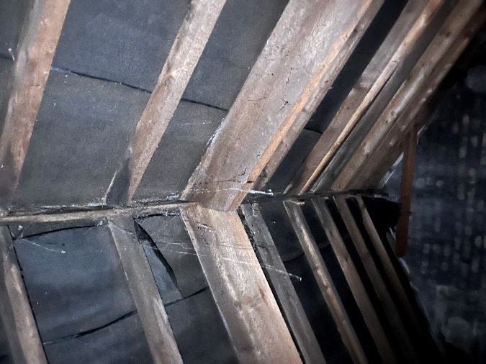

Windows
Description:  All windows observed in the internal survey are all uPVC. Windows on the first floors is a Tilt and Turn window and a casement window with a hinge. All windows are double glazed.  Condition:  The internal survey has shown most windows to produce condensation when the heater is on, or an occupant is in the room. The windows are generally in good conditions. Bedroom three was the worse out of the three rooms on the first floor with moulds growing on the surrounding area and in the window itself (See image across). Bedroom two was observed to only have minor mould growth and Bedroom one had none.  Cause/Defect:  Main problem is the age of some of the windows which is affecting the thermal performance of the property. Due to previous works Bedroom one window may be more recent hence having the best thermal efficiency out of the three.  Recommendation:  Regular maintenance such as removing growth around the windows help prevents health issue to the occupants. Due to the age of windows, it is a good opportunity to consider how to improve its thermal performance. This can be done by either replacing the window or the addition of airtight layer and thermal break to provide more insulation and prevent warm air from escaping. | 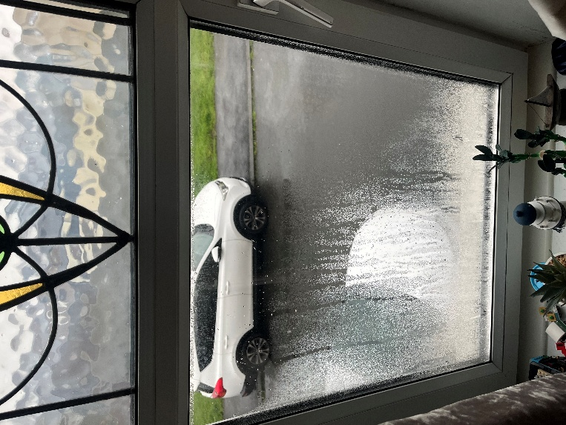  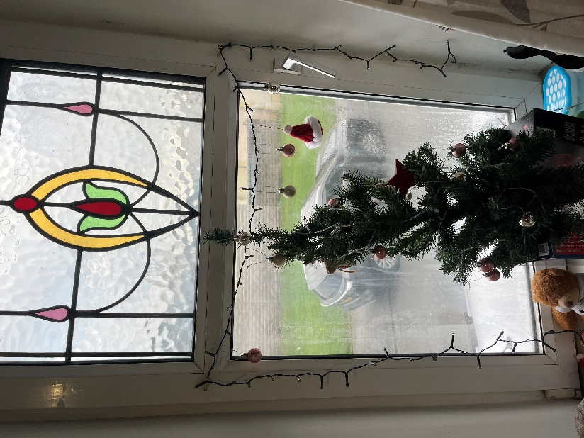  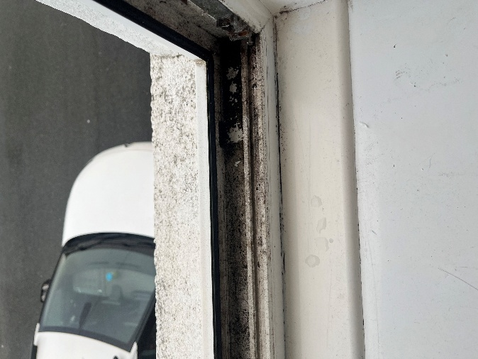  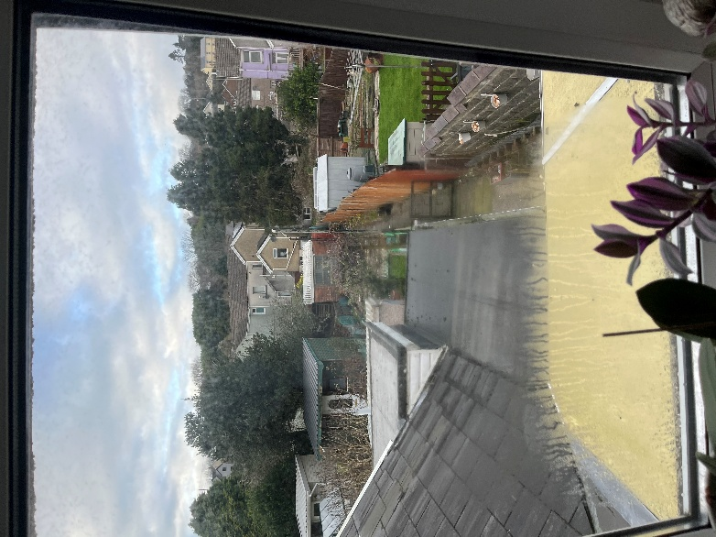

Walls
Description:  The first floor has been split into three main bedrooms where the internal walls have been fitted with plasterboard. Entire first floor has been coated/painted in white with a smooth texture.  Condition:  Bedroom one and two walls are generally in good condition, where bedroom two has minor mould growth. Bedroom three is in good condition but exhibits lots of mould to surrounding areas near the windows and behind furniture. Some walls have been damaged and cracks have been observed. Walls is observed to be hollow.  Cause/Defect:  Damaged walls can be affected by its age or caused by moving furniture or doing works. Mould growth is caused by excess moisture in the room which is most likely caused by condensation in the windows. Hollow walls means that it is void and is unlikely insulated  Recommendation:  It is recommended to do a full inspection of the house to determine which walls are load bearing and non-load bearing. Re-painting and fixed damages on wall are required.  Removal of moulds on the wall is required to maintain safety when it comes to the health of the occupants.  Specific room like bedroom three is noticed to have a massive temperature dropped compared to the other rooms during the survey. This is likely to the lack of insulation and airtight layer allowing the warm air to escape or condense.  This gives a good opportunity to explore various methods to improve thermal efficiency. Adding insulation to void spaces and the assumed cavity wall can help. Making sure all junctions are airtight and insulated properly where thermal bridging is prevented. | 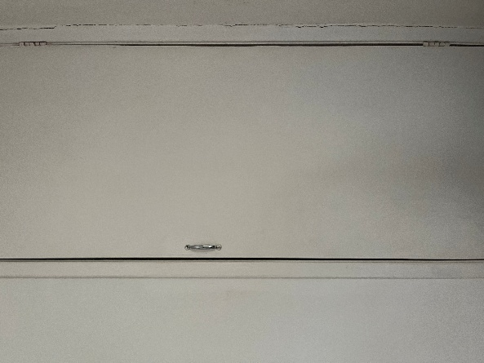  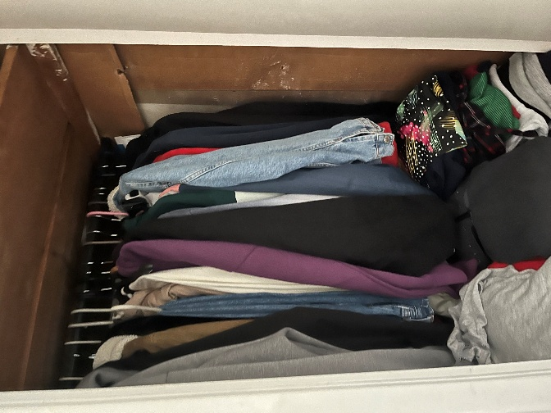  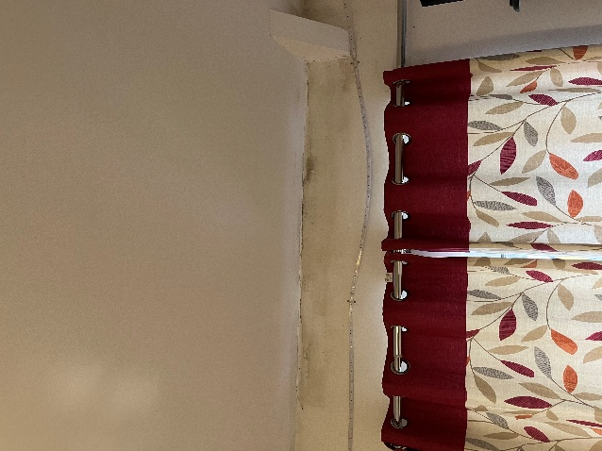  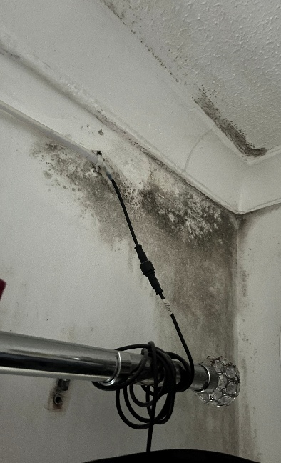  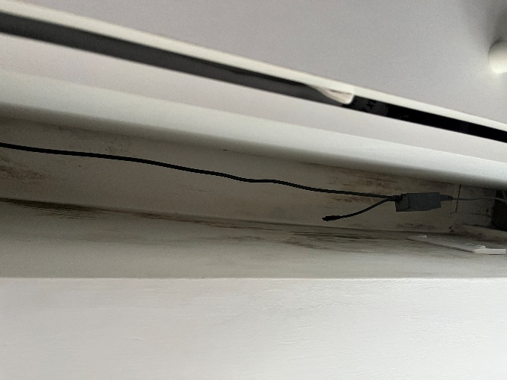

Downstairs (Ground Floor)

Kitchen Roof Compartment
Description:  Like the loft it is a traditional timber pitch and cut, black felt and batten. Insulated at rafters. Pipes, wires, chimney for the boiler is located here.  Condition:  The timber structure of the roof is in good condition with no deflection or cuts observed. However, insulation is in poor condition and not up to current building regulations, old insulation has just been left in one corner (see image across). Exposure of wires and pipes are just scattered across this area. Good seal around the chimney.  Cause/Defect:  Insulation has deteriorated over time, and previous works have not laid it out properly  Recommendation:  Like for the loft it is recommended that a full inspection is done on this area as well. Insulation should be replaced and is increased to recommended thickness.  Good opportunity to explore other ways to improve thermal efficiency such as airtight layer. Insulation on the loft hatch is recommended to further improve thermal performance. Pipes and wires can be organised better to allow the area to be insulated. | 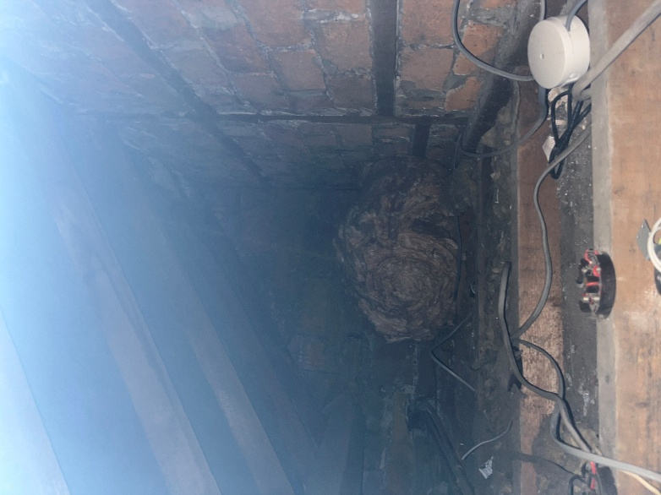  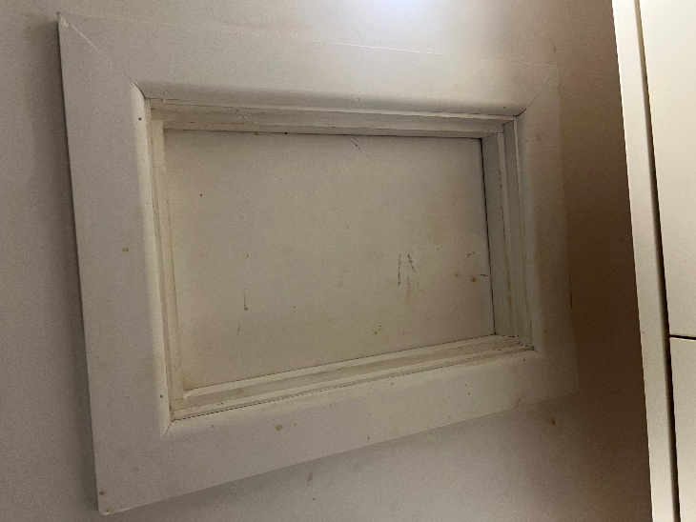  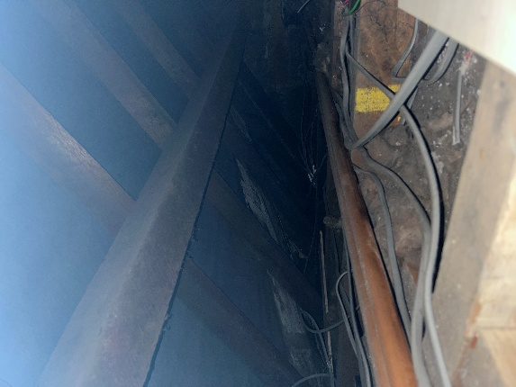  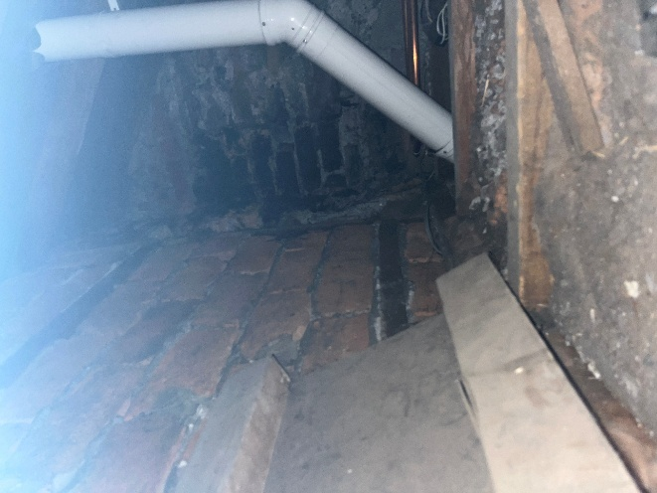

Windows
Description:  All windows observed in the internal survey are all uPVC. On the ground level most are casement windows with a variety of hinged on the side and top, one window at the front of the house is a Tilt and Turn. All windows are double glazed.  Condition:  All windows on the ground floor are in good condition. Minor condensation occurs when the heater is on or the kitchen is being used. No mould growth could be seen in the surrounding areas regarding all windows.  Cause/Defect:  Main problem is the age of some of the windows which is affecting the thermal performance of the property.  Recommendation:  Due to the assumed age of the windows similar recommendations found for the first-floor windows can be applied here. It is again a good opportunity to consider how to improve its thermal performance. Maintenance such as keeping it clean can help expand its life span and improve occupant health. | 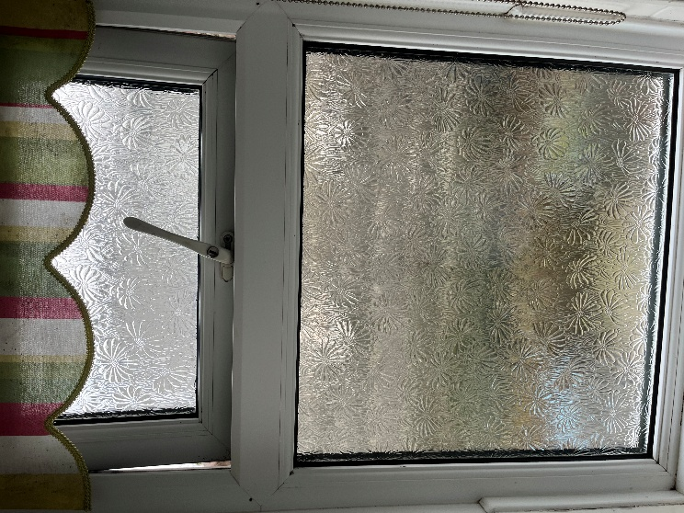  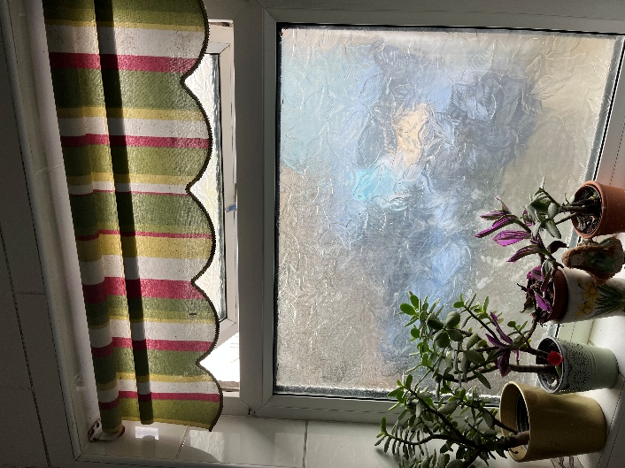  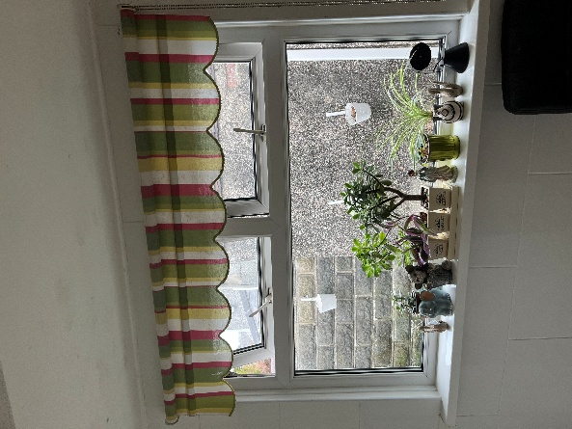  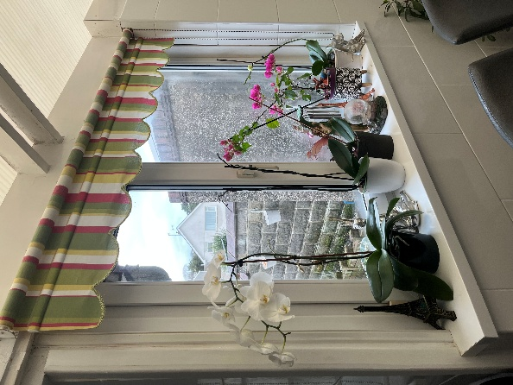  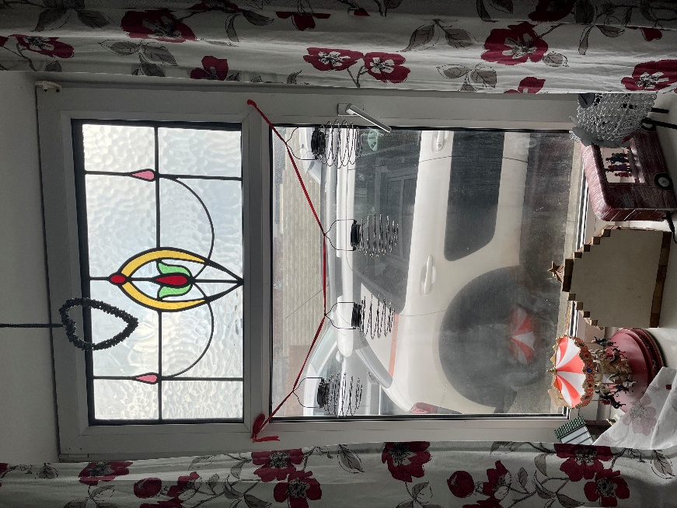

Walls
Description:  The Ground floor is split into three main rooms the kitchen/diner, lounge, and the sitting room. Minor rooms such as the bathroom and entrance hall can be found. Internal walls have been fitted with plasterboard. Entire first floor has been coated/painted in white with a smooth texture.  Condition:  Generally, in good condition. Minor cracking and damage have been observed in some rooms. No mould growth was observed. Observed to be solid wall. Air vent in the bathroom is broken, and old uPVC pipes are left exposed. Wallpaper from ceiling is damaged.  Cause/Defect:  Damaged walls can be affected by its age or caused by moving furniture or doing works. Solid wall indicates that the walls is filled and potentially insulated which backs up the information of no mould growth was found. Air vent is out of date and is in-efficient and old pipes have been left from previous works.  Recommendation:  Like for the first floor it is recommended to do a full inspection of the house to determine which walls are load bearing and non-load bearing. Re-painting and fixed damages on wall are required.  Air vent should be replaced, and any exposed pipes should be removed and filled accordingly to prevent thermal bridging.  It is good to conduct an energy performance survey to determine the thermal performance of the area. This allows the identification how thermal efficiency can be further improved. Make sure that there is a good airtight layer and insulation around junctions. | 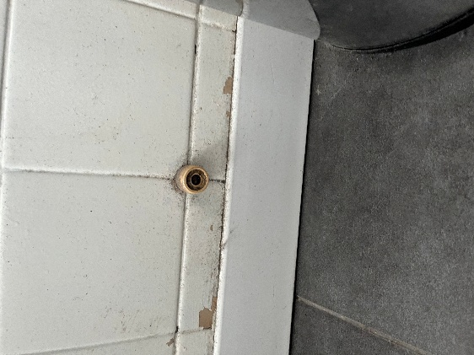  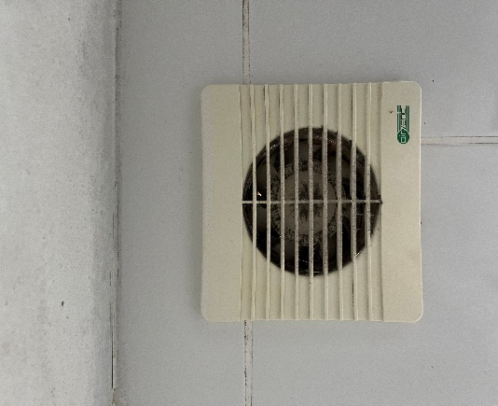  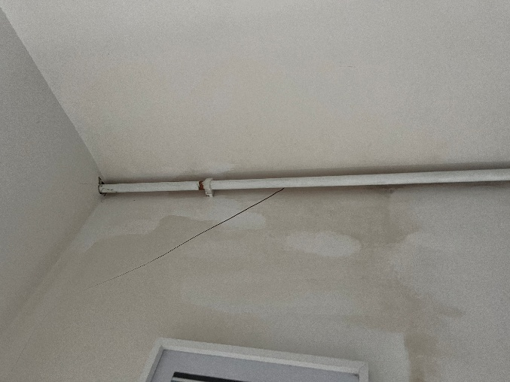  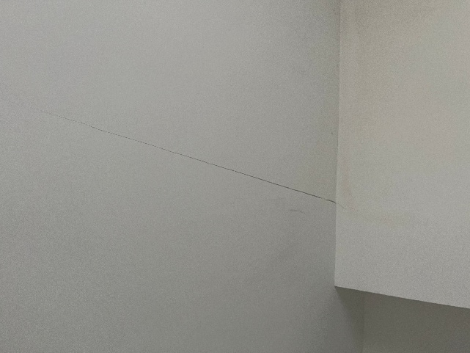  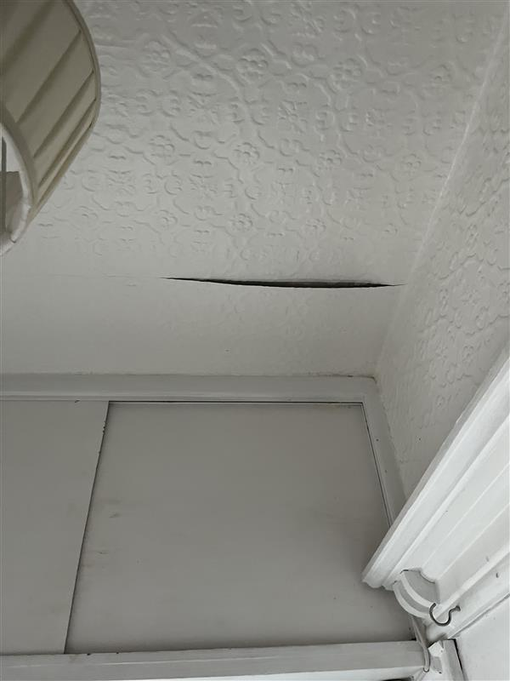

Floor
Description:  Concrete solid floor covered in a mix of carpet, laminated wood flooring, and tile flooring.  Condition:  All floorings are in good condition. Some areas have the underlayment exposed and damaged. Best to note that without the use of additional equipment’s there is no determining the actual condition of the concrete floor.  Cause/Defect:  Due to age some areas of the flooring may been damaged where the underlayment was also affected.  Recommendation:  Have the floor fully inspected to find out the structural condition. Any elements in the flooring damaged should be fixed and replaced. | 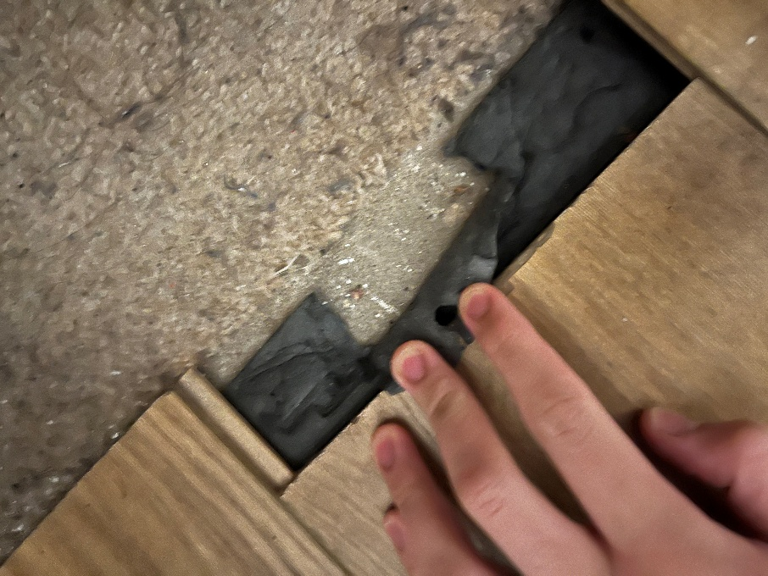

Deep Retrofit Recommendation
A deep retrofit is a holistic approach that creates a whole building strategy to ensure all elements work together for maximum efficiency. With more countries like the Uk looking for ways to reduce carbon emissions emitted from built environments. Passivhaus is a top leading organisation in this sector, where existing buildings such as the property above has been retrofitted up to the full EnerPHit standard. Every building comes with their own set of challenges and budget limitations which is crucial to ensure that the right steps are taken and up to standard. (Palmer. J and Lewis. S, 2022). There are 5 main principles of a deep retrofit these are:
- Insulation
- Thermal Bridging
- Ventilation
- Windows and Doors
- Air Tightness
Buildings that have been retrofitted to EnerPHit standards has shown a significant reduction in Carbon emissions and improve the health and wellbeing of the occupants. With the various building standards in is important that all works is in compliance with PAS 2035:2023.

Insulation:
With the survey conducted and previous house data such as the EPC and old pictures it can be determined that the current property lacks insulation in various areas of the house. For a house to be certified to be energy efficient it would need to be up to standard with modern building regulations. Insulation for Walls the Approved Document L (ADL) requires existing dwellings for refurbishment to have met the target U-value of 0.30 W/(m²K) for retained fabric. (Approved Document L, 2024). When it comes to adding insulation to various parts of the house other element such as air tightness and thermal bridging should be massively considered. With the assumption of an uninsulated cavity wall filling this area can massively reduce heat loss. Materials such as Polyurethane (PUR) foam insulation is a highly efficient and known for its excellent thermal resistance while providing an airtight seal and good moisture control. Mineral wool is also a good choice for a balanced for fire safety, and lower embodied carbon typically in masonry cavities. (Brown. I 2025 A). To achieve the target U-value the thickness of the insulation is key for new build a thickness of around 150mm or more depending on the material’s thermal performance, for existing builds with smaller cavities high performance insulation such as Polyurethane allows for a thinner insulation layer.
To further boost the thermal performance the addition of an External Wall Insulation (EWI) is recommended in a deep retrofit. Materials like Expanded Polystyrene (EPS) and mineral wool both offer great thermal performance. In this instance Mineral Wool is most suitable providing breathability, fire resistance and soundproofing. EWI is an excellent way for existing building such as the property surveyed that may lack the cavity space needed for a sufficient and efficient internal wall insulation. (Brown. I 2025 A).
With the poor condition of the insulation found in the loft and in the kitchen roof compartment is it required that this is replaced. For UK roofs, ADL requires U-values of 0.13-0.18 W/(m²K) and thickness of insulation ranges from 140mm to over 200mm for pitched roofs, for the best optimal performance a thickness up to 270mm is recommended. (Approved Document L, 2024). The insulation material will depend on the occupants needs. Material such as mineral wool is used for being versatile and a good choice for insulation between rafters. For the best thermal performance material such as rigid insulation boards (PIR) is recommended. Electrical wires and pipes should be installed above the newly installed insulation to prevent any problems such as fires from occurring. (Brown. I 2025 A).
With the current property having solid concrete floors with no insulation, it is highly recommended that insulation is installed to enhance comfort and well-being of the occupants whilst improving thermal efficiency. There are generally two options, the most common is adding insulation over the existing slab which has lower disruption or by digging out and insulation below slab which gives the best thermal performance but very disruptive. It is important that a Damp Proof Membrane is also installed under the insulation to prevent the build up damp and moisture which can damage the insulation and any timber components. (Department for Energy Security and Net Zero, 2022). DPM should be connected to existing wall DPC to avoid moisture pathways. To prevent thermal bridging insulation should cover all junctions where the floor meets the walls. Both methods can increase the floor level where more works needs to be done on doors, thresholds and skirtings. When considering flood risk the increase in floor level creates shallower floodwater which prevents it from reaching internal finishes and services. ADL says that a U-value of 0.25 W/(m²K) should be achieved depending on the type of material and its thickness. PIR should be at least 100mm with common floor insulation such as EPS and Mineral wool should be 150mm. (Brown. I 2025 A).
Thermal Bypass is the degradation of thermal performance due to air passing around/behind the insulation or that passes through the insulation and wicks out heat.
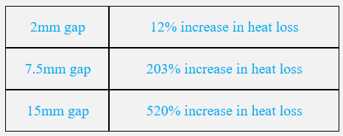
(Sidall. M 2022)
Preventing thermal bypass by using blown insulation for odd, shaped areas, using the right tools to cut boards to ensure a straight and vertical cut which can result in fewer gaps. (Brown. I 2025).

Air Tightness and Thermal Bridging:
For all areas where insulation is present it is key that other elements such as a DPM or DPC and air tightness layers are installed. These should be carefully considered on junctions or where there is a penetration of a component such as pipes. For a retrofit build there is two options to further prevent heat lost. Airtightness helps stop the uncontrolled leaks through drats and vapor movement through the entire building envelope to help improve comfort and prevent condensation. Wind tightness blocks wind-driven rain and cold air from penetrating the exterior wall/insulation layer. For this house it is recommended that an airtight layer is installed. ADL has specified that for new build maximum air permeability should be at 8.0 m³/(h·m²) @ 50Pa. This should be used as a benchmark for any buildings going through a deep retrofit to identify potential improvements. (Approved Document L, 2024). When considering air tightness, it should be looking at junctions on windows and various structural elements of the house.
Any components penetrating through the external/internal walls such as the unused pipes seen on the survey should be removed and filled. Any pipes still in use and penetrates the building insulated envelope should have method to prevent thermal bridging. Thermal break a type of material with low thermal conductivity can be inserted within structural element where it crosses the insulation line. Another way is by having continuous insulation covering the entire structure. Having sufficient seal and airtightness around gaps and joint around the penetration should be achieved. (Brown. I 2025 B).
Ventilation:
Evidence of mould growth in certain rooms shows either the lack of ventilation or air tightness around windows. In rooms such as the bathroom a broken ventilation system was seen during the survey. Fixing these vents is crucial in removing moisture and pollutants from wet rooms such as the bathroom. If airtightness has been achieved the option of having a mechanical ventilation while less airtight rooms can use natural ventilation (windows). Air quality is important to ensure the compliance to modern building regulations. With the risk of radon gas ventilation is important in ensuring the safety of the occupant. A controlled ventilation system provides a balance in energy efficiency and air quality. (Approve Document F, 2022) and (Approve Document L, 2024). All new ventilation system needs to be inspected and tested to ensure that existing components achieve a “functional performance”. (BSI, 2023)
Windows and Doors:
Due to the age of some of the windows replacing them is ideal. ADL has specified that for a replacement window it should have a U-value of 1.4 0.25 W/(m²K), for doors with less than 60% glass the maximum U-Value should also be 1.40.25 W/(m²K). To ensure the compliance in building regulations, windows and doors must use double-glazing with low emissivity glass. For the best thermal performance, the use of triple glazing is suitable. (Approved Document L, 2024). It is important that areas such as the window frames are considered. The use of composite uPVC window frames comes with built-in thermal breaks, and good practice of having a continuous insulation around the window reveal is ideal. Air tightness is important in ensuring that no warm air escapes. An airtight seal prevents draft and moisture which prevents the growths of moulds improving health and wellbeing of the occupants. (Passivhaus Trust, n.d).

Reference List
Brown.I (2025 A) Insulation Options. [online] Retrofit Coordination and Management (ACBA5026) University of Wales Trinity Saint David. Presentation slides provided by the lecturer which is accessed by the University Learning Platform. (Accessed on 14 October 2025)
Brown.I (2025 B) Thermal Bridging. [online] Retrofit Coordination and Management (ACBA5026) University of Wales Trinity Saint David. Presentation slides provided by the lecturer which is accessed by the University Learning Platform. (Accessed on 28 October 2025)
ChatGPT (2025) Used to create the structure of the report. [online] Available at: https://chatgpt.com/ (Accessed on 8 November 2025)
Digimaps (n.d) Historical Maps. [online] Available at: https://digimap.edina.ac.uk/ (Accessed on 8 November 2025)
Zoopla (2016) 41 Salem Road, Llanelli, SA15 3PZ. [online] Available at: https://www.zoopla.co.uk/property/uprn/100100173825/ (Accessed on 8 November 2025)
Gov.UK (2014) Energy Performance Certificates (EPC). [online] Available at: https://find-energy-certificate.service.gov.uk/energy-certificate/8734-7027-2090-9136-4996#renting (Accessed on 8 November 2025)
Propertychecker (n.d) 41 Salem Road, Llanelli. [online] Available at: https://propertychecker.co.uk/property-details/?pid=34063101472a697a6efa12236179c3b2&postcode=SA15%203PZ (Accessed on 8 November 2025)
Google Earth (n.d) 41 Salem Road. [online] Available at: https://earth.google.com/web/search/41+Salem+Road,+Felinfoel,+Llanelli/@51.6965959,-4.1471844,31.60421828a,500.02018379d,35y,0h,0t,0r/data=CiwiJgokCSUpNHM42UlAEdSpnjMm2UlAGR-TXkH8lRDAIXPhFIg5lxDAQgIIAToDCgEwQgIIAEoNCP___________wEQAA (Accessed on 8 November 2025)
BSI (2023) PAS 2035:2023. [online] Available at: https://www.bsigroup.com/en-GB/insights-and-media/insights/brochures/pas-2035-retrofitting-dwellings-for-improved-energy-efficiency/ (Accessed on 13 December 2025)
RICS (n.d) House surveys (UK): the costs, types and benefits of an RICS Home Survey. [online] Available at: https://www.rics.org/consumer-guides/house-surveys-uk-the-costs-types-and-benefits-of-an-rics-home-survey (Accessed on 13 December 2025)
Palmer. J and Lewis. S (2022) Passivhaus retrofit in the Uk. [online] Available at: https://passivhaus.uk/passivhaus-retrofit-in-the-uk/ (Accessed on 13 December 2025)
Welsh Government (2024) Approved Document L: conservation of fuel and power. [online] Available at: https://www.gov.wales/approved-document-l-conservation-fuel-and-power (Accessed on 14 December 2025)
Department for Energy Security and Net Zero (2022) Solid floor insulation (SFI): best practice. [online] Available at: https://www.gov.uk/government/publications/solid-floor-insulation-sfi-best-practice?utm_source=chatgpt.com (Accessed on 14 December 2025)
Sidall. M (2022) Thermal Bypass Risks. [online] Available at: https://passivhaus.uk/thermal-bypass-risks/ (Accessed on 14 December 2025)
Passivhaus Trust (n.d) Passivhaus: a route to net zero Retrofit. [online] Available at: https://www.passivhaustrust.org.uk/UserFiles/File/Primers/2021%20PHT%20Primer%20retrofit%20v2.2.pdf (Accessed on 3 January 2026)
Welsh Government (2022) Approved Document F – Ventilation. [online] Available at: https://www.gov.wales/sites/default/files/publications/2022-05/approved-document-f-vol-1.pdf (Accessed on 3 January 2026)

