Network Operating Systems and Services – Worksheet 1
Author: Liam Aaron Jarvis (2000388)
Network Operating Systems and Services (ACCA5023)
School of Applied Computing
Wales Institute of Science and ART
Date of Submission: 4th of March

Table of Contents
Page
Introduction 3
Building a Virtual LAN Using Type 2 Hypervisor Management Software 3
Creation of Virtual Machines 3
Virtual Network Configurations 15
Deploying a Network Directory Service and Network Objects 23
Creating User Account Objects 27
Object Attributes of Interest 31
Adjoining the Domain and Testing User Logins 33
Differences between Type 1 and 2 Hypervisors 37
Cloud Computing Explained – Benefits and Drawbacks 37
Domain Name System (DNS) And Its Significance Within Active Directory Domain Services 39
‘Role or Feature Based Installation’ Critical Roles 40
Reflection/Conclusion 41
Reference List 42

Introduction
This document covers Worksheet 1 of NOSS, Build a virtual LAN using a type 2 hypervisor management software, deploy a network directory service and active directory network objects, and a final observational task.

Building a Virtual LAN Using Type 2 Hypervisor Management Software

Creation of Virtual Machines
Firstly, create 2 Windows server virtual machines using Virtual Box. To do this, select “New”. Set the machine name and select Windows Other 64 Bit. The following settings were used for the server machines:
Memory Size: 4096MB
Hard Disk: Create a virtual hard disk now > VDI
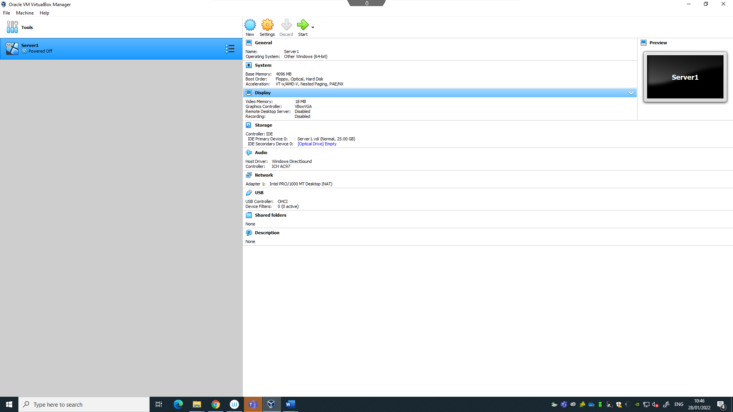
Storage: Dynamically Allocated, 25GB
The same can be done for Server 2:

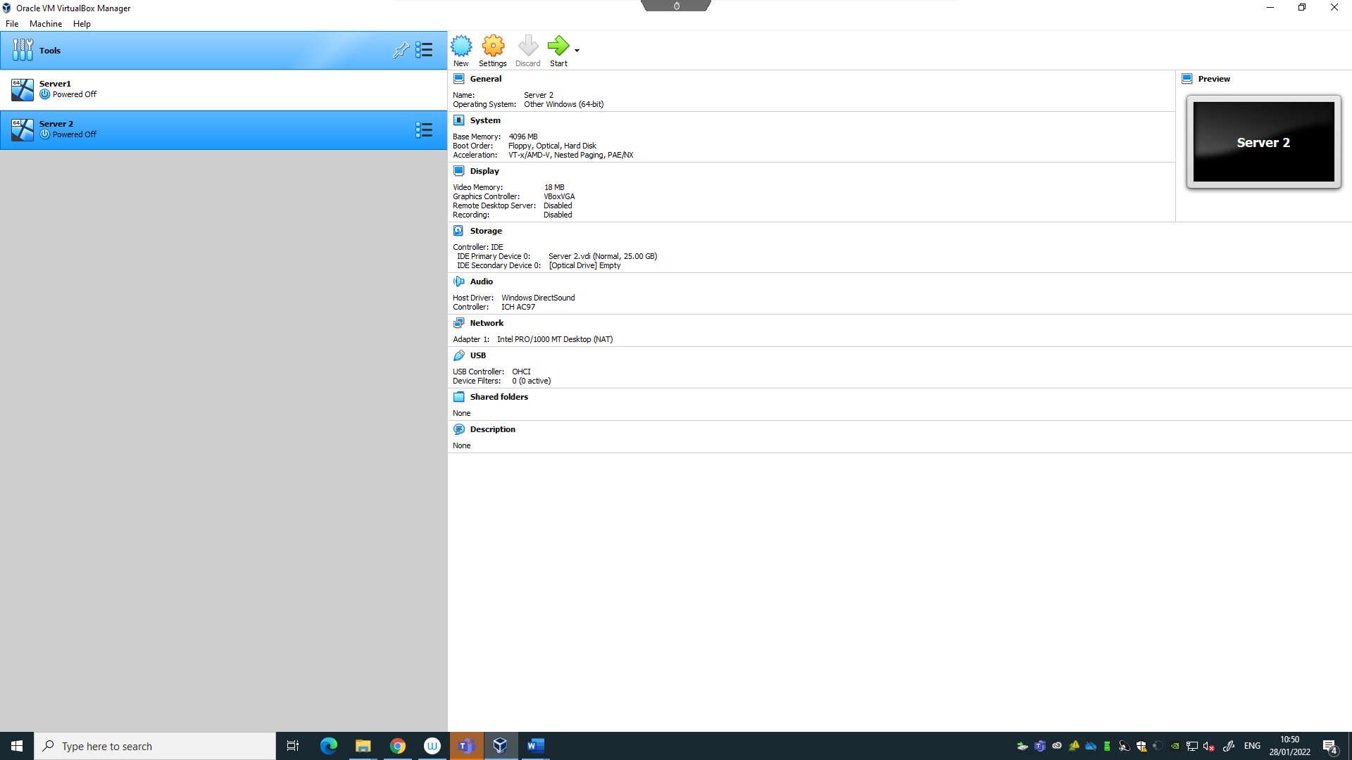

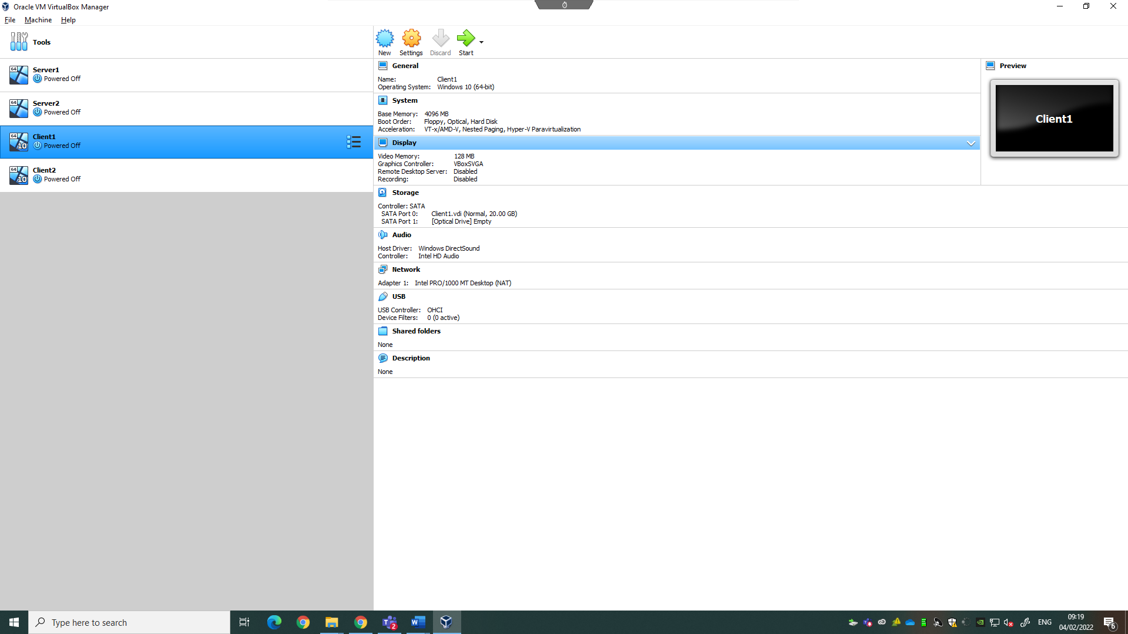
The same can be done for the client machines, the differences being:
Version: Windows 10 64 Bit
Storage: 20GB (The extra space is not needed)

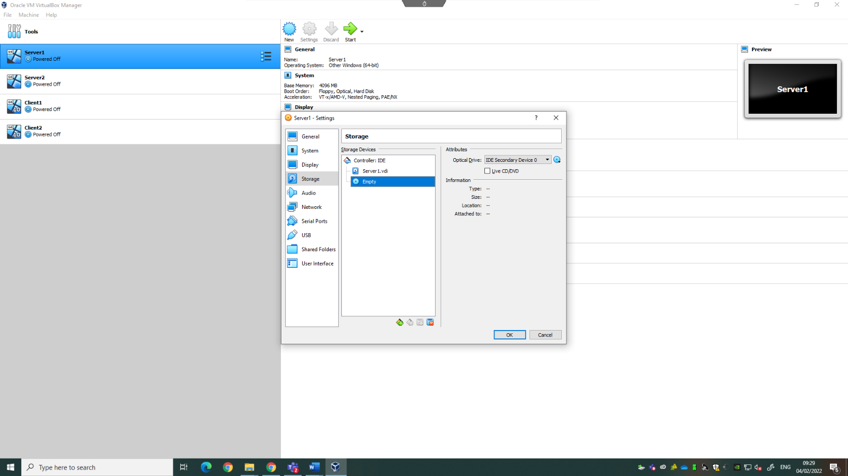
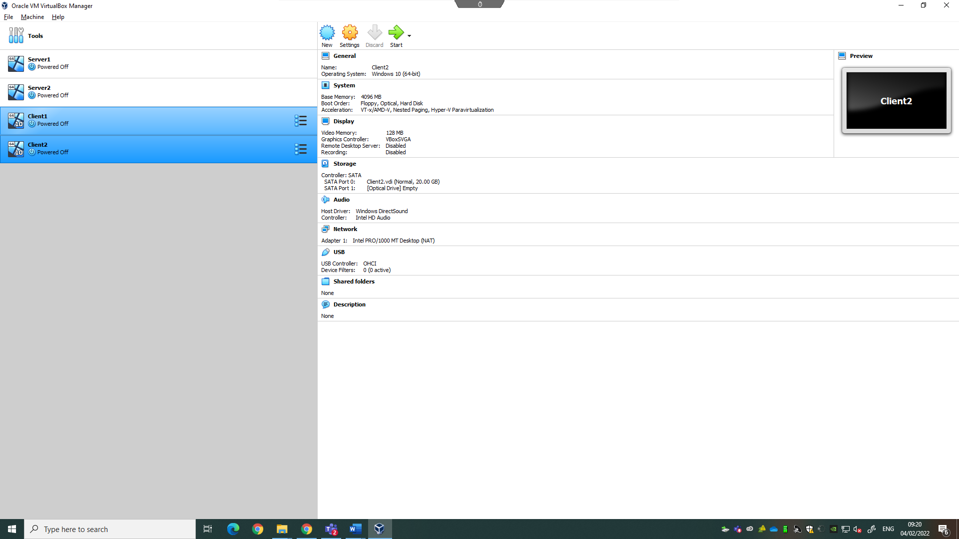
Just like a physical PC, once the machine is built, the operating system must be installed. First, install the OS for the server machines. Open settings and open the storage category. Select the disk icon named “Empty”:
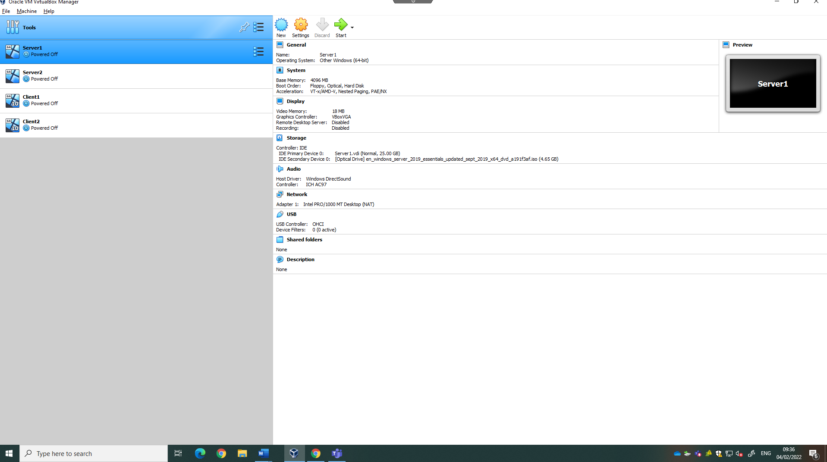
Under attributes there is another disk icon, select this and then from the drop-down list select “choose a disk file”. Then, select the windows server 2019 essential ISO and select ok.
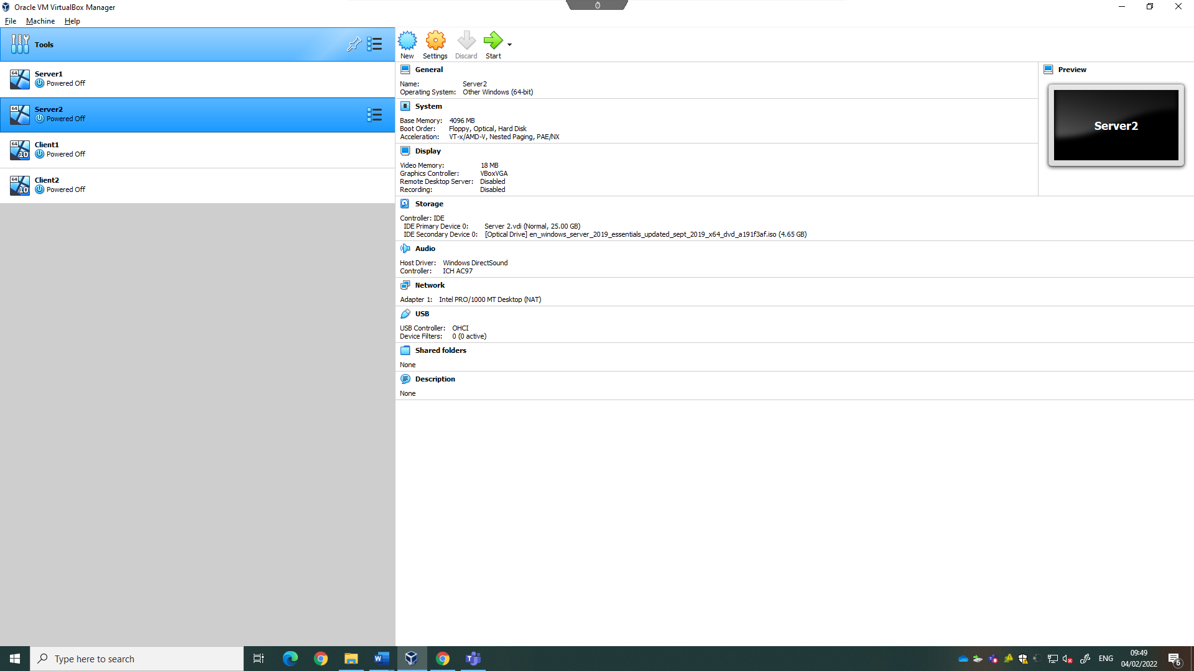

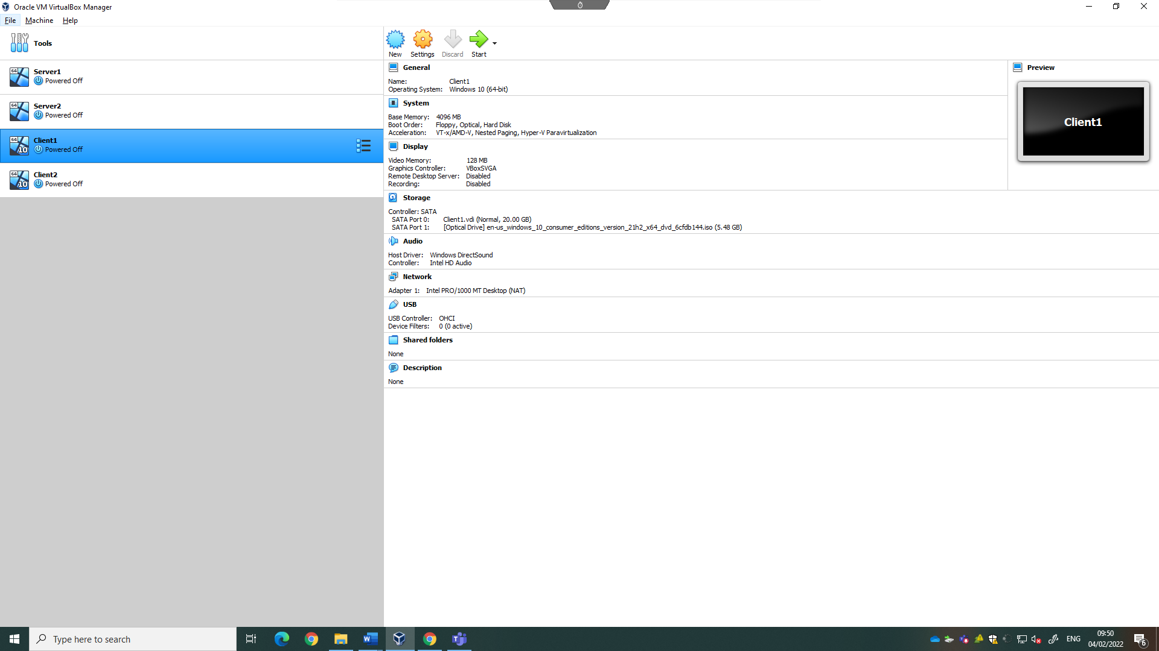
The same can be done for the client machines, but instead select windows 10 consumer edition 21h2 ISO.
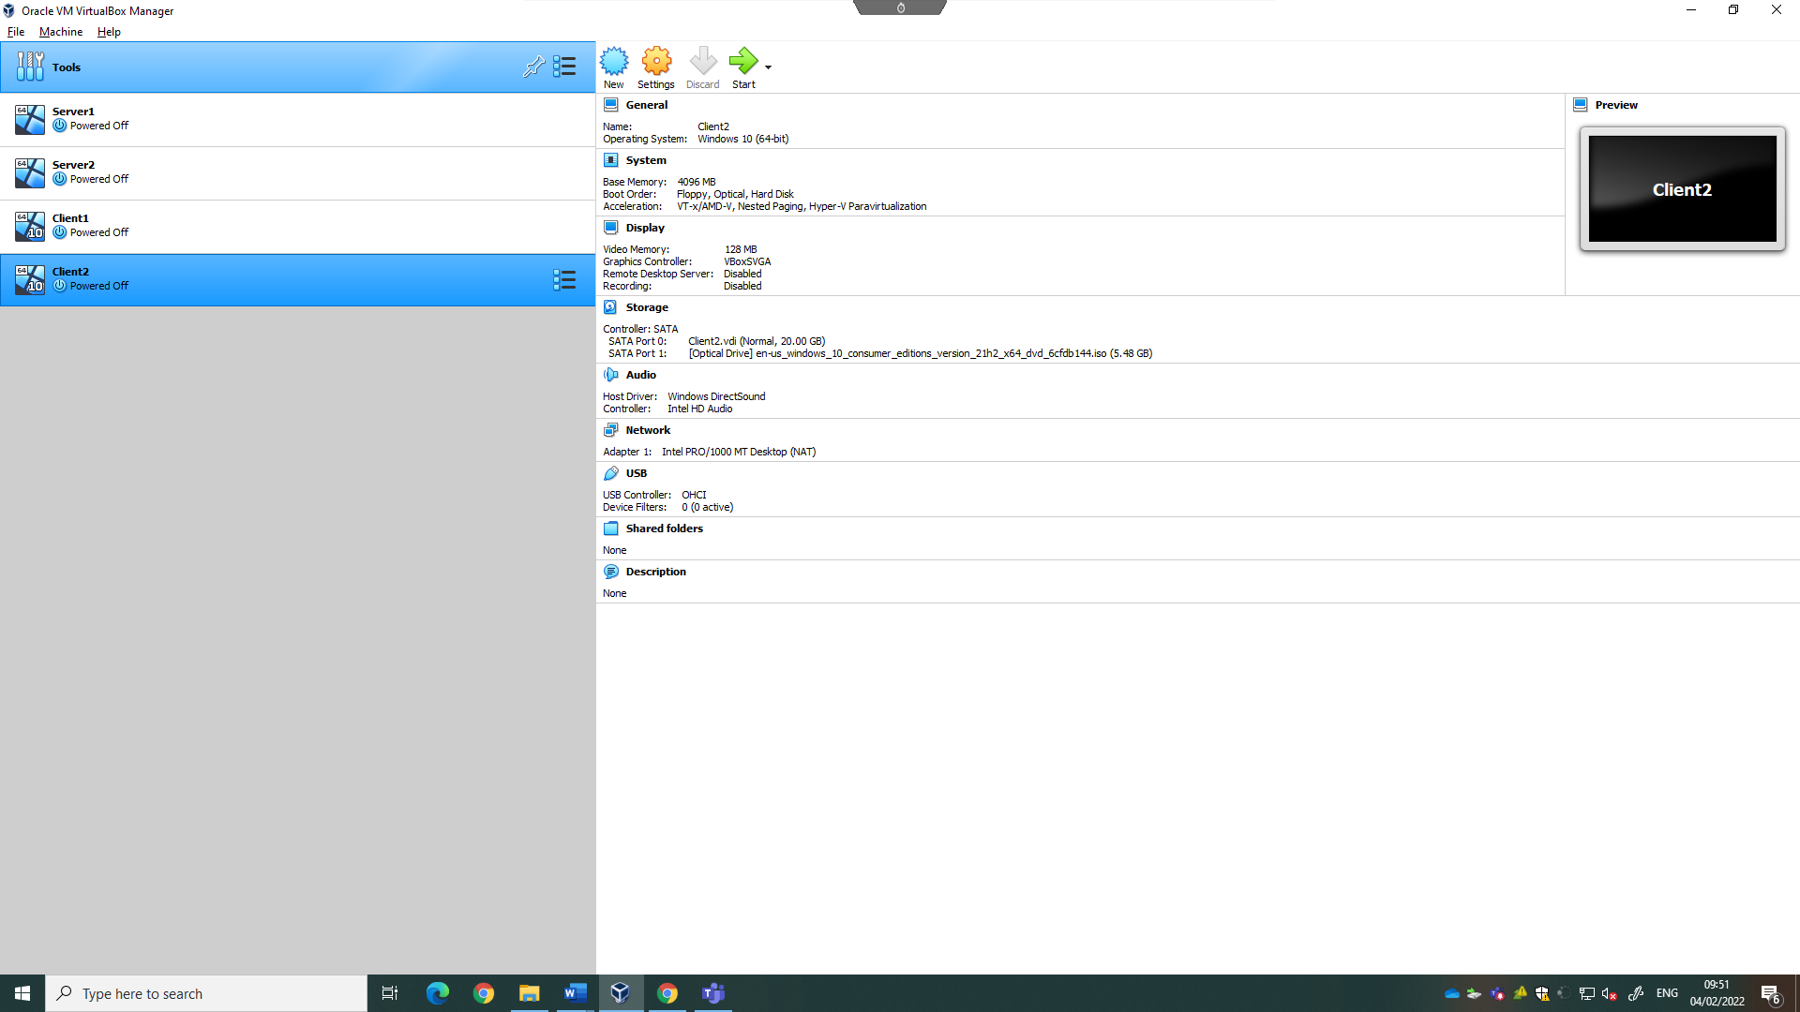

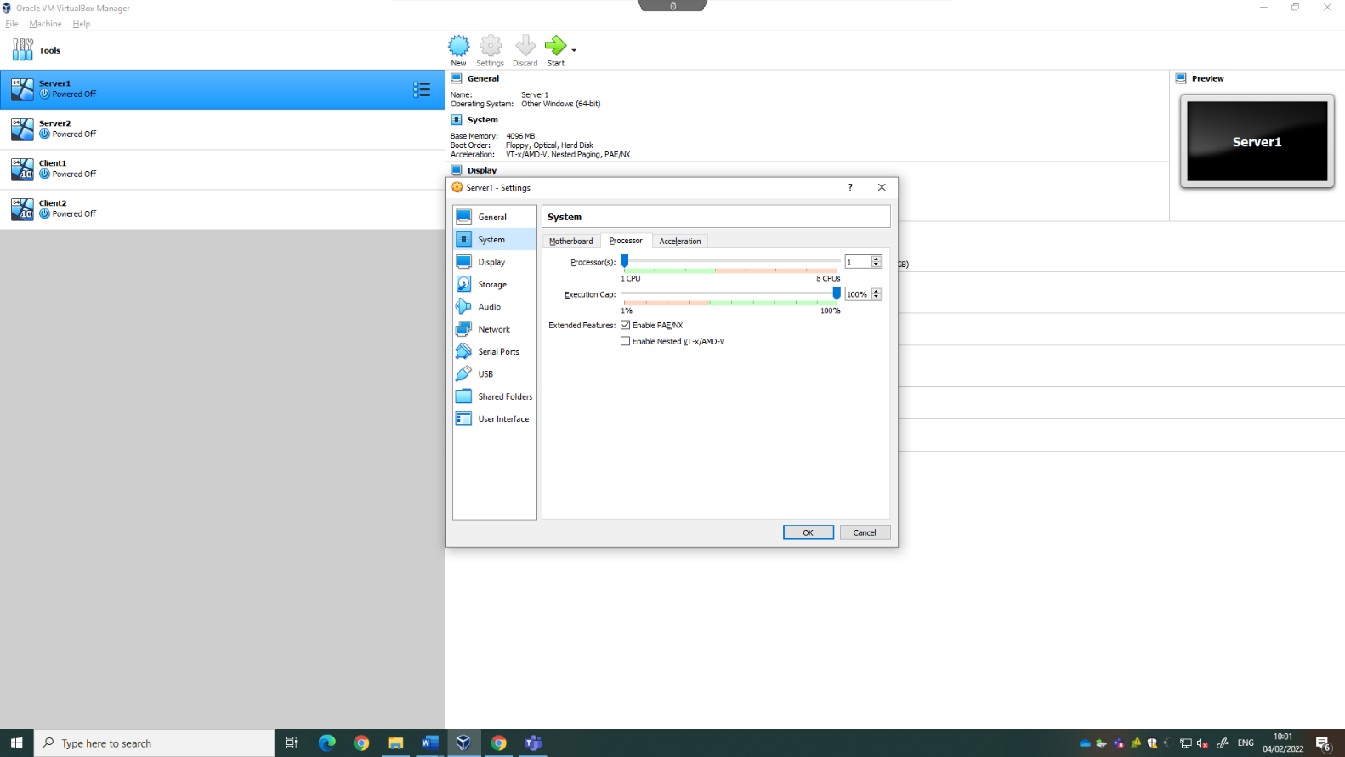
Before any other steps are taken, optimisations can be done to the machines to improve their performance. To do this, select a machine and choose settings. From here, choose the System Category, Processor Tab. On this tab, TICKPAE/NX, AS This makes the physical address register of the CPU of the host PC to be more readily accessible by the VMs.

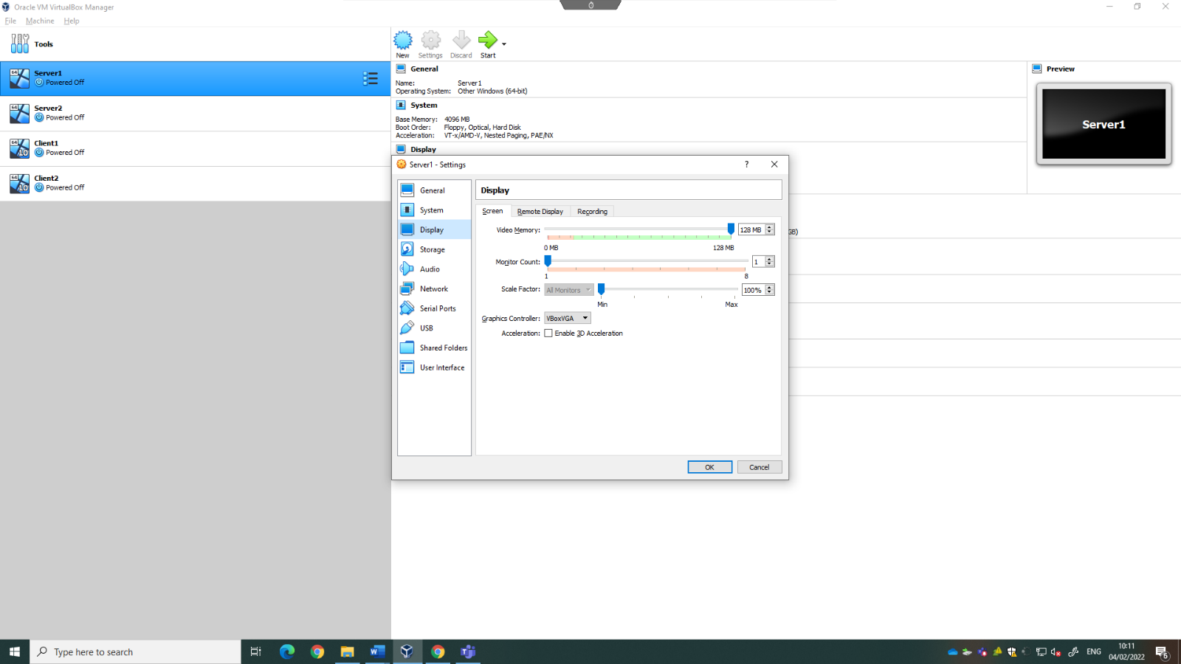
After doing this, go into the display category and set the video memory to 128MB.

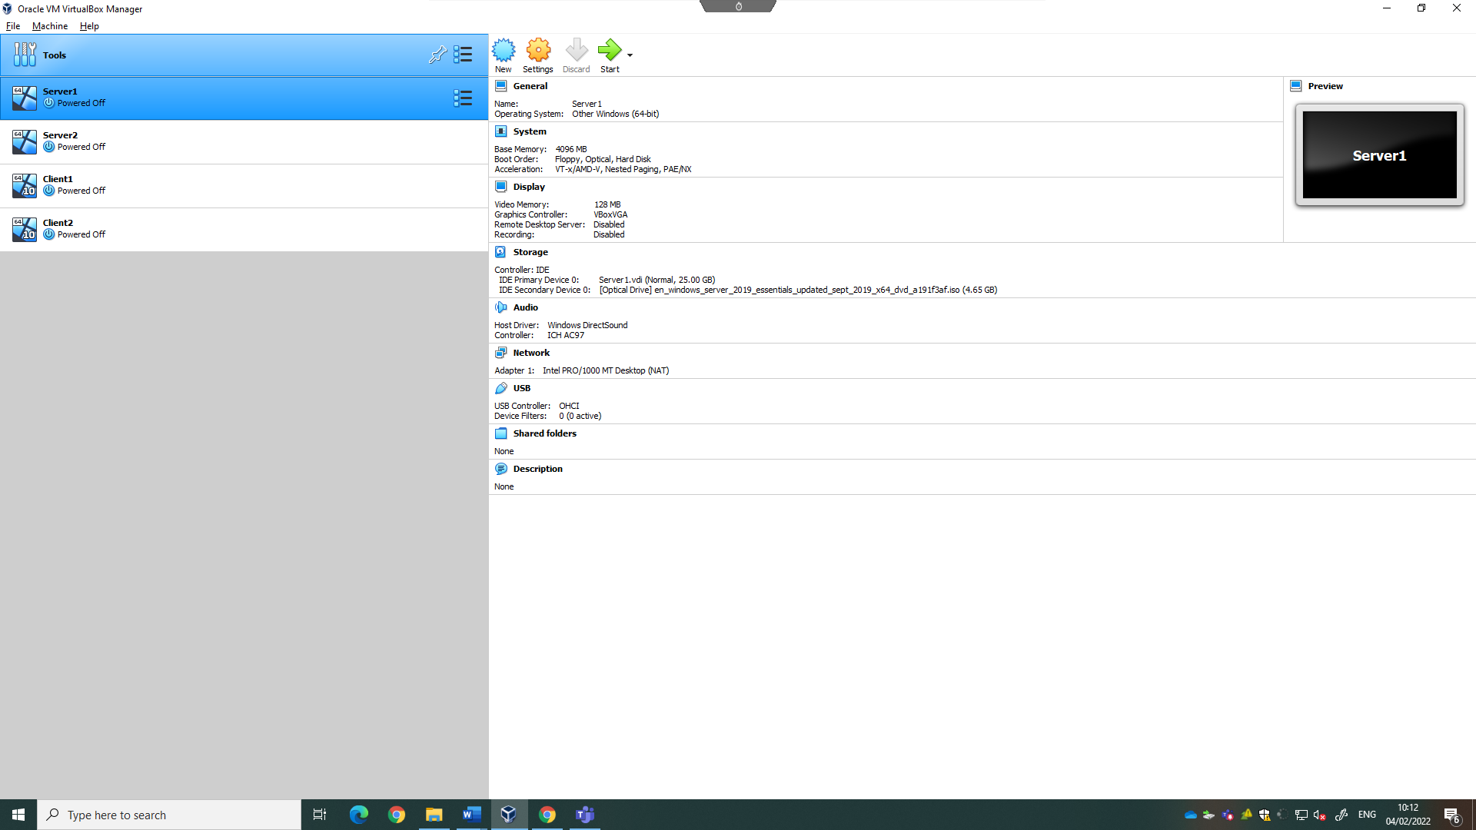
These changes can be seen below:
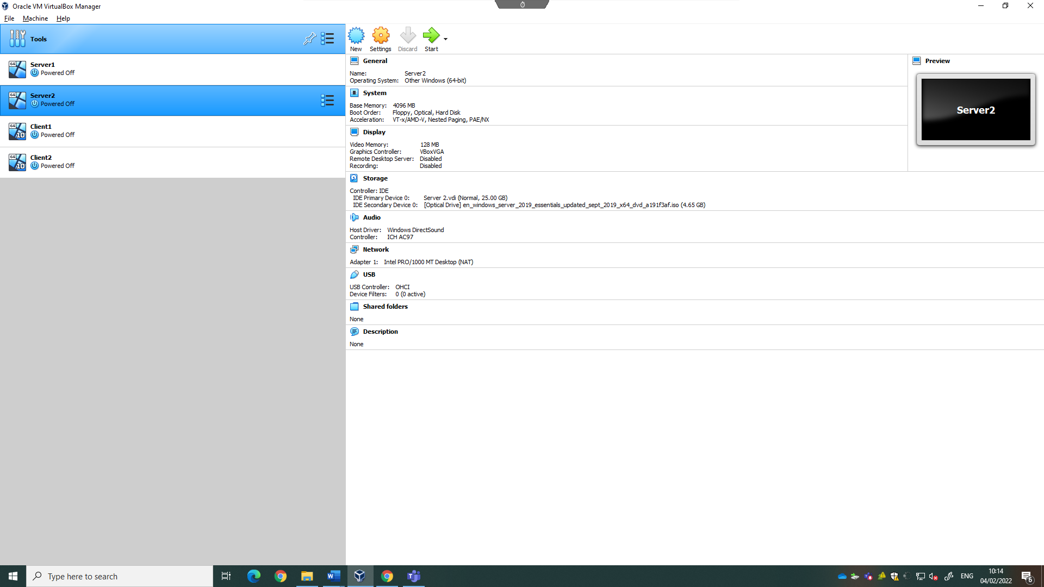
The same can be done for the other machines.

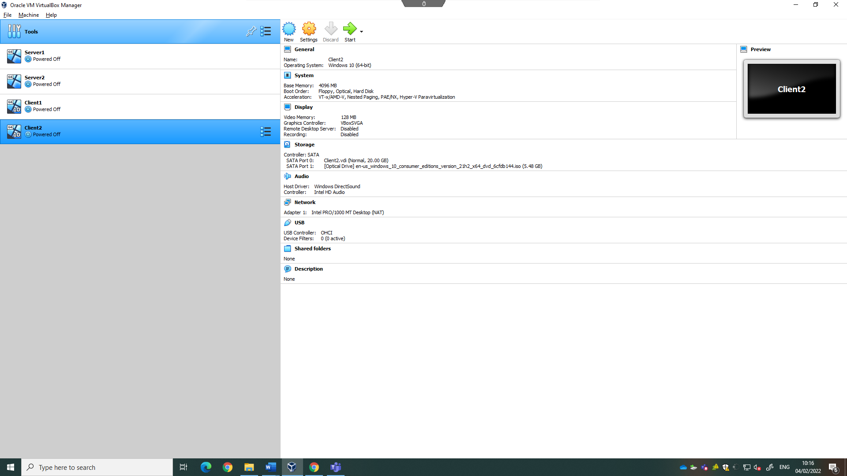
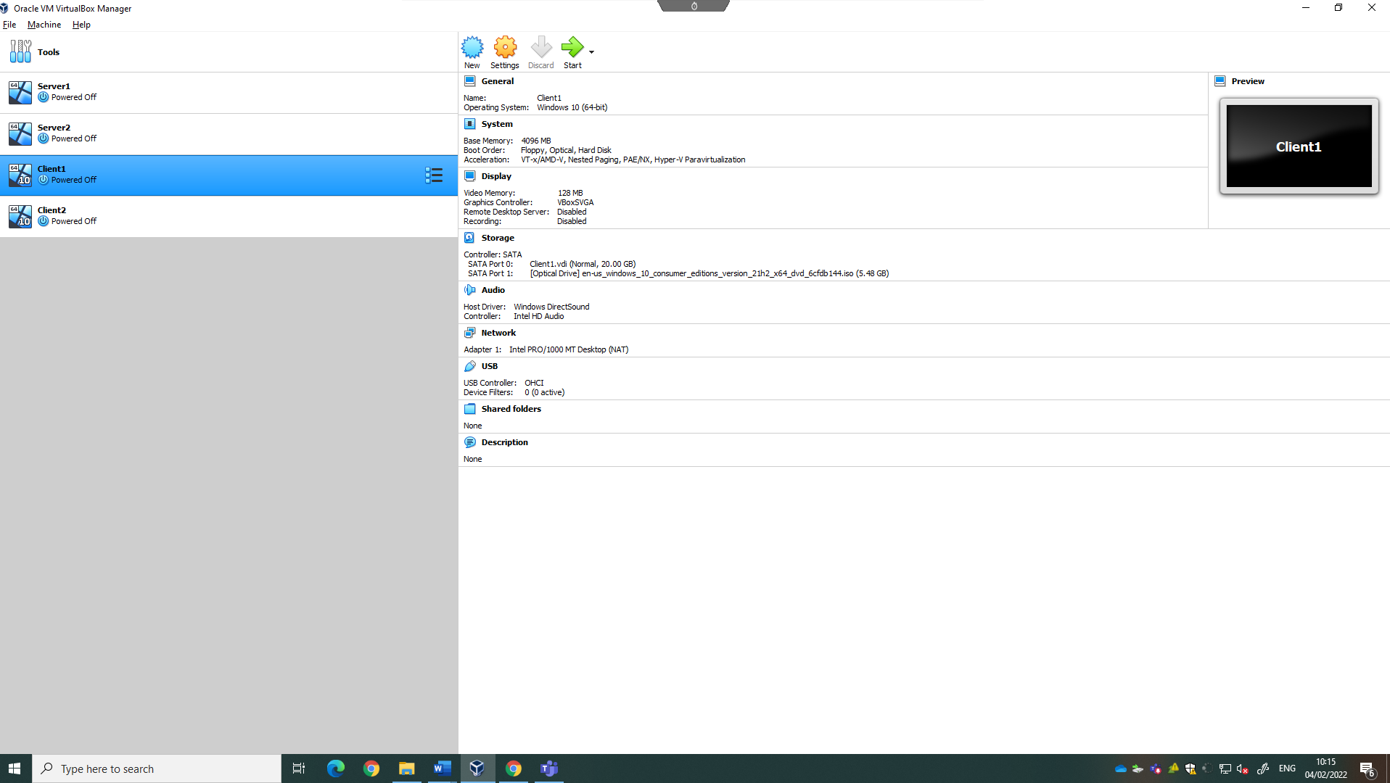

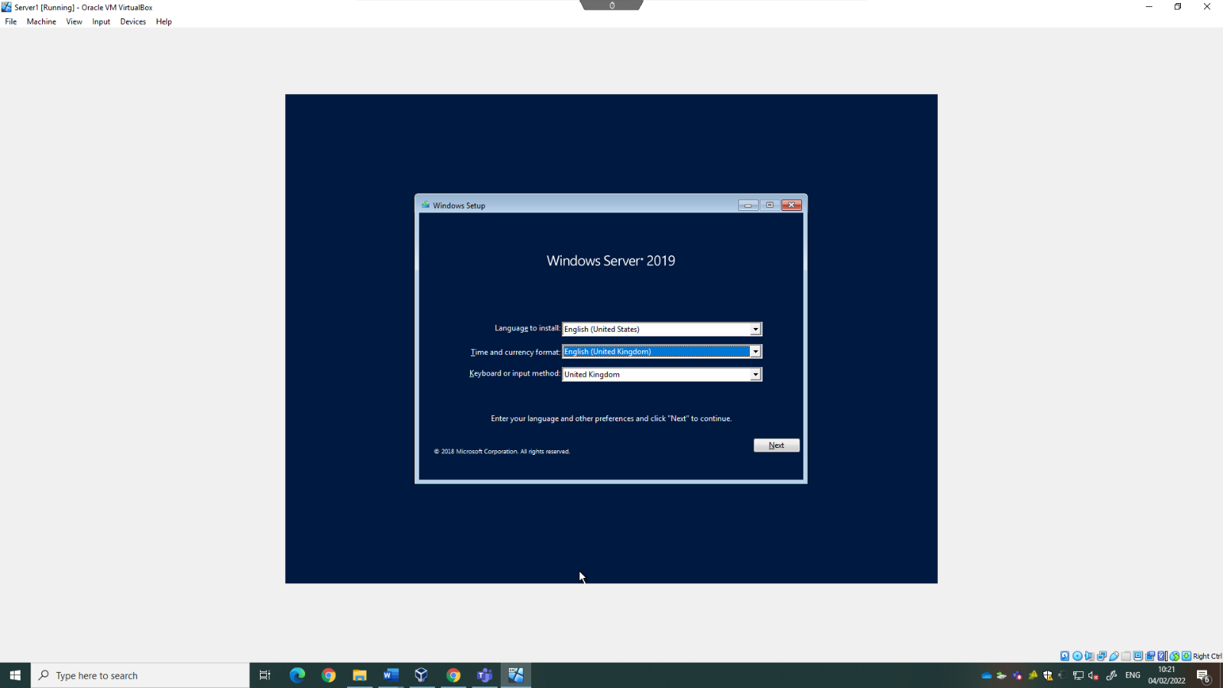
The OS can now be setup on each machine by booting up the machines.
When prompted on which type of installation is required, select custom as the machine is new and will have no existing files. Windows will then install the necessary files and restart. After windows is installed, you are prompted for a password. The one used for these machines were: No5sP@ssw0rd, but any can be used.
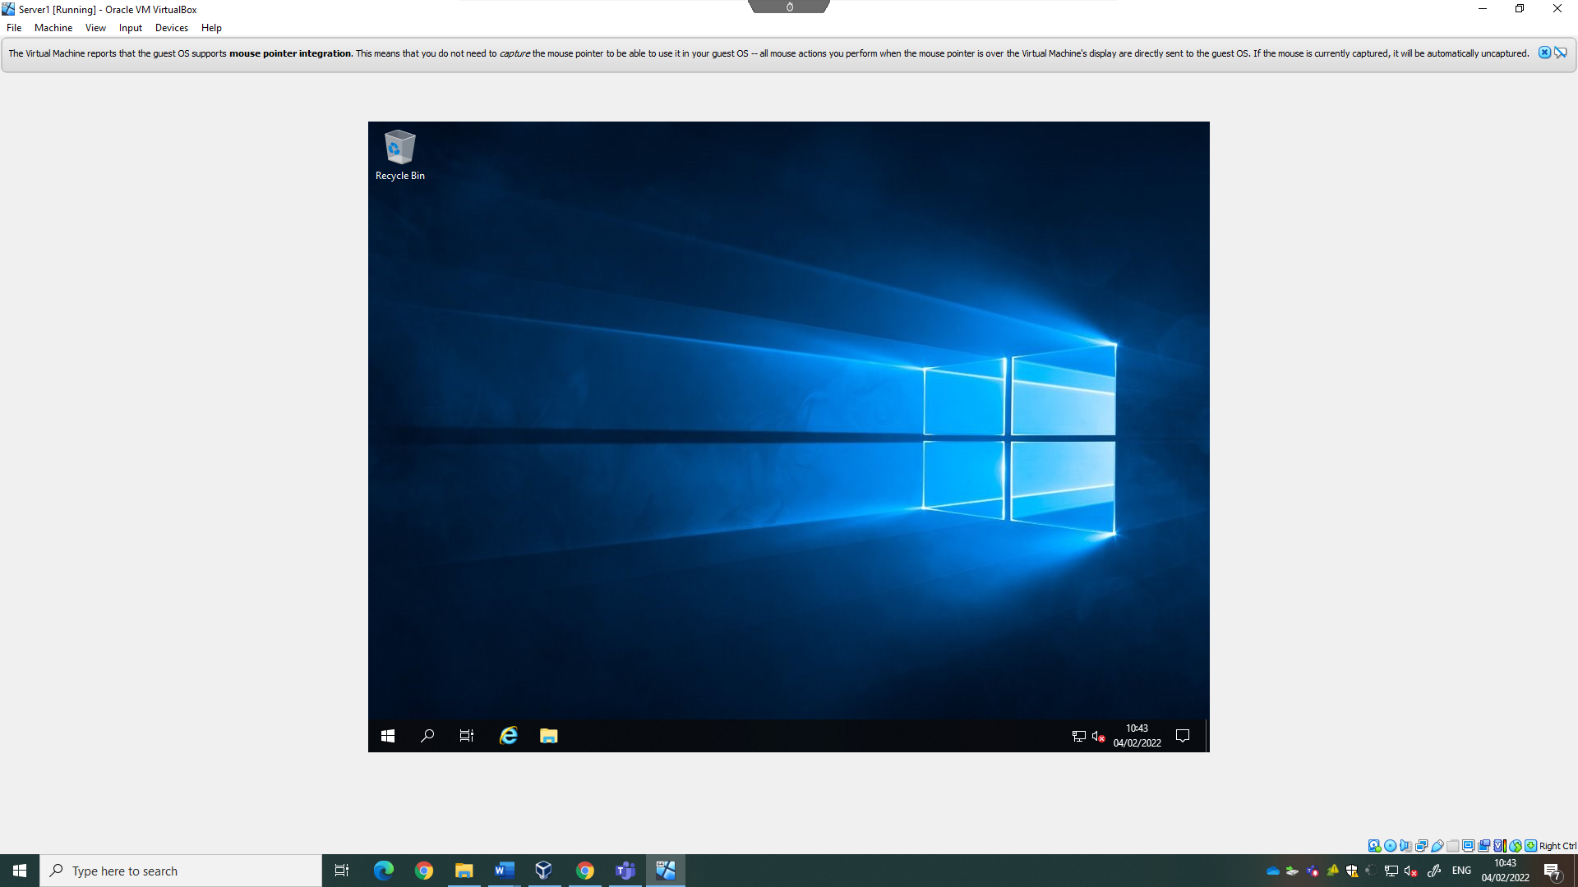

Virtual Network Configurations
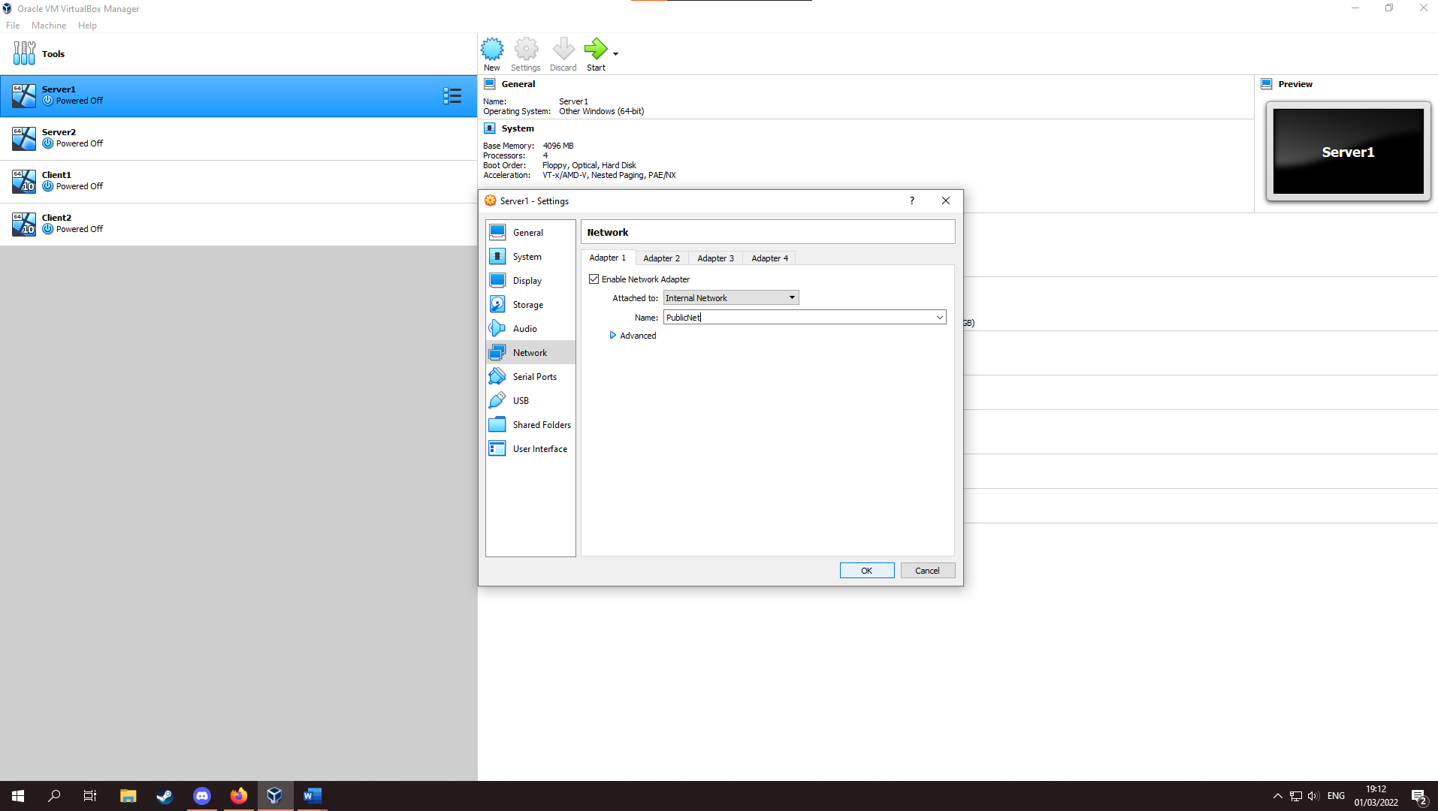
After setting up all systems, the virtual networks can be setup. To do this, close any machines currently running, and then chose server 1. From here, choose the Network category and under tab 1, and from the drop-down list named “Attached to:” select “Internal Network, and rename this to PublicNet.

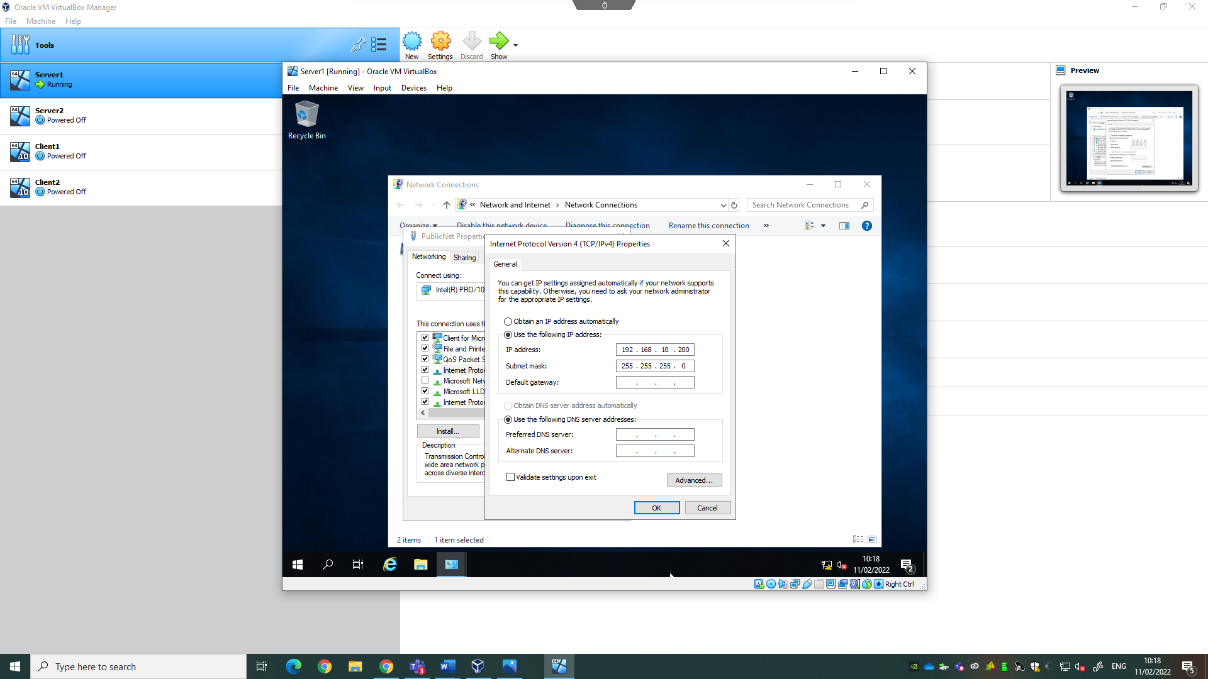
After doing this, select ok and boot up the system. Once logged in, use search bar and search for “Control Panel”. From here, under “Network and Internet” select “View network status and tasks” and then select “change adapter settings”. From here, select “Ethernet”, “Rename this connection” and rename it to “PublicNet”. Right click “PublicNet” and choose properties, and then double click “Internet Protocol Version 4 (TCP/IPv4)”. Lastly, choose “Use the following IP Address” and insert the IP address. (“192.168.10.200” was used as per figure 1 of worksheet 1). When entering the subnet mask, it should automatically populate as “255.255.255.0”. This is the subnet mask for a Class C IPV4 IP address.

After PublicNet for server1 is setup, the private network can be setup after shutdown. Navigate back to the network category and enable adapter 2, using it to create the first private network:
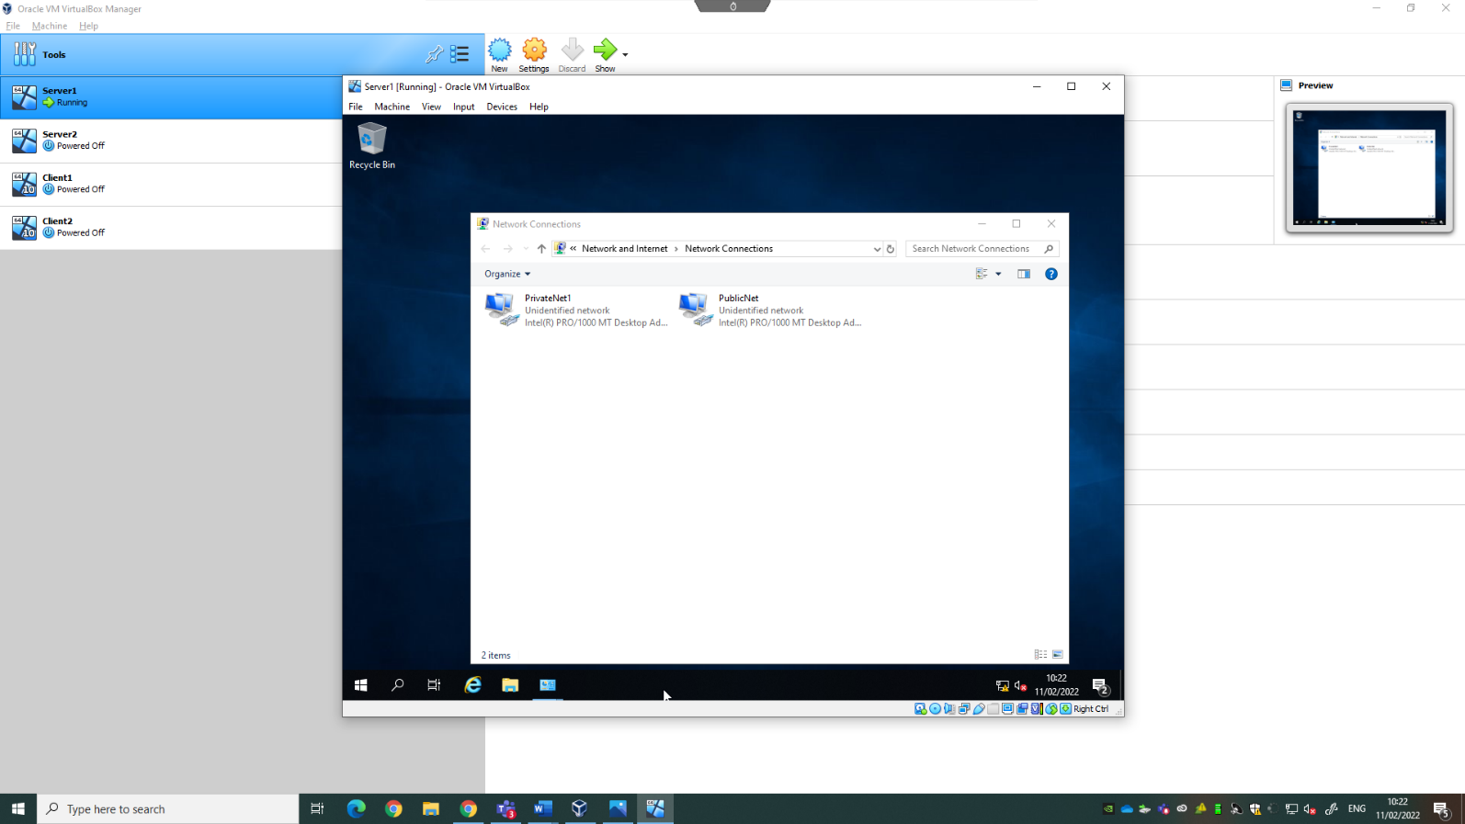
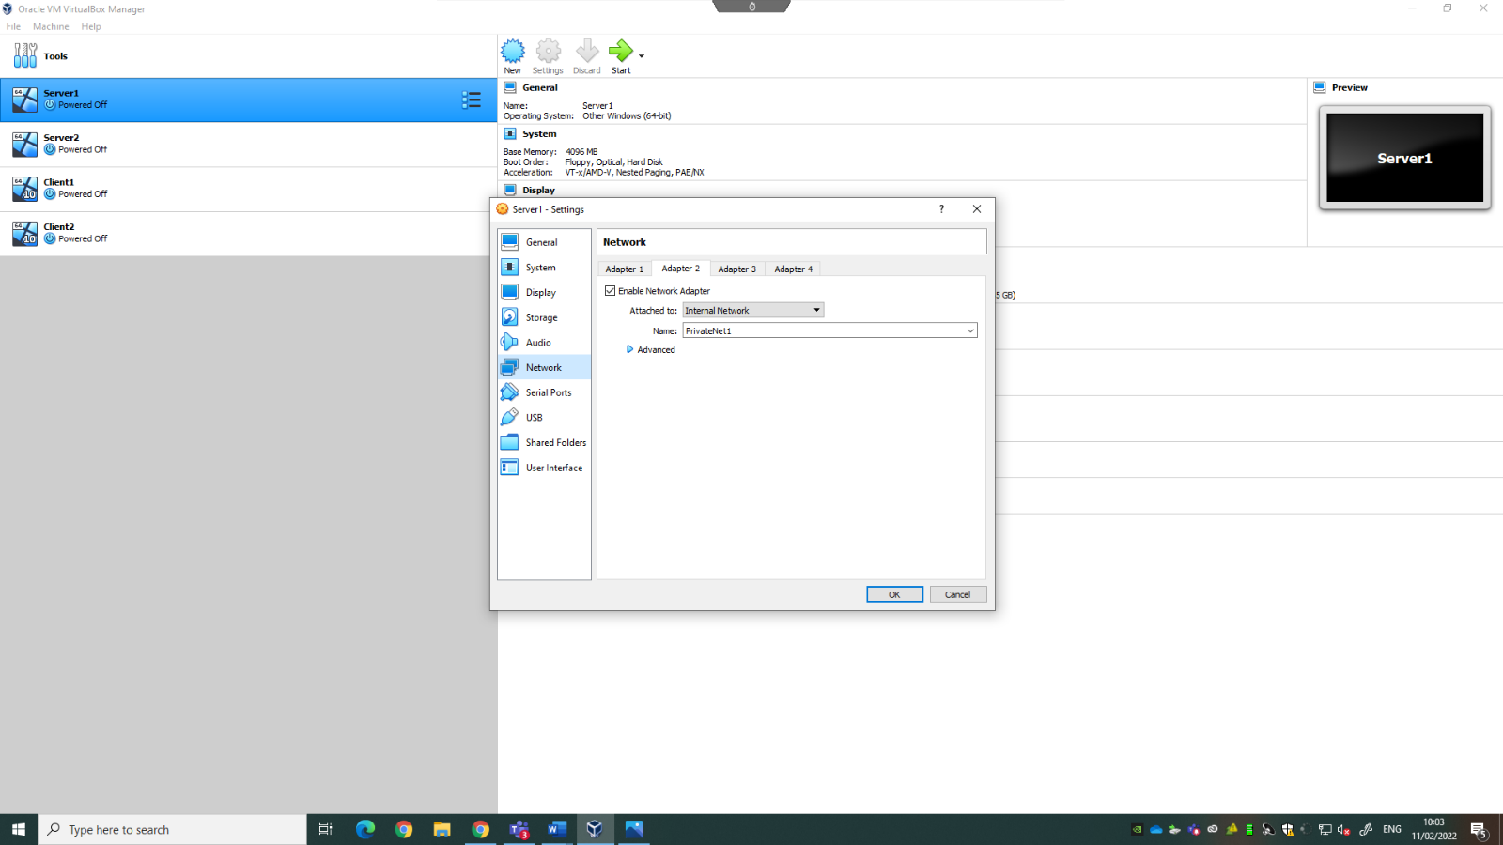
Boot up the system and navigate back to “change adapter settings”. From here, select “Ethernet” and rename it to “PrivateNet1”.

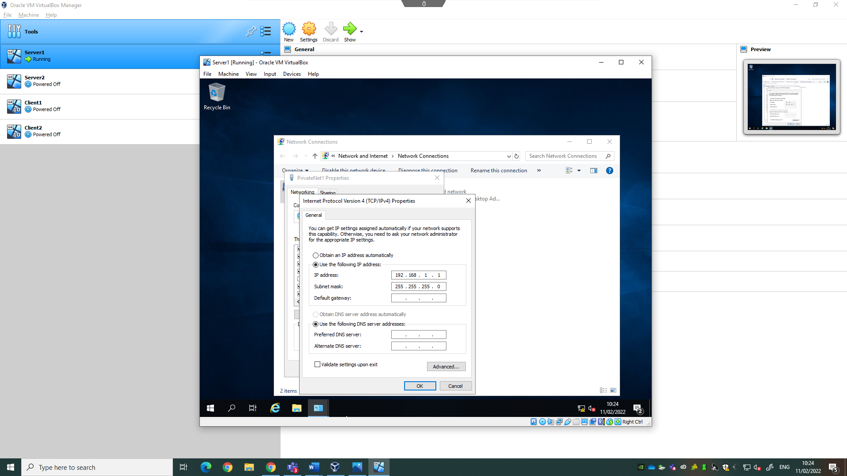
From here, set the manual IP address of PrivateNet1 (as per figure 1.)
Now, the network adapter for Client1 can be configured. Navigate to the network category of Client1, ensuring Internal Network is selected and when renaming the adapter, there should now be a drop-down list where “PrivateNet1” can be selected.

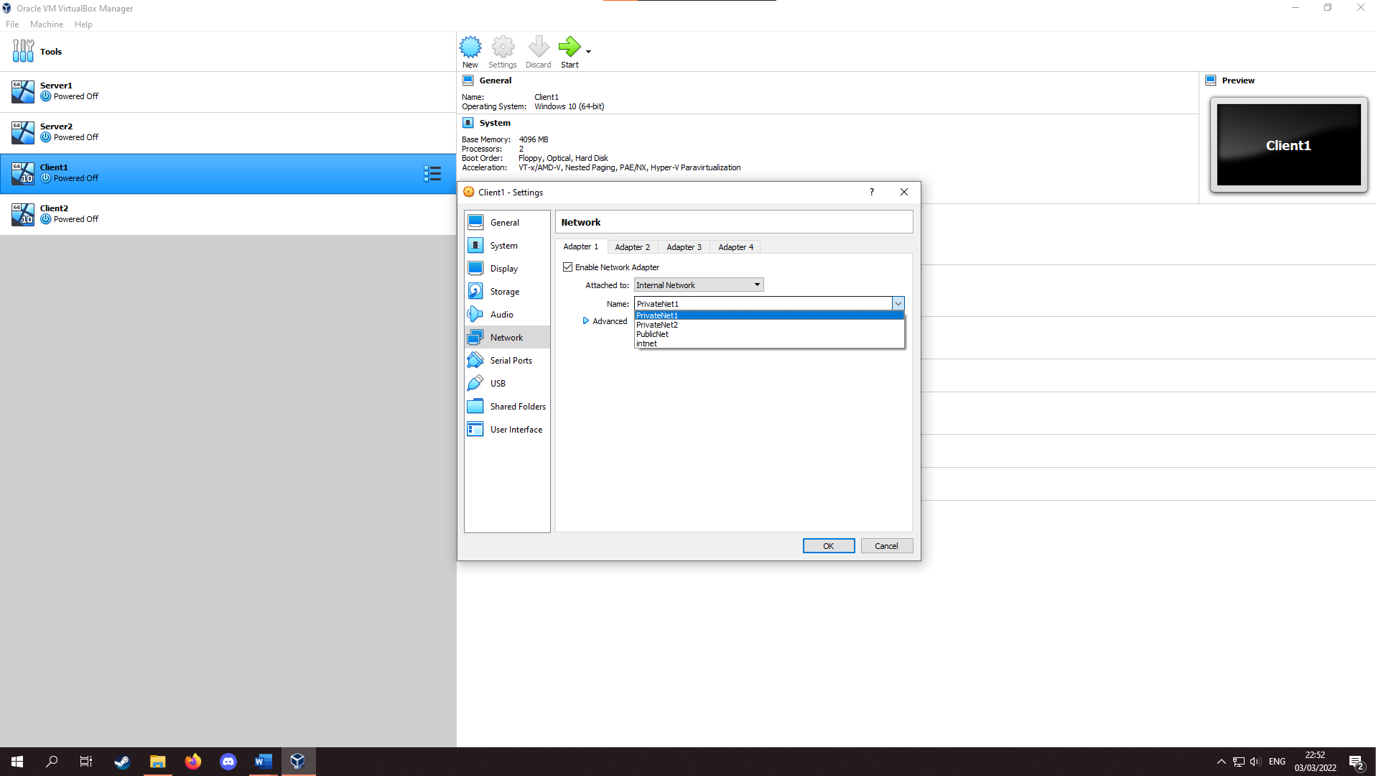
Boot up the system and repeat the previous steps, renaming the adapter to “PrivateNet1” and setting the manual IP address.

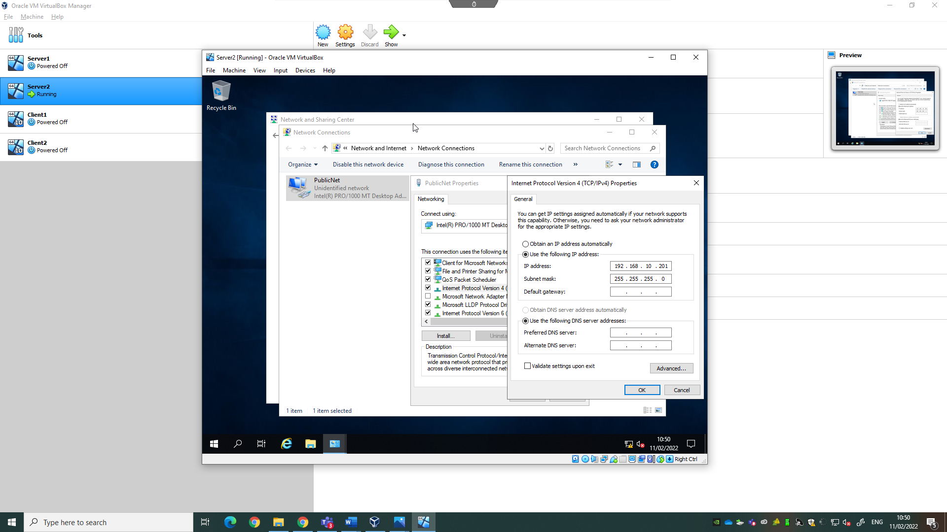
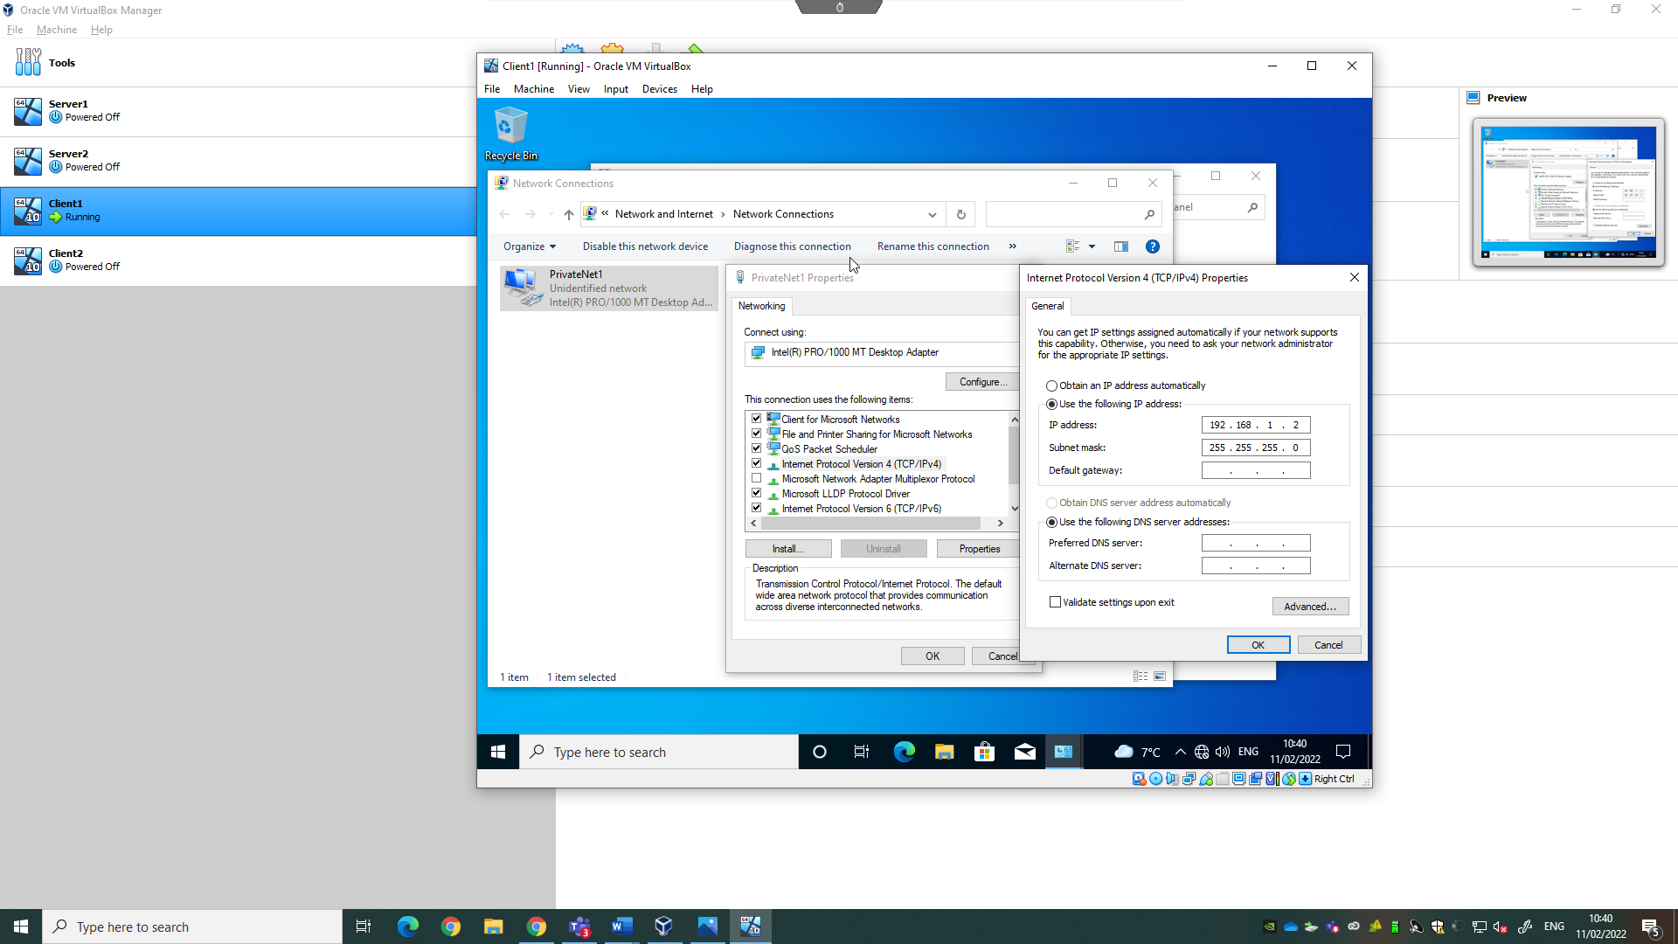
These steps can be repeated for Server2 and Client2. The main differences being using a different private network for these systems, as shown below:

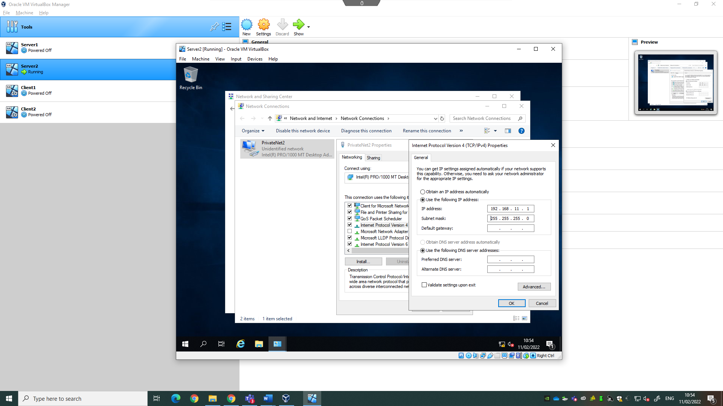
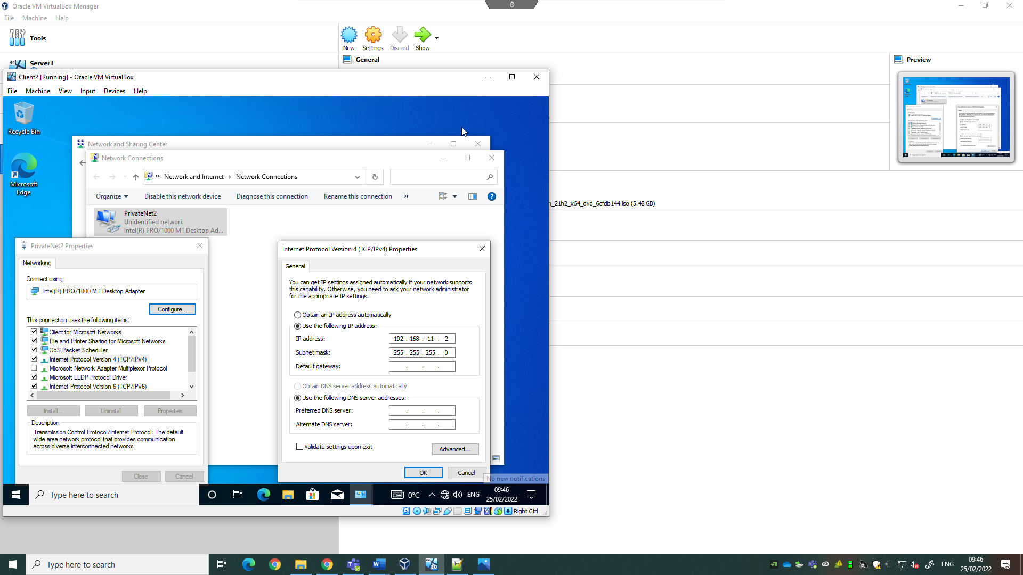

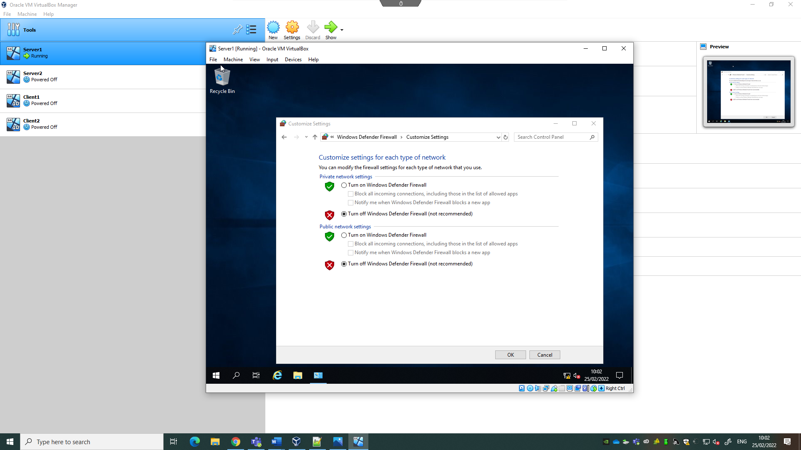
From here, a ping can be used to verify that the network adapters have been correctly configured. Before doing so, the firewalls on each system need to be disabled, as ping is an ICMP (Internet Control Message Protocol command, which is denied by a firewall in an OOBE (Out-of-box Experience) environment. To do so, open the control panel on the system and choose “System and Security”. Under Windows Defender Firewall, select “Check firewall status” and then select the “Turn Windows Defender Firewall On or Off” option from the left, and turn it off for both public and private networks settings.
Once this is done, open both server 1 and client 1, and use the command prompt window to ping client 1 from server 1, using the command “ping” followed by the IP address of client 1. If a reply is received, the LAN has been successfully configured, as shown below:

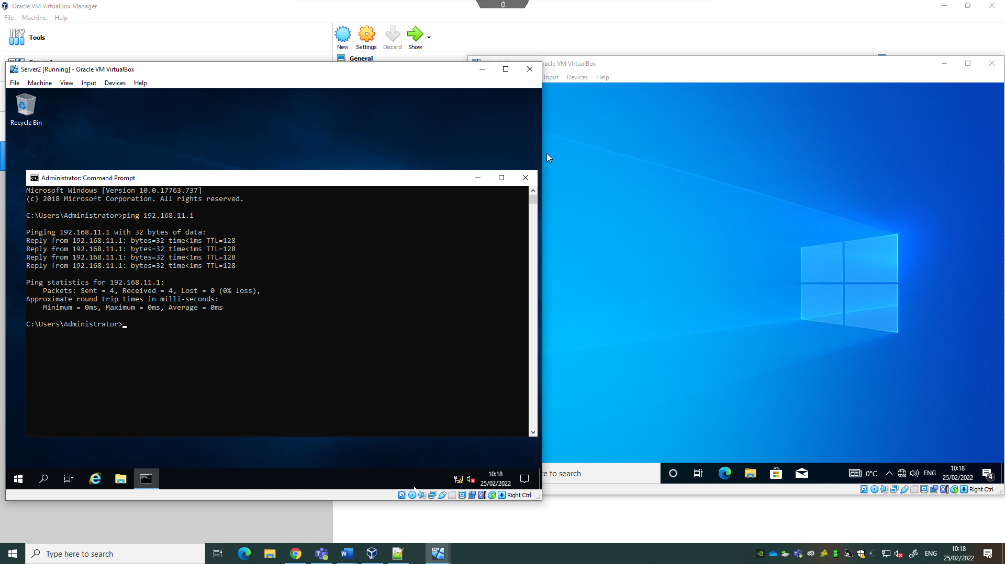
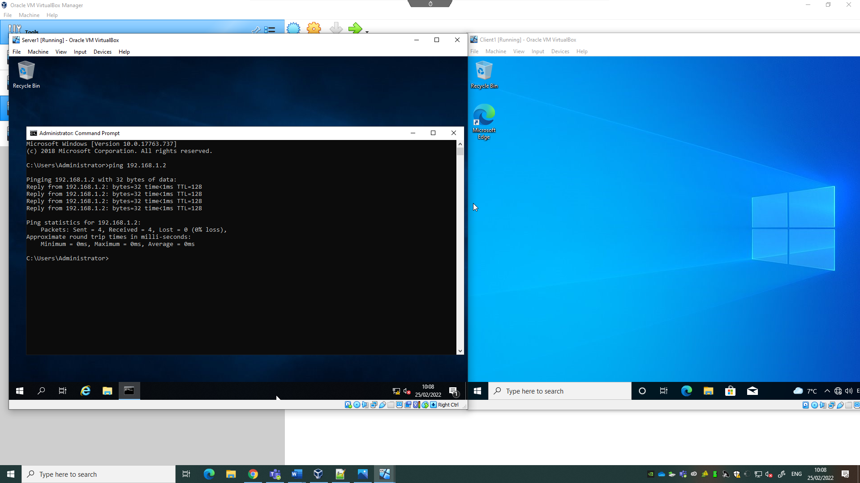
Do the same for Server 2 and Client 2 to ensure the LAN has been correctly configured.

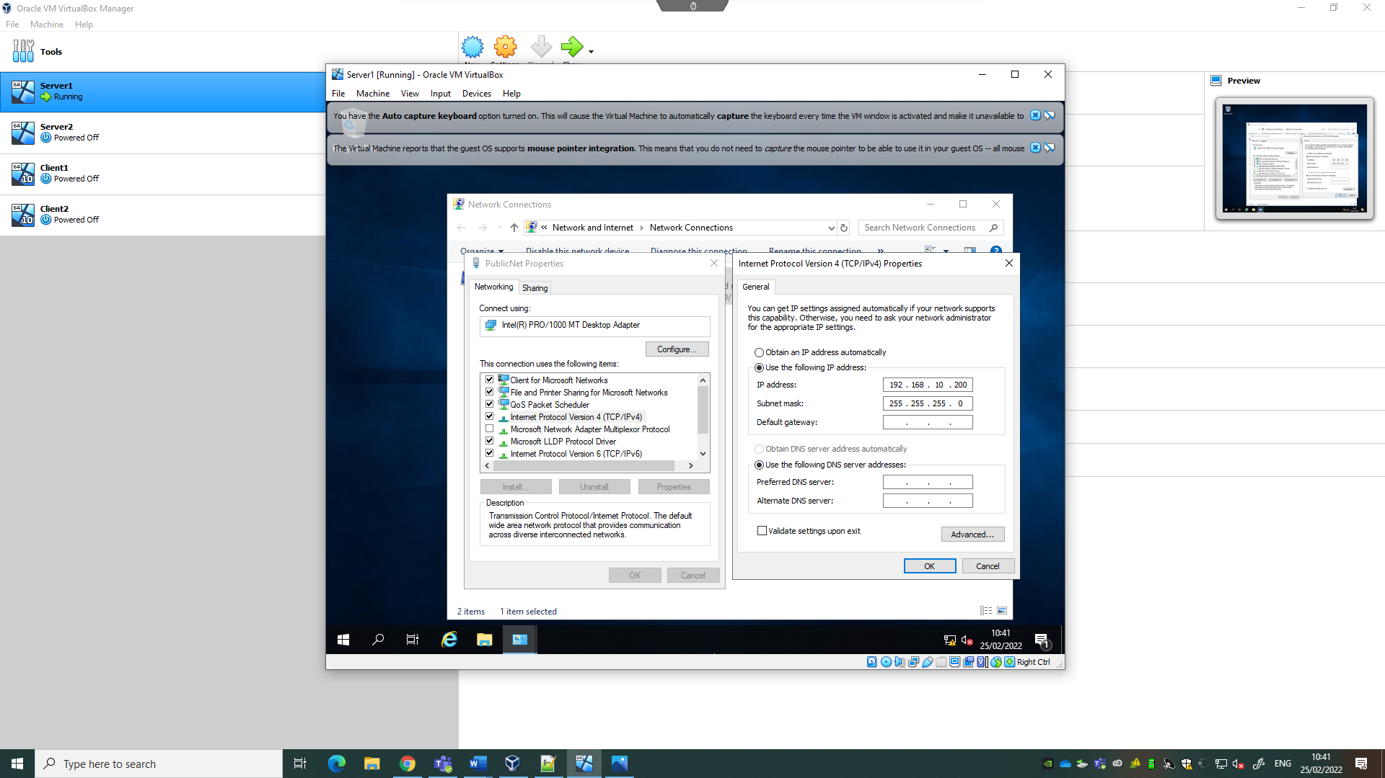
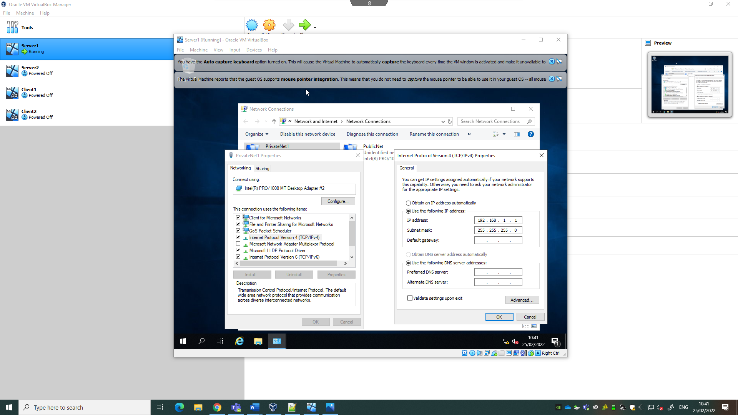
Deploying a Network Directory Service and Network Objects

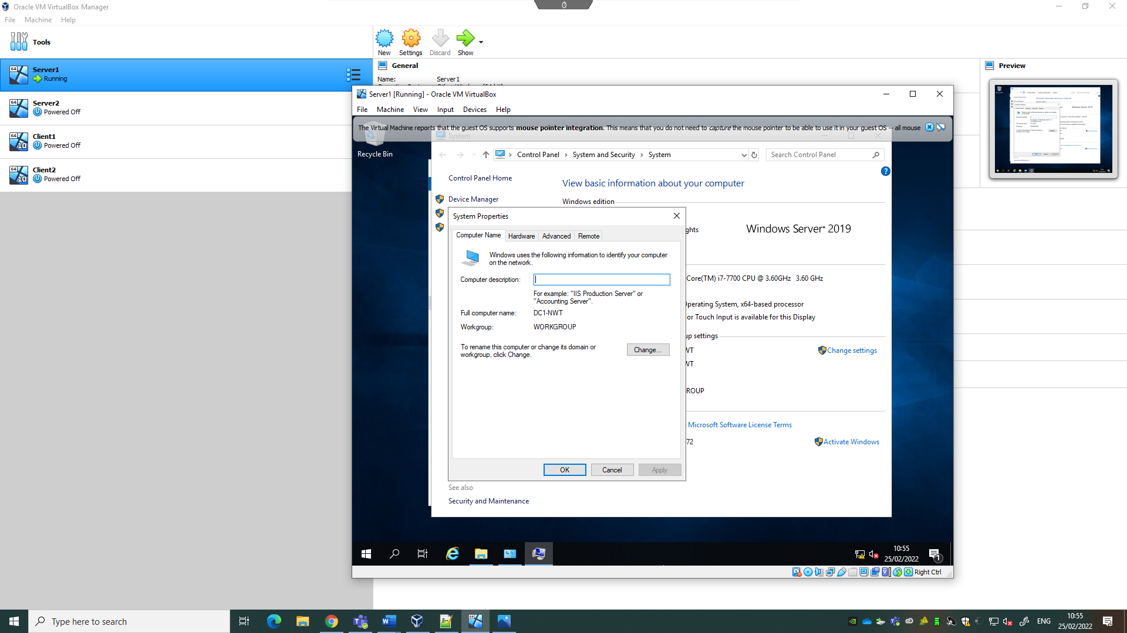
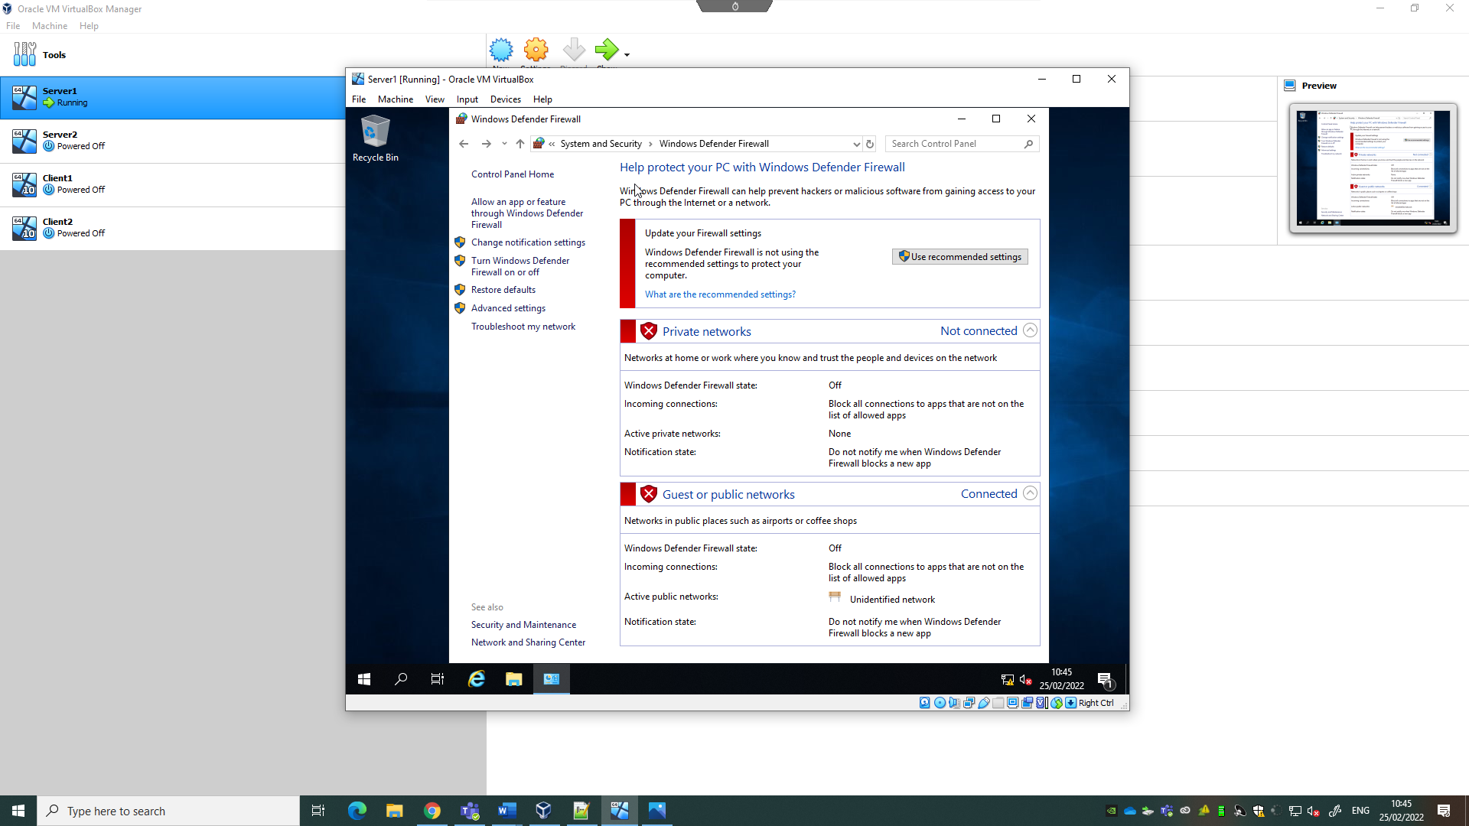
Server 1 will be used as the Domain Controller, so renaming the system to make it easier to identify is worthwhile. Go to This PC, right click This PC, and choose properties, Advanced System Settings, Computer Name and click change. From here, rename the computer and select OK. The PC should now be renamed after restarting, as shown below:
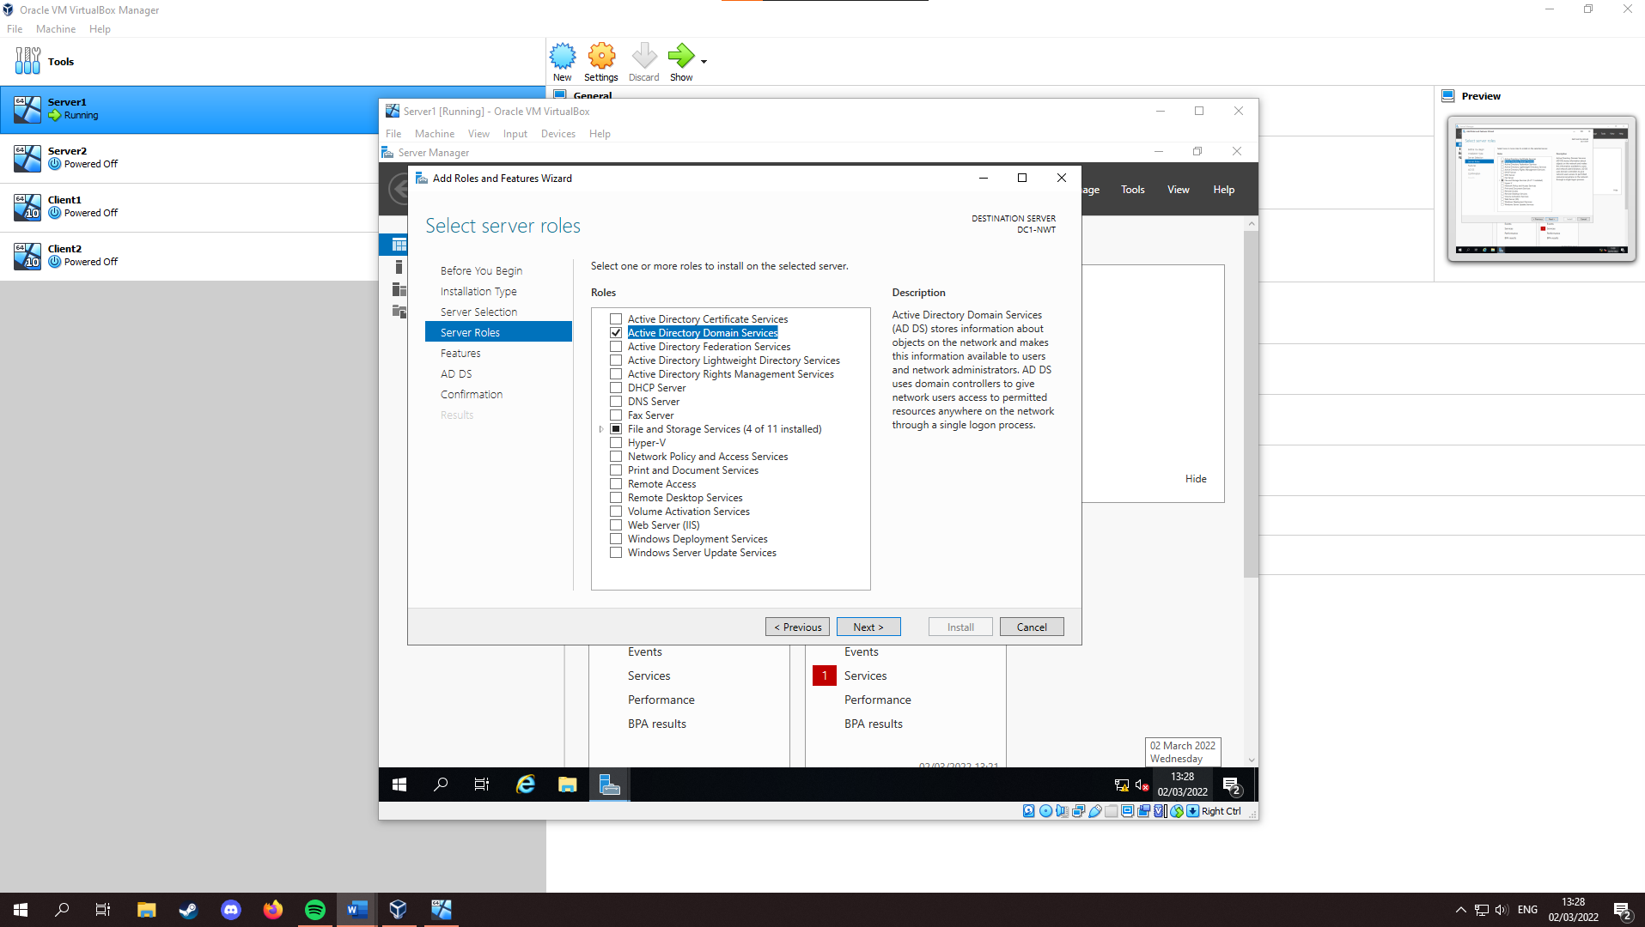
From here, the Active Directory can be deployed. On Server 1, search and select “Server Manager”. Once in the server manager, click “Add roles and features”, Next, “Role-Based or feature-based installation” and Next, Select the Server1 machine, and “Next” again. then select “Active Directory Domain Services”, “Add Features”, and tick AD DS:
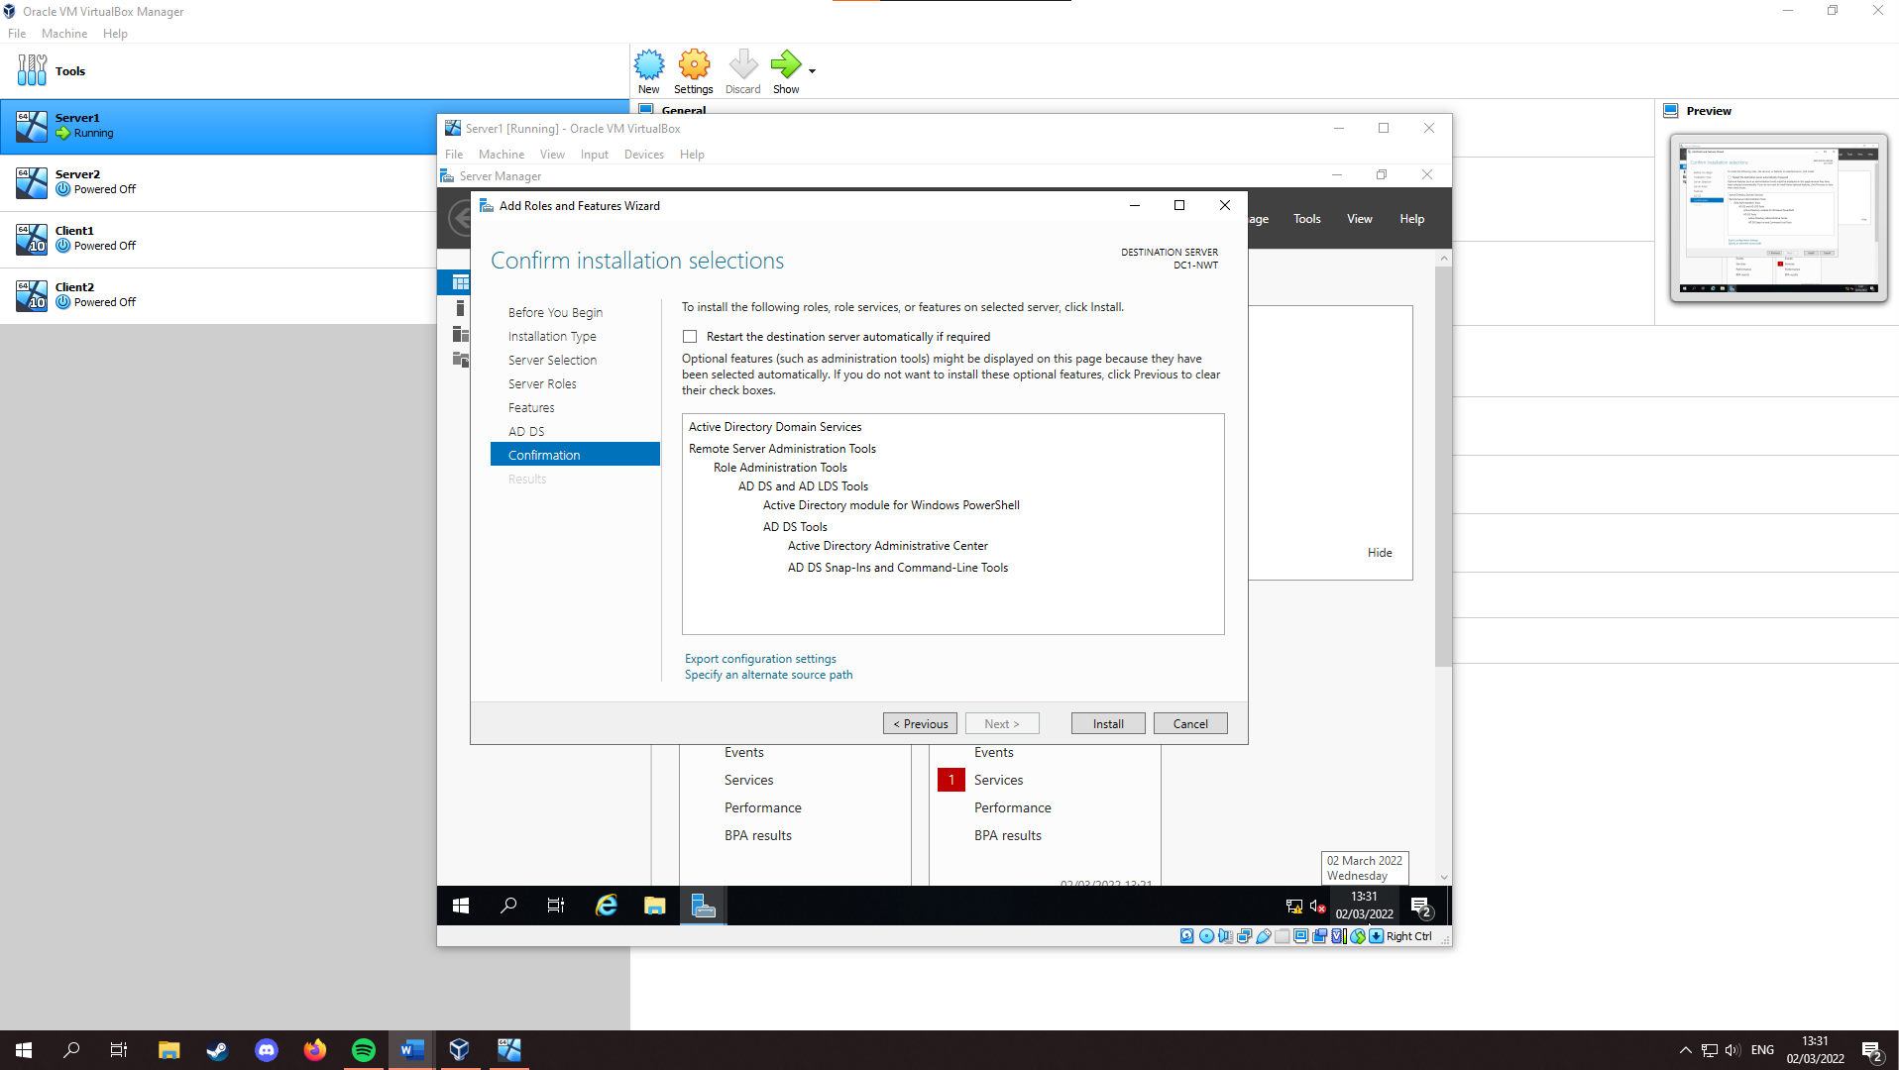
After this, keep selecting “Next” until you reach “Confirm installation selections” and install.
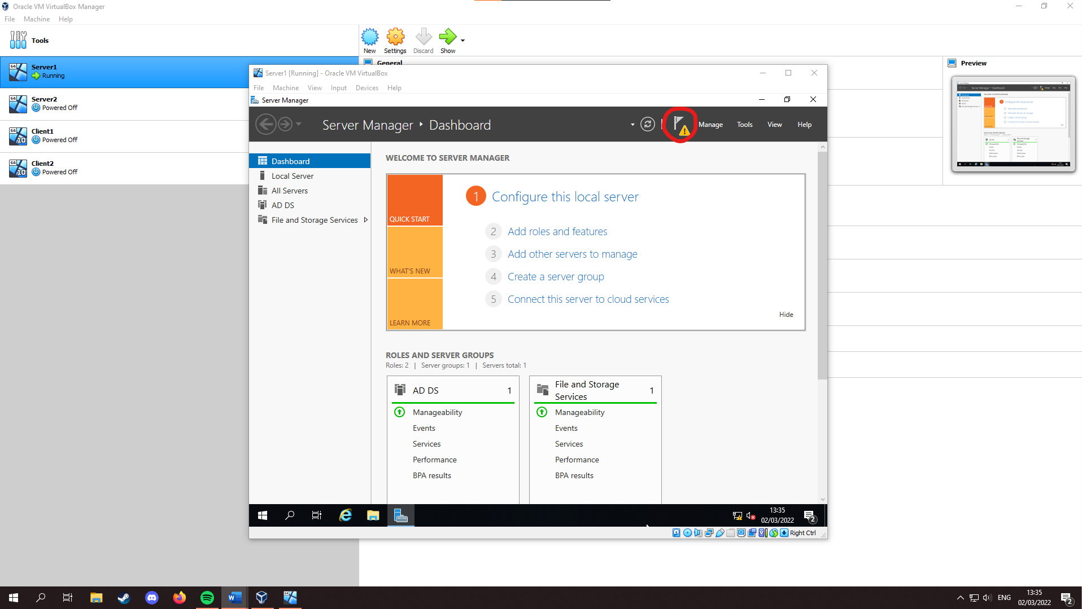
Once installed, close the window, and select notifications.
From here, select “Promote this server to a domain controller” and choose “Add a new forest”, and set the Root domain name (“nosstask.msft” was used). After this, click “Next”
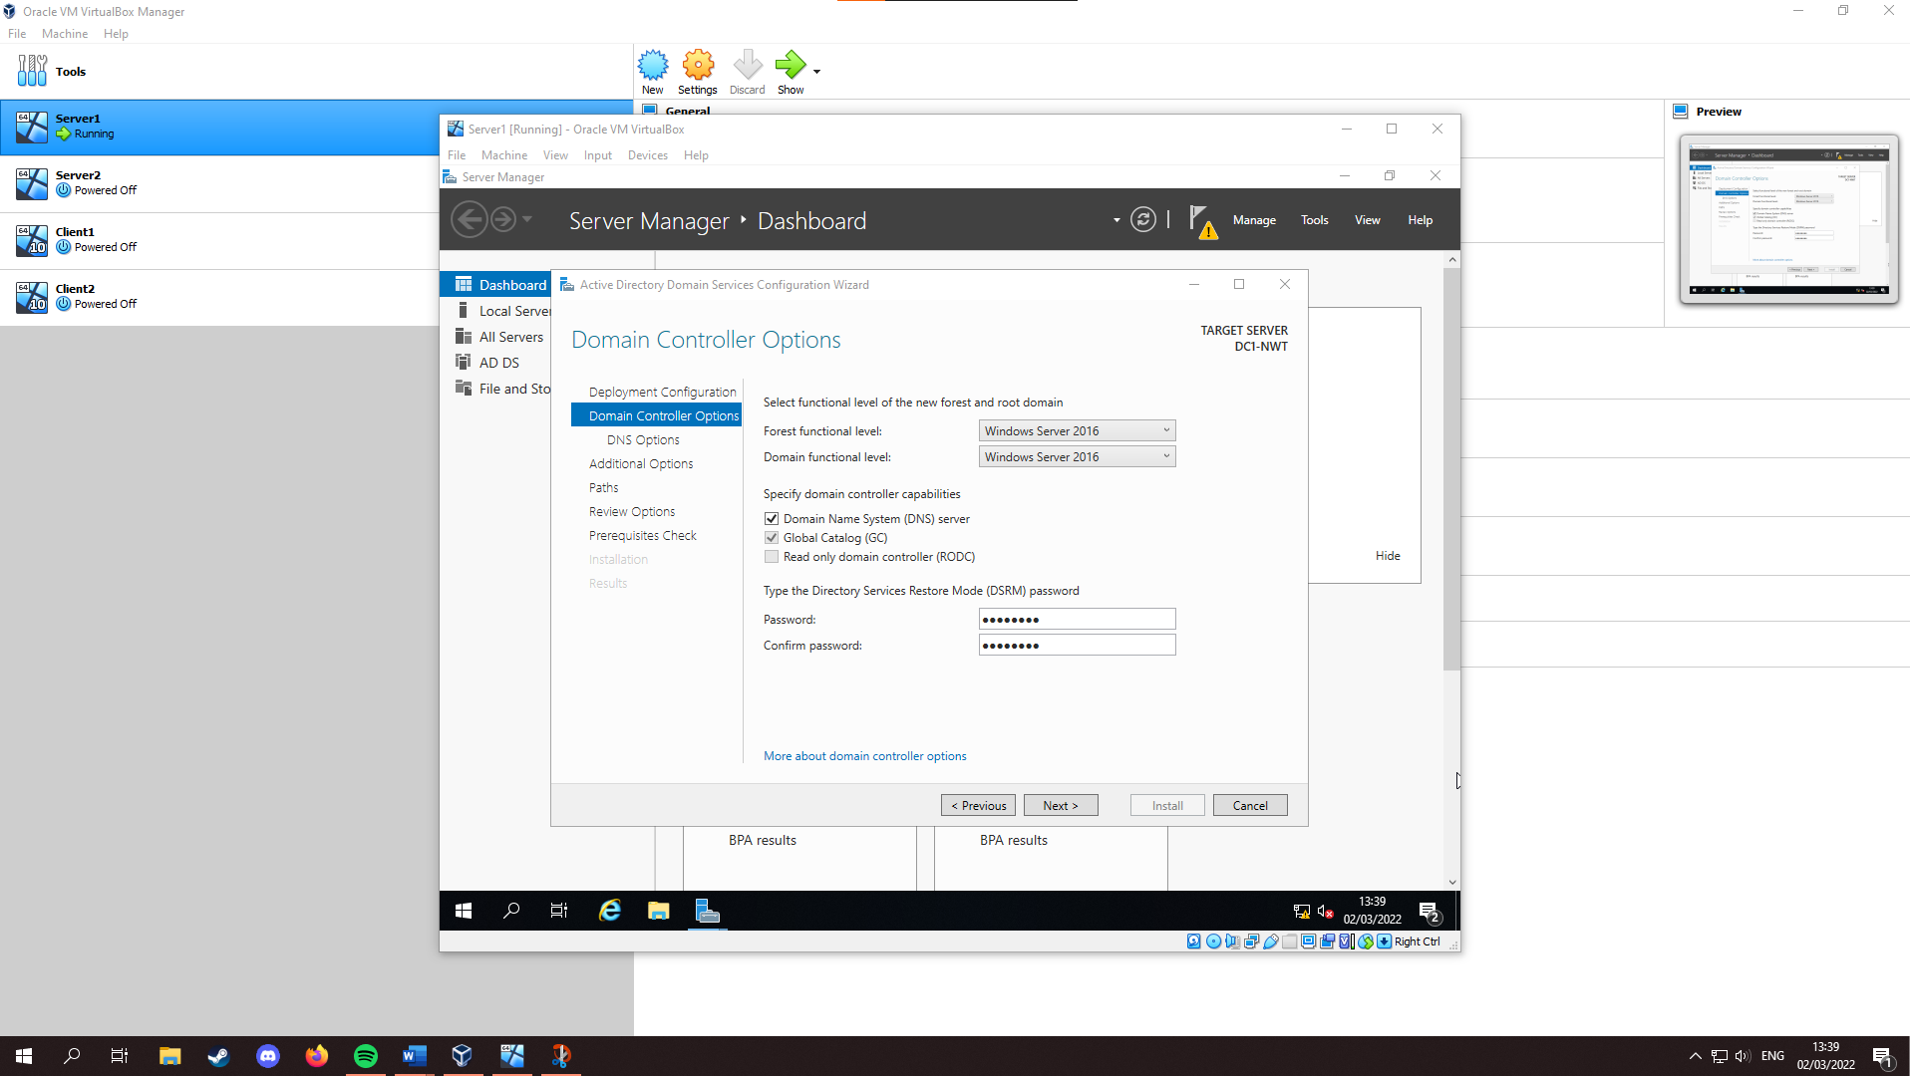
From here, ensure the Domain Controller Options are the same as below, setting the DSRM password. (“P@s5w0r9” is used below.)
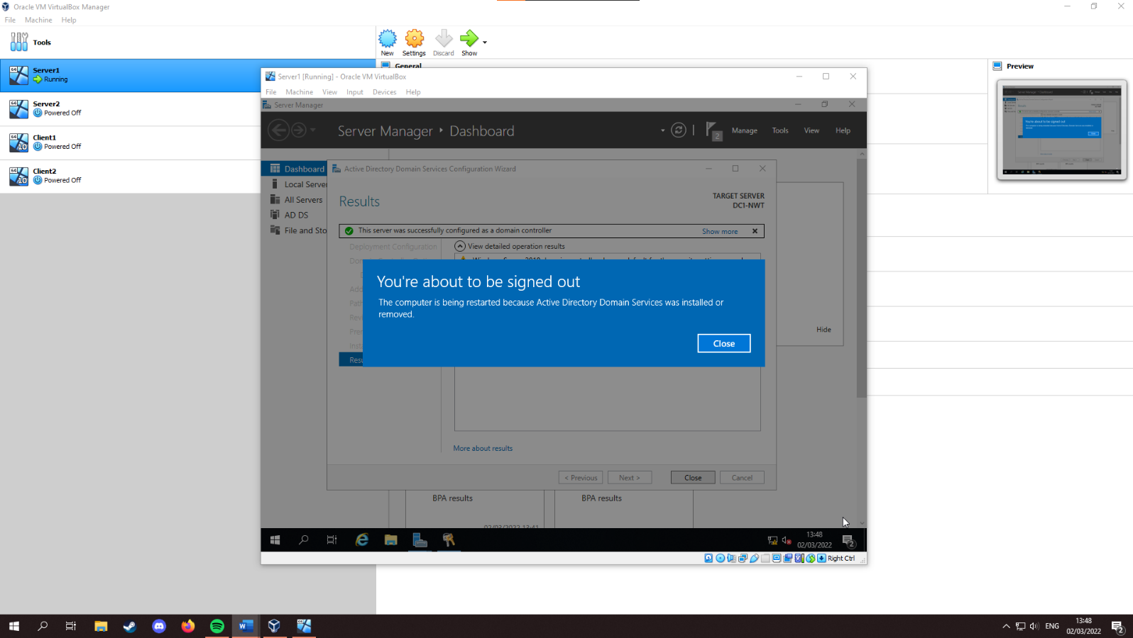
From here, keep selecting “Next” until you reach “Prerequisites Check”, ignoring the DNS warning. At “Prerequisites Check” select “Install”, after which you will be prompted with this screen, and the system will reboot:

Creating User Account Objects
Click start >Windows Administrative Tools > Double click “Active Directory User and Computers. From here, click the arrow to the left of “nosstask.msft”, and select “Domain Controllers” to verify DC1-NWT is listed as the nosstask.msft domain controller.

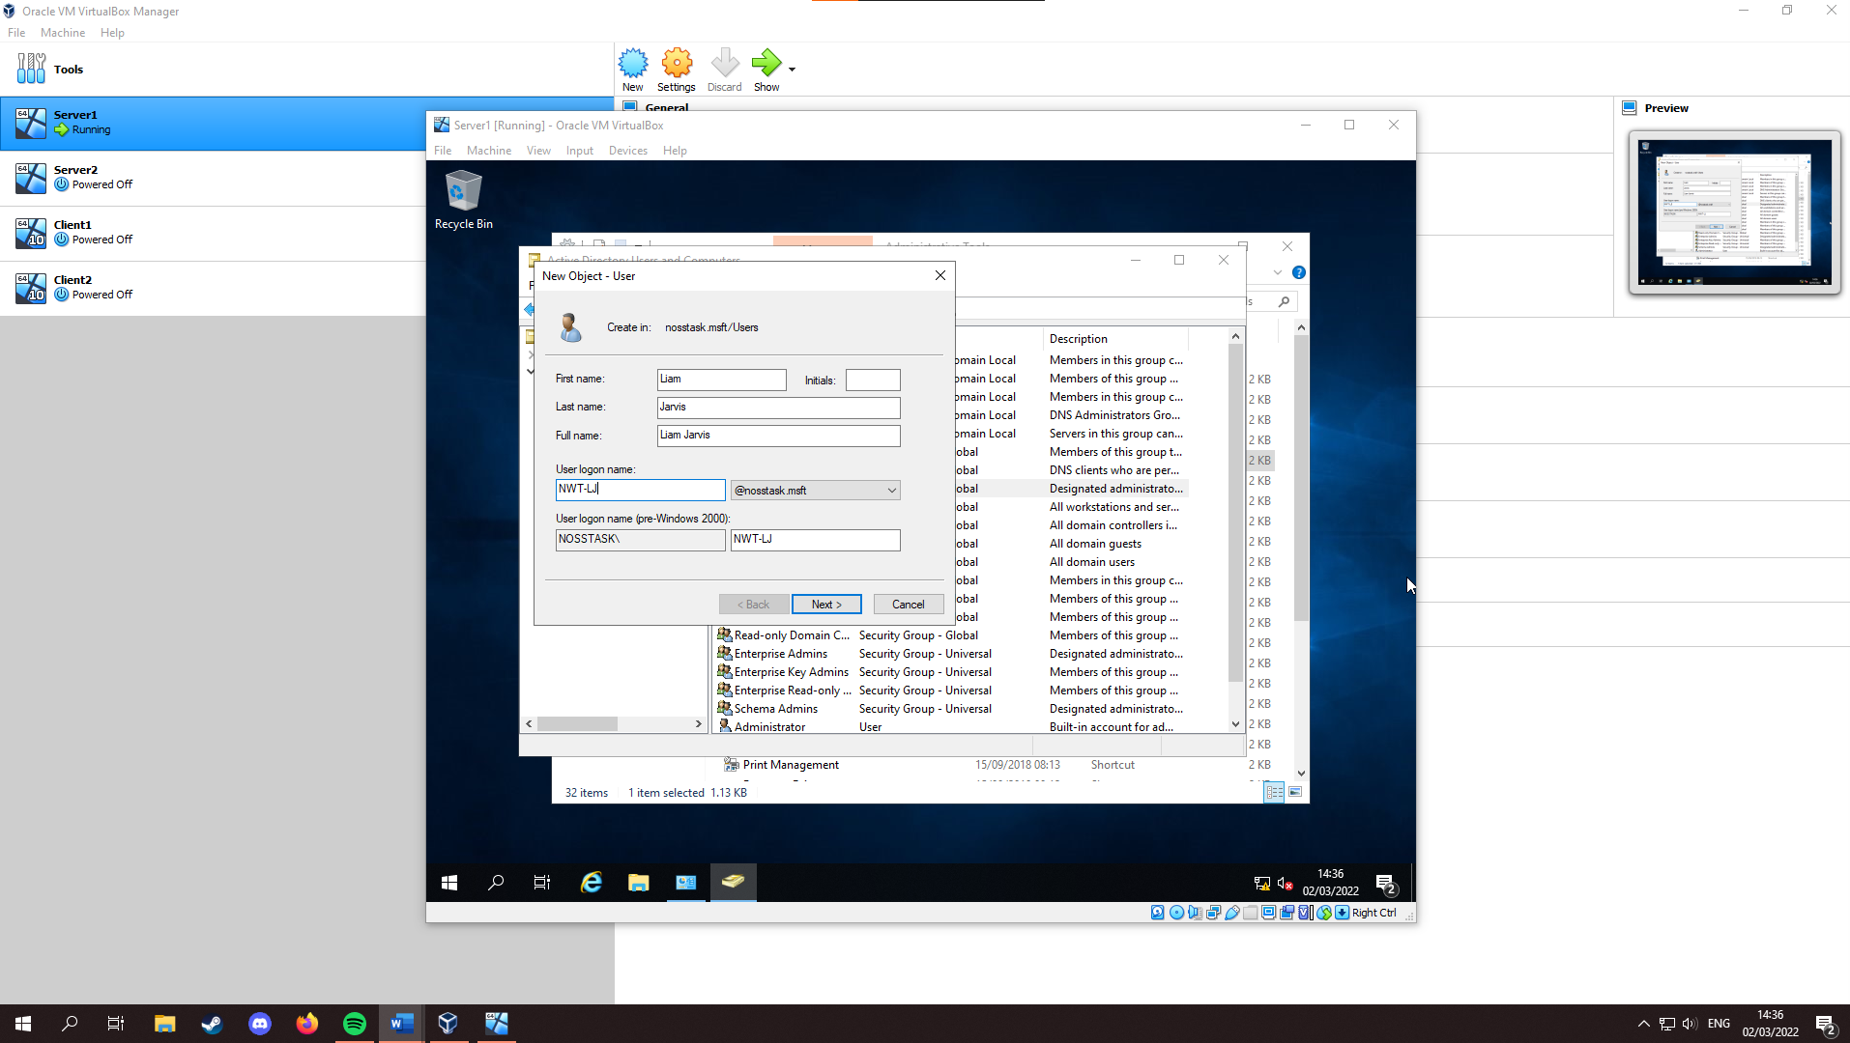
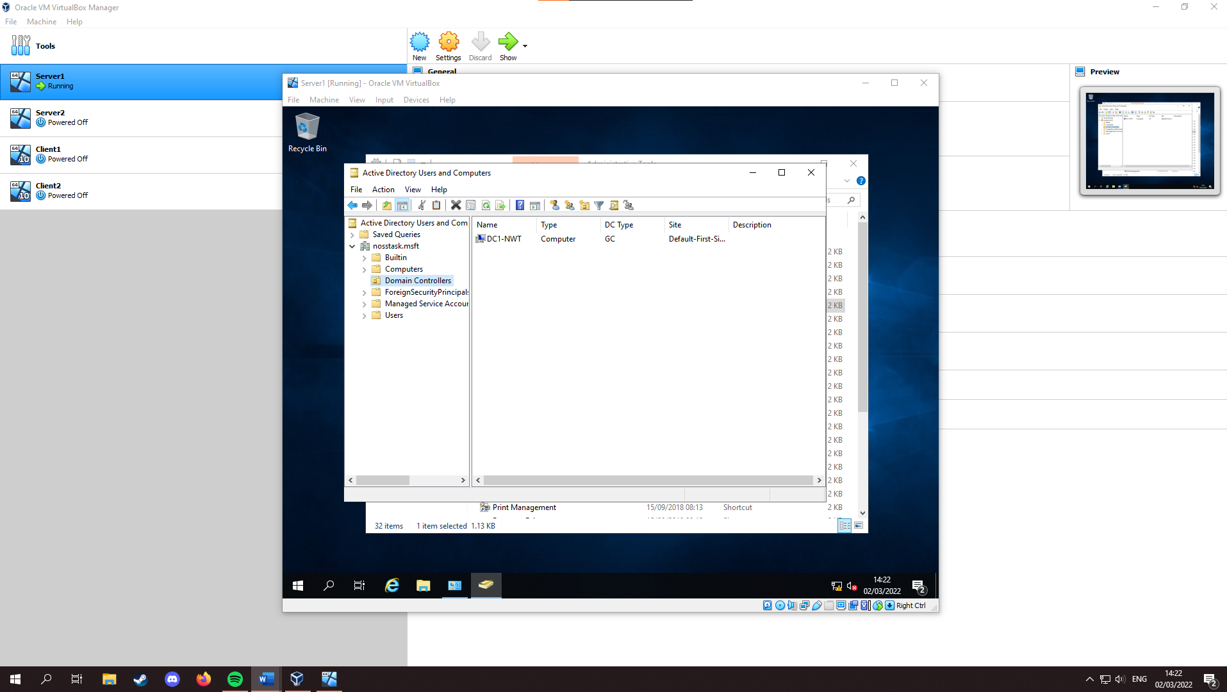
From here, it is a good idea to create a failsafe account, in case of a hack or loss of password. To do this, right click the “Users” container and select “New” > “User”, and fill in the user details.

Select Next and enter a password, for example: “Fl1Nt321”. Untick “User must change password at next logon”, tick “Password never expires”, and select Next, and then “Finish”.
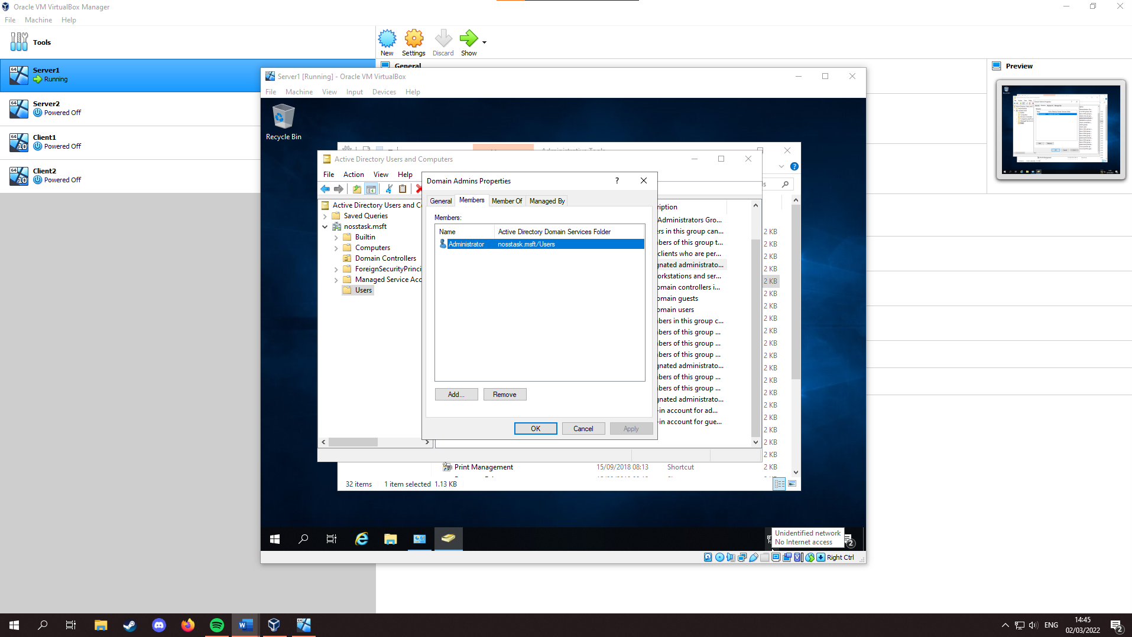
From here, the user can be added to the Domain Admins group. Select the “Users” container, sort by type, and double click “Domain Admins”. Select the “Members” tab, where the current user account is shown.
Select “Add…” and enter the name of the user just created, and select “Check Names”, the user should show.

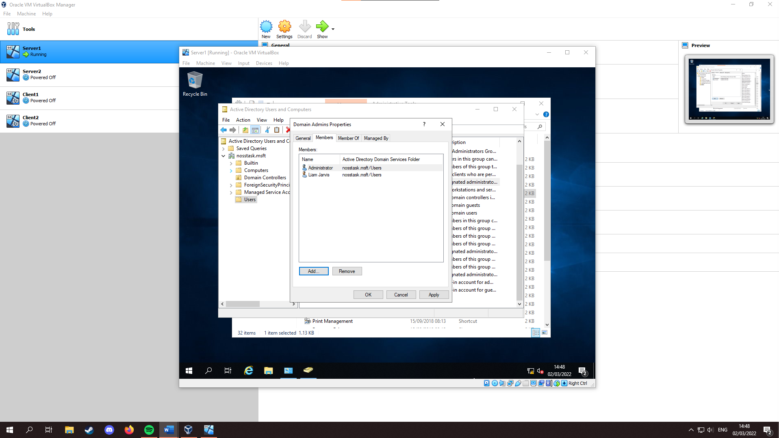
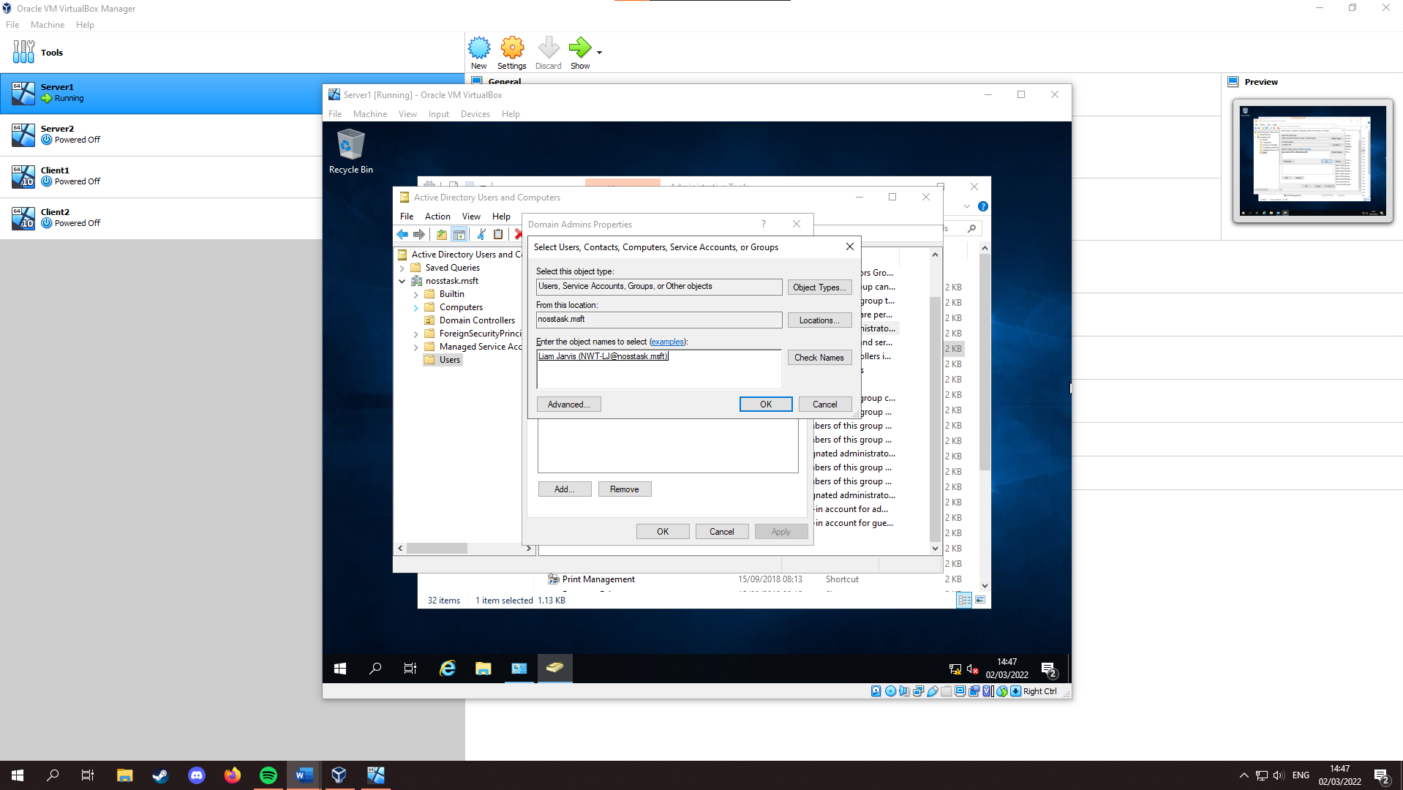

Object Attributes of Interest
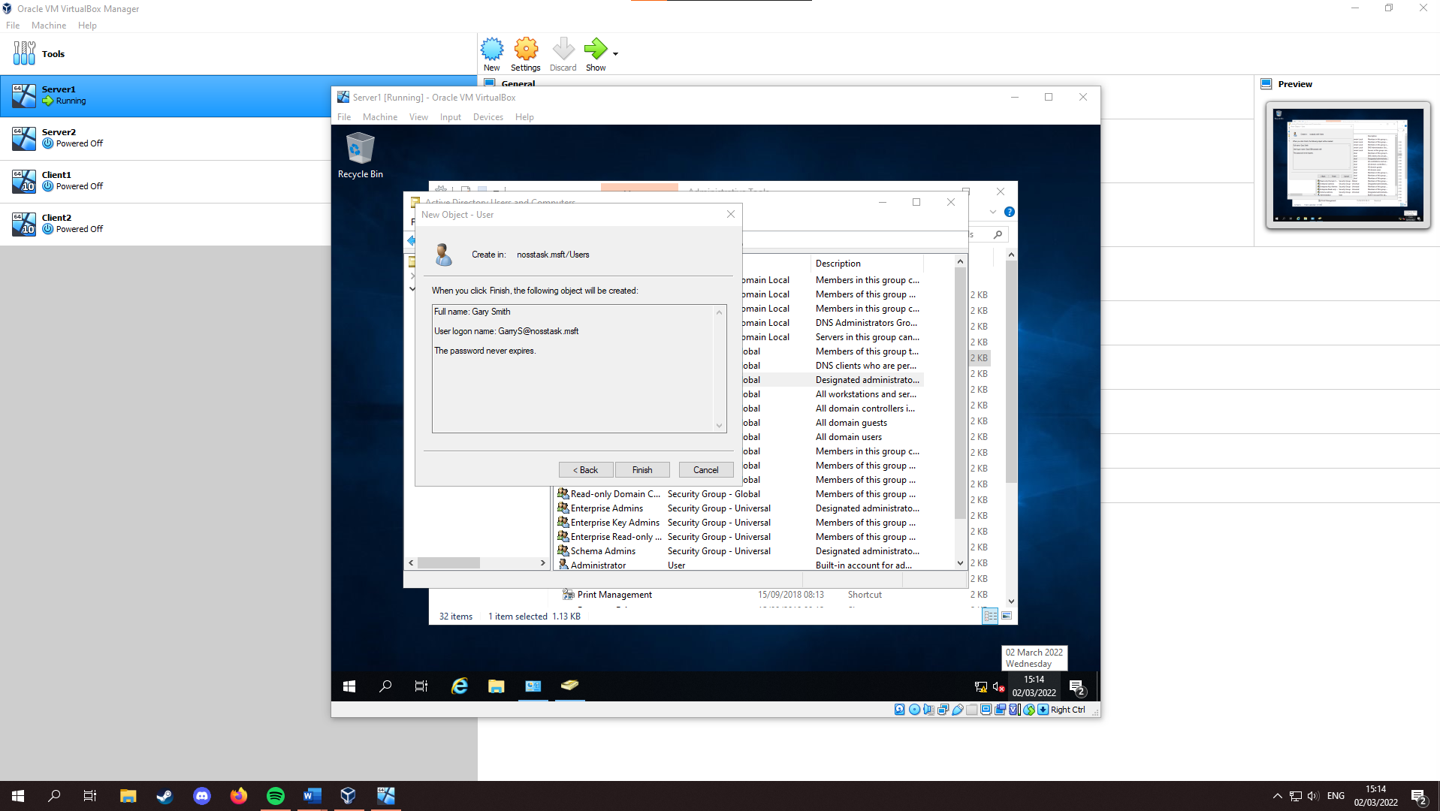
Within “Active Directory Users and Computers” on Server1, Create another user within the Users folder.
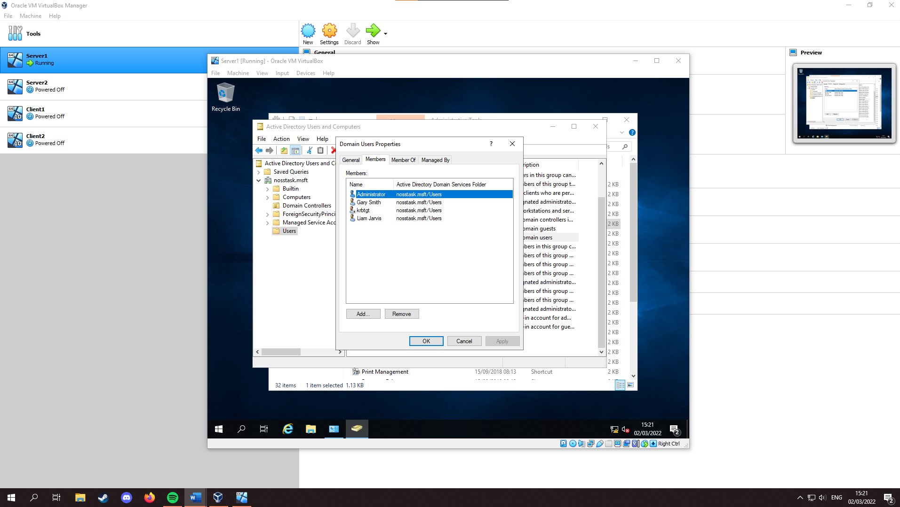
From here, the user should be found in “Domain Users”.
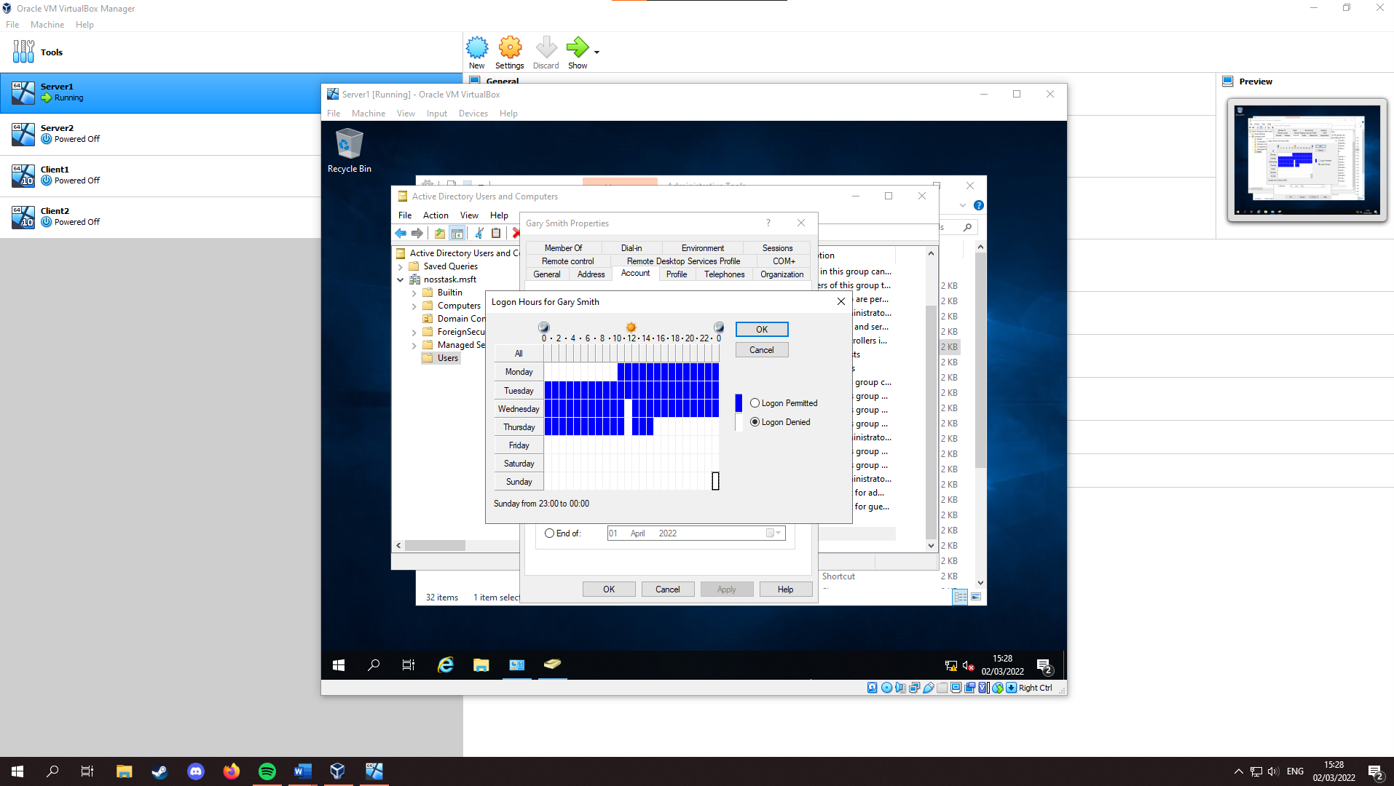
Exit this menu, and in “Users” right click the user, “Properties”, “Account Tab”, “Logon Hours…” and enter the hours permitted:
Select “OK” and tick “User cannot change password”.

Adjoining the Domain and Testing User Logins
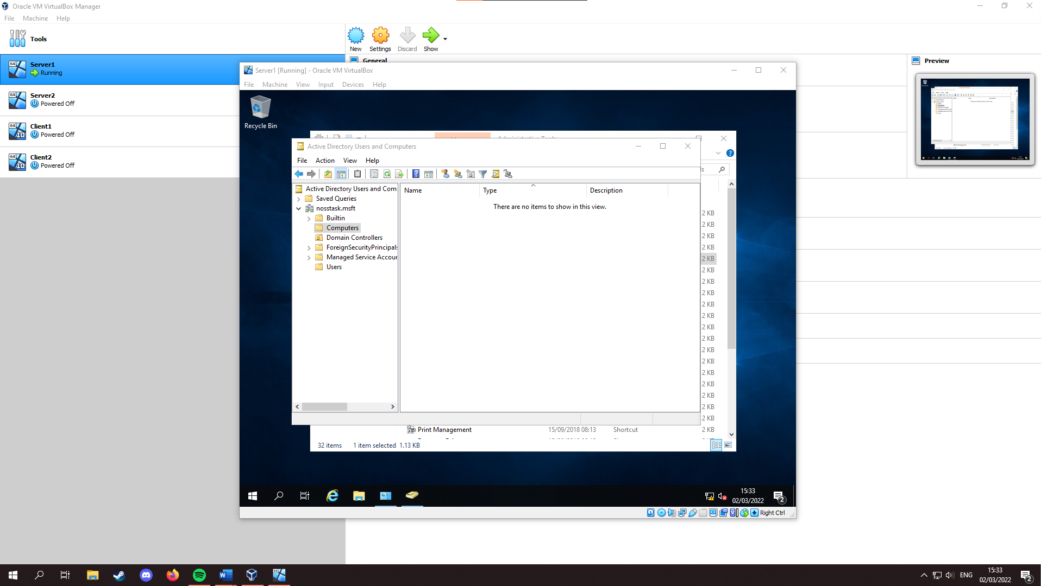
Within “Active Directory Users and Computers” on Server1, select the “Computers” container.
Right click the whitespace > New > Computer. Enter a computer name. (“WS1-NWT” was used) and select “OK”.
From here, login to Client1, Search “This PC”, Right click, “Properties”, “Rename this PC” enter the computer name just specified and restart. After logging back in, navigate to “Change adapter settings” as done previously. Right click “PrivateNet1”, “properties”, “double click Internet Protocol Version 4” and in “Preferred DNS server”, enter the IP Address of the PrivateNet1 adapter for server 1:

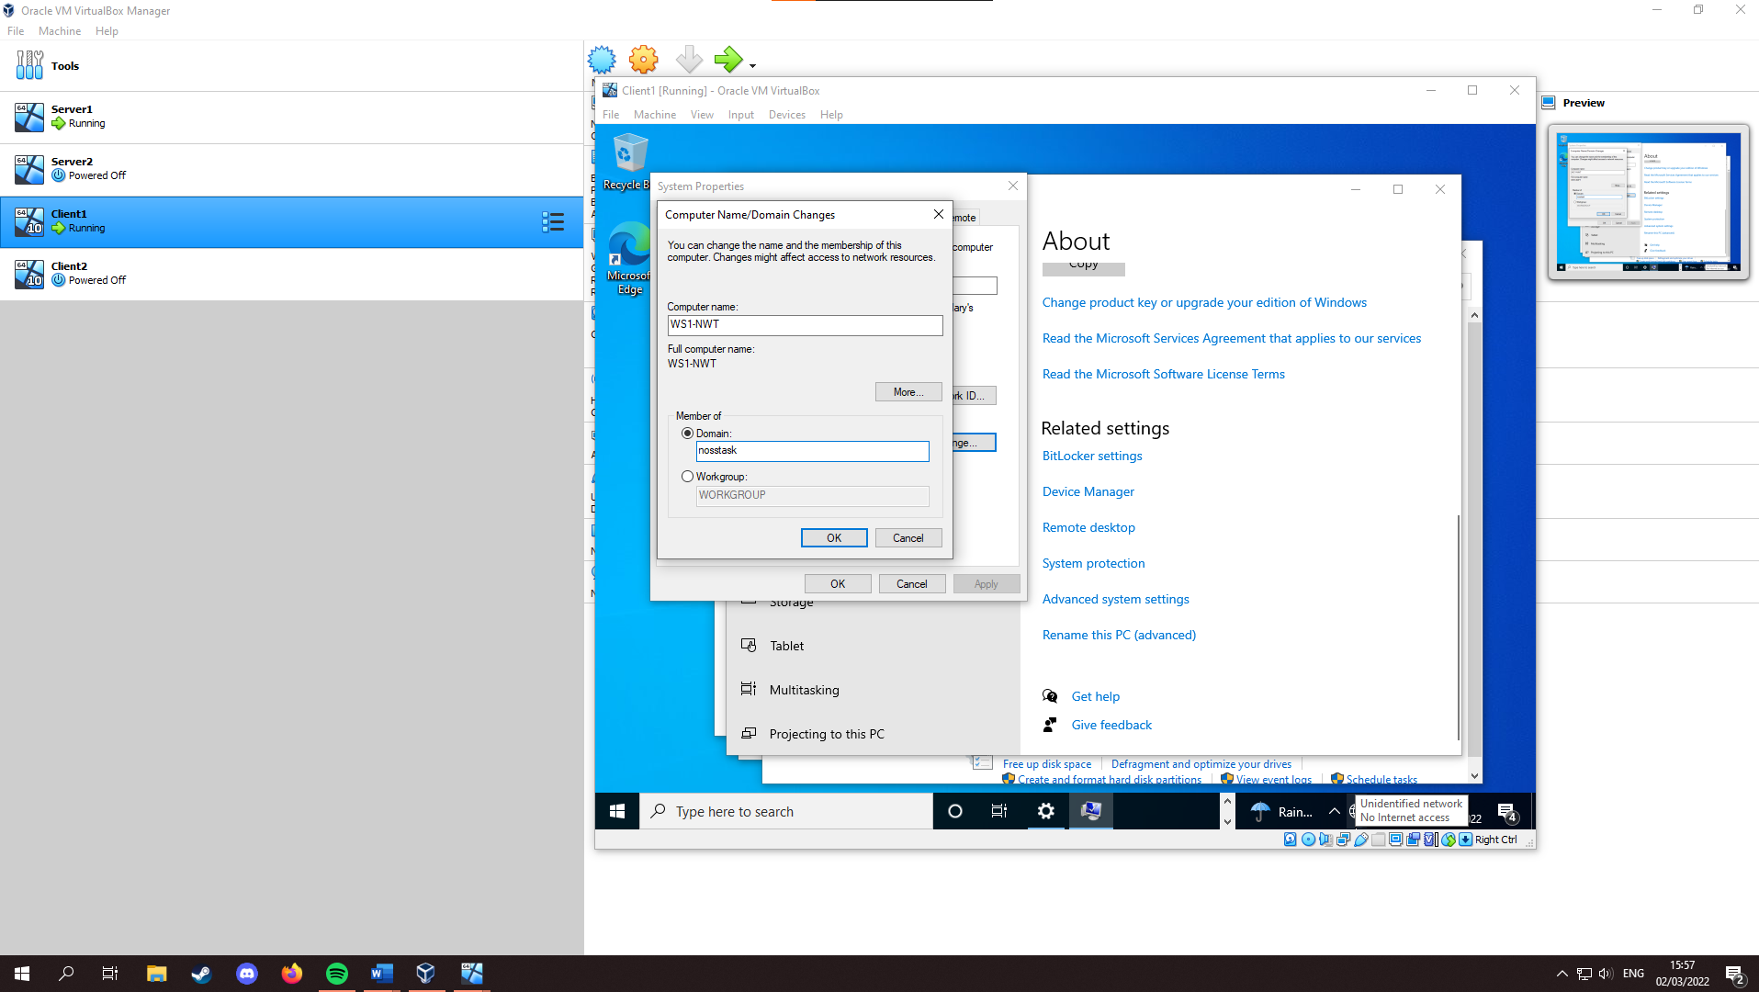
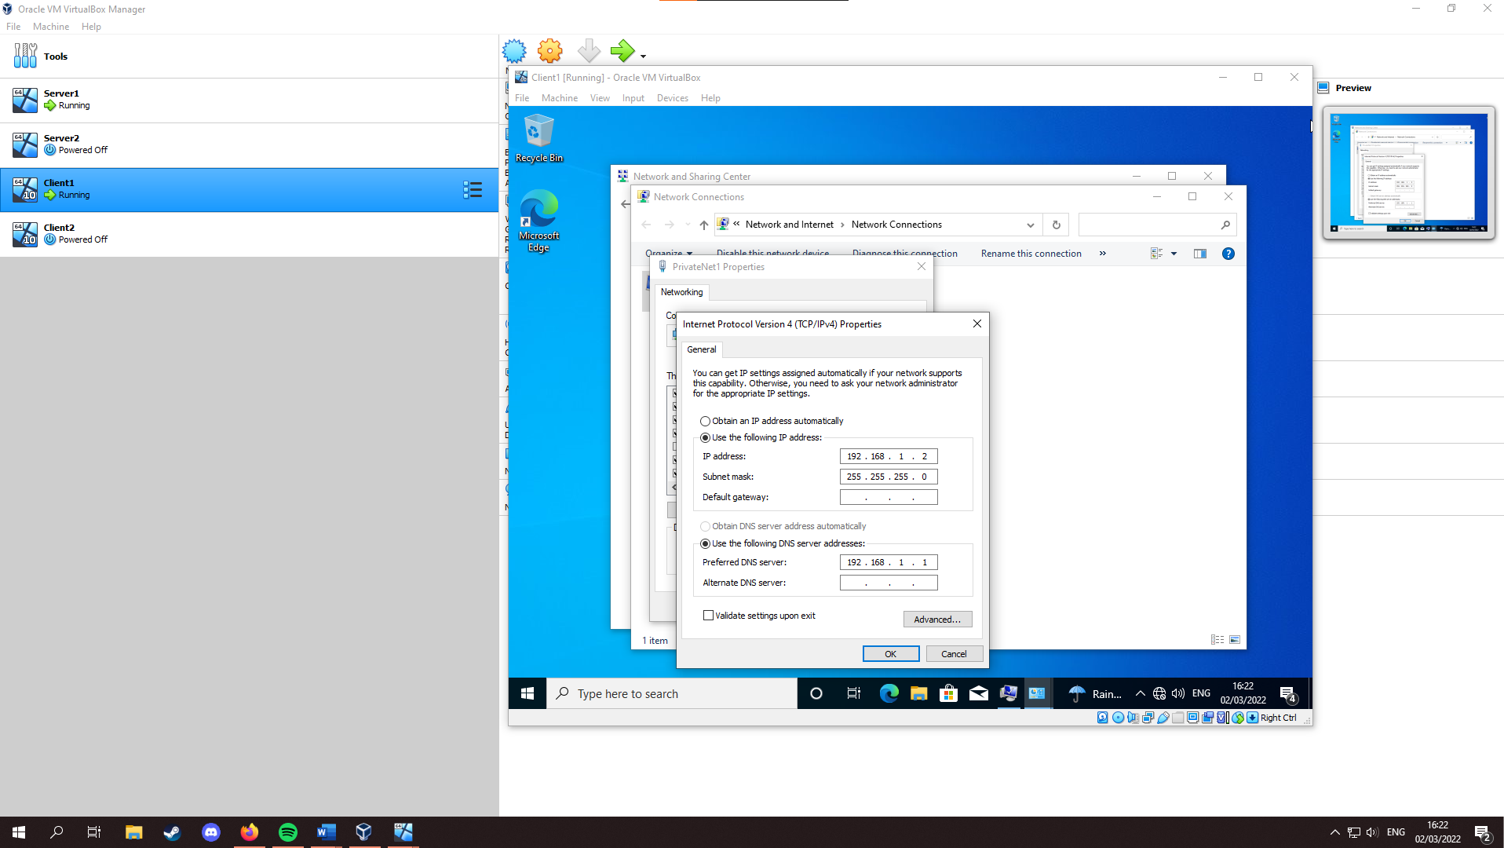
Navigate back to This PC properties, select “Advanced system settings” and select the “Computer Name” tab. Select “Change…” and enter the root domain name created on Server1:

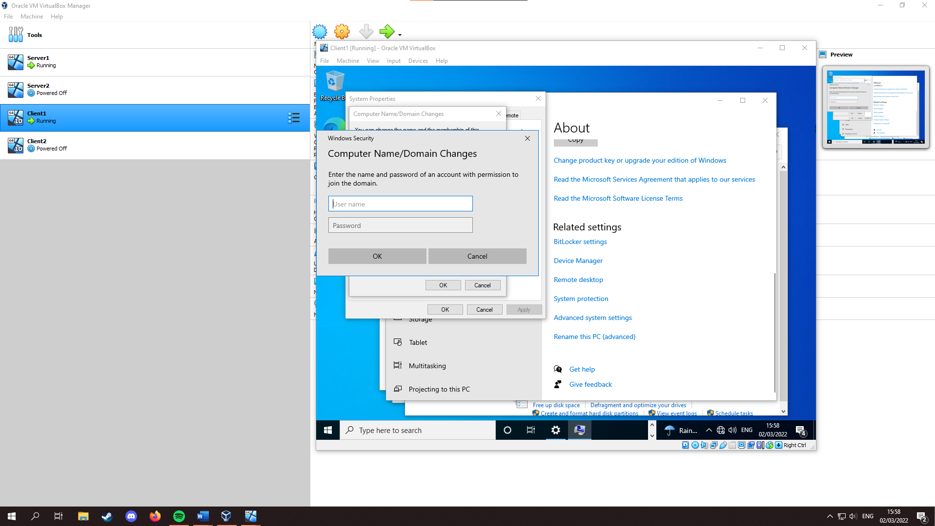
Select OK and you should be prompted with this window:
Enter a username and password and continue.
You should now be presented with this:

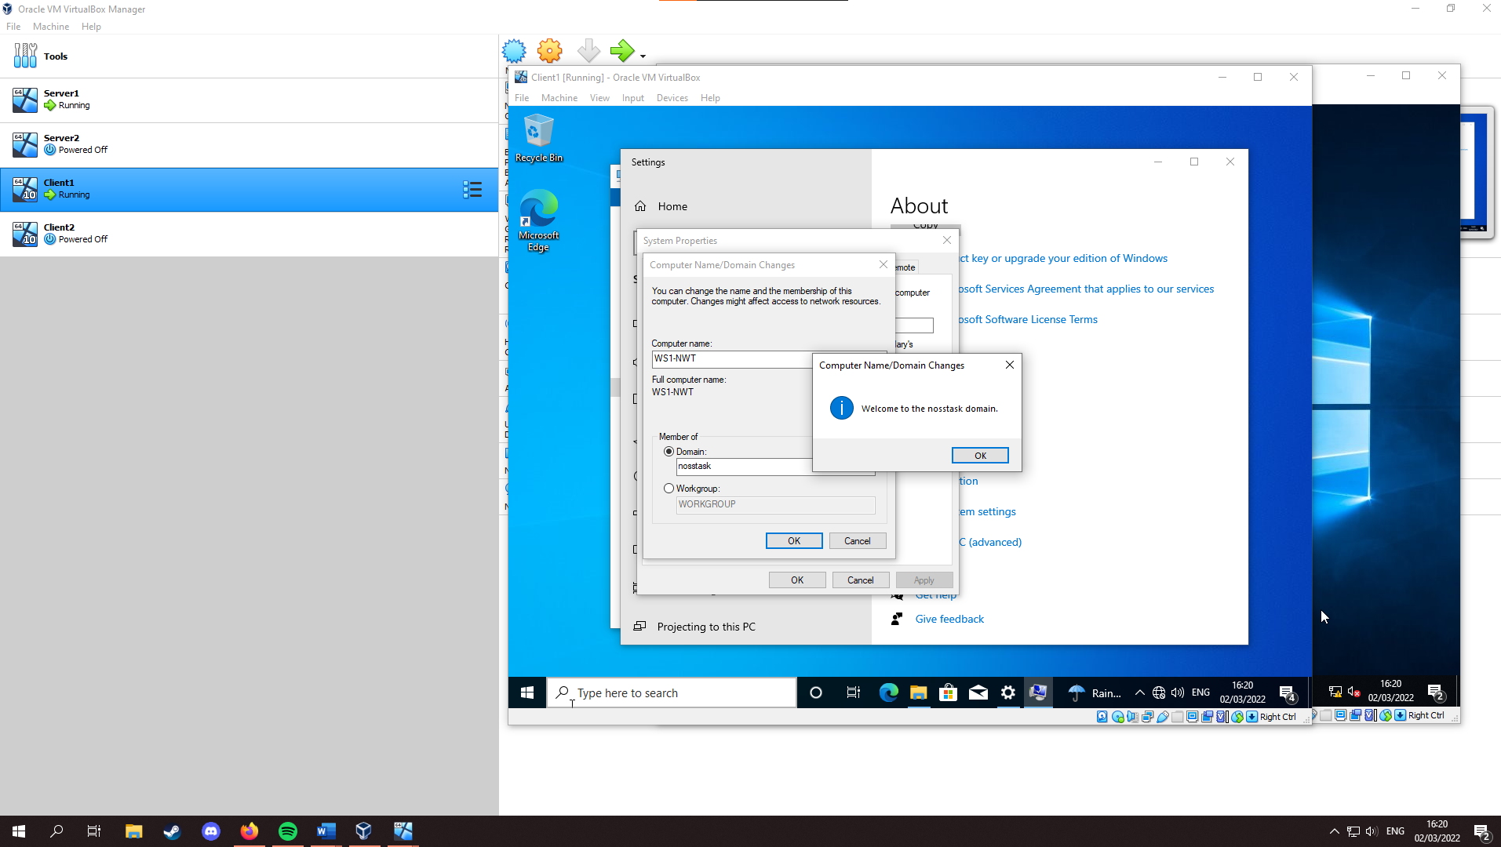
From here, restart the system. Once the system is started up again, you should see 2 users now, select “Other User” and enter the Username and Password for the domain. You should be able to use this account on Client1, but not Server1.

Observational Task

Differences between Type 1 and 2 Hypervisors
A hypervisor “Or virtual Machine manager (VMM) is a computer software which in conjunction with the hardware creates and runs virtual machines.” [1] The host machine “runs on or more virtual machines”, [1] these virtual machines are called guest machines.
Type 1 Hypervisors “run directly on the host’s hardware to control the hardware and to manage guest operating systems” [1]. Some examples of Type 1 Hypervisors include “IBM z/VM, Xen, Oracle VM Server, Microsoft Hyper-V, and VMware ESX/ESXi.” [1]. Type 2 Hypervisors “run on a conventional operating system (OS) just as other computer programs do. A guest operating system runs as a process on the host with the hypervisor abstracting guest operating systems from the host operating system.” [1]. Some examples include “VMware Workstation, VMware Player, VirtualBox, Parallels Desktop for Mac, and QEMU” [1]. Below is a table, briefly explaining both hypervisors, comparing their benefits and drawbacks, and some example vendors for each:
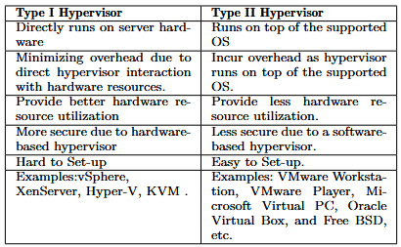

[2]

Cloud Computing Explained – Benefits and Drawbacks
Cloud computing “is a method of providing shared computing resources, including applications, computing, storage, networking, development, and deployment platforms as well as business processes.” [9] With cloud computing comes many advantages and disadvantages that user must weigh up against each other to see if it is worth it for them.
Starting with the advantages, cloud computing is relatively simple to use. “Applications that take the favorable cloud-based from are generally far less demanding to set up and maintain than a proportionate level of administration installed on the premises.” [14] All user need “is a straightforward web browser, leaving the complexities of management to the service provider.” [14]
Another advantage is cost effectiveness, as it mitigates ownership fees, along with other costs. “Removing costly systems and the requirement for the client to amin them normally gives organizations a noteworthy cost reserves that more than counterbalance the charges for clous storage.” [14]
One more advantage of cloud computing, is the scalability it offers. Scalability refers to “the ability to increase or decrease IT resources as needed to meet changing demand” [15]. This scalability is hard to get with physical hardware, as you must either pay more for future proofing, or upgrade as your business expands, both of which can be quite costly. Use of the cloud allows business “to react in real time to unusual spikes in traffic, while under a specific on-premises cloud or non-cloud arrangement, then client would need to officially secure or rent the important resources required in order to deal with the usage peaks.” [14]
These advantages are just some of the reasons why businesses choose to integrate the cloud into their network. However, it does come with some disadvantages. Some of these disadvantages include reliability issues, or the cloud service in question being “unavailable for extended periods of time due to errors and system crashes”, leaving the business unable to perform some of its functions until the service is restored, which they can’t influence.
Cloud also increases the chance cyber-attacks. “Hackers may break and enter into a client’s applications hosted on the cloud, and thus access and distribute sensitive data.“ [14]. This mainly happens when attacker use Man-in-the-middle attacks on employees accessing the business via the cloud on unencrypted WiFi. Using either mobile data, or a VPN, both of which encrypt your incoming and outgoing data, can help to remedy this.
With its many advantages outweighing the disadvantages for most businesses or users, cloud computing has become massively important within a networking environment for businesses, and Tech Companies caught onto this and offered their own cloud service solutions to both businesses and customers. Some of these vendors include Microsoft Azure, Amazon Web Services, Google Cloud Platform, IBM Cloud, Oracle Cloud, etc…

Domain Name System (DNS) And Its Significance Within Active Directory Domain Services
DNS “is the TCP/IP facility that lets you use names rather than numbers to refer to host computers. Without DNS, you’d buy books from 207.171.182.16 rather than from www.amazon.com” [3] To provide unique DNS names for each host computer on the internet, DNS uses Divide and Conquer. “DNS use a hierarchical naming system that’s similar to the way folders are organised hierarchically on a Windows computer. Instead of folders however, DNS organizes its names into domains. Each domain includes all the names that appear directly beneath it in the DNS hierarchy.” [3]. Below is a graph, detailing the DNS hierarchy briefly:
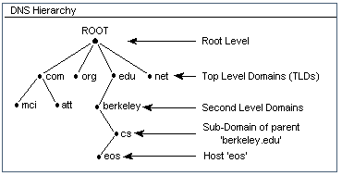

[4]

DNS is not just significant for the internet either, as hinted in the header. DNS is used by Active Directory Domain Services “to make it possible for clients to locate domain controllers and for the domain controllers that host the directory service to communicate with each other.” [5] A domain controller stores user account information, authenticates users, and enforces security policy for a windows domain.

‘Role or Feature Based Installation’ Critical Roles
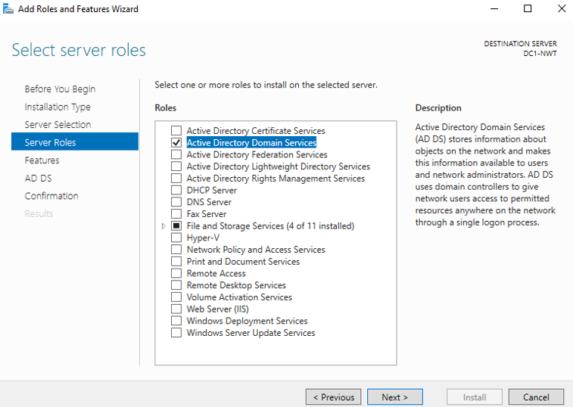
AD (Active Directory) is one of the critical roles in ‘role or Feature based installation’ as part on an enterprise network, and there are many others, as shown below:
One of these roles are DHCP Servers. DHCP (Dynamic Host Configuration Protocol) “automatically configures the IP address for every host on a network, thus assuring that each host has a valid, unique IP address.” [6] A DHCP server is a separate server dedicated to DHCP, rather than running the protocol on a router or switch, resulting in less stress on these devices, especially in bigger networking environments that require both DHCP IPv4 and IPv6 address. Within a small network, like the one built in this document, a DHCP Server would not be needed. However, on a bigger network with many host devices, a DHCP server significantly reduces the time it would take to manually assign IP address to each host device and allows devices to leave and join the network at any time with no hassle to the network manager or user.
Another important role would be Active Directory Rights Management Services (AD RMS). AD RMS allows organisations to “retain control over sensitive documents, for example, so that they cannot be e-mailed to unauthorized users” [7] This allows the network manager to protect documents from those not meant to access and/or distribute them. AD RMS infrastructure makes use of AD RMS Clients, and AD RMS Servers.
“AD RMS clients, which request licenses and enforce assigned rights protection at the document level to files and messages.
AD RMS servers, which administers account certification, licensing and publishing services that use Active Directory as well as assisting clients in locating these services.” [8]

Terminologies used In Document

Firewall
A Firewall is simply a device that controls “the flow of network traffic between network or hosts that employ differing security postures.”. [10] This means that a firewall can be configured to either block certain IP address from sending data through the firewall, or only allow a certain range of IP addresses to send data through the firewall, for example business devices on the network, or another network the business owns.
As shown in this document, Windows has a built-in firewall solution, bundled in with Windows Defender. It offers two-way network traffic filtering and is easy to use as most the configuration is done out of the box. When a new program is run, you will be told by Windows that the application is being blocked from internet use by the firewall, and you can allow the program to send and receive date if you choose.
macOS used on apple computers also has a built-in firewall like Windows, that filters traffic two-way, incoming and outgoing packets. However, unlike windows it is not on by default, and must be enabled by the user. This can be useful for more tech savvy users that either want to use a third-party firewall, or simply don’t want a firewall on the device, but the most users, this could be a problem, as they may not even know what a firewall is, and that they need to activate it. Most Linux Distributions also come with a firewall, but like macOS, it is not enabled, and may need to be configured by the user. Unlike the Windows Firewall, the Linux Firewall is managed by the Netfliter Linux Kernal Subsystem, which means a firewall administrator or network manager to set their own policies for incoming connection. The Windows alternative is controlled by a program in user mode, meaning it has less settings that can be tweaked when compared to Linux. However, this does mean the Linux Firewall is harder to understand and use when compared to the simplicity of the Windows Firewall.

Ping Command
The ping command allows the user to “check the connection between two computers or other devices on an IP network”. [11] “Ping stands for Packet InterNet Groper and uses ICMP echo packets to test the connection.” [11] The ping command works by typing “ping” and the IP address of the device you want verify is connected to the device issuing the ping command. This was shown previously in the document on windows, but this command also works the same on both Linux and macOS.

OOBE (Out of Box Experience)
OOBE is simply “The experience of setting up and using a new computer or software package.” [12]. The OOBE presents itself after windows is installed and the user boots up the system for the first time. On windows the “OOBE consists of a series of screens that require customers to accept the license agreement, connect to the internet, log in with, or sign up for a Microsoft Account, and share information with the OEM.” [13].
macOS has a similar OOBE to windows, the main difference being how it is stylised, and agreeing to Apples own license agreement. Some Linux distros, such as Ubuntu also have an OOBE, but is very streamlined, asking for a location, username and password, and a welcome message once you log into ubuntu. It has no license agreement, as Linux is an open-source software.

Reflection/Conclusion
The screenshots and accompanying text within this document give a good overview of how to set up VMs and use them build a virtual LAN with a type 2 Hypervisor, and how to deploy a network directory service and active directory network objects. The document helps to guide users through each of the steps within the document, with the use of screenshots and accompanying narration. The document also provides narration on why certain steps are taken, as well as concepts used within a NOSS (Network Operating Systems and Services) environment, through the use of accompanying comments of screenshots and the observational task. This results in a document that can be used by anyone to both recreate the steps taken within the screenshots, as well as to gain a better understanding of the concepts involved in a NOSS environment, such as Virtual machines, Network Directory Services, Server management, etc… The document is clear and concise and informative for the word count provided. However, it could provide more narration on why certain steps were taken, and less focus on user steps, as at times, the document does tend to lend itself more into a user manual.

Reference List
[1] A. Vasudevan, Practical Security Properties on Commodity Computing Platforms: The uber eXtensible Micro-Hypervisor Framework, Pittsburgh: Springer, 2019, pp. 4-5. [E-book]
[2] A. U. Rehman, R. L. Aguiar, and J. P. Barraca, Network Functions Virtualization: The Long Road to Commercial Deployments, IEEE, 2019 pp. 5. [E-book]
[3] D. Lowe, Networking For Dummies, 9th ed., Hoboken: Wiley Publishing, Inc., 2009, pp. 125. [E-book]
[4] InetDaemon, “DNS Hierarchy”, InetDaemon.Com, May. 19, 2018. [Online] Available: https://www.inetdaemon.com/tutorials/internet/dns/operation/hierarchy.shtml [Accessed Mar. 3, 2022].
[5] Microsoft, “DNS and AD DS”, Microsoft Docs, Aug. 29, 2021. [Online] Available: https://docs.microsoft.com/en-us/windows-server/identity/ad-ds/plan/dns-and-ad-ds [Accessed Mar. 3, 2022].
[6] D. Lowe, Networking All-in-One Desk Reference For Dummies, 3rd ed., Hoboken: Wiley Publishing, Inc., 2008, pp. 287. [E-book]
[7] S. Clines, and M. Loughry, Active Directory For Dummies, 2nd ed., Indianapolis: Wiley Publishing, Inc., 2009, pp. 9. [E-book]
[8] Microsoft, “How AD RMS Works”, Microsoft Docs, Aug. 29, 2021. [Online] Available: https://docs.microsoft.com/en-us/previous-versions/windows/it-pro/windows-server-2012-r2-and-2012/jj590750(v=ws.11) [Accessed Mar. 3, 2022].
[9] J. S. Hurwitz, and D. Kirsch, Cloud Computing for Dummies, 2nd ed., Hoboken: Wiley Publishing, Inc., 2020, pp. 8. [E-book]
[10] K. Scarfone, and P. Hoffman, Guidelines on Firewalls and Firewall Policy: Recommendations of the National Institute of Standards and Technology, Gaithersburg: DIANE Publishing Company, 2010, pp ES-1. [E-book]
[11] J. Habraken, Absolute Beginner’s Guide to Networking, 4th ed., Indianapolis: Que Publishing, 2003, ch. 13, pp. 399. [E-book]
[12] PCMag, “OOBE”, PCMag.com, [Online] Available: https://www.pcmag.com/encyclopedia/term/oobe [Accessed Mar. 4, 2022]
[13] Microsoft, “Customize the Windows 10 Out of Box Experience (OOBE)”, Microsoft Docs, Aug. 29, 2021. [Online] Available: https://docs.microsoft.com/en-us/windows-hardware/customize/desktop/customize-oobe [Accessed Mar. 4, 2022]
[14] P. A Abdalla, and A. Varol, “Advantages to Disadvantages of Cloud Computing for Small-Sized businesses” First University Department of Software Engineering, Elazig, 2019. [Online] Available: https://booksc.org/ireader/76727088 [Accessed Mar. 4, 2022]
[15] VMware, “What is cloud scalability?”, VMware.com, [Online] Available: https://www.vmware.com/topics/glossary/content/cloud-scalability.html [Accessed Mar. 4, 2022]

