Assignment 1
By Krzysztof Matela
Programming in C and documentation

Page index:
Page 2 ……………………………………………………………………………………………………. Variables, Loops and Arrays
Page 3 ……………………………………………………………………………………………………………………………………… Task 1
Page 5 ……………………………………………………………………………………………………………………………………… Task 2
Page 7 ……………………………………………………………………………………………………………………………………… Task 3
Page 10 ……………………………………………………………………………………………………………………………………. Task 4
Page 15 …………………………………………………………………………………………………………………….. Reference page

Variables, Loops and Arrays
- Variables
Variables, as the name suggests contain varying values. The are essential in programming because they are stored in memory location (RAM). Important notice is that variables are case sensitive and some of the functions of the C are written with capital letters and so each variable must start with a small case letter else, programs might confuse variables and functions. There 4 main types of variables available:
Int Integer – refers to a whole number
Float Double – refers to a number with decimal point
Char Character – refers to a single character
String String – refers to a series of characters
- For-Loops
When there’s a need to do repetitive tasks for loops are extremely useful. They allow developer to specify the criteria on which they run and it is most commonly defined as: for(i=0; i<5; i++){}. Within curly brackets is the code that would run. For criteria definition is as follows: Index is defined as ‘i’ that starts from 0, then criteria that would stop it (e.g. ‘I’ is less than 5) and what to do with each pass (i++ stands for increment by 1). With the logic that with each pass increments index by 1, it is often referred as a “counting loop”.
- Arrays
Typing variables named for e.g. number1, number2, number3 etc… will have time consuming impact and will reserve a lot of memory storage. Therefore, it is best to use an array. They can store a several values within the same memory allocation. For example, instead of defining 3 individual variables, you can define one as for e.g. number[2] which will have 3 values that I can store. It is important to notice that all arrays start at zero so the example above have 3 storage spaces of: number[0], number[1], and number[2].

Task 1 – Program that will receive and display users height, age and his/her name.
Problems:
- First thing that I need to do is to identify required types of variables. There are 4 types of variables altogether:
char – single character
string – series of characters
int – whole number
float – number with decimal point
- Another problem is displaying text on the screen and collecting input into the right variables.
Solutions:
- For the name I will require a string; for age, an integer; and for height, a float number with 2 decimal points.
- Displaying text one the screen is done using ‘printf(“text”);’ command and input collection is done using ‘scanf(“%x”, &y); command where ‘x’ is the type of variable to receive and ‘y’ is the name of the variable.
Code:
--------------------------------------------------------------------------------------------------------------------------------------
#include <stdio.h>

void main() {
// code goes here

// declaring 3 types of variables
int theAge; // integer
float theHeight; // float
char theName[100]; // string

// display text
printf("What is your name? \n");
// collect text
scanf("%s", &theName);

printf("What is your age? \n");

scanf("%d", &theAge);

printf("What is your height? \n");

scanf("%f", &theHeight);

printf("\nYour name is %s \n", theName);
printf("Your height is %.2f meters \n", theHeight);
printf("and you are %d years old \n\n", theAge);

}
--------------------------------------------------------------------------------------------------------------------------------------
Testing:
I have run the program and input all of the required fields to check if the output is correct.
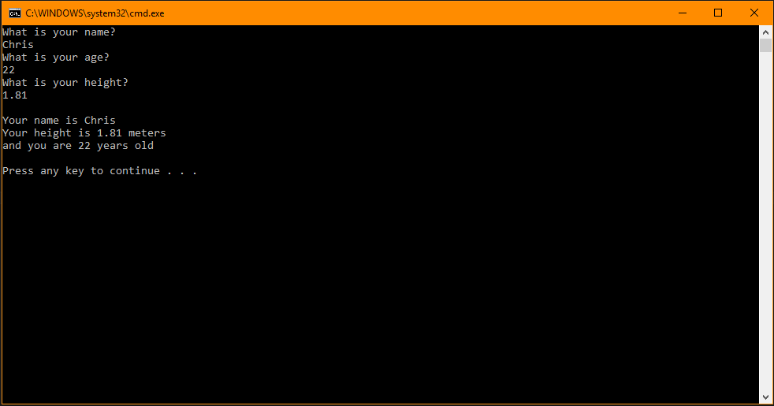
Task 2 – Program that would allow a user to enter dimensions of two shapes and then calculate a shaded area of a shape that looks like this:
Problem:
- My only problem is the calculation algorithm for both shapes because one of them requires a ‘pi’ number.
Solution:
- According to Microsoft⁽¹⁾ Visual Studio contains math defines that will allow me to use preconfigured number PI for my calculation. In order to use them, I must include another library and defines using this code:
#define _USE_MATH_DEFINES // This will allow me to use PI
#include <math.h>
float pi = M_PI;
After that everything else is just pure math and the code looks like this:
--------------------------------------------------------------------------------------------------------------------------------------
#include <stdio.h>

#define _USE_MATH_DEFINES // This will allow me to use PI
#include <math.h>

void main() {
// code goes here

// declaring variables required for calculations
float pi, radius, height, base, piR, resultCircle, resultTriangle, resultShaded;
pi = M_PI; // PI in C defined

// testing result of PI
// printf("the pi is %.16f \n", pi);

printf("Calculated shaded area \n");
printf("input radius of a circle \n");

scanf("%f", &radius);

// pi * radius
piR = radius * pi;
// πr²
resultCircle = piR * piR;
printf("area of a circle is %.2f \n", resultCircle);

printf("input height of a triangle \n");

scanf("%f", &height);

printf("input base length of a triangle \n");

scanf("%f", &base);

// (b*h)/2
resultTriangle = (height * base) / 2;

printf("area of a triangle is %.2f \n", resultTriangle);

// Area of Circle minus area of a Triangle
resultShaded = resultCircle - resultTriangle;

printf("shaded area is %f \n", resultShaded);
}
--------------------------------------------------------------------------------------------------------------------------------------
Testing:
I have input test values and did the same in the excel to make sure that it is correct:
Excel output:
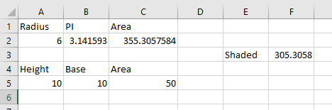
Program output:
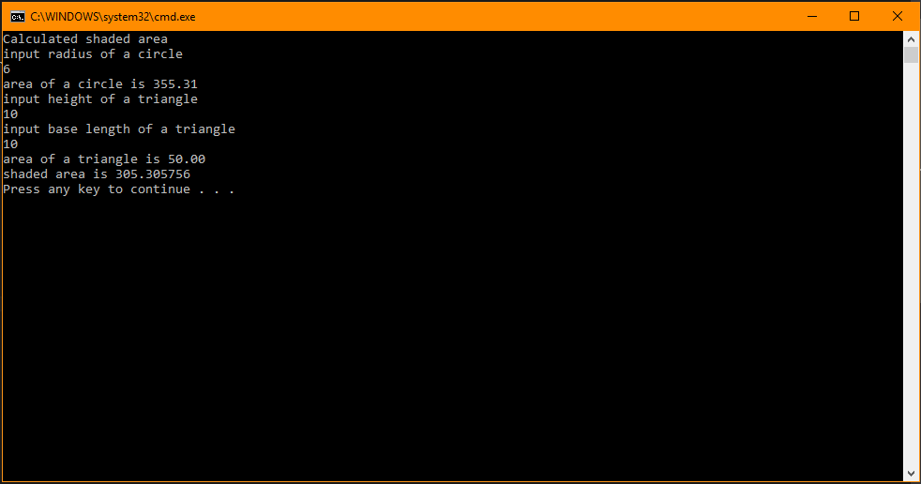
Calculation is correct.
Task 3 – Program that would allow user to input prices of 5 different products into an array and then calculate the total price with 20% VAT.
Problems:
- First problem is that there are 5 products to be input into an array that means there will be 5 repetitive actions to consider.
- Another problem is as to how to add all of the values from an array altogether.
- And last problem to the calculation algorithm to find 20% of total price.
Solutions:
- Since there will be 5 products input into the program I have decided to use while function with ‘I’ as the criteria. This loop will run for 5 times giving a loop to collect all of the 5 prices. Along this while loop, there’s a need to display 5 different text notes as to which index of a product to input. For that I have decided to use “switch case” function which uses the same criteria as the ‘while’ loop giving me 5 different text messages for each product. Alternatively, I could have used the ‘for’ loop and replace just a single word within a text with each pass. That method would shrink the code but it would increase in complexity.
- Fallowing info that all of the values are in the exact same array, I have decided to use the ‘for’ loop that with each pass will continue to add all of the prices together until the end of the loop.
- Lastly, I have calculated and stored 20% VAT from the whole by using this formula: VAT = total * 20 / 100. One last thing to do is to add two values together and then display these on the screen.
Code:
--------------------------------------------------------------------------------------------------------------------------------------
#include <stdio.h>

void main() {
float products[5], total, vat;
int i = 0;
total = 0;

// program description
printf("Calculate total and add 20%% VAT\n");

// while function to determine how many products will be add to an array
while (i != 5) {

// switch function to choose different texts while in same function
switch (i)
{
case 1:
printf("Please input second product\n");
break;
case 2:
printf("Please input third product\n");
break;
case 3:
printf("Please input fourth product\n");
break;
case 4:
printf("Please input fifth product\n");
break;
default:
printf("Please input first product\n");
break;
}

// input float number into an array
scanf(" %f", &products[i]);

// add 1 to i
i++;
}

// add all products together
for (i = 0; i < 5; i++) {
total = total + products[i];
}

// calculate the vat
vat = total * 20 / 100;

// add vat to total
total = total + vat;

// display whole
printf("The total is %.2f\n", total);
}
--------------------------------------------------------------------------------------------------------------------------------------
Testing:
Using the same method for testing as in ‘Shaded area’ program, I have input example values into the excel spreadsheet to validate the program calculations.
Excel output:
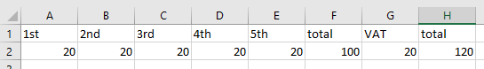
As you can see here, the calculations are correct and the loop is working as intended.
Program output:
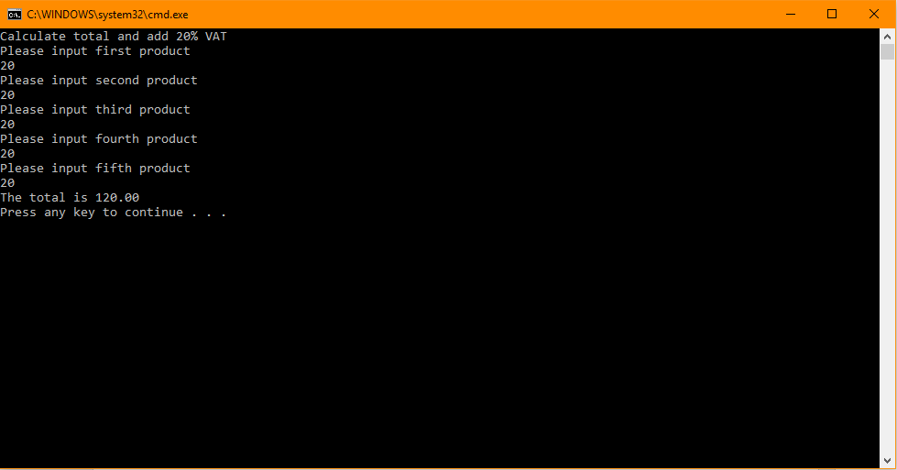
Task 4 – 3 symbols fruit machine
This program has a lot of the requirements so I have decided to break it down a little:
There are 3 symbols displayed at random (going from 1 to 5)
User can have as many goes as they like
Any three of the same number will pay out 20 points
Any combination of two fives will pay out 100 points
Three fives will pay out a jackpot of 2000 points
Problems:
- First problem is how to give user as many goes as they like?
- I need to randomize and display 3 different numbers
- Then I will have to find a way of detecting 3 of the same number
- I need a system that will differentiate the jackpot from remaining 3 of the same number
- Lastly, I will need to detect 2 fives that will pay out more points and make sure that it will not pay out when there are already 3 of fives and user received a jackpot
Solutions:
- To give user as many goes as they like I used ‘while’ function and have given two criteria to consider. Depending on where the user is using ‘Y’ or ‘y’ must have no impact on the loop or some issues will appear. Therefore, if user inputs anything else, the program will finish.
- To randomize 3 different numbers, I have used a subroutine to do it. It will randomize a number going from range of 1 to 5. Within the main loop however I have used the arrays within the ‘for’ function in order to have each random number assigned to different position of an array so I can then compare those values together.
- To detect 3 of the same type I have produced an ‘if’ function that will run only if 3 values are the same. Within that function I have nested another ‘if’ that detects if at least any of them is 5 and if yes, it will pay out 2000 points and if not, it will only pay out 20 points. Lastly, if the jackpot is payed out, it will set a Boolean to ‘true’ for another if to use. This method also solves problem number 4.
- One last ‘if’ statement is there to detect if any 2 fives are displayed in order to pay out a smaller jackpot of 100 points. And when it finishes, it resets the Boolean to ‘false’ to be checked again in the future.
Code:
--------------------------------------------------------------------------------------------------------------------------------------
#include <stdio.h>
#include <stdlib.h>
#include <time.h>
int getRandom();

void main() {
// include program timer
srand(time(NULL)); // once per program

// declare variables
int rnd[3], i, points;
points = 0;
char goOn = 'y';
bool detect = false;

// intro
printf("Fruit Machine\n");

// give user as many tries as he like
while (goOn == 'y' || goOn == 'Y') {

// get 3 random numbers
for (i = 0; i < 3; i++) {
rnd[i] = getRandom();
printf("%d ", rnd[i]);
}

// if first, second, and third are equal - add points
if (rnd[0] == rnd[1] && rnd[1] == rnd[2]) {
if (rnd[0] != 5) {
points += 20;
}
else {
points += 2000;
detect = true;
}
}

// compare first with second, first with third, and second with third if they are equal to 5
if (detect == false) {
if (rnd[0] == 5 && rnd[1] == 5) {
points += 100;
}
else if (rnd[1] == 5 && rnd[2] == 5) {
points += 100;
}
else if (rnd[0] == 5 && rnd[2] == 5) {
points += 100;
}
}

detect = false;
printf("\nYou have %d points \n", points);
printf("Continue? y/n? \n");

// scan character
scanf(" %c", &goOn);
// reset detect
detect = false;

}
// outro
printf("Thanks for playing :)\n");
}

// external function for creating random numbers
int getRandom() {
int myRand;
int low = 1;
int high = 5;

myRand = rand() % (high - low + 1) + low;

return myRand;
}
--------------------------------------------------------------------------------------------------------------------------------------
Testing:
One last task is to test the program to see if it’s working as intended.
2 fives have pay out 100 points
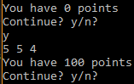
Any 3 of the same number pay out 20 points
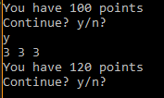
3 fives pay out 2000 points (without pay out for 2 fives)
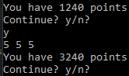
Typing ‘n’ or ‘N’ ends the program
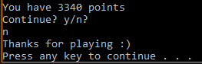

Reference Page:
- Math Constants by Microsoft, URL: https://docs.microsoft.com/en-us/cpp/c-runtime-library/math-constants?view=vs-2017

