Assignment 2 – Project Outcomes
CHANGEMAKERS: creativity and value creation
joseph williams - 1902388
2020
In this document is a link to my assignment presentation video and a screenshot of my presentation first page title screen.

Link to my assignment presentation video:
https://www.youtube.com/watch?v=WRVwVkJ5MH8&feature=youtu.be

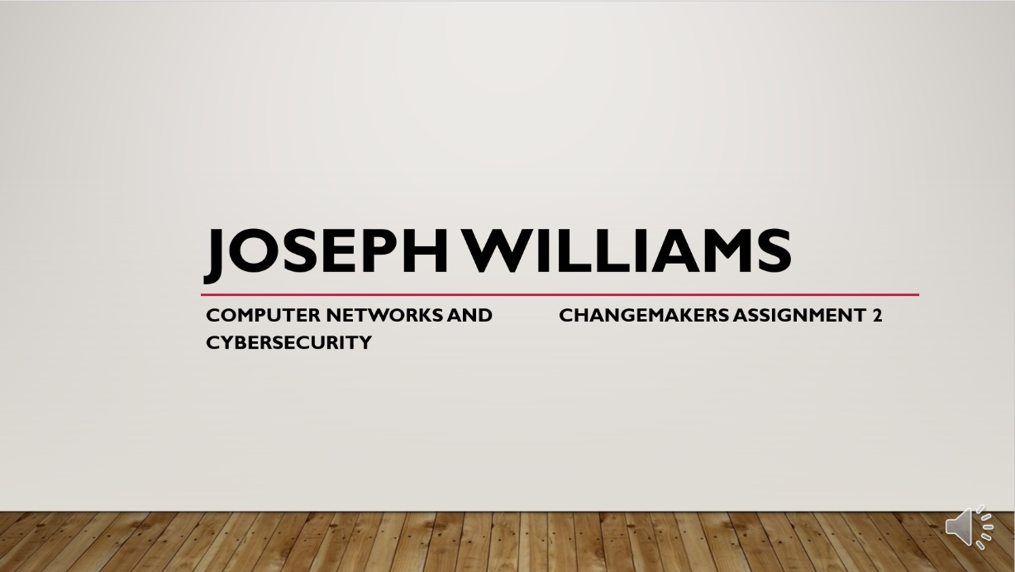
Screenshot of my assignment presentation:

