Student Name: Charlie Barriscale
P Number: 2501144
Programme of Study: Graphic Design
Module: ADAD4022 Ways Of Thinking

Tasks in the order I received them:
Task one: semiotic analysis- 528 words
Task two: manifesto- 532 words
Task three: practice based writing- 508 words

Task One: Semiotics
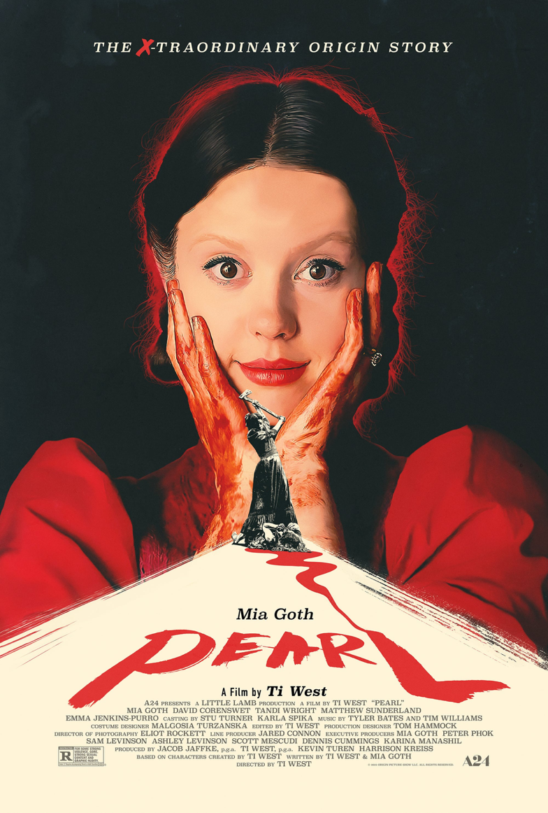
Semiotics in a very specific definition can be referred to the hidden meanings and emotions that can be invoked or generated through media like graphic design. As one of the co-founders for the concept of semiotics, Ferdinand de Saussure (1857-1913) paved the way for future creatives and semioticians so that we can have a better understanding of the effects that creative works can have on people as well as the intended meaning and purpose that the creator or designer had for their work. I will be analysing this poster and the story of the character portrayed in it to fully understand the design choices.

Fig 1, (Studio MOCEAN, 2022, Pearl Movie Poster)

The movie “Pearl” was created in 2022 by Ti West who had directed, produced as well as co-wrote the movie with the lead actress Mia Goth. Mia Goth is also the one you see featured in this poster for the movie. This movie was created as a prequel story for another movie called “X”. Ti West stated in an interview, “if you've seen X, PEARL is enriched by that.” (West, 2022). This solidifies the connection of the stories and how PEARL is a powerful addition to the original X movie but also has a completely original and separate style within the story and design for it. PEARL was set in 1918 and this becomes evident in the poster design. While it doesn't take a large influence from actual poster design from that time period it still includes specific elements such as the beige colour that creates a path for the text that can bring you back to an earlier time in history. The specific beige colour used in the poster could even invoke nostalgia. Another way that this poster design correlates to the poster design that was created during 1918 is the truly vibrant red that is featured. Like so many poster design from that time period, it often had a signature colour or colours that popped on the yellowish-beige paper. The designers for this poster most likely took this into account for the PEARL poster. The deep red is a way for the designers to invoke feelings of fear and suggestions of violence to the viewers. The poster very bluntly suggests some form of brutality or ferocity throughout the film. As well as the red creating an atmosphere of violence, It can also be related to the sheer passion that the main character of PEARL has towards becoming a star. The way in which the main character is looking directly at you as the viewer of the poster creates an eerie and disturbing impression that could make you uncomfortable or even in danger. This design choice for the poster is a great way of representing the main characters unbreakable determination to reach stardom even if it means hurting or killing anyone that gets in her way. The connection of the typeface for the movie title in the poster to the look of blood is another way that the design has incorporated the main concept for the movie into a single poster so that it can be cohesive as well as it being a way to visually direct the viewers attention throughout the poster.

Task Two: Manifesto

- Freedom is important
- Ideas should be shared and appreciated with others
- Self fulfilment should be your main goal
- Creativity isn’t genetic or inherited but learnt
- Creative activities can lead to self discovery
- Have time to yourself to comprehend what happens to you
- Your gut feeling should be the one you follow most
- Don’t let your creativity become a chore

3. Self fulfilment should be your main goal

We live in a time where almost everyone is too concerned with the issues and fortune of others people. “Never judge someone's character based on the words of another” ( Suzy Kaseem ,2010). To maintain a healthy wellbeing and mentality it is necessary that you focus on your own goals and aspirations. I believe that if you aren't able to accept yourself and understand your own wants and needs then you can’t find peace or enjoyment. Without self fulfilment you are also unable to be there for others as truly as you could. However, I don't say this without knowing that you can't solely focus on your own personal gain and achievements. It is just as important to gain connections and friendships so that you can grow as a person while you're aiming for your goals. Strong relationships can even uplift you in ways that can help you in achieving everything you want for yourself. It is also very important to surround yourself with the right people because if you create relationships with people that will bring you down or don't respect you enough to understand your values then that could damage your chances at success. It is also important to understand that you shouldn't give up experiences that could define you in pursuit of your success or achievement. This is because failure is a natural part of being human and failing can expand your potential so that you can find new ways to succeed.

2. Ideas should be shared and appreciated with others

I feel as though ideas you have are such a powerful tool to help you develop your skills and knowledge. The collaboration of people and their different viewpoints on specific things creates such a beautiful connection between them that allows for their ideas to be explored and developed even further. “ When people talk, listen completely, most people never listen.” ( Ernest Hemingway, 1967). Hearing and understanding others opinions on an idea you have is such an important part of creative endeavors as you can learn what you could improve and what you never thought of before because everyone's ideas and opinions are so profoundly different and unique. It is important for people to take a step back and acknowledge people's discoveries and ideas before making decisions and judgments about it.

- Don’t let your creativity become a chore

In the modern day, creativity has become so monetised in that a persons ideas or expression has turned into something they can't enjoy as much as they would be able to because for a lot of people there isn't a choice. “ We have to continually be jumping off a cliff and developing our wings on the way down” ( Kurt's Vonnegut, 2013). When your creativity becomes compromised because of expectations or others negative feedback then you aren't able to truly create something that reflects you and your ability. I can acknowledge that this having critical feedback can be helpful for your own development but it shouldn't be hurtful and unnecessary because that can create an atmosphere of anxiety for a person surrounding their work. This could then compromise their relationship with their own creativity. This may even turn into a resentment towards any creative expression as well as making them even more uncomfortable when getting feedback.

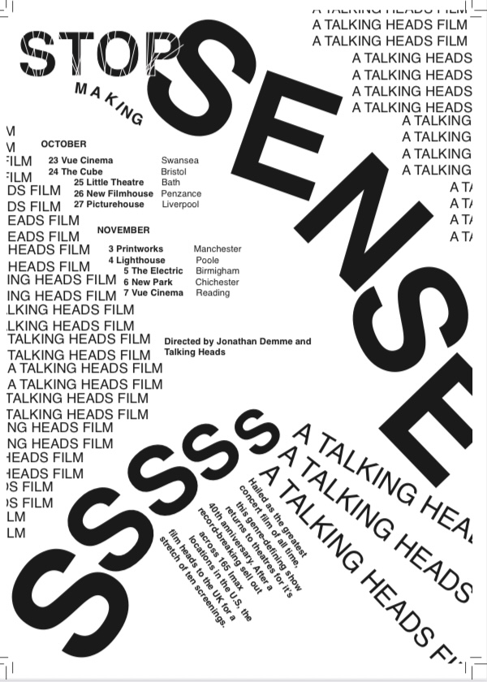
Task three: Practice based writing
Fig 1, (Stop Making Sense, own image, 2025)

A collection of random words and letters to create something meaningful and informative. The brief for this task was to create a poster for the talking heads concert movie tour around the UK. We had to use the Helvetica typeface and we were allowed to using various sizes for the typeface as long as the text included the provided text. I found this task truly enjoyable because you had such strict instructions for what you could do but at the same time it allowed for your imagination to be used in unconventional ways. I think the composition of my work was done well but I wish I would have taken more time to explore different ways to position the text as I only tried one or two different versions to create my final design. I think I was able to create a clear visual hierarchy through the use of making the more important information in bold or even larger sizes. Another thing I would have liked to try is finding ways to fill the white space. I believe I was also able to create a cohesive flow between the text so that the eye can be drawn through the information smoothly. I believe that my design for the poster was able to truly represent the atmosphere and message of the band in that the composition embodies chaos and does “make sense.” Another thing I like about my poster design is that I framed the important text nicely using smaller lines of text so that I could put emphasis onto the main information that I wanted people to look at. “Art is nothing more than creating emotion in your own form” (Shannon L. Adder, 2012) I think that I was able to capture an emotion and atmosphere of chaos and anxiety through this poster. While this was an early point in my graphic design course I still feel very proud of this work and how I was able to apply the knowledge of the last couple of weeks into the design for this poster.
One of the things I can takeaway from looking back at my work like this is that in future I would like to be more open to experimentation with my work so that I can further develop ideas so that I don't see a design as a straight line to the final but instead a journey in which I can figure out multiple ways of creating a solution to a problem. “Everything in life should be approached as a project. Every project can be broken down.” (Scott Belsky, 2010). I believe that in future I should try and break down the task into smaller steps so that I can fully understand my goals for the project and take more care in my thought process for the design, composition and execution. I would also like to take the lesson of being comfortable in myself to make mistakes with my work so that I can learn from them in the future.

Bibliography

“Art is nothing more than creating an emotion in your own form.”
Shannon L. Alder
Graphic Design Quotes- https://www.goodreads.com/quotes/tag/graphic-design ( Accessed 8th of December)
“Everything in life should be approached as a project. Every project can be broken down."
Scott Belsky, Making Ideas Happen: Overcoming the Obstacles Between Vision and Rea
Graphic Design Quotes- https://www.goodreads.com/quotes/tag/graphic-design ( Accessed 8th of December)
“if you've seen X, PEARL is enriched by that.” (West, 2022).
https://rue-morgue.com/exclusive-interview-ti-west-on-making-pearl-a-very-different-kind-of-prequel/ (Accessed 26th of November)
“Never judge someone's character based on the words of another”- Suzy Kassem, Rise Up and Salute the Sun: The Writings of Suzy Kassem
Graphic Design Quotes- https://www.goodreads.com/quotes/tag/graphic-design ( Accessed 8th of December)
“We have to continually be jumping off cliffs and developing our wings on the way down.”
Kurt Vonnegut, If This Isn't Nice, What Is?: Advice for the Young
Graphic Design Quotes- https://www.goodreads.com/quotes/tag/graphic-design ( Accessed 8th of December)
“When people talk, listen completely. Most people never listen.”
Ernest Hemingway
Graphic Design Quotes- https://www.goodreads.com/quotes/tag/graphic-design ( Accessed 8th of December)

List of figures
Figure 1, (Studio MOCEAN, 2022, Pearl Movie Poster)
Available at:
https://pin.it/77ge0mls5

Figure 1 Talking Heads Poster (own image, 2025)

