BSc Health and Social Care
Module: Changemakers: Building your Personal Brand for Sustainable Employment
Module Code: BMHP5015
Assignment Title: Component 2 – Employability Skills and Personal Branding Report
Student Name: Kiran Ashraf
Student Number: 2331397
Submission Date: 2 April 2026
Word Count: 2000 words

TABLE OF CONTENTS
1. INTRODUCTION 3
2. OVERVIEW OF THE CHOSEN JOB ROLE 3
3. ANALYSIS OF EMPLOYABILITY SKILLS REQUIRED FOR THE ROLE 4
4. EVALUATION OF MY CURRENT SKILLS 5
5. CURRENT EXPERIENCE AND QUALIFICATIONS 6
6. BUILDING MY PERSONAL BRAND 6
7. PROMOTING PROFESSIONAL IDENTITY AND NETWORKING 6
8. UNIQUE VALUE AND CONTRIBUTION TO THE ROLE 7
9. ACTION PLAN AND TIMELINE FOR SKILL DEVELOPMENT 7
10. COMMUNICATING MY SKILLS TO EMPLOYERS 7
11. CONCLUSION 8
REFERENCES 9

1. INTRODUCTION
The health and social care sector in the United Kingdom play an important role in enhancing the well-being of individuals and communities. Professionals in this sector come together to help ensure vulnerable populations are safe and individuals have the support they need to lead safe and independent lives. One of the most important professions that exists within this sector is social work. Social workers help people and families with social, emotional or financial problems and guide them to the services that can help enhance their quality of life (Prospects, 2025). This report is about the job of a Social Worker in the UK, which is in line with my professional goals. The report examines some of the employability skills required to do this job and considers where I am in terms of the skills entailed, and how these can be improved. Furthermore, the report outlines a five- year action plan to aid my career progression. In addition, the report considers what can be done to create a strong personal brand that can promote professional identity and build a professional network that can support long-term employment in the health and social care sector.

2. OVERVIEW OF THE CHOSEN JOB ROLE
Social workers play a vital role in supporting vulnerable individuals, families and communities. Their field of work is concerned with safeguarding people from harm, championing social justice and supporting people to overcome social and personal challenges (BASW, 2025). In the UK, social workers can be in the field of children, families, people with disabilities, elderly people or people who suffer from mental health issues. According to the National Careers Service, social workers support the protection of vulnerable people from abuse or neglect and provide support for individuals to live independently in their community (National Careers Service, 2025). They will often work in multidisciplinary teams alongside healthcare professionals, educators and community organisations to provide coordinated support. A current example of a UK job vacancy shows the responsibilities of a social worker. For example, the Children's Social Worker - Assessment or Safeguarding Service role advertised by Liverpool City Council specifies that professionals would need to manage caseloads of children and families and thoroughly carry out assessments and make complex decisions regarding risk and safeguarding (Liverpool City Council, 2025). The job description also serves to identify some responsibilities that may include conducting top-notch assessments, identifying threats and safeguarding issues and ensuring that the welfare of children is paramount during decision-making processes.
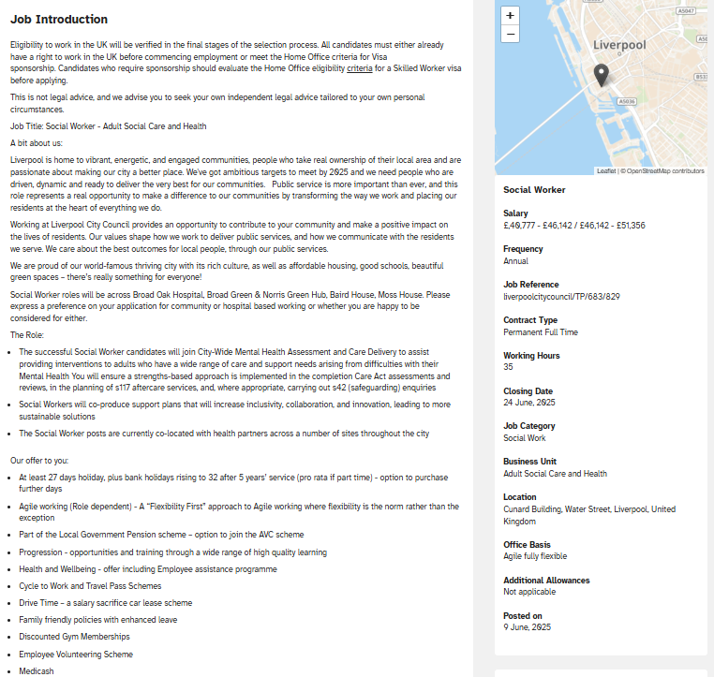
Figure 1: Example UK Social Worker Job Vacancy Source: Liverpool City Council Job Portal (2025)
These responsibilities are indicative of the fact that the profession involves high levels of decision-making, communication, and protection skills. The role also involves social workers to be able to maintain professional judgement and implement evidence-based practices in supporting vulnerable people (Liverpool City Council, 2025).

3. ANALYSIS OF EMPLOYABILITY SKILLS REQUIRED FOR THE ROLE
Employability skills is a vital set of skills that can help individuals to function well in the workplace. In relation to social work, these skills are of particular importance since those working in the field are responsible for working with vulnerable individuals and are called upon to deal with complex situations in which they must address safeguarding, ethical decision-making and multidisciplinary collaboration. Communication skills are among the most important skills needed in the field of social work. Social workers must be able to communicate well with service users, families and other professionals. This includes active listening, empathy and being able to explain complex information clearly and sensitively. Effective communication also helps where there is a need to build trust at the professional and service user level, which is essential for successful interventions (UCAS, 2025). Empathy and emotional intelligence are also important. Social workers are often involved in aiding those in conditions of trauma, abuse or poverty. Understanding the emotional experiences of service users enables professionals to be responsive and provide meaningful support. Emotional intelligence also allows social workers to handle difficult conversations and have professional relationships. Another major skill is problem-solving and decision-making. Social workers are frequently involved with confusing cases where there are safeguarding issues or family crises. In such situations, professionals need to be able to assess the risks, analyse the available evidence and make choices that prioritise the safety and well-being of service users. It can be emphasized that, according to research, social workers tend to use professional judgment and critical reflection when finding the appropriate interventions (Prospects, 2025). Teamwork and collaboration are also essential. Social workers rarely work alone and frequently work with professionals working in healthcare, education and community organisations. Effective teamwork ensures that effective services are provided to the individuals and that effective coordination of services is achieved. Resilience and stress management are just as important as social work can be a tactile situation, emotionally requiring the social worker. Professionals need to be able to maintain their composure under pressure and adhere to ethical practices even if they are in difficult situations. Finally, there are organisational and digital skills which are increasingly important. Social workers must keep accurate case records, and they must administer their roles using digital systems within local authorities and healthcare organisations.

4. EVALUATION OF MY CURRENT SKILLS
To establish my suitability for a career in social work, I assessed my existing abilities through self-reflection and feedback that was gained from academic learning experience within my health and social care programme. One of my greatest abilities is communication. Through presentation, group discussions and coursework activities, I have developed the ability to express ideas clearly and interact effectively with others. This skill will be especially useful in dealing with service users and multidisciplinary teams. Another important strength is empathy. Learning about health and social care has allowed me to learn more about the difficulties of vulnerable individuals. I have evolved the skills to consider different points of view and to respond with compassion and sensitivity. Another area of competence is teamwork. Collaborative academic assignments have enabled me to work well with others and have developed skills of cooperation and shared problem-solving. These experiences have helped me to be more positive in contributing to professional teams. Despite these strengths, however, there are several areas where further development is necessary. One important area is the practical experience. Although academic knowledge is a good theoretical background, real experience in the social care settings is needed to build up professional competence. Another area that needs to be improved is decision-making under complex situations. Social workers have the responsibility to frequently evaluate risk and make safeguarding decisions that will impact the lives of individuals. Developing this skill will take exposure to practical case management and professional training.

5. CURRENT EXPERIENCE AND QUALIFICATIONS
My current academic programme, the BSc Health and Social Care degree, gives me important knowledge about social policy, legislation and ethical practice in safeguarding. The programme also develops critical thinking skills, which are required in analysing complex social issues. Academic coursework has enabled me to explore case studies that are linked to safeguarding, health inequalities and social policy. These experiences have deepened my understanding of the challenges experienced by vulnerable populations and the professional responsibilities of working within the sector. However, earning practical experience through volunteer work or placements with community organisations will enhance my employability to a high degree. Work experience is widely recognised as being an important part of social work training as it enables the student to apply the theoretical knowledge in real-life situations (BASW, 2025).

6. BUILDING MY PERSONAL BRAND
Personal branding refers to the process of presenting one's skills, values and professional identity in a manner that brings credibility and expertise. In the competitive modern employment world, building a strong personal brand can go a long way to increasing employability and professional visibility. For the would-be social workers, personal branding includes showing commitment to ethical practice, empathy and social justice. A good personal brand can showcase an individual's commitment to working towards helping vulnerable communities and the hireable skills to work with multidisciplinary teams. Developing a professional presence on the Internet is a great way of creating a personal brand. Platforms like LinkedIn enable people to market their qualifications, experiences and professional accomplishments. A solid and well-structured profile can be used to showcase professional commitment and help connect with professionals in the chosen field. In addition, sharing of relevant insights relating to social care, volunteering experiences and academic achievements can strengthen professional identity and show engagement with the sector.

7. PROMOTING PROFESSIONAL IDENTITY AND NETWORKING
Professional identity is an individual's perception of his/her role in a profession and how they see themselves in terms of their self-presentation to others. In social work, professional identity is highly shaped by values such as compassion, respect, equality and ethical responsibility. Networking is an important strategy for career development as it enables people to get connected to professionals who can bring guidance, mentorship and employment opportunities. Building professional relationships can also give individuals insight into the realities of the profession and help to keep them informed about career opportunities. People attending career fairs, joining professional conferences and connecting with the social workforce on the internet are the best ways to build a worldwide professional network. These activities give the aspiring professionals a chance to learn from experienced professionals and get insights about the ways the career can be pursued.

8. UNIQUE VALUE AND CONTRIBUTION TO THE ROLE
Every professional has their own strengths that they can bring to their work. My possible contribution to the Social Work profession is that I am strongly empathy-driven, communicative and have a strong commitment to helping those who are vulnerable. My academic knowledge in health and social care will also give a great understanding of safeguarding policies, social inequalities and ethical practice. These competencies can aid in effective decision-making and help ensure that the service users are provided with appropriate support. Using a combination of theoretical knowledge, practical experience and ongoing professional development, I seek to make a positive contribution to the well-being of individuals and communities.

9. ACTION PLAN AND TIMELINE FOR SKILL DEVELOPMENT
To accomplish my career goal to be a social worker, I have set up a five-year action plan. Within the first 2 years of study, my focus will be on completing my BSc Health and Social Care degree whilst gaining good academic/research skills. During this time, I will also be setting up a professional LinkedIn and begin volunteering within community organisations. During the next two years, I intend to get practical working experience in social care settings and attend professional training workshops about safeguarding and case management. In the last step of the plan, I hope to be able to apply for training or entry-level social work positions. Continuous professional development will always be a priority as I look to develop specialised knowledge in areas such as mental health or child protection.

10. COMMUNICATING MY SKILLS TO EMPLOYERS
Presenting skills in an effective way to employers is the key to securing a job. One of the most important tools for achieving this is a well-structured curriculum vitae (CV) which highlights relevant qualifications, skills and experiences. A professional LinkedIn profile will also enable me to showcase my personal brand as well as connect with professionals in the sector. In addition, I have a professional portfolio showcasing academic work, training certificates and reflective learning experiences which will evidence my commitment to professional development. These are strategies that will help ensure that my abilities are communicated clearly and effectively to potential employers.

11. CONCLUSION
This report discussed the employability skills that the role of a social worker in the United Kingdom requires and assessed how my current skills compare to these requirements. The analysis showed that social work demands a varying array of competencies, which include communication, empathy, problem-solving, teamwork and resilience. Through self-assessment, I realized that one of my strengths is my ability to communicate and empathize with others, and one of my areas for improvement is my professional experience and decision-making skills. The immunisation of a sound and solid personal brand and professional network will also be crucial to the employability enrichment. The five-year action plan described in this report is a clear path for building the knowledge, skills and experiences that I need to reach my career goal. By remaining engaged in continuous professional development and exhibiting practical experience in the sector, I wish to make a positive contribution to the well-being of vulnerable individuals and communities.

REFERENCES
BASW (2025) How to become a social worker. Available at: https://basw.co.uk/careers/how-become-social-worker (Accessed: 13 March 2026).
Liverpool City Council (2025) Social Worker – Assessment or Safeguarding Service Job Description. Available at: https://jobs.liverpool.gov.uk/jobs/job/Social-Worker-Assessment-or-Safeguarding-Service/1456 (Accessed: 13 March 2026).
National Careers Service (2025) Social worker job profile. Available at: https://nationalcareers.service.gov.uk/job-profiles/social-worker (Accessed: 13 March 2026).
Prospects (2025) Social worker job profile. Available at: https://www.prospects.ac.uk/job-profiles/social-worker (Accessed: 13 March 2026).
UCAS (2025) How to become a social worker. Available at: https://www.ucas.com/careers-advice/how-to-become/social-worker (Accessed: 13 March 2026).
Social Work England (2026) About social work regulation. Available at: https://www.socialworkengland.org.uk (Accessed: 13 March 2026).

