Reward for Performance and Contribution

Rebecca Rees

Word Count 4268

(AC 1.1)

Doyle (CIPD, n.d.) states that reward sends a clear message about what an organisation values and how it aligns with cultural and goals. It reflects employee priorities, such as recognition, development, and fair pay, and is important for attracting and retaining talent. The CIPD (n.d.) highlights that reward involves designing and delivering pay and benefits to reflect organisational culture while remaining externally competitive. At Eco-Insulate, high turnover and low morale can stem from the absence of incentives, a lack of benefits and also unequal benefits. The CIPD (2025) recommends a ‘total reward’ approach, combining financial and non-financial elements. For example, this could include flexibility, autonomy, development and also recognition. A fair and transparent reward practice can build trust and foster inclusion, whilst recognition schemes and performance-based incentives could enhance productivity, motivation and encourage behaviours that supports the organisations goals and sustainability. The CIPD (2025) also highlights the need to balance internal fairness with external market competitiveness through job evaluation and benchmarking.
The CIPD (2022) Reward Management Survey shows that total reward extends beyond pay to include career development, health and wellbeing, and flexibility, promoting fairness and transparency, especially when these benefits are accessible to everyone.

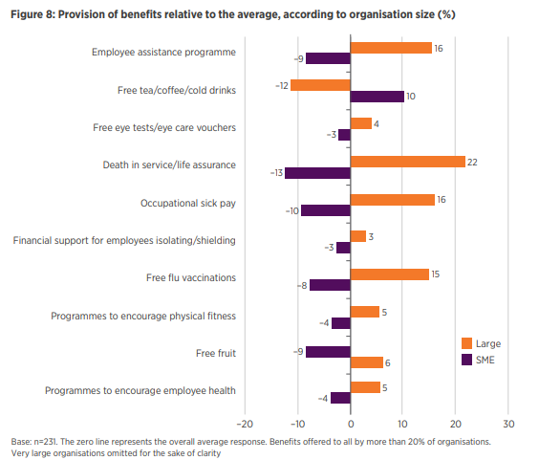CIPD (2022)

The survey found that 92% of employers offer career development, over half contribute at least 6% to pensions, and many provide wellbeing support such as debt counselling. Many organisations also provide support like debt counselling and protection against financial scams, which can improve employee reliance and engagement. However, poor communication of reward packages can reduce their impact, making clear and consistent communication essential for it to become effective.
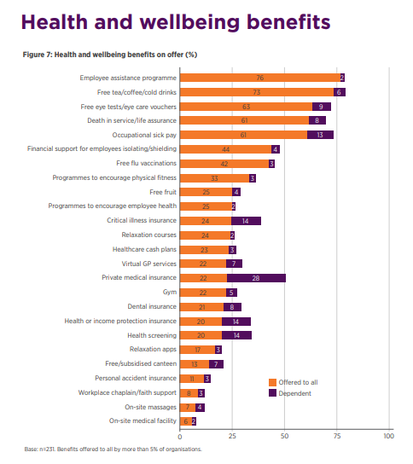(CIPD, 2022)

Armstrong, (2023) emphasises that fairness, transparency, and alignment with business objectives are essential principles. Intrinsic rewards, like autonomy, and purpose, can boost engagement, whilst intrinsic rewards help attract and retain talent. Linking rewards to behaviours and outcomes supports performance management, and when aligned with organisational values, rewards become a strategic tool for retention and engagement. The CIPD (2025) advises balancing internal fairness with external competitiveness through job evaluation and benchmarking. Perkins & Jones (2020) highlight the importance of legal compliance, covering the Equality Act 2010, the National Minimum Wage Act 1998, and Gender Pay reporting, to promote fairness and prevent discrimination, which supports a culture build around trust.
For Eco-Insulate, applying these reward principles can directly address cultural and performance challenges. A strategic total reward approach, that integrates recognition, equitable benefits, development opportunities and competitive pay, would strengthen engagement, improve retention and create an inclusive workplace, making them an ‘employer of choice.’

(AC 1.2)

Woodham & Perkins in Taylor & Woodhams (2022) argue that economic theories focusing solely on pay are limited, especially once a minimum threshold is met. Long term motivation and performance are more effectively driven by intrinsic motivators such as fairness, purpose, and satisfaction. Cotton (2024) notes that the ‘new pay’ approach links bonuses to performance and business goals, offering flexibility and cost control for employers. While employees may earn more, these payments are uncertain, meaning success depends on clear criteria, ethical alignment, and effective communication to maintain motivation. At Eco-Insulate, with high turnover and low morale, understanding the balance between extrinsic and intrinsic rewards is critical.

According to Woodham & Perkins (2022), intrinsic rewards come from meaningful work, autonomy, and development opportunities, while extrinsic rewards include pay, status, and flexibility. They maintain that success depends on alignment with organisational culture. Armstrong (2023) supports this, stating that well-designed reward systems foster engagement, motivation and sustained performance. For Eco-Insulate, introducing both financial incentives and recognition schemes could address the current lack of motivation.

The CIPD (2025a) stresses that total reward, includes integrating financial and non-financial elements and is most effective when tailored to the organisation, workforce, and its purpose. Extrinsic rewards, such as performance related bonuses, directly link effort to financial gain, supporting Vroom’s Expectancy Theory (1964) in Woodhams & Perkins (2022), which states that employees are motivated when they believe effort will lead to valued rewards. Adams’ (1965) Equity Theory is also relevant, as the absence of transparent pay structures at Eco-Insulate has damaged morale. Employees compare their input-reward balance with others, and perceived inequalities can lead to disengagement.

The psychological contract, as noted by Woodhams & Perkins (2022), underpins unspoken expectations between employers and employee. If effort is not matched by fair reward, then motivation and commitment can decline. Clear communication of rewards policies can help rebuild trust and employer branding. Here, Eco-Insulate could measure performance through appraisals or KPIs to support reward decisions.
Intrinsic rewards, including recognition, career growth, and autonomy, enhance engagement and the CIPD (2025a) notes that employees increasingly value flexible working and development opportunities. Armstong (2023) maintains that these align with Herzberg’s Two-factor Theory (1966), which distinguished between ‘motivators’ (being achievement and growth) and ‘hygiene factors’ (being pay and conditions). Armstong suggests that while competitive pay and fair conditions are essential, they must be complemented by intrinsic motivators to boost retention and performance. Taylor & Woodhams (2022) maintain that a total reward strategy combining intrinsic and extrinsic elements is vital for creating a positive culture. For Eco-Insulate, this means not only revising pay structures but also investing in personal development and recognition. When rewards are received as fair, they enhance employee contribution and organisational success.

(AC 2.1)

Pay structures are important for managing earnings in a fair, consistent and strategic way. At Eco-Insulate, where there is no incentive scheme and employee morale is low, implementing a structured pay system could improve motivation, reduce turnover, and enhance organisational performance. According to the CIPD (2024), pay structures align reward strategies with organisational goals, encourage appropriate behaviours, and support career development.

There are various types of formal pay structures, as Armstrong (2023, pg. 427) identifies below:
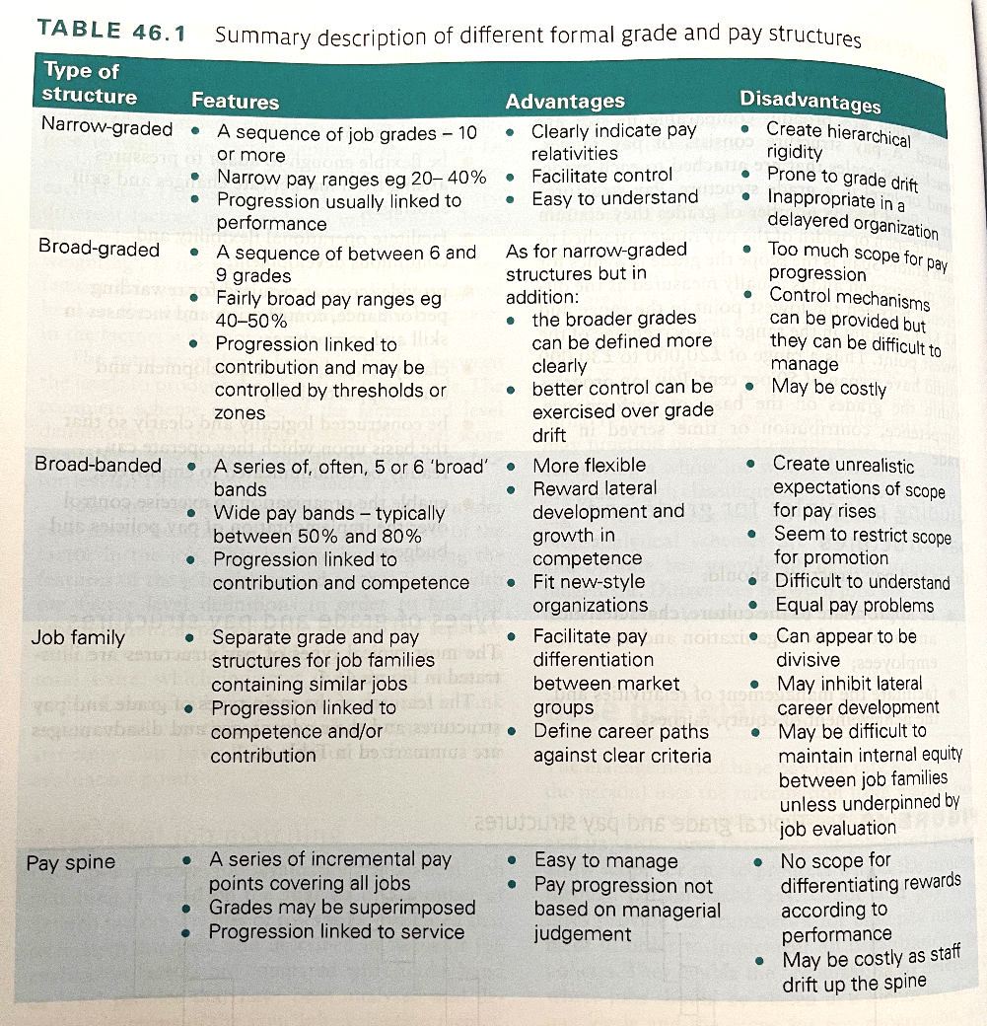Armstrong (2023, pg. 427)

The CIPD (2024) explain how informal pay structures like spot rates are often used for low-skilled or senior roles, offering a fixed salary but no scope for progression. In contrast, individual pay ranges allow for variation within roles, encouraging performance related progression. Narrow graded structures include many pay bands with small differences between them, enabling incremental progression often based on service. However, the CIPD (2024) does acknowledge they can lead to ‘grade drift’ and inflexibility. Alternatively Broad-banded structures, consolidate into fewer, wider bands, offering more flexibility. However, Jeffrey, (2019) does acknowledge that there is a risk of pay inequality without strong governance. Eco-Insulate may benefit from broad-graded or career family structures that support varied roles, both skilled and un-skilled and any development pathways.

The CIPD (2024) states that pay progression should be fair and free from bias, supporting inclusion and legal compliance. Progression can be based on length of service, performance, competencies, or market pressures. Eco-Insulate currently relies on measured day work, limiting reward for contribution. Introducing performance and skills-based pay would support development and incentivise learning. Pay structures must also be transparent. Howlett (2019) cites a CIPD Reward Management Survey showing 60% of employees had never had their pay explained, and only 34% believed pay was fairly distributed. This lack of communication fuels mistrust and disengagement. Cotton (CIPD 2024) emphasises transparency and regular audits to maintain fairness and compliance. For Eco-Insulate, better communication around pay decisions could help build trust and strengthen their employer brand.

Currently, Eco-Insulate offers a non-contributory pension and 28 days of leave but lacks incentive schemes. As noted by the CIPD (2024) and Cotton (2024), a total reward approach could include PRP, bonuses, gainsharing, share schemes, enhanced leave, private healthcare, childcare support, and flexible working. Each benefit has different merits: bonuses and profit sharing can drive performance, while flexible working can improve work-life balance and retention. Jeffery (2019) stresses that structured pay systems reduce subjectivity, encourage fairness, and enhance engagement. However, overcomplicated systems, such as those with excessive pay grades, can be unmanageable. The right structure must align with organisational goals and be regularly reviewed. Eco-Insulate should adopt a structured, transparent pay system to improve performance and morale, helping the company become an ‘employer of choice.’

(AC 2.2)

Contingent rewards such as Performance Related Pay (PRP) and Competency Related Pay (CRP) can significantly influence motivation, capability, and outcomes when applied fairly and strategically. The CIPD (2024a) notes that PRP link effort directly to reward, enhancing accountability and focus on results. However, the CIPD also warns that over reliance on incentives can lead to risk taking. Jeffrey (2019) maintains that perceived unfairness or unclear criteria can reduce motivation, whilst Cotton (2024) acknowledges that PRP offers lump sum rewards for high performance, however, these must be re-earned, which can potentially create pressure if targets are unrealistic. For Eco-Insulate, transparent PRP could improve morale and direct employee efforts toward agreed outcomes and performance.
Team based PRP can promote collaboration and the sharing of information. Cotton (2024) describes gainsharing as rewarding groups for collective improvement, which could strengthen teamwork and address Eco-Insulates cultural challenges. However, Jeffrey (2019) cautions that purely individualised PRP risks unhealthy competition and manipulation of targets. Cotton (2024) emphases than team PRP is most effective when objectives are shared, achievable, and clearly aligned with strategy.
At the organisational level, Cotton (2024) explains that PRP can align workforce contributions with strategic goals while controlling fixed costs. It supports the ‘new pay’ philosophy, increasing the proportion of variable pay linked to contribution. This approach could help Eco-Insulate attract and retain high performers and help avoid inflating the pay bill. Fröber & Dreisbach (2016) note that for motivation to be sustained, contingent rewards must be directly linked to measurable outcomes.
Competency Related Pay (CRP) provides an alternative by linking pay to skills or behaviour competencies. Taylor & Woodhams (2022) argue that this supports personal development and motivation by providing a clear connection between growth and reward. Armstrong (2023) notes that CRP aligns with Vroom’s Expectancy Theory, where employees are more engages when they feel their effort will lead to valued outcomes and employees perceive the system to be fair.
Taylor & Woodhams (2022) explain that though CRP is applied individually, it can strengthen team capability when competencies are embedded within shared goals. This encourages mentoring and exchanging of knowledge, however Armstrong (2023) warns that fairness depends on trained managers conducting consistent assessments. Organisationally, both Armstong (2023) and Taylor & Woodhams (2022) highlight CRP’s role in building long term capability and future leadership pipelines. However, if competency frameworks are poorly communicated or outdated, engagement may fall. For Eco-Insulate, a balanced contingent reward strategy combining PRP’s performance incentives with CRP’s capability development could address low morale, enhance performance at all levels and improve retention.

(AC 2.3)

According to the CIPD (2025b), employee benefits are non-cash elements of a reward package that support recruitment, retention, wellbeing, and motivation. These include pensions, healthcare, childcare, gym access, flexible working, and voluntary perks. Their value depends on alignment with employee needs, organisational goals, and available resources.
Pensions are among the most common and valued benefits. The CIPD (2025) maintain they offer long-term financial security and are perceived as a marker of a responsible employer. They note pensions boost loyalty, particularly for mid to late-career employees planning retirement. Taylor (2009) also emphasises their retention value, as the marginal cost of leaving rises over time. However, Lupton, Rowe, & Whittle (CIPD 2015) explain employees often undervalue, deferred rewards due to ‘hyperbolic discounting’, especially early in careers. This can limit motivational value unless employers regularly communicate their long-term worth at different life stages.
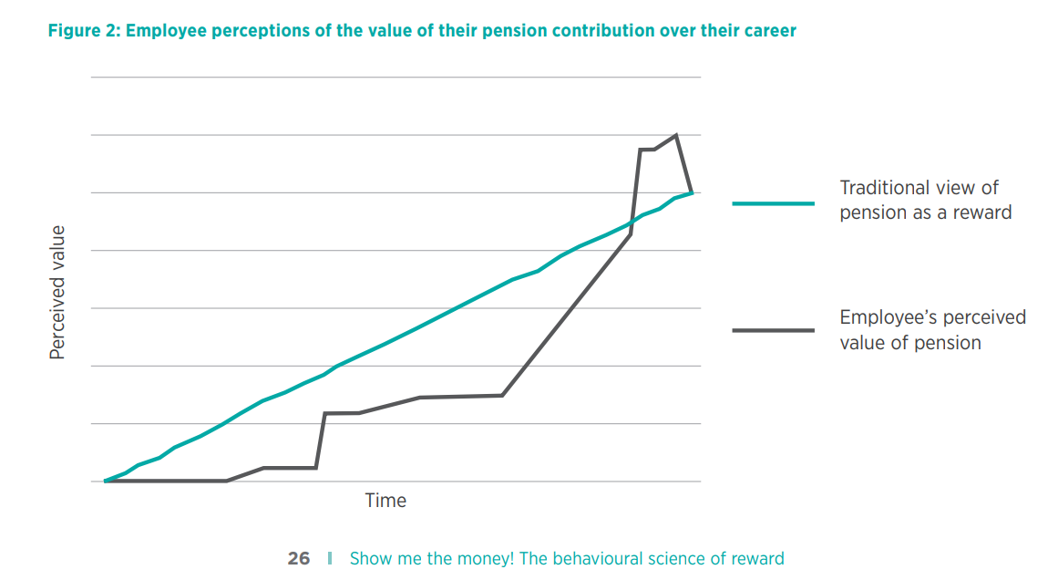
Lupton, B, Rowe, A & Whittle, R. (CIPD 2015) The behavioural science of reward

According to the CIPD (2023) Health and wellbeing at work, healthcare and wellbeing benefits like occupational sick pay, Employee Assistance Programmes (EAPs), vaccinations, and life insurance can boost employee morale, reduce sickness absence and support overall productivity. According to the CIPD (2023), 84% of organisations now offer EAPs, 57% promote financial wellbeing, and 46% provide menopause support. These provisions contribute to a more inclusive and healthy work environment, with 53% of employers now adopting standalone wellbeing strategies, and 69% of senior leaders actively prioritising wellbeing, (CIPD, 2023), demonstrates that these benefits are now central to reward strategies. For organisations like Eco-Insulate, low-cost wellbeing options could be introduced to show care for its employees.
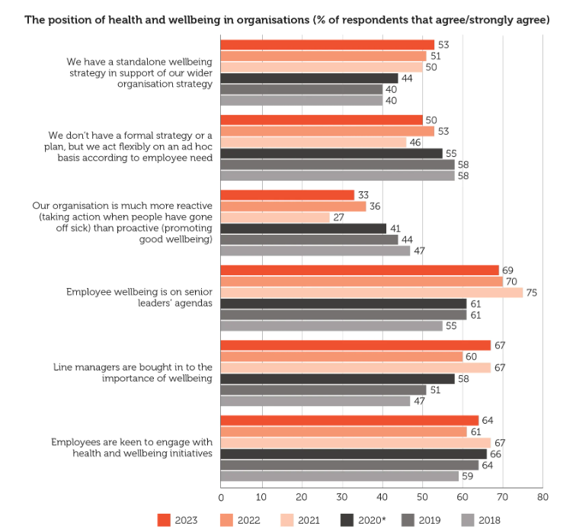CIPD (2023)

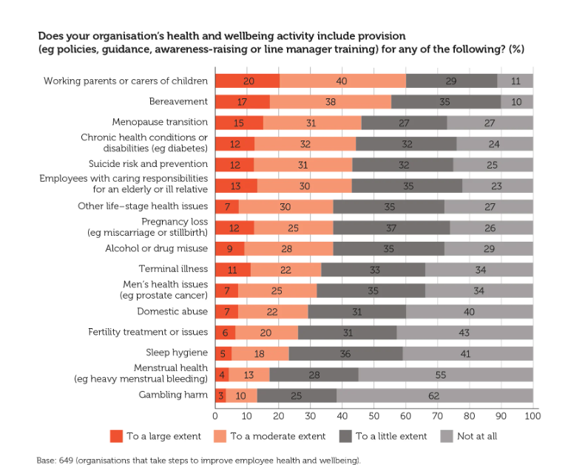CIPD (2023)

Flexible and voluntary benefits, such as salary sacrifice schemes for childcare, bikes, and travel, enable employees to tailor reward packages to individual needs. The CIPD (2025b) notes this promotes inclusivity, especially for employees with caring responsibilities, long commutes, or specific lifestyle needs. These benefits enhance fairness and autonomy, improving engagement, but the CIPD (2015) warns that excessive choice can cause decision fatigue. Therefore, benefits should be simple, clear and well communicated. HMRC (2021) states that tax exemptions are limited to specific benefits, including workplace pensions, pension advice, pre-October 2018 childcare vouchers, workplace nurseries, and bicycle/safety equipment under the Cycle to Wok scheme.
The merits of benefits depend on the strategic alignment, communication, and relevance to employee needs. As noted by the CIPD (2025b), well designed benefits support attraction, retention, motivation, inclusivity, and organisational performance. For Eco-insulate, expanding and effectively communicating benefits could improve morale, strengthen employer branding and enhance retention.

(AC 2.4)
According to Armstrong, (2023) recognition schemes involve showing appreciation, whether informally via daily praise or formally through structured programmes such as awards. Recognition may be private, between a manager and employee, or public, such as during events or on digital platforms. While some schemes involve monetary rewards like bonuses or vouchers, many are non-financial and maybe a sincere thank you. Armstrong (2023) does note that a simple acknowledgment of a well done can significantly boost morale when authentically delivered to the employee. People Management (2022) found that informal recognition, especially from line managers, has a powerful effect on engagement and that employees who felt supported by their managers are 3.4 times more likely to be engaged. This reinforces the motivational value of everyday acknowledgments and the importance of building trust and emotional connection.
Gallup (2024) similarly found that lack of recognition is linked to turnover; employees who don’t feel recognised are twice as likely to consider leaving the organisation they work for. Their research shows only one in three employees felt adequately praised in the past week. Recognition was most memorable when it came from a line manager (28%) or senior leader (24%), highlighting the importance of visible leadership. Effective methods include public praise, private feedback, promotions, and increased responsibility. Gallup (2024) recommends weekly praise to reinforce values and motivation. The CIPD (2020) supports this view that recognition, when aligned with employee preferences and organisational values, can play a central role in motivation and retention, with cost being less important than consistency and authenticity.
The CIPD (2020) maintain that one modern and inclusive form of recognition is digital via company intranet or social media. Public visibility boosts employee pride and enhances branding, especially when employees share recognition with their networks. Tailoring recognition to personal interests can also deepen engagement, offering rewards like adventure days, wellness boxes or subscriptions, shows thoughtfulness and builds loyalty by reinforcing the psychological contract. Recognition through learning opportunities is another form of recognition, such as tuition supports, paid days for access to learning and demonstrates a long-term investment in employee growth and supports talent development to help retain talent. The CIPD (2020) notes that seeking employees’ input or involving them in decisions validates their expertise and promotes a sense of belonging. Regular appreciation events, like thank you weeks or wellness days or celebration lunches build positive workplace culture and morale. For organisations like Eco-Insulate, embedding a culture of regular, meaningful recognition is essential for improving morale and performance.

(AC 3.1)

According to People Management (2023), in the current climate of economic uncertainty and the volatile labour market, the reward environment must respond to significant retention and engagement challenges. A 2023 industry report revealed that 35% of employees are predicted to leave their roles within a year, raising to 40% among frontline employees, however 81% of HR leaders are not prioritising recognition and reward. This disconnects between employee expectations and organisational strategy creates a threat to retention and performance. People Management (2023) highlights that 82% of employees feel happier when recognised, with engaged staff being 87% less likely to leave, with orgnaisations being 21% more profitable. Furthermore, 41% of organisations with peer-to-peer recognition schemes reported improved customer satisfaction. These statistics reinforce that recognition and reward are not just engagement tools but also important for productivity and employer branding and the retention of talent.
At Eco-Insulate, the reward environment is shaped by both external and internal factors. Externally, a loosening UK labour market is significant. The House of Commons Library (2025) reports that the employment rate rose to 75.2%, while unemployment increased to 4.7%, and economic inactivity currently remains high at 21.0%. This is a result from weak confidence in the labour market, slowing economic growth and a fall in job vacancies to 727,000. The report notes the competition for skilled labour in manufacturing remains high, furthering the need for organisations to have an attractive and competitive reward strategy. Bon, E. (2025) supports this with the CIPD (2025) Labour Market Outlook, which highlights a challenging reward environment, with employer confidence falling to its lowest level outside the pandemic and redundancy intention remaining high at 24%.
Real wage pressure is another key external factor. The House of Commons Library (2025) notes that although nominal wages rose by 5%, real wages only increased by 1.7 - 1.8% after adjusting for inflation. As the cost of living rises, employers face pressure to offer higher pay or alternative rewards, such as increased benefits or flexibility. This puts extra strain on Eco-Insulate to remain competitive or risk losing skilled workers to better paid employers.
Eco-Insulate also faces pressure from the April 2025 increase in employers’ National Insurance contributions, which Cooper (2025) notes rose from 13.8% to 15%, alongside a threshold reduction to £5,000. This significantly increases payroll costs for organisations like Eco-Insulate. The Office for Budget Responsibility (2025) estimates 60% of these costs will be passed to employees and customers, risking wage stagnation if unmanaged.

Internally, Eco-Insulate struggles with high turnover, low morale, and lacks structured reward schemes. In manufacturing, many competitors offer bonuses or shift allowances, like TATA Steel (TATA Steel, n.d.), putting Eco-Insulate at a disadvantage. Addressing these weaknesses, alongside external pressures, requires a structured reward strategy. Aligning reward with labour market realities and employee expectations can improve retention, motivation, and productivity, helping Eco-Insulate become an ‘employer of choice.’

(AC 3.2)

To develop effective insight into pay structures and reward strategy, organisations should adopt appropriate methods of gathering and measuring benchmarking data. The CIPD (2025c) identifies two main approaches: job evaluation (JE) and market pricing. JE is an internal method used to assess the relative value of roles within an organisation. According to the CIPD (2025c) it ensures internal equity and supports the development of structured pay frameworks.

The CIPD (2025C) note two types of JE: analytical schemes, such as points rating or factor comparison, and non-analytical schemes, like job ranking or classification. The CIPD (2025c) maintains that analytical JE is highly reliable and valid, as it breaks down into detailed sections including knowledge, responsibility, and communication, providing objective, and consistent scoring. The structure ensures fairness and transparency, and it supports legal defences against equal pay claims. However, it can be time consuming and in some instances its applicability may be limited in smaller organisations or for more fluid roles.

In contrast, non-analytical JE is quicker, simpler and more cost effective, making it more applicable to smaller businesses with fewer job types. The CIPD (2025c) maintains that these methods are more subjective, reducing their reliability and validity as roles are evaluated in whole without detailed breakdowns, and consistency can vary, which limits their use in more complex or highly regulated reward environment.

Market pricing compares internal pay levels with external market rates, helping organisations stay competitive in recruitment and retention. The CIPD (2025c) notes it can involve benchmarking basic salary, total remuneration, or benefits packages. This method is highly applicable in sectors facing talent shortages or high turnover, but its validity depends on the accuracy of role comparisons and the quality of data available at the time. The CIPD does highlight that if roles are highly specialised or titles vary significantly, benchmarking may be misleading. Reliability can be affected by outdated information and inconsistent sources.

External benchmarking data is often drawn from salary survey, like those offered by Croner (n.d.), who provide ‘quartile and decile’ comparisons across ‘50,000 jobs records’ which is filtered by region, sector and job level. This would allow HR professional and Eco-Insulate to assess pay competitiveness and adjust reward structures accordingly. Croner’s Salary search tool supports recruitment and retention decisions and is regularly updated to ensure high reliability. However, the validity can be reduced if job roles do not align exactly or if the data is generalised but government statistics like the ONS can complement salary surveys. Fundamentally, combining internal job evaluation methods with external salary benchmarking enables organisations like Eco-Insulate to develop awareness and insight into fair and competitive pay. Understanding the validity and reliability of each method is important for aligning reward with the business strategy and expectations of its workforce.

(AC 3.3)

ACAS (2014) defines job evaluation (JE) as ‘a method of determining on a systematic basis the relative importance of a number of different jobs.’ Its primary purpose is to ensure that organisations establish a transparent and equitable pay structure that does not discriminate and is seen as fair by employees. JE enables organisations to compare roles based on their description, contribution, continuity, transparency, and legal compliance.
There are two main types of job evaluation: analytical and non-analytical. ACAS (2014) explains that analytical approaches assess’ jobs by breaking them down into measurable components or ‘factors’ such as skill, effort responsibility, and working conditions. These factors are then weighted and scored using a structured points system to determine the role’s value within the organisation. This method is objective and can provide a defensible basis in equal pay claims, particularly under The Equality Act 2010, (Ali, 2024). As Armstrong (2023) highlights, analytical schemes promote consistency and fairness by using transparent criteria that align with organisational values and legal requirements.
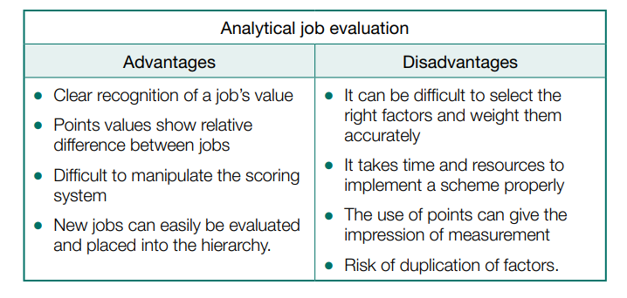ACAS (2014)

Point factor evaluation, is a widely used analytical method and offers comparability across roles. The CIPD (2025c) also highlights job matching, comparing internal roles to benchmarked roles and levelling, which places jobs within pre-defined grades or banding; these analytical tools support reward strategy, grading consistency and continuity.

In contrast, non-analytical approaches such as job ranking, classification, and paired comparisons assess jobs holistically rather than breaking them into measurable parts. ACAS (2014) notes that these methods are simpler and more cost effective, making them more applicable to smaller businesses. However, they do caveat this with a warning that non-analytical schemes lack objectivity and are not suitable as legal defence in an equal value pay claims. Their subjective nature makes them less reliable in unionised or highly regulated environments.

The difference between formal and informal approaches is also important. Formal methods involve structured processes such as written job descriptions, scoring systems, employee consultation and evaluation panels. There are more likely to deliver fairness and legal compliance. In contrast, informal approaches, like relying on managers judgments are quicker but are prone to bias, inconsistency and lack transparency. ACAS (2014) stress the importance of employee involvement and consistent documentation to ensure fairness. Job evaluation provides a foundation to fair and defensible pay decisions. Combining formal, analytical methods with tools like job matching and levelling helps organisations like Eco-Insulate align pay structures with business strategy, legal requirements and helps manage the expectations of its employees.

(AC 3.4)

A key legislative requirement influencing reward practice in the UK is the Equality Act 2010, which enforces equal pay for men and women undertaking equal work (Daniels, 2022). The CIPD (2025d) notes this applies to ‘like work,’ ‘work rated as equivalent,’ and ‘work of equal value,’ covering basic salary plus non-discretionary bonuses, overtime, pensions, and benefits in kind. To remain compliant, organisations must use fair, defensible job evaluation schemes, particularly analytical methods assessing skills, responsibilities, and working conditions. This aligns pay structures with legal requirements and mitigates discrimination claims. Daniels (2022) adds that claimants in disputes must identify a valid comparator of the opposite sex undertaking work meeting one of these categories.

McGuigan (2022) illustrates this via the Co-op equal pay case, where predominantly female shop floor staff claimed equal value to predominantly male distribution workers. Co-op conceded comparability, enabling expert evaluation. If proven, the employer must justify disparities with factors unrelated to sex, risking back pay and equalisation. For Eco-Insulate, where production roles may be male dominated and administrative roles female dominated, robust pay evaluations, audits, and transparency are vital to prevent inequalities and maintain compliance.

The CIPD (2025e) highlights gender pay gap (GPG) reporting under the Equality Act 2010 (Gender Pay Gap Information) Regulations 2017 and where organisations with 250 plus employees must publish yearly reports on a ‘snapshot date’ (31 March public sector, 5 April private/voluntary) detailing ‘mean and median’ hourly and bonus pay gaps, bonus distribution, and gender distribution across pay quartiles. While equal pay law compares individuals, GPG reporting highlights broader trends and structural inequalities. The Equality and Human Rights Commission (EHRC) enforces compliance, issuing warnings, demanding action plans, or seeking court orders. Non-compliance risks reputational damage, public ‘name and shame,’ and tribunal evidence.

For Eco-Insulate, GPG reporting may not yet be statutory due to headcount, but growth could trigger it. Early preparation by collecting pay data, reviewing structures, and addressing disparities will strengthen compliance, equality, and diversity. Voluntary reporting could also support recruitment, retention, and employer brand in a competitive labour market.

Bibliography

ACAS (2014) Job evaluation: considerations and risks booklet Available at: https://www.acas.org.uk/sites/default/files/2021-03/job-evaluation-considerations-and-risks-advisory-booklet.pdf (Accessed 07/08/2025)

Ali, L (CIPD 2024) Equality, diversity and inclusion in the Workplace Available at: https://www.cipd.org/uk/knowledge/factsheets/diversity-factsheet/ (Accessed 08/08/2025)

Armstrong, M & Taylor, S (2023) Armstrong’s Handbook of Human Research Management Practice 16th Edition: Kogan Page: London

Bon, E. (2025) Labour Market Outlook – spring 2025. London: Chartered Institute of Personnel and Development. Available at: https://www.cipd.org/contentassets/cf73843a106949d9b16ac2bc9b526278/8869-lmo-spring-2025-web.pdf (Accessed 07/08/2025)

CIPD (n.d) Reward - The Profession Map Available at:
https://www.cipd.org/uk/the-people-profession/the-profession-map/explore-the-profession-map/specialist-knowledge/reward/ (Accessed 05/07/2025)

CIPD (2020) Five ideas for employee recognition Available at:
https://www.cipd.org/uk/about/news/five-ideas-employee-recognition/ (Accessed 18/07/2025)

CIPD (2022) Reward Management Survey
https://www.cipd.org/uk/knowledge/reports/reward-surveys/ (Accessed 05/07/2025)

CIPD (2023) Health and wellbeing at work Available at:
https://www.cipd.org/uk/knowledge/reports/health-well-being-work/ (14/07/2025)

CIPD (2024) Pay Structures and Pay Available at:
https://www.cipd.org/uk/knowledge/factsheets/pay-structures-factsheet/ (Accessed 08/07/2025)

CIPD (2024a) Performance Related Pay Available at:
https://www.cipd.org/uk/knowledge/factsheets/pay-performance-factsheet/ (Accessed 09/07/2025)

CIPD (2025) Strategic & Total Reward Available at:
https://www.cipd.org/uk/knowledge/factsheets/strategic-total-factsheet/#what (Accessed 05/07/2025

CIPD (2025a) Reward Available at:
https://www.cipd.org/uk/knowledge/factsheets/reward-factsheet/#reward (Accessed 06/07/2025)

CIPD (2025b) Employee Benefits: An Introduction Available at: https://www.cipd.org/uk/knowledge/factsheets/benefits-factsheet/ (Accessed 07/07/2025)

CIPD (2025c) Job Evaluation & Market Pricing Available at: https://www.cipd.org/uk/knowledge/factsheets/market-pricing-factsheet/#JEschemes (Accessed 07/08/2025)

CIPD (2025d) Equal Pay: UK Employment Law Available at: https://www.cipd.org/uk/knowledge/employment-law/equal-pay/#legislation-overview (Accessed 1108/2025)

CIPD (2025e) Gender Pay Gap reporting: UK employment Law Available at: https://www.cipd.org/uk/knowledge/employment-law/gender-pay-gap-law/ (Accessed 11/08/2025)

Cooper, T (2025) Employers’ National Insurance: How 2025 rise affects businesses and what we do now/ Sage Advice UK. Available at:
https://www.sage.com/en-gb/blog/employers-national-insurance-rise/#:~:text=The%20Office%20for%20Budget%20Responsibility,in%20lower%20profits%2C%20it%20forecast. (Accessed 06/08/2025)

Cotton, C, Marriott, L & Perkins, S (2022) Reward Management Survey 2022: Survey Report Available at: https://www.cipd.org/globalassets/media/knowledge/knowledge-hub/reports/reward-management-survey-2022_tcm18-108776.pdf (Accessed 06/07/2025)

Cotton, C (2024) Bonus & Incentives Available at:
Available at: https://www.cipd.org/uk/knowledge/factsheets/bonuses-factsheet/ (Accessed 08/07/2025)

Croner (n.d.) Salary Surveys & Pay Benchmarking Available at: https://croner.co.uk/services/reward/salary-surveys-benchmarking/ (Accessed 07/08/2025)

Daniels, K (2022) Introduction to Employment Law, Sixth Edition. Kogan Page: London

Fröber, K., & Dreisbach, G. (2016). How performance (non-)contingent reward modulates cognitive control. Acta psychological, 168, 65–77. Available at: https://www.sciencedirect.com/science/article/abs/pii/S0001691816300749?via%3Dihub (Accessed 09/07/2025)

Francis-Devine, B. and Powell, A. (2024) UK labour market statistics. Available at: https://researchbriefings.files.parliament.uk/documents/CBP-9366/CBP-9366.pdf (Accessed 06/08/2025)

GALLUP (2024) The Importance of Employee Recognition: Low cost, High Impact Available at: https://www.gallup.com/workplace/236441/employee-recognition-low-cost-high-impact.aspx (Accessed 16/07/2025)

Ghosh, D., Buss, M., & Shivhare, A. (2024). Does Contingent Reward Leadership Enhance or Diminish Team Creativity? It Depends on Leader (Un-) Predictability. Journal of Leadership & Organizational Studies, 31(2), 224- Available at: https://journals.sagepub.com/doi/10.1177/15480518231216868 (Accessed 09/07/2025)

Herzberg, F (1966) Work and the Nature of Man, New York, Staple Press

Howlett, E (2019) People Management – CIPD Most employees have never had their pay explained to them Available at https://www.peoplemanagement.co.uk/article/1746569/most-employees-never-had-their-pay-explained (Accessed 08/07/2025)

HMRC (2021) Salary Sacrifice for Employers Available at:
https://www.gov.uk/guidance/salary-sacrifice-and-the-effects-on-paye (Accessed 12/07/2025)

Jeffrey, R (2019) People Management – CIPD How much should you really pay people? Available at: https://www.peoplemanagement.co.uk/article/1744300/how-much-really-pay-people Accessed (08/07/2025)

Lupton, B, Rowe, A & Whittle, R. (CIPD 2015) The behavioural science of reward Available at: https://www.cipd.org/globalassets/media/knowledge/knowledge-hub/reports/show-me-the-money_2015-behavioural-science-of-reward_tcm18-9560.pdf (Accessed 12/07/2025)

McGuigan, D (2022) Hr Magazine Co-op workers success in first stage of equal pay battle Available at: https://www.hrmagazine.co.uk/content/comment/co-op-workers-succeed-in-first-stage-of-equal-pay-battle/ (Accessed 11/08/2025)

McMullen, T. and Scott, D. (2020) The Journal of Total Rewards. Third Quarter, pp6-14 Available at: https://ecommons.luc.edu/cgi/viewcontent.cgi?article=1209&context=business_facpubs (Accessed 06/07/2025)

OBR. UK (2025) Economic and fiscal outlook 2025 Available at:
https://obr.uk/economic-and-fiscal-outlooks/ (Accessed 06/08/2025)

Perkins, S J & Jones (2020) Reward Management: Alternatives, consequences and contexts, London: Kogan Page.

People Management (2022) Employers are three times more engaged when they feel supported by their managers, study shows. Available at: https://www.peoplemanagement.co.uk/article/1806097/employees-three-times-engaged-when-feel-supported-managers-study-shows (Accessed 15/07/2025)

People Management (2023) Why recognition and reward in 2023? Available at: https://www.peoplemanagement.co.uk/article/1816014/why-recognition-reward-2023#:~:text=82%25%20of%20employees%20are%20happier,more%20profitable%20to%20the%20business. (Accessed 18/07/2025)

TATA Steel (n.d.) Benefits Available at:
https://www.tatasteeluk.com/jobs/working-at-tata-steel/benefits (Accessed 06/08/2025)
Taylor, S. (2009) Occupational pensions. In: WHITE, G. and DRUCKER, J. (eds) Reward management: a critical text. London: Routledge.

Taylor, S & Woodhams, C (2022) Human Resource Management: People and Organisations 3rd Edition, London: Kogan Page.

