MODULE NAME: Problem Solving and Decision Making
MODULE CODE: LCLM4004
STUDENT NAME: Akram Hussain
STUDENT ID: 2523749
LECTURER: Annamarie Dufficy Anita Nan
Assignment 1: Presentation

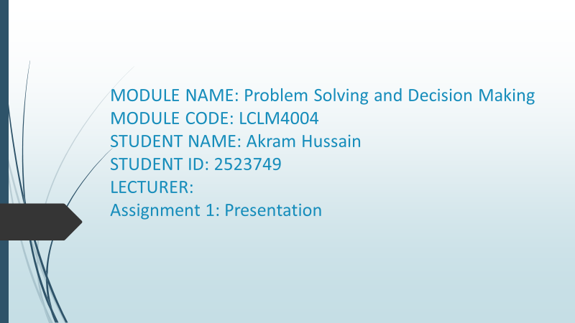

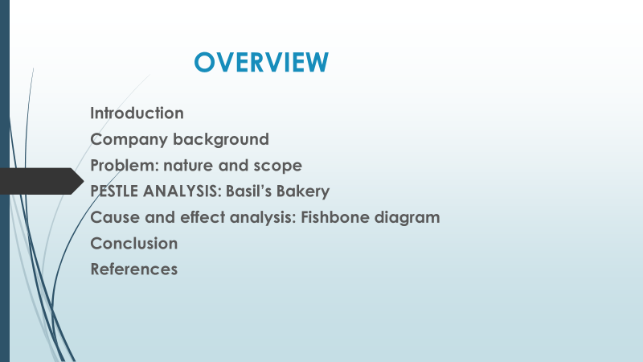

Introduction
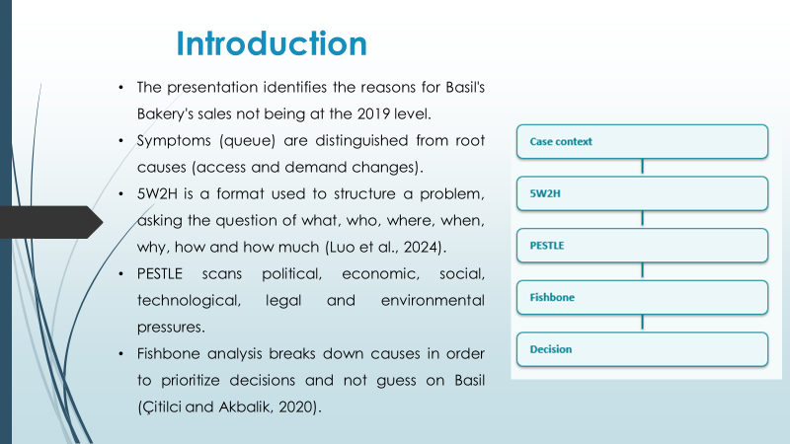
The way the slides are presented is followed in the report: context, problem scope, 5W2H, PESTLE, fishbone, options, implementation and conclusion. The aim is to analyze the reasons behind the sales completely below their 2019 level and to support the correct decision instead of any incorrect one rather than to make a fast response (Luo et al., 2024; Çitilci and Akbalik, 2020).

Company background
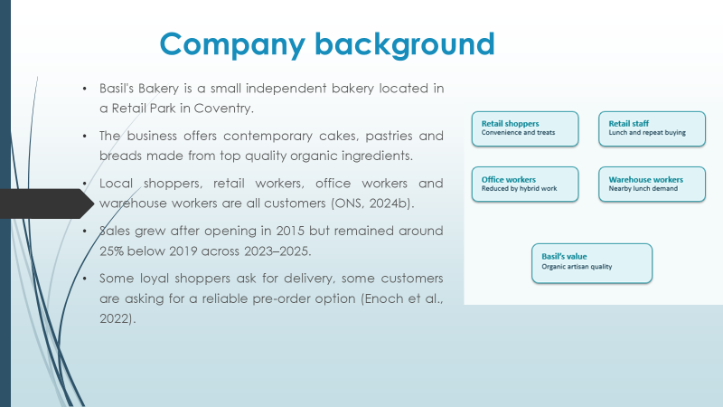
Basil's Bakery is an independent bakery based in Coventry, selling artisan cakes, pastries, and breads using organic ingredients, since 2015. It started with the usual in-shopping demand of walk-in customers, but this core strength has been eroded by changes in footfall in retail locations, and hybrid working patterns (ONS, 2024b; Enoch et al., 2022).

Problem: nature and scope
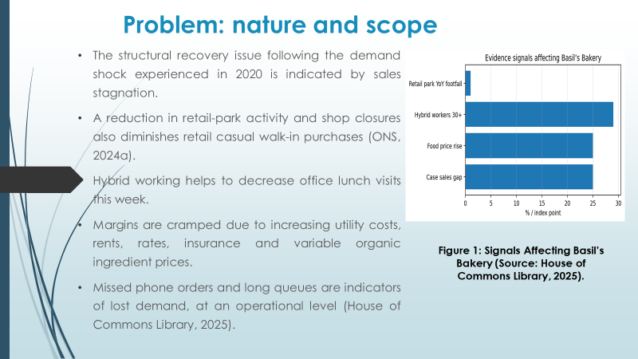

The issue is not the product itself, it's a business-model mismatch. Passenger traffic has decreased from unplanned drop-offs and utilities, rents, rates, stock for organic charge have gone up. Note that this is not a short-term drop but a strategic viability issue, given how the costs of goods and services have decreased due to fewer transactions on the same cost base (ONS, 2024a; House of Commons Library, 2025).

Problem: nature and scope - 5W2H model applied
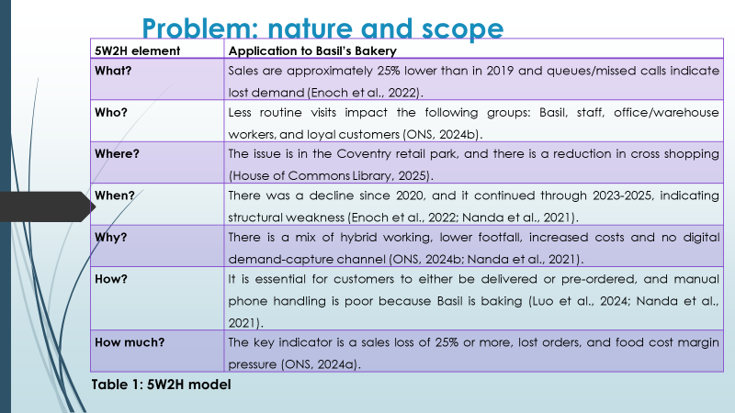

The 5W2H method deals with the problem in the following way: What, Who, Where, When, Why, How and How much can help Basil break down a general gripe into specific problems and actions. The only drawback about this is that it determines questions, not priorities, and as such will need to be acted upon along with the PESTLE and fishbone analysis (Luo et al., 2024; Kumah et al., 2024).
5W2H element | Application to Basil’s Bakery
What? | Sales are approximately 25% lower than in 2019 and queues/missed calls indicate lost demand (Enoch et al., 2022).
Who? | Less routine visits impact the following groups: Basil, staff, office/warehouse workers, and loyal customers (ONS, 2024b).
Where? | The issue is in the Coventry retail park, and there is a reduction in cross shopping (House of Commons Library, 2025).
When? | There was a decline since 2020, and it continued through 2023-2025, indicating structural weakness (Enoch et al., 2022; Nanda et al., 2021).
Why? | There is a mix of hybrid working, lower footfall, increased costs and no digital demand-capture channel (ONS, 2024b; Nanda et al., 2021).
How? | It is essential for customers to either be delivered or pre-ordered, and manual phone handling is poor because Basil is baking (Luo et al., 2024; Nanda et al., 2021).
How much? | The key indicator is a sales loss of 25% or more, lost orders, and food cost margin pressure (ONS, 2024a).
Table: 5W2H model

PESTLE ANALYSIS: Basil’s Bakery
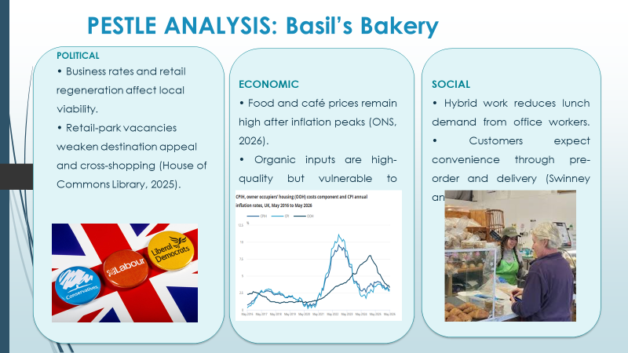
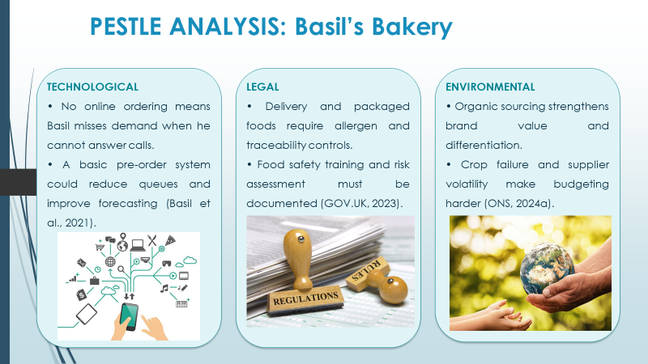
PESTLE is suitable, as there are a lot of external pressures affecting Basil. Such a scan is provided for political, economic, social, technological, legal and environmental aspects but should be connected with decisions, otherwise it is descriptive (Çitilci and Akbalik, 2020; CIPD, 2024).
The PESTLE evidence suggests that Basil should not wait for Guardian's footfall on the shops in the Foryds to go back to normal values. The more attractive course of action is to safeguard the artisan brand and provide for pre-ordering, timed collection, and limited delivery for customers who have shifted their ways (Nanda et al., 2021; Swinney and Selby, 2025).
PESTLE factor | Critical application to Basil’s Bakery
Political | Destination appeal is impacted by business rates, regeneration and vacancy management (House of Commons Library, 2025).
Economic | The impact of food inflation and rising overheads on margins and discretionary spending (ONS, 2026).
Social | Hybrid working helps to decrease lunch rush congestion on weekdays and increase convenience expectations (ONS, 2024b; Swinney and Selby, 2025).
Technological | When Basil is unresponsive to calls, the demand is lost due to lack of online ordering (Basil et al., 2021).
Legal | Foods that are delivered and packaged foods are subject to allergen and food-safety responsibilities (Food Standards Agency, 2021; GOV.UK, 2023).
Environmental | Organic sourcing separates the brand from the rest, but adds to the volatility of supplier costs (ONS, 2024a).
Table 2: PESTLE Analysis Cause and effect analysis (Fishbone diagram)
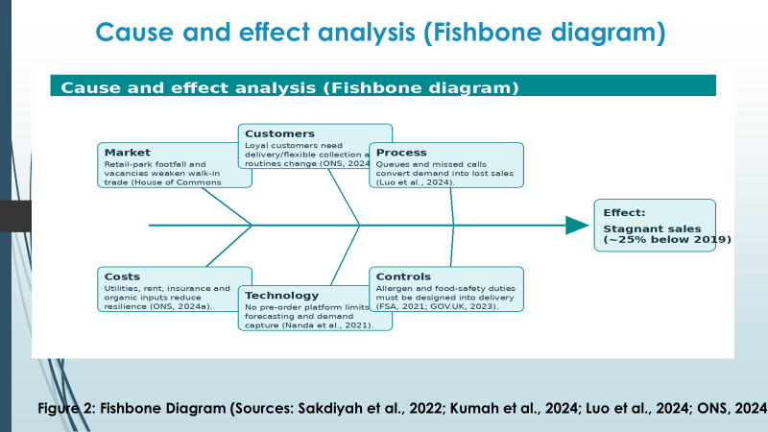
Fishbone analysis allows breaking symptoms down to underlying causes and presents causes in clusters rather than singly. The main effect in Basil is stagnant sales, which likely cause is factors affecting the market, customers, process, costs, and technology or controls (Kumah et al., 2024; Sakdiyah et al., 2022).
Cause category | Root-cause interpretation
Market | When retail-park footfall is lower, this leads to lower demand for casual walk-in (House of Commons Library, 2025).
Customers | Although the products are still desired by the loyal customers, they also require flexible collection or delivery (ONS, 2024b).
Process | The demand is lost sales (Luo et al., 2024) if it waits in a queue or is not answered.
Costs | These costs (such as utilities, rent, insurance and organic inputs) decrease resilience (ONS, 2024a).
Technology | There is no pre-order platform that restricts forecasting and customer communication (Nanda et al., 2021).
Controls | Any new services need to be managed to ensure they comply with the duties of managing allergens, labelling and food safety (Food Standards Agency, 2021; GOV.UK, 2023).
Table 3: Fishbone Model
Weak access channels are the priority root cause; this is the fishbone judgement. It is advisable to take this decision without compromising on the quality of the product as this is one of their strengths, but by eliminating the frictions in the customer/service relationship through the service redesign in a controlled manner (Kumah et al., 2024; Nanda et al., 2021).

Conclusion
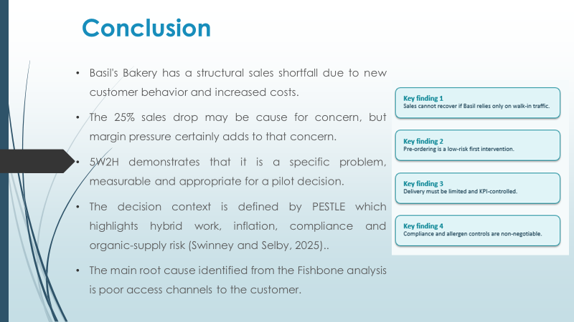
Basil's Bakery has a solution to a strategic challenge: the demand is not gone, but now, how has it found a different way to get there? Measuring makes for a pilot, not closure and significant additional growth. Once Basil encompasses orders in the preservation of quality, compliance, then future decisions can be made based on evidence. The central goal, then, is to adapt rather than reinvent the brand, as it would retain its commercial value if access were improved (Swinney and Selby, 2025).

References
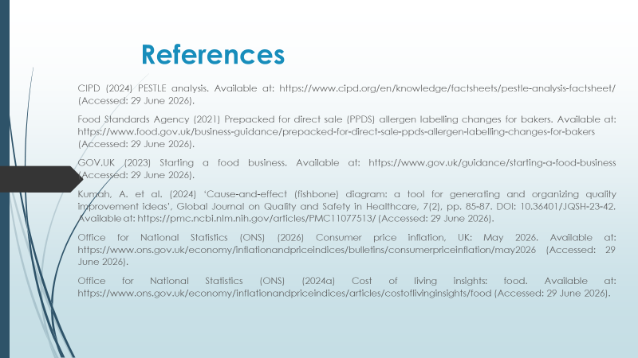
CIPD (2024) PESTLE analysis. Available at: https://www.cipd.org/en/knowledge/factsheets/pestle-analysis-factsheet/ (Accessed: 29 June 2026).
Çitilci, T. and Akbalik, M. (2020) ‘The importance of PESTEL analysis for environmental scanning process’, in Handbook of Research on Decision-Making Techniques in Financial Marketing. DOI: 10.4018/978-1-7998-2559-3.ch016. Available at: https://doi.org/10.4018/978-1-7998-2559-3.ch016 (Accessed: 29 June 2026).
Enoch, M. et al. (2022) ‘When COVID-19 came to town: Measuring the impact of the coronavirus pandemic on footfall on six high streets in England’, Environment and Planning B: Urban Analytics and City Science, 49(3), pp. 1091-1111. DOI: 10.1177/23998083211048497. Available at: https://doi.org/10.1177/23998083211048497 (Accessed: 29 June 2026).
Food Standards Agency (2021) Prepacked for direct sale (PPDS) allergen labelling changes for bakers. Available at: https://www.food.gov.uk/business-guidance/prepacked-for-direct-sale-ppds-allergen-labelling-changes-for-bakers (Accessed: 29 June 2026).
GOV.UK (2023) Starting a food business. Available at: https://www.gov.uk/guidance/starting-a-food-business (Accessed: 29 June 2026).
House of Commons Library (2025) Retail sector in the UK. Available at: https://commonslibrary.parliament.uk/research-briefings/sn06186/ (Accessed: 29 June 2026).
Kumah, A. et al. (2024) ‘Cause-and-effect (fishbone) diagram: a tool for generating and organizing quality improvement ideas’, Global Journal on Quality and Safety in Healthcare, 7(2), pp. 85-87. DOI: 10.36401/JQSH-23-42. Available at: https://pmc.ncbi.nlm.nih.gov/articles/PMC11077513/ (Accessed: 29 June 2026).
Luo, L., Hong, Q. and Zhong, M. (2024) ‘The application of 5W2H management model in the construction of enterprise economic and strategic management system’, Applied Mathematics and Nonlinear Sciences, 9(1), pp. 1-20. DOI: 10.2478/amns-2024-0776. Available at: https://doi.org/10.2478/amns-2024-0776 (Accessed: 29 June 2026).
Nanda, A., Xu, Y. and Zhang, F. (2021) ‘How would the COVID-19 pandemic reshape retail real estate and high streets through acceleration of e-commerce and digitalization?’, Journal of Urban Management, 10(2), pp. 110-124. DOI: 10.1016/j.jum.2021.04.001. Available at: https://doi.org/10.1016/j.jum.2021.04.001 (Accessed: 29 June 2026).
Office for National Statistics (ONS) (2026) Consumer price inflation, UK: May 2026. Available at: https://www.ons.gov.uk/economy/inflationandpriceindices/bulletins/consumerpriceinflation/may2026 (Accessed: 29 June 2026).
Office for National Statistics (ONS) (2024a) Cost of living insights: food. Available at: https://www.ons.gov.uk/economy/inflationandpriceindices/articles/costoflivinginsights/food (Accessed: 29 June 2026).
Office for National Statistics (ONS) (2024b) Who are the hybrid workers? Available at: https://www.ons.gov.uk/employmentandlabourmarket/peopleinwork/employmentandemployeetypes/articles/whoarethehybridworkers/2024-11-11 (Accessed: 29 June 2026).
Sakdiyah, S.H., Eltivia, N. and Afandi, A. (2022) ‘Root cause analysis using fishbone diagram: company management decision making’, Journal of Applied Business, Taxation and Economics Research, 1(6), pp. 566-576. DOI: 10.54408/jabter.v1i6.103. Available at: https://doi.org/10.54408/jabter.v1i6.103 (Accessed: 29 June 2026).
Swinney, P. and Selby, O. (2025) The impact of hybrid working on the high street. Centre for Cities. DOI: Not applicable. Available at: https://www.centreforcities.org/publication/the-impact-of-hybrid-working-on-the-high-street/ (Accessed: 29 June 2026).


