Jack Twaddle (2428017)

Calorimetry Lab Report

Contents
Introduction 2
Purpose of experiment 2
Hypothesis That Will be Tested 2
Variables and Equations Used 3
Results 3
Experimental Data 3
Key Findings and Patterns Observed 3
Discussion 3
Interpret Results and Their Significance 3
Relevance to OME 3
Limitations and Sources of Error 3
Conclusion 4
Summary of key findings 4
Potential Directions for Further Research 4
References 4
Appendix 5
List of All Materials and Equipment 5
Description of Experimental Procedure 5
Procedure to measure HC_{calorimeter}: 5
Procedure to measure c_{p} _{metal}: 5
Procedure to measure q_{reaction}: 6

Introduction

Purpose of experiment
The aims of this experiment are to:
- Measure the value of the heat capacity of the Calorimeter.
- Measure the specific heat capacity of a metal.
- Measure the molar heat of reaction of HCl and with NaOH.

Hypothesis That Will be Tested
By using the equation Q= McΔT where m is mass, C is specific heat capacity and ΔT is the change in temperature, the amount of heat transferred from a substance with a known mass can be calculated. This can be applied to determining the heat capacity of the calorimeter, the specific heat of a metal and to measure the molar heat of a reaction of HCl with NaOH. If heat loss is minimized and accurate measurements are taken, then results will be close to authentic values.

Variables and Equations Used
For Experiment 1 –
Independent Variable – Initial temperatures of water both cold and hot
Dependent Variable – Max temperature of water.
Controlled Variable - The mass of the water.

For Experiment 2 -
Independent Variable – The temperature of the known substance (Aluminium)
Dependent Variable – Temperature of the metal and water.
Controlled Variable – Mass of the metal and water.

For Experiment 3 –
Independent Variable – Volume of HCl and NaOH
Dependent Variable – Temperature change.
Controlled Variable – Moles of HCl and NaOH.

Results

Experimental Data
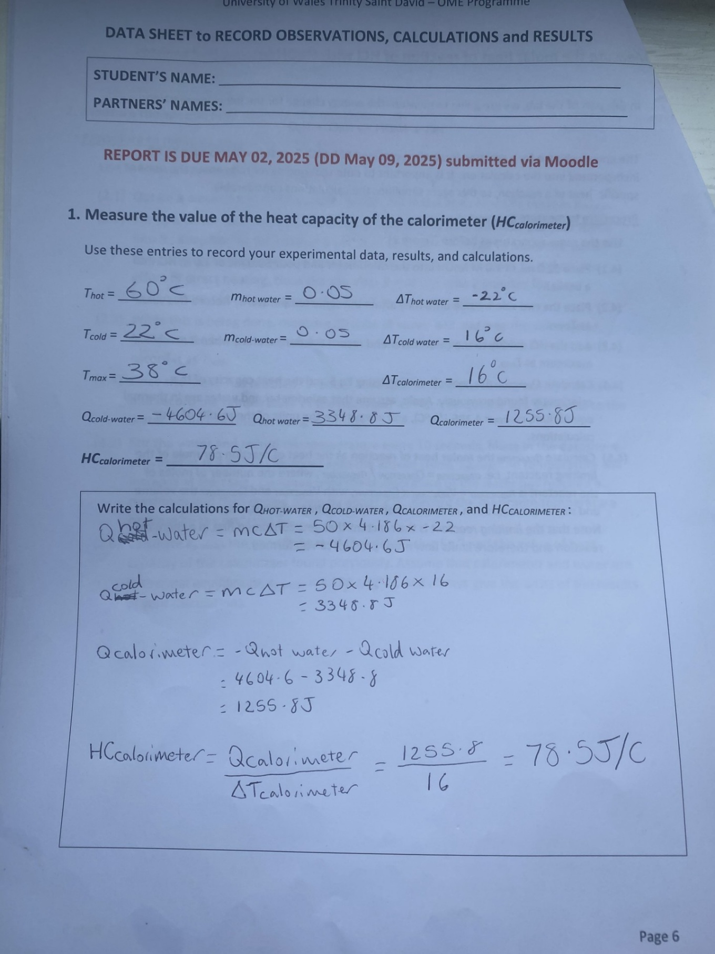
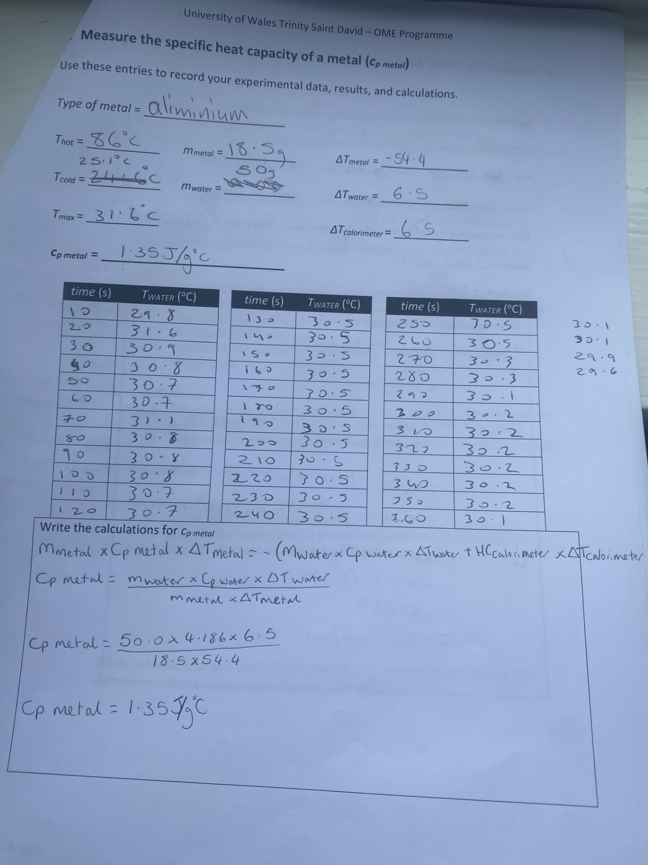
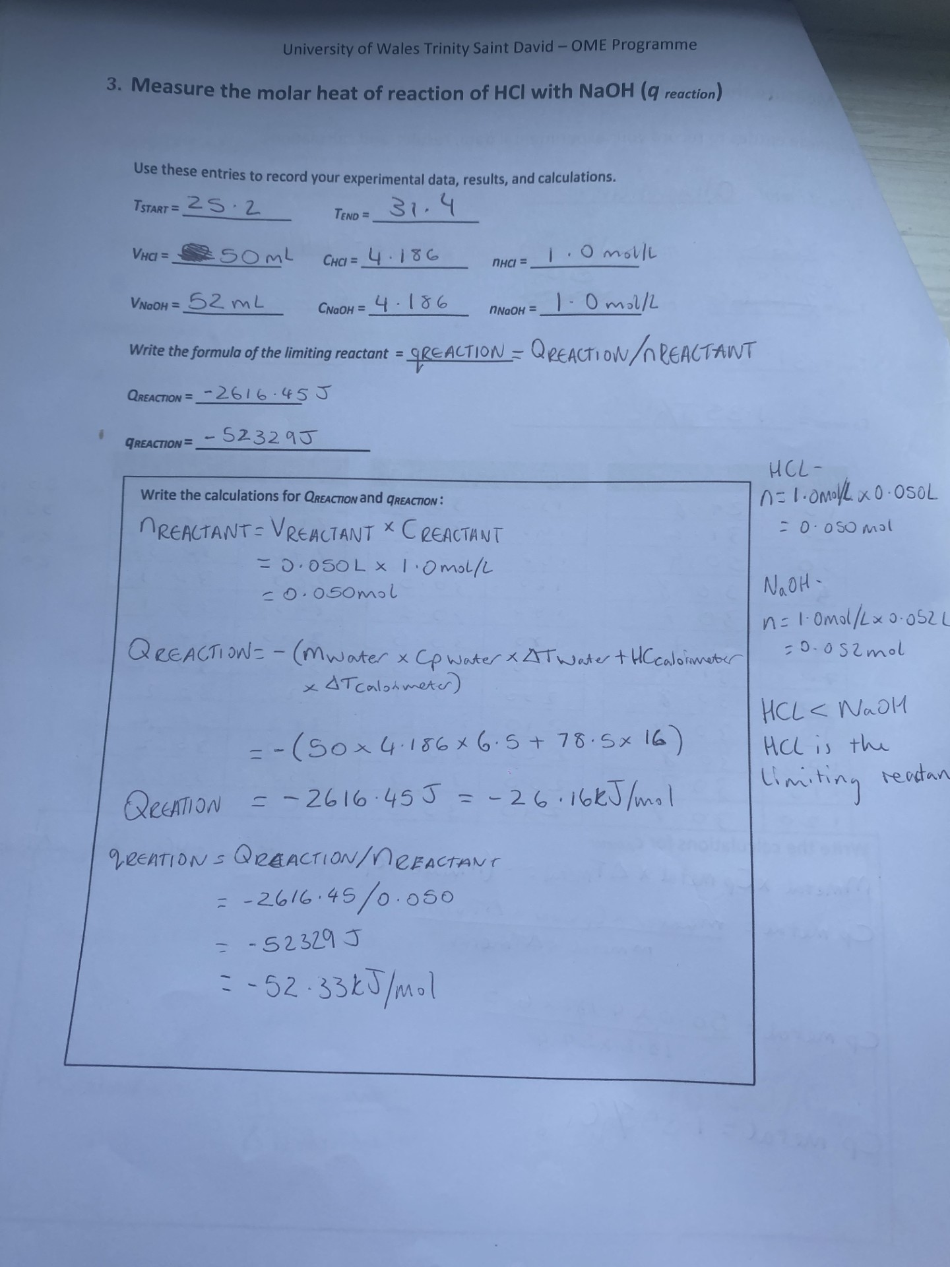

Key Findings and Patterns Observed
For the first experiment, using the heat capacity of water that was provided as 4.186J/g˚C along with the measured temperature changes and masses the Heat Capacity of the calorimeter was calculated to be 78.5J/˚C.
For the second experiment, again using the heat capacity of water (4.186J/g˚C) along with mass of the aluminium and temperature changes, the specific heat capacity of aluminium was calculated to be 1.35J/g ˚C.
For the final experiment of measuring the molar heat of reaction with HCl with NaOH the heat of reaction was calculated to be -52.33kJ/mol. This was calculated by using the results provided from the previous experiments as well as the current one.

Discussion

Interpret Results and Their Significance
The heat capacity of the calorimeter was calculated successfully to be 78.5J/C. This was calculated by measuring the temperature and mass of the hot and cold water, using these results determining the heat capacity of the calorimeter was calculated using the Equations:
Q = m × c_{p} × ΔT (Eq.1)
- Q_{hot-water} = Q_{cold-water}+ Q_{calorimeter} (Eq.5)
Q_{calorimeter} = HC_{calorimeter} × ΔT_{calorimeter} (Eq.6)

Once the heat capacity of the calorimeter is calculated this shows how much energy is required to increase the temperature of the calorimeter by 1˚C.
In the second experiment a metal sample of Aluminium was added and results were recorded for the temperatures hot, cold and max, the mass and the change in temperatures of the metal, water and calorimeter. From these results the specific heat capacity of the metal was calculated using the equation:
m_{metal} × c_{p metal} × ΔT_{metal} = (Eq.3)
= - (m_{water} × c_{p water} × ΔT_{water} + HC_{calorimeter} × ΔT_{calorimeter})
Cp metal was calculated to be 1.35J/g ˚C which means there was an error at some point during the experiment as Aluminium’s heat capacity value is 0.897J/g ˚C Must find a reference to support this. Errors that might have played a part in this could be heat being lost when the aluminium was transferred into the water and the water not being stirred correctly resulting in a lower temperature reading.
In the third experiment HCl and NaOH was added so that the molar heat of reaction could be measured. The following equations were used to calculate this:
Q_{reaction} = - (m_{water} × c_{p water} × ΔT_{water} + HC_{calorimeter} × ΔT_{calorimeter}) (Eq. 4)
n _{reactant} = V _{reactant} x C _{reactant} (Eq.7)
$q_{reaction}= \frac{Q_{reaction}}{n_{reactant}}$ (Eq.8)
By implementing the results from this experiment into the equations the $q_{reaction}$ was calculated to be -52.33kJ/mol. This result shows that a slight error had occurred which could be from the solutions not being mixed properly or heat loss due to the surroundings as the desired result is around -58kJ/mol. The negative answer shows that the reaction was exothermic since there was a temperature increase.

Relevance to OME

Limitations and Sources of Error
A limitation that was noticed during the experiment was due to the use of Styrofoam coffee cups and the lid having tiny gaps for the thermometer and stirrer to come through there is still enough room for heat to escape which can interfere with results and their accuracy.
A source of error would be inaccurate readings of the thermometer, this is because the Styrofoam cups and lid is not see-through therefore the lid must be opened to see the thermometers reading. Also, the thermometer must stay in the solution to keep the reading still, so eye level readings can’t be made.

Conclusion

Summary of key findings

Potential Directions for Further Research
A potential direction for further research would be to improve the insulation material to minimise heat loss as this will improve the accuracy of results.

References

[1] | S. R. R. a. W. E. Garner, “Calorimetry of High Explosives,” vol. 103-A, pp. 539-555, 1923.

Appendix

List of All Materials and Equipment
- Two Styrofoam cups (one inside the other) with a lid
- Thermometer
- Stirrer
- Bunsen Burner
- Known Metal Sample
- Stand and Clamp

Description of Experimental Procedure
Set up the calorimeter as shown.
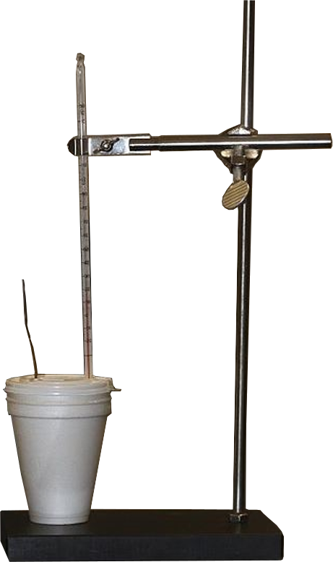

Procedure to measure HC_{calorimeter}:
- Add 50.0 mL of water to the Styrofoam coffee cups, and close with a lid. Add the thermometer and stirring rod to set up your calorimeter.
- Take 50.0 mL of water in a separate beaker and heat to about 80 °C. Close the gas and wait till the temperature reaches 60 °C. When the "hot water" is ready, record its temperature as T_{hot}.
- Measure the temperature of the water in the calorimeter, and record it as T_{cold}.
- Add the hot water to the water in the calorimeter, and mix thoroughly, while watching the thermometer. Record the maximum equilibrium temperature of the mixture, record it as T_{max}.
- Calculate the heat capacity of the calorimeter, HC_{calorimeter} , using Eq. 1, Eq.5, and Eq.6:
- - Q_{hot-water} = Q_{cold-water}+ Q_{calorimeter} (Eq.5)
- Q_{calorimeter} = HC_{calorimeter} × ΔT_{calorimeter} (Eq.6)
- where Q_{hot-water} is the heat lost by the hot water, while Q_{Cold-water} and Q_{calorimeter} are the amounts of heat gained by the cold water and calorimeter, respectively. Calculate Q_{hot-water} and Q_{cold-water} with Eq.1, then use Eq. 5 to find Q_{calorimeter}, and finally Eq.6 to obtain the value of heat capacity of the calorimeter, HC_{calorimeter}.
- Note: The mass (m) and temperature change (ΔT) for both the hot and cold water can be obtained from the experimental data, also the ΔT of the calorimeter can be found from the same data. For example, ΔT_{cold-water} = T_{max} – T_{cold}. Assume that the calorimeter is in thermal equilibrium with the water during the experiment. The specific heat capacity of water is c_{p} _{water} = 4.186 J/(gºC). Always specify the units of the results obtained from your calculations.

Procedure to measure c_{p} _{metal}:
- Use the same apparatus as before (Figure 1).
- Obtain a piece of the metal sample. Weigh the metal and record its mass as m_{metal}.
- Set up a water bath, heat the water until boiling, and then carefully put your metal into it. Keep boiling for another 5 minutes, to allow the metal to reach the same temperature as the water. Try to avoid heating the metal directly! To reduce the effect of direct heating, close the gas after 5 min and wait 2 minutes for the temperature of boiling water and piece of metal to equilibrate.
- While this is being done, measure 30.0 mL of water and add it to the calorimeter. Measure the temperature of the water in the calorimeter, as done previously, and record it as T_{cold}.
- Once the metal has reached "thermal equilibrium" with the boiling water, measure and record the temperature of the hot water as T_{hot}, and quickly add the metal to the water in the calorimeter using the tongs.
- Stir the water and record the temperature every 10 seconds, filling in the datasheet provided at the end of this script with the entries (time, T_{water}). The temperature will increase at the start. Continue until the temperature of the water has reached a maximum and then cooled down by about 2 ºC. Record the maximum temperature reached by the water as T_{max}.
- Calculate c_{p} _{metal} the specific heat of the metal using Eq.3 and the value of heat capacity of the calorimeter found previously. Assume that calorimeter and water are in thermal equilibrium, c_{p} _{water} = 4.186 J/(gºC), and always give the units of the results of your calculations.

Procedure to measure q_{reaction}:
- Use the same apparatus as before (Figure 1).
- Place 52.0 mL of 1.0 M NaOH into the calorimeter and pour 50.0 mL of 1.0 M HCl into a beaker.
- Place the two side-by-side until they attain the same temperature. Record this value as 𝑇_{start}.
- Add the HCl quickly to the calorimeter and record the temperature when it reaches a maximum as 𝑇_{end}.
- Calculate Q_{reaction}, the heat of reaction, using Eq.4 and the heat capacity of the calorimeter found previously. Again, assume that calorimeter and water are in thermal equilibrium, c_{p water} = 4.186 J/(g°C), and always give the units of the results of the calculations.
- Calculate 𝑞_{reaction}, the molar heat of reaction, as the heat of reaction per mole of the limiting reactant, i.e.:
  - $q_{reaction}= \frac{Q_{reaction}}{n_{reactant}}$
- where the number of moles of reactant is: n _{reactant} = V _{reactant} x C _{reactant} , where V _{reactant} is the volume of LIMITING reactant and C _{reactant} is the concentration of LIMITING reactant.
- Note: The LIMITING reactant is the reactant that gets consumed first in a chemical reaction and therefore limits how much product can be formed.

