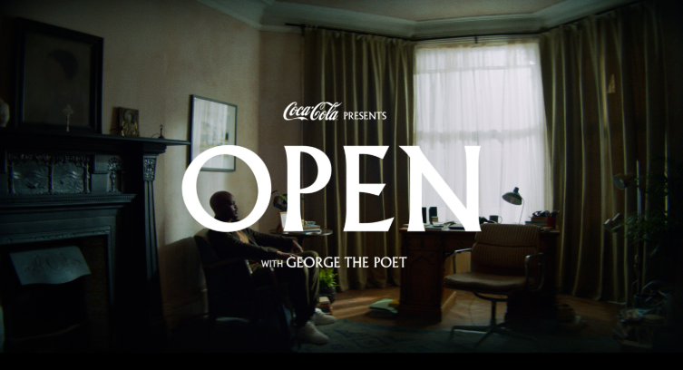

PRESENTED TO THE BUSINESS SCHOOL OF THE UNIVERISTY OF WALES TRINITY SAINT DAVID, LONDON CAMPUS IN PARTUAL FULFILMENT OF THE REQUIREMENTS FOR THE DEGREE OF MASTER OF BUSINESS ADMINSTRATION (MBA) FOR THE MODULE:
Marketing Management
2. ASSIGNMENT
University of Wales Trinity Saint David


SUBMITTED BY
MANAL ABDEL KHALEQ (1920273)

Lecturer: Tushara Balendran, Course: Master of Business Administration 2020/2021
Table of Content
I. Introduction 3
II. Communication 3
III. The Shannon and Weaver macro-model of the communication process 3
IV. Integrated Marketing Communications 4
V. Current promotional concepts of the Coca-Cola Company 5
VI. Recommendation of promotional strategies for the Coca-Cola Company 7
1. Online Promotions 7
2. Offline Promotions 8
VII. Branding Strategies and Brand Equity of the Coca-Cola Company 12
VIII. Keller's Brand Equity Model 15
IX. Advantages and Disadvantages of Keller's Brand Equity Model 17
X. Brand Equity, Stakeholders and Corporate Social Responsibility (CSR) 17
XI. The Customer Journey and the Customer Touchpoints 18
1. The Customer Journey 18
(1) Problem awareness 18
(2) Evaluation and Consideration 18
(3) Commitment/Purchase decision 19
(4) Retention/post-purchase evaluation 19
(5) Advocacy 19
XII. The Coca-Cola Company's touchpoints and customer journey 20
1. The Customer Touchpoints of the Coca-Cola Company 20
(1) Social Media -Pre-Purchase and Post-Purchase stage 20
(2) Company Events 20
(3) Peer referral 21
2. The Customer Journey and touchpoints related to the Coca-Cola Company 21
XIII. Advantages and disadvantages of the Coca-Cola Customer Journey 22
VIV. Conclusion 24
List of References 25

I. Introduction
In the last decades 'relationship marketing' has become increasingly important due to the integration of technical innovation into marketing management and intensified competition shaping the strategies of the most successful companies worldwide (Jobber and Ellis-Chadwick,2016). A decisive factor for organisations to become successful is adding value to their products or service through meeting customers' expectations on a high level and enable a positive customer experience from the first until the last interaction with the company. Although the single touchpoints of a company (providing a contact point and interaction between the customer and the company) determine the satisfaction on each step separately. It must, however, be considered that the customer 'end-to-end journey' reflects a holistic experience and requires a comprehensive approach. In order not to lose sight of this objective, strategies and solutions need to be in place that encompasses that provides the customer with an excellent service from the beginning until the end of his or her customer journey (Maechler,Neher,and Park,2016). Against this backdrop, this report is assessing the customer touchpoints and the customer journey of the Coca-Cola Company to evaluate whether the expectations of current and potential shareholders, particularly customers are met. As a foundation of the implemented relationship marketing strategies of the company, the current promotional strategies will be analysed as well as recommendations potential communication strategies expressed. In this framework, the brand equity of the company and its brand-building strategies based on Keller's brand equity model will be evaluated.

II. Communication
The Coca-Cola Company is communicating with its target market through numerous tools and channels to convey its messages and influence potential consumers by utilising the classic marketing mix.
Communication is defined as 'a process by which messages or information are sent between people and places' through 'various methods such as speaking, writing, body language, or other signals to share information or messages' (Cambridge Dictionary,2020)
The function of marketing communications is to engage with consumers in order to convince them to purchase a particular product or service of a company (cf. Kottler,2019). Besides the impact of an increase in sales, marketing communications are valuable instruments to create a strong brand image which may imprint on the consumers' memory in the long-run (Brun,Schoenmueller and Schafer,2012).

III. The Shannon and Weaver macro-model of the communication process
The Shannon and Weaver macro-model of the communication process underlines the fundamental elements of a successful communication procedure (cf. Kotler,2019). The transmission model was created by Claude Shannon and Warren Weaver in 1949 and comprises the following elements: a sender (the company) who encodes a message into signals via a transmission medium, (for example the radio, TV, newspapers magazines) to the receiver which constitutes the target market in the marketing framework (cf. Chandler and Munday,2011). The latter decodes the message, in other words, interprets the information received and allocates a meaning to it, namely understands the message (cf. Hollensen,2019) which results in a positive or negative response (feedback) returned to the sender (cf. Figure 1). The last element, noise presents the advertising clutter. Messages from competitors transferred to the (same) target audience may have a disrupting impact on the message (Sherlekar and Gordon,2010).

Figure 1 , Shannon and Weaver's macro-model of the communication process (Kotler,2019)
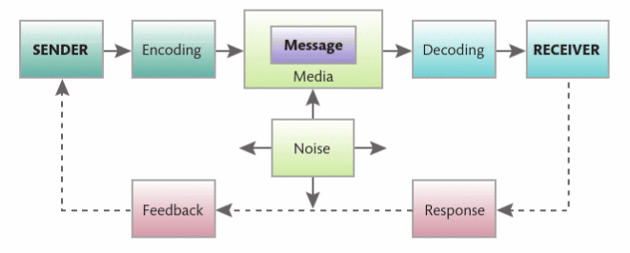

IV. Integrated Marketing Communications
For effective and efficient communication it is fundamental for marketers to identify their target group, determine the communication objectives, calculate the budget, and create the communication mix, and finally evaluate the results. These elements reflect the five stages of the Integrated Marketing Communication Campaign (IMC).
IMC is a concept based on the utilisation of various interlinked promotion strategies communicating with the target market over time (cf. Schultz,1993) which are harmonised in one promotion campaign aiming at the transmission of a synergistic message to maximise communication effectiveness and efficiency (Jobber and Ellis-Chadwick,2016). The changed course of action from linear, transactional communications to ICM on grounds of a continuous, customer-centered marketing communication promises the greatest deal of success in shaping a relationship between the company's brand and the consumer (cf. Hollensen).

V. Current promotional concepts of the Coca-Cola Company
The Coca-Cola Company implements IMC by utilising a combination of various promotions simultaneously in one campaign exhausting all types of the marketing communication to create brand awareness including advertising, sales promotion, personal selling, sponsorship ('Events and experiences'), public relations, publicity, and direct marketing, word-of-mouth marketing, social media marketing (9 marketing communications mix, cf. Kotler,2019).
The current UK campaign of the company 'Open Like Never Before' launched on 1 August 2020 meets the spirit of the time within the Covid-19 framework (Coca-Cola Great Britain,2020).
The Covid19 pandemic brought individual and societal changes due to the time of self-reflection and decrease in speed directing peoples' focus on the important things in life, such as quality time with family and friends, but also lead to space for self-analysis. The latter, allowed reflections ones' status-quo and raised the question of the 'new normal'. Moreover, it encourages to be 'open for change' 'in this time of social and cultural change in a world forever changed by the pandemic' as it is emphasised in the statement of Coca-Cola regarding the 'Open Like Never Before' (cf. Figure 2).
Figure 2, 'Open Like Never Before' Campaign, August 2020 (Coca-Cola Great Britain,2020).

The vice-president of consumer psychology at the market research company Chadwick Martin Bailey underlines that the consumption habits of customers may change in the long run due to Covid-19 (Ashford,2020). She emphasises that 'consumption is driven by very strong motivations, like emotion, identity, and social connection' (cf. Danziger,2020). The campaign presents an excellent symbiosis of all the emotional and actual changes the consumers experience as a short-term impact but also the anticipated societal changes the pandemic may bring in the long run.
With this campaign the company sticks to its relationship marketing strategies, particularly strengthening a personal relationship with its customers on grounds of emotions inducing 'shared moments of happiness' (cf. Coca-Cola Australia). In the past, Coca-Cola has launched different campaigns such as the 'share a Coke' campaign engaging the consumer on a personal level through 'customised' coke bottles around the globe and a variation of this campaign was concluded in 2017 in the UK, namely the 'Play a coke promotion' (cf. Williams,2017). These campaigns are interlinked with Smartphone Applications for the customers to scan the product and therefore, interact with the company through digital marketing (cf. Coca-Cola,Google PlayStore; Figure 3).
Figure 3,'Coca-Cola Play a Coke Promotion (Williams,2017)
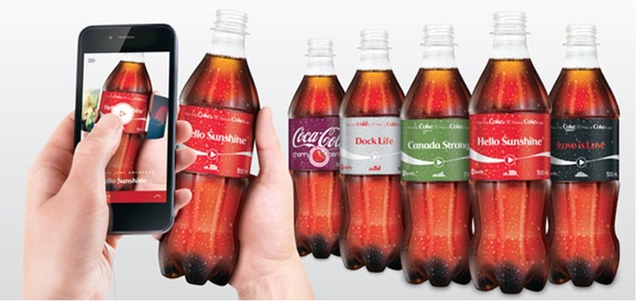

Happiness, joy, community, and togetherness are 'emotions' that are strongly connected with the brand image of Coca-Cola. Facts about a brand are of secondary importance for the purchase decision of consumers, essential is what consumers 'feel about brands instead' (Montaque,2018).
The current campaign, however, is slightly different from the promotions before. The celebrity endorsement Coca-Cola utilises with London born award-winning George 'The Poet' Mpanga known from the podcast: 'Have you heard George's Podcast' reflects a deeper purpose of contemporary issues of our times (Mead,2020). Mpanga is discussing political and social topics in his podcast and his public statements (Hall,2020) which give the campaign a sociopolitical inclination. This is supported by the fact and the TV/YouTube advertising spot comprises a poem and is reflecting on these challenging times and the interpretation of individual and societal changes (Coca-Cola Great Britain,2020). Besides celebrity endorsement in the TV spot, Coca-Cola raised the topic of Covid-19 in the framework of its integrated marketing communications campaign through its current relief efforts around the globe with a donation of more than 100 million for charity (Coca-Cola Great Britain,2020). The societal marketing concept of the company for public health emphasises the consistency and harmony of its present campaign. The geniality of this campaign lies in the fact that the company jumped on the bandwagon of the emotional train which is determining society at the moment, especially the 'national sentiment' of being positive about returning to normality (cf. Contagious,2020). By establishing the connection between the campaign the emotional state of the society the consumer will associate this emotion of 'change' inevitably with the brand Coca-Cola in a positive way as designated in the poem of the Mpanga.
VI. Recommendation of promotional strategies for the Coca-Cola Company
1. Online Promotion
As stated beforehand the Coca-Cola company is utilising the entire communication channels and instruments the marketing mix offers, nevertheless there is always room to break new ground.
The developments and changes in the communication environment due to technological innovation poses new challenges on organisations to analyse which communication channel is effective for which framework and circumstances (Jobber and Ellis-Chadwick,2016). Smartphone Applications are already utilised appropriately by the Coca-Cola Company to connect and interact with their customers as stated above. However, there is another way to establish a relationship with consumers and achieving an increase in sales through sales promotion simultaneously.
McDonalds' strategy to combine its smartphone application with sales promotion may serve as a role model. The website of McDonald's holds a category 'Deals & Our App' where customers are informed which deals they would get by utilising the company's smartphone application (cf. McDonald's,2020). For example, consumers would get a 'free large fries' when ordering through the application (cf. Figure 4). Certainly, the Coca-Cola Company is not a restaurant chain and is operating mainly through retailers and wholesalers. Therefore, it would be a matter of negotiation with retail sellers and wholesalers synchronising their system to accept 'digital coupons' which are originated in a 'Coca-Cola -Smartphone-Application' and could be applicable in different retail stores.

Figure 4: McDonald's website, 'Deals & Our App - Exclusive deals', (2020)
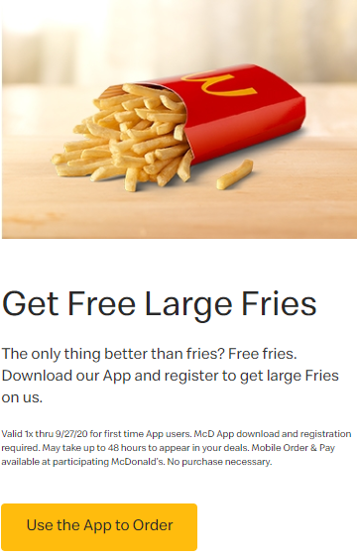
The combination of digital marketing through the smartphone application and sales promotion, for example, buy one get one free, multipacks of a variety of Coca-Cola products or discount coupons would not only increasing sales but also lead to engagement of the customer with the brand through the interaction with the smartphone application. The advantage of the digital medium of a smartphone application is cost-efficiency, whereas printed media, such as coupons in newspapers and magazines involves higher costs (cf. Jobber and Ellis-Chadwick,2016). The interaction between the consumer and the Coca-Cola Company through their website or the Application can be supported by search engine results from, for example, Google and Yahoo to advertise the coupons available for sales promotion, but also could also be posted on social media, like Facebook, Instagram, and Twitter within the same period.

2. Offline Promotion / Traditional promotional strategies
Sales Promotion
Sales promotion is implemented by the company on a regular basis. Nevertheless, the above-mentioned sales promotion via smartphone application can also be adopted in combination with advertisements in the press such as printed coupons in magazines and newspapers as a non-personal mass communication tool (cf. Kotler,2019) to strike new paths. This idea is also related to McDonald's coupon/voucher campaigns which not only provide for digital coupons via their smartphone application but also supply consumers with the paper version of the coupons to ensure accessibility (cf. McDonald's GB,2020). However, the younger targeted audience might not be reached by traditional printed press such as newspapers and magazines, whereas the frequency of the wide target market of at least daily newspapers could be favourable for the effectiveness of the advert/communication tool.
This approach can be classified as a pull-positioning strategy targeting end-consumers and end-user business customers to create brand awareness and convince the targeted audience to purchase the products through incentives or pre-announcements to stimulate a purchasing initiative (Jobber and Ellis-Chadwick,2016). This efficient tool to boost sales and comprises the elements of communication, incentive invitation (Kotler,2019) setting the expectation of the consumer that the product will be available in the stores (Jobber and Ellis-Chadwick). In contrast, the push-position strategy would focus on the supply chain and pass the incentives to the channel of a middleman such as a wholesaler and retailer to stock and display the product in the right position to create brand awareness in order to increase sales (cf. Figure 5).

Figure 5: 'A Push versus a Pull Strategy' (Mariadoss,2017)
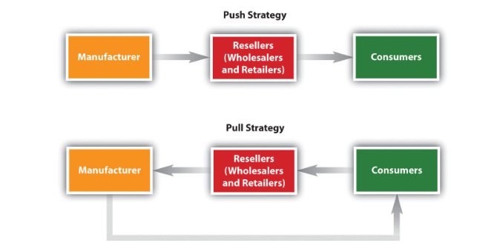

As mentioned above the Coca-Cola Company utilised celebrity endorsement in the past, it endorsed particularly athletes, actors, and musicians to promote the brand (Weaver,2013).
The product placement in the Netflix series 'Stranger Things' of the reviving 'New Coke' was ventured given its disastrous failure after its market introduction in the 1980s (Davis,2016) but also innovative (Taylor,2019). The nostalgic product was reintroduced in the market from 4 July 2019 for some time in cooperation with the product placement in the popular Netflix series (cf. Figure 6). Moreover, the campaign was encompassed with a celebrity-endorsed video and cinema advertisement featuring the characters of the series (Taylor,2019).

Figure 6, The revival of New Coke placed in Netflix Series: Stranger Things (Taylor,2019)

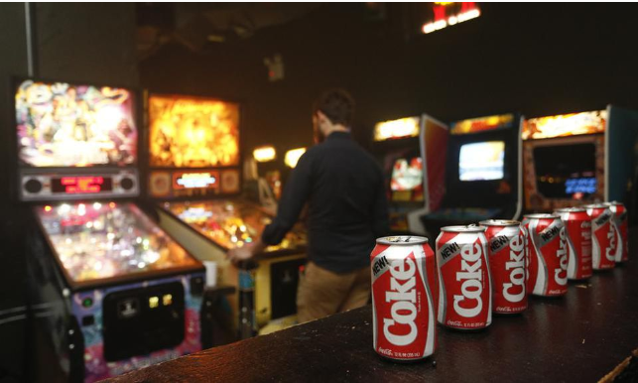
The cooperation with Netflix may provide a new promotional strategy with respect to celebrity endorsement by characters of the famous Netflix series. Netflix, is one of the world's largest entertainment companies and is considered to be the new cinema (McGurk,2017) with an exploding growth of 15.7 million new subscribers in the first quarter of 2020 (Lee,2020). Further cooperation with the entertainment service would reach a great audience with over 182 million subscribers to the service (Lee,2020).
Consideration must, however, be given to the fact that endorsing celebrities could present a risky undertaking. It may be a blessing, on the one hand, as public figures are useful instruments to establish and boost the brand image and increase sales (Kotler,2019). On the other hand, celebrity endorsement could evolve to be a curse where the famous person gets involved in scandals or embarrassing situations, or simply loses fame (Kotler,2019). Furthermore, it is manifest that celebrity endorsement is cost-intensive. Due to the large financial resources, Coca-Cola has the latter will not pose a limitation on the marketing strategy. In the past year alone (2019), Coca-Cola spent around 4,24 billion USD for marketing and promotion worldwide (Cotton,2020).
To minimise the risks of that the promotional strategy of celebrity endorsement, two strategies could be recommended for the Coca-Cola given the particular recommendation to concentrate on children as a target audience with its products (for example, through the creation of a 'Kids Cola' but also concerning the products that are already manufactured especially for children, such as 'Honest Kids'). Firstly, celebrity endorsement could be replaced through 'character celebrity endorsement'. The effectiveness of endorsing animated-character' could be reinforced through cooperation with 'Netflix Kids' by utilising series characters and engage product placement in the famous Netflix series for children.
As stated above, social media became an integral part of the world of marketing. This dogma applies particularly to marketing strategies of the Generation Alpha, the most technically skilled generation of all times growing up with all sorts of technical products available on the market such as smartphones, children's computers, tablets, etc. (Carter,2016). This generation possesses a great influence and power on their parent's spending behaviour despite their young age (given the fact that the oldest child of this generation is merely six years old) (cf. Carter,2016).
Another advantage of endorsing the brand with a child celebrity presents the elimination of the negative impact on the brand due to any inappropriate behaviour or scandals. An appropriate choice may be, for example, the nine-year-old 'YouTuber' Ryan with his channel 'Ryan's World' presenting inter alia toys reviews with 26,4 million followers on YouTube (cf. Youtube,2020) and its female counterpart seven-year-old 'fashionista' Laerta with 1,1 million followers on Instagram (Instagram,2020). Both children have an enormous influence on children of Generation Alpha, Generation Z, and the purchase behaviour of their Millennial parents and would present the perfect fit for creating brand awareness (cf. Carter,2016).

VII. Branding Strategies and Brand Equity of the Coca-Cola Company
A brand is a fundamental, intangible value of an organisation consisting of the brand 'name, symbol, logo, design, or image' and packaging (Kotler,2019). A company may use parts of or include all components in the branding process to create its own brand identity to differentiate their products from the rival brands (Jobber and Ellis-Chadwick,2016). Branding impacts the associations of the consumer towards a brand and reflects consumers' experience with the product or with the service, which is essential for low involvement products with high similarity to other brands (cf. Kotler,2019). Coca-Cola's emotional brand strategy is evoking feelings such as happiness, togetherness, belonging, and it is particularly, strongly associated with the Christmas season which stimulates pleasant and homely sentiments (cf. Hodgson,2017/Figure XX). Having regard to the lack of functional role of the brand which sole function is to 'refresh' the consumer as all the other substitutes and rival products, the emotional role of the Coca-Cola brand must be considered as its most valuable asset (cf. Kottler,2019)
Figure 7, Coca-Cola Great Britain, History of the Coca-Cola Christmas-Trucks (n.d.)
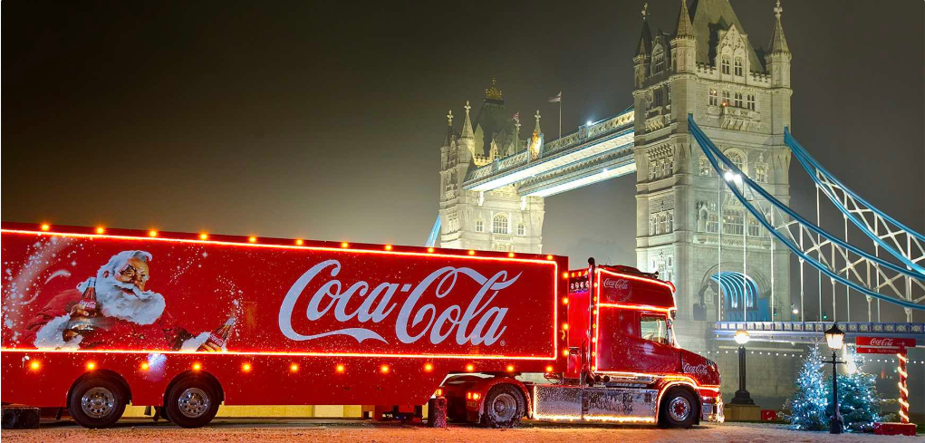

The clever branding strategy of one of the world's most recognised brand has not been achieved without lessons to learn on the pathway to success. The aforementioned failure of replacing the formula of 'Coca-Cola Classic' in the 1980s with the new brand 'New Coke' as a re-branding approach and the recent implementation of a 'one brand strategy' demonstrates that courageous company decisions are not always adequately rewarded by the consumers (cf. Davis,2016). In the framework of the 'Taste the Feeling' campaign (2016/2017) Coca-Cola introduced the 'one brand strategy' in unifying all Cola brands under one 'visual identity' in order to simplify the consumer's choice of his or her favourite product. Nevertheless, the similarity of the products due to the label which comprises a larger red disc on each product made the differentiation for the consumer more difficult (cf. Figure 8). Moreover, the low-calorie product variation Diet Coke and Coke Zero had high brand equity on their own which may vanish through the new branding strategy and might lead to confusion of brand loyal consumers of these brands (Davis, 2016).

Figure 8 Coca-Cola's 'one branding strategy' (Davis,2016)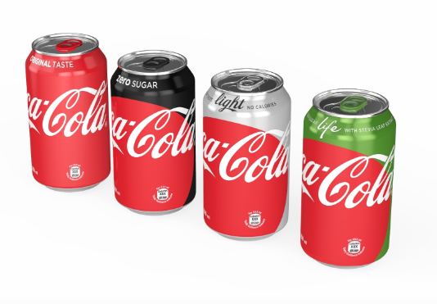

Coca-Cola utilises the individual product branding strategy for most of its products, including Coca-Cola, Fanta, Capri Sun, Sprite, Honest, etc. Each brand is recognised for its own merits and strengths. However, the individual brand strategy is cost-intense since each brand requires a different marketing strategy. The above mentioned 'one brand' strategy from 2016 of the Coca-Cola beverages can be qualified as rebranding concerning Diet Coke and Coke Zero (cf. Million,2017). This rebranding strategy is no longer implemented, hence Coke Zero and Diet Coke, Cherry Coke and Coca-Cola Life may be qualified as strategic brand extensions. Noteworthy, Coca-Cola Life has been removed from the UK market in 2017 (Arthur,2017). The object of this paper is the Coca-Cola brand and its extensions. Regarding the Cola fizzy drinks of the company the brand personality and the product packaging present substantial branding strategies. Noteworthy, Coca-Cola classic with its different flavours, for example Cherry Coke, or Coca-Cola Vanilla or Peach can be qualified as line filling regarding the applied brand strategy. As stated above the brand is associated strongly with Christmas and the 'Coca-Cola Santa Clause' is functioning as a brand character since 1931 (cf. Figure 9, Coca-Cola and Father Christmas,n.d.).

Figure 9- Coca-Cola GB 'Coca-Cola and Father Christmas' (n.d.)
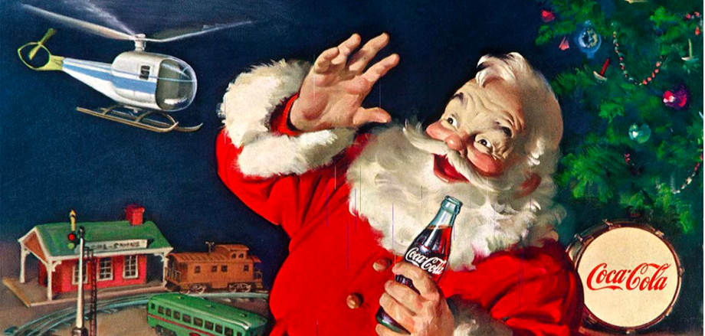

Coca-Cola's unique colour combination in red and white and its specially created logo lettering ensures an exceptionally high recognition value and helps consumers to distinguish Coca-Cola from other brands.
A strong brand is the most valuable asset of a company reflecting the consumers' perception of quality and their positive associations. Moreover, it allows the creation of brand loyalty, ensures high profits, and strengthens the competitive advantage since barriers for new entrants are created (Jobber and Ellis-Chadwick,2016).
Brand equity from the financial/company's perspective is 'the total financial value of the brand' (Sheehan,2011). The tangible assets of proprietary-based brand equity can include assets such as patents (Jobber and Ellis-Chadwick,2016). It is self-explanatory that strong brands determine brand equity, namely the financial value of the company which accounts to 63,365 million USD concerning the Coca-Cola Company which puts it in fifth place in the ranking of the 100 highest-valued brands in the world (cf. Interbrand,2019). The customer-based brand equity, however, 'resides in the mind of the consumer' comprising the brand awareness and brand image. (Jobber and Ellis-Chadwick,2016). It is the costumers' knowledge, association, and perception of a brand that impacts their behaviour to choose one brand over the brand of the competition (Jobber and Ellis-Chadwick,2016).

VIII. Keller's Brand Equity model
Keller's brand equity model (also referred to as the 'brand resonance model' or 'customer-based brand equity model') comprises the different core elements of brand-building as a fundamental marketing activity aiming at the creation of a strong and successful brand (Jobber and Ellis-Chadwick,2016). The model is reflected in a pyramid comprising six blocks namely, identity, meaning, response, and relationship (cf. Figure 10).
On the identity level, the organisation needs to secure that customers recognise the brand and associate a particular product with it due to brand awareness communicated by the company in harmony with the positioning strategy (cf. Kotler, 2019). The second level of the brand-building activity comprises the creation of a 'meaning' in the minds of the consumers through bridging material or immaterial associations (Kotler,2019). The brand meaning goes beyond the actual value or identity of the brand and may for example be interlinked with the societal marketing concept. The brand-related judgement and feelings of the customer must lead to a positive response matching brand image and meaning, in other words, deliver promises and expectation which were set on the previous stages.

Figure 10 'Keller's Brand Equity Model' (Kotler,2019)
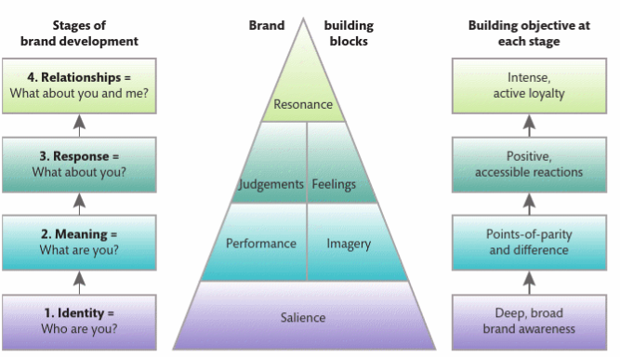

The Coca-Cola Company built its brand identity on an omnipresent, 'all-American brand'. Its uniqueness stems from its company history inventing the product Coca-Cola. Authenticity and naturalness ('the real-thing') are the core elements of the positioning strategy of the brand which ensures the distribution of happiness, togetherness, and community (Hodgson,2017). As the most recognised brand in the world Coca-Cola achieved comprehensive brand awareness and salience over its rivals.
The meaning that initiates brand loyalty in relation to the Coca-Cola Company is the sentimental values that are connected with the brand. The performance of the product includes a unique taste that brings refreshment, and energy triggering the imagery of happiness, Christmas, and belonging. As stated beforehand Coca-Cola is practicing the societal marketing concept with respect to environmental protection and charity, particularly in the framework of the Covid-19 pandemic (see above). On the response stage, Coca-Cola is evoking the reaction in accordance with the brand identity and meaning. The response of consumers to the brand is associated with feelings like happiness, joy, self-respect, and the celebration of social relationships such as family and friends (Hodgson,2017). The last stage on the top of the pyramid is the relationship that the company creates regarding their brand in building a consumer community around the brand who pro-actively promote the brand due to their brand loyalty (Kotler,2019). The social media pages of the Coca-Cola Company underline the community that arose around that successful brand with 106 million followers on Facebook (Facebook,2020), 2,8 million followers on Instagram (Instagram,2020), and 3,3 million followers on Twitter (Twitter,2020). Consumers get involved pro-actively on these social media pages to glorify 'their' Coca-Cola brand due to a bond to the brand.
Figure 11: Keller's Band Equity Model related to the Coca-Cola Company (CocaColaBranding,2016)

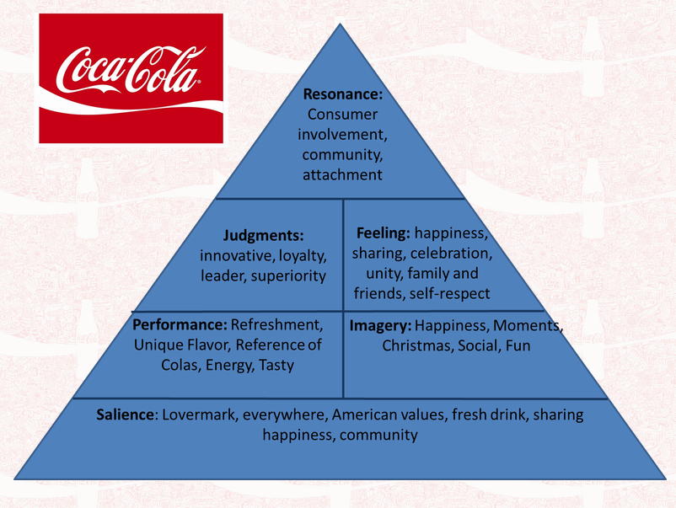

IX. Advantages and Disadvantages or Keller's Brand equity model
Keller's brand equity model helps companies to develop and reach their high-value brand potential (Jobber and Ellis-Chadwick,2016). Increasing profits through utilising the a high-value creating potential of the brand lies in the interests of the shareholders of a company (Claudiu-Catalin and Florea, 2012). As an effective brand-building tool the strengths of this model lies within the ability to establish brand loyalty and actuate pro-active relationships between organisations and their consumers. (cf. Kotler,2019). The model is furthermore, confirmed by the success of the leading global brands such as 'Apple, Google, Coca-Cola, Microsoft, IBM, and General Electric which outstand in all of the 'six blocks' of Keller's brand equity model (cf. Jobber and Ellis-Chadwick,2016). Strong brand equity serves as a foundation on which marketers can expand with marketing communication tools to increase sales (cf. Keller,2009).
In this framework, it has been questioned where the main focus of strength of the brand lies, particularly as the customer-based brand equity model attributes this aspect merely to the consumer. Furthermore, it is questionable how this strength and value of the brand can be measured (Claudiu-Catalin and Florea, 2012).
The limitations of Keller's brand equity model lies in the implementation of the model in the business to business (B2B) framework. Scholars argue, that 'feelings' are irrelevant in the 'sales-dominated' industrial market brands merely lead to confusion. Therefore, brand equity and brand-building concepts are redundant (Thomson, Knox and Mitchell,1997/). A different view is held by Rosenbroijer who acknowledges the increased importance of brand equity in the industrial market (2001) with the potential of contributing value to the industrial business framework (Gordon,Calantone and di Benedetto,1993). Given the fact, that the decision-makers in B2B sales transactions are humans who are subjected to impressionable behaviour the necessity of brand-building and equity must be recognised. In order to implement Keller's brand equity model effectively on the B2B market the model needs modification (Kuhn, Alpert and Pope,2008).

X. Brand Equity, Stakeholders and Corporate Social Responsibility (CSR)
The expectations of shareholders of a company comprise high profits and growth of the company they invested in to gain returns on their investment and high dividends (Darskuviene, 2014). The latter can be achieved through inter alia a strong brand equity (Jobber and Ellis-Chadwick,2016). According to the stakeholder theory, the influence on a company's decision encompasses more than the shareholder interest, particularly stakeholder, namely an internal and external range of group can be affected by the company in a positive or negative way and hence have a legitimate interest in the company (cf. Donaldson and Preston,1995). As a result, the responsibilities of organisations go beyond the scope of economic responsibility and encompass legal, ethical, and philanthropic responsibilities (Corporate Social Responsibility model). In practice, CSR implementation could include environmental protection and sustainable production, fair trade regarding the supply chain, support for the local communities, enhancement employee relation through 'fair pay', equal job and career development opportunities, and regarding consumers, safety, honesty in communication (cf. Jobber and Ellis-Chadwick,2016). Despite the costs involved, CSR result in increasing the company's reputation and can be complemented through a societal marketing concept to achieve credibility and a coherent brand image (cf. Jobber and Ellis-Chadwick,2016).

XI. The Customer Journey and the Customer Touchpoints
In the framework of customer relationship management, the customer journey and the customer touchpoints are elements to achieve consumer loyalty (Kotler,2019)
According to the Marketing Dictionary 'The customer journey and customer touch points are defined as the multiple online and offline touchpoints that determine how a consumer comes into contact with a brand, seeks more information and makes a purchase decision. Successful brands focus on developing a seamless journey from awareness to engagement to purchase that ensures that touchpoints interconnect and enhance the experience. Also known as Path to Purchase (P2P)' (Marketing Dictionary,2019).
1. The Customer Journey
A rational decision-making consumer is going through different stages in the consumer decision-making process before the purchase is concluded.
In order to comprehend consumer behaviour, Engel, Blackwell, and Kollat originally created a model of the 'consumer buying decision process' in 1968 which is referred to as the Engel-Blackwell-Kollat model (Yarnold,2014). The five steps of the consumer's decision-making process were formed by Blackwell, Miniard, and Engel in 2005 (cf. Jobber and Ellis-Chadwick,2016). The end-to-end-journey relates to this decision-making process and comprises 'all interactions in between a customer being completely unaware of a company through becoming aware, investigating it, buying it, using and assimilating it, through to becoming an advocate - telling others they should buy it and use it too'. (Transformation,n.d.)
(1) Problem awareness
The first stages of the customer journey are also reflected in the consumer decision-making process and is initiated by the 'need recognition'. At this stage a need or want is activated when the consumer is aware of the particular problem. The problem awareness is referring to the recognition of the discrepancy of an actual state and the desired situation which the consumer is trying to balance through purchasing a particular good or a specific service (Hollensen,2019).
In contrast to the decision-making process within the customer journey, the consumer is trying on to find a solution to his or her problem through an active search of information on the first stage.
(2) Evaluation and Consideration
If the need and want are considerably strong and the information search was activated the consumers are moving to the next stage where they are searching for further information in order to minimise social, financial, and psychological risks (cf. Jobber and Chadwick,2016). The internal information search refers to an evaluation of information the consumer memorises from experience (Hollensen,2019). If the internal information research was not sufficient enough the consumer will consult external information sources to gain information, such as personal sources (for example recommendation from family, friends, or consumer's reference group, cf. Hollensen,2019), commercial sources such as IMC (different types of promotion, made available by companies their marketers, salespersons, but also the label information, cf. Hollensen,2019). The external information sources could also be public sources which are non-commercial sources and may include for example the consultation of an expert opinion from an individual or an organisation, such as doctors, lawyers, government agencies, consumer-interest groups (Hollensen,2019). On the same stage, the consumer is evaluating alternatives through focusing on their 'invoked set of limited brands' with the desired attributes and aspects (choice criteria), including cost factor, performance aspect, social attributes (e.g. popularity of the brand among family, friends, and society) and the availability of the product (Hollensen,2019). According to the evoked set theory, consumers are concentrating on the set of brands which they can easily recall and with which they are familiar with (cf. Business Dictionary,'Evoked Set',n.d)
In this framework, consumers weigh all aspects to determine which brand will most likely satisfy their needs and wants in the best possible way which leads to step 3 'the purchase decision'.
(3) Commitment / Purchase decision
After the information search, the evaluation of the alternatives, and the decision on the brand of choice the consumer moves to the commitment/purchase decision stage. On this stage, different purchase options are available including at-home shopping (online shopping with a delivery option of the product to the consumer's home) or in-store purchasing which can be influenced regarding the choice of the store by its location, the variety of stock, the high-quality of service, and the retail-store image. At this stage, it is essential, to have customer reviews available, particularly for high involvement products.
(4) Retention / post-purchase evaluation
In the fourth stage the customer is determining whether the purchased good is satisfactory or dissatisfactory (cf.Hollensen,2019). Although marketing strategies are aiming at creating a positive customer experience for the consumers, sometimes they will experience post-purchase uncertainty whether they made the right choice, which is known as cognitive dissonances (Jobber and Ellis-Chadwick,2016). In order to minimise dissonance, effective after-sales service may be implemented by the company to reassure the consumer about the high quality of the product or to solve issues the consumer experienced. An advertisement may also play a role to reassure the consumer and minimise post-purchase concerns.
In the framework of the customer journey the consumer is repetitively purchasing the brand and may develop brand loyalty or even establish an emotional connection to the brand. The company should establish post-purchase communication with its costumers, for example requesting feedback and acknowledging brand loyalty through incentives.
(5) Advocacy
At the final stage, the consumer is functioning as an advocate for the brand of a specific company on the fifth stage of the customer journey spreading the positive word-of-mouth. The company shall reward this through incentives and rewards.

XII. The Coca-Cola Company's touchpoints and customer journey
In relation to the Coca-Cola Company, the problem awareness would constitute the recognition of thirst by the consumer and could also be part of the routine purchase of groceries. Generally speaking, Coca-Cola beverages are low-involvement products due to the minimal investment and (financial, psychological, and social) risk interlinked with the purchase decision.
Although the classification of high and low involvement products are subjected to the social class or earnings of the buyer, in regards to the UK, the fizzy drinks concerned are products that members of every social class may 'entail minimal effort and consideration' to purchase these products (cf. Business dictionary,n.d.). The consumer tends to purchase low involvement products out of a habit or impulse than high involvement products since they do not concern their personality or defining their lifestyle. (cf. Jobber and Ellis-Chadwick,2016). Against the backdrop of the minor importance of purchase situation, it is not worth making an effort of reflecting and evaluating alternatives, particularly when consumers already recall the good experience with a product (Jobber and Ellis-Chadwick,2016).

1. The Customer Touchpoints of the Coca-Cola Company
The identified the customer touchpoints of the Coca-Cola Company on different stages are as follows:
(1) Social Media - Pre-Purchase and Post-Purchase stage
The Coca-Cola Company is utilising social media to provide customer touchpoints to enhance customer interaction, including Facebook, Instagram, and Twitter. The advantage of social media is manifestly a cost-efficient way to reach a large amount of the target audience to promote their products, but also to build a relationship with customers and potential consumers. For the Coca-Cola company, social media is a platform to promote the overall brand image through promoting campaigns against racism, implementing the societal marketing concept (cf. donations and support in the framework of Covid-19) but also to promote the environmental protection approaches. Social media can be relevant to create awareness and provide information in the pre-purchase stage but also to provide a platform of interaction for the customer in the post-purchase stage. Particularly, the amount of likes and followers on the company's social media websites enhances the overall image, result in an automatic proliferation and constitutes free promotion through the consumer.
(2) Company Events
On the UK website of Coca-Cola, particularly the 'Media Centre' the company releases inter alia its latest events, including the annual 'Christmas Truck Tour' comprising 19 events across the UK (Coca-Cola,MediaCentre,2019). Another promotional event in the UK was provided in October 2019 where the company popped up six photo booths in Covent Garden where visitors can take snapshots of themselves with or without family and friends (Green,2019). Company events are useful tools to create brand awareness, especially to reach people who are completely unaware of the brand. Usually, Coca-Cola events are providing some part of fun interaction with the consumer with physical evidence. For example, the photo booth produces photos of the consumers with the Coca-Cola brand on it. The consumer therefore would keep a 'piece of the brand' which is personalised with the consumer's picture functioning as a constant reminder of the brand.
It is also useful for consumers who already made a positive experience with the brand ( in the framework of the post-purchase stage). Customers who are not brand loyal yet may memorize the brand again.
These events are touchpoints for customers to interact with the company and its brands.
(3) Peer referral
The Coca-Cola Company is implementing pro-actively word of mouth marketing, for example with its 'share a coke campaign' in 2016 consumer interacted with family and friends via social media when they spotted names on a Coca-Cola bottle, such as a specific friend's name or general labels including 'friend', 'mom', 'dad' etc. and posted pictures of these brand labels on social media tagging the friend or family member concerned. This clever campaign set the ball rolling for a free word of mouth promotion (Windle,2016).

2. The Customer Journey and touchpoints related to the Coca Cola Company
Figure 12 The customer journey and customer touchpoints of Coca-Cola (Wienese,2018)
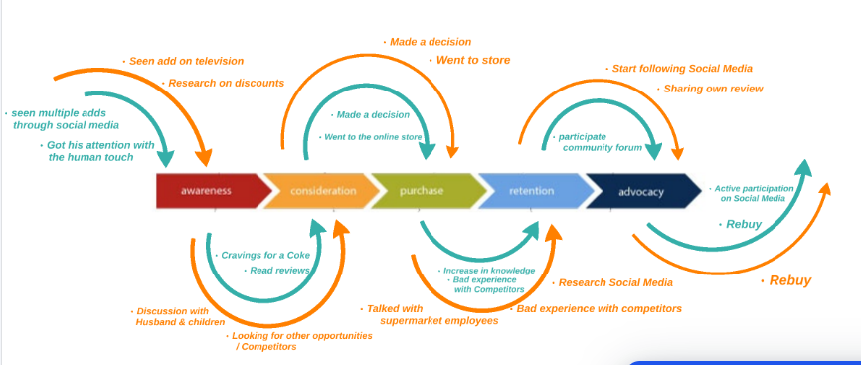

In the pre-purchase stage, consumers and potential customers are aware of multiple promotion types of the IMC that Coca-Cola utilised to create brand awareness, for example through a TV advertisement or other traditional channels, such as radio or a billboard chart (cf. Figure 12).
The information research might have led to the Facebook page of Coca-Cola or to other social media platforms such as Instagram to gather information. The consumer is aware of his or her needs and wants in craving for a Coke due to thirst, the lack of caffeine, or simply for refreshment. The consumer might talk about it with family and friends or read the reviews on Facebook or other internet platforms to evaluate alternatives (for example buying a Pepsi drink). The consumer may also have been in touch with the brand on a walk through Covent Garden with friends where a photo booth was provided for visitors to take pictures. After the consideration stage, the consumer moved on to the purchase stage and may visit a supermarket, online website to order food and beverages. On the website of the online supermarket the consumer is looking for Coca-Cola through the search function and will see the product which has already reviews attached from other supermarket customers. On this occasion, the customer adds a bottle of Coca-Cola to the virtual shopping basket (which constitutes a common alternative to the physical in-store shopping, particularly during the Covid-19 pandemic). Alternatively, the consumer underpins his or her purchase decision by walking into a store to buy a bottle or can of Coca-Cola when he or she has a strong need or want of that product. At the purchasing stage, the consumer also may check supermarket brochures and becomes aware of the sales promotion of Coca-Cola. In the supermarket the consumer may request advice from a salesperson/supermarket staff about the product. In the post-purchase stages subsequently to a satisfying experience with the product, the consumer becomes brand loyal and repetitively purchase the product. To support the brand and spread the word of mouth the customer expresses publicly his or her loyalty to the brand through liking the Facebook page of the company and following Coca-Cola on Twitter and Instagram and or signing up for newsletters. Through (positive) comments on social media, the customer comments on the company's events, campaigns, and other promotional activities. The consumer might write a blog about his or her experience with the brand.

XIII. Advantages and disadvantages of the Coca-Cola Customer Journey
The customer's end-to-end journey should be an all-round excellent experience from the first step of the journey until the last step (cf. Maechler,Neher,and Park,2016). The IMC strategy of Coca-Cola is the company's strong side as demonstrated above. Therefore, it is favourable for Coca-Cola to create brand awareness at the pre-purchase/awareness stage of the customer journey.
Having regards to the fact that social media comprises a major touchpoint for Coca-Cola concerning the pre-purchase and post-purchase stage it is worth taking a closer look to the implementation of this tool. According to research findings for a positive customer experience a 'clear and consistent communication' is fundamental (Maechler,Neher, and Park,2016). In order to build a relationship with the customer and encourage brand loyalty, post-purchase communication can be a decisive factor. As Figure 12 emphasises the communication of the Coca-Cola Company on Facebook leaves room for improvement. A customer is reporting that he was not able to find his favourite Coca-Coca beverage on stock in his local store. The comment by the customer was made in the framework of the Coca-Cola 'Premier League Trophy Tour' which can be qualified as a positive customer touchpoint interconnecting happy moments of football with Coca-Cola, however the response to the customer request was unsatisfactory from the customer perspective as the company just refers to the store manager of his local shop. A successful and solution-oriented communication would have been to offer to investigate and compensate the apparently brand loyal consumer. The referral to the 'right department' should have been concluded through the company by capturing customer and store details rather than apologizing that they 'cannot be more helpful'. Hereby the company leaves the customer alone to sort out a problem which lies in the sphere of the company, the wholesalers, and retailers. The comment of the chat moderator is attributed to the Coca-Cola Company and lacks professionalism, integrity, and good business practice. The inadequate problem management not only may impact the re-buying decision of the customer concerned, but it could also impact the purchasing decision of potential consumers since this response may have a deterring effect. Furthermore, Coca-Cola could reach out to customers following the brand on social media to ask for a product feedback survey via post with an included link. This recommendation would give customers the opportunity who would like to get in touch with the company to give feedback on their purchase experience and the company would gain marketing data in a cost-efficient way to enhance their customer relationship management. This recommendation is in accordance with the total engagement model (cf. Figure 13) emphasis the alignment of all four major elements, namely brand advertising, culture, customer experience, and customer value propositions (Roberts and Alpert,2010). In order to realise the key elements of the aforementioned model, the internal company culture must be incorporated as core values by staff members to be able to deliver a 'value proposition and planned customer experience' through the employees (Roberts and Alpert,2010).
Figure 12 Screenshot of a Coca-Cola post on Facebook on 20 March 2019 (Facebook,Coca-Cola,2020).
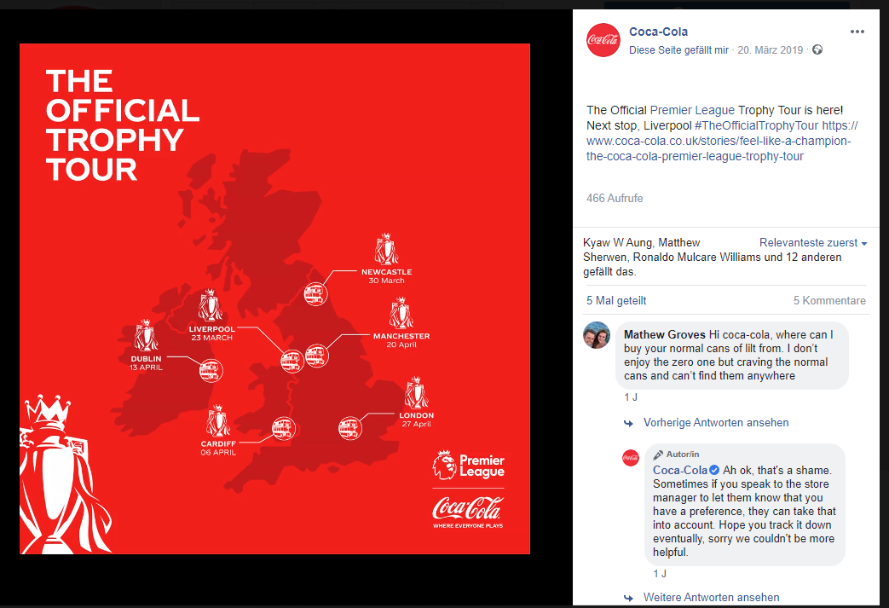

Figure 13 'Total Engagement Model' (Roberts and Alpert,2010)
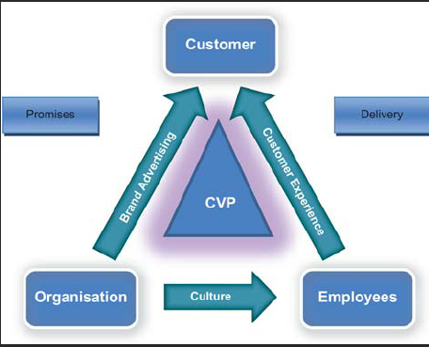

XIV . Conclusion
This report analysed the customer journey of the Coca-Cola company considering the promotional strategies, particularly IMC and the customer touchpoints. It can be stated that the Coca-Cola company is utilising comprehensively all communication channels available to enhance its relationship marketing strategies. It was revealed that the medium social media as a touchpoint leaves room for improvement to achieve an overall excellent customer experience as part of the bigger picture, namely the customer journey the customer end-to-end journey. It is only through this approach that protects the economic interests of shareholders. It was furthermore determined, that this approach must be combined with CSR on grounds of the stakeholder theory accepting legal, ethical, and philanthropic responsibilities to meet the whole range of current and future stakeholders' expectations.

List of References

- Arthur,R. (2017), 'Coca-Cola Life axe in the UK' BeverageDaily, 6 April [Online]. Available at https://www.beveragedaily.com/Article/2017/04/07/Coca-Cola-Life-axed-in-the-UK [Accessed on 1 September 2020].
- Ashford, J. (2020), 'Coronavirus: five long-term changes to our lives', The Week, 16 March, [Online]. Available at https://www.theweek.co.uk/106193/coronavirus-five-long-term-changes-to-our-lives [Accessed on 26 August 2020].
- Bold, B. (2014), '128 years of Coca-Cola and its many brand extensions', Campaign, 12 June, [Online]. Available at https://www.campaignlive.co.uk/article/128-years-coca-cola-its-brand-extensions/1298515 [Accessed on 1 September 2020].

- Brun, M., Schoenmueller, V. and Schafer, D.B. (2012),'Are social media replacing traditional media in terms of brand equity creation?' Management Research Review, 35(9).
- BusinessDictionary.com (n.d), 'Low Involvement Product' [Online]. Available at http://www.businessdictionary.com/definition/low-involvement-product.html [Accessed on 1 September 2020].
- Cambridge Dictionary,(2020), 'Communication', Cambridge University Press, [Online]. Available at https://dictionary.cambridge.org/dictionary/english/communication [Accessed on 26 Augsut 2020]

- Chandler, D. and Munday, R.(2011), 'A Dictionary of Media and Communication', Oxford, Oxford University Press.
- Carter, C.M. (2016), 'The Complete Guide To Generation Alpha, The Children of Millennials' Forbes Media, 21 December,[Online].Available at https://www.forbes.com/sites/christinecarter/2016/12/21/the-complete-guide-to-generation-alpha-the-children-of-millennials/#5b6aa1963623 [Accessed on 1 September 2020].
- CocaColaBranding (2016), 'Keller Model Overview', 1 September, [Online]. Available at https://cocacolabranding.wordpress.com/2016/09/01/keller-model-overview/ [Accessed on 1 September 2020].

- Coca-Cola Great Britain (2020), 'Open like Never before: Coca-Cola and George the Poet unite to send message in current time of change', 1 August, [Online]. Available at https://www.coca-cola.co.uk/marketing/campaigns/latest/open-like-never-before--coca-cola-and-george-the-poet-unite-to-s [Accessed on 26 August 2020].

- Coca-Cola Great Britain,(n.d.), 'History of the Coca-Cola Christmas-Trucks', [Online], Available at https://www.coca-cola.co.uk/our-business/history/holidays-are-coming-the-history-of-coca-cola-and-christmas [Accessed on 1 September 2020].
- Coca-Cola Great Britain,(n.d.),'Coca-Cola and Father Christmas' [Online]. Available at https://www.coca-cola.co.uk/marketing/christmas/coca-cola-and-father-christmas--the-sundblom-santa-story [Accessed on 1 September 2020].
- Coca-Cola, Media Centre (2019), 'Christmas Truck Tour', [Online]. Available at https://www.coca-cola.co.uk/our-business/media-centre/holidays-are-coming-2019 [Accessed on 2 September].
- Coca-Cola Australia,(2020),'What was the 'share a Coke' campaign?', [Online]. Available at https://www.coca-colacompany.com/au/faqs/what-was-the-share-a-coke-campaign [Accessed on 28 August 2020].
- Coca-Cola, Google PlayStore (n.d.),'Coca-Cola',[Online] https://play.google.com/store/apps/details?id=com.coca_cola.android.ccnamobileapp&hl=en_GB [Accessed on 28 August 2020].
- Coca-Cola,News,(2020), 'Coca-Cola to Pause All Social Media Activity in July',[Online]. Available at https://www.coca-colacompany.com/news/coca-cola-to-pause-all-social-media-activity-in-july [Accessed on 28 August 2020].
- Cotton,B.(2020), 'How much money does Coca-Cola spend on advertising', Business Leader UK, 4 March,[Online]. Available at https://www.businessleader.co.uk/how-much-money-does-coca-cola-spend-on-advertising/80315/#:~:text=Coca%2DCola%27s%20advertising%20campaigns%20boost,%243.96bn%20spent%20in%202017. [Accessed on 1 September 2020]
- Contagious, 2020, 'Coke returns to brand advertising with George The Poet spot', 25 August 2020, [Online]. Available at: https://www.contagious.com/news-and-views/campaign-of-the-week-coke-returns-to-brand-advertising-with-george-the-poet-spot [Accessed on 28 August 2020].
- Claudiu-Catalin, M. and Florea, D. (2012) 'A critical analysis of brand equity evaluation methods',[Online]. Available at https://www.researchgate.net/publication/260172764_A_CRITICAL_ANALISYS_OF_BRAND_EQUITY_EVALUATION_METHODS [Accessed on 2 September 2020]

- Danziger, P.N.(2020), 'After Panic Buying Subsides, Will Coronavirus Make Lasting Changes To Consumer Psychology?', Forbes Media, 16 March, [Online]. Available at
https://www.forbes.com/sites/pamdanziger/2020/03/08/first-comes-panic-buying-but-afterwards-will-the-coronavirus-leave-lasting-changes-to-consumer-psychology/#f08aafb77e8a [Accessed on 26 August 2020].

- Darskuviene, V.(2014), 'Stakeholders expectations and influence on company decisions',[Online]. Available at https://www.researchgate.net/publication/277610035_Stakeholder_expectations_and_influence_on_company_decisions [Accessed on 2 September 2020]

- Davies,G. (2020), 'Blackout Tuesday: What is it - and why were people posting black squares on Instagram?' The Telegraph, 2 June, [Online]. Available on https://www.telegraph.co.uk/news/2020/06/03/blackout-tuesday-black-squares-instagram/ [Accessed on 28 August 2020].
- Davis,S.(2016), 'If You Thought New Coke Was A Disaster, You Haven't Seen Their New Packaging', Forbes Media, 9 May [Online]. Available at https://www.forbes.com/sites/scottdavis/2016/05/09/if-you-thought-new-coke-was-a-disaster-you-havent-seen-their-new-packaging/#5a6f9895760d [Accessed on 1 September 2020].
- Donaldson,T. and Preston,L.E. (1995), 'The Stakeholders Theory of the Corporation: Concept, Evidence, and Implications, Academy of Management Review (20(1),15-91.

- Facebook (n.d), 'Coca-Cola-GB', [Online]. Available at https://www.facebook.com/cocacolaGB [Accessed on 28 August 2020].
- Frazier, M. (2014), 'Should the polar bear still sell Coca-Cola?' The New Yorker, 6 November [Online]. Available at https://www.newyorker.com/business/currency/polar-bear-still-sell-coca-cola [Accessed on 1 September 2020].
- Gordon, G.L., Calantone, R.J., and di Benedetto, C.A., 1993. Brand Equity in the Business-toBusiness Sector: An Exploratory Study. Journal of Product and Brand Management. 2(3), 4- 16.
- Green, A. (2019), 'Coca-Cola is popped up the ultimate photo booth in Covent Garden', 1 October, [Online]. Available at http://urbanintention.co.uk/food-drink/coca-cola-is-popped-up-the-ultimate-photo-booth-in-covent-garden/ [Accessed on 2 September 2020].

- Hall, E.(2020), 'Coca-Cola exits self-imposed marketing lockdown with a manifesto for change by George The Poet and 72andSunny' [Online]. Available at https://www.moreaboutadvertising.com/2020/07/coca-cola-exits-self-imposed-marketing-lockdown-with-a-manifesto-for-change-by-george-the-poet-and-72andsunny/ [Accessed on 26 August 2020].
- Hawks,M.(2015), 'Guide to Consumer Decision Journey and the Search Cycle', 24 September, [Online]. Available at https://www.seosavvy.com/blog/guide-to-consumer-decision-journey-and-the-search-cycle/ [Accessed on 1 September 2020]
- Hodgson,S. (2017), 'Holidays are coming: The Cola Cola Christmas branding story' 31 December, [Online]. Available at https://medium.com/@Stewart_Fabrik/holidays-are-coming-the-coca-cola-christmas-branding-story-8f08e2be8def [Accessed on 28 August 2020].

- Hollensen, S., (2019). 'Marketing management'. 4th. edn. Harlow, United Kingdom: Pearson Education Limited.
- Influenster,(n.d.), 'Coca-Cola', [Online]. https://www.influenster.com/reviews/coca-cola-soda?__cf_chl_jschl_tk__=aad3aa95f1c881933fa53163d6b407d62f83bcdf-1599237949-0-AUvpguvAeXKMEpFXx7wqzzC4E3ppjPa_vJij7kyp6CG37RnXKbx5HJ7OTqAlSH8tvVsBSbtZMtu28Zd2BGmzbw5NO_1wSyLMeVft7Ys4NTxxCyxuvUnY-G7FxrsykRoKALSWOzGG5y9OdKv7FNJepm1WvSN4EBRLGWwfe09yA3dXlPVKKDHLr_xnVfZZM-phZGIv35ljJOaVON-OkOgbr9qSlgXkGnB3TjIkzqw8wYrt41PUWOjE2b2mqiTYy5O6B4KDFVo9_YjZZENistVtNjiSjTHt10wYFcsJto0t5kS7Xru0Seh76XwMk3ZJpn6zmywQLgASAaBDcCAZohZXwHOXqppxFOfer8bOq1ksYSO3 [Accessed on 1 September 2020].
- Instagram,(2020), 'Fashion_Laerta', [Online]. Available at https://www.instagram.com/fashion_laerta/ [Accessed on 1 September 2020].
- Jobber, D. and Ellis-Chadwick, F. (2016), 'Principles and Practice of Marketing', 8th ed., London, McGrw-Hill Education.
- Keller, K.L.(2009), 'Building strong brands in a modern marketing communications environment', Journal of Marketing Communication, 15 (2-3).
- Kimbarovsky,R. (2020), 'How To Create a Unique and Memorable Brand Identity in 2020', 9 January [Online]. Available at https://www.crowdspring.com/blog/brand-identity/ [Accessed on 1 September 2020].

- Kuhn, K.L., Alpert, F. and Pope, N.K.L., (2008). 'An application of Keller's brand equity model in a B2B context'. Qualitative market research, 11(1), pp. 40-58.
- Lee, E. (2020), 'Everyone You know Signed Up for Netflix', The New York Times, 21 April, [Online]. Available at https://www.nytimes.com/2020/04/21/business/media/netflix-q1-2020-earnings-nflx.html [Accessed on 1 September 2020].

- Lightman,A. (2020),'The Virus a Reminder of Something Lost Long Ago', The Atlantic,[Online]. Available at https://www.theatlantic.com/ideas/archive/2020/04/coronavirus-is-changing-habits-of-mind/609181/ [Accessed on 26 August 2020].
- Madge, J. (2020), 'George The Poet's optimistic soliloquy of change for Coke' 30 July, [Online]. Available at https://shots.net/news/view/george-the-poets-optimistic-soliloquy-of-change-for-coke [Accessed on 27 August 2020].
- Maechler, N., Neher, K. and Park, R. (2016), 'From touchpoints to journeys: seeing the world as customers do', McKinsey & Company, 4 March, [Online]. Available at https://www.mckinsey.com/business-functions/marketing-and-sales/our-insights/from-touchpoints-to-journeys-seeing-the-world-as-customers-do [Accessed on 2 September 2020].

- Maqbool,A. (2020), 'Black Lives Matter: From social media post to global movement'
BBC, 10 July, [Online]. Available at https://www.bbc.co.uk/news/world-us-canada-53273381 [Accessed on 28 August 2020].
- Mariadoss,B.J.(2017),'Core Principles of Marketing' Minnesota, University of Minnesota Libraries Publishing, [Online], Available at https://opentext.wsu.edu/marketing/chapter/11-7-sales-promotions/ [Accessed on 26 August 2020].
- Marketing Dictionary (2019), 'The Modern Marketer's Dictionary: The Customer Journey' 24 April, [Online]. Available at https://www.marketingevolution.com/knowledge-center/the-modern-marketers-dictionary-the-customer-journey [Accessed 1 September 2020].
- Mayhew, K. and Anand, P. (2020) 'Covid-19 and the UK Labour Market' , Oxford Review of Economic Policy, graa017, 2 June, [Online]
Available at https://doi.org/10.1093/oxrep/graa017 [Accessed 26 July 2020].
- McGurk,S. (2017),'Why Netflix is the death of cinema and the saviour of film' GQ Britain, 16 May [Online]. Available at https://www.gq-magazine.co.uk/article/netflix-death-of-cinemas [Accessed on 1 September 2020]
- McDonalds GB,(2020), 'Deals', [Online]. Available at: https://www.mcdonalds.com/gb/en-gb/deals.html [Accessed 1 September 2020].
- McDonalds,(2020), 'Deals and Our App -Exclusive Deals', [Online]. Available at https://www.mcdonalds.com/us/en-us/deals.html [Accessed on 28 August 2020].
- Mead,R. (2020), 'George the Poet’s Undefinably Good Podcast', The New Yorker, 8 March [Online]. Available at https://www.newyorker.com/culture/podcast-dept/george-the-poets-undefinably-good-podcast [Accessed on 27 August 2020].
- Million,M.(2017), 'A Closer Look at the Rebranding of Coca-Cola Zero', 4 August, [Online]. Available at https://www.fullsurge.com/blog/a-closer-look-at-the-rebranding-of-coca-cola-zero#:~:text=The%20goal%20is%20to%20portray,at%20times%20want%20no%2Dsugar [Accessed on 1 September 2020].
- Montaque, T. (2018),'3 Steps to Build a Lasting Emotional Connection With Customers', AdWeek,30 October,[Online]. Available at https://www.adweek.com/brand-marketing/3-steps-to-build-a-lasting-emotional-connection-with-customers/ [Accessed on 28 August 2020].
- MyConsumer.com (n.d.), 'Customer Touchpoints', [Online]. https://www.mycustomer.com/hr-glossary/customer-touchpoints#:~:text=Customer%20touchpoints%20are%20any%20point,a%20form%20of%20customer%20touchpoints. [Accessed on 2 September 2020].
- Neal, C., Quester,P. and Hawkins, I. (2007), 'Consumer Behaviour. Implications for Marketing Strategy', Boston, Mass: Irwin.
- Roberts,C and Alpert, F. (2010), 'Total customer engagement: designing and aligning key strategic elements to achieve growth' 23 May, Research Gate,[Online]. Available at: https://www.researchgate.net/publication/49513186_Total_customer_engagement_Designing_and_aligning_key_strategic_elements_to_achieve_growth/figures?lo=1 [Accessed on 2 September 2020].
- Rosenbroijer, C.J., 2001. Industrial Brand Management: A Distributor’s Perspective in the UK Fine-Paper Industry. Journal of Product and Brand Management. 10(1), 7-25
- Schultz,D. (1993), 'Integrated marketing communications: maybe definition is in the point of view', Marketing News, 18 January, 17.
- Scott, J. (2020), 'What risks does Covid-19' pose to society in the long-term?' World Economic Forum, 26 May, [Online]. Available at: https://www.theweek.co.uk/106193/coronavirus-five-long-term-changes-to-our-lives
[Accessed on 26 August 2020]
- Sheehan, B., (2011). 'Marketing management'. Lausanne, AVA Academia.
- Sherlekar,S.A. and Gordon, E.(2010), 'Marketing Mangement', 2nd. edn., Mumbai India, Himalaya Pub. House.
- Sweney, M.(2020), 'From boardroom to spare room: the working from home revolution', The Guardian,18 April, [Online]. Available at https://www.theguardian.com/money/2020/apr/18/from-boardroom-to-spare-room-the-working-from-home-revolution-coronavirus [Accessed on 26 August 2020].
- Talbot,P.(2019),'Inside Coca-Cola's Marketing Strategy', Forbes Media, 26 April, Available at https://www.forbes.com/sites/paultalbot/2019/04/26/inside-coca-colas-marketing-strategy/#6f88525c1280 [Accessed on 1 September 2020].
- The Coca-Cola Company (n.d.), 'An Enduring Legacy', [Online]. Available at https://www.coca-colacompany.com/news/coca-colas-polar-bears [Accessed on01 September 2020].
- Thompson, K.E., Knox, S.D., and Mitchell, H.G., (1997/1998), 'Business to Business Brand Attributes in a Changing Purchasing Environment'. Irish Marketing Review. 10(2), 25-32.
- Transformation (n.d.), 'Customer Journey', [Online]. Available at https://transformation.ai/customer-journey-definition/ [Accessed on 1 September 2020]

- Weaver,J.(2013), 'Coke gets 'real' with celebrities', NBC, 9 January, [Online]. Available at http://www.nbcnews.com/id/3073196/t/coke-gets-real-celebrities/ [Accessed on 1 September 2020].
- Wienese,D. (2018), 'Customer Journey Map - Coca-Cola' 4 April [Online]. Available at https://prezi.com/tpzucspihzds/customer-journey-map-sem-amp-sara/ [Accessed on 2 September 2020].
- Williams, R. (2017), 'Coca-Cola fast forwards 'Play a Coke' promo with bigger marketing push', 3 May, [Online]. Available at https://www.mobilemarketer.com/news/coca-cola-fast-forwards-play-a-coke-promo-with-bigger-marketing-push/441853/ [Accessed on 28 August 2020].

Windle,K. (2016), 'Share a Coke and a Word: How Coca-Cola Captured Millennials Through Word of Mouth Marketing' 19 May,[Online]. Available at https://medium.com/@kwindle/share-a-coke-and-a-word-how-coca-cola-captured-millennials-through-word-of-mouth-marketing-44896573d21c#:~:text=When%20consumers%20found%20friends%27%20names,was%20free%20to%20Coca%2DCola. [Accessed on 2 September 2020].

- Yarnold, R.(2014), 'Consumer Marketing for 5 Step Model-Marketo',[Online]. Available at https://blog.marketo.com/2014/09/how-consumers-decide-marketing-for-the-5-step-model.html [Accessed on 1 September 2020].
- YouTube,(2020), 'Ryan's World' [Online]. Available at https://www.youtube.com/channel/UChGJGhZ9SOOHvBB0Y4DOO_w [Accessed on 1 September 2020].

