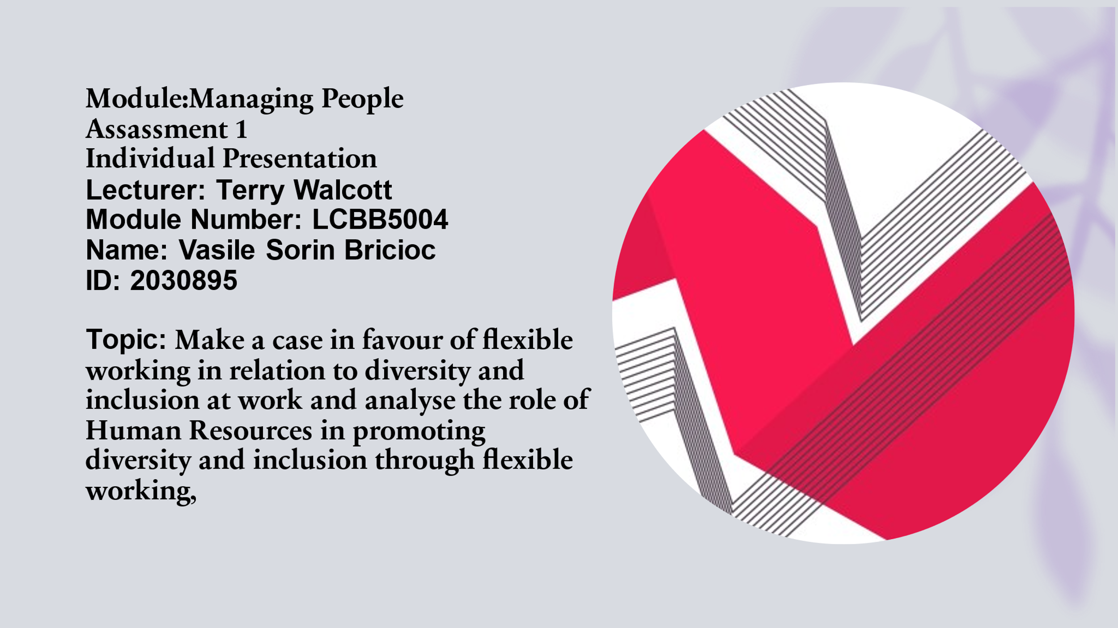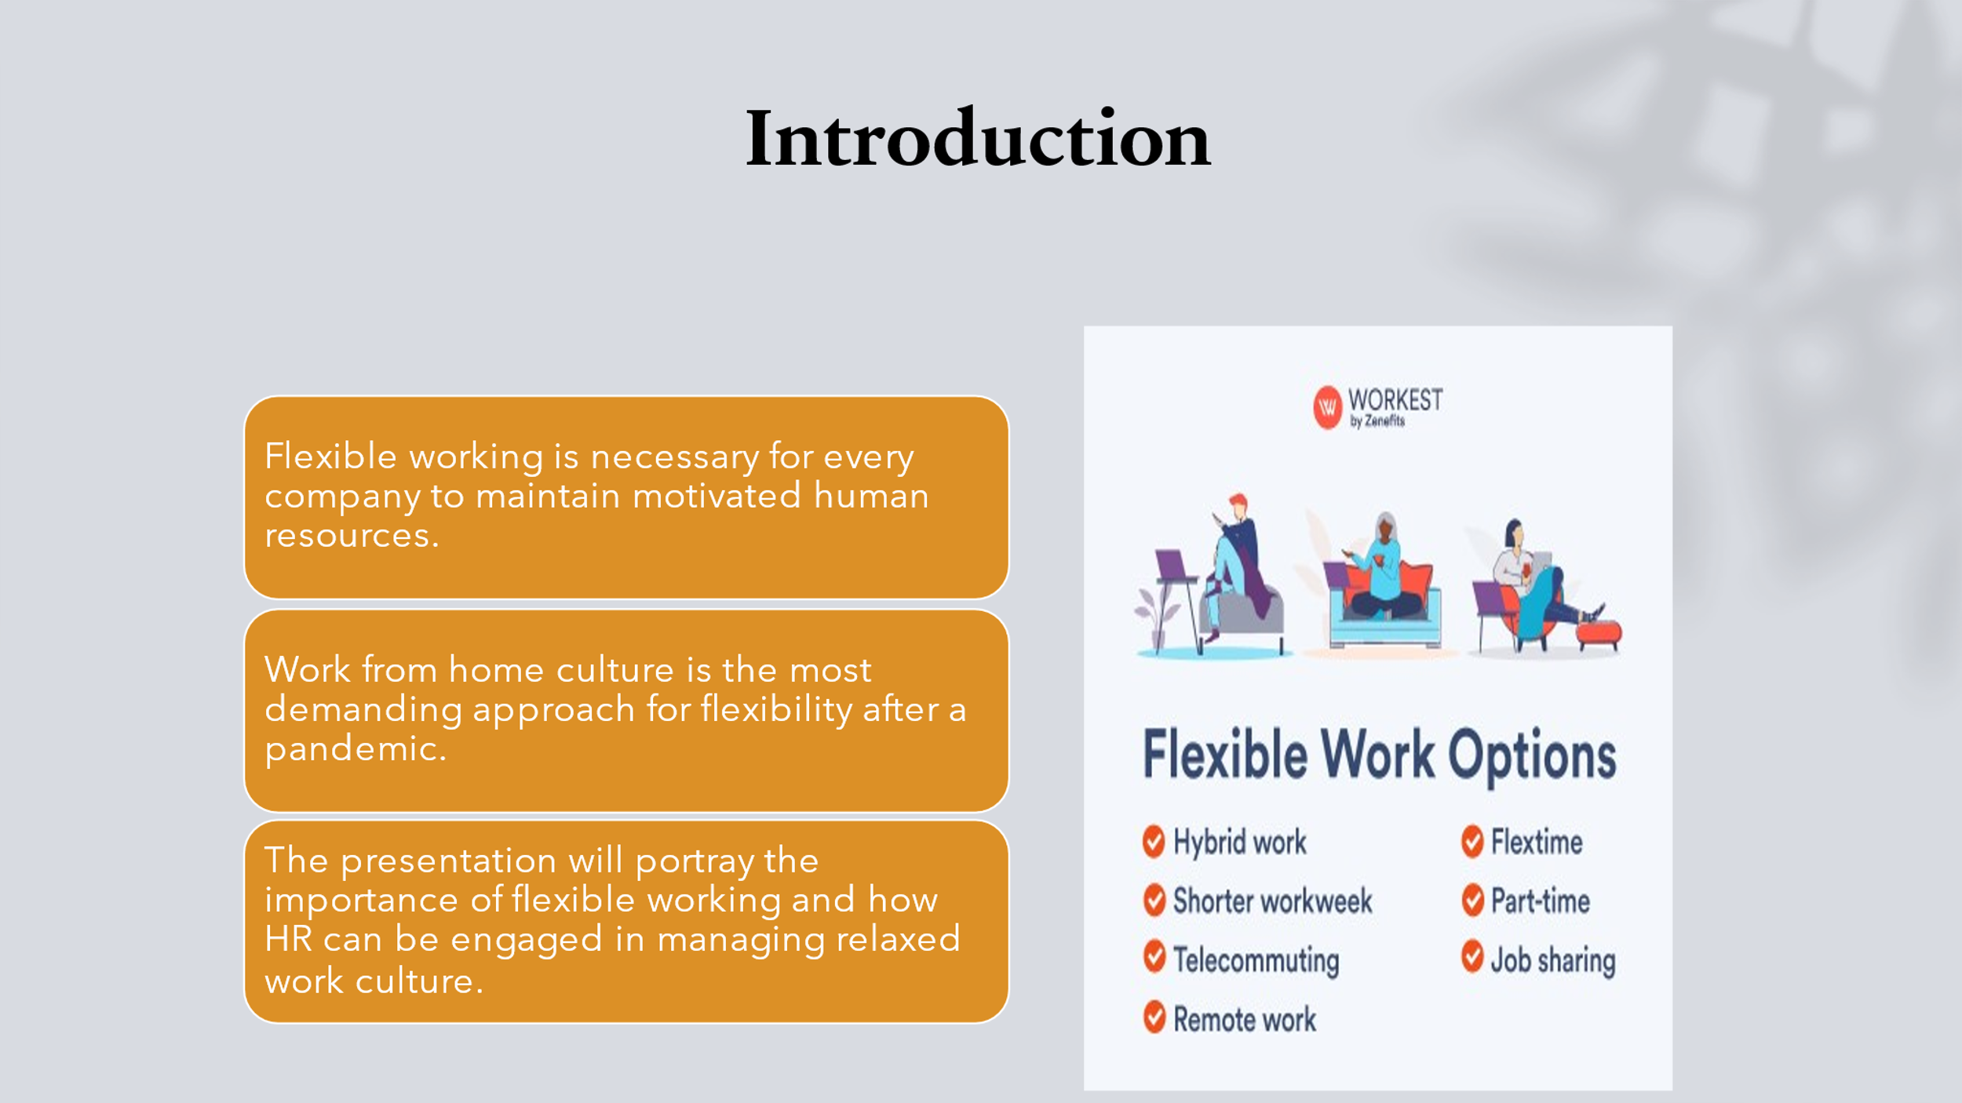It is true that during the pandemic situation, there was a restriction on free movement and people were prevented through the social distancing principle. In this regard, working from home is the best way for an organisation to attract human resources and maintain safety in a closed culture system. Thus, the presentation is based on opening a new area of discussion regarding flexible working concerning inclusion and diversity at work.
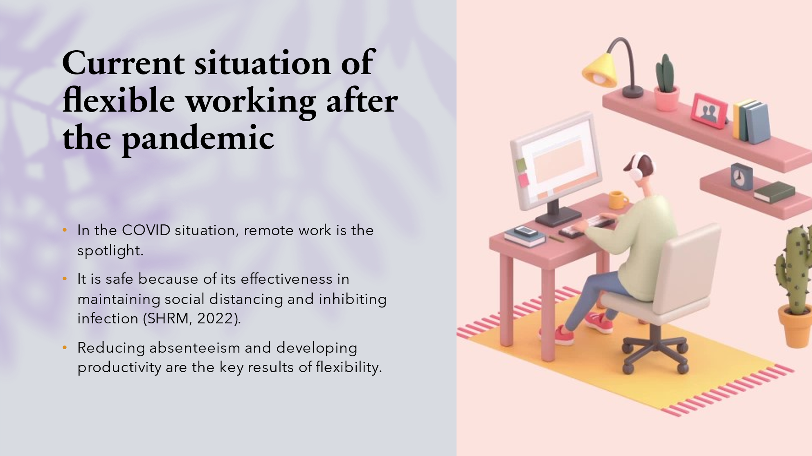It is seen that a number of big companies are focusing on supporting the employee base by involving flexible working facilities after the pandemic. It is seen through a survey that some employees want to work from home part of the week whereas some of them want to work from home throughout the week. Therefore, it is clear that the demand culture for flexible working after the pandemic is gradually developing.
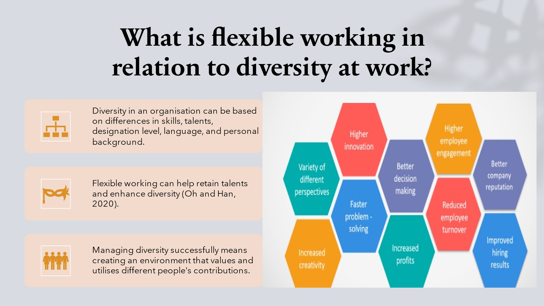It can be highlighted that if flexible culture is not maintained in an organisation, the authority may fail to retain talented employees. Therefore, it is prominent that the retail sector has held a flexible work culture; hence, their human resources retention has not been negatively affected even during the pandemic. It has also become helpful to establish a diverse pool of workforce. 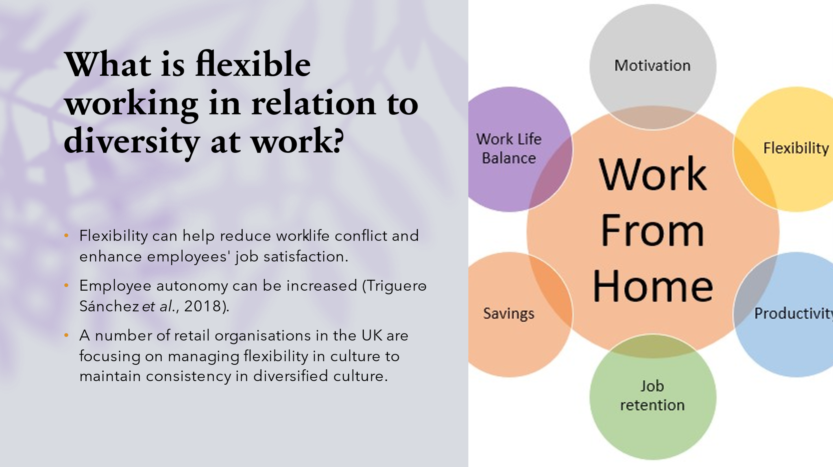
In modern times post-pandemic, it is true that if companies do not give flexibility to employees, retaining them can be challenging. Along with this, absenteeism can be increased. In order to introduce flexibility, a company can maintain employees from diversified backgrounds. For example, if a Muslim employee wants to have prayer during office hours, he can manage the remote working process, which can be tough to manage during work from the office. 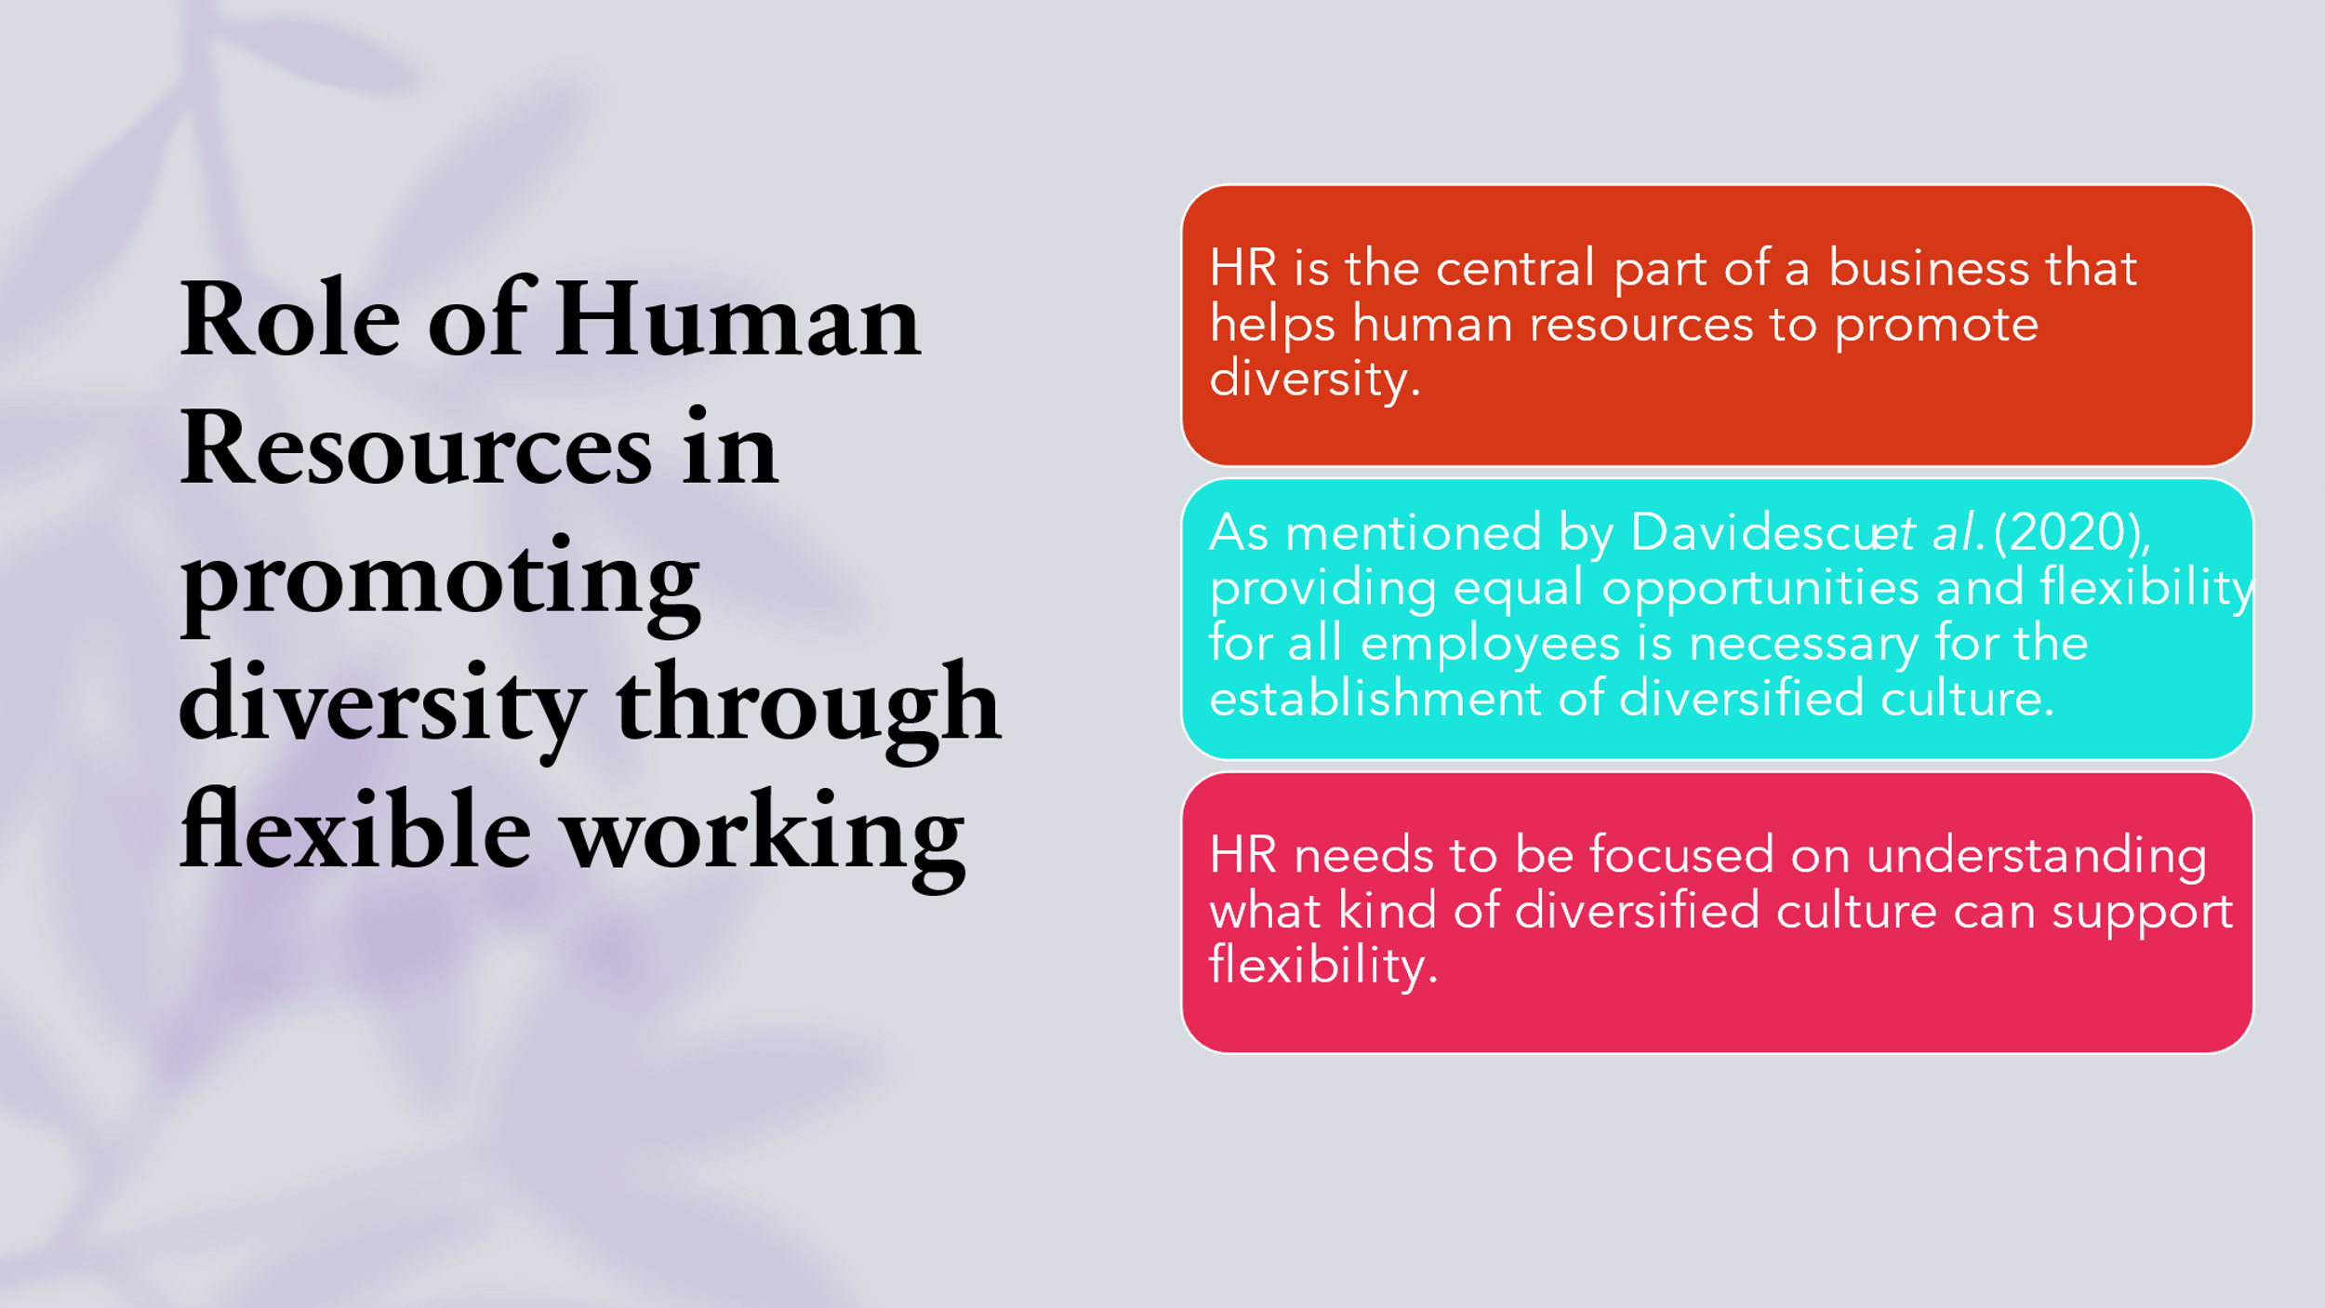
There can be different aspects of diversified business culture, such as age-based segregation of work, skill-based division of labour, and experience-based work culture. From this point of view, it can be stated that if HR emphasises the implementation of flexible culture, all types of division of labour can be sustained.
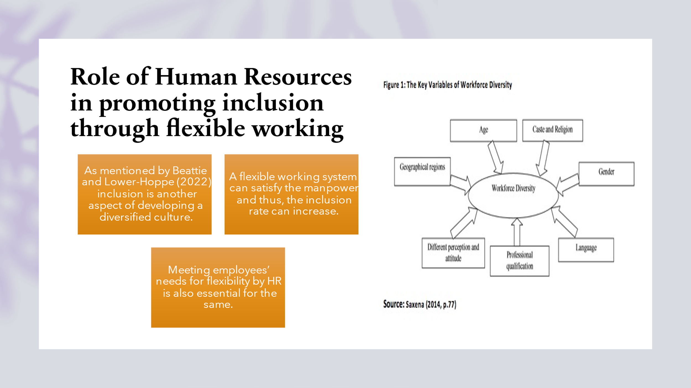It is evident that HR is only responsible for handling the manpower; without developing the inclusion rate, creating business success cannot be possible. Hence, inclusion is necessary. Apart from this, it is highlighted that the flexible work culture of remote working can encourage employees to be attentive towards the business process development. On the other hand, thorough training and development will be necessary for inclusion and flexible working.
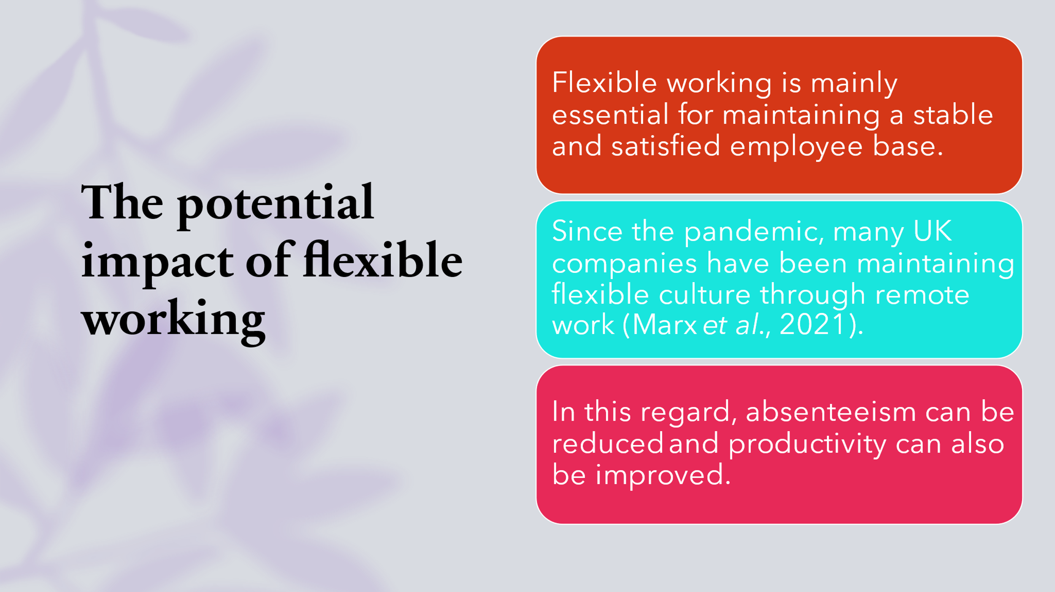Therefore, it is proven true that without a remote work policy and flexible work system, it can never be possible to maintain business processes during the lockdown period. Most companies have maintained their business policies through remote working methods, and this kind of flexible working becomes necessary for managing business value continually in the post-pandemic scenario.
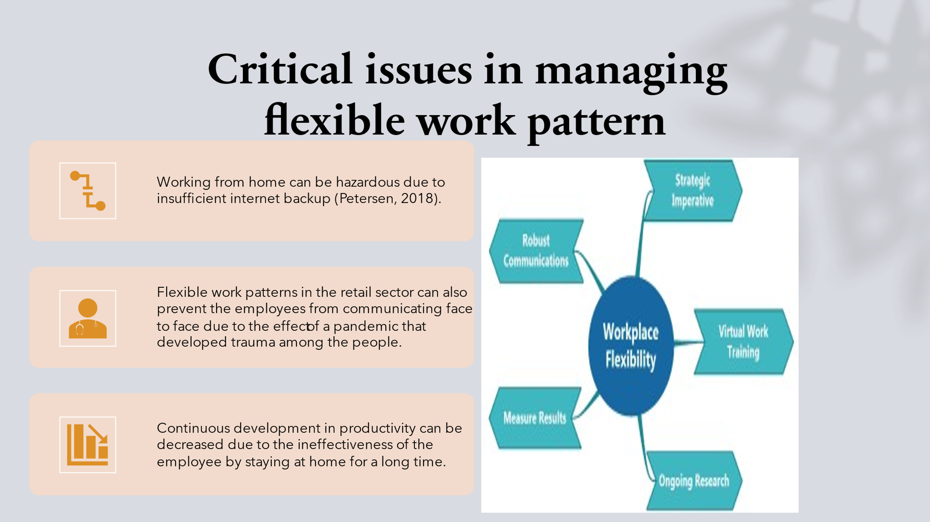It has been noticed that employees can become highly ineffective in their working field due to the flexible job opportunity and work-from-home structure during office time. It can decrease the positive working engagement in the business due to less work energy and a negative mindset.
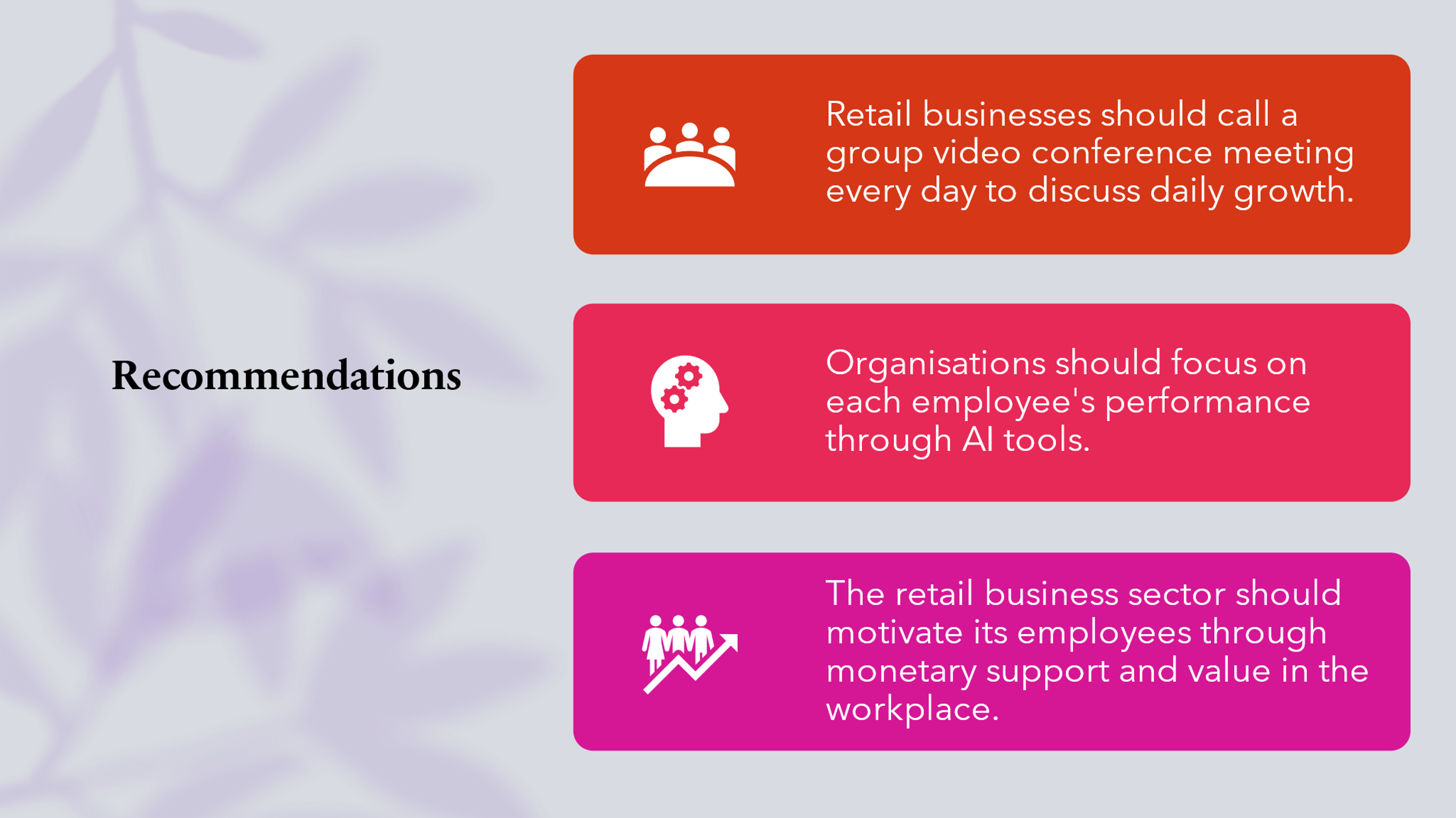Adequate motivational support by the business can increase employee engagement in the retail business sector. Implementing AI tools can also help the managers in the retail industry to focus on employee productivity where the life support value can encourage them to work with higher efficiency. The business should implement Herzberg's motivational theory to provide job security and health safety for employees, increasing their potential working ability.
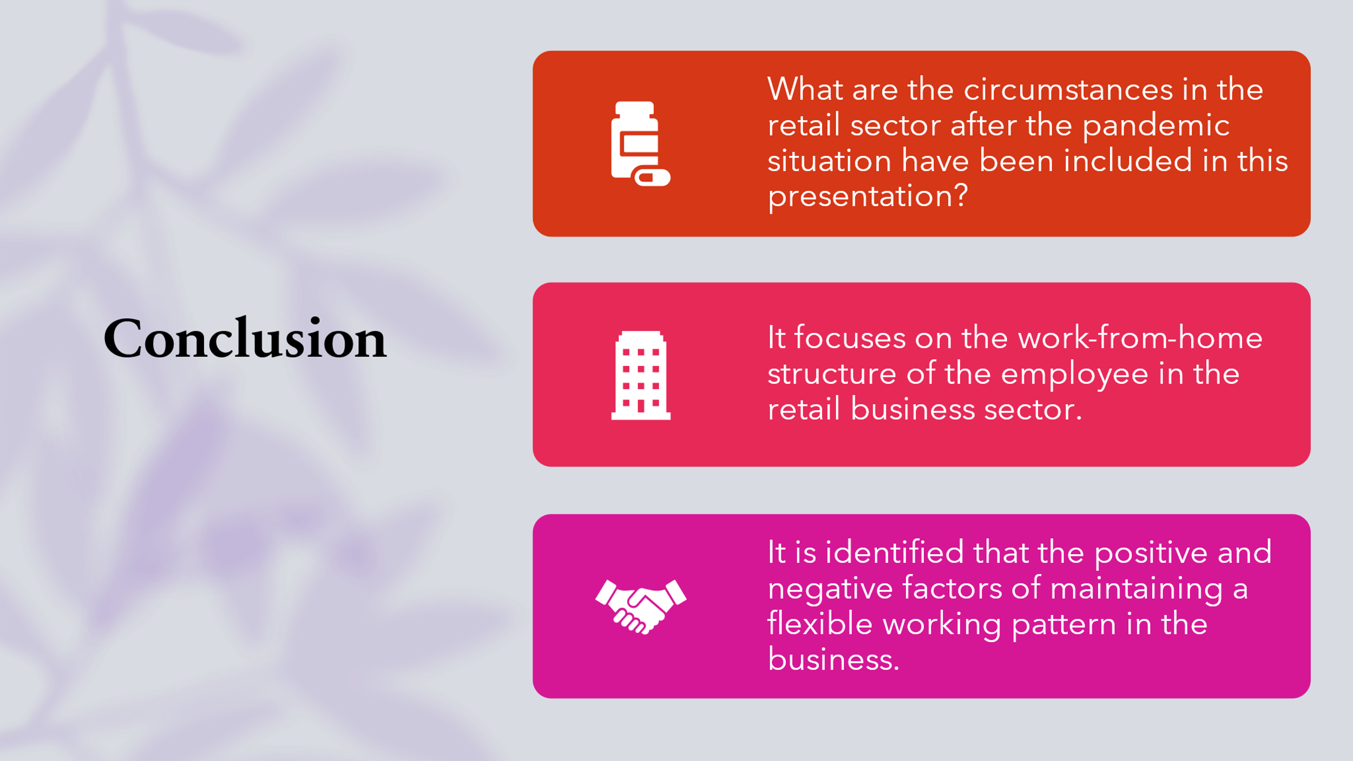Based on the situational outcome of the post-pandemic period, it has been required to maintain the flexible working structure in the retail business sector. The effects of implementing a flexible working structure in the retail industry have been explained throughout this presentation, analysing positive and negative impacts on the business. Also, the motivational factors that can increase employee efficiency have been included.


