Nathan J Morris

The following report will include a construction phase plan for the construction of a bridge linking two halves of an industrial estate, including Risk assessments, method statements and also identify current health and safety legislation appropriate to this project .
Access bridge construction
Neath port talbot council

Table of Contents
1. Introduction 2
1.1 Aim of the report 2
2. Construction Phase Plan 3
2.1. Nature of Project 3
2.2 Existing environment 4
2.3 Site compound 4
2.4 Health and safety 4
2.5 Work involving particular risk 5
2.6 Site specific measures 6
3. Site specific risk assessments 6
4. Method statements 7
5. Health and safety legislation 7
5.1 Client 7
5.2 Principal Designer 7
5.3 Principal Contractor 8
6. Appendices 9
7.1 Working near high voltage power lines – Method statement 19
7.2 Working at height – Method statement 19
7.3 Lifting operations – LOLER – Method statement 19
7.4 Excavations – Method statement 20
7. Drawings 22
8. References 23
9. Bibliography 23

Introduction

The below text is a brief overview of the proposed development written by the client, a location plan can be found in Figure 1 below.
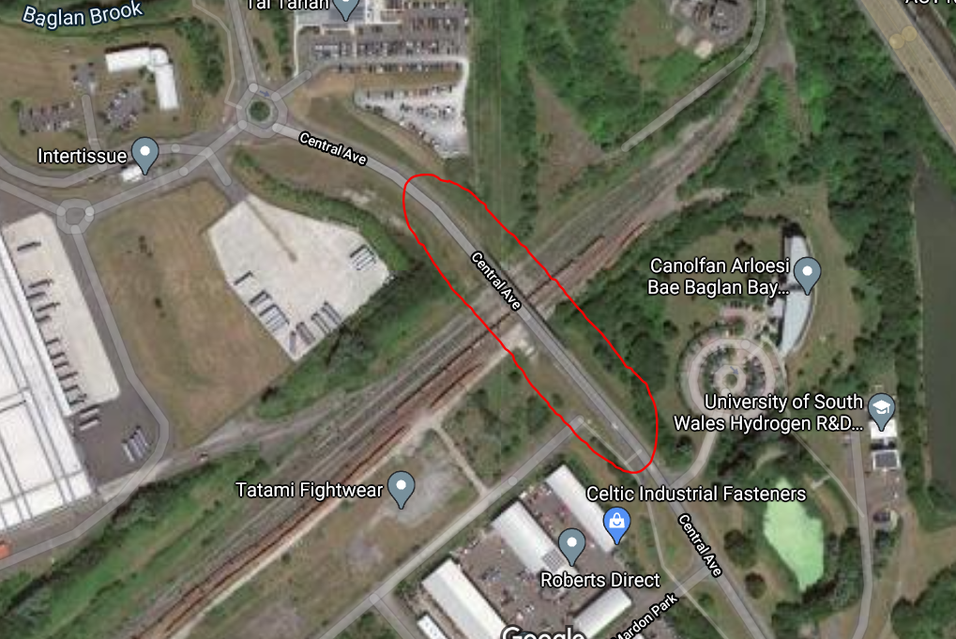
“Neath port talbot council have received planning consent for the construction of a bridge linking two halves of an industrial estate together. The bridge will provide access over a small railway line and provide good access to the local area”

Aim of the report

The below report will aim to provide a detailed construction phase plan for all major activities, specific method statements for three major work activities, three site specific risk assessments for three of the work activities and identify the relevant health and safety legislation for this construction project.

Construction Phase Plan

Nature of Project

Client: Neath port Talbot council
Address:
Neath Port Talbot CBC
Civic Centre,
Port Talbot
SA13 1PJ

Description of project:
- Construction of a bridge to link two sides of an industrial estate over small railway line
- Pile foundations to be used
- Piers to be made of material reinforced concrete
- Deck to be manufactured off site

The construction phase plan below is designed to comply with HSE guidance document L153 and construction design and management (CDM) regulations 2015. (HSE,2020)

Project start date : 6th May 2021 Completion date : 6th May 2023
Duration : 104 weeks
Principal Designer : John s Flower
The Quays, Brunel way, Baglan energy park, Neath, SA112GG
Tel 07984984654

Main Contractor : Costain
Email mnc@Costain.co.uk
Address: Costain LTD, Stillhouse lane, Bristol, BS34EB
Tel 01179 347100

2.2 Existing environment

Site description
The existing site has a small railway line running through the centre of it which will be directly underneath the bridge, either side of the proposed bridge there is relatively new construction consisting of office blocks with a road leading up to a fenced off access point where the bridge will connect in.
Access
There is good access both sides of the development and close proximity to the M4, with adequate space for site cabins.
Surveys
All surveys and drawings have been completed in advance of the work commencing and are readily available upon request and will be on site provided to the site foreman and held in the main reception building on site.

2.3 Site compound

Security
Site security to be provided by main contractor, Herras fencing surrounding the compound will be erected and security on site 24/7 will be required. All personal will be required to sign into site via main reception building and have full site inductions prior to work commencing
Welfare
All welfare facilities to be provided by main contractor within site compound, consisting of office space, canteen, wash and toilet facilities

2.4 Health and safety

Personal protective equipment
Helmet, boots, hi viz to be worn at all times in addition to job specific PPE. Main contractor PPE requirements to be adopted.
Parking
All vehicles to be parked in designated area and reverse parking procedure followed
Smoking / mobile phones
Smoking and use of mobile phones only allowed in designated areas.
Safety briefings / toolbox talks
These will be held each morning by the site Forman and after any incident / change of construction phase
Site induction
All personal will be required to read and sign the site induction register prior to going on site
Hot works
All permits to be issued and closed by designated P.C
Fire / site Alarms
Upon hearing the alarm all personnel will be required to walk to the designated area on site
Emergency contact details
First aiders details will be held in the main reception cabin, but all emergencies will require the dialling of 999 and the Nearest Accident and Emergency hospital is Morriston hospital, sa66nl. Good phone signal is present throughout site
Site safety file
A site safety information booklet will be available in the main reception cabin, containing all site rules, HSE law poster,Employers liability insurance, site rules and other applicable documentation.

2.5 Work involving particular risk

Under the construction (design and management) regulations 2015, work involving particular risks are outlined below (gov.uk,2020)
1. Work which puts workers at risk of burial under earth falls, engulfment in swampland or falling from a height, where the risk is particularly aggravated by the nature of the work or processes used or by the environment at the place of work or site.
2. Work that puts workers at risk from chemical or biological substances constituting a particular danger to the health or safety of workers or involving a legal requirement for health monitoring.
3. Work with Ionizing radiation requiring the designation of controlled or supervised areas under regulation 16 of the Ionising Radiations Regulations 1999.
4. Work near high voltage power lines.
5. Work near buried services.
6. Work exposing workers to the risk of drowning
7. Work in chambers, manholes, wells, underground earthworks and tunnels.
8. Work carried out by divers having a system of air supply.
9. Work carried out by workers in caissons with a compressed air atmosphere
10. Work involving the use of explosives.
11. Work involving the assembly or dismantling of heavy prefabricated components using lifting equipment.
12. Additional Measures

2.6 Site specific measures

In addition to the many H&S procedures there are 4 main site-specific procedures that will be expanded upon below and detailed Risk assessments and method statements produced for these
Working near high voltage power lines
This measure will be detailed in the appendices to this report (appendix 1)
Working at height
This measure will be detailed in the appendices to this report (appendix 2)
Lifting operations and lifting equipment - LOLER
This measure will be detailed in the appendices to this report (appendix 3)
Excavations
This measure will be detailed in the appendices to this report (appendix 4)

Site specific risk assessments

Working near high voltage power lines
Appendix 1
Working at height
Appendix 2
Lifting operations and lifting equipment - LOLER
Appendix 3
Excavations
Appendix 4

Method statements

Working near high voltage power lines
Appendix 5
Working at height
Appendix 6
Lifting operations and lifting equipment - LOLER
Appendix 7
Excavations
Appendix 8

Health and safety legislation

The Health and safety legislation for this project falls under the construction (Design and Management) Regulations 2015 and this came into force on the 6th April 2015 (HSE,2020). This legislation replaced the previous CDM 2007 regulations.

There are three main duty holders under this regulation and the subheadings below will outline their main roles and responsibilities and which are most applicable to this project.

5.1 Client

The client which can be defined as “any person for whom the project is carried out” (HSE,2020). The client for this project is Neath port Talbot council will need to ensure there are sufficient funds for the project, set out clear roles and responsibilities for their selected project team and select and hire a competent principal designer for this project and satisfactorily prove their capabilities.
The client must also ensure that a health and safety construction phase plan is produced prior to the construction phase of the project and ensure both the principal designer and contractor carry out their duties.

Principal Designer

A designer according to CDM regulations is an “organisation or individual who prepares or modifies a design for a construction project, or arranges for or instructs someone to do so” (HSE,2020)
Regulation 8 of part 3 of CDM 2015 states that a designer or contractor must be competent with the right skillset to experience and knowledge to undertake projects which they are capable of and in a safe manner (HSE,2020).
The principal designer must assist the client in providing pre construction information to any appointed designer / contractor and ensure designers carry out their duties
Principal designers must also identify, eliminate and control any foreseeable risks (HSE,2020)
In the above project the principal designer is also Neath port Talbot council in house design team

Principal Contractor

The Principal contractors main role is to “plan, manage, monitor and coordinate health and safety in the construction phase of a project” (HSE,2020).
This can include preparing the construction phase plan, liasing with both the client and principle designer and coordinate work between various contractors working on site. This can include site security, site inductions, provide welfare provisions and ensure site operatives are adhering to all health and safety procedures.
The principal contractor for this project is Costain.

Appendices

 |  |  |  | Consequence (C)
 |  |  |  | No Effect 1 | Minor Injuries 2 | Major Injuries 3 |  |  | Fatalities 4 | Risk Rating (RR)
 | F  r  e  q  u  e  n  c  y  (F) | Negligible 1 |  | Low  1 | Low  2 | Low  3 |  |  | Low  4 | 1-4 Trivial,  requires little  attention
 | F  r  e  q  u  e  n  c  y  (F) | Unlikely 2 |  | Low  2 | Low  4 | Acceptable  6 |  |  | Acceptable  8 | 5-8 Acceptable,  requires hazards to  be avoided
 | F  r  e  q  u  e  n  c  y  (F) | Likely 3 |  | Low  3 | Acceptable  6 | Substantial  9 |  |  | Substantial  12 | 9-12 Substantial,  requires hazards to  be reduced
 | F  r  e  q  u  e  n  c  y  (F) | Probable 4 |  | Low  4 | Acceptable  8 | Substantial  12 |  |  | Intolerable  16 | 13-16 Intolerable,  requires hazards to  be controlled /  eliminated
RISK ASSESSMENT |  |  |  |  |  |  |  | ACTIVITY:
(C) CONSEQUENCE |  |  | (F) FREQUENCY |  |  |  | (RR) | RISK RATING
1. Negligible/No effect |  |  | 1. Negligible |  |  |  | 1 – 4 | Trivial
2. Minor Injuries |  |  | 2. Unlikely |  |  |  | 5 – 8 | Acceptable
3. Major Injuries |  |  | 3. Likely |  |  |  | 9 – 12 | Substantial |  |  | } WORK MUST
4. Fatalities |  |  | 4. Probable |  |  |  | 13 – 16 | Intolerable |  |  | } NOT START

Working near high voltage power lines
Appendix 5

Hazard | Those at risk | Risk / effect | Before Control | Control | After Control
High voltage power lines | Site / plant operatives | Almost certain death as a result of Electrocution to personnel which could also result in a fire or explosion.  Excavators and other items of plant inc. Hiabs etc inadvertently coming into contact with over head power lines which cross the work area.  Operatives carrying items such as scaffold tubes over their shoulder and coming into contact with the overhead power lines. | 4x4=16 | When carrying out site inductions make everyone aware of any overhead power lines that cross the work area.  If unsure treat all over head lines as power lines.  Refer to guidance notes HSE GS6 for safe working practises. Erect Goal Posts and bunting tape on both sides of the power lines.  No unloading activity or storing of equipment is to take place under the overhead lines.  If any excavations are to be carried out under power lines then the regional electricity company ie WPD must be contacted and will be asked to visit site to give safe working distances. In this case only excavators with Height Restrictors should be used. When working close to (i.e. minimum 8m) power lines excavators will come under the control of Banksmen.  IF IN DOUBT, STOP & ASK IS IT SAFE TO CONTINUE | 4x2=8

Working at height
Appendix 6
Hazard | Those at risk | Risk / effect | Before Control | Control | After Control
Falling from height / objects falling from height | Site operatives falling from height, operatives working below | Persons falling from height when climbing ladders to access and egress excavations / pillars  Serious injury or even possible death as a result of falling from an insecure, poorly positioned or a defective ladder whilst gaining access too or egress from excavations under construction. | 3x4=12 | No ladder greater than 9m in length must be used on site.  All scaffold to be erected by qualified tradesmen and inspected weekly.  Ensure boots are free from mud. Ensure rungs are free from mud  The carrying of tools and equipment is prohibited when climbing ladders.  The usage of ladders will be monitored regularly to ensure operatives are using them in accordance with the appropriate RA.  Ladder inspections must be recorded on the inspection sheet and on the weekly PUWER report form. Each ladder must have a unique plant number and tagged to state that it has been inspected.  All hand held tools and loose items are too removed and placed in a bucket which can be safely lowered by means of a rope.  Scaffold to have edge protection of minimum height 950mm, fitted with toe boards where there is a risk of objects being kicked or falling and causing injury to those working below.Only one person to be on the ladder at any one time. All others must stand clear of the ladder. PPE to be worn at all times | 3x2=6

Lifting operations and lifting equipment - LOLER
Appendix 7
Hazard | Those at risk | Risk / effect | Before Control | Control | After Control
Lifting of loads | Site operatives  Crane operators  Members of the public  Road / rail users | Risk of serious injury or possible death as a result of falling loads or crane overturning.  Defective equipment and un-trained crane operators.  Uncontrolled lifting of load causing failure of lifting appliances or equipment.  Uncontrolled slewing causing collision with plant and crushing type injury to operatives  Failure of lifting equipment.  Failure of lifting tackle.  Insecure loads. | 4x3=12 | Set up exclusion zone to prevent unauthorised access to the work area where the load is being lifted.  Check ground conditions are firm and flat to prevent any overturning of the crane.  Ensure a lift plan has been completed and the crane is capable of lifting the load by checking lift curves and the current lifting certificate which is kept on the crane to determine the SWL at the relevant radius.  Ensure the crane has a certificate of conformity, periodic inspection certificate, lifting tackle certificates and a current operator’s license (CPCS).  Ensure only trained slingers attached load (CPCS) and control the lifting operation. If the load is to be moved ensure banksmen are in attendance when load is being transported. | 4x2=8

Excavations
Appendix 8

Hazard | Those at risk | Risk / effect | Before Control | Control | After Control
Excavations | Site / plant operatives | The risk of serious injury or possible death by inadvertently hitting a buried services such as an electrical cable, gas main, water main etc  Resulting in Electrocution / Burns due to inadvertent contact with buried electrical services.  Explosion due to inadvertent contact with gas mains, all resulting in serious injury to personnel and inconvenience to consumers of Public Utility Companies. | 4x4=16 | All excavations should be carried out in accordance with GS 47 “Avoiding Danger From Underground Services”. Ensure the utility service drawings are available on site. Request a Permit to Excavate from your Site Manager. Before breaking ground the Ganger MUST complete the Pre Excavation Checklist. Those working in and around buried services should be wearing Flame Resistant Clothing. Carry out a CAT scan of the entire area. Mark out any services that’s been detected with the CAT3+ & Genny with spray paint and check them against the drawings. Lift any covers to help identify the depth and route of buried services. Check for scars in the tarmac. The excavator fitted with a TOOTHLESS Bucket can remove the top tarmac surface. Then using a shovel and no mechanical plant or sharp/ pointed implemented tools carefully break the surface and start to hand dig. Continue to CAT scan as you dig. Having hand dug to a depth of approx 300mm and having not come across any service then the excavator can be used to remove the spoil to a depth of 200mm thus always leaving 100mm of proven ground. If at any time the banksman signals to stop then the driver will stop and carefully lift the bucket out of the ground. This method of excavation will continue until such time you are satisfied that no services are present. If you come across any services treat them as LIVE. Support and protect any exposed service. | 4x2=8

7.1 Working near high voltage power lines – Method statement
Appendix 1
A copy on site of the HSE’s GS6 “Avoiding Danger From Overhead Power Lines” should be available throughout the project. (HSE,2020)
All staff should be briefed in the dangers of overhead power lines
Goal posts will be erected, and a designated site path established for all vehicles with a minimum of 6m horizontal distance from the nearest wire
All power lines to be treated as Live!.
If any vehicle does touch an overhead wire, either stay in the vehicle or if you do need to exit the vehicle jump as far away from it as possible and do not return or touch it.

7.2 Working at height – Method statement
Appendix 2
All employees to have appropriate certificates and tickets before being allowed on site, and the working at height regulations 2005 procedure made available for reference.
Site foreman will carry out dynamic risk assessment before any working at height is undertaken.
All equipment will be inspected in accordance with HSE guidelines.
Ladders to be used as an access point for scaffold and should be tied and footed and inspected in accordance with relevant procedures.
All site operatives to read HSE leaflet INDG402 before using ladders (HSE,2020)
All scaffold to be erected by approved contractor and all fitted with toe boards to correct specification.
Daily checks will be undertaken by site foreman and defects reported / equipment disabled immediately

7.3 Lifting operations – LOLER – Method statement
Appendix 3
For the lifting of the concrete deck, the pre manufactured deck will be brought to site and placed in designated marked out area
The crane will arrive on site via the pre determined route and set up on site
As per manufacturers guidelines the crane will use appropriate lifting platforms and area cordoned off by temporary barriers
The lift supervisor will carry out all checks and instruct the crane driver to position lifting arm in place for rigging
The rigger will signal once this is complete and a test lift of no more than 50mm will occur to check lift balance etc
Once the lift supervisor is happy with the balance and weather conditions the lift will begin
The deck will be manoeuvred into place and the pre drilled fixing points secured
Once this has taken place the load will be de rigged and the crane will return to its starting position and the set up process reversed
All lifting operations must conform to the lifting operations and lifting equipment regulations 1998 (LOLER) (HSE,2020)

7.4 Excavations – Method statement
Appendix 4
A copy of the HSE’s HSG 47 “Avoiding Danger From Buried Services” must be on site and used as a reference throughout the excavation process. (HSE,2020)
Prior to any excavation being carried out, a Permit to Excavate will be issued by the Site Manager following a thorough survey / CAT scan of the area. The permit will include copies of all the utility services drawings in the area. Those operatives involved will be briefed onto the permit and the appropriate RAMS. The ganger MUST also complete a Pre Excavation Checklist to ensure he has followed all the required procedures to ensure a safe dig.
All services will be carefully located by means of thoroughly surveying the work area using the utility service drawings as a reference and the CAT4+ & Genny.
All services should be assumed live!
Ensure any services that are located are marked up using different colour spray paints for each of the services found, Only hand dig techniques will be permitted around any buried services. Any services that have been exposed will be protected and supported across the excavations and clearly highlighted.
No sharp / pointed implemented tools or mechanical equipment will be permitted to be used within 0.5m of any service. Also don’t attempt to remove concrete from around or close to any buried services.
Wherever practically possible mechanical excavation will be the preferred method of excavation. When the breaking of the bituminous surface is required, it will be broken out by the use of a machine mounted hydraulic breaker attached to the excavator. All personnel including the operator in the immediate vicinity of the breaking operation shall wear ear defenders and eye protection at all times.
If any services are discovered that were previously unforeseen or lay undetected, excavation will cease whilst further investigation is carried out. Any services uncovered will be assumed LIVE until written confirmation has been received that can confirm otherwise.
All movements by any machine will be carried out under the supervision of nominated and trained banks man(s). All operators of plant will be certified, competent and trained with CPCS qualification.
The excavated material will be either loaded directly onto a grab wagon or into a dumper or then stored in the compound area. It will then be removed from the compound and taken to a licensed tip. In order to comply with the Landfill Regulations, all muck away tickets are to be coded with a specific six-digit number. A Duty of Care waste transfer note must be produced for each load day that is transported from site.

Drawings

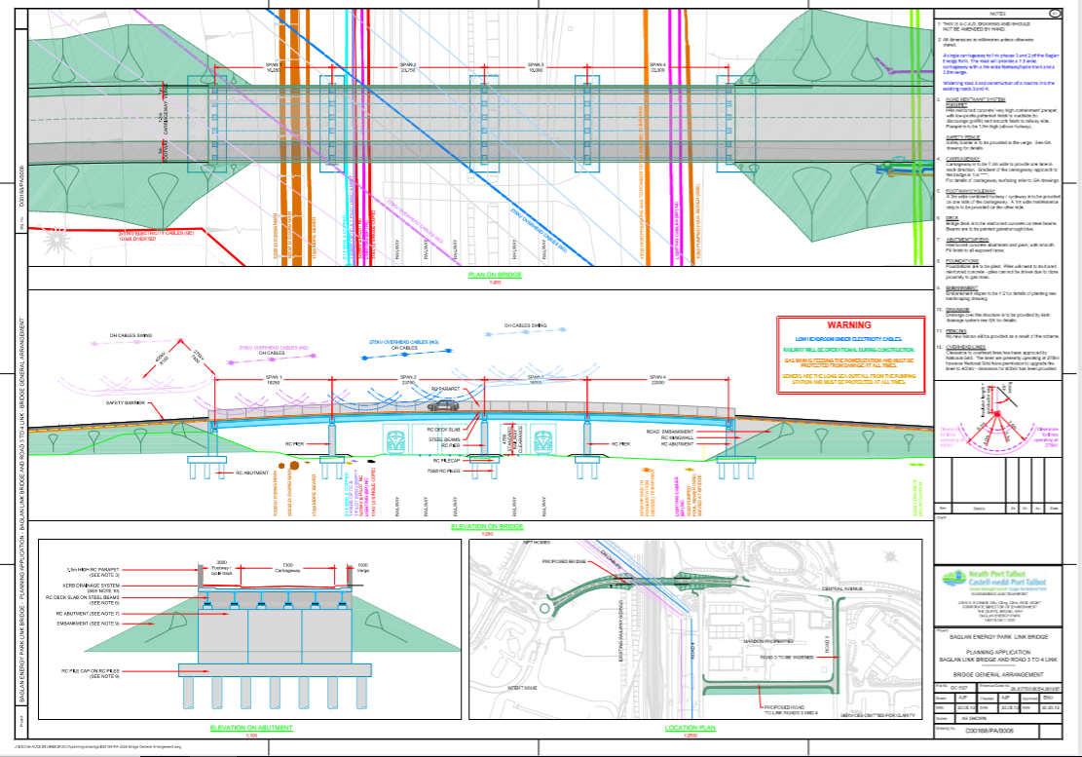

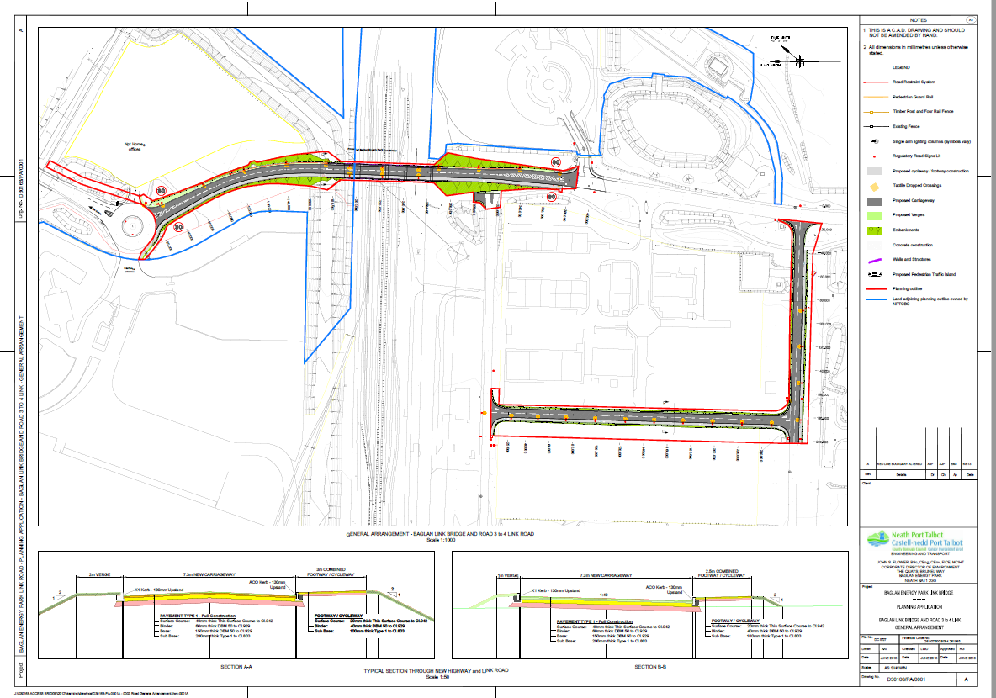

References

- CDM 2015. Available at: https://www.legislation.gov.uk/uksi/2015/51/schedule/3/made (Accessed 10/11/2020)
- Health and safety executive website. Available at: https://www.hse.gov.uk (Accessed 11/11/2020)

Bibliography

- Chudley,R. Greeno,R.(12th Edition)(2020). Building construction handbook. Oxford: Routledge

- Health and safety executive website. Available at: https://www.hse.gov.uk/pubns/priced/l153.pdf
- (Accessed 11/11/2020)

