3/20/2026
University of Wales Trinity saint David
London cumpus
Assignment one
E-Portfolio
E-Portfolio link: https://2442557.wixsite.com/aleem

Module Name: Learning in the Digital Era
Module Code: ACCA 4025

Student Name: Aleem Uddin Ali
Student ID: 2442557
Group: 2

Lecturer’s Name: Koushik Modak
Table of Contents
Introduction 2
Main Body 3
Task 1: Essential Academic and Employment Skills for the Future Career Path 3
(a) Report on Essential Academic and Employment Skills 3
(b) Evaluation of Task 1 (a) based on the Similarity report 5
Task 2: Collaborative Mind Map and Individual Poster 6
Mind Map (Collaborative) 6
Poster 7
Task 3: Virtual Collaboration and RefWorks 8
Virtual Collaboration 8
Step-by-step process and guide to RefWorks. 10
Task 4: E-Portfolio Creation and Illustrative Review 23
(a) E-Portfolio Creation 23
(b) Illustrative Review of E-Portfolio Tool Selection 31
Conclusion 32
Task 1 References: 33
Task 3 References: 33

Introduction
This assignment outlines the importance of developing the professional skills needed to succeed in your current role or future career. It also examines how effective teamwork supports clear communication and organised task planning, enabling groups to work more efficiently. In addition, it explores how modern tools, such as mind mapping software, can aid in generating and refining ideas. The paper further explains how to design and present academic posters that effectively communicate research findings. It also discusses the use of automated referencing tools to simplify the citation process. Finally, the report highlights how creating an online e-portfolio can showcase your learning, projects, and skills, helping to enhance both academic performance and future career opportunities.

Main Body

Task 1: Essential Academic and Employment Skills for the Future Career Path

(a) Report on Essential Academic and Employment Skills
When conversing effectively, you are better able to comprehend both spoken and nonverbal information. This covers textual communication, body language interpretation, clear speaking, and active listening. Possessing outstanding communication skills allows you to engage audiences with confidence and accomplish your goals, which will increase the organization's productivity and profitability. Having good communication skills helps you make better decisions, solve problems quickly, and comprehend others better.[1]
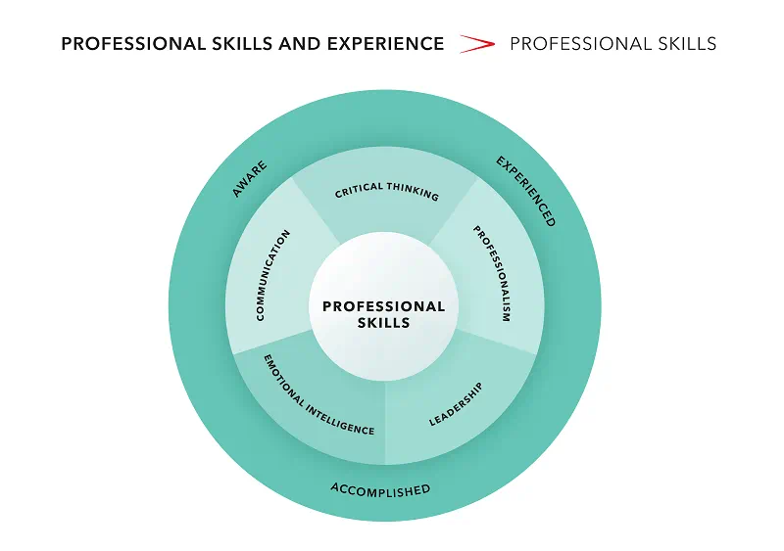
Figure 1: Essential Academic and Employment Skills [2]

Achieving success as a team and boosting both productivity and profits depend heavily on strong collaboration and teamwork. Key elements of effective group work include trust, mutual respect, problem-solving abilities, critical thinking, careful planning, organization, honesty, and ethical behavior. Together, these qualities enable teams to work efficiently, share diverse perspectives, build meaningful connections, and reach common goals. Accountability is encouraged, morale is raised, communication is improved, and the business may learn and grow continuously in a supportive team environment.[3]
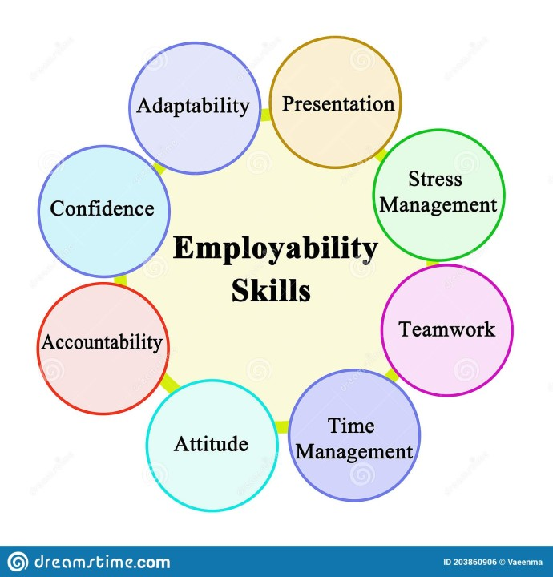
Figure 2: Essential Academic and Employment Skills. [4]

Time management involves organizing, prioritizing, planning, and executing tasks in a way that ensures they are completed effectively. It enhances productivity, efficiency, and overall performance, all of which support an organization’s growth. By allocating your time wisely across different responsibilities, you can achieve your goals more easily, reduce stress, and maintain higher energy levels.

To boost productivity in an organization, management and leadership are crucial tools. Effective communication, problem-solving, conflict resolution, decision-making, motivation, enthusiasm, and integrity to be fair and tough are some of these. Motivating people is crucial for carrying out duties, boosting output, and creating a cooperative atmosphere. To guarantee long-term success, effective leaders also establish trust, give clear direction, encourage professional development, and adjust to change.[5]

(b) Evaluation of Task 1 (a) based on the Similarity report

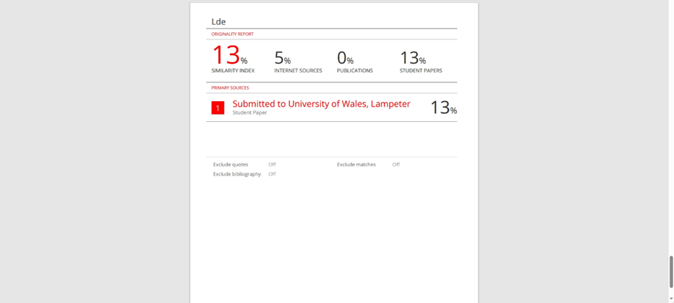

The similarity report showed a 13% match. Much of this overlap appears to come from work submitted by students at UWTSD Lampeter, as the templates used are commonly shared, and I did not significantly alter them for my assignment.
Based on this, I anticipate achieving a grade in the range of 40% to 50%. I have demonstrated time, effort, and research in completing this work. However, I could have managed my time more effectively by being more concise and paying closer attention to the word count from the start. To meet the required length, I have since edited and rephrased sections of my writing. In future, I plan to dedicate more time to research, compare a wider range of sources, and take more detailed notes to improve the overall quality of my work.

Task 2: Collaborative Mind Map and Individual Poster

Mind Map (Collaborative)

Mind Map Link: https://mm.tt/map/3750715697?t=cABH4IeUmT

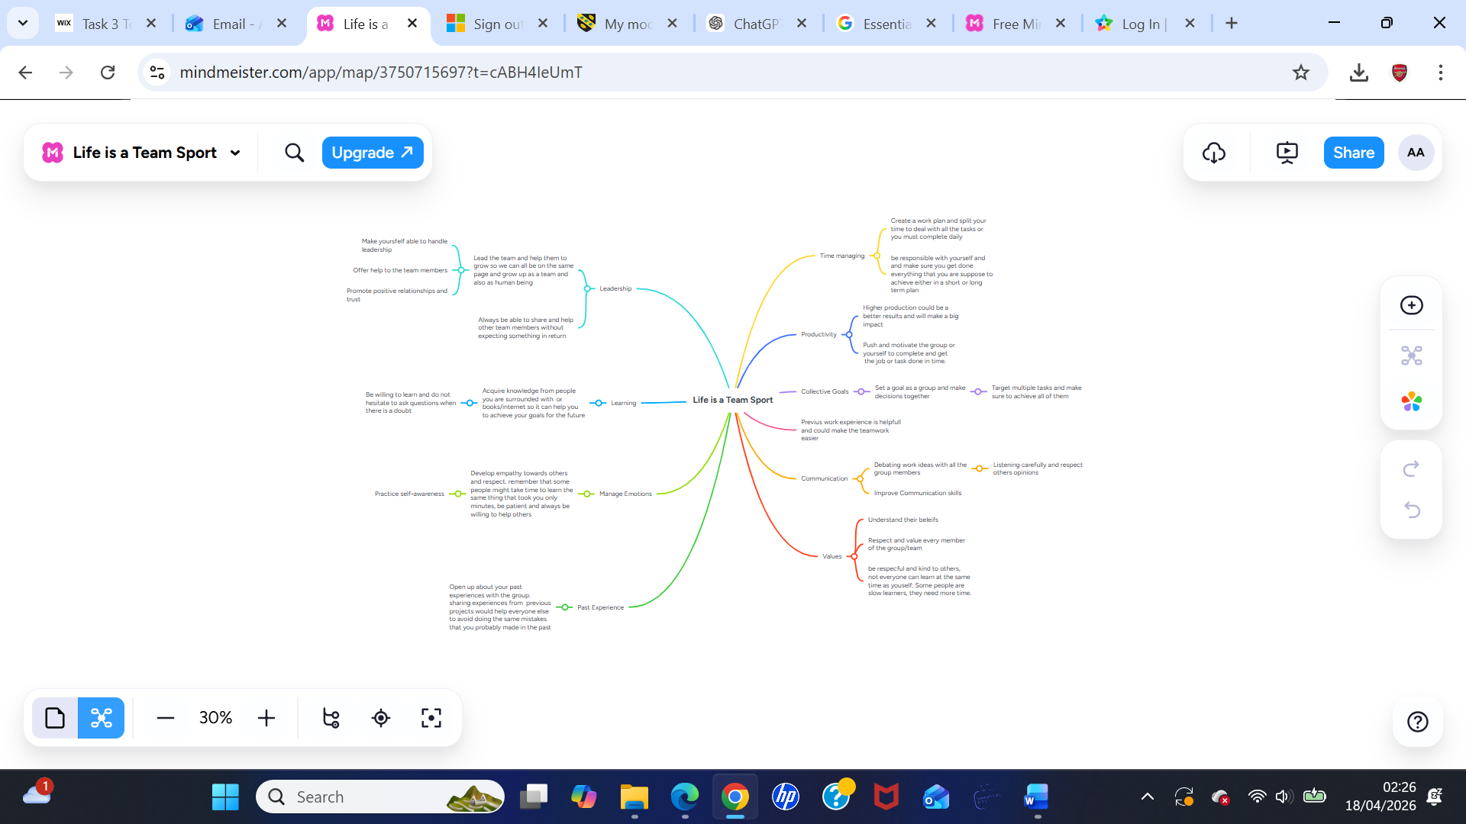

Poster

Poster Link: https://canva.link/3lujvh20garq454

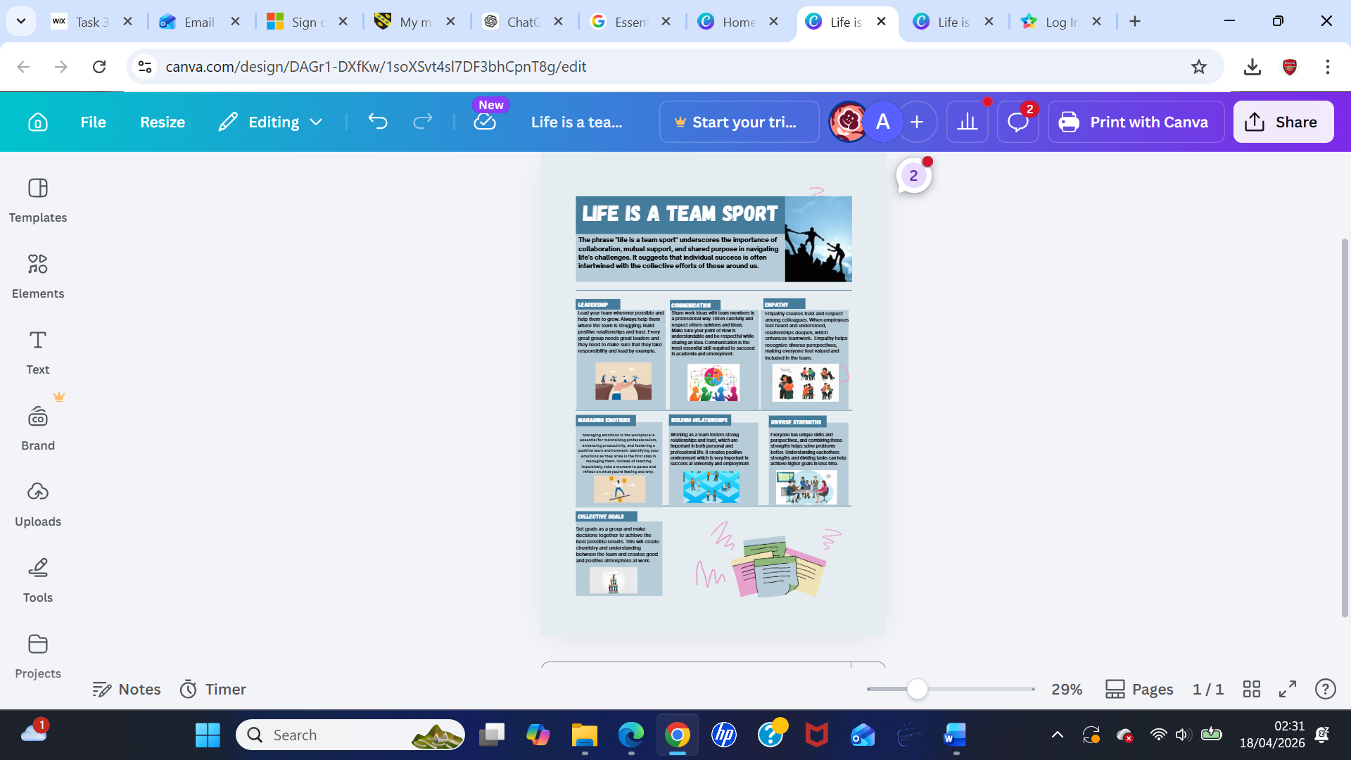

Task 3: Virtual Collaboration and RefWorks

Virtual Collaboration
Topic1: Forming
Working collaboratively online involves using digital tools and platforms such as Slack, Microsoft Teams, Zoom, and Google Workspace to create a shared environment where team members can communicate and complete tasks together.
Building and understanding your team requires maintaining open communication by being honest, transparent, and authentic. This approach helps develop trust, strengthens relationships, and creates a more confident and connected team dynamic.
You can use "Tuckman's stages of team development" when forming and structuring a team. By adhering to this theory, you can build and achieve a great team, increase your group work, and have a strong group presence. To maximize the benefits of group work, concentrate on setting clear goals, participating, and communicating openly.[1]
1. Forming
2. Storming
3. Norming
4. Performing
5. Adjourning

Figure 1: Tuckman's stages of team development [2]

Collaborating within a well-structured team environment helps members gain a clearer understanding of each other’s personalities and behaviours, making it easier to recognise individual strengths and weaknesses. A lack of trust is a major source of team dysfunction; without it, conflicts are more likely to arise, commitment to tasks and teammates can weaken, and accountability for mistakes may be avoided. This may result in a dysfunctional team, but addressing the underlying cause of the issue will help you and your team members learn how to work together to overcome challenges, which will produce excellent results.[3]
Applying the F.A.S.T. goal-setting approach can lead to highly effective results and strong performance. When used within a team, it encourages collaboration and helps achieve meaningful outcomes. It also improves communication and understanding, while building confidence in both yourself and your teammates. As a result, you may feel more at ease contributing to discussions, asking and answering questions, and engaging in group work, which boosts overall productivity. Staying clear about goals and being open in sharing ideas can also increase motivation and lead to more successful team achievements.

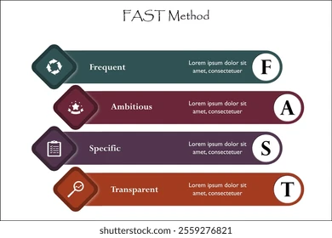
Figure 2: FAST method diagram [4]

Step-by-step process and guide to RefWorks.

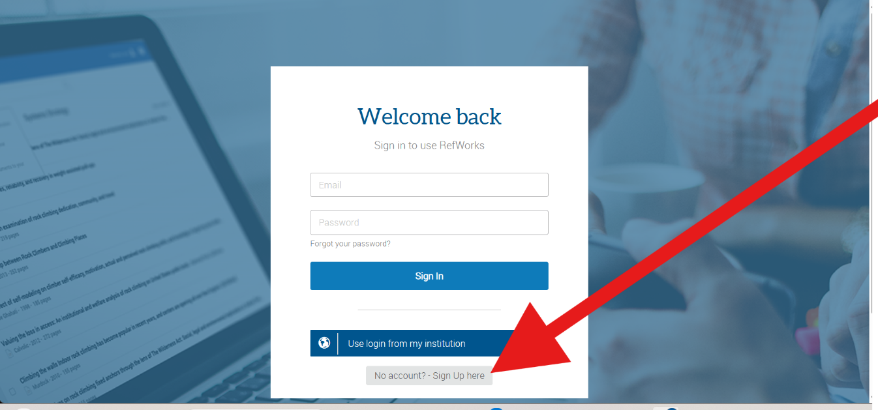Create an account with RefWorks or log in to your RefWorks account.

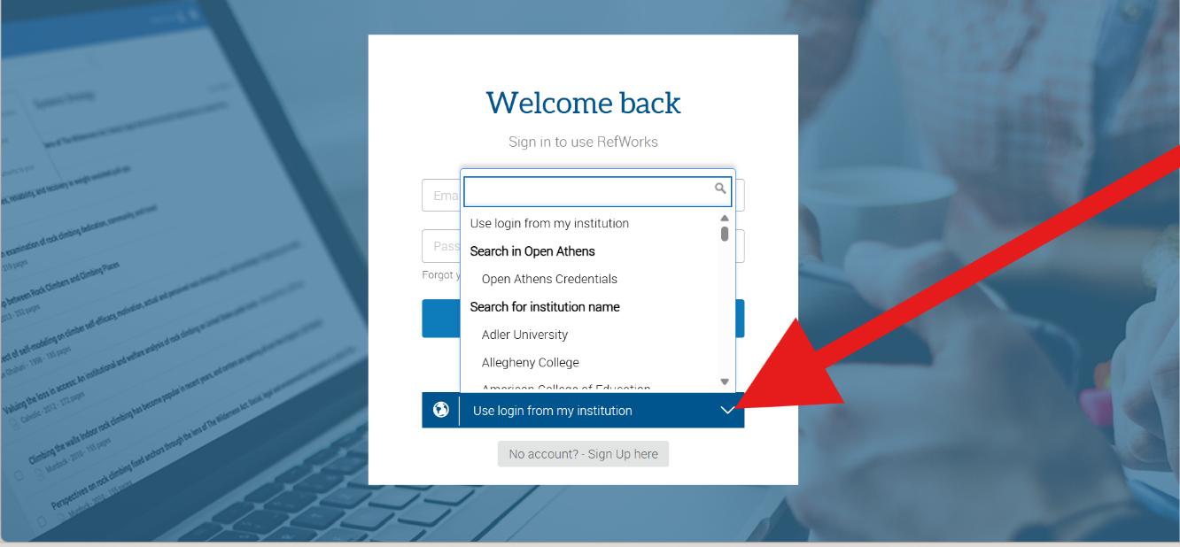Select your institute.

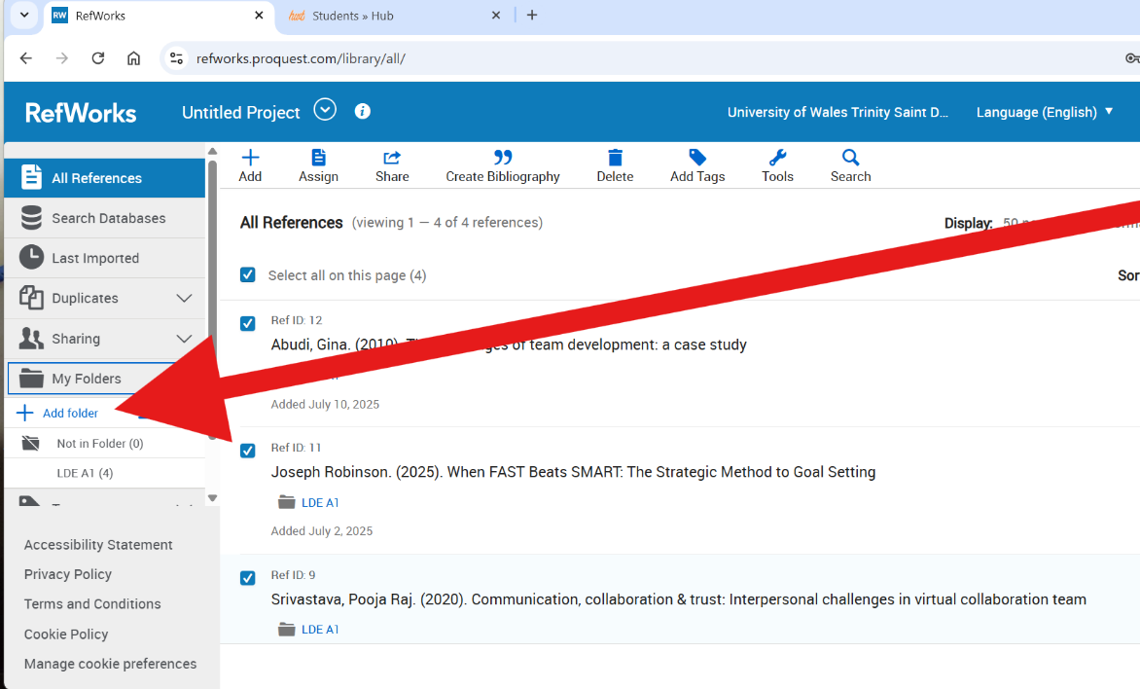
Select to add a folder.

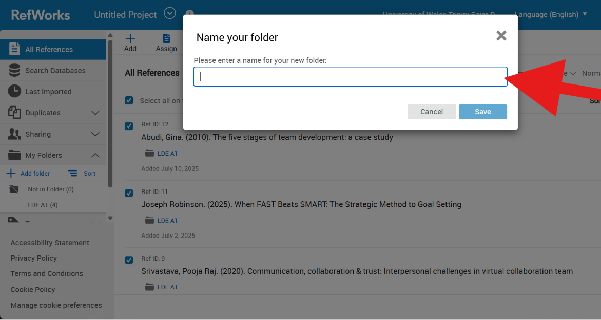
Name your folders to organize to add relevant citations, and a reference list.

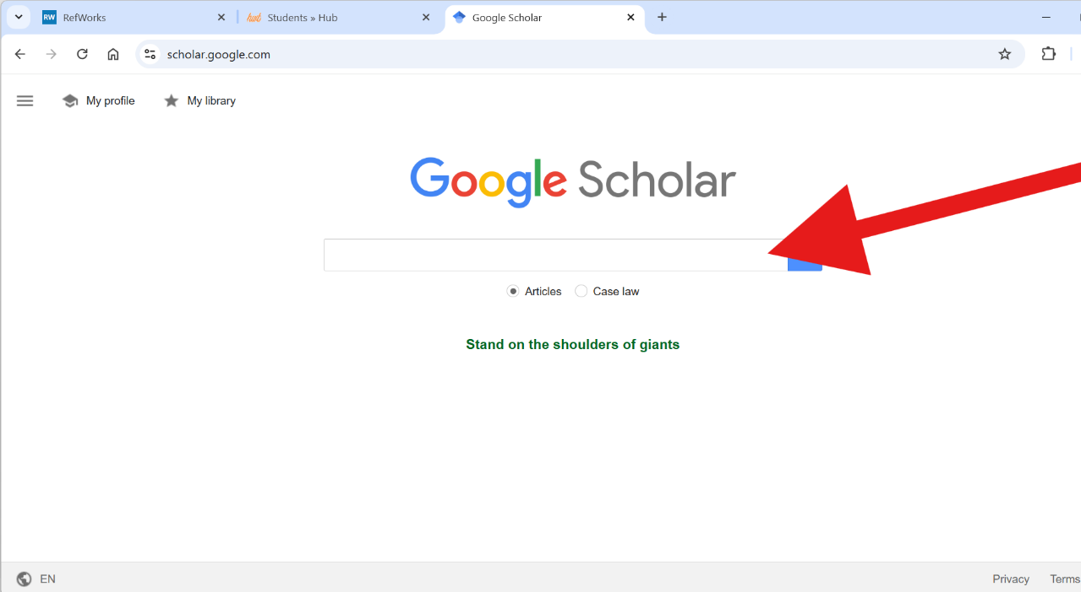Getting your citations and a reference, you can use the search engine Google Scholar to retrieve the information to link to RefWorks.

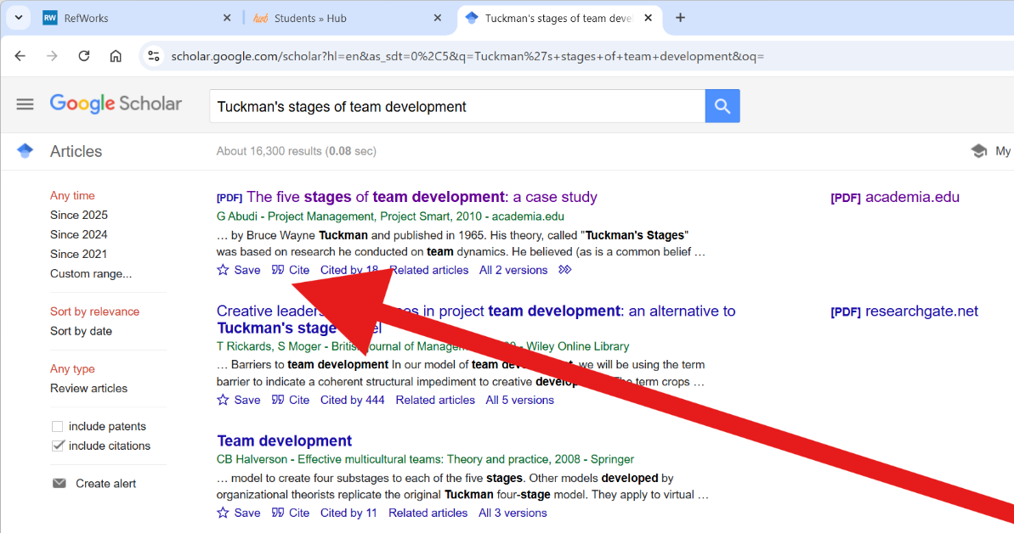
Search the topic you require and to link the Reference to RefWorks, select Cite.

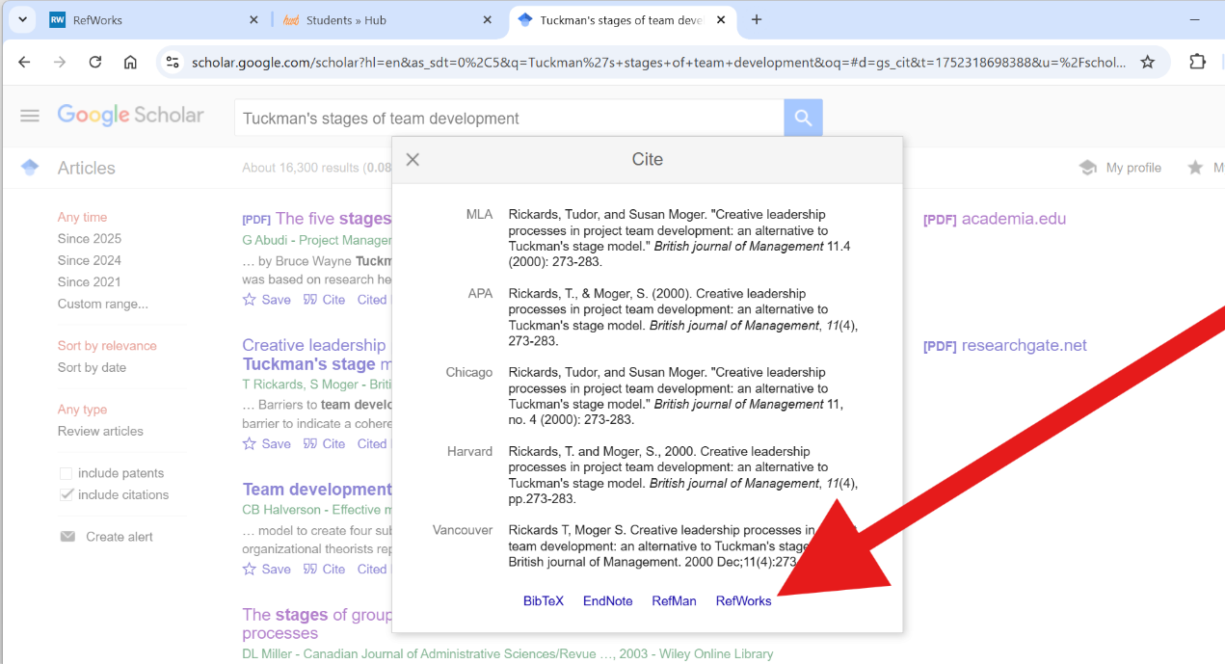
Select RefWorks to link the information to RefWorks.

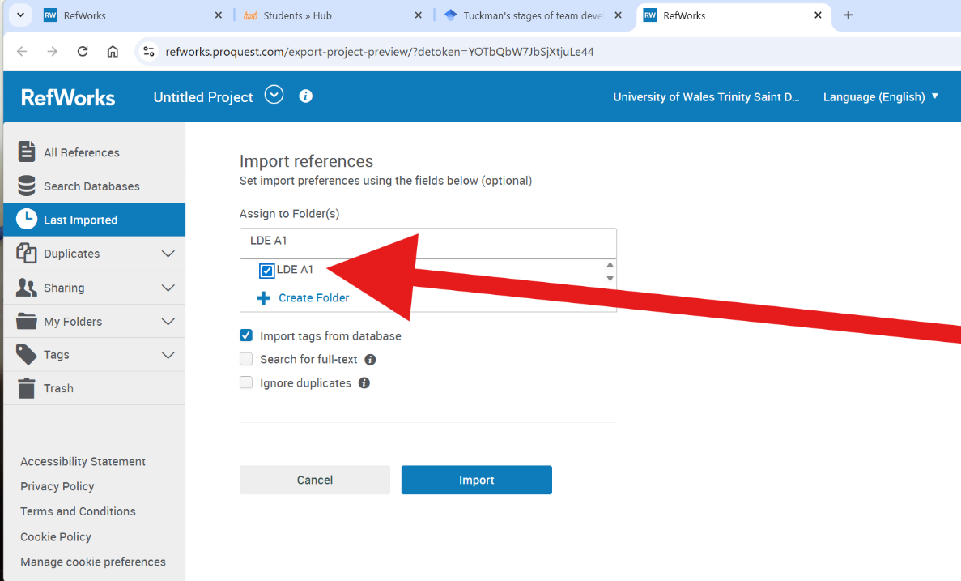
Select your chosen folder to store your citation.

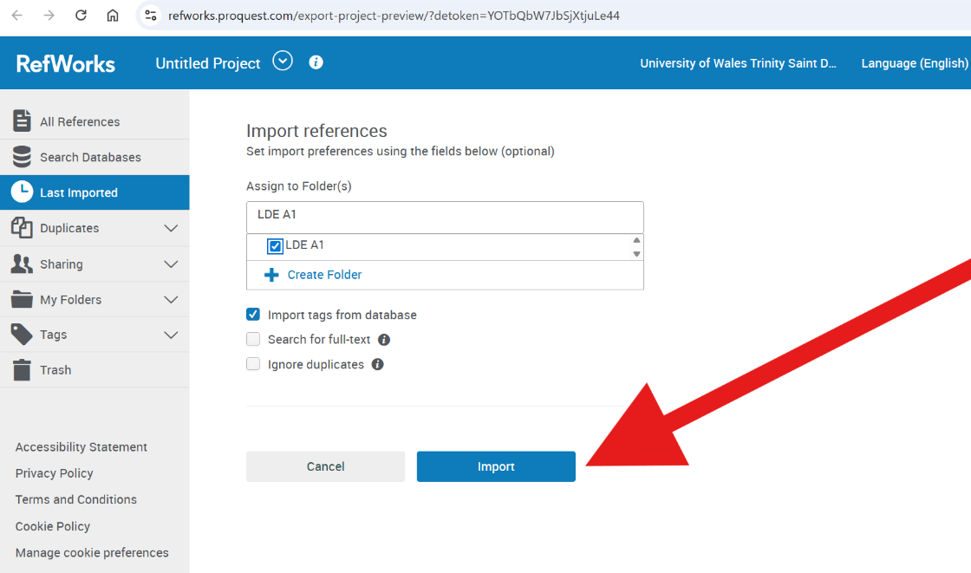
Select import references to retrieve the information.

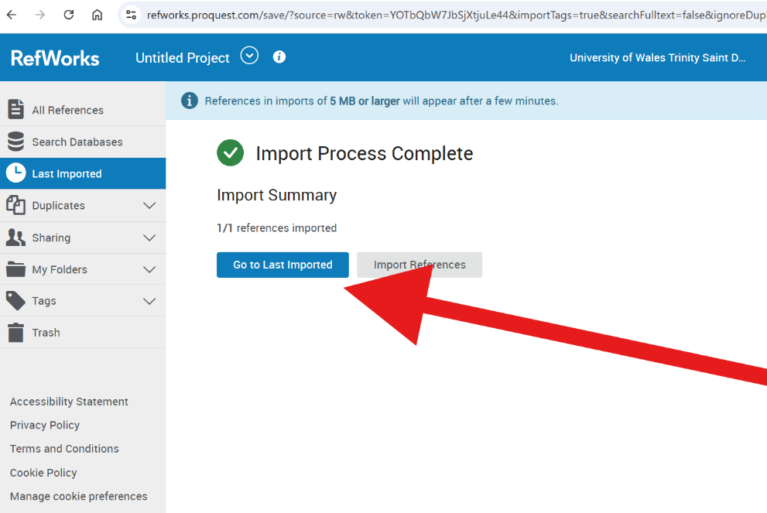
Select the last imported.

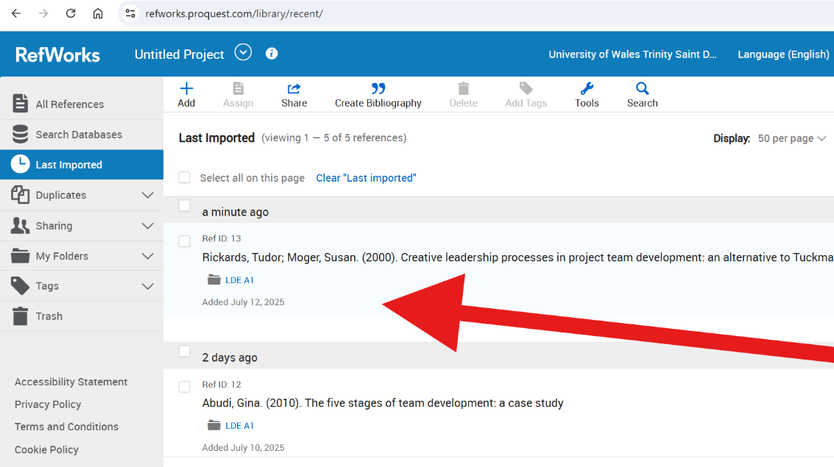
Checked to see the last import.

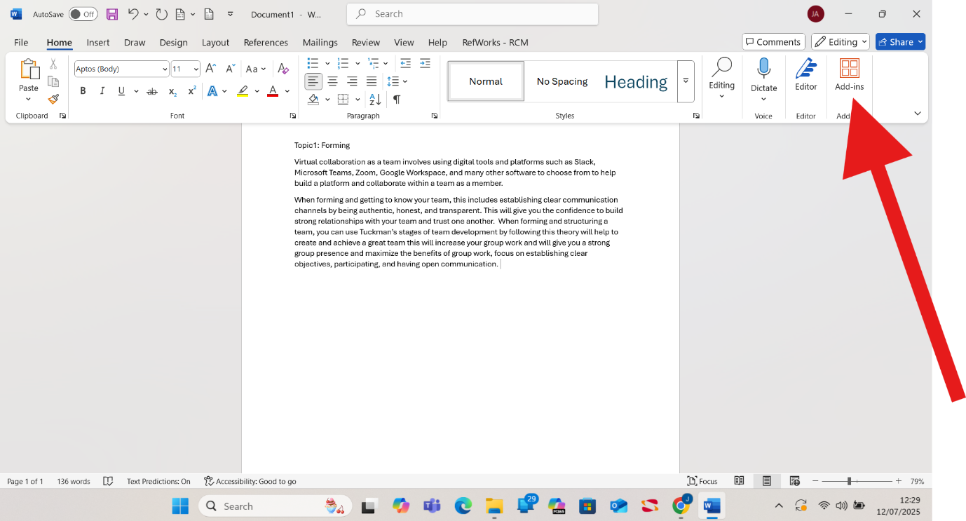
To add citations and references to a Word document, open your document and select on Add-in.

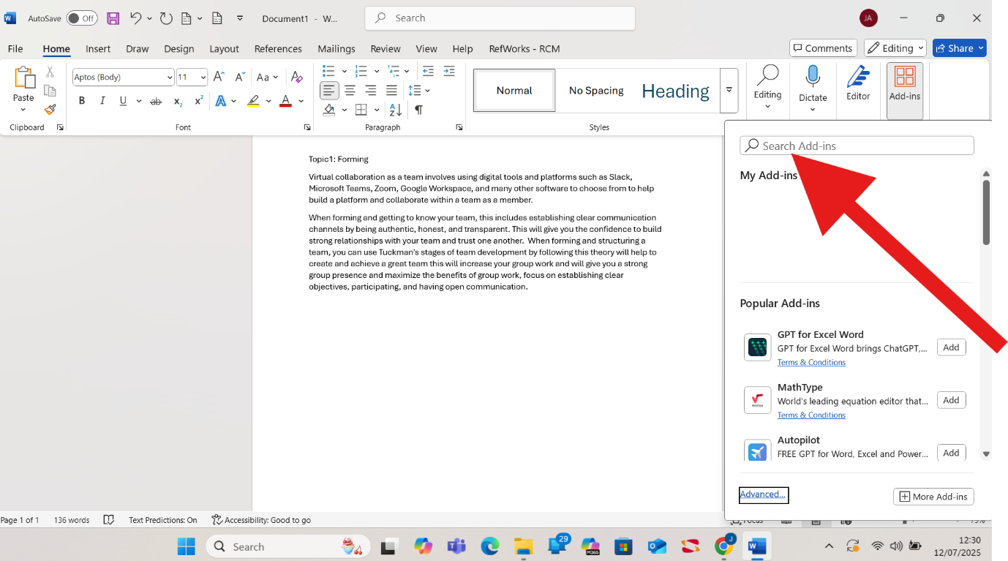Search RefWorks.

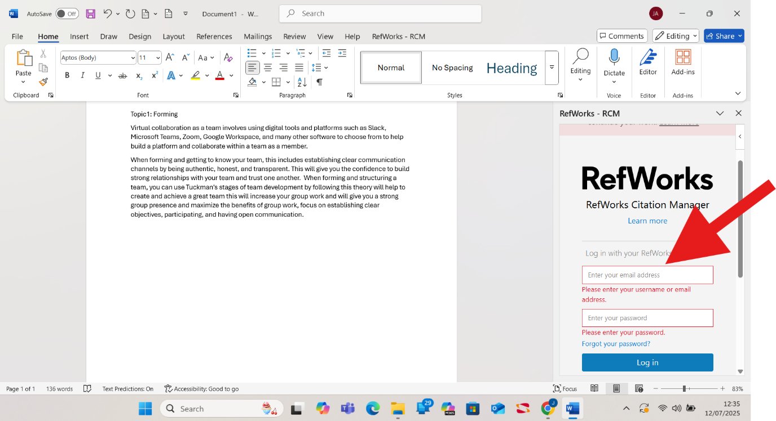
It will prompt you to log in to your RefWorks account.

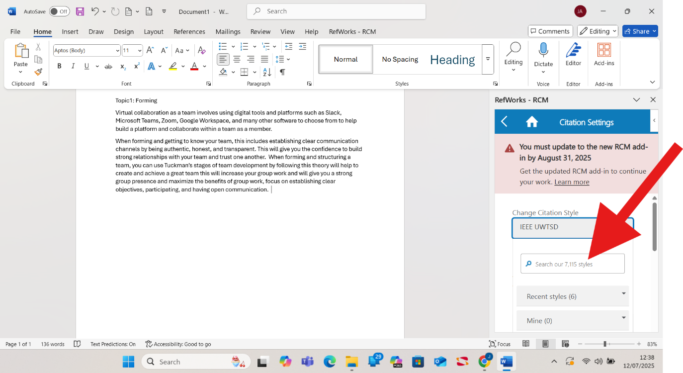Search for your institute and the reference type.

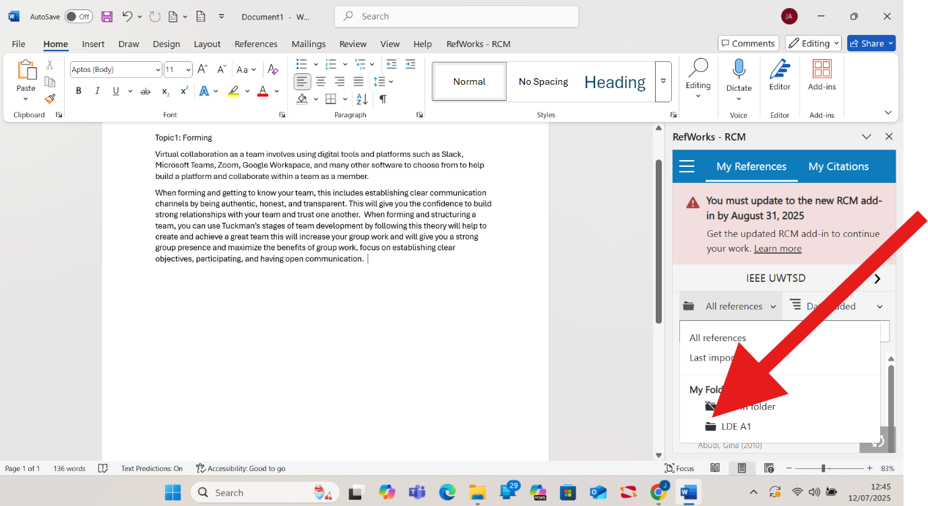Select the folder.

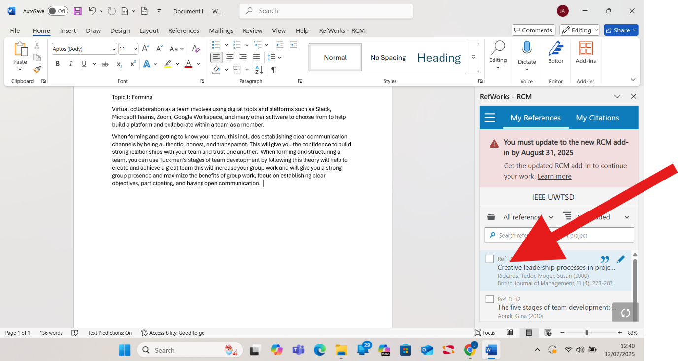Select the citation to add to the document.

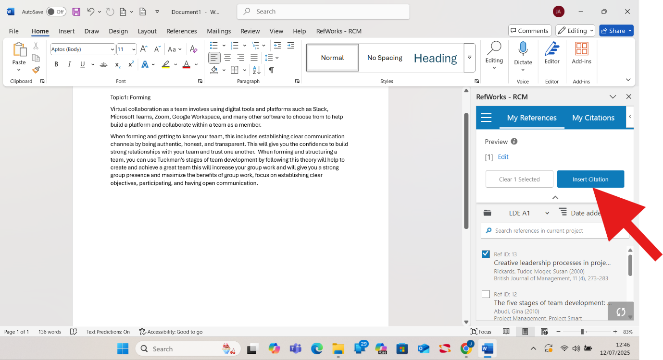Select the import citation.

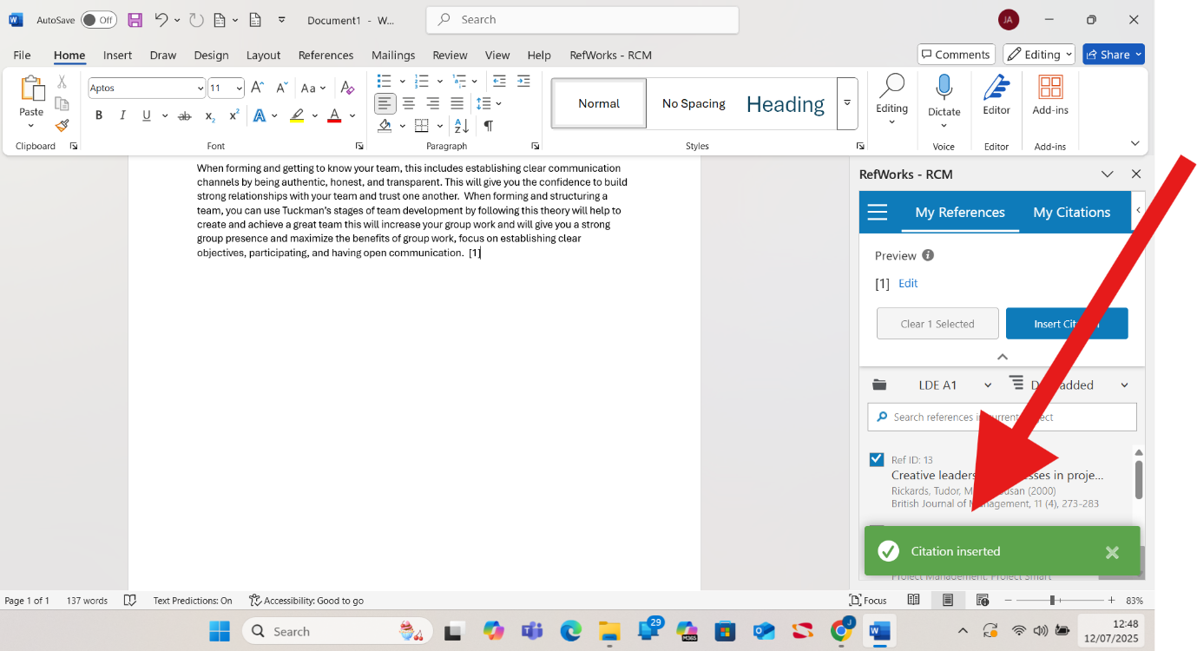
A prompt will appear to confirm the citation imported.

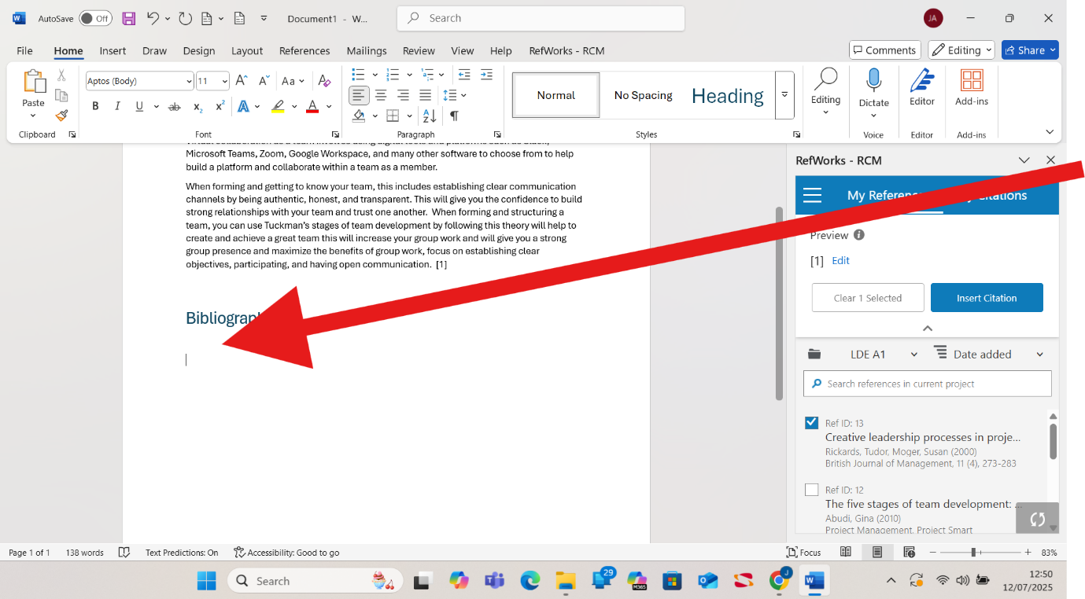To create a bibliography.

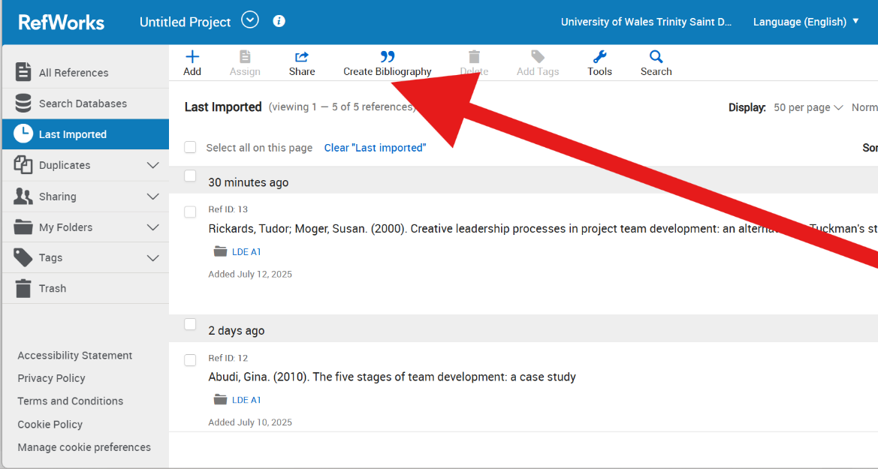
On RefWorks, select Create bibliography.

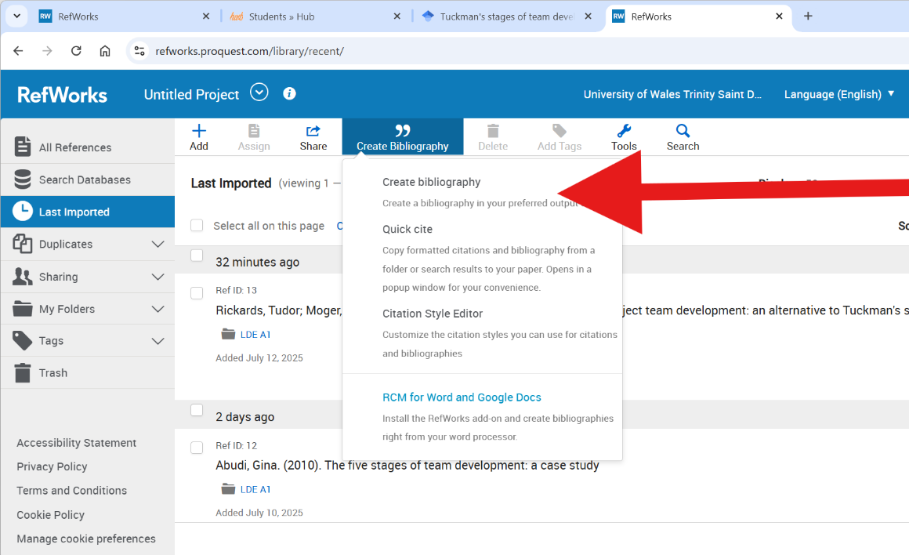
Select Create bibliography.

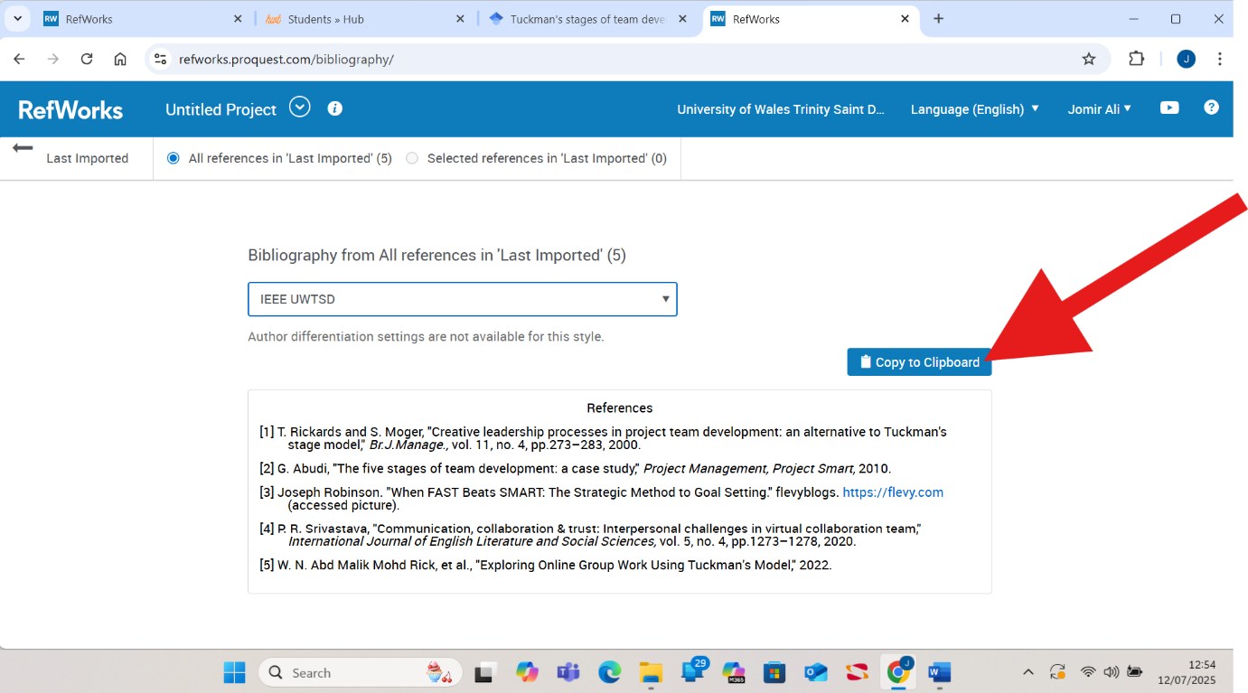Select copy to clipboard.

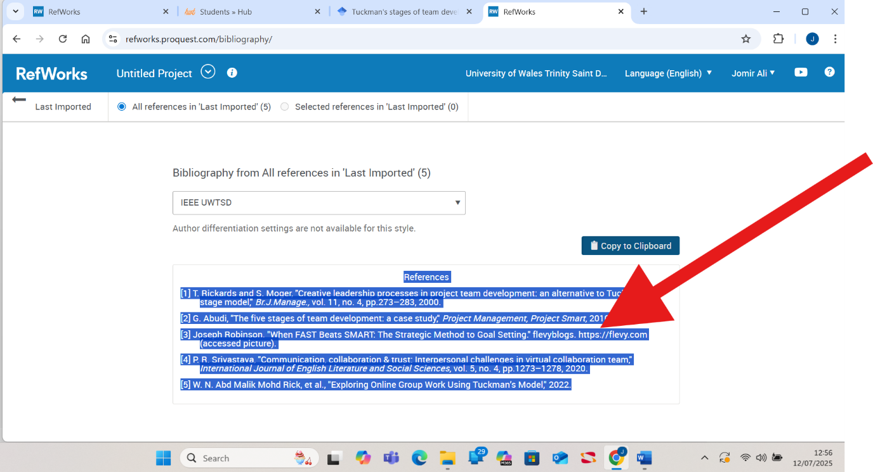Once copied, it will appear highlighted.

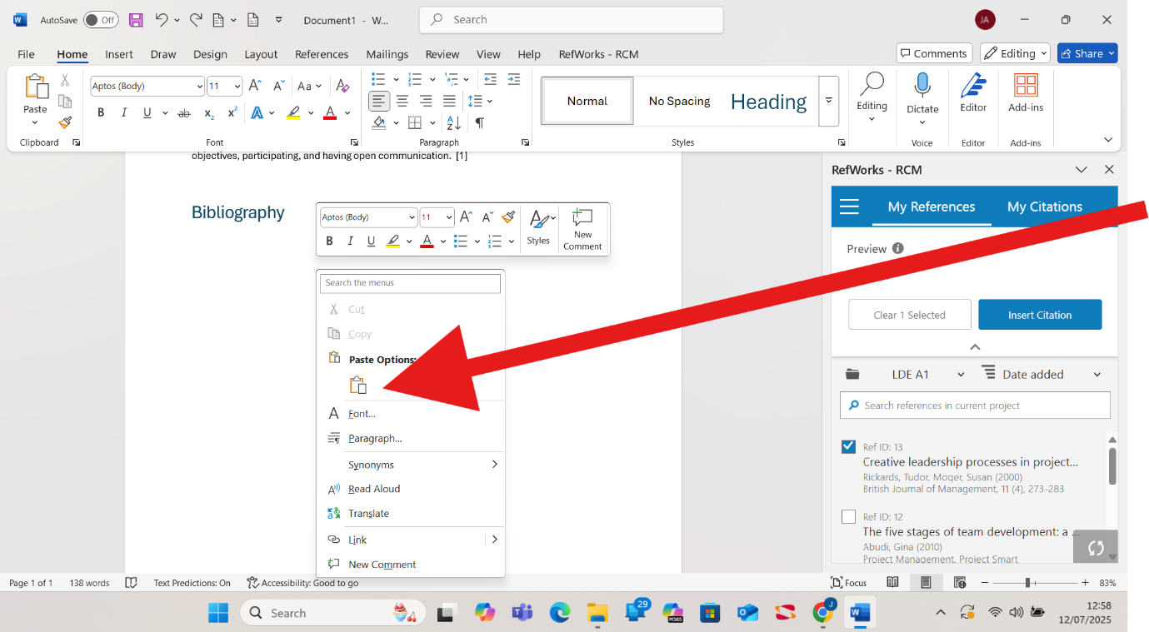Open your Word document and select Paste.

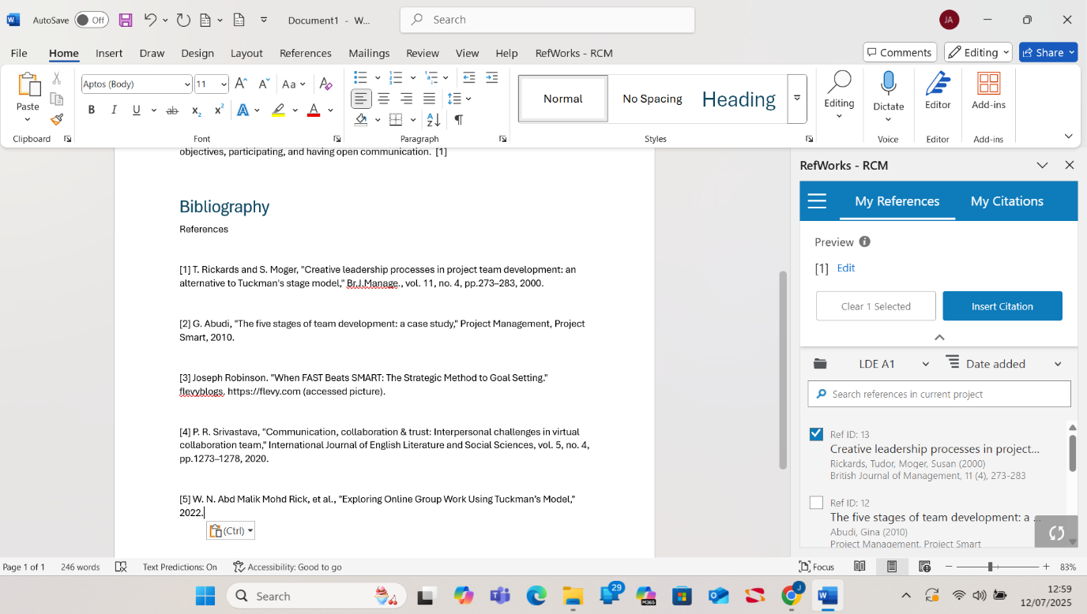Bibliography successfully pasted.

Task 4: E-Portfolio Creation and Illustrative Review

(a) E-Portfolio Creation

https://2442557.wixsite.com/aleem

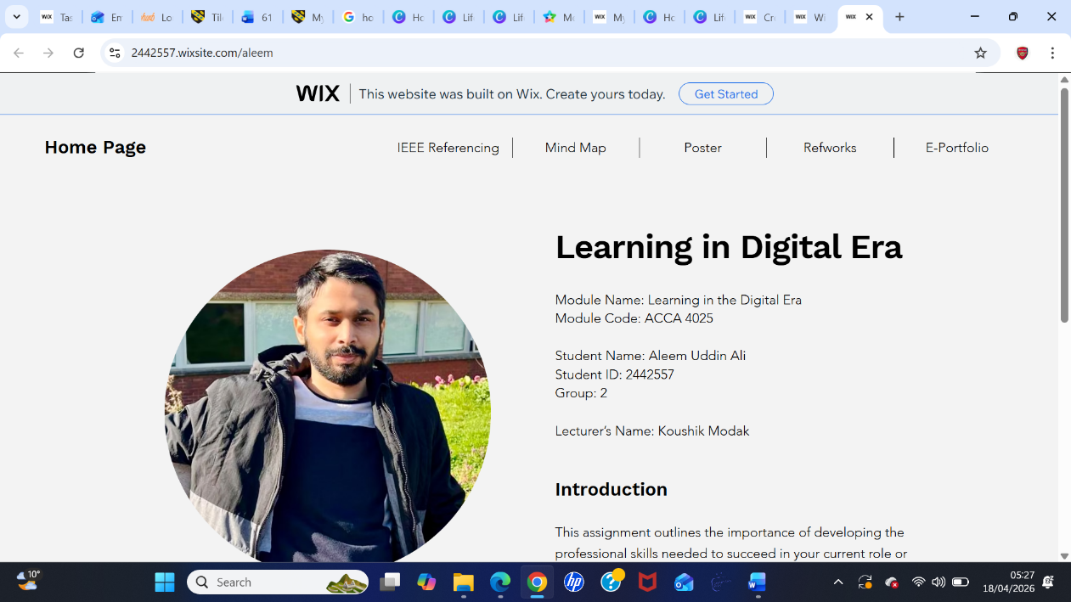

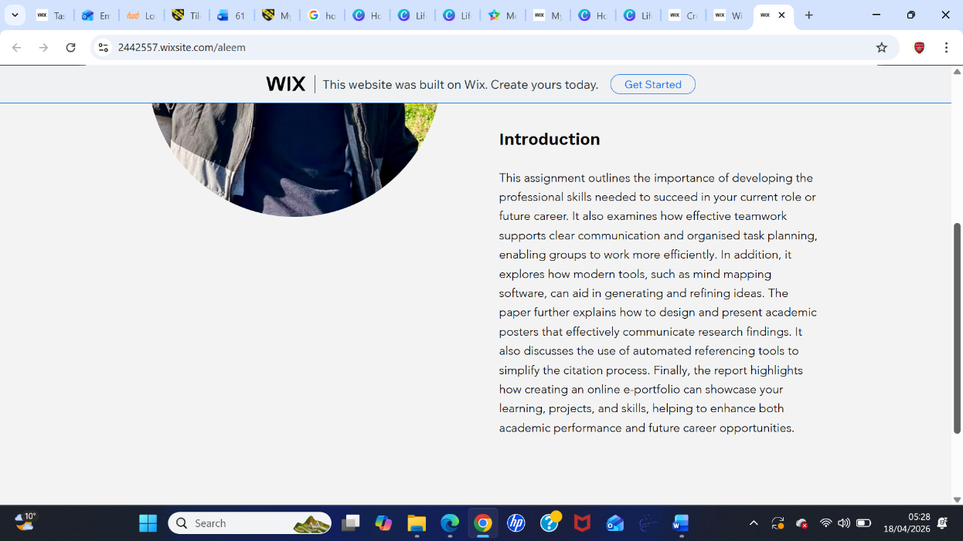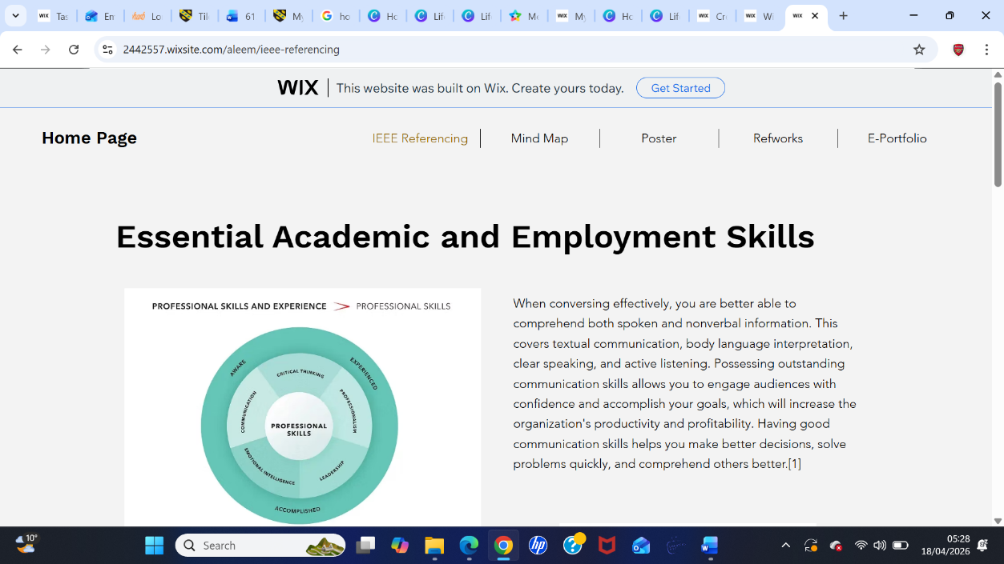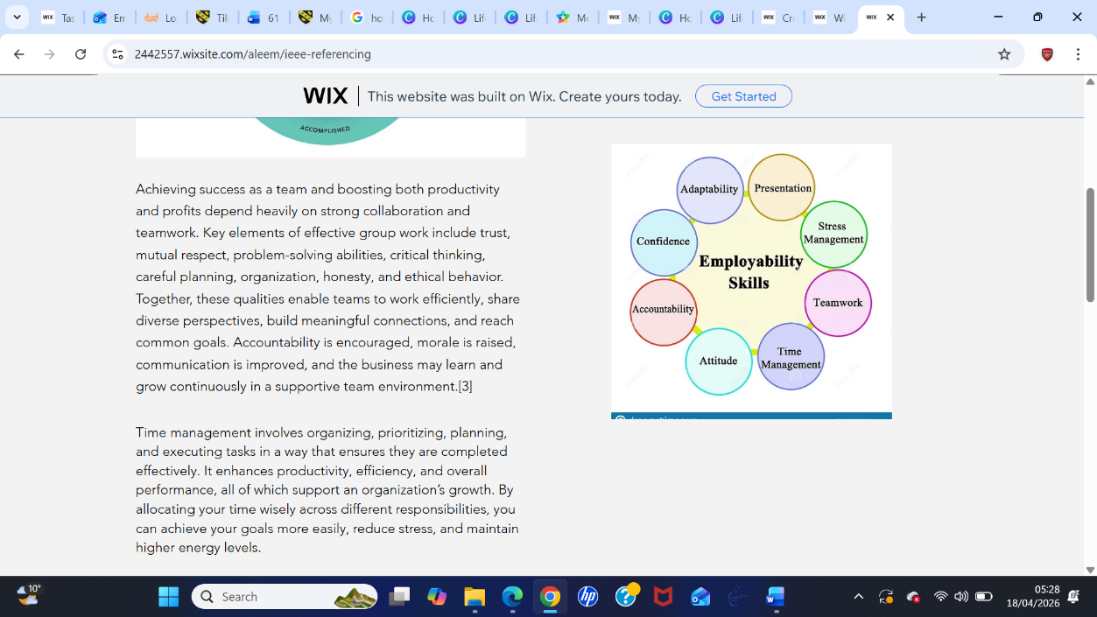
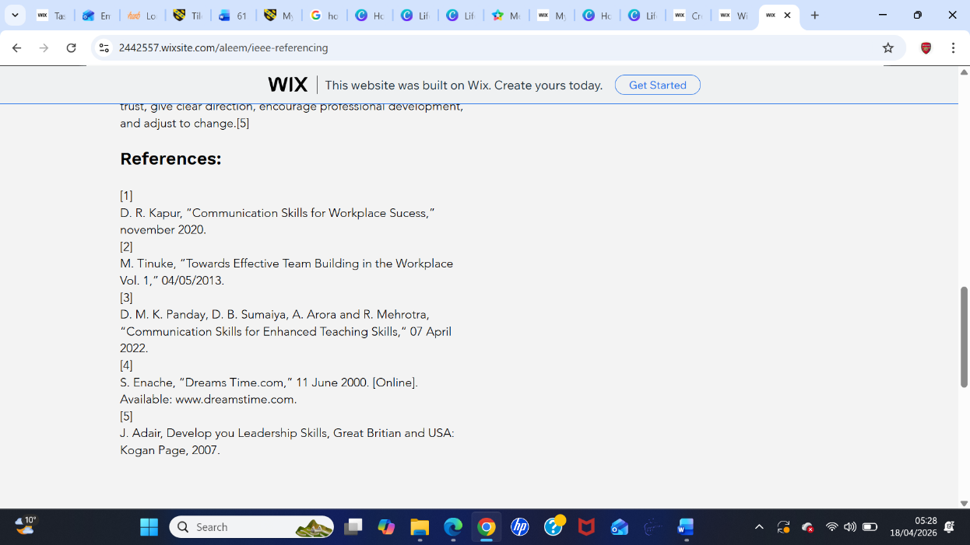
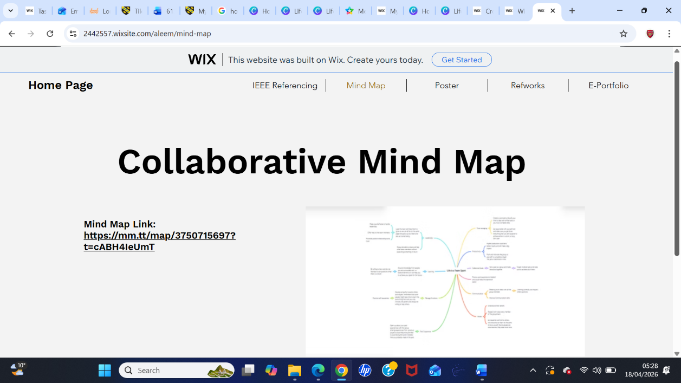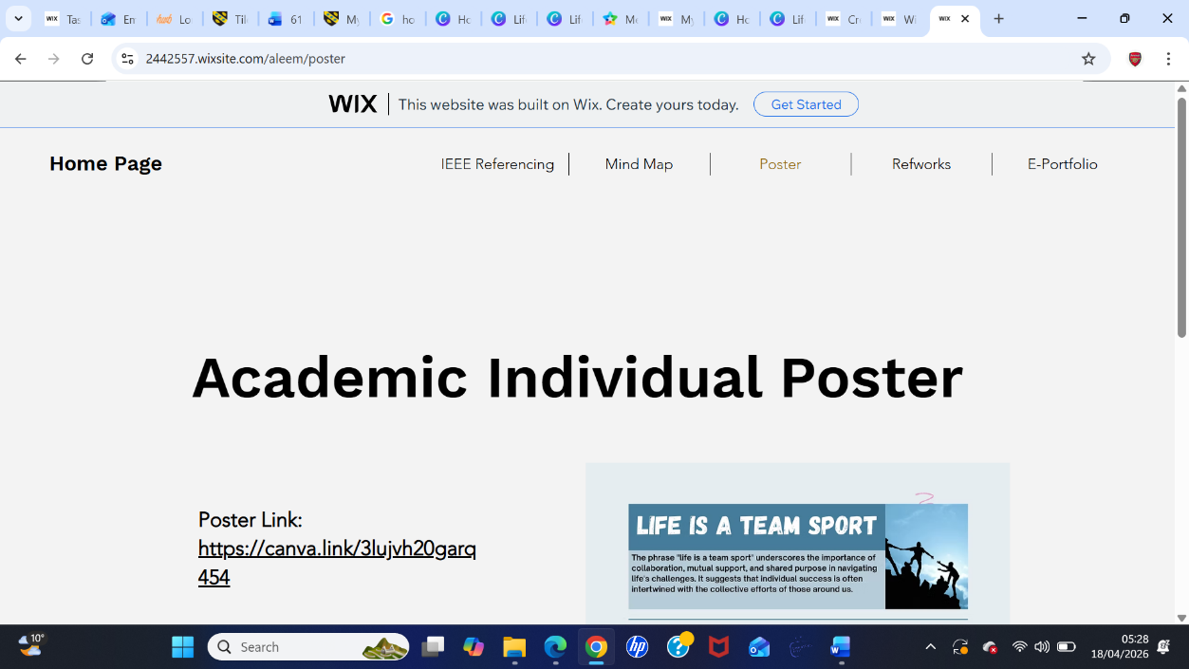
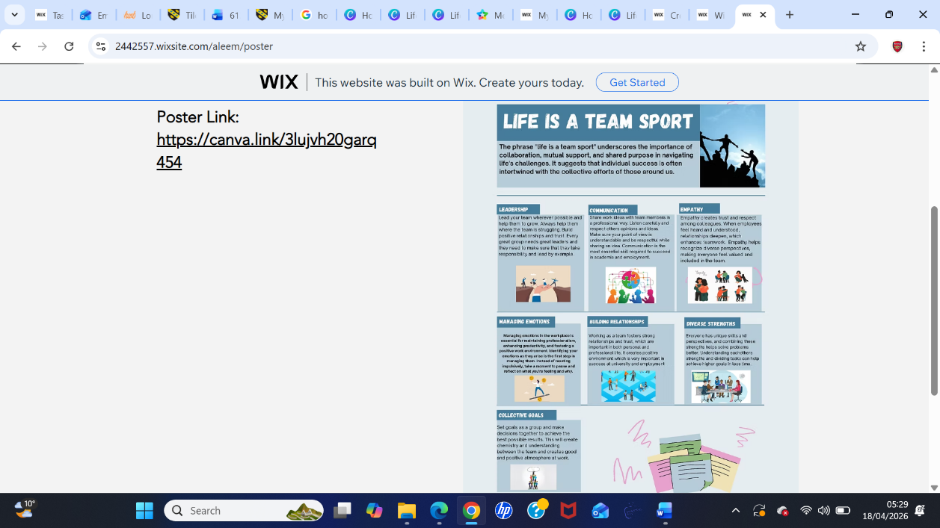
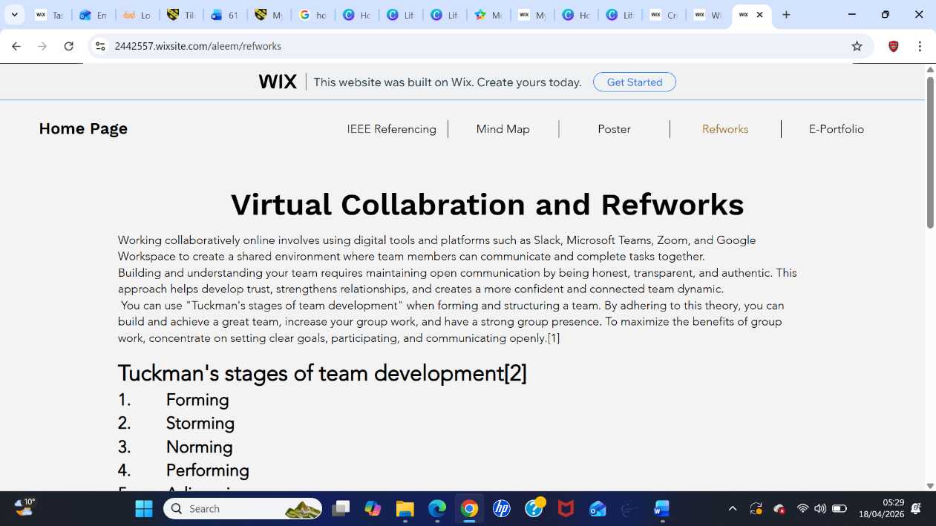
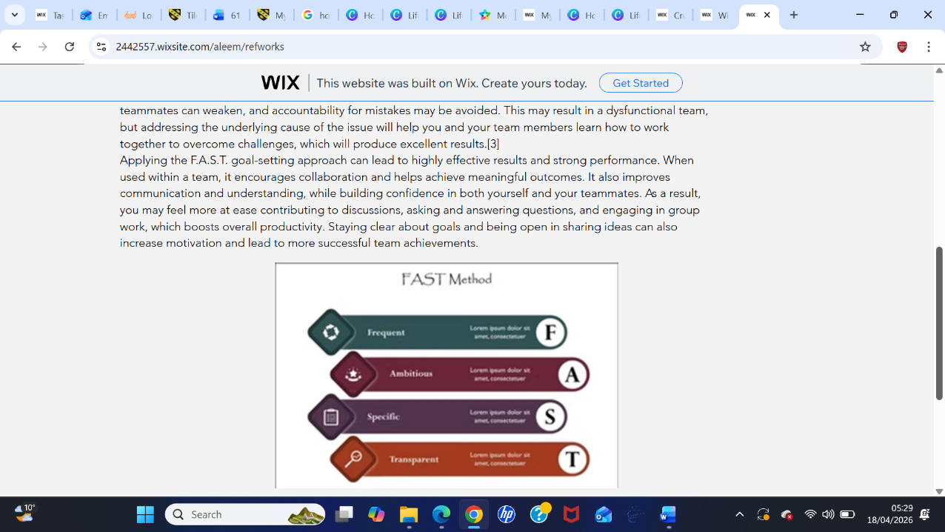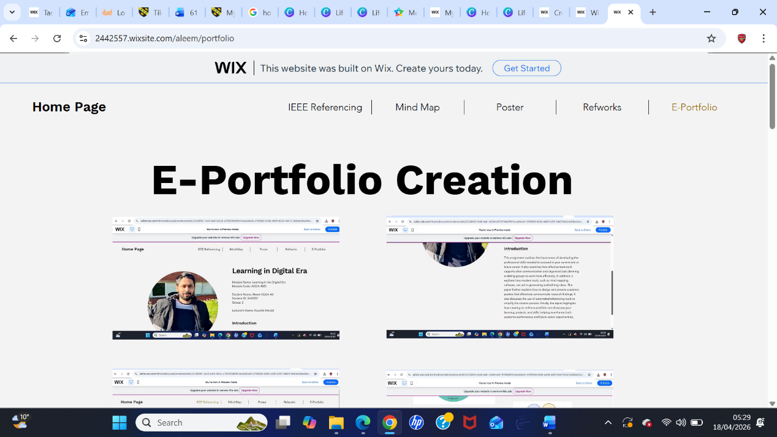
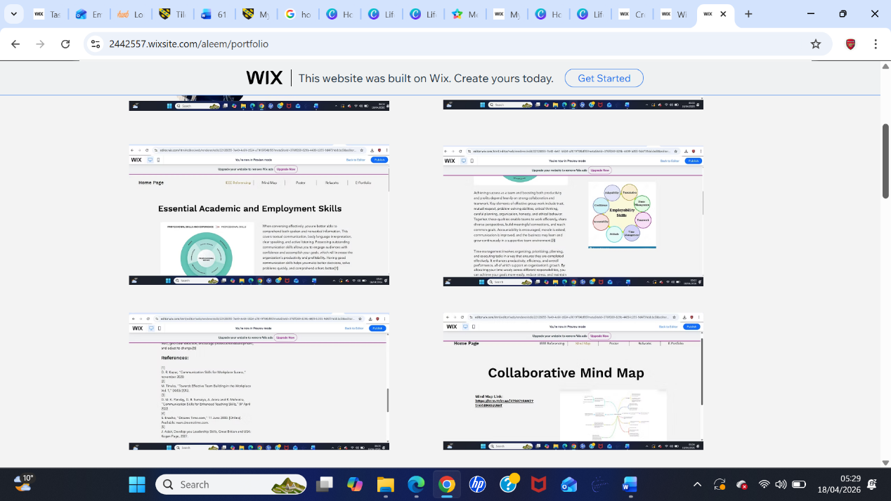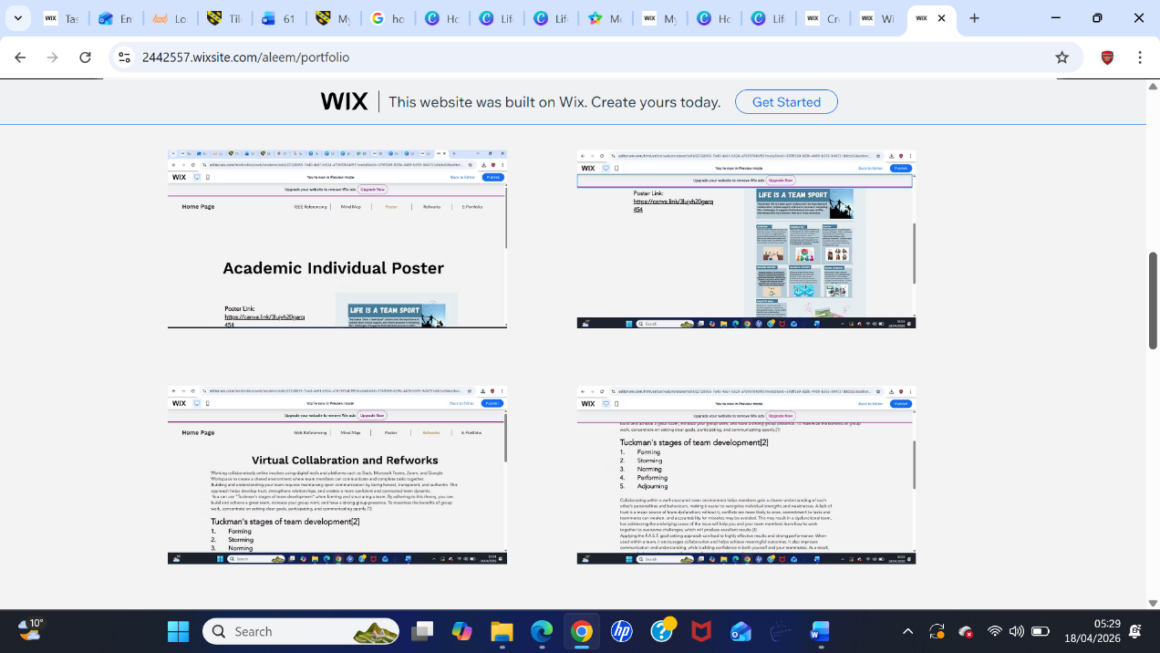
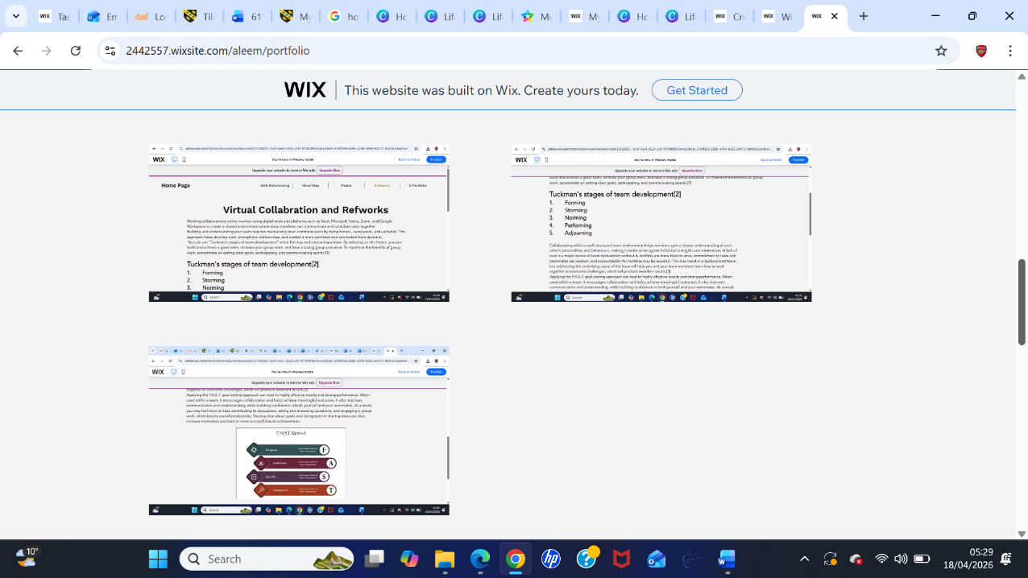

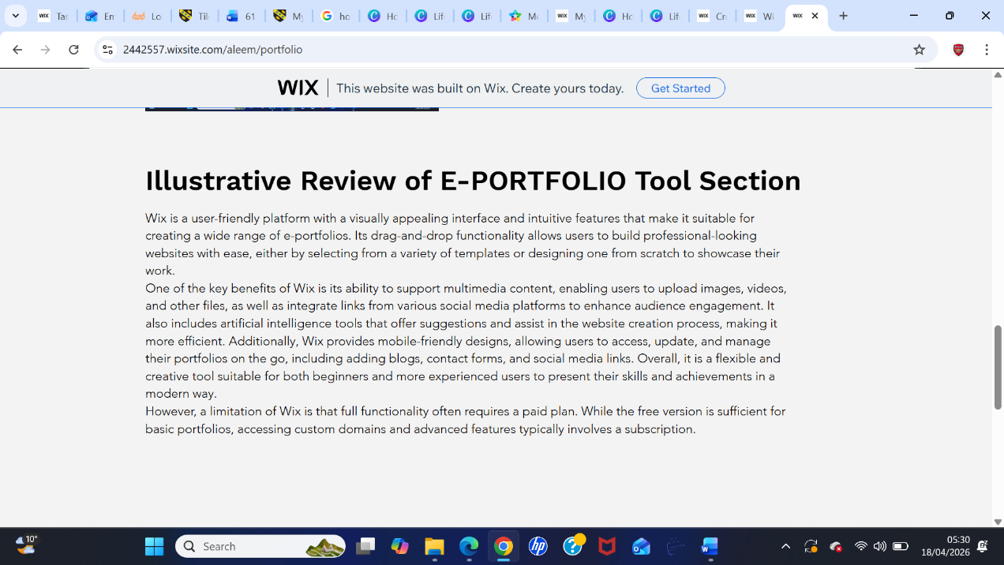

(b) Illustrative Review of E-Portfolio Tool Selection

Wix is a user-friendly platform with a visually appealing interface and intuitive features that make it suitable for creating a wide range of e-portfolios. Its drag-and-drop functionality allows users to build professional-looking websites with ease, either by selecting from a variety of templates or designing one from scratch to showcase their work.
One of the key benefits of Wix is its ability to support multimedia content, enabling users to upload images, videos, and other files, as well as integrate links from various social media platforms to enhance audience engagement. It also includes artificial intelligence tools that offer suggestions and assist in the website creation process, making it more efficient. Additionally, Wix provides mobile-friendly designs, allowing users to access, update, and manage their portfolios on the go, including adding blogs, contact forms, and social media links. Overall, it is a flexible and creative tool suitable for both beginners and more experienced users to present their skills and achievements in a modern way.
However, a limitation of Wix is that full functionality often requires a paid plan. While the free version is sufficient for basic portfolios, accessing custom domains and advanced features typically involves a subscription.

Conclusion
In conclusion, this report explores how references and citations can be effectively managed to support and strengthen academic research. It examines different referencing styles and tools, including RefWorks and IEEE referencing features, and evaluates their use in organising scholarly work. The report also includes collaborative mind maps created using modern software, as well as individual academic posters developed on an online platform, both of which support creativity, organisation, and clear visual communication of complex ideas. Finally, it considers how online e-portfolios can be used to design and develop websites that showcase professional portfolios for businesses, including CVs and other related content, offering a range of practical benefits.

Task 1 References:

[1] | D. R. Kapur, “Communication Skills for Workplace Sucess,” november 2020.
[2] | M. Tinuke, “Towards Effective Team Building in the Workplace Vol. 1,” 04/05/2013.
[3] | D. M. K. Panday, D. B. Sumaiya, A. Arora and R. Mehrotra, “Communication Skills for Enhanced Teaching Skills,” 07 April 2022.
[4] | S. Enache, “Dreams Time.com,” 11 June 2000. [Online]. Available: www.dreamstime.com.
[5] | J. Adair, Develop you Leadership Skills, Great Britian and USA: Kogan Page, 2007.

Task 3 References:
[1] G. Abudi, "The five stages of team development: a case study," Project Management, Project Smart, 2010.
[2] W. N. Abd Malik Mohd Rick, et al., "Exploring Online Group Work Using Tuckman’s Model," 2022.
[3] Joseph Robinson. "When FAST Beats SMART: The Strategic Method to Goal Setting." flevyblogs. https://flevy.com (accessed picture).
[4] P. R. Srivastava, "Communication, collaboration & trust: Interpersonal challenges in virtual collaboration team," International Journal of English Literature and Social Sciences, vol. 5, no. 4, pp.1273–1278, 2020.

