Part 1
Q1 – (AC1.1)
Although ethical principles can be difficult to define, Lawton (1998) explains that ethics is ‘like a set of principles that guide the way that we behave’. Some ethical principles could be equality and fairness; integrity and honesty; respect for others; not causing harm to others; and being law abiding. Waite et al (2021) breaks up ethical perspectives into three – deontology, which is ‘doing the right thing’; teleology, that ‘actions must be judged by their consequences’; and utilitarianism, which ‘considers decisions/actions that result in happiness as doing the right thing’.
Professional values, defined by the CIPD Profession Map, published in 2018, are set out as principles-led, ‘going beyond policy and process to do what’s right’; evidence-based, ‘using a range of evidence and expertise to make decisions’; and outcomes-driven, ‘focussing on work which creates value for people and organisations’.
One ethical principle that I feel is important and underpins all behaviour at work is equality and fairness.
These inform our approach to work by ensuring our policies and procedures are fair for all employees. For example, our policy on conducting an investigation follows the ACAS guide (2019) which has 6 steps:
- Organisational preparation – if a formal investigation is necessary, then it should be organised immediately. We must decide who and what to investigate, who will be the investigating officer, define the remit and provide a timeframe.
- Investigator’s preparation – the investigator will create the plan, they determine what evidence is needed, who they will interview and make references to internal policies for guidance.
- Handling an investigation meeting – In the meeting, the investigator will interview the people involved, they will also create the questions, decide if the individual(s) needs to be accompanied and arrange a way of recording the meeting, in the FUW there is an unbiased minute taker for the meetings and if needed the virtual meeting can be recorded.
- Gathering evidence – here the investigator collects the facts based on evidence, this could be from CCTV, emails, witness testimonies, timesheets etc. It is important that the investigator considers the credibility and reliability of the evidence.
- Report the investigation findings – the investigating office will produce a report explaining their findings, giving a recommendation if needed, and noting any supporting documents, but they will not suggest a possible outcome to the disciplinary/grievance hearing.
- After the investigation – the investigation officer is no longer involved after the investigation has come to an end as it would be unfair, but the decision will made by the person conducting the disciplinary process usually.
One of the professional values is principles-led, being inclusive and supportive of all employees.
In the UK we have the Equality Act 2010 which provides legal protection for protected characteristics such as age, disability, race etc. but in order to ensure fairness it is integral to the organisation we consider some other characteristics as well, such as caring responsibilities, culture, and mental health to name a few. This ensures that regardless of an employee’s background they will be treated fairly which does not always mean equal but with equity, meaning they will be provided the exact resources needed to reach an equal outcome regardless of personal differences.
This also feeds into how we conduct an investigation within the organisation as it would be fair to consider having an employee accompanied for an investigation, but if there were other personal factors to consider it may be appropriate to encourage accompaniment and other reasonable adjustments.

Q2 – (AC1.2)
There are many legislations that help guide and inform people professionals from The Human Rights Act 1998 to Data Protection Laws.
Two examples of ways that I and the FUW conform to these legislations, is during the recruitment and selection process and with the changes in the flexible working laws.
During the recruitment process it is essential to maintain fairness this can be achieved by following the company’s Recruitment and Selection Policy which is based on the ACAS Code of Conduct for recruitment which gives advice on avoiding discrimination. Based on the Equality Act 2010, it is important that every step of the recruitment process adheres to the law, this involves the advertising, interviewing and selection of new employees.
When advertising a new opening we will advertise on various websites to get a diverse pool of applicants, we ensure that we can offer reasonable support and adjustments for anyone that would like to apply and might be offered an interview, and in particular in the FUW we ensure all our jobs are offered bilingually, in Welsh and English. It is also crucial that protected characteristics are not factored into the selection process. It is crucial to ensure the policies and procedures are followed to ensure that even unintentional discrimination doesn’t occur.
In April this year (2024) there was a change in Flexible Working Laws, some of the main changes that have occurred, are that it is now a day one right, an employee does not have to outline how the change would affect the company, requests must be dealt with within 2 months and an employee can now make 2 flexible working requests within a 12 month period (Aldridge and Pugh, 2023).
The first thing, we and any business had to do was to review and update current policies and procedures to ensure they comply with the new regulations. It was also crucial to ensure that all managers were aware of and adept to deal with any flexible working request that may come their way “effectively and empathically” says Willetts (2023, cited Aldridge and Pugh, 2023).

Q3 – (AC2.1)
- I have shown inclusivity and respectfulness to others through feedback sessions. As a manager having 1 to 1 sessions and appraisals are key to ensuring a respectful relationship but also that work is being completed. During feedback sessions I am mindful of my terminology, and I will adapt my communication styles, sometimes feedback will be in the form of written feedback, but from experience with my team, verbal feedback is most beneficial to be able to discuss matters immediately and this also eliminates any mis communication and interpretation through written feedback. Having said this I do follow up with written feedback to ensure understanding and to remind everyone involved of what was discussed. One way I feel I could further enhance this is by asking more questions to ensure understanding during the oral feedback.
- I have been involved with welfare meeting and investigation meetings during the last few months, especially in investigation meetings it is important to ensure that everyone involved in treated fairly and feels respected, one element is ensuring that the investigating officer has all the necessary evidence for the investigation and to ensure any employees that have been asked to participate in the investigation have had the offer of an accompanying person although it isn’t a statutory right. To further enhance my inclusivity as an organisation we could look at other options of recording investigations such as audio recording as it would not go against the organisation’s policy, although ACAS (2019, p.20) does suggest that sometimes “being taped may be intimidating to an interviewee, making them less able to talk openly about the matter”. Another way I would like to further enhance my inclusivity and respectfulness is by being involved in the planning of an investigation by creating the question set to ensure these are worded in a respectful way for the interviewee.
- In November 2023 our organisation moved over to a new HR system. This change impacted every single member of staff. The process started a few months before the change was implemented. A change in system was necessary therefore gaining feedback on whether it should happen was not necessary but as Waite et al. 2021 outlines it is important to plan and manage change, as everyone can respond to change differently. We ensured that all members of staff were aware of the change, and had time to learn about the new system as much as possible beforehand. I lead on the training aspect of the system which involved creating step-by-step guides and videos on using the system, offering 1 to 1 sessions for any staff especially managers and ensuring there was a clear open-door policy with any questions that arose. To ensure this task was fully inclusive and respectful for all, one thing I could have done to enhance my behaviour was to send out a short survey to all members of staff to find out how they learn and absorb information, this would have helped with ore targeted training, but it would also have ensured that all members of staff got the support they needed as some may not have felt confident in speaking out and asking for support.
Q4 – (AC2.2)
It is imperative that people practise professionals stay up-to-date with developments in the world of work as legislation and case law is evolving all the time, and so is best practice from ACAS. Due to these changes, if organisations didn’t stay up-to-date they would risk not complying with current regulations by having outdated policies which could end up with a case at tribunal. One of the changes that came into effect in March 2024 was regarding Paternity Leave (2024) these required an update in policies immediately to maintain trust and respect within the organisation as well as complying with law.
My two recommendations for staying up-to-date with developments in the world of work would be signing up to the People Management daily newsletter and attending webinars from reputable providers. I have been signed up to the PM daily since the start of my course and it is very informative, it has an array of articles from current news regarding HR related matters, these stories help drive our policies to ensure that we are protecting our employees and also the company. My other recommendation is signing up to webinars, I find webinars very useful because these are also current but there is also the opportunity to ask questions, one webinar I attended recently was from Croner on ‘How to Conduct a Disciplinary Investigation’ this was very useful and gave more of a discussion based on the ACAS guide. Another seminar that I will be attending is the Employment Law Advisory Bureau which will outline the new employment law changes for 2024. Again this will be a great opportunity to discuss the upcoming changes in person but also gain an insight into the reasons behind the changes and other experiences for other companies.
Part 2 (AC2.3)
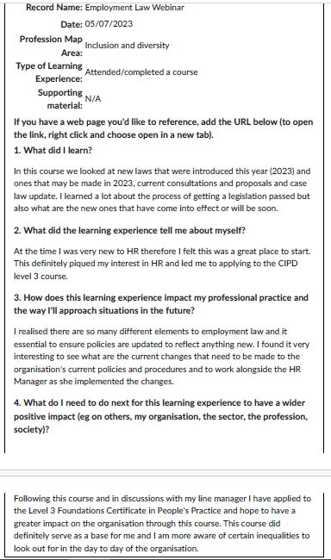
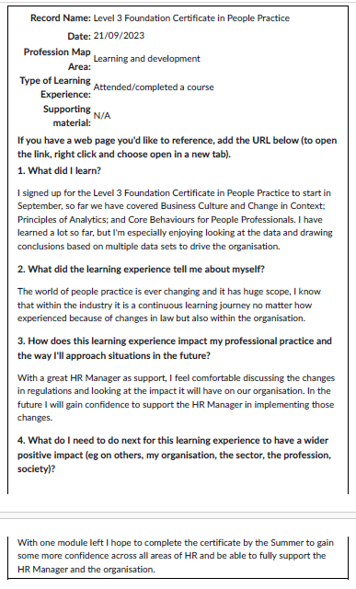
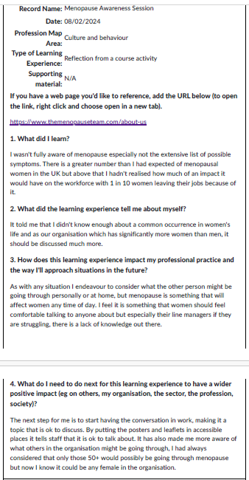
Reference list
ACAS (2023) How employers should recruit. Available at https://www.acas.org.uk/hiring-someone (Accessed: 2 April 2024)
Advisory, Conciliation and Arbitration Service [ACAS] (2019) Conducting Workplace Investigations. Available at: https://www.acas.org.uk/acas-guide-to-conducting-workplace-investigations (Accessed: 3 April 2024)
Aldridge, C. and Pugh, A. (2023) ‘Everything employers need to know about changes to flexible working laws’, People Management, 3 August. Available at https://www.peoplemanagement.co.uk/article/1832300/everything-employers-need-know-changes-flexible-working-laws (Accessed: 2 April 2024)
CIPD (2023) Explore the Profession Map. Available at: https://www.cipd.org/uk/the-people-profession/the-profession-map/explore-the-profession-map/ (Accessed: 10 April 2024)
Equality Act 2010 Available at: https://www.legislation.gov.uk/ukpga/2010/15/contents (Accessed: 2 April 2024)
Lawton, A (1998) Ethical Management for the Public Services, Open University Press
Paternity Leave (Amendment) Regulations 2024 Available at: https://www.legislation.gov.uk/uksi/2024/329/contents/made (Accessed: 10 April 2024)
The Flexible Working Regulations 2014 Available at https://www.legislation.gov.uk/uksi/2014/1398 (Accessed: 3 April)
UK Government I Flexible Working. Available at: https://www.gov.uk/flexible-working (Accessed: 3 April 2024)
Waite, K., Beevers, K., Small, N., Tomlinson, K. and Hussain, S. (2021) People practice: a complete guide. London: Kogan Page Limited.

