University of Wales Trinity Saint David
2D Diffusion Equation model using the Explicit Finite Difference Method
Thomas Rosser
2214462
Apprenticeship in Mechanical and Manufacturing Engineering (BEng)
27th of January 2025
Computational Methods – ACMA6012
Word Count - 3097


Table of Contents
Table of Contents 2
Table of Figures 3
Table of Equations 4
Table of Tables 5
1. Introduction 6
2. The Governing Equation. 7
2.1 Background information. 7
2.2 Heat equation and definitions 7
2.3 Heat equation importance 7
3. Numerical Method chosen to discretise the governing equation 8
3.1 Derivative approximation from Taylors series 8
3.2 Forward difference approximation 8
3.3 Backward difference approximation 8
3.4 Central Difference approximation 9
3.5 Second Derivative Approximation 9
3.6 Explicit finite Difference 9
3.6.1 Discretisation of the spatial domain 9
3.6.2 Discretisation of the temporal domain. 10
3.6.3 Substitution of Derivative Terms with Finite Difference Approximations. 10
3.6.4 Formulating the explicit finite difference equation and the introduction of Fourier number 10
3.7 Stability Criterion 11
4 The initial boundary conditions and analytical solution. 11
4.1 Initial and Boundary Conditions 11
4.2 Analytical Solution and Justification for Initial and Boundary Conditions 12
5. Codes details and explanations 12
5.1 Code introduction 12
5.2 Common tools 13
5.3 Code explanation 13
5.3.1 Workspace management 13
5.3.2 Material properties 13
5.3.3 User inputs for spatial consideration 14
5.3.4 Grid spacing 14
3.3.5 Rows and Columns to initialise matrix. 15
3.3.6 Initial Boundary conditions 15
3.3.7 Time step 16
3.3.8 T2 and Convergence criterion 17
3.3.9 Using Explicit Finite difference method 17
3.3.10 Analytical solution 19
3.3.11 Plots 20
3.3.11 simulation results and error plot 21
6. Validation of the code 22
7. Analysis of the code results. 23
7.1 Grid spacing 23
7.2 Time step 24
7.3 Tolerance 25
8. Limitations of the model. 26
8.1Limitations due to the Numerical Method 26
8.1.1 Round off error 26
8.1.2 Truncation error 26
8.1.3 Complex geometry 26
8.1.4 Stability 27
8.2 Limitations due to Coding: 27
8.2.1 Thermal Equilibrium Modelling 27
9. Suggested improvements to the model and future developments. 27
9.1 Improved Stability and Accuracy - ADI or Implicit Finite Difference Method (FDM) 27
9.2 Handling Complex Geometries - Numerical Alternatives to FDM 27
9.3 Modelling Thermal Equilibrium - Robust Modelling of Thermal Equilibrium 27
10. Conclusion 28
11. References 29
12. Appendix. 31

Table of Figures
Figure 1 - Workspace management 10
Figure 2 - Material properties 10
Figure 3 - Material properties (command window) 10
Figure 4 - User inputs for spatial consideration 11
Figure 5 - User inputs for spatial consideration (Command window) 11
Figure 6 - Grid Spacing 11
Figure 7 - Grid spacing (Command window) 11
Figure 8 - Rows and columns to initialise matrix 12
Figure 9 - Rows and columns to initialise matrix (Command window) 12
Figure 10 - Initial boundary conditions 12
Figure 11 - Initial boundary conditions (Commandd window) 12
Figure 12 - Time step 13
Figure 13 - Time step (Command window) 13
Figure 14 - T2 and convergence criterion 13
Figure 15 - Using Explicity Finite difference method 15
Figure 16 - Using Explicity Finite difference method (Command window) 16
Figure 17 - Analytical solution 16
Figure 18 - Analytical solution (Command window) 17
Figure 19 - Plots 17
Figure 20 - Plots (Command window) 18
Figure 21 - Simulation results 18
Figure 22 - Simulation results 19
Figure 23 - Temperature maps 19
Figure 24 - Grid Spacing data graph 20
Figure 25 - Time step data graph 21
Figure 26 - Tolerance data graph 22

Table of Equations
Equation 1 5
Equation 2 - Taylors series 6
Equation 3 - Forward difference approximation 6
Equation 4 - Backwards difference approximation 6
Equation 5 - Central Difference approximation 7
Equation 6 - Second derivative approximation 7
Equation 7 - EFDM Derivation 8
Equation 8 - EFDM Derivation 8
Equation 9 - EFDM Derivation 8
Equation 10 - EFDM 8
Equation 11 - EFDM (MATLAB) 8
Equation 12 - Analytical solution 9

Table of Tables
Table 1 - Grid spacing data 20
Table 2 - Time step data 21
Table 3 - Tolerance data 22

Introduction
This study uses the Explicit Finite Difference Method (EFDM) to investigate the temperature distribution within an aluminium plate. The study's goal is to validate the numerical approach and compare the findings to analytical solutions while recognising accuracy and efficiency.

The study opens with an overview of the subject and its significance, including the governing equations and boundary conditions for heat conduction. This section provides the foundation for the numerical method. Next, the methodology details the implementation of EFDM, including discretisation, initial conditions, iterative computation, and the convergence criterion. MATLAB was used to carry out these calculations.
The results and discussion section displays calculated temperature profiles over the aluminium plate and compares the numerical findings to the analytical solution, addressing variations and variables affecting accuracy. Finally, the conclusion summarises major findings, discusses the method's strengths and shortcomings, and makes recommendations for future improvements.
The primary objectives of this study are to:
- Develop and use EFDM to solve the heat conduction problem within MATLAB.
- Compare numerical and analytical results for validation.
- Analyse the accuracy and computational efficiency of EFDM.
By addressing these objectives, the study contributes to understanding numerical techniques for heat transfer analysis.

The Governing Equation.

2.1 Background information.
Thermal energy moves from hotter to colder locations according to a fundamental physical process called heat transfer. There are three main ways that heat is transferred: conduction, convection, and radiation (BBC Bitesize, 2025). This study focuses on conduction, which is a process that is caused by temperature gradients within a stationary medium. Conduction is mathematically described using the heat conduction equation, which is derived from Fourier’s law and the principles of energy conservation. This heat equations is the basis for many engineering analyses and is essential for calculating temperature distributions within materials (Helmenstine, 2022).

2.2 Heat equation and definitions
The heat conduction equation explains the spatial and temporal variations in a material's temperature. The equation for a two-dimensional system in which no heat is produced internally is expressed as follows (Helmenstine, 2022):
$\frac{∂^{2}T}{{∂x}^{2}}+\frac{∂^{2}T}{∂y^{2}}= \frac{1}{α} . \frac{∂T}{∂t}$ Equation 1
$\frac{∂^{2}T}{{∂x}^{2}}+\frac{∂^{2}T}{∂y^{2}}$ are the second derivatives of temperature that describe the temperature changes across the material with respect to spatial coordinates y and 𝑥.
$\frac{∂T}{∂t}$ is the rate of change of temperature over time.
$a$ is the thermal diffusivity, which shows the rate at which heat moves through the material, it can be mathematically written as $a=\frac{k}{p . c}$ where:
- $t$ is the time (s)
- $T$ is the temperature (°c)
- $k$is the thermal conductivity (W.$m^{-1}.k^{-1})$
- 𝜌 is the density (kg.$m^{-3})$
- $m$ is the specific heat (J.$kg^{-1}.k^{-1}$)

2.3 Heat equation importance
To enable optimised designs for thermal management, the heat equation is essential for forecasting temperature distributions in engineering systems. For instance, it helps with modelling heat dissipation in mechanical structures, assessing cooling systems for electronics, and establishing the thickness of insulation needed for pipelines. It can be used in a wide range of disciplines, including renewable energy, materials science, aerospace, and civil engineering (Anthony, 2023).

Numerical Method chosen to discretise the governing equation

3.1 Derivative approximation from Taylors series
The Taylors series equation provides a mathematical baseline to approximate functions as a sum of terms calculated from the derivatives of the equation at any point.
$f\left(x\right)=f\left(x_{0}\right)+f^{'}\left(x_{0}\right).\frac{(x-x_{0})^{1}}{1!}+f^{''}\left(x_{0}\right)\frac{(x-x_{0})^{2}}{2!}+…$ Equation 2 - Taylors series (Rob Pearce, 2017)

3.2 Forward difference approximation
The Taylors series is put into terms that relates the value of a function at point x0 to the value of the function at the nearby point (X0=h). It is then rearranged and used to make the forward difference approximation to f’(x0).
$$f\left(x_{0}+h\right)=f\left(x_{0}\right)+hf^{'}\left(x_{0}\right)+ \frac{h^{2}}{2!}f^{''}\left(x_{0}\right)+…$$
$$\frac{f\left(x_{0}+h\right)}{h}=f\left(x_{0}\right)+ \frac{h}{2!}f^{''}\left(x_{0}\right)+…$$
$f^{'}\left(x_{0}\right)≈ \frac{f\left(x_{0}+h\right)-f(x_{0})}{h}$ Equation 3 - Forward difference approximation (Kaw, 2023)

3.3 Backward difference approximation
The Taylors series is put into terms that relates the value of a function at point x0 to the value of the function at the nearby point (X0=h). Its yields are then rearranged so the backwards difference approximation can be constructed.
$$f\left(x_{0}-h\right)=f\left(x_{0}\right)-hf^{'}\left(x_{0}\right)+\frac{h^{2}}{2!}f^{''}\left(x_{0}\right)-…$$
$$\frac{f\left(x_{0}-h\right)-f(x_{0})}{h}=-f'\left(x_{0}\right)+\frac{h^{2}}{2!}f^{''}\left(x_{0}\right)-…$$
$f^{'}\left(x_{0}\right)≈ \frac{f\left(x_{0}\right)-f(x_{0}-h)}{h}$ Equation 4 - Backwards difference approximation (Kaw, 2023)

Central Difference approximation
Both the Forward and Backward can be combined then rearranged to get an improved approximation.
$$f\left(x_{0}+h\right)-f\left(x_{0}-h\right)=2.[hf^{'}\left(x_{0}\right)+…]$$
$$\frac{f\left(x_{0}+h\right)-f\left(x_{0}-h\right)}{2.h}=f^{'}\left(x_{0}\right)+…]$$
$f^{'}\left(x_{0}\right)≈\frac{f\left(x_{0}+h\right)-f(x_{0}-h)}{2h}$ Equation 5 - Central Difference approximation (Djellouli, 2024)

Second Derivative Approximation
Similarly, if the two approximations are added they can be derived to higher order derivatives.
$$f\left(x_{0}+h\right)+f\left(x_{0}-h\right)=2f\left(x_{0}\right)+h^{2}f"(x_{0})+…$$
$$\frac{f\left(x_{0}+h\right)-2f\left(x_{0}\right)+f\left(x_{0}-h\right)}{h^{2}}=f"(x_{0})+…$$
$f''(x_{0})≈\frac{f\left(x_{0}+h\right)-2f\left(x_{0}\right)+f(x_{0}-h)}{h^{2}}$ Equation 6 - Second derivative approximation (YEW, 2011)
For numerical solutions, these approximations are crucial for discretising partial differential equations, like the heat equation, into finite difference equations.

3.6 Explicit finite Difference
To derive the explicit finite difference scheme for the heat equation, the spatial and temporal domains must be discretised. Additionally, derivative terms must be replaced using finite difference approximations. The steps involved can be summarised as follows (Visualslope, 2024) (Hans Petter Langtangen and Linge, 2017) :

3.6.1 Discretisation of the spatial domain
For the finite difference method to be implemented, the spatial domain is discretised into a uniform grid of discrete points. The grid point coordinates are expressed by $x_{i}=i.∆x$ and $y_{j}=j.∆y$ where $i$ and $j$ represent the indices in the $x$ and $y$ direction. Individual grid points, represented as $P(i,j)$, operates with its closest neighbours during the computation:
North ($i,j+1),$
South $(i,j-1),$
East $(i+1,j),$
West $(i-1,1),$

3.6.2 Discretisation of the temporal domain.
To calculate the temperature field at particular time intervals, the temporal domain is separated into discrete time steps. Let $t^{n}=n.∆t$, where Δ𝑡 is the selected time step size and 𝑛 is the current time step. As a result, at each grid point, the temperature $T(x,y,t)$ can be represented as $T_{i,j}^{n}$.

3.6.3 Substitution of Derivative Terms with Finite Difference Approximations.
The derivatives in the heat equation are substituted with the appropriate finite difference approximations to create the explicit finite difference scheme using academic sources: (Jaan Kiusalaas, 2014) (Giles, 2019) (YEW, 2011).
By replacing the temporal derivative $\frac{∂T}{∂t}$ using the forward difference approximation where $T_{i,j}^{n}$ represents the temperature at grid point (i,j) and time step $n$, and $∆t$ is the time step size (Eq. 7).
$\frac{∂T}{∂t}=\frac{T_{i,j}^{n+1}-T_{i,j}^{n}}{∆t}$ Equation 7 - EFDM Derivation
The central difference approximations replace the spatial second derivatives $\frac{∂^{2}T}{∂x^{2}}$ and $\frac{∂^{2}T}{∂y^{2}}$. Where $∆x$ and $∆y$are the special step sizes in the $x$and $y$ directions, respectively (Eq. 8).
$\frac{∂^{2}T}{∂x^{2}} ≈ \frac{T_{i+1,i}^{n}-2T_{i,j}^{n}+T_{i-1,j}^{n}}{∆x^{2}}$, $\frac{∂^{2}T}{∂y^{2}}≈ \frac{T_{i,j+1}^{n}-2 T_{i,j}^{n}+T_{i,j-1}^{n}}{∆y^{2}}$ Equation 8 - EFDM Derivation

3.6.4 Formulating the explicit finite difference equation and the introduction of Fourier number
The heat equation can yield the finite difference form by substituting the forward and central difference approximations (Eq. 9).
$$\frac{∂T}{∂t}=α(\frac{∂^{2}T}{∂x^{2}}+\frac{∂^{2}T}{∂y^{2}})$$
$T_{i,j}^{n+1}=T_{i,j}^{n}+α∆t (\frac{T_{i+1,i}^{n}-2T_{i,j}^{n}+T_{i-1,j}^{n}}{∆x^{2}}+ \frac{T_{i,j+1}^{n}-2 T_{i,j}^{n}+T_{i,j-1}^{n}}{∆y^{2}})$Equation 9 - EFDM Derivation
Fouriers number is defined as $Fo=α∆t/∆x^{2}$ to implement it into the equation. For a uniform grid where $∆x= ∆y$, the equation becomes (Eq. 10):
$T_{i,j}^{n+t}=Fo (T_{i+1,j}^{n}+ T_{i-1,j}^{n}+T_{i,j+1}^{n}+T_{i,j-1}^{n}-(4-\frac{1}{F_{0}}){.T}_{i,j}^{n})$ Equation 10 - EFDM
To make the equation applicable to the assignment and matlab, the temporal and special domains are substituted in (Eq. 11):
$T_{p}^{t+∆t}=Fo (T_{E}^{t}+ T_{W}^{t}+T_{N}^{t}+T_{S}^{t}-(4-\frac{1}{F_{0}}){.T}_{P}^{t})$Equation 11 - EFDM (MATLAB)

3.7 Stability Criterion
The explicit finite difference scheme's numerical accuracy and convergence depend on the stability criterion. When the Fourier number for this assignment is less than or equal to 0.25, stability is attained.
The Fourier number represents the balance of heat conduction and storage at each time step. If this value exceeds 0.25, the solution becomes unstable, resulting in errors that grow and diverge. To maintain stability, the time step size must be small in comparison to the grid spacing and thermal diffusivity (Diomidis Spinellis, 2006).
This criterion guides the choice of time and spatial discretisation, ensuring that the explicit method produces consistent results without instability. Simulations that adhere to this condition can accurately model heat transfer behaviour over time.

The initial boundary conditions and analytical solution.

4.1 Initial and Boundary Conditions
To uniquely define the temperature field across the spatial and temporal domains, the heat transfer problem requires the specification of initial and boundary conditions. The initial condition specifies the distribution of temperatures at the start of the time interval. The initial temperature distribution across the plate is defined for this problem to ensure that the boundary conditions are met.
The boundary conditions considered are as follows:
- North Boundary: $T\left(x, Y_{dim}, t\right)=T_{0}$, where the temperature is fixed at $T_{0}$
- South Boundary: $T\left(x,0,t\right)=-T_{0}$, where the temperature is fixed at $-T_{0}$
- East Boundary: $\frac{∂T(X_{dim},y,t)}{∂x}=0$, representing an insulated boundary with no heat flux in the x direction
- West Boundary: $\frac{∂T(0,y,t)}{∂x}=0$, also representing an insulated boundary with no heat flux in the x direction.
The north and south boundaries are examples of Dirichlet boundary conditions, in which the temperature is directly specified and held constant at $T_{0}$and $-T_{0}$, respectively (Cotter, 2024).
The east and west boundaries are Neumann boundary conditions, which specify the temperature's derivative with respect to x. These conditions constitute an insulated boundary, which ensures that no heat flux occurs over the boundary (Shen, 2019).

4.2 Analytical Solution and Justification for Initial and Boundary Conditions
The boundary conditions used are precisely tailored to allow the derivation of an analytical solution to the heat equation. The analytical answer is given as follows:
$T\left(x,y\right)=-T_{0}+\frac{2.T_{0}}{Y_{dim}}.y+\sum_{k=1}^{∞}{(\frac{1}{(100.k.π)^{2}}.[1-\left(-1)^{k}\right].\frac{\sin\left(\frac{k.π.x}{Y_{dim}}\right)}{\sinh\left(\frac{k.π.X_{dim}}{Y_{dim}}\right)}.[\cosh\left(\frac{k.π.x}{Y_{dim}}\right)-\cosh{(\frac{k.π.\left(x-X_{dim}\right)}{Y_{dim}})])}}$Equation 12 - Analytical solution (Bcs and Daileda, n.d.)
The chosen boundary and initial conditions simplify the heat equation, making it possible to solve analytically. Some conditions cause nonlinearity or need the use of numerical methods; therefore, this is not always feasible. These conditions ensure that the problem is tractable and serve as a benchmark for validating the numerical scheme's accuracy and dependability (Bcs and Daileda, n.d.).

5. Codes details and explanations

5.1 Code introduction
This code is written to calculate the temperature distribution within an aluminium plate through time using numerical and analytical methods previously mentioned in the report. The code itself is designed to be watertight meaning that the parameters entered are acceptable for the criteria and user friendly, allowing the user to understand the code within the command window. The code was written in Matlab (MathWorks, 2019) with the assisted help of Matlab guides (John Paul Mueller, 2021) (The parameters for the codes explanation are 5x5m with 1m grid spacing, boundary temperature of 50°c and a time step of 3600s)

5.2 Common tools
Throughout the code there are multiple common tools used:
%, this is a comment operator that is only displayed in the workspace
; , this is used as an output suppressor to ensure the text it follows does not display in the command window.
\n , is a new line operator to make the command window appear in a more readable manor.

5.3 Code explanation

5.3.1 Workspace management
‘Clc’ clears the command window. ‘Clear’ removes all the variables from the workspace and ‘close all’ closes all open figure windows. These ensure a clean and organised workspace (Fig 1).
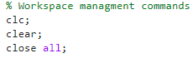
Figure 1 - Workspace management

5.3.2 Material properties
Here the aluminium plates properties are assigned using K for thermal conductivity, Rho for Density and c for specific heat (Fig. 2). These properties are then displayed in the command window (Fig. 3).
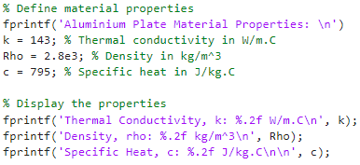
Figure 2 - Material properties
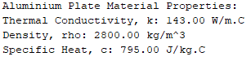
Figure 3 - Material properties (command window)

5.3.3 User inputs for spatial consideration
This part of the code begins with a ‘user inputs:’ that displays in the command window. Follow by a while loop which asks the user for their ‘X’ and ‘Y’ dimension of the plate (Fig, 4). If a dimension is not greater that 0 the loop presents a message asking the user to re-input a correct value (Fig. 5).
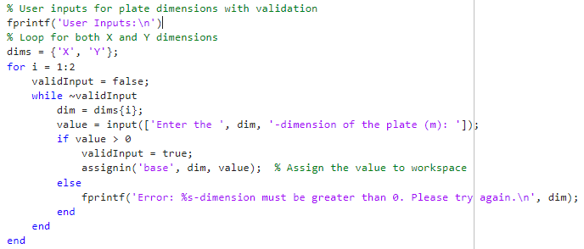
Figure 4 - User inputs for spatial consideration
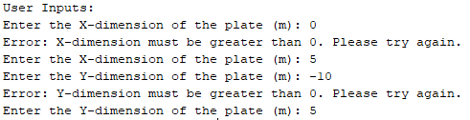
Figure 5 - User inputs for spatial consideration (Command window)

5.3.4 Grid spacing
Using a while loop the user is asked to input their chosen grid spacing in meters (Fig. 6). However, if the input does not meet the criteria of being divisible by both dimensions and a positive number, the value would have to be put in again until correct (Fig. 7)
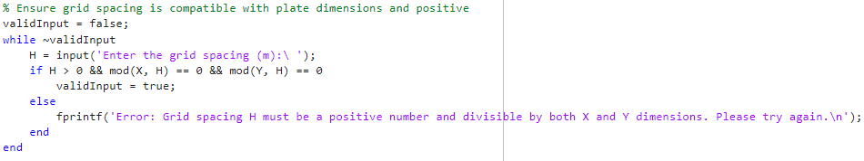
Figure 6 - Grid Spacing
Figure 7 - Grid spacing (Command window)

3.3.5 Rows and Columns to initialise matrix.
Using the dimensions, the Rows and Columns of the matrix are calculated then displayed to the user (Fig. 8 & Fig 9). The initial temperature matrix (T1) is then initialised for use later in the code.
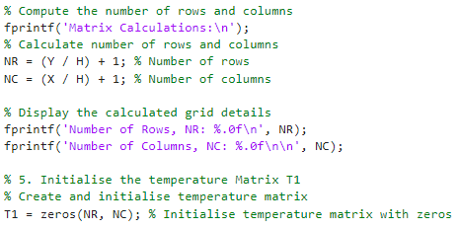
Figure 8 - Rows and columns to initialise matrix
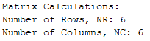
Figure 9 - Rows and columns to initialise matrix (Command window)

3.3.6 Initial Boundary conditions
The user is then asked to input the temperature of the north boundary that will be applied to the plate, the code then continues to set the north and south boundary in the matrix T1 (Fig. 10 & 11).
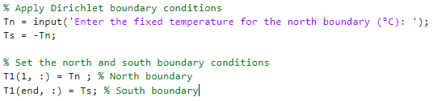
Figure 10 - Initial boundary conditions
Figure 11 - Initial boundary conditions (Commandd window)

3.3.7 Time step
Before the user inputs the timestep the alpha value and maximum value are determined. These are then used in the while loop to ensure that the timestep is a positive number and within the allowed maximum range, and that the Fourier number calculated within the loop is 0.25 or less to ensure the accuracy of the simulation (Fig. 12). The results are then displayed in the command window (Fig. 13).
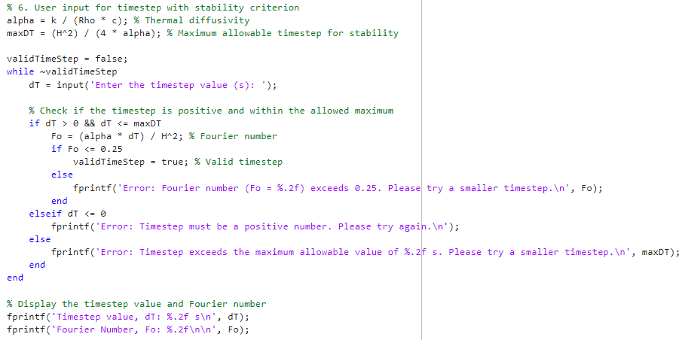
Figure 12 - Time step
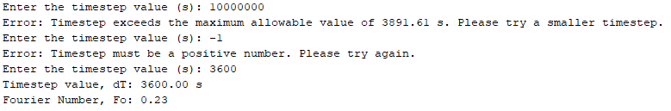
Figure 13 - Time step (Command window)

3.3.8 T2 and Convergence criterion
T2 is initialised using T1 ready for the node calculations and the convergence criterion is determined (Fig. 14).
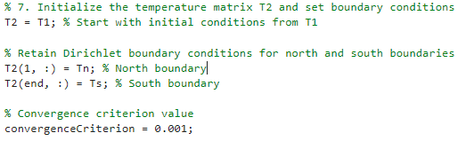
Figure 14 - T2 and convergence criterion

3.3.9 Using Explicit Finite difference method
The use of the EFDM begins with defining the properties of the time loop. The convergence flag controls the continuation of the loop, initially set to false, once the convergence is reached it will be set to true and the loop will stop. The iteration counter will track how many times it takes the loop to converge. MaxDifference is used to track the largest change in temperature between the two time steps, its set to infinity to ensure the loop starts and runs at least once until the max difference is less than the convergence criterion.
The while loop firstly uses the EFD equation for the internal nodes, then for the east and west boundaries as the EFD is different for the east and west boundaries due to them being insulated. The loop then updates the temperature matrix and checks for convergence (Fig. 15).
The code then calculates the total simulation time using the iterations and determined time step. The numerical matrix is then displayed in the command window (Fig. 16)
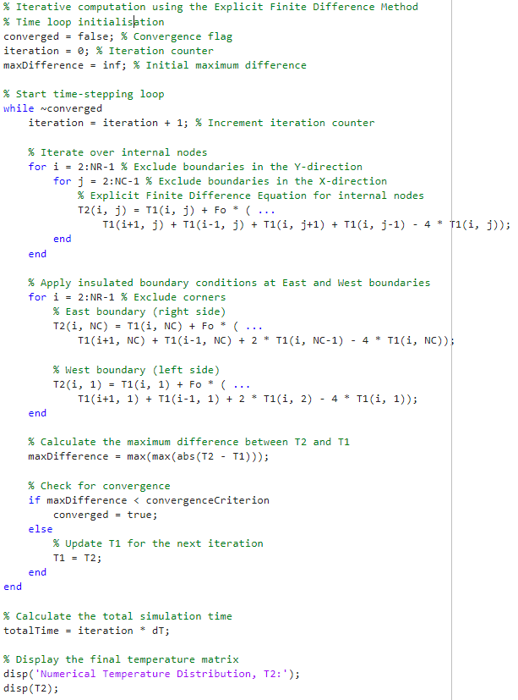
Figure 15 - Using Explicit Finite difference method
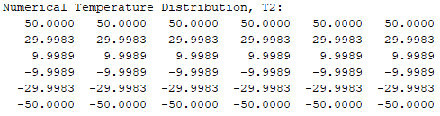
Figure 16 - Using Explicity Finite difference method (Command window)

3.3.10 Analytical solution
TA is initialised followed by the dimensions and initial temperature put into the correct terms for the analytical equation (Fig. 17). The loop then applies the equation to every grid point. The final calculated temperature matrix is then displayed in the command window (Fig. 18).
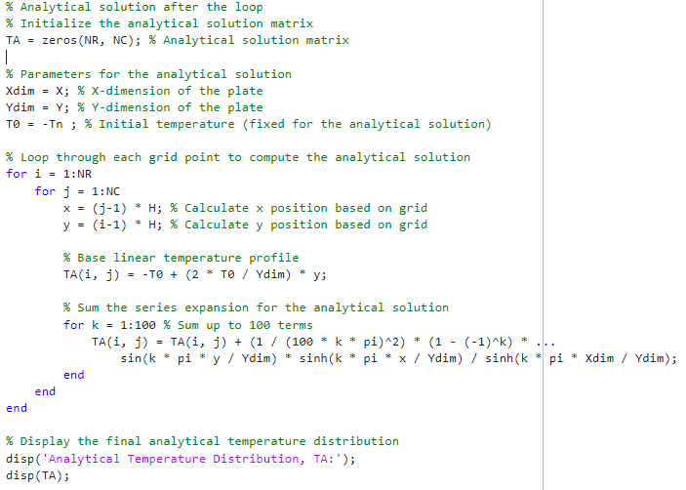
Figure 17 - Analytical solution
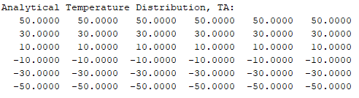
Figure 18 - Analytical solution (Command window)

3.3.11 Plots
The numerical and analytical matrixes are then plot into figures that visually represent the temperature distribution within the aluminium plate using hot/red, blue/cold colours (Fig 19 & 20).
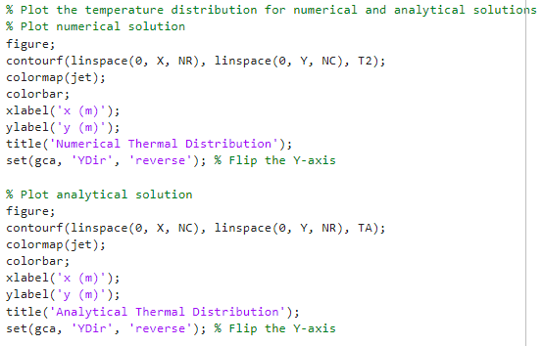
Figure 19 - Plots
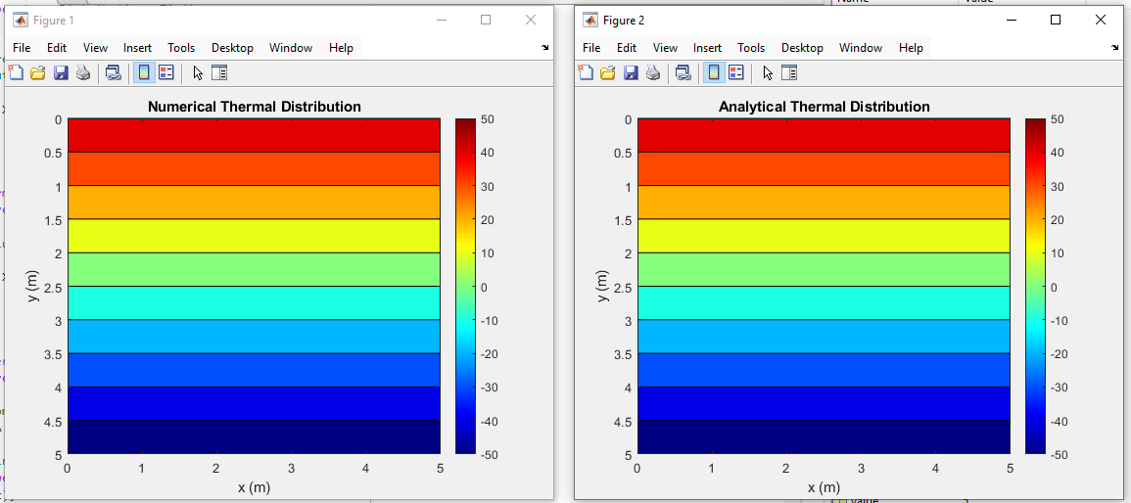
Figure 20 - Plots (Command window)

3.3.11 simulation results and error plot
The numerical matrix and analytical matrix are subtracted from one another, the matrix is then displayed and shown to the user as an error plot (Fig.23). The largest number from this matrix is then displayed as “Largest difference”. The other results from the code are also displayed under “simulation results”: number of iterations and the total time to reach thermal equilibrium (Fig. 21).
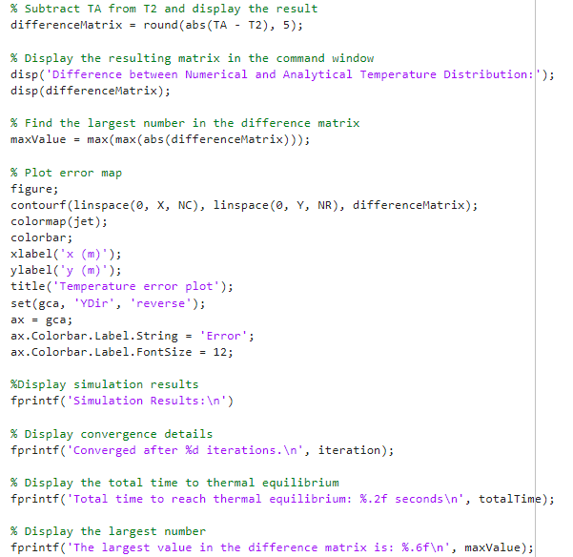
Figure 21 - Simulation results

6. Validation of the code
The comparison of the numerical and analytical temperature distributions shows strong agreement with only a maximum difference of 0.0017°C, validating the accuracy of the numerical method. Both results produced identical boundary values, while the inner values showed only minor discrepancies.
The numerical result took 25 iterations, achieving thermal equilibrium in 90,000seconds, showing the efficiency and stability of the method. Minor differences are Likely due to numerical truncation or rounding errors which however are within acceptable limits (Fig. 22).
Along with the two temperature maps this code also produced an error map to give the user a visual representation of the accuracy of the results. These maps are very similar, proving further that the results are reliable (Fig, 23).
In summary, the numerical method was proved to be reliable and precise for solving this thermal equilibrium problem, with results almost replicating the analytical solution.
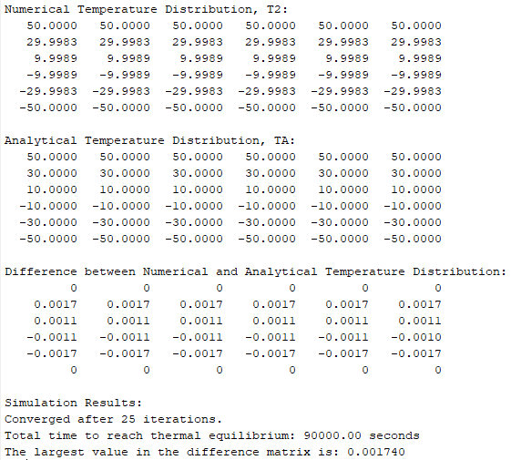
Figure 22 - Simulation results
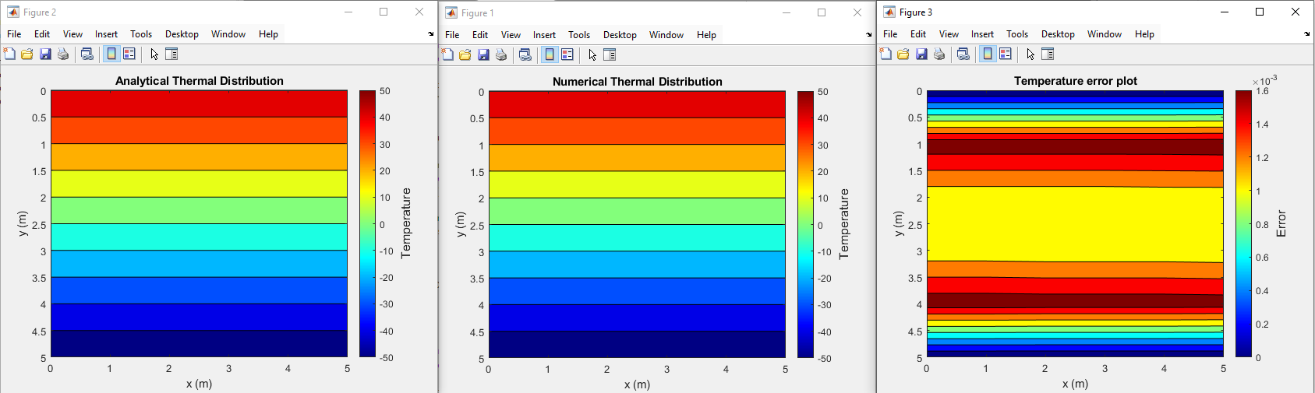
Figure 23 – Temperature and error maps

7. Analysis of the code results.
This sensitivity analysis of the code reveales how variations in grid spacing, time step, and thermal equilibrium tolerance influenced the time required to achieve thermal equilibrium. The key findings and conclusions are summarized below

7.1 Grid spacing
The thermal equilibrium time decreased dramatically as grid spacing decreased, from 282,600 seconds (4 m spacing) to 251,700 seconds (0.2 m spacing). At finer resolutions, decreasing grid spacing improved results precision while having a smaller impact on thermal equilibrium time. Beyond a certain point, reducing grid spacing increases computational cost without significantly improving accuracy (Tab. 1).
The deviations at 1.2 m and 2 m grid spacings are most likely caused by; numerical artefacts, slower convergence behaviour, or discretisation effects, which caused minor irregularities in thermal equilibrium times. These are minor differences that have no bearing on the overall trend (Fig. 24) (Anderson, Pletcher and Tannehill, 2013).
Table 1 - Grid spacing data
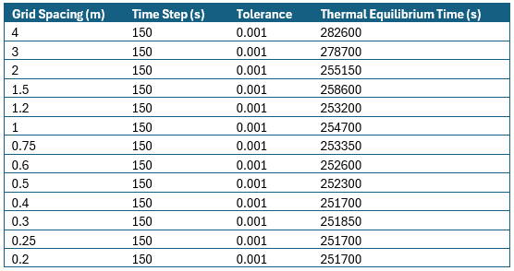
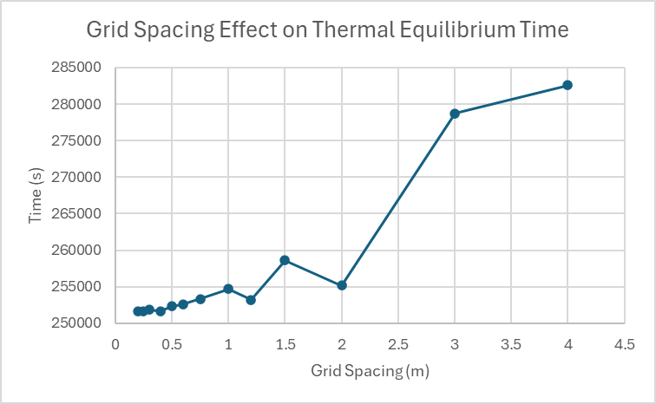
Figure 24 - Grid Spacing data graph

7.2 Time step
Reducing the time step from 2,000 seconds to 25 seconds resulted in a significant decrease in thermal equilibrium time, from 528,000 seconds to 282,775 (Tab. 2). Larger time steps resulted in slower convergence, most likely due to inaccuracies in iterative updates (Fig. 25). Smaller time steps improved the simulation's convergence rate and numerical stability but required more computational iterations. A time step of 150 seconds may provide the best balance of accuracy and computational efficiency.
Table 2 - Time step data
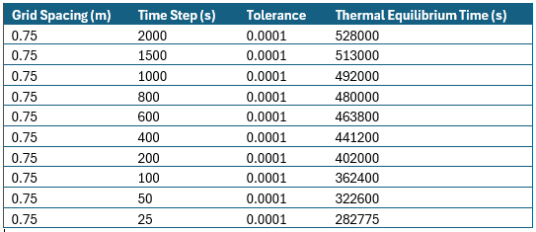
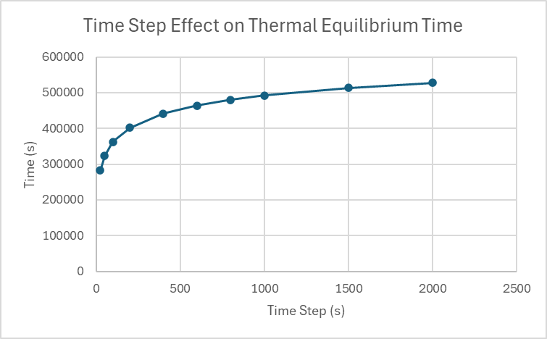
Figure 25 - Time step data graph

7.3 Tolerance
Lowering the tolerance from 0.1 to 0.000001 resulted in a significant increase in thermal equilibrium time, from 57,500 to 723,500 seconds (Tab. 3). This behaviour resulted from the stricter convergence criterion, which required finer accuracy before terminating the simulation. Stricter tolerances improved the solution's precision while significantly increasing computation time. Selecting a reasonable tolerance, such as 0.001, strikes a balance between accuracy and efficiency (Fig. 26).
Table 3 - Tolerance data
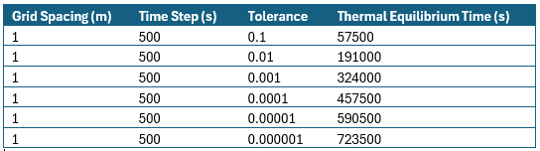
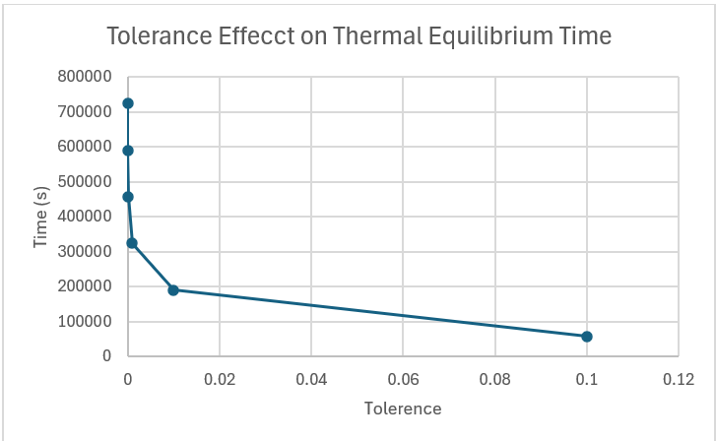
Figure 26 - Tolerance data graph

Limitations of the model.

8.1Limitations due to the Numerical Method

8.1.1 Round off error
These errors occur due to the limited precision of numerical calculations in computers, which can result in minor inaccuracies in computed results. These errors can accumulate over many iterations and have an impact on the final temperature distribution (Chapra, 2018).

8.1.2 Truncation error
When applying finite differences to a continuous differential equation (such as the heat equation), the solution is only an approximation of the true solution. Truncation errors result from the discretisation of the domain and time steps, which can lead to a loss of accuracy (Arieh Iserles, 2009).

8.1.3 Complex geometry
The Explicit Finite Difference Method (EFDM) has limitations when dealing with complex geometries, especially those with curved boundaries or irregular shapes. The method is best suited for solving problems in rectangular or simple polygonal domains, which can be a drawback when dealing with more complex geometry (Ammari, 2019).

8.1.4 Stability
Stability is an important consideration in numerical methods. In EFDM, the solution's stability is determined by the time step and spatial step. If the time step is too large, the solution may become unstable, resulting in oscillations or divergence in the temperature distribution (Chapra, 2018).

Limitations due to Coding:

8.2.1 Thermal Equilibrium Modelling
A common method for modelling thermal equilibrium in coding is to compare temperature differences between iterations to a predetermined tolerance. However, this method is not ideal because the tolerance level chosen can have a significant impact on the outcome. The sensitivity of the solution to the tolerance factor introduces uncertainty, and there is no simple method for determining the best tolerance value. This may result in inaccurate representations of the physical process of thermal equilibrium (Hoffman, 2001).

- Suggested improvements to the model and future developments.

9.1 Improved Stability and Accuracy - ADI or Implicit Finite Difference Method (FDM)
To avoid the stability issues of the EFDM, other methods like Alternating Direction Implicit or Implicit FDM can be used. These methods allow larger time steps without effecting the stability, where the EFDM must have a Fourier number under 0.25. ADI and implicit FDM are more difficult to use but have more advantages for large scale simulations or models requiring larger time steps, such as simulating a larger aluminium plate where heat takes significantly longer to reach thermal equilibrium.

9.2 Handling Complex Geometries - Numerical Alternatives to FDM
Simple geometries such as rectangular domains are more suitable for the EFDM method. To handle more complex geometries other numerical methods such as the Finite Element method, Finite Volume method and the Boundary Element Method are more suitable as they offer greater flexibility in modelling and accuracy for complex physical systems (Sjodin, 2016).

9.3 Modelling Thermal Equilibrium - Robust Modelling of Thermal Equilibrium
The method used in this study for modelling thermal equilibrium used a convergence criterion based on temperature differences between successive iteration. This method is simple but not ideal, a more physically representative and robust method could be investigated. This could be to involve more sophisticated approaches that don’t solely rely on tolerance thresholds, ensuring more accurate and stable representation of thermal equilibrium in larger simulations (Rice, 2015).
These suggested improvements and developments would enhance the stability and accuracy of the model whilst also extending its applicability to more complex scenarios.

Conclusion
This study successfully explored the temperature distribution within an aluminium plate using the Explicit Finite difference method, achieving one of the primary aims which was to validate the numerical approach by comparing is accuracy with an analytical solution.
By systematically implementing the EFDM, the objectives of discretising the governing heat equation, defining the initial boundary conditions and iteratively solving the temperature matrix were achieved. The numerical results closely matched the analytical solution proving the reliability of the EFDM.
The analysis of the model reveals that the EFDM provides accurate results when an appropriate time step and spacing are used. However, computational efficiency can be a limitation for finer spacings and longer simulation times. The derivations used in the numerical results were attributes to discretisation errors and stability constraints inherent to the explicit method.
In summary, this study highlight the EFDM’s effectiveness as a tool for heat transfer analysis, while also emphasising the need to balance computational cost and accuracy. By meeting the stated objectives, the report provides valuable insights into numerical methods for solving heat conduction problems and lays the groundwork for future research to improve the technique and broaden its applications.

References
Ammari, H. (2019). Lecture 6: Finite difference methods Numerical methods for ODEs. [online] Available at: https://people.math.ethz.ch/~grsam/SS21/NAII/resources/slides/ODE-Lecture6.pdf.
Anderson, D.A., Pletcher, R.H. and Tannehill, J.C. (2013). Computational fluid mechanics and heat transfer. Boca Raton: Crc Press, Taylor & Francis Group.
Anthony (2023). Why is Heat Transfer Important? - Engineering Cheat Sheet. [online] Engineering Cheat Sheet - Where future engineers go to learn and share their work. Available at: https://engineeringcheatsheet.com/heat-transfer/why-is-heat-transfer-important/.
Arieh Iserles (2009). A first course in the numerical analysis of differential equations. Cambridge: Cambridge University Press.
BBC Bitesize. (2025). Heat transfer. [online] Available at: https://www.bbc.co.uk/bitesize/articles/zh63ydm#zksfsk7.
Bcs, H. and Daileda, R. (n.d.). The two-dimensional heat equation Partial Differential Equations Lecture 12 Daileda The 2-D heat equation. [online] Available at: http://ramanujan.math.trinity.edu/rdaileda/teach/s17/m3357/lectures/lecture12.pdf [Accessed 26 Jan. 2025].
Chapra, S.C. (2018). Applied numerical methods with MATLAB for engineers and scientists. New York, N.Y.: Mcgraw-Hill Education.
Cotter, C. (2024). 7. Dirichlet boundary conditions — Finite element course 2024.0 documentation. [online] Github.io. Available at: https://finite-element.github.io/7_boundary_conditions.html [Accessed 26 Jan. 2025].
Diomidis Spinellis (2006). Code Quality. Adobe Press.
Djellouli, A. (2024). Central Difference Method. [online] Adamdjellouli.com. Available at: https://adamdjellouli.com/articles/numerical_methods/3_differentiation/central_difference [Accessed 26 Jan. 2025].
Giles, M. (2019). Lecture 1: Introduction to finite difference methods. [online] Available at: https://people.maths.ox.ac.uk/~gilesm/AIMS/lec1.pdf [Accessed 26 Jan. 2025].
Hans Petter Langtangen and Linge, S. (2017). Finite Difference Computing with PDEs. Springer.
Helmenstine, A. (2022). Heat Transfer - Conduction, Convection, Radiation. [online] Science Notes and Projects. Available at: https://sciencenotes.org/heat-transfer-conduction-convection-radiation/.
Hoffman, J.D. (2001). Numerical methods for engineers and scientists. Boca Raton: Crc Press.
Jaan Kiusalaas (2014). Numerical methods in engineering with Python. Cambridge: Cambridge University Press.
John Paul Mueller (2021). Matlab For Dummies. S.L.: John Wiley.
Kaw, A. (2023). 2.02: Numerical Differentiation of Continuous Functions. [online] Mathematics LibreTexts. Available at: https://math.libretexts.org/Workbench/Numerical_Methods_with_Applications_(Kaw)/2%3A_Differentiation/2.02%3A_Numerical_Differentiation_of_Continuous_Functions.
MathWorks (2019). MATLAB - MathWorks. [online] Mathworks.com. Available at: https://www.mathworks.com/products/matlab.html.
Rice (2015). Using a while loop to check convergence. [online] Mathworks.com. Available at: https://www.mathworks.com/matlabcentral/answers/181159-using-a-while-loop-to-check-convergence [Accessed 26 Jan. 2025].
Rob Pearce (2017). Taylor Series. [online] Mathsisfun.com. Available at: https://www.mathsisfun.com/algebra/taylor-series.html.
Shen, W. (2019). Introduction To Numerical Computation, An (Second Edition). World Scientific.
Sjodin, B. (2016). What’s The Difference Between FEM, FDM and FVM? [online] Machine Design. Available at: https://www.machinedesign.com/additive-3d-printing/fea-and-simulation/article/21832072/whats-the-difference-between-fem-fdm-and-fvm.
Visualslope. (2024). Available at: https://visualslope.com/Library/FDM-for-heat-transfering.pdf.
YEW, A. (2011). Numerical differentiation: finite differences. [online] Available at: https://www.dam.brown.edu/people/alcyew/handouts/numdiff.pdf.

Appendix.
% Workspace managment commands
clc;
clear;
close all;

% Define material properties
fprintf('Aluminium Plate Material Properties: \n')
k = 143; % Thermal conductivity in W/m.C
Rho = 2.8e3; % Density in kg/m^3
c = 795; % Specific heat in J/kg.C

% Display the properties
fprintf('Thermal Conductivity, k: %.2f W/m.C\n', k);
fprintf('Density, rho: %.2f kg/m^3\n', Rho);
fprintf('Specific Heat, c: %.2f J/kg.C\n\n', c);

% User imputs for spatial consideration
% Prompt user for plate dimensions with validation
fprintf('User Inputs\n')
validInputX = false;
while ~validInputX
X = input('Enter the X-dimension of the plate (m): ');
if X >= 1
validInputX = true;
else
fprintf('Error: X-dimension must be 1 or greater. Please try again.\n');
end
end

validInputY = false;
while ~validInputY
Y = input('Enter the Y-dimension of the plate (m): ');
if Y >= 1
validInputY = true;
else
fprintf('Error: Y-dimension must be 1 or greater. Please try again.\n');
end
end

% Ensure grid spacing is compatible with plate dimensions and positive
validInput = false;
while ~validInput
H = input('Enter the grid spacing (m):\ ');
if H > 0 && mod(X, H) == 0 && mod(Y, H) == 0
validInput = true;
else
fprintf('Error: Grid spacing H must be a positive number and divisible by both X and Y dimensions. Please try again.\n');
end
end

%Space in command window
fprintf('\n');

% Compute the number of rows and columns
fprintf('Matrix Calculations:\n');
% Calculate number of rows and columns
NR = (Y / H) + 1; % Number of rows
NC = (X / H) + 1; % Number of columns

% Display the calculated grid details
fprintf('Number of Rows, NR: %.0f\n', NR);
fprintf('Number of Columns, NC: %.0f\n\n', NC);

% Initialise the temperature Matrix T1
% Create and initialize temperature matrix
T1 = zeros(NR, NC); % Initialize temperature matrix with zeros

% Apply Dirichlet boundary conditions
Tn = input('Enter the fixed temperature for the north boundary (°C): ');
Ts = -Tn;

% Set the north and south boundary conditions
T1(1, :) = Tn ; % North boundary
T1(end, :) = Ts; % South boundary

% 6. User input for timestep with stability criterion
alpha = k / (Rho * c); % Thermal diffusivity
maxDT = (H^2) / (4 * alpha); % Maximum allowable timestep for stability

validTimeStep = false;
while ~validTimeStep
dT = input('Enter the timestep value (s): ');

% Check if the timestep is positive and within the allowed maximum
if dT > 0 && dT <= maxDT
Fo = (alpha * dT) / H^2; % Fourier number
if Fo <= 0.25
validTimeStep = true; % Valid timestep
else
fprintf('Error: Fourier number (Fo = %.2f) exceeds 0.25. Please try a smaller timestep.\n', Fo);
end
elseif dT <= 0
fprintf('Error: Timestep must be a positive number. Please try again.\n');
else
fprintf('Error: Timestep exceeds the maximum allowable value of %.2f s. Please try a smaller timestep.\n', maxDT);
end
end

% Display the timestep value and Fourier number
fprintf('Timestep value, dT: %.2f s\n', dT);
fprintf('Fourier Number, Fo: %.2f\n\n', Fo);

% Initialize the temperature matrix T2 and set boundary conditions
T2 = T1; % Start with initial conditions from T1

% Retain Dirichlet boundary conditions for north and south boundaries
T2(1, :) = Tn; % North boundary
T2(end, :) = Ts; % South boundary

% Convergence criterion value
convergenceCriterion = 0.001;

% Iterative computation using the Explicit Finite Difference Method
% Time loop initialization
converged = false; % Convergence flag
iteration = 0; % Iteration counter
maxDifference = inf; % Initial maximum difference

% Start time-stepping loop
while ~converged
iteration = iteration + 1; % Increment iteration counter

% Iterate over internal nodes
for i = 2:NR-1 % Exclude boundaries in the Y-direction
for j = 2:NC-1 % Exclude boundaries in the X-direction
% Explicit Finite Difference Equation for internal nodes
T2(i, j) = T1(i, j) + Fo * ( ...
T1(i+1, j) + T1(i-1, j) + T1(i, j+1) + T1(i, j-1) - 4 * T1(i, j));
end
end

% Apply insulated boundary conditions at East and West boundaries
for i = 2:NR-1 % Exclude corners
% East boundary (right side)
T2(i, NC) = T1(i, NC) + Fo * ( ...
T1(i+1, NC) + T1(i-1, NC) + 2 * T1(i, NC-1) - 4 * T1(i, NC));

% West boundary (left side)
T2(i, 1) = T1(i, 1) + Fo * ( ...
T1(i+1, 1) + T1(i-1, 1) + 2 * T1(i, 2) - 4 * T1(i, 1));
end

% Calculate the maximum difference between T2 and T1
maxDifference = max(max(abs(T2 - T1)));

% Check for convergence
if maxDifference < convergenceCriterion
converged = true;
else
% Update T1 for the next iteration
T1 = T2;
end
end

% Calculate the total simulation time
totalTime = iteration * dT;

% Display the final temperature matrix
disp('Numerical Temperature Distribution, T2:');
disp(T2);

% Analytical solution after the loop
% Initialize the analytical solution matrix
TA = zeros(NR, NC); % Analytical solution matrix

% Parameters for the analytical solution
Xdim = X; % X-dimension of the plate
Ydim = Y; % Y-dimension of the plate
T0 = -Tn ; % Initial temperature (fixed for the analytical solution)

% Loop through each grid point to compute the analytical solution
for i = 1:NR
for j = 1:NC
x = (j-1) * H; % Calculate x position based on grid
y = (i-1) * H; % Calculate y position based on grid

% Base linear temperature profile
TA(i, j) = -T0 + (2 * T0 / Ydim) * y;

% Sum the series expansion for the analytical solution
for k = 1:100 % Sum up to 100 terms
TA(i, j) = TA(i, j) + (1 / (100 * k * pi)^2) * (1 - (-1)^k) * ...
sin(k * pi * y / Ydim) * sinh(k * pi * x / Ydim) / sinh(k * pi * Xdim / Ydim);
end
end
end

% Display the final analytical temperature distribution
disp('Analytical Temperature Distribution, TA:');
disp(TA);

% Plot the temperature distribution for numerical and analytical solutions
% Plot numerical solution
figure;
contourf(linspace(0, X, NR), linspace(0, Y, NC), T2);
colormap(jet);
colorbar;
xlabel('x (m)');
ylabel('y (m)');
title('Numerical Thermal Distribution');
set(gca, 'YDir', 'reverse');
ax = gca;
ax.Colorbar.Label.String = 'Temperature';
ax.Colorbar.Label.FontSize = 12;

% Plot analytical solution
figure;
contourf(linspace(0, X, NC), linspace(0, Y, NR), TA);
colormap(jet);
colorbar;
xlabel('x (m)');
ylabel('y (m)');
title('Analytical Thermal Distribution');
set(gca, 'YDir', 'reverse');
ax = gca;
ax.Colorbar.Label.String = 'Temperature';
ax.Colorbar.Label.FontSize = 12;

% Subtract TA from T2 and display the result
differenceMatrix = round(abs(TA - T2), 5);

% Display the resulting matrix in the command window
disp('Difference between Numerical and Analytical Temperature Distribution:');
disp(differenceMatrix);

% Find the largest number in the difference matrix
maxValue = max(max(abs(differenceMatrix)));

% Plot error map
figure;
contourf(linspace(0, X, NC), linspace(0, Y, NR), differenceMatrix);
colormap(jet);
colorbar;
xlabel('x (m)');
ylabel('y (m)');
title('Temperature error plot');
set(gca, 'YDir', 'reverse');
ax = gca;
ax.Colorbar.Label.String = 'Error';
ax.Colorbar.Label.FontSize = 12;

%Display simulation results
fprintf('Simulation Results:\n')

% Display convergence details
fprintf('Converged after %d iterations.\n', iteration);

% Display the total time to thermal equilibrium
fprintf('Total time to reach thermal equilibrium: %.2f seconds\n', totalTime);

% Display the largest number
fprintf('The largest value in the difference matrix is: %.6f\n', maxValue);

