Assessment 2

Student Name: Aniko Balogh
Student ID: 2018980
Module name: Mental Disorder and Psychopathology
Module Code: BMHP 6006
Lecturer Name: Bianca Sanfilippo

Table of content:

Introduction 3
Anxiety disorder 4
Schizophrenia 6
Autism 9
Conclusion 11
References 13
Appendix 15

Introduction
This report will critically examine and evaluate three mental disorders from the ICD-10 (WHO, 2010). We will look at the classification, diagnosis, treatment and measurements of rehabilitation of the following disorders: General Anxiety Disorder, Schizophrenia and Autism.
ICD-10 means “International Statistical Classification of Diseases and Related Health Problems 10th Revision (ICD-10) Version for 2010” (WHO,2010). There are twenty-two chapters in ICD-10, and the chapter on mental and behavioural disorders is chapter five.
The WHO definition of a mental disorder is “A mental disorder is characterised by a clinically significant disturbance in an individual's cognition, emotional regulation, or behaviour. It is usually associated with distress or impairment in important areas of functioning” (WHO,2022); accordingly to WHO, one in every eight people lives with some mental disorder. Thankfully to the ever-improving health care, there are ways to identify and help a person with a mental disorder.
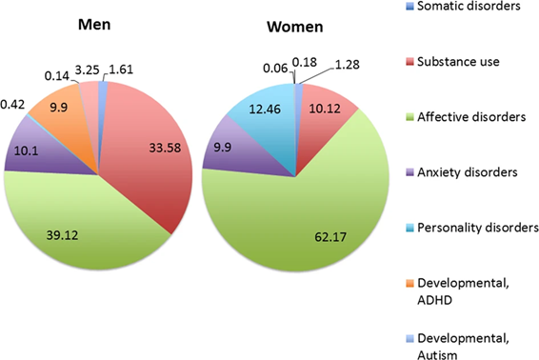

General Anxiety Disorder (GAD)
General anxiety disorder can be found under Neurotic, stress-related and somatoform disorders in ICD-10, F-40 to F-48, and GAD is under F-41.1 (WHO. 2010).
Definition:
Accordingly, to NHS, GAD is when someone feels stressed, anxious, worrying or fearful over a more extended period. Anxiety is expected, for example, before an important meeting, job interview or holiday. But people suffering from GAD feel higher level and more often worried. They are worried all the time about everything. People suffering from a higher level of anxiety can lose control of their lives. Some of the symptoms of GAD are: Feeling restless, wound-up, easily fatigued, having difficulty concentrating, Being irritable, Having headaches, muscle aches, stomach aches, or unexplained pains, and having Difficulty controlling feelings of worry. General Anxiety can be a symptom of several other disorders, such as Panic disorder, Phobias, and Post-traumatic disorder (NHS, 2022). The condition is more common in people between the age of 35 and 55. Accordingly to Mental Health Foundation, in the UK, there were 8.2 million cases of anxiety in the year 2013; women are almost twice as likely to be diagnosed with anxiety than men. It doesn’t necessarily mean women are more affected, but it can be because they are more likely to turn to professionals if they feel unwell (Mental Health Foundation, 2016). There are different levels of anxiety. There are four anxiety levels: mild anxiety, moderate anxiety, severe anxiety, and panic level anxiety.

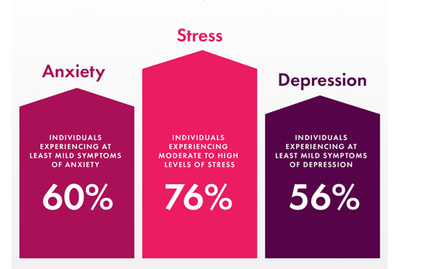(Champion Health, 2013)

The causes of anxiety.
There are different factors of anxiety, Biological, Psychological and Social.
The Biological factors are Genetics, Neurotransmitter imbalance, Disease, Medications and Dietary factors. A child who has a parent with an anxiety disorder is more likely to suffer from the same condition during their life than a child whose parents do not have GAD.
Psychological factors: Low self-esteem, negative emotions, personality traits, Cognitive difference, intra-personal conflicts, Developmental crises. Brain functional studies have shown that some neurotransmitters are linked to the neurobiology of anxiety.
Social Causes: Adverse Life Experiences, Lack of social support, Work stress, Lack of social skills, Changing values, Conflict with societal norms and high social expectations. Any challenging or complex life event like losing a loved one, job-related or relationship-related stress, or poverty can contribute to anxiety. (Shri, 2010)
Diagnosis:
Although GAD is common and ordinary, people should see their GP if anxiety affects their everyday life. For example, If the person feels worried and thinks of the worst things that can happen, it affects their personal lives and relationship, they should see GP. It is hard to diagnose Anxiety as it has a lot of overlapping syndromes with other conditions, such as depression, or even physical illnesses that can cause the symptoms of GAD, like Iron and vitamin B-12 deficiency.
The GP will first ask many questions about the patient’s lifestyle, physical and psychological symptoms and how long the person feels those things. The person will most likely be diagnosed with GAD if the symptoms are consistent for at least 6 Months. After the questionnaire, the doctor will roll out any physical illnesses and do a blood test (NHS, 2022).
After ruling out the other conditions, the patient can be diagnosed with anxiety, and treatment can begin accordingly to the Anxiety severity.
Treatment:
If the Anxiety is milder, it can be self-cured with herbal teas; teas are good for anxiety, yoga and self-help books. If that doesn’t help, talking Therapy can be helpful too. The GP will refer to Cognitive Behaviour Therapy CBT. A person can refer themselves to talking therapies and don’t need a GP for that. Cognitive Behaviour Therapy is a guided self-help talking therapy proven to be the most successful therapy for GAD. The person can be offered help in several different ways. Work through a workbook in their own time to guide service where they can see a therapist once or twice a week. Or fully supported group therapies where the person can be kept in a group. The negative side of talking and self-Therapy is that it takes some time to feel improvement. But once the progress happens, it is the most effective and with no side effects.
If CBT is ineffective, the person will be offered more intensive therapy where they can meet a therapist once or twice a week. This therapy usually will be for three to four months. Relaxation therapy can also help before trying medication if there is no change. Applied relaxation is a therapy focusing on relaxing the muscles in a certain way; only trained professionals can help to guide how to relax the muscles and respond to an anxiety trigger. Relaxation Therapy is one-to-one therapy over three to four months. It also takes longer to be effective and is unavailable in some regions.
If the Anxiety is severe, then medications will be involved. Depending on the severity of the symptoms, there are different types of medicines for short-term or long-term help. The GP will decide which medication is the best suited for the person. The negative side of this therapy is that there can be many side effects from the drugs.
Measurements of rehabilitation:
The GAD-7 is a questionnaire made out of seven questions; professionals use it as a tool to measure the severality of the anxiety in the patient. (Appendix 1)
The use of complementary therapies, such as Yoga, helps reduce anxiety. At least once a week, practising yoga for two to three months can be positive for reducing stress and anxiety for people.

Schizophrenia
Classification of Schizophrenia within the ICD–10 is classified as a schizotypal and delusional disorder (F20-F29) (WHO. 2010).
Definition:
Schizophrenia is a complicated mental health disorder. It can be mild, severe or even disabling. It is a mental disorder described by interruptions in thinking, views, emotional responsiveness, and social connections. There is much-mistaken belief about it; even professionals don’t all agree on what it is and what causes it. (NHS, 2019)
Causes:
The exact causes of Schizophrenia are unknown, but research indicates that a combination of a few factors can make the person vulnerable to schizophrenia combination of physical, genetic, psychological and environmental factors. Schizophrenia is not as common as other mental disorders; it is more common in men than women and affects mainly people in late adolescence. Accordingly to WHO worldwide, Schizophrenia affects approximately 24 million people or 1 in 300 people (0.32%) (WHO, 2022).
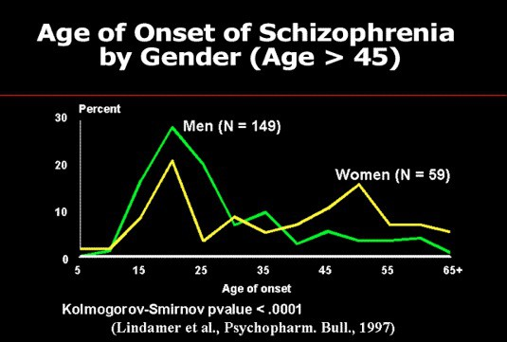
(Living With Schizophrenia, 2022)
Schizophrenia can run in the family, but genetics is not the only factor that triggers episodes of schizophrenia. The evidence that the disorder is partly genetic comes from research examining identical twins. If one twin has the disorder, the other can develop to 1 in 2, dropping to 1 in 8 chances for regular twins. For the rest of the population, it is 1 in 100. Therefore, it is genetic, but other factors need to be met for the person to develop schizophrenia. Studies have shown that the brain of people with schizophrenia is structured differently. Neurotransmitters are chemicals that carry messages between brain cells. There is a link between neurotransmitters and schizophrenia because medications that alter the levels of neurotransmitters in the brain are known to relieve some of the symptoms of schizophrenia, and research suggests that when change happens in two of the neurotransmitters, dopamine and serotonin and the imbalance between two of those is the main reason for the schizophrenia.
Pregnancy and difficult birth can raise the risk of schizophrenia, low birth weight, premature labour or lack of oxygen. Other triggers like stress due to a job or the death of a loved one, abuse, emotional, physical or sexual can be a trigger. Drug substant misuse can increase the risk of schizophrenia (NHS, 2019)
Symptoms of schizophrenia are hallucinations – hearing or seeing things that do not exist.
Delusion –false belief or judgment about external reality, losing interest in everyday activities, not caring about your personal hygiene, wanting to avoid people, including friends.
Diagnosis:
If someone experiences any of the symptoms should see their GP as soon as possible; treating schizophrenia as early as possible makes the chances of successful treatments higher. There will be a few tests to diagnose the disorder. Usually, it will be carried out by a mental health care professional, such as a psychiatrist. Doctors will run some tests to rule out any other conditions. Blood and urine tests will be done. After that, psychological tests like imaging and brain activity tests will be carried out. Once the diagnosis is made and the outcome is that the person is positive for schizophrenia, treatments will include combination therapies—antipsychotic medicines and cognitive behavioural therapy (CBT). The different talking therapies help patients identify the problem’s root and what kind of behavioural changes need to be done.
measurements of rehabilitation
Schizophrenia is a long-term mental illness; therefore, finding a way to support the patient in the long term is important. They should have a good quality of life regardless of their disorder. No one tool can assess the quality of care the patient receives, For this reason, the Quality Indicator for Rehabilitative Care care-QuIRC ( Appendix 2) was developed.
The service manager will complete the assessment (The QuIRC) and give a rating on seven different factors.
NICE guidelines are evidence-based recommendations for health and care in England. NICE Guidance is there to recognise and help people to receive the care they need. And for the best quality care.
Recommendations for improvement of Schizophrenia
Talking therapies can help to improve the lives of people suffering from schizophrenia.
Yoga and meditation help people to find a way to self-control the mind and body; regularly practising yoga can help people suffering from schizophrenia because it allows people to control and relax their minds.

Autism
F80-F89 Disorders of psychological development, ICD, 2010. F84- Pervasive developmental disorders, F84.0-Childhood autism (WHO, 2010)
Definition:
Autism is a lifelong spectrum disorder that affects social interactions and communication.
Over one in 100 people has autism spectrum disorder in the UK, adults and children. This is an estimated number as some are still waiting to be also diagnosed, and many might not even know they have this disorder. (The National Autistic Society, 2023)
Autism is more common in boys than girls, an analysis published in 2017 found there are about 4.2 boys with autism for every girl (Zeliadt, 2018)
Accordingly to the Centres for Disease Control and Prevention (CDC), There are over 75,000.000 people, which is 1% of the world population, have autism spectrum disorder; the country with the highest diagnosed rate is Qatar, and the lowest is France (Zauderer, 2022)
Causes
The causes of autism are still unclear; some believe there is one cause for it others think it is a few different factors that lead to autism. Scientists find strong evidence that autism is genetic and multiple genes responsible for it rather than just one. No evidence has been found for vaccination to have any effect on autism (National Autistic Society, 2023)
Some other factors are important too, not just genetic factors, such as difficult birth or having been born to older parents.
What we know about autism changed a lot in past years, but still, much research needs to be done, and that is why autism spectrum disorder is an ever-changing definition.
Signs /symptoms
Signs can be shown from as early as 18 months, but reliable diagnoses can be made around the age of two or three.
Autistic people find it challenging to communicate with the world around them; They see things differently. They have difficulty with social interaction and have restricted interests or too deep interest in certain things.
Early signs in childhood can be no eye contact; the child does not respond to their name, prefers to stay alone, trouble to understand what other feels. For example, the child does not seem affected if the mother is sad or happy. Repetitive movements or speech patterns do not like loud sounds or intense light, strange ways of moving around.
Diagnosis
Autism has a long and complicated diagnosis process as there is not a simple test to make to diagnose. Doctors will need to see the behaviour and development of the child to diagnose. If the parent is concerned, speaking to the school first, to SENCO staff special education needs member is a good idea. They can confirm if the worry is real and if further investigation is required. If so, a health visitor, GP, or school in an older child case can be The first contact with which parents can raise their concerns. They will assess the child’s development with a group of specialists; autism specialists will work together to find the diagnosis. They will speak to people who know the child, like nursery or schools, Family and friends. Speak, and language therapists will help with the diagnosis as well.
Diagnosis can help the child get the proper school support and get extra teachers and extra one-to-one support for academic achievements. It can help to provide mental and financial support to the parent or carer. It can be expensive at times to have an autistic child who needs extra support, particular food, clothes or development toys and equipment (NHS, 2022)
For an adult to be diagnosed with autism, it can help to reach out to the proper support and benefit from the Autism Act 2009, which supports people with autism to live everyday life as independently as possible. The Autism Act Increases awareness and understanding of autism and develops a clear and consistent pathway for diagnosis. Improving access to the services and support people need to live independently within the community. Helps to get into Employment. (Legalisation gov, 2009)
There is no treatment for autism; current options are to reduce symptoms that interfere with daily functioning and quality of life. As autism is different to everyone, there will not be one correct way to help; there are many therapies that people can use to enable them to maintain everyday life as possible, Behavioural management therapy, Cognitive behaviours therapy,
Educational and school-based therapies, Joint attention therapy, Medication treatment, Nutritional therapy, Occupational therapy, Parent-mediated therapy, Physical therapy, social skills training, and Speech-language therapy.
For improvement, Food supplements, Specialized diets, and Animal-assisted therapy, research has shown that assisted animals can teach the autistic child empathy, social skills and communication. Arts therapies, Developmental therapies and Mind-body therapies such as yoga and biofeedback Yoga was found to have a positive impact on people suffering from Autism, especially on children. They were a lot calmer after Yoga (CDC, 2023).
Measurements of rehabilitation are the Childhood Autism Rating Scale (CARS) and observation, called ADOS standardised assessment tool, to aid a psychologist in diagnosing Autism Spectrum Disorder (ASD) in children and adults. ‘Autism Diagnostic Observation Schedule’. It consists of structured and semi-structured tasks and generally takes 30 to 60 minutes to complete.

Conclusion
While all three mental disorders are different still, they have a lot in common; for all the three disorders, the causes are unclear yet, and more research is needed, but it is sure the causes are a combination of genetic and environmental factors. When it comes to improving the patient’s life, all disorders suggest talking therapy and yoga for improvement. We understand now how important it is to care for people with mental health and the government introduced many plans, acts and ways to help those people to maintain as normal life as possible. Like the Care Act 2009. We know that to maintain a happy, balanced life for people in need, a personal centre approach is essential.
WHO Mental Health Action Plan 2013-2030 was launched in 2019 to expand the WHO Mental Health Action Plan 2013-2020, initially recognized in 2013. The plan is centred around the idea that “mental health is valued, promoted and protected, mental disorders are prevented, and persons affected by these disorders are able to exercise the full range of human rights and to access high quality, culturally-appropriate health and social care in a timely way to promote recovery, in order to attain the highest possible level of health and participate fully in society and at work, free from stigmatisation and discrimination.” (NCD, 2023)

References:
Centre of disease control and Prevention (2023) Treatment and Intervention Services for Autism Spectrum Disorder. Available at: https://www.cdc.gov/ncbddd/autism/treatment.html (Accessed: 04/05/2023)
Champion Health (2023) Anxiety Statistics UK: 2023. Available at: https://championhealth.co.uk/insights/anxiety-statistics/ (Accessed: 14/04/2023)
Legalisation Gov (2009) Autism Act 2009, available at: https://www.legislation.gov.uk/ukpga/2009/15/contents (accessed: 04/05/2023)
Living With Schizophrenia (2022) Schizophrenia and Dangerous Behaviour, available at: https://livingwithschizophreniauk.org/information-sheets/schizophrenia-and-dangerous-behaviour/ (Accessed: 16/04/2023)
Mental Health Foundation (2016) Anxiety: Statics, Available at: https://www.mentalhealth.org.uk/explore-mental-health/mental-health-statistics/anxiety-statistics (Accessed: 14/04/2023)
National Autistic Society, (2023) What is autism? Available at https://www.autism.org.uk/advice-and-guidance/what-is-autismt:, (Accessed: 1/05/2023)
NCD Alliance (2023) Mental Health and Neurological Disorders. Available at: https://ncdalliance.org/why-ncds/ncds/mental-health-and-neurological-disorders?gclid=Cj0KCQjw0tKiBhC6ARIsAAOXutnDNpzc5XyBljjFSP53-35e8rCAFkKw8eak_tbkLDinDk-9OXdbtMoaAif-EALw_wcB (Accessed: 05/05/2023)
Nikolette Zeliadt (2018) Autism’s sex ratio, explained, available at: https://www.spectrumnews.org/news/autisms-sex-ratio-explained/ (Accessed: 01/05/2023)
NHS (2021) Anxiety and panic attacks. Available at: Anxiety and panic attacks - NHS (www.nhs.uk) (Accessed:14/04/2023). )
NHS (2019) Causes – Schizophrenia. Available at: https://www.nhs.uk/mental-health/conditions/schizophrenia/causes/ (Accessed: 16/04/2023)
NHS (2022) How to get diagnosed as autistic. Available at: https://www.nhs.uk/conditions/autism/getting-diagnosed/how-to-get-diagnosed/ (Accessed: 04/05/2023)
NHS (2022) Overview - Generalised anxiety disorder in adults. Available at: https://www.nhs.uk/mental-health/conditions/generalised-anxiety-disorder/overview/ (Accessed: 14/04/2023)
NHS (2019) Overview – Schizophrenia. Available at: https://www.nhs.uk/mental-health/conditions/schizophrenia/overview/ (Accessed: 16/04/2023)
Richa Shri (2010) Anxiety: Causes and Management, Available at: https://so06.tci-thaijo.org/index.php/IJBS/article/view/2205/1843 (Accessed: 14/04/2023)
Steven Zauderer (2022) 69+ Autism Statistics: How Many People Have Autism? Available at: https://www.crossrivertherapy.com/autism-statistics (Accessed: 04/05/2023)
The National Autistic Society (2023) The causes of autism. Available at: https://www.autism.org.uk/advice-and-guidance/what-is-autism/the-causes-of-autism (Accessed: 04/05/2023)
World Health Organisation, WHO (2010) ICD-10 VERSION. Available at: https://icd.who.int/browse10/2010/en#/F30-F39 (Accessed:14/04/2023).
World Health Organisation, WHO (2022) Mental Disorders. Available at: https://www.who.int/news-room/fact-sheets/detail/mental-disorders (Accessed: 14/04/2023)
WHO (2022) Schizophrenia, available at: https://www.who.int/news-room/fact-sheets/detail/schizophrenia (Accessed: 16/04/2022)

Appendix
1.

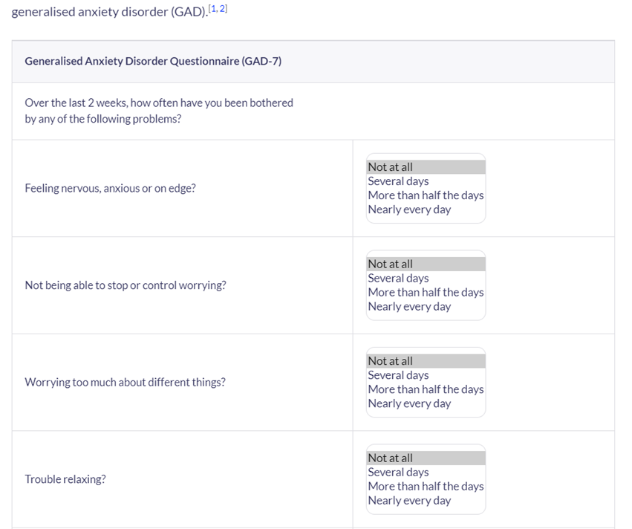

Appendix 2
‘Quality Indicator for Rehabilitative Care (QuIRC-SA)’
The indicators to be considered are the these:
‘Living Environment’,
‘Therapeutic Environment’,
Treatments and Interventions,
Self-Management and Autonomy,
Social Interface,
Human Rights
Recovery Based Practice.

