1 . Executive summary
2 . Marketing vision
2.1 marketing objectives
2.2 strategic choice
2.3 innovative customer journey
3 . marketing program/ initiatives
3.1 key strategies
3.2 implementation details
- Recommendations on resource requirements
- Suggestions for monitoring performance
6 . references
7 . appendix
7.1 organization summary
7.2 Environmental Marketing Audit

1: executive summary
This report is a follow-up to the first part of the presentation report in March 2021, which analyzes the environmental marketing and Uniqlo's customer journey. The following suggestions are put forward.
From the presentation:
- A shopping trip in which physical experience and digital technology interweave and promote each other. Digital technology enriches physical channels, while digital channels become more humane. The end result is a more personalized and attractive experience. (Christina ·INZ· de la flo, 2020)
- RFID tags。One of the most exciting developments in the use of RFID technology is its potential to change the way customers browse and buy products in physical stores. The idea behind this is to reduce the checkout team and shorten the POS stage. （Comparesoft,2021).
- Automatic delivery robot and shop assistant. Robot store assistants have built-in 3D scanners, which can help them identify products and even guide customers to find them by navigating in the store. （Ben Forgan. 2020）
- A cashier-free shop. Customers can simply walk out of the store, automatically scan their goods, and deduct the total amount from their accounts, which may soon become popular. （GARIMA. (2020) Cashierless Stores – The Self Driving Technology that is Reinventing Retail. Available at: https://www.netsolutions.com/insights/cashierless-stores-future-of-retail/ (Accessed: 2 May 2021).
From the report:
- The digital service StyleHint, which is a one-stop service for customers, is launched,Customers only need to upload their own or bloggers' wearing photos, and the APP can recommend similar styles of Uniqlo brand.
- Create an independent innovative marketing department to coordinate online and offline omni-channel marketing. "The integration or input of various online and offline user experiences is more to make users feel the same brand experience. This consistency also strengthens the leading sense and technological attributes of Uniqlo brand, and enables consumers to better enter the brand closed loop in all channels, which is also an operational idea to strengthen loyalty. ". (Xu Baiwei, 2020)
- Starting from the needs of users, provide all kinds of life information, in what weather, environment and state, what clothes to wear, how to match and so on.
- At the same time, we will cooperate with various platforms to collect and analyze user needs, so as to adjust Uniqlo's services and even products.

2,Introduction
Uniqlo is the most powerful clothing brand under Fast Retailing Group of Japan. Fast Retailing Group, established in 1963, is the largest clothing retailer in Japan,Uniqlo was established in 1984,At the beginning of its establishment, Uniqlo was only a small clothing store selling suits,Now, Uniqlo has become a well-known fast fashion clothing brand in Asia and even in the world, the third largest and the largest cheap clothing brand in Asia,Its clothing products are selling well all over the world and gradually become synonymous with fashion trends. （marketline,2020）

This work will evaluate what kind of innovative customer care plan Uniqlo should create to improve customers' understanding of Uniqlo, and promote the implementation of innovative customer care plan through various communication channel management, marketing plan implementation management and required resource management,At the same time, it will create a marketing performance evaluation index system to better evaluate customer trips to meet the expectations of Uniqlo stakeholders.
Based on Uniqlo's current marketing ability, this paper determines the organization's marketing strategy and the specific marketing strategy needed to realize the marketing strategy, and at the same time determines the specific target customer classification, pushes the related marketing content of Uniqlo to the target customers through the channels that the target customers pay attention to, and sets up the corresponding marketing performance evaluation index system to accurately grasp the customer's needs and feedback, and make a quick response to it, in order to improve the customer's awareness of the brand and thus enhance the brand influence of Uniqlo.
The purpose and goal of the report is to determine the innovative customer care plan, evaluate its feasibility through the specific marketing implementation plan, and put forward suggestions for the organization on this basis, so as to guide Uniqlo to achieve its marketing goal of enhancing customers' brand awareness.
This report will adopt the theory and framework applicable to the existing Uniqlo organization.

3,Main research and analysis
Based on the analysis and suggestions demonstrated in the first part, this section puts forward the innovative customer care plan and elaborates the specific marketing strategy,On this basis, it analyzes its feasibility and the necessary conditions for its realization, and evaluates the differences between the customer journey and before the implementation of the innovative customer care plan.

3.1 Information from Presentation
The first part demonstrates and analyzes the internal and external environment of Uniqlo,Advantages and disadvantages; Opportunities and challenges; Current marketing level; For the suggestion of innovative marketing strategy, the external and internal audit will be analyzed based on the mode specified by Fahy (2012), and the environmental audit table will be placed in the appendix.

The main results showed that the virus from COVID-19 (S. 。And Chatzitheodoridis, 2021), trade protectionism (Carvalho, m.,. Azevedo, A. And Massuquetti, 2019), environmental protection and sustainable development (polasky, S.,. Kling, C.L., Levin, 2019) will further affect the market share of Uniqlo, a fast fashion consumer brand.
At the same time, the economic recovery in Greater China (Mainland China, Hong Kong and Taiwan) and South Asia will create the biggest growth of Uniqlo in 2020 (Carvalho, M. ,. Azevedo, A. And Massuquetti, 2019), global internet access, wide application of mobile phones and other technological advances make online shopping more convenient, and distribution and logistics faster (Priambodo, I.T., Sasmoko, S.,. ABDINAGORO, S.B,and BANDUR, 2021), which provides Uniqlo with an opportunity to rapidly develop digital marketing.
First, Uniqlo STP analysis
(a) market segmentation
For clothing retail industry, there are two dimensions in market segmentation. First, it is divided into men's wear and women's wear by gender. Secondly, it is subdivided according to age, which mainly includes 3-12 years old, 12-18 years old, 18-30 years old, 30-45 years old, 45-55 years old and over 55 years old. Among them, 18-30 years old and 30-45 years old are the main consumers. 18-30-year-old people have certain economic ability, and their fashion needs come from socializing,They dare to try fresh and diverse clothing styles, and their pursuit of fashion is slightly higher than comfort. The price of single items purchased by people aged 30-45 is the highest among all people,This consumer group often has stable and higher income ability, relatively stable dressing style, and has its own independent opinion on fashion, so it is less likely to follow the trend of consumption,The pursuit of comfort is slightly higher than fashion.
(2) Target market
At the beginning of its business, Uniqlo established the business philosophy of "casual clothes that everyone can wear". Looking at Uniqlo stores, from babies to middle-aged and elderly people, Uniqlo's target consumers cover people of all ages. Uniqlo's design style is simple and comfortable, with few unconventional designs.
Uniqlo's commodity prices are also very close to the people, mainly in 59 yuan, 79 yuan and 99 yuan, which makes Uniqlo's target market range very wide.
However, as a fast fashion clothing brand with both online and offline channels, Uniqlo's main target market is female consumers aged 18-30 and 30-45 . They have enough spending power and fashion demand, and are willing to try to use various channels for consumption. According to the data of Uniqlo Tmall flagship store, we can see that the clothing category for women of this age is the most comprehensive and the sales volume is the highest among all products.
(C) the market positioning
Uniqlo's products are positioned as simple and comfortable, "clothes are the supporting role, talents are the leading role", simple style, solid color design and loose version, and meet the needs of consumers of different ages and genders with simple and comfortable clothing style. Uniqlo's price is defined as cheap clothing, which does not distinguish consumers by price, and aims to be accepted by the public at an approachable price.
Second, Uniqlo 4Ps marketing strategy analysis
(a) product strategy
When Uniqlo is mentioned, "simplicity", "versatility" and "comfort" will appear in consumers' minds, and these impressions are exactly the product positioning that Uniqlo wants to shape. Uniqlo mainly provides basic products, instead of grandiose design, its products are mainly solid color design. Uniqlo's product categories are comprehensive, covering UT, shirts, sweaters, overskirt, dresses, down jackets, thermal underwear, socks and other categories. Clothing sizes are also very comprehensive, ranging from XS to XXXL,People of all sizes can find suitable products in Uniqlo.
In terms of fashion, Uniqlo has set up product research and development centers in Tokyo, new york, Paris and Milan, which can capture the latest fashion information and bring inspiration for product design. Uniqlo has also launched a series of designers cooperation in recent years, cooperating with many internationally renowned designers including Ines de la Fressange, J.W,Anderson and Lemaire. This series of products has both fashion and comfort, and the price is no different from other Uniqlo products,Once launched, it has been enthusiastically sought after by consumers, and the supply is often in short supply.
Uniqlo also continuously upgrades its product technology. Heattech thermal underwear is a new material developed by Uniqlo and Toray Co., Ltd., the world's top fiber manufacturer. The cloth can absorb water vapor emitted by human body, and can convert kinetic energy of water molecules discharged by human body into heat energy, so as to improve the somatosensory temperature, and the discharged water vapor can be evaporated more easily due to the increase of temperature. Heattech thermal underwear is lighter and thinner than ordinary thermal underwear, but its thermal insulation effect is far superior to that of similar products, which is deeply loved by consumers.
(B) the price strategy
Uniqlo's pricing strategies are mainly divided into two types: penetration pricing strategy and price adjustment strategy.
Penetration pricing strategy: Uniqlo intentionally sets the price very low at the beginning of product listing, and takes advantage of consumers' psychology of seeking honesty, so as to enter the market and seize market share. Sacrifice part of the profits of a single commodity for long-term gains. Because the price range of Uniqlo itself is not high, penetration pricing strategy will not reduce consumers' psychological expectations for its products.
Price adjustment strategy: reduce the price during the hot sale period, and further lower the commodity price on the basis of being already very cheap. In order to ensure profits, other brands only cut prices drastically when goods are cleared, while Uniqlo can cut prices drastically when goods are selling well on the premise of ensuring profits. In this case, consumers who hesitate will have the consumer psychology of "not buying but regretting", and the goods will be robbed, which is also the reason why Uniqlo rarely has inventory backlog.
(C) channel strategy
1,Offline store channels
Uniqlo's store is designed as a warehouse-style clothing supermarket,Products are displayed in different areas according to men's, women's and children's clothing, and the same type of clothing with different colors will be placed in the same area. All sizes of clothes in the store will be placed on the shelves,Customers can find what size of clothes they want, and then queue up for fitting or checkout,This display mode can save both store space and labor cost. Self-service shopping also gives customers more free shopping space,The decoration style of Uniqlo stores is simple,The main color in the store is white, which sets off the goods,Soft light music is played in the store, making the whole shopping experience comfortable and comfortable.
2,Online sales channels
Uniqlo's online sales channels include Tmall flagship store, Uniqlo official APP and WeChat applet. Uniqlo adopts the mode of omni-channel inventory exchange,Customers can pick up, try on and return goods at the store when placing orders through any online channel,Customers can get accurate and convenient services from physical stores at preferential prices through online channels. The bridge connecting online and offline channels is the electronic POP "excellent clothing code" of goods,By querying the "excellent clothing code", all information about goods can be quickly obtained, including the inventory information of online stores of various colors and sizes of the goods.
At the same time, offline stores will issue some online channel coupons, which will attract offline customers to spend in other channels, increase the download and usage of APP, divert offline stores and form a virtuous circle, and realize the two-way integration between online and offline.
(4) Publicity strategy
Last summer, Uniqlo and KAWS co-branded T-shirts were snapped up, which became a hot spot in the society for a time, and earned enough gimmicks for Uniqlo. According to the data of Tmall flagship store, it shows that all the products are sold out in one minute, not to mention the offline stores, and some people even fought for it. Co-branding is undoubtedly a very successful IP marketing,As early as 2014, Uniqlo began to sell co-branded products, including Disney, Marvel Comics, Murakami Takashi, Keith Haring and other artists,This year, it also cooperated with hot singer Billie Eilish.
In consumer psychology, people call the phenomenon of increasing purchasing behavior caused by "scarcity value" as "scarcity effect", and the key point of scarcity effect is to introduce competitive atmosphere when selling, which leads to the shortage of products. The joint name effect makes consumers more willing to spend, and finally expands the consumer groups of products from the original fan economy to the IP economy, which also explodes the public's demand for scarce goods.
Through the fashion of products and the use of consumers' psychology, they successfully carried out marketing.
Third, Uniqlo brand existing problems and solutions
(a) the product level
Although Uniqlo's simple and versatile product style has always been popular with consumers, the advocated values of individuality make young consumers more willing to try various styles of clothing. At this time, Uniqlo's product style is too monotonous. It is suggested that Uniqlo can add the popular elements of the season to the design of its products, and conduct online research and big data analysis for consumers of this age group, so as to make consumers' portraits more accurate, make products more suitable for their needs, and achieve the purpose of attracting more young consumers.
(B) the marketing level
First of all, the self-service sales method is the standard of fast fashion brands, which can not only save labor costs, but also reduce shop area. For shops set up in popular scenic spots, a large part of the tourists are tourists, so a certain rest area is set up, and free tea and magazines are provided to provide a better consumption experience for tired consumers.
Secondly, KOL effect prevails today, and an influential blogger can better promote sales,Uniqlo can choose to cooperate with KOL of major social platforms to launch wear and ride sharing, so as to better carry out marketing.
IV,Conclusion
Uniqlo can develop so rapidly that its excellent brand management is the foundation of success. From fashion and comfort, unique style, not following the mainstream product design, to simple and generous store management, giving consumers a comfortable consumption experience, to successful joint marketing and successful omni-channel transformation under the new retail format, the experience has very high reference value and reference significance for other clothing brands.

3.2,Uniqlo Marketing Strategy

Uniqlo's marketing strategy analysis can be divided into the following three aspects: market segmentation, target market selection and market positioning, and cooperate with the corresponding marketing means to serve the implementation of the strategy, so as to fully achieve the goal of enterprise marketing strategy.
(a) market segmentation
The scale of fast fashion clothing market is very large, including numerous brands and enterprises, including international famous brands, domestic famous brands and domestic small and medium-sized clothing enterprises,Therefore, if you want to gain a foothold in such a huge market and occupy a certain market position, market segmentation will be a necessary link.
First of all, it is necessary to evaluate the geographical distribution and consumption capacity of clothing consumers, extract areas with large consumption scale according to the evaluation results, analyze the demand characteristics of consumers according to the local environmental characteristics of social and natural, and carry out accurate market positioning,In a city, Uniqlo needs to conduct on-the-spot investigation according to the urban population mobility, transportation infrastructure and other factors, and strictly analyze the target location to ensure that Uniqlo stores can have stable customers and income after opening.
Uniqlo's products are mostly comfortable and affordable, which is suitable for consumers of all ages, but it can't meet consumers' demand for more novel patterns and colors,Uniqlo advocates formal, business and leisure or some special functions,At present, Uniqlo's market segmentation divides consumers into many groups, but Uniqlo tries its best to serve the most consumers. At present, Uniqlo's market segments are mainly women's wear, men's wear, baby's wear, customized co-branded men's and women's wear, special material clothing, business dress, etc,Uniqlo has also joined many popular colors in the market, such as "avocado green",In the design of products, more attention should be paid to the blessing of brands,For example, international famous big-name designers can be invited to design clothing, so that most of them can have more clothing.
(B) the choice of target market
The result of market segmentation is to choose the target market for enterprises. Uniqlo has chosen a fairly large target market according to its own advantages and disadvantages, but in different regions and different time periods, the target market of Uniqlo needs to change at any time. For example, for Uniqlo global flagship stores in Nanjing West Road and Huaihai Middle Road in Shanghai, the target market should not be nearby residents, but more domestic and foreign tourists in the Bund scenic spot, who have no specific demand for goods and no stable repurchase rate,Therefore, the marketing strategy will focus on how to improve the purchase rate of tourists and improve the sales ability of shop assistants,However, for Uniqlo stores in second-tier cities, Uniqlo's target market should be fixed crowds of customers such as new and old residential areas, schools and office buildings nearby,The layout of stores should be changed according to different consumer groups,Generally, Uniqlo's booth near the university town should show more clothes suitable for young people, and use some cartoons and joint names to improve the repurchase rate.
(C) the market positioning
Uniqlo needs to be subdivided in the overall positioning of "serving life",For example, in the positioning of young consumers, Uniqlo needs to subdivide the tide brand and the classic cartoons and movies,In 2019, Uniqlo launched Uniqlo, KAWS and Sesame Street,The three joint names burst into red overnight, and many young consumers squatted in the middle of the night,The stores in the country basically sold out within 30 minutes of opening the store,It can be seen that Uniqlo's joint products were subdivided and consumed.
(4) Marketing means
Under the general direction of marketing strategy, Uniqlo needs to adopt more marketing means to assist it. First of all, Uniqlo needs to adopt the marketing method of "internet plus",On the basis of entering Tmall early for online distribution, it also needs to develop its own APP software and WeChat applet,It needs to support the new way of online payment stores to bring convenience to consumers for shopping,It needs to comprehensively promote the "e-membership" system in 2021, and issue coupons to different degrees according to the amount of money purchased by customers, so as to improve consumers' recognition of brands and repurchase rate. Secondly, in addition to "low price", Uniqlo also needs to provide high-quality services,Although Uniqlo advocates "independent and self-help shopping" so that customers can choose products without being disturbed, Uniqlo employees need to provide necessary and timely services when consumers stop and hesitate, such as timely delivery of shopping baskets when customers enter the door, recommending sizes for customers and other detailed services,In addition, Uniqlo needs to develop "fit shirts". Finally, Uniqlo needs to fulfill its corporate social responsibility and carry out extensive publicity. Therefore, Uniqlo's "recycling of used clothes" will be recognized by the society,In 2021, the activity of changing used clothes in Miao Xiu can be launched,Consumers can bring used clothes to the store for donation and get unique Miao Xiu works, which will attract a large number of consumers to come to the store, improve Uniqlo's position in consumers' minds and indirectly increase the staged turnover.
3.3 Uniqlo Marketing Strategy Problems and Countermeasures
At present, for Uniqlo, the trend of blind expansion may not be applicable,How to implement the innovative customer care plan in place is the problem that enterprises need to consider,In the process of strategic development and marketing management of enterprises, there are also some problems,This paper will also put forward some feasible countermeasures.
First, the marketing of "internet plus" is both an opportunity and a challenge. In addition to the publicity and popularization of enterprises on the Internet, people's spontaneous online publicity also brings more opportunities to Uniqlo, such as "Little Red Book", "Weibo" and other online platforms, and there are often some clothing matchmakers or online celebrity who spontaneously recommend a certain commodity, which makes a large number of consumers concentrate on buying at stores in a certain period of time,However, Uniqlo is difficult to grasp the rapidly changing trend of the market, which makes the supply of a popular commodity far less than the demand, and enterprises are easy to make lagging strategies according to market phenomena. Therefore, Uniqlo should make improvements to this problem: First, the market department and stores in various regions should pay attention to the online marketing platform operated by the people spontaneously, and make sales forecasts and production preparations according to market dynamics; Secondly, in the era of "online celebrity economy", Uniqlo should also pack the online celebrity nature of related main products from time to time, and control the sales trend of goods from the inside out; Finally, Uniqlo needs to be careful whether to choose a large number of replenishment when encountering unexpected commodity trends.
Second, Uniqlo's staged market positioning is in great conflict with the actual situation of goods. Uniqlo, like other fast fashion clothing brands, will encounter the problem of when new products will be put on during the season change, which also brings troubles about the duration of products in the current season. For example, in the flagship store of Uniqlo in Shanghai, most of the summer clothes have been sold by the end of July, and all the shops have stopped updating the summer clothes,More and more autumn and winter clothes have entered the booth, but there is no doubt that the demand for summer clothes is still very large, so more consumers have chosen ZARA and H&M with a large number of summer clothes discounts,Uniqlo is difficult to choose between the loss risk of summer clothes discounts and the risk of updating in advance. Therefore, Uniqlo should make improvements to this problem: first, make a transition to change seasons, and sell four-season clothing at the same time in the same store to reduce the rejection rate of consumers for out-of-season clothing; Secondly, the combination marketing of discounted summer clothes and Shangxin autumn clothes not only improves the purchase rate of new goods, but also makes up for the loss of summer clothes discount slightly; Finally, according to the financial reports and operating conditions of the related enterprises in the previous year, we carefully choose the new time and new way for the next year's seasonal goods.
Third, the training of marketing ability of store employees should also be included in the strategic planning of enterprise marketing. For enterprises, goods are money, but for Uniqlo, not only goods, but every employee also represents money. Uniqlo stores generally have both formal employees and a certain proportion of campus interns. Although Uniqlo has perfected the training for regular employees, the training for interns is still lacking,When consumers meet inexperienced interns, they can't get high-quality service,When inquiring about the inventory quantity of a certain commodity, interns will simply answer "no" or "don't know", which makes the goods that might still be in the library not sold,Therefore, Uniqlo should make improvements to this problem: First, when choosing interns, pay more attention to their sense of responsibility and service attitude,Secondly, regular one-to-one or one-to-many training and inspections are conducted for regular employees and interns, and the achievements of interns are directly linked to the job evaluation of regular employees, so as to truly realize the concept of Uniqlo full staff management and realize full staff marketing; Finally, strengthen the marketing method in employee training, and urge employees to constantly improve the way of recommending goods and communicating with others.

3.4: Customer Tour
The determined customer journey should be seamless (Maechler, Neher and Park, 2016); Levitt (1960) thought that everything in marketing must follow the customer's thinking,Based on this, Uniqlo's innovative customer care plan should ensure the seamless connection of customers from contact to purchase. Richardson (2010) established a process that can determine the customization of products or services, which should bring happiness to customers through cognition, participation, purchase and use, all of which are based on understanding the real needs of users.

The research identified the customer's contact points at a pleasant level (Kano, in wholesalers and Fahy, 2012). The first factor of marketing is to determine the customer's purchase motivation, which is the starting point of the customer's journey (Jobber and Fahy, 2012), and Luce (1966) studied the contact point of customer satisfaction.
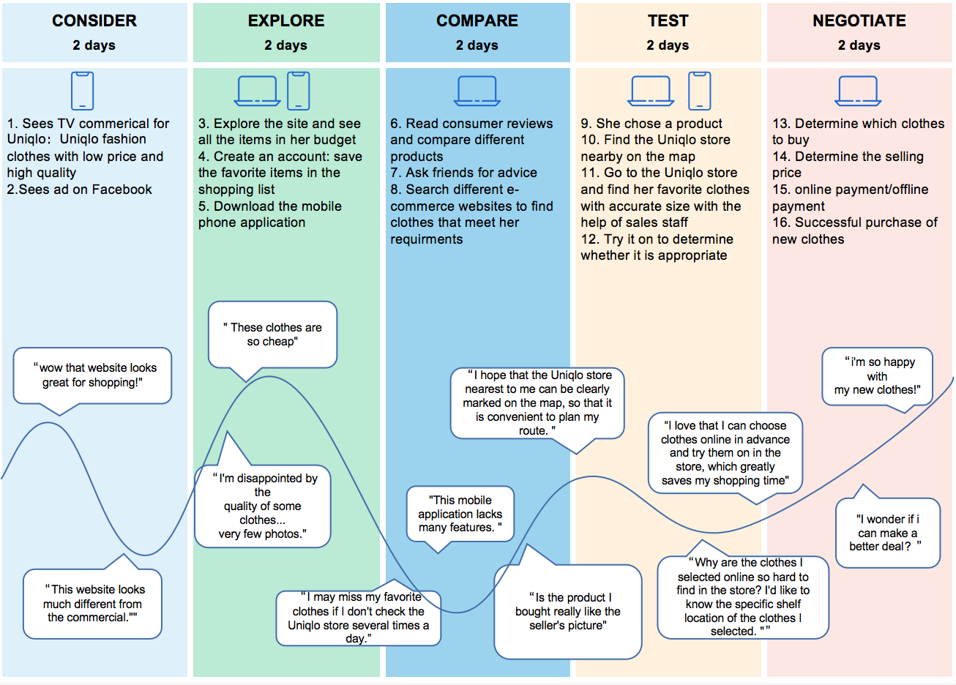
The survey is based on the truth of the interviewees, and the digital development is changing with each passing day,Uniqlo can collect customer information in real time on its official website and interact effectively with customers at the same time (Van Bommel et al., 2014, edelman and Singh, 2015). In addition, you can also learn free digital skills in marketing provided by Google (Google, 2017).
However, Schultz (1997) thinks that it is important to understand technical data, but it is more important to understand the true psychology of customers.
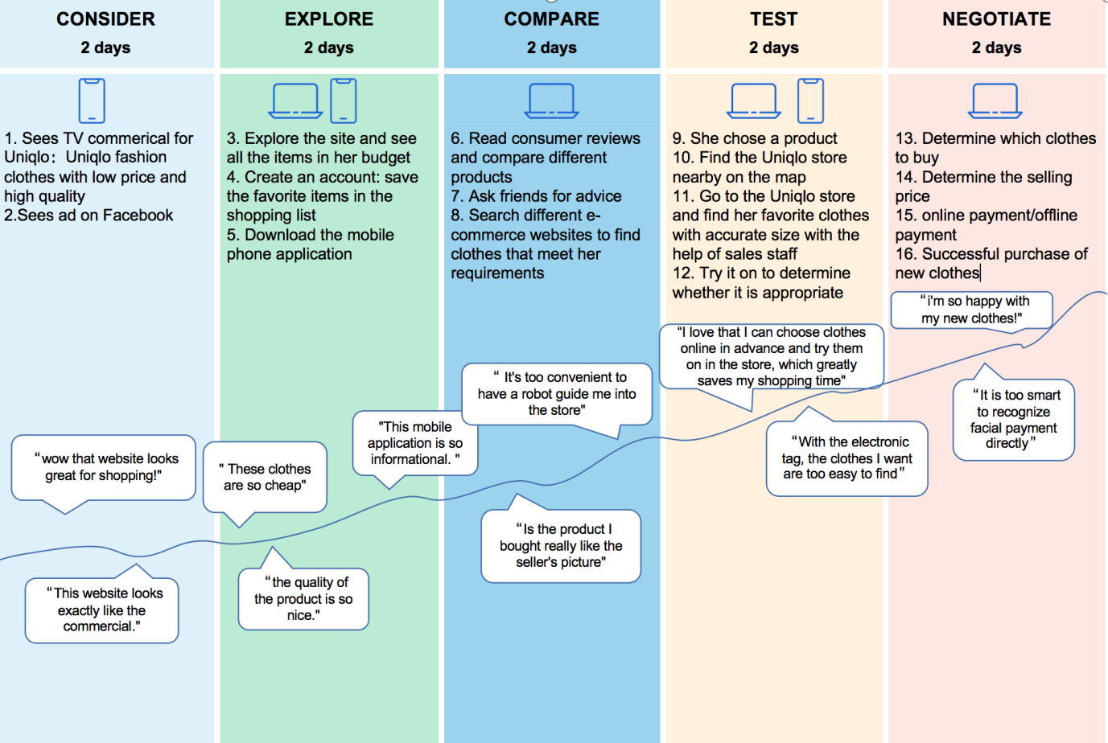

Interviewee Xiao A likes to read the articles published by Uniqlo on WeChat WeChat official account, which will introduce the latest fashion of Uniqlo in time, and Uniqlo models will also show how to dress better. Whenever she sees her favorite clothes, Xiaoxi clicks on the pictures and jumps to Uniqlo's WeChat applet to buy them directly, which saves her a lot of things. "I didn't like Uniqlo before and thought it was a basic model, but in recent years I found that Uniqlo's clothes are getting better and better matched. What's more, the clothes recommended by his family's WeChat WeChat official account are all very nice,I wear them directly according to the model's appearance, which saves worry and money. ". Respondents told BusinessWeek/Chinese Edition. Feedback from other interviewees shows that Uniqlo customers are satisfied with the online journey and often feel very confident in contacting Uniqlo, and they expect to be respected.

Word of mouth is a good reference,Another Uniqlo fan, Jian Jie, lives in Xi 'an, a city in western China, and is an engineer in a construction company. Because of his work, he often flies around the country. For him, the best service provided by Uniqlo Pocket Flagship Store is to place orders online and pick up goods in offline stores. Jian Jie said, "I am a person who has no fixed place to live, and I often can't provide an exact mailing address when I shop online. Now I can buy clothes at Uniqlo's flagship store and pick up the goods at the nearest store. Sometimes, in order to change into a decent shirt immediately, I will directly ask Uniqlo's nearest store to deliver goods to me online, and I can put on new clothes in an hour or two, which is very convenient. ". (Business Weekly, 2020) Yurinski (2011) thinks that tactical subdivision is a specific method to target new customers and match it with the internal strength of the organization. Word-of-mouth marketing is the most effective way to acquire new customers.

Ensuring the internal strength of the organization not only meets the basic needs, but also exceeds the basic needs, which makes Uniqlo in a very favorable position in the customer journey-Uniqlo has won the Tmall Double Eleven clothing sales champion for six consecutive years and the title of the most favorite employer of college students (MarketLine,2021),This not only shows that Uniqlo has been recognized by customers, but also shows that Uniqlo has exceeded customer expectations. Customers are the only core. Compared with other new retail enterprises, Uniqlo's innovative customer care plan should take the essential needs of customers as the bottom logic of all thinking and practice, and design a digital marketing model based on it, so that the practice of this model can always run through the whole organization, rather than a one-time activity. As a clothing retailer, Uniqlo has more than 800 direct-operated stores and e-commerce companies in China (Stokes, 2020),They need to serve the essential needs of customers, and think more about how to make customers buy a satisfactory product and get good service, whether online or in stores, instead of just focusing on the number of store growth. Uniqlo's operation should comply with and create customers' needs, and create innovative marketing strategies based on this concept (kotler et al., 2020).
Recommendations on resource requirements
- human resources
- time
- fund
- material
Suggestions for monitoring performance
- Choose the indicators to monitor, and make sure you choose those that will have an impact on your organization's goals. KPIs are usually linked to "transformation". This can be defined as any indicator that generates valuable interaction with online business. Uniqlo digital marketing can monitor the number of people covered and the interaction of visitors.
- Leading Indicators (leading indicators). Leading indicator is an indicator used by economists to explain the trend of economy. Leading indicators are also useful in marketing, because they can show that time and energy are having some impact, even if it has not yet produced significant results. For example, you may monitor how many people stay on the website for more than 3 minutes, even if they have not filled out the contact information form.
- Indicators that shouldn't be monitored, things that can't affect them. If you can't change it, it's meaningless to turn it into KPI.
- Associate budget with KPI
- Make your digital marketing KPI S.M.A.R.T, and each participant should have a clear understanding of his KPI and daily goals. For different participants, even if KPI is clearly quantified, they will easily have different understandings of goals. Therefore, all KPIs should follow the SMART principle: Specific, Measurable, Achievable, Relevant and Time-Bound
- Set limits for KPIs, which can be set by using traffic light system in Excel.
- Align KPIs to the RACE model

4,Conclusion

Because coastal companies are an organization that monitors the external environment and ensures the normal operation of the internal environment, they are in a strong and flexible position in any selected and determined strategy, which can expand to their target market and ensure that they have the ability to implement the necessary strategies to achieve these goals; According to the necessary standards, they are a market-oriented organization, not a static one.

Their resources, including financial and human resources, create an agile organization, and employees can make decisions and take actions according to decisions; This not only refers to any requirements or experiences of customers during their journey, but also refers to the wider social housing market and the knowledge and understanding of this industry.

The two goals of this report can be achieved by the coastal companies determining their own marketing planning process and creating a framework that can achieve and meet smart goals (concrete, measurable, achievable, realistic and time sensitive). For these two elements, strategies and tactics will be decided by the board of directors, and implemented and controlled by employees.
5,Suggestions
It is believed that all the suggestions can be realized in an increasingly stimulating competitive environment, which is wise and will ensure the growth of Uniqlo.
This report is a follow-up to the first part of the presentation report in March 2021, which analyzes the environmental marketing and Uniqlo's customer journey. The following suggestions are put forward.
From the presentation:
- A shopping trip in which physical experience and digital technology interweave and promote each other. Digital technology enriches physical channels, while digital channels become more humane. The end result is a more personalized and attractive experience. (Christina ·INZ· de la flo, 2020)
- RFID tags。One of the most exciting developments in the use of RFID technology is its potential to change the way customers browse and buy products in physical stores. The idea behind this is to reduce the checkout team and shorten the POS stage. （Comparesoft,2021).
- Automatic delivery robot and shop assistant. Robot store assistants have built-in 3D scanners, which can help them identify products and even guide customers to find them by navigating in the store. （Ben Forgan. 2020）
- A cashier-free shop. Customers can simply walk out of the store, automatically scan their goods, and deduct the total amount from their accounts, which may soon become popular. （GARIMA. (2020) Cashierless Stores – The Self Driving Technology that is Reinventing Retail. Available at: https://www.netsolutions.com/insights/cashierless-stores-future-of-retail/ (Accessed: 2 May 2021).
From the report:
- The digital service StyleHint, which is a one-stop service for customers, is launched,Customers only need to upload their own or bloggers' wearing photos, and the APP can recommend similar styles of Uniqlo brand.
- Create an independent innovative marketing department to coordinate online and offline omni-channel marketing. "The integration or input of various online and offline user experiences is more to make users feel the same brand experience. This consistency also strengthens the leading sense and technological attributes of Uniqlo brand, and enables consumers to better enter the brand closed loop in all channels, which is also an operational idea to strengthen loyalty. ". (Xu Baiwei, 2020)
- Starting from the needs of users, provide all kinds of life information, in what weather, environment and state, what clothes to wear, how to match and so on. At the same time, we will cooperate with various platforms to collect and analyze user needs, so as to adjust Uniqlo's services and even products.

Activity | Target Audience | Messaging | Channel | Objective (SMART) | Measure of success | Timescale | Responsibilities | Cost

Internal Marketing Audit Checklist
Operating results (by product, customer, geographic region)
On February 17, 2021, the market value of Fast Retailing Group, the parent company of Uniqlo, reached 10.8725 trillion yen at the close, surpassing Inditex, the parent company of ZARA, and becoming one of the largest clothing listed companies in the world. （Harvard Business Review, 2021）
Sales, Profit margins, costs
Market share
Strategic issues analysis
Penetration pricing strategy
Marketing objectives
Create better products or services, thus driving sales growth. (Uniqlo, 2020)
Market segmentation
Customers of all ages
Competitive advantage and Core competencies
Extremely cost-effective
Positioning
Digital retailer
Portfolio analysis
The parent company Fast Retailing Group has greatly reduced its M&A plans since 2012 (Jennifer, 2014)
Uniqlo actively acquired some shares of other fashion brands, such as Elise in Vietnam, to gain overseas profits (Mira, 2018).
Moderate investment portfolio can help Uniqlo spread risks and ensure revenue.
Marketing operations effectiveness
On February 17, 2021, the market value of Fast Retailing Group, the parent company of Uniqlo, reached 10.8725 trillion yen at the close, surpassing Inditex, the parent company of ZARA, and becoming one of the largest clothing listed companies in the world. （Harvard Business Review, 2021）
Product, Price, Promotion, Distribution
Uniqlo's products are positioned as simple and comfortable, "clothes are the supporting role, talents are the leading role", simple style, solid color design and loose version, and meet the needs of consumers of different ages and genders with simple and comfortable clothing style. Uniqlo's price is defined as cheap clothing, which does not distinguish consumers by price, and aims to be accepted by the public at an approachable price. (Xinhua News Agency, 2020)
Marketing structures and organization
Independent marketing team
Marketing training
Institutionalized marketing training
Intra- and interdepartmental communication
Accessible communication
Marketing systems
Independent marketing team
Marketing information system, Marketing planning and control systems
Uniqlo's new marketing plans and activities will be announced in advance in official website. (CBN, 2020)

External Marketing Audit Checklist
Macroenvironment
Economic: 1. Economic recession since 2008（Gromski, P.S., Smith, A.D., Lawlor, D.A., Sharara, F.I. and Nelson, S.M. 2021） 2. The impact of COVID-19（ Kalogiannidis, S. and Chatzitheodoridis, F. 2021） 3. Economic recovery in Greater China (Mainland China, Hongkong and Taiwan) and South Asia
Socialcultural: 1. Population structure: birth rates and aging population 2. Social duty: donated money, masks, and infrared thermometers to local medical institutions and to partner factories and business partners in China during COVID-19
Technological: 1.Global access to the Internet 2.Wide application of mobile phones 3.Other technological advances（PRIAMBODO, I.T., SASMOKO, S., ABDINAGORO, S.B. and BANDUR, A. 2021）
Political:1. The internationalization— 2252 stores in 25 countries 2. Trade protectionism policy upheld by Trump’s administration from 2017 to 2020（ Carvalho, M., Azevedo, A. and Massuquetti, A. 2019）
Legal：More laws and regulations on e-commerce
Environmental: Increased awareness of environmental protection and sustainable development（Polasky, S., Kling, C.L., Levin, S.A., Carpenter, S.R., Daily, G.C., Ehrlich, P.R., Heal, G.M. and Lubchenco, J., 2019.）
The Market
Market:In 2019, the cumulative operating income of enterprises above designated size in China's garment industry was 1,601.033 billion yuan. (National Bureau of Statistics, 2020)
Customers:Consumers of all ages, among which the main consumers are 18-30 years old and 30-45 years old (Uniqlo, 2020)
Market-segmentation:The price of a single item purchased by people aged 30-45 is the highest among all people.This consumer group often has stable and high income ability,and the pursuit of comfort is slightly higher than fashion. (Zhang Lan 2019)
Distribution:The competitive pressure from substitutes is very high, which lies in the low replacement cost of clothing industry. (Walters, 2018)
Suppliers: Many suppliers that provide standardized products; Long-term friendly cooperative relations.
Competition
Who are the major competitors: actual and potential:ZARA ,H&M ,GAP
What are their objectives and strategies:ZARA: Rapid Competition Strategy H&M: Price Competition Strategy (Richardson, 2019)
What are their strengths (distinctive competencies) and weaknesses (vulnerability analysis):
ZARA Advantages: Fast R&D cycle Disadvantages: High price (Business Review, 2019)
Market shares and size of competitors:
ZARA ,H&M have been ranked as the first and second fast fashion brands in the world until 2020, and Uniqlo ranked third in the world. （MarkerLine,2020)
Profitability analysis:
The parent company Fast Retailing Group has greatly reduced its M&A plans since 2012 (Jennifer, 2014)
Uniqlo actively acquired some shares of other fashion brands, such as Elise in Vietnam, to gain overseas profits (Mira, 2018).
Moderate investment portfolio can help Uniqlo spread risks and ensure revenue.
Entry barriers:
High R&D costs and difficult to provide differentiated products and customer services;
the existing mature channel network.

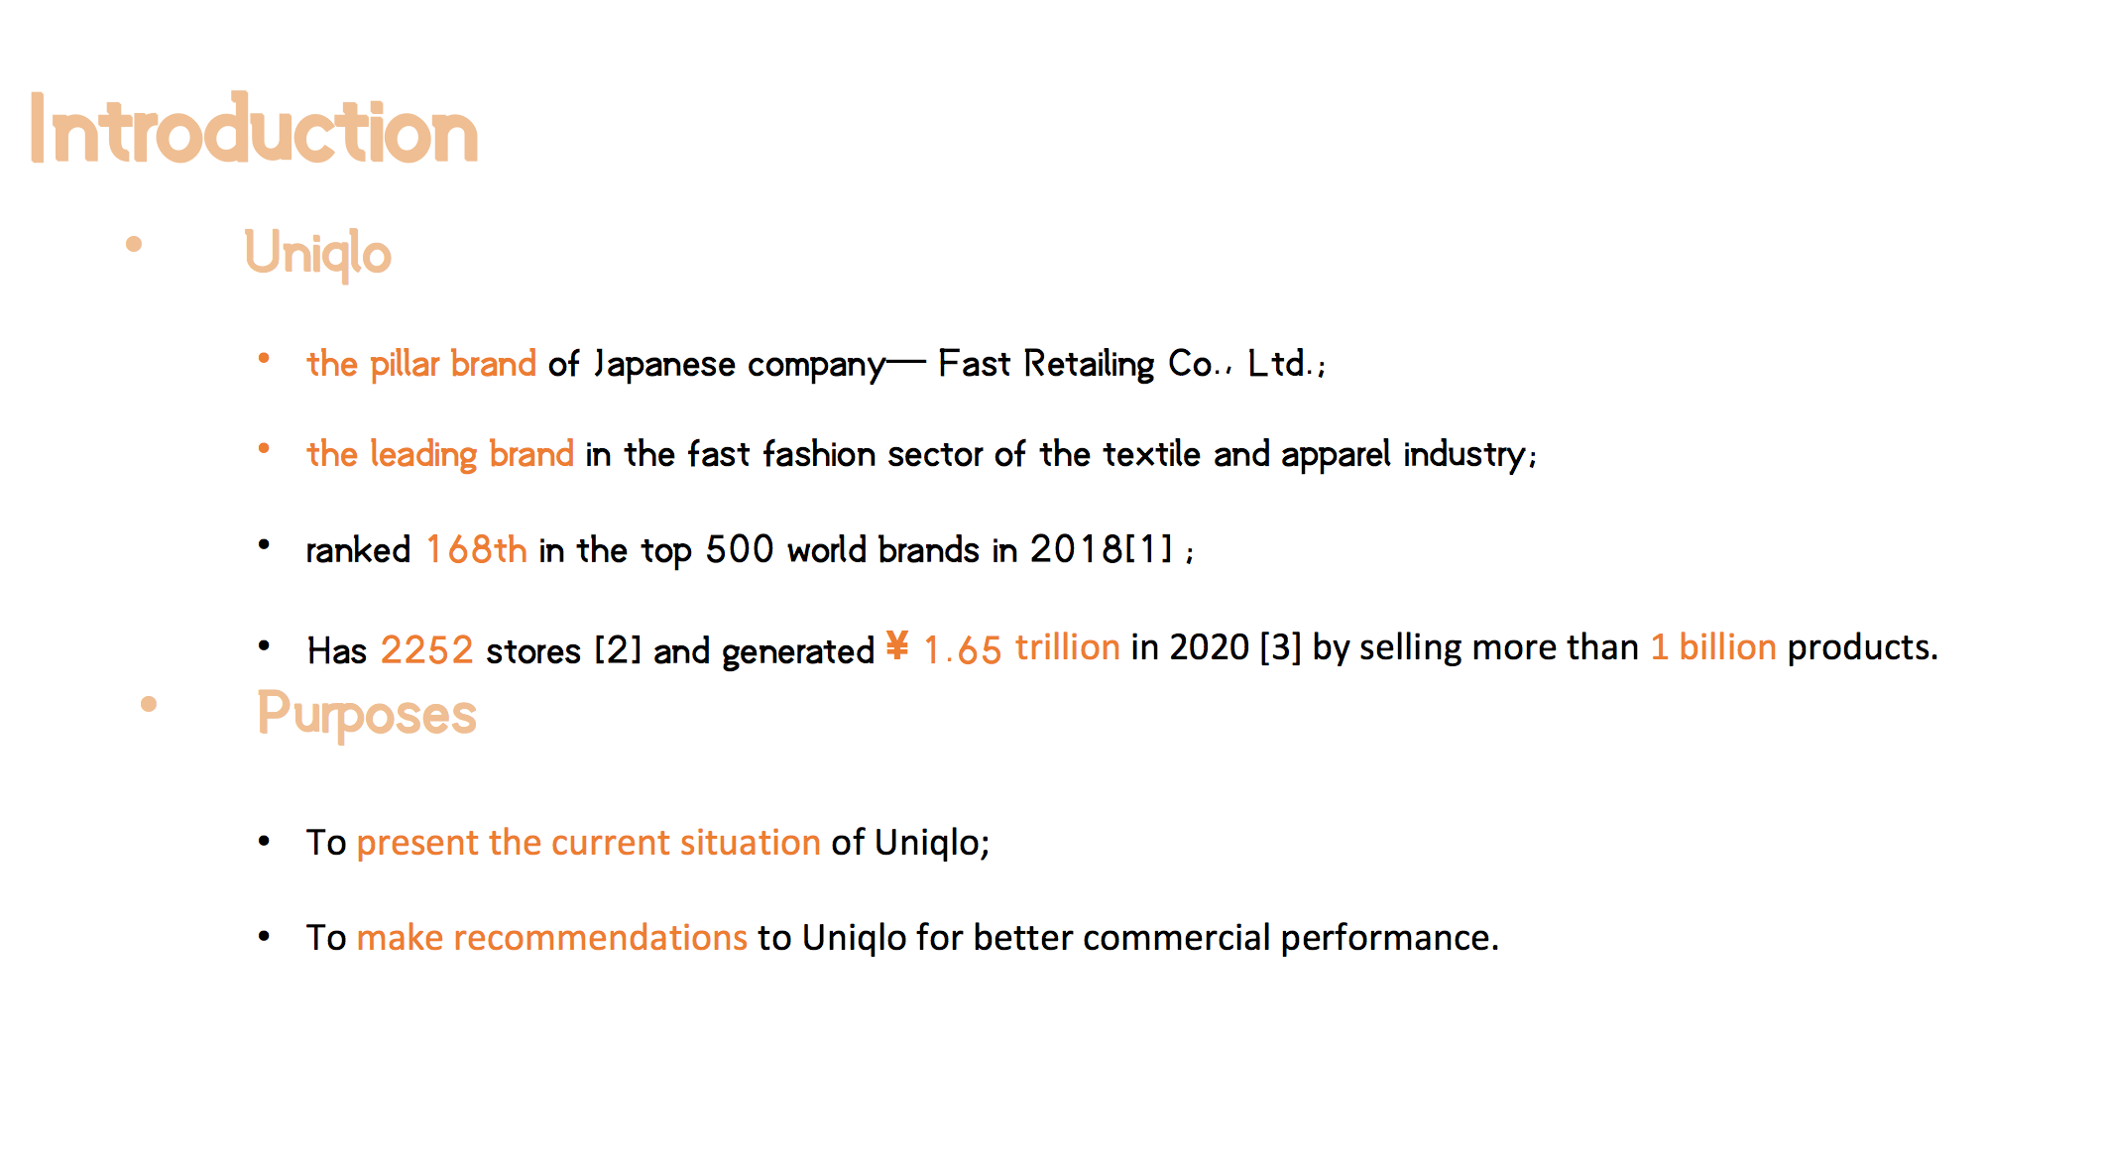
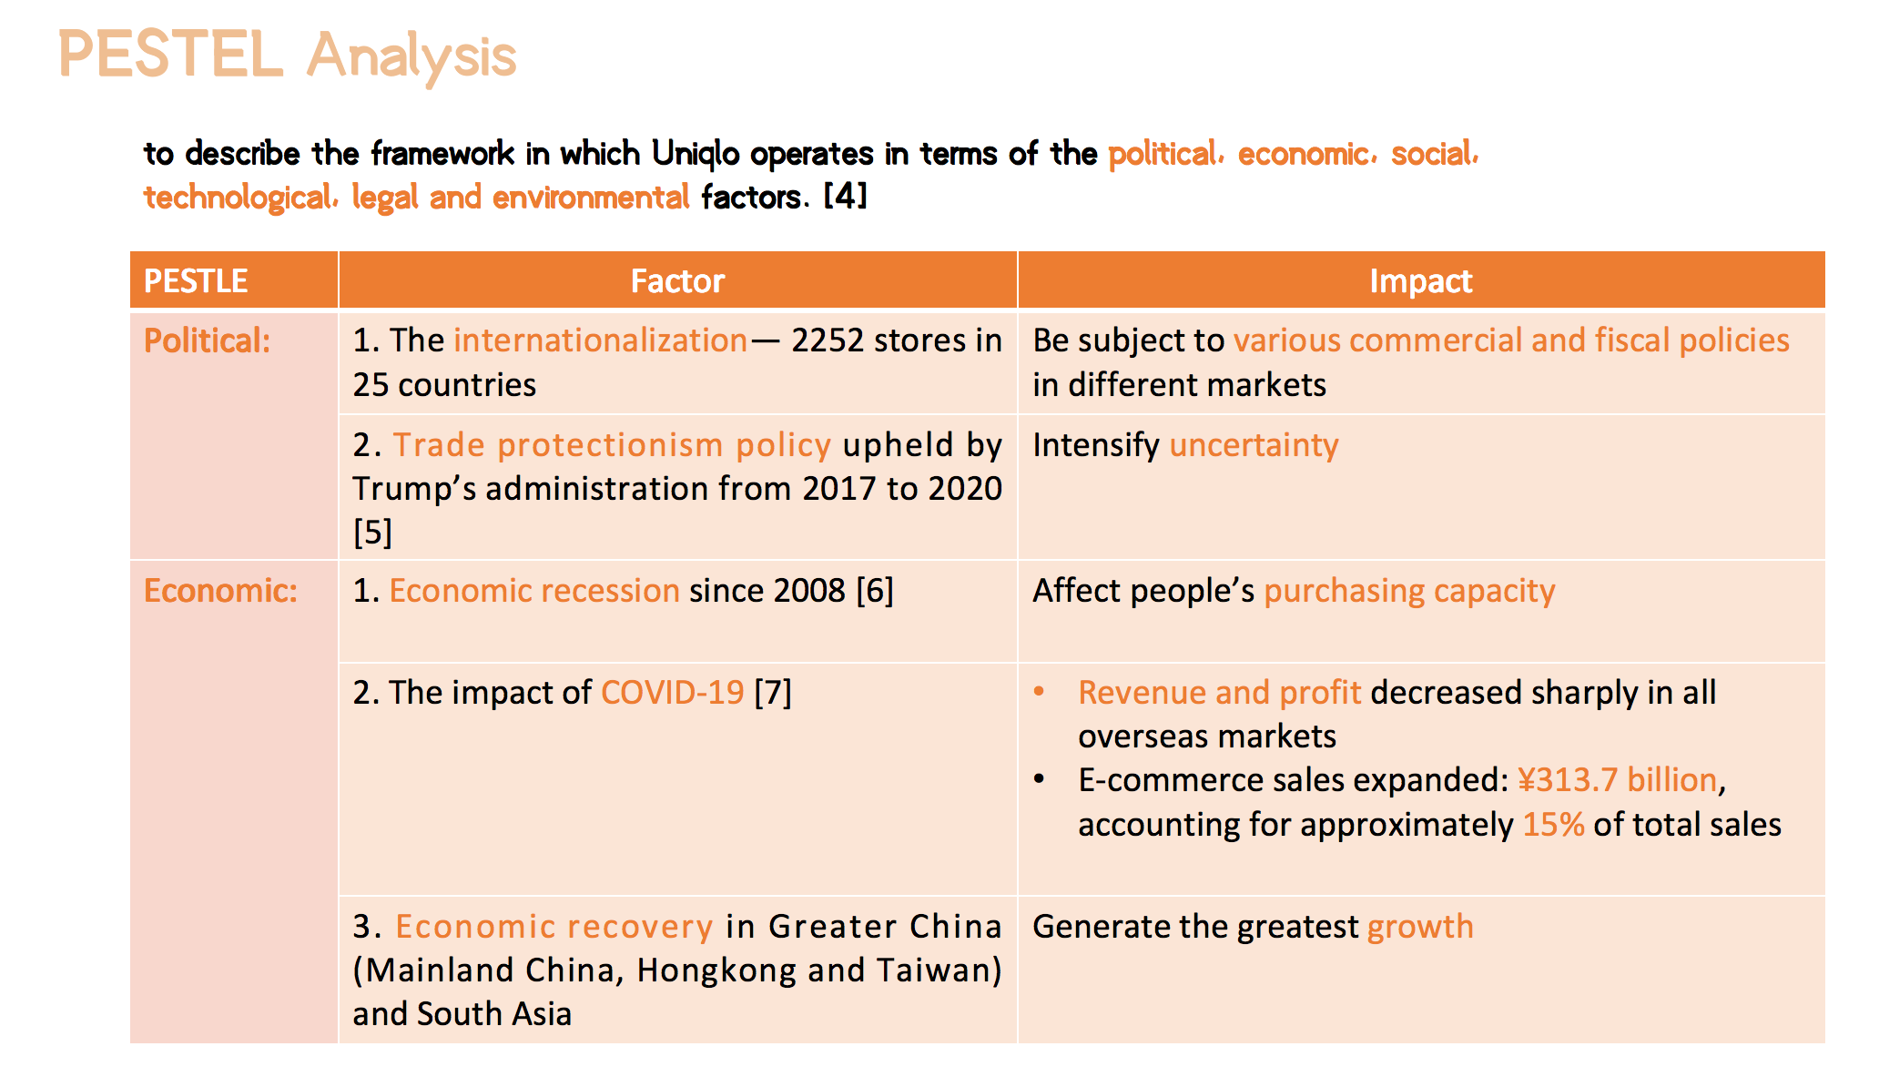
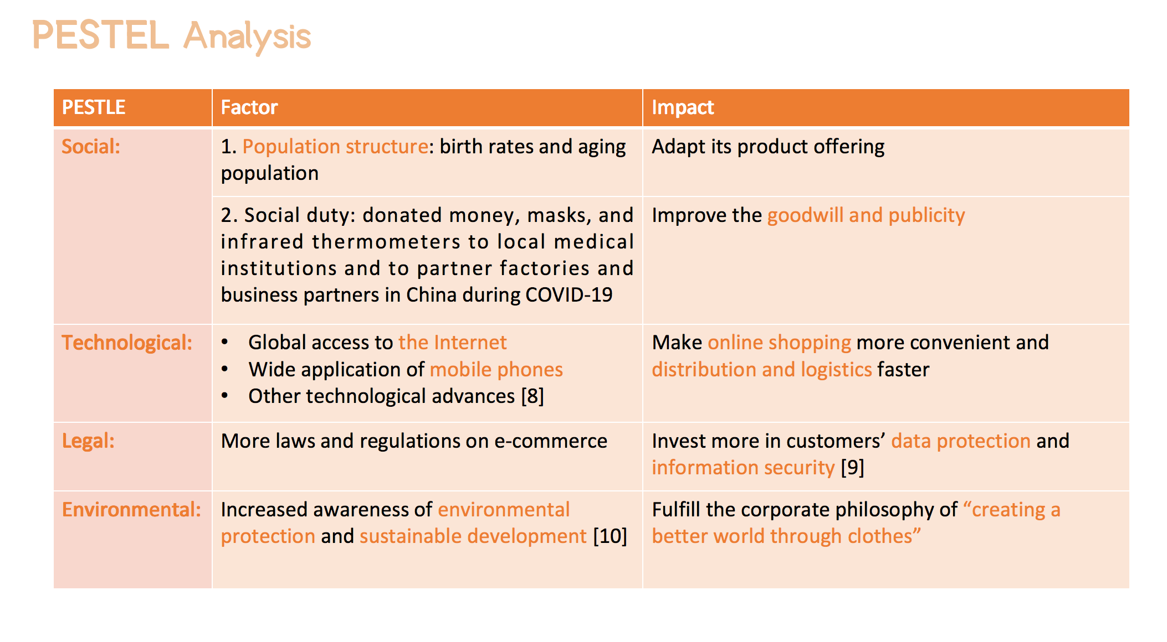
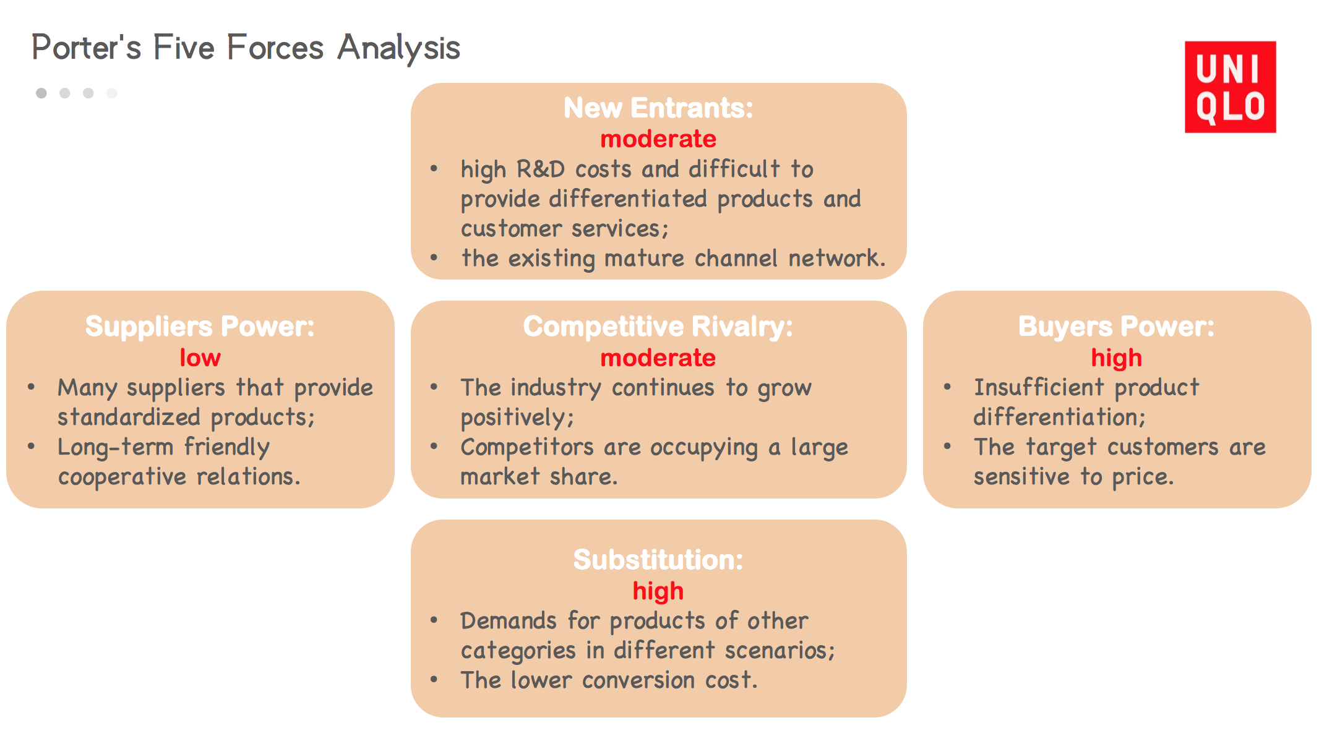
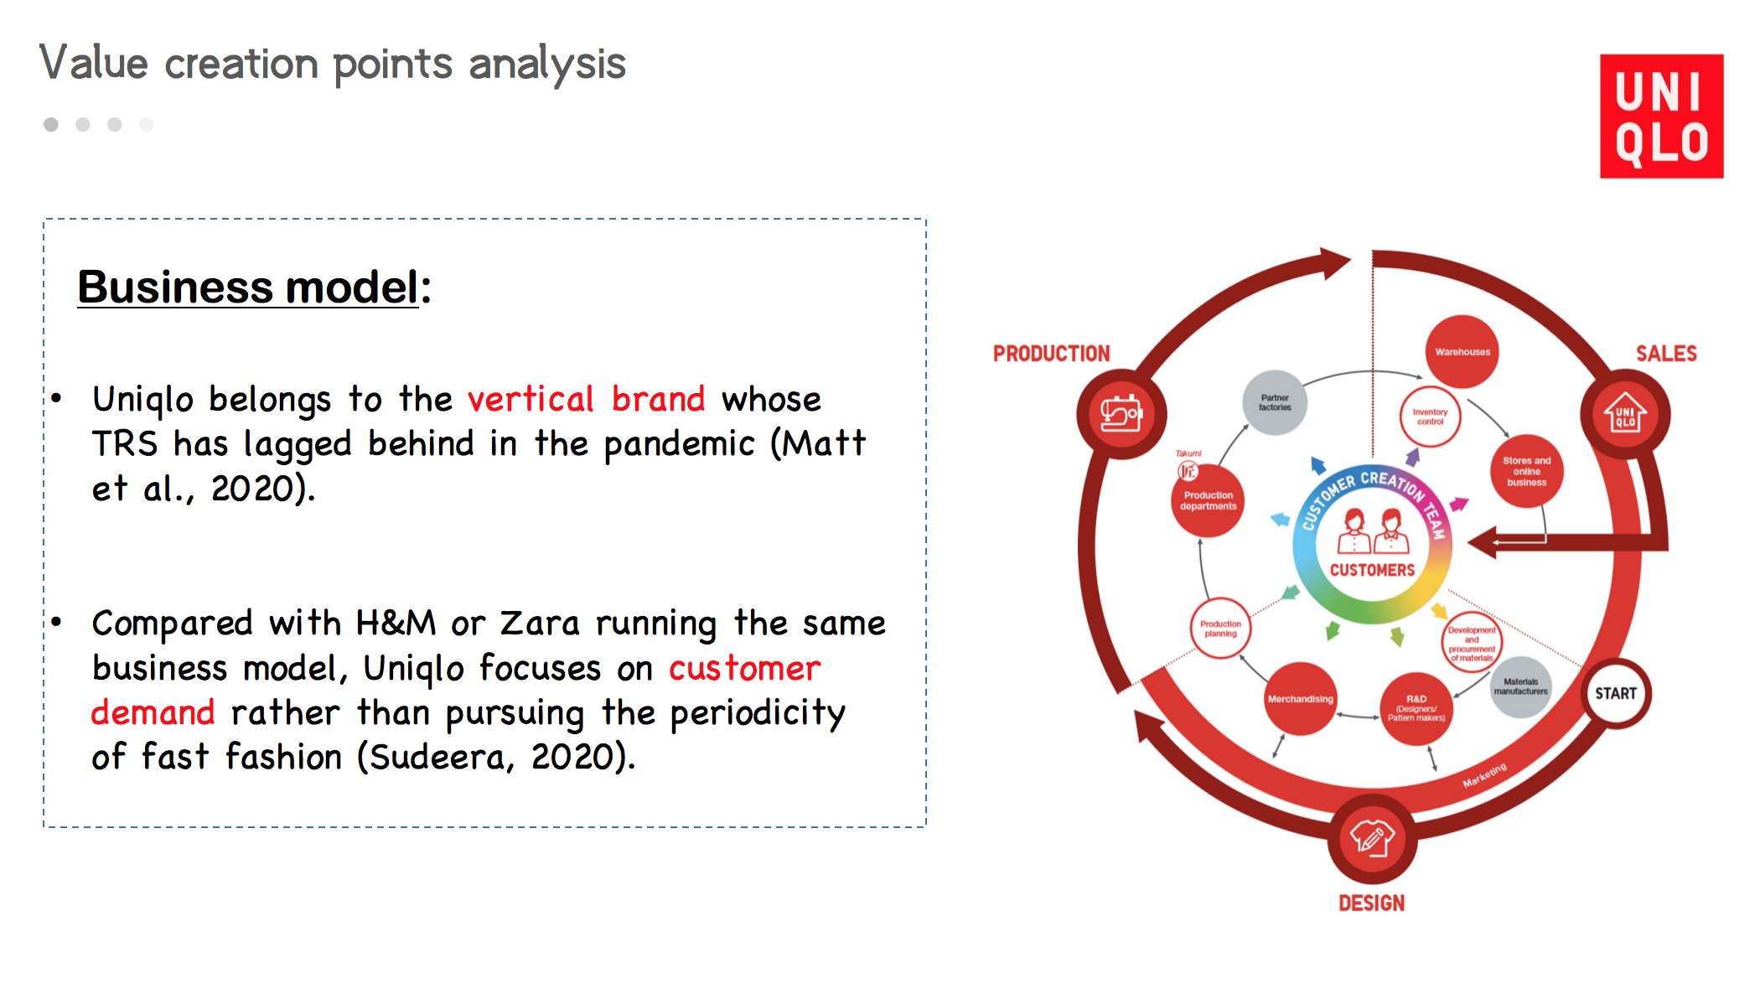
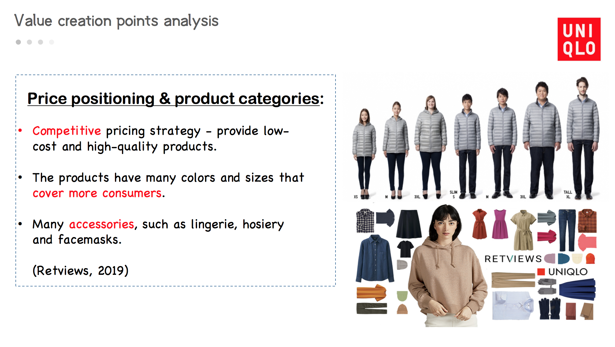
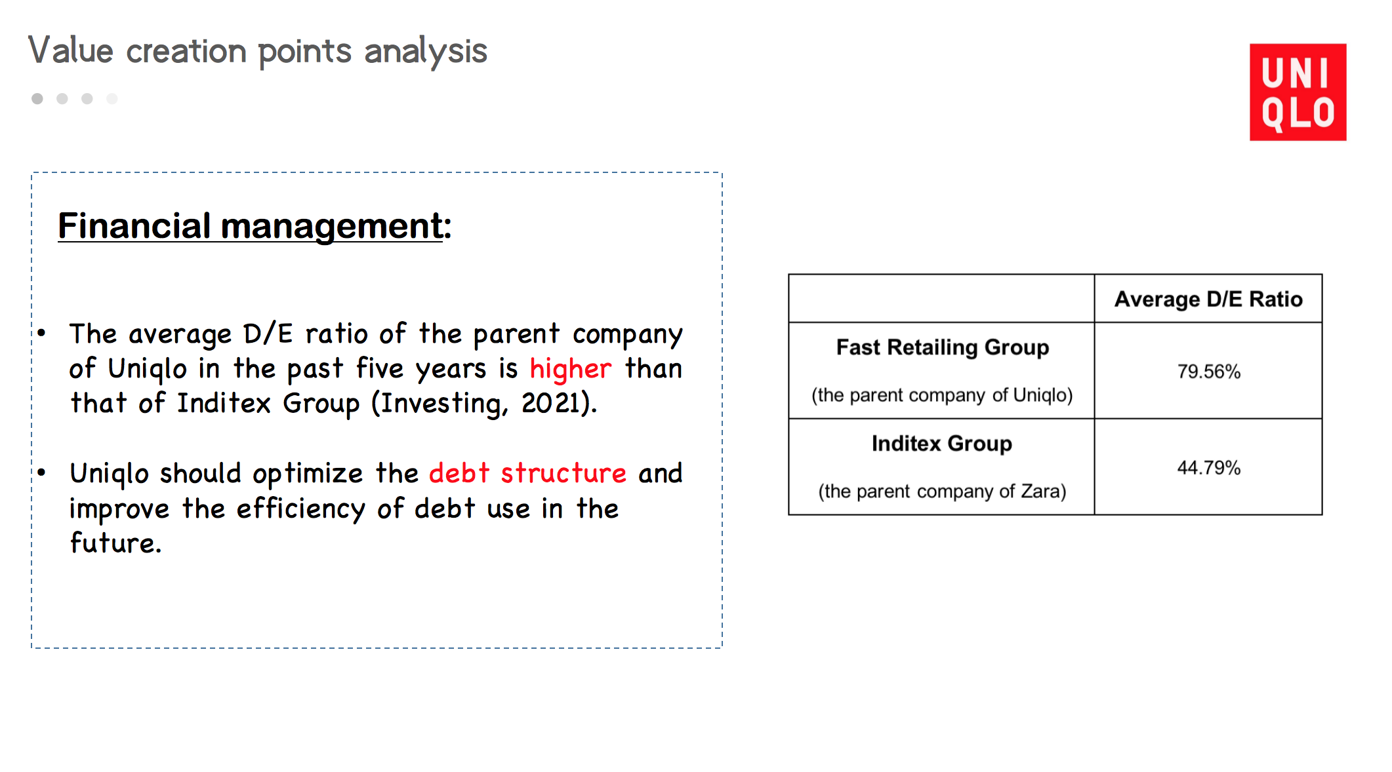
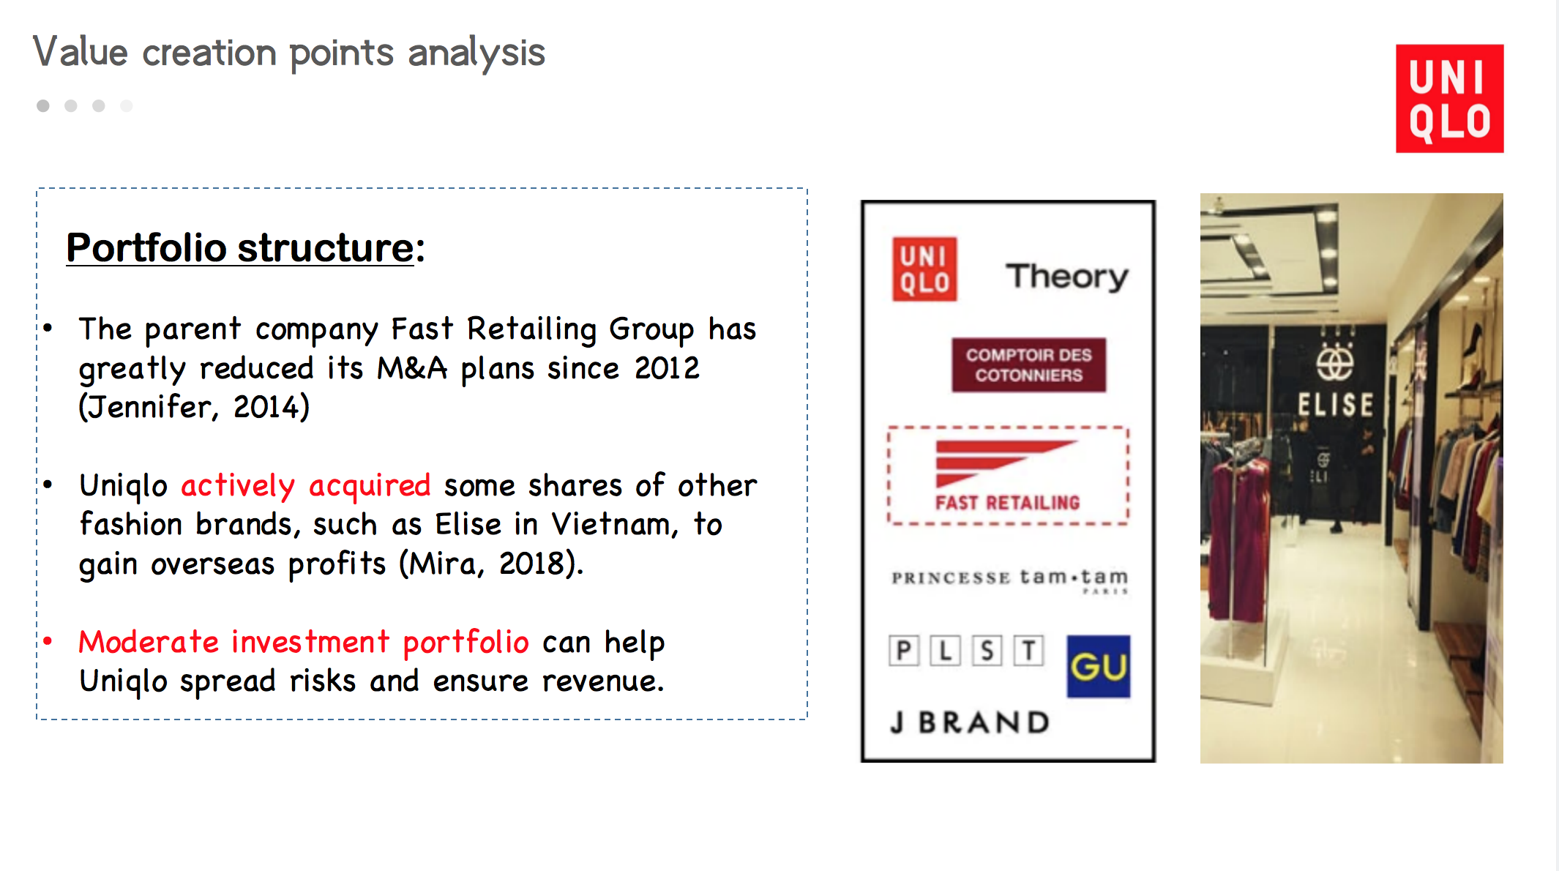
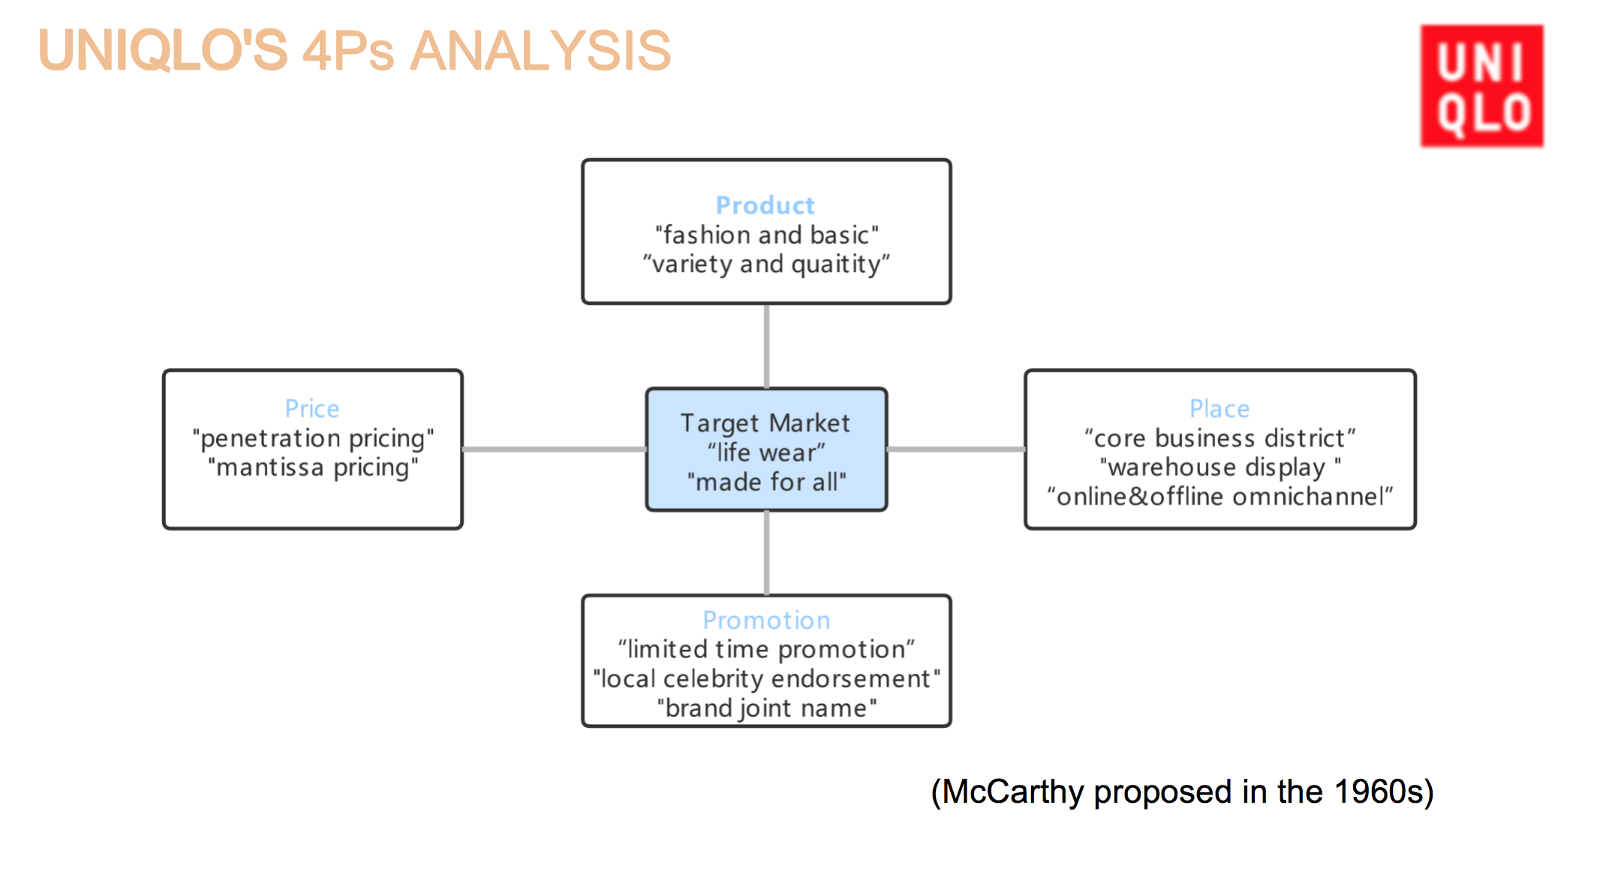
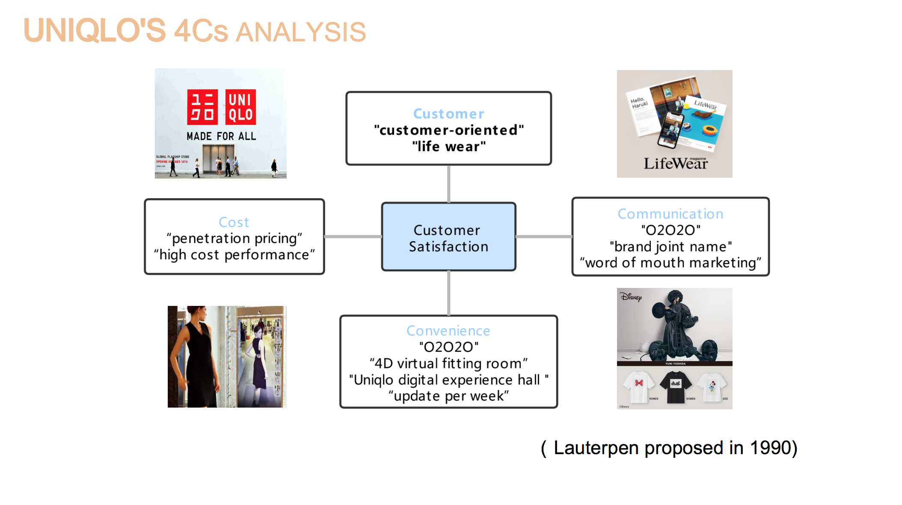
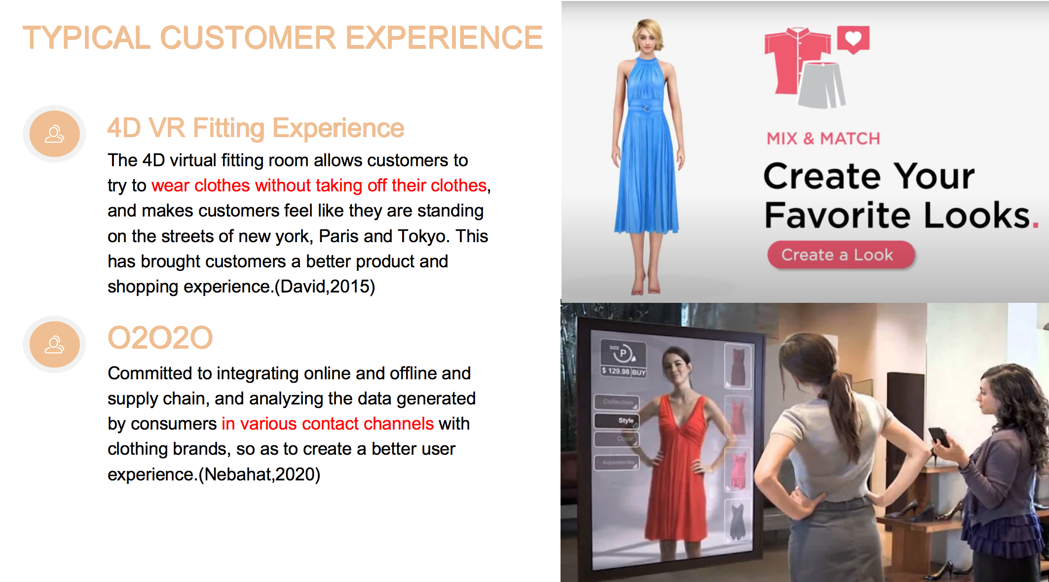
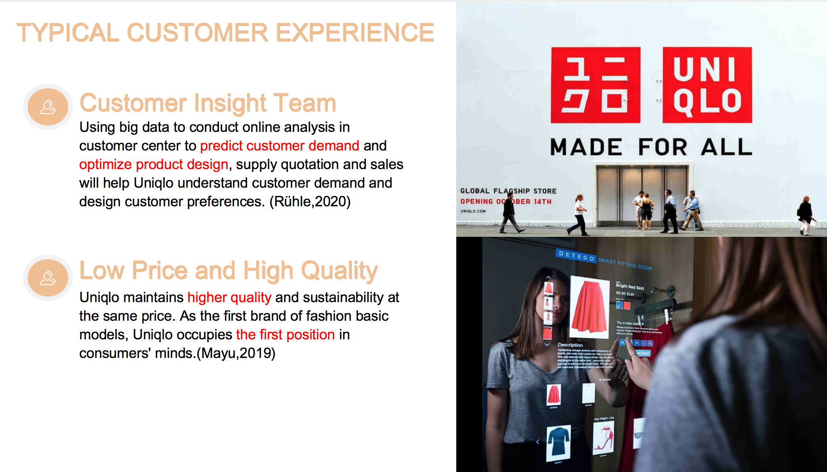
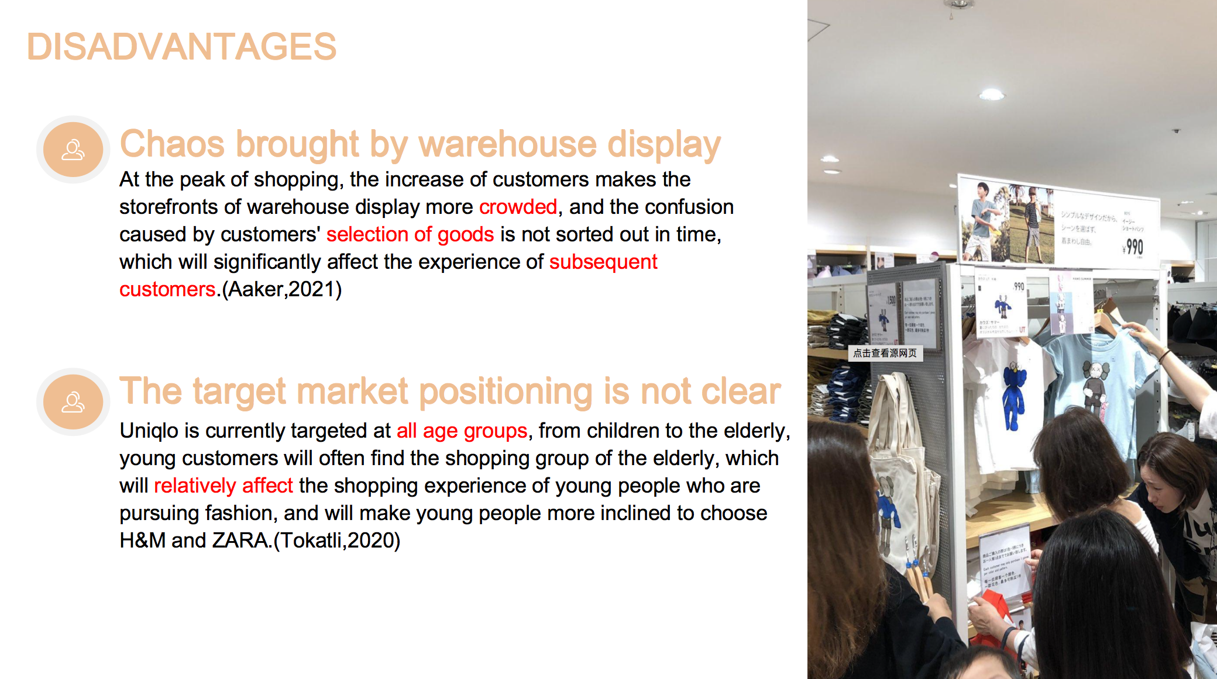
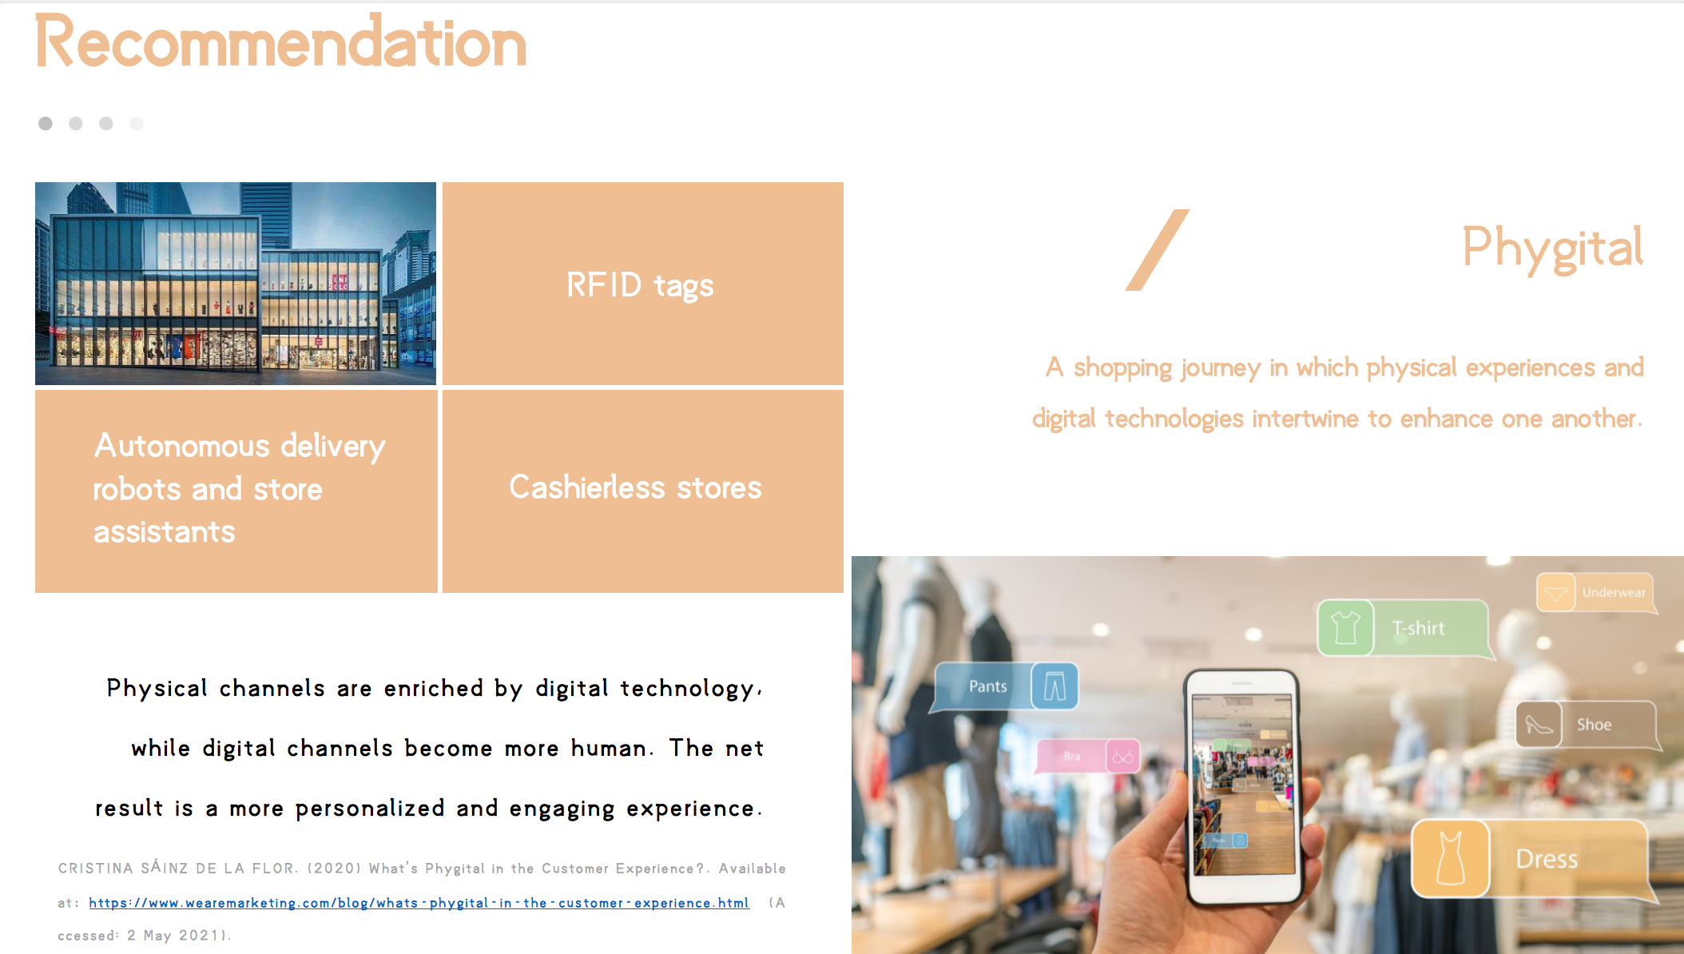
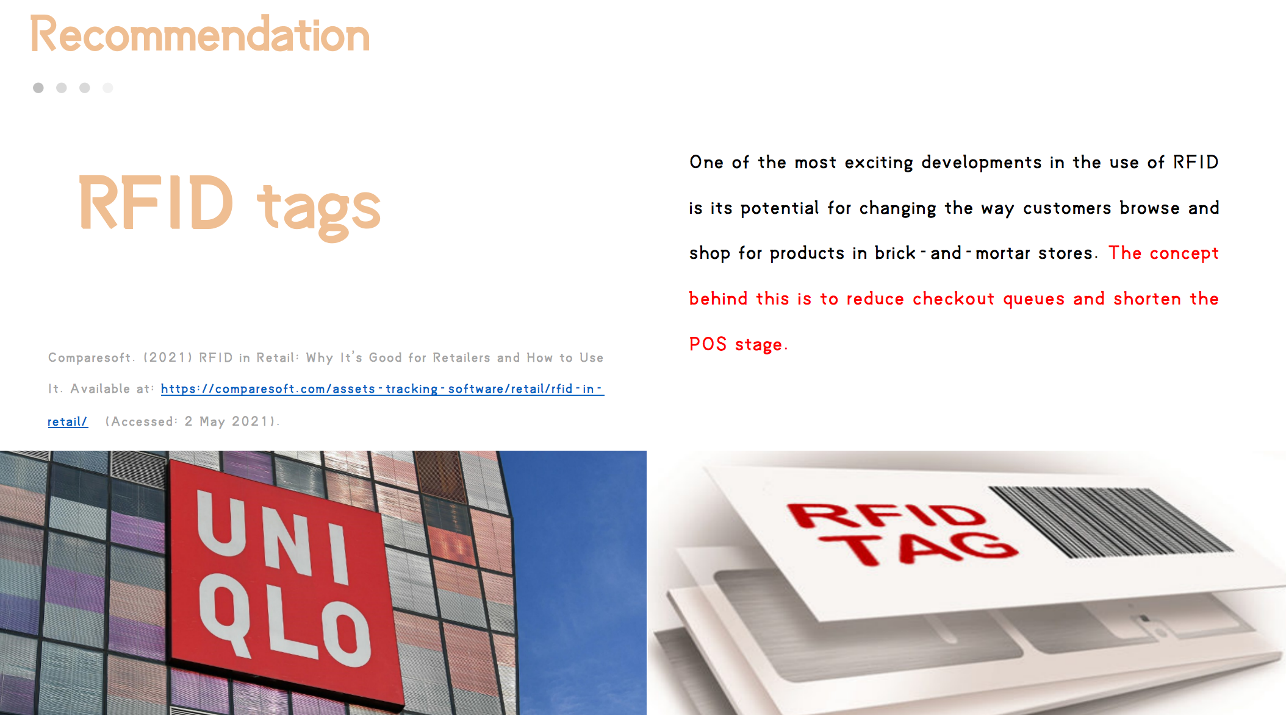
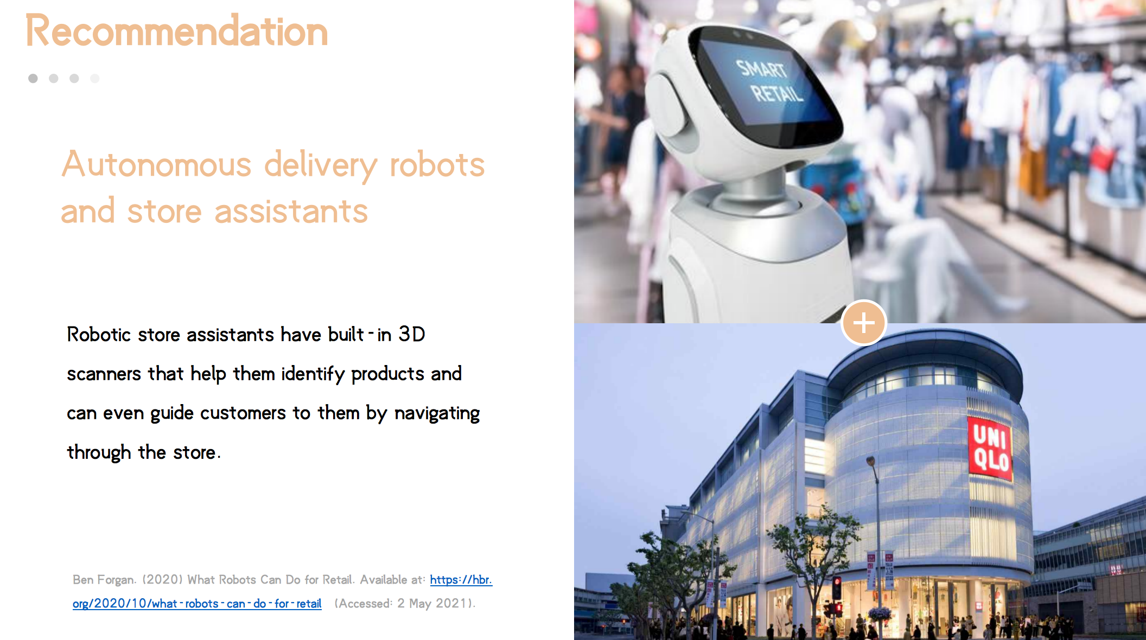
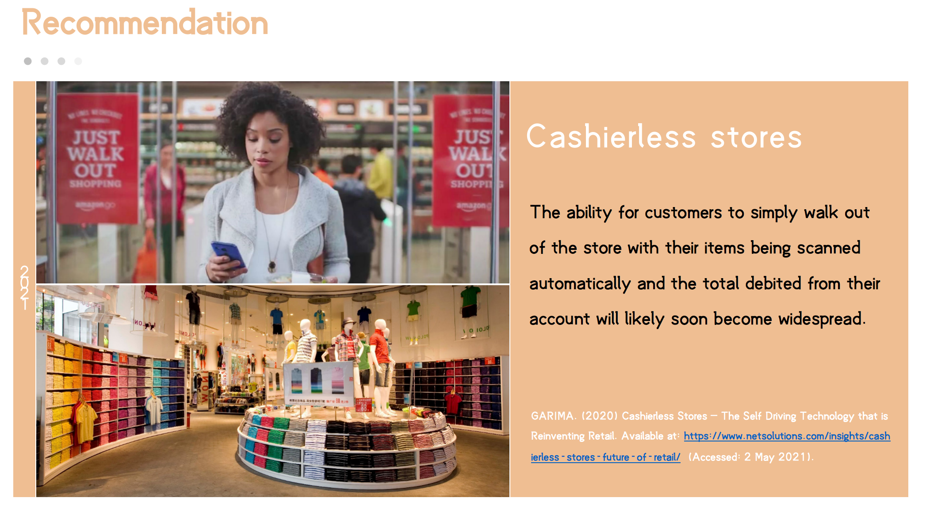

references
[1] Guo peilin. uniqlo's cross-cultural marketing strategy in China [J]. business news, 2020(10):8-9.
[2] Li Yuanyuan. On the inspiration of Uniqlo's marketing strategy to Chinese clothing brand enterprises [J]. Modern Marketing (Business Edition), 2020(03):115-116.
[3] Wang Jinling. Uniqlo Marketing Strategy Analysis [J]. Taxation, 2019,13(28):191+194.
[4] Cao Mengdie. Research on Salary Management in FMCG Industry —— Taking Uniqlo as an example [J]. China Business Theory, 2019(17):126-127.
[5] Zhang Xinyuan, Yu Hurong, Yang Yanhua. Analysis of Uniqlo Training Needs and Implementation Path Based on Integration of Production and Education [J]. Journal of Xi 'an University of Arts and Sciences (Social Science Edition), 2019,22(03):104-107.
[6] Editorial Department of this magazine, Qin Xianpu. Roundtable Dialogue: Imagination and Creativity of Design [J]. China Advertising, 2019(06):73-80.
[7] Li Wenchen. Research on the marketing strategy of fast fashion brand ZARA in China [D]. Jilin University of Finance and Economics, 2019.
[8] Zhou Yuting. Research on omni-channel layout of retail enterprises from the perspective of consumers [D]. Southwestern University of Finance and Economics, 2019.
[9] Qin Xianpu. Wu Pinhui: It's a classic to do basic perfection [J]. China Advertising, 2019(01):46-51.
[10] Chen Qing. Thinking about SPA mode based on network platform —— Taking Japanese UNIQLO as an example [J]. economic research guide, 2018(35):170-172.
[11] Qin Xianpu. Five major problems, the way to decrypt Uniqlo [J]. China Advertising, 2018(12):90-94.
[12] Guo xuehua. fast fashion brand marketing strategy analysis-taking uniqlo as an example [J]. western leather, 2018,40(20):74+78.
[13] Yuxin Wang. Uniqlo Key Performance Indicators Design [J]. Time Finance, 2018(27):330-331.
[14] Hu Yibo. Research on Marketing Strategy of Fast Fashion in China [D]. capital university of economics and business, 2018.
[15] Li Meiying. analysis of clothing brand marketing mode under new retail format [D]. Guangxi university, 2018.
[16] Xu jiao-ru. translation of clothing-related texts [D]. Donghua university, 2018.
[17] Hou zewei. on enterprise brand management in the era of "internet plus"-taking UNIQLO as an example [J]. China business theory, 2018(09):22-23.
[18] Duan Jiaqi. Uniqlo VS ZARA: so different, but equally successful [J]. Sales and Marketing (Management Edition), 2018(01):89-92.
[19] Wu pinhui. uniqlo Wu pinhui: leading the sustainable growth of brands and consumers [J]. successful marketing, 2017(Z6):20-21.
[20] Chen Yan. Research on Supply Chain Management of Clothing Industry [D]. Zhejiang University of Technology, 2017.
[21] Guo Xue, Jin Zhen, Ben Chengyue, Chen Lingyan, Yan Wenjing. Research on fuzzy comprehensive evaluation of customer satisfaction from the perspective of enterprise competitive intelligence-taking Uniqlo as an example [J]. Modern Business, 2017(28):25-27.
[22] Wen Xin. Uniqlo: Activate physical retail with offline experience [J]. China Chain, 2017(10):48-49.
[23] Liu Xueying. analysis and research of brand clothing O2O(Online to Offline) business model [D]. Xi' an engineering university, 2017.
[24] Wang Qian, Qian Zhen. Research on China's Localization Marketing Strategy of Multinational Corporations-Taking Japanese Uniqlo Company as an example [J]. China Business Theory, 2017(24):67-68.
[25] Li Jicheng. Comparative Study on Clothing online to offline from the Perspective of Supply Chain [J]. Jiangsu Business Theory, 2017(07):28-30+43.
[26] Yan Ming. Uniqlo Marketing Strategy Research [D]. Xi 'an University of Technology, 2017.
[27] Hu Hao. Giordano Supply Chain Inventory Management [D]. Jiangxi University of Finance and Economics, 2017.
[28] Jiang Ting. Research on the Relationship between Brands and Fans in Social Media Environment [D]. Soochow University, 2017.
[29] dong Yu. research on the influence of fast fashion clothing brand image on customer loyalty [D]. Wuhan university, 2017.
[30] Zhao Xiaomao. Uniqlo Fast Fashion Brand Marketing Strategy Research in China [D]. Jilin University, 2017.
[31] Wu Haoran. Talking about Uniqlo's innovative model and its impact on the development of Chinese enterprises [J]. Small and medium-sized enterprise management and technology (next issue), 2017(03):142-145.
[32] Qiu Ge, Song Yang. Research on Clothing Brand Marketing Strategy in New Media Era [D]. Soochow University, 2017.
[33] Feng Huakui. Want to kill Uniqlo? How can MUJI succeed in China [J]. Sales and Marketing (Management Edition), 2017(03):39-41.
[34] Zheng Bin. Interactive communication "technology+innovation" is the second half of mobile Xu Li [J]. Successful Marketing, 2017(Z1):83.
Gao Shibo, Gu Renxu, Wang Chunmeng, Xu Shuhui. Research on the Spatial Expansion Path and Evolution Characteristics of Fast Fashion Enterprises-Taking Uniqlo as an Example [J]. World Geography Research, 2017,26(01):102-111.
[36] Pang Yu. Talking about the problems and countermeasures in Uniqlo's competitive strategy [J]. Public Investment Guide, 2017(02):179.
[37] He Yuan. Research on Social Media Marketing Strategy of TPN Company [D]. shenyang ligong university, 2017.
[38] Feng Weidong. Brand is a matter of life and death [J]. State-owned Assets Report, 2017(01):106-109.
[39] Jing Zhao .90-year-old college students' leisure wear consumption values [D]. Zhejiang Sci-Tech University, 2016.
[40] Liu Wan, Dong Jie. Uniqlo and Suning are different in O2O transformation [J]. Enterprise Management, 2016(12):100-102.
[41] Bao Rushuang. Research on Cross-border Cooperation Strategy between Regional Brands and International Brands [D]. East China University of Science and Technology, 2016.
[42] Wu Jing. Analysis of Sato Koshi and creative skills in advertising design [J]. Life 167, 2016(32):53+61.
[43]. Events [J]. Chinese Costume, 2016(11):10.
[44] Wang Song. Uniqlo cross-border cooperation series network advertising marketing strategy analysis [J]. Value Engineering, 2016,35(25):22-23.
[45]. Highlights [J]. China Advertising, 2016(07):135-137.
[46] Yang Niansheng. Uniqlo [J]. Textile Science Research, 2016(07):76-77.
[47] Long Piao, Zheng Yuanqiang, Tang Yaoping. Uniqlo, training should also be customer-oriented [J]. Enterprise Management, 2016(06):76-77.

4.2 Uniqlo Brand Joint Marketing Strategy Based on 41 Analysis
4. 2. 1 Interesting Marketing Strategy The essence of the Internet is entertainment. In the new era, online marketing needs to grasp the psychology of most users, that is, entertaining and interesting. Today's consumers are not only concerned about the basic functions of products, but also keen on the consumption culture in products. Therefore, the marketing information should be entertaining and interesting. Therefore, the interest principle is at the core position in the current network integrated marketing. Facing the market environment with equal competitors' strength, similar content production mode and similar marketing channels, innovative marketing can be a "breakthrough point", and interest is the key factor in this process.
1. Take advantage of hot spots and fun marketing.
With the development of network, people pay more and more attention to hot topics. Now, on various network information platforms, many hot topics and events have attracted considerable attention. These hot spots can be broadcast quickly and attract a large number of users' attention. As a production enterprise, it is of great operational space and significance to seize and create hot spots to attract potential consumers from different groups.
For example, Uniqlo has achieved a good sales volume of LINE FRIENDS UT series, and its large sales are closely related to the Korean drama "You from the Stars". The protagonist in the drama uses Line (Korean communication software) to communicate, and many of its fans are converted into UT consumers, which are sold out in Hong Kong and other places in China. There are many reasons for the success of LINE FRIENDS: First, its cute cartoon image has affinity; Second, it is influenced by Line communication. Line has a broad user base; Third, the popularity of hot IP has been touched. "You from the Stars" has a wide audience base. Uniqlo takes advantage of the popularity of "You from the Stars" to quickly push its products to the market and achieve a sales breakthrough.
Uniqlo's UT series is generally combined with popular hot spots. In 2015, The Avengers set a record of 1. 409 billion yuan in China. In anticipation of the movie-watching event in The Avengers, UT joined hands with Marvel Comics to launch a The Avengers-themed T-shirt at the same time as the movie was released. At the same time, UT launched a large-scale marketing campaign in online stores, which attracted the crazy pursuit of fans in Marvel Comics.
2. The fun of creation and design
A t-shirt store named "UT STORE HARAJUKU" was opened in UNIQLO, Japan. Based on the idea of "Future T-shirt Convenience Store", a unique, fresh and interesting creative design was carried out. When you enter the store, you can directly see the hanging T-shirts, which are packed in bottle-shaped boxes with different designs. The sales process is to go to the T-shirt first and then buy it. There are usually more than 500 kinds of T-shirts in the store. You can search the desired T-shirts from color, style, keywords, etc. Upstairs is an art exhibition room showing photos of artists and celebrities wearing UT. T-shirts are stuffed into plastic cans for sale, which is an unprecedented method of purchasing with interesting personality, which makes UT-launch a topic in Japan, and there are also products that have been robbed and sold out. The store has been filled with many customers for several days.
4. 2. 2 Interactive marketing strategy.
Marketing based on interactive principle will have high requirements for experience. Customers participate in experiential marketing activities in order to obtain personalized experiential value and meet their spiritual needs. The interactivity of various communication channels is getting stronger and stronger, which brings satisfying experience to consumers and is one of the keys to the success of marketing activities. Interactive marketing will make consumers easy to have "closeness", at the same time, consumers also have the right to choose, as the main body of information dissemination, feedback to the originator through some expressions, and find interesting points to participate, thus creating a strong sense of identity, thus strengthening the emotion between brands and consumers. Interactive marketing needs to enrich, innovate and develop the marketing process. For example, carry out some recommendation, DIY, comment contests, etc., to attract consumers to participate and enhance emotional communication with consumers, so as to enhance user viscosity.
1. Open participation to maximize social interaction
UNIQLO Lucky Line is a successful case of Uniqlo social marketing. Users can apply for Facebook account to participate in the queue, and the system sends information to users to attract users' friends to participate. Consumers can choose clothes and colors in the queue, which also enhances personal participation. Creative packaging is carried out in different environments when mobile phones are used. When realistic pictures are displayed, users can shine at the moment and quickly enter the created scenes. In addition, a variety of unexpected, novel and stimulating elements trigger users to discuss and spread on social networks, which in turn leads to multiple diffusion and spread. In Taipei, China, Japan, the game has attracted many consumers to participate in it. Offline "queuing marketing" also makes people have a deep impression that "Uniqlo is very popular, waiting in line with fire", which further expands the publicity effect, attracts more consumers to know and buy Uniqlo, and forms a particularly popular "queuing effect" at present. More than 1.33 million people participated in the queue directly, which became a very representative marketing activity at the end of 2010.
2. Interaction of communication mode
After the "Uniqlo lucky line" campaign, Uniqlo launched the "First Wave of Trying on Everyone in 2011" campaign on a particularly popular social platform. Users can leave a message on the public homepage to apply for trying on Uniqlo, and successful applicants can receive free reward products. After that, they need to send out experiences and related photos on the network platform, and then they will launch online voting. The top ranked ones can also get gift certificates from Uniqlo. This online marketing campaign fully mobilized the fans of the brand, and made them participate in product promotion, experience the products and at the same time have a deep impression on the brand. Admittedly, Uniqlo has set off another wave of network upsurge, which has made a more influential promotion of the brand through network and user communication.
4. 2. 3 Personalized Marketing Strategy
Individualization is also very important in network integrated marketing, which is the foundation of the other three marketing principles. Many successful production and operation activities benefit from grasping consumers' personality. It is based on the principle of individuality, and on the basis of pursuing difference and alienation, it encourages the market to be refined and makes the products increasingly rich. The intensification of industrial competition, the escalation of content homogenization and the improvement of audience status make the personality principle more valuable. In the era of experience economy, many products and services are built around experience, creating interesting personalized experience through reasonable creativity. Youyi Library can create personalized experience by using consumer's social big data, which makes the presentation of brand stories more diverse and easily arouses consumers' emotional resonance.
1. Personalized content creation
Uniqlo hopes that UT can have greater cultural attraction. Uniqlo now holds UT Design Competition every year, which will formulate a theme according to the current trend. People from different parts of the world can participate, and the 10 most popular designs will be selected through online voting after the submitted works, and then UNIQLO will commercialize these winning designs and sell them in Uniqlo stores around the world. By giving the design and voting to the audience, we can see more different designs. While maintaining this popularity, more users will be integrated into the UT culture created by Uniqlo.
2. Personalized service
In order to further parasitize consumers' sense of participation, Uniqlo has also launched UT customized service in its home country: "UTme!" . Consumers can order unique UT through mobile phone software. You can choose to share it with friends or pay 1990 0 yuan (about RMB 120 yuan) to make this T-shirt. This clever way is full of social topics, fully arouses users' interest in UT, and forms a good word-of-mouth marketing. 2. Let consumers participate in the creation. Users can create at will within the standards of APP, and use APP to reshape and re-express Uniqlo products and brands. This not only stimulates users' sense of participation, actively seeks and uses social platforms to disseminate information, but also brings active UGC (user-created content) to Uniqlo. The whole activity is a marketing process in which consumers personally participate in interaction and creation, focusing on customers, spreading in mass media through consumers' own personality and creativity, sharing and participating in interaction, and then brand awareness and product transformation. 3. Give users a life attitude, and users can freely combine in any way to form their own unique lifestyle.
3. Personalized brand communication
WORLD UNIQLOCK is one of Uniqlo's most famous marketing activities. UNIQLOCK won the interactive grand prize in Cannes Advertising Festival in 2008 after it won the highest honor award in interactive category in oneshow, and gained worldwide recognition and understanding.
UNIQLO creates a functional plug-in for blogs around the world according to its own brand, which combines dancing, music, clocks and other elements. With music, there will be a model film at intervals, and they wear Uniqlo's main clothing every season. Unique pictures and nice music are impressive, and more importantly, they will be attracted by UNIQLO clothing inadvertently, and use UNIQLOCK to fully display the products. In addition, UNIQLOCK widget can be embedded into blogs or websites. Make it a tool to communicate UNIQLOCK and blog.
4. 2. 4 Profitable Marketing Strategy
Interest, interaction and personality point out how to improve the effectiveness of marketing activities from different aspects, and interest is a penetrating factor in the whole process of online marketing. Therefore, compared with interest, interaction and personality, the principle of interest is more distinctive, and it can show stronger objectivity and stability in its operation, that is, there are potential interests of different consumers objectively. Interest has the function of connecting different participants. According to the fun and personality of marketing projects alone, different types of organizations and individuals (such as media, channels, sponsors, etc.) will not be easy to integrate. Interests are fundamentally the link connecting different subjects in marketing activities. This is also the ultimate goal of all principles and marketing activities. In the network marketing activities, the orientation of all work is to get higher information arrival rate, and then get more benefits.
1. Functional benefit marketing strategy
Products are built on the basis of providing consumers with the required functional benefits, and they must meet the needs of consumers in the way they need. Network marketing can explain and explain the usefulness of products to the audience in a more comprehensive way, and gradually cultivate the interest relationship between product content and consumers. At the same time, in various marketing activities in the form of network, consumers can actually get full interest on the network platform, for example, they can get virtual status recognition on the network through forwarding and commenting, and they can get corresponding rewards in kind through online interaction, which not only satisfies the interests of audiences in all aspects, but also can be transformed into online marketing in turn.
For example, Uniqlo will launch corresponding promotional activities on holidays, with no threshold for postage, coupons or lottery. Sometimes Uniqlo will cooperate with LEGO toys and other manufacturers. If you buy any LEGO series clothes in the store, you will be given mini LEGO toys or other souvenirs. There are also the Daily Random Award and Lucky Digital Memorial Award in the activity room of "Uniqlo lucky line". In addition, the participation prize was selected, and the participants who completed the queue the most will be awarded with 20 Uniqlo clothes. In addition, almost all queued users can get a 10% discount coupon, which not only greatly increases the number of Uniqlo fans on the social platform, but also attracts more passengers to Uniqlo stores and promotes the sales of the stores.
Finding the "key points of interest" suitable for marketing objectives and determining the accurate marketing scope on this basis can establish a good foundation for the follow-up marketing activities, and at the same time be more conducive to the exertion of other principles.
2. Emotional interest marketing strategy
Emotional experience can stimulate deeper emotional response, and through consumers' emotional appeal to products, brand can establish emotional ties with consumers. The emotional benefits of joint marketing strategy are reflected in the "spiritual value" obtained by consumers when buying or using brands, or a kind of self-feeling when individuals buy or use brands, which can make brands more competitive in the market. For example, UNIQLO's co-branded series designed with "Weekly Youth Jump" hit the nostalgic heart of many enthusiastic teenagers, which coincided with the 50th anniversary of the publication of "Weekly Youth Jump", and thousands of teenagers from all over the world paid for their feelings.
3. Self-expression of interest marketing strategy
Emotional interest is the inner feelings of consumers when using the brand, while self-expression interest is the cognition of others when you use the product. When branding through marketing, self-expression is a deeper expression. To convey self-expression interests, it is necessary to build functional and emotional interests in consumers' minds. Consumers use well-known brand products as a way to express their interests, which shows that brands and their consumption are fashionable, individual, successful and smart. Therefore, consumers choose brands that can represent their own personality, identity or convey their own life philosophy. Uniqlo's UT series meets the needs of young users to express themselves and pursue their sense of existence. Uniqlo actively exploits and uses high-quality IP through brand alliance, and continuously injects cultural connotation into T-shirts through cooperation with various IP, making UT a medium to show users' interests and attitudes.

5.2 On the basis of improving product quality, highlight product differences
At present, most consumers in China consider many factors when buying clothes, such as price, style, brand, style, texture and so on. Therefore, in addition to comprehensively exploring and understanding the various needs of consumers, enterprises must lay a solid foundation for the implementation of brand alliance. This foundation is the product. As the foundation of brand survival, products must always be in the most important and basic position.
For clothing brands, product quality has rich connotations. It is not only the quality of clothing texture, but also the design quality of clothing. The shoddy texture and poor design are intolerable. Uniqlo can stand out from the crowd, and its control in these two aspects is worth learning. In fact, the difference between Uniqlo is to provide customers with the latest, economical and effective choice.
Whether it's marketing strategy or brand strategy, we all need high-quality clothing products as a guarantee. Without high-quality clothing products, no matter how good the marketing strategy is, it can't keep the brand alive, but it will leave consumers with a bad product experience and brand impression. The original foundation has not been consolidated, and the joint development of brands will only worsen the original business situation. In addition, product design is the core link to highlight product differences and distinguish it from other brands to ensure the unique value of brands, and it is the soul of brands and even products. Therefore, it is the fundamental requirement of improving the competitiveness of China's garment enterprises to dig deep into consumer demand, improve product quality and improve the overall innovative design ability. Product differentiation Through the analysis of Uniqlo brand alliance, China can learn from its localization marketing strategy and create fan economy by using high-quality IP.
5.2. 1 Localized marketing, playing emotional cards
The shortcut to quickly enter consumers' minds is to find simple and familiar information and repeat it in various ways. Uniqlo often faces cultural barriers when exploring overseas markets. Uniqlo's UT series has narrowed the distance with consumers with different cultural backgrounds by joining hands with overseas designers, artists and global high-quality IP, and successfully reduced the resistance of brand development in Britain, the United States, China and other markets, and won a number of loyal brand advocates. In order to improve the brand's influence and popularity, Uniqlo is good at making use of the localization strategy and choosing the advertising design and spokesperson familiar to its consumers. In an interview, John Jay, the creative president of Fast Retailing Group, once said, "My focus is not on advertising, but on connection, including discovering the connection between local culture and today's popular culture. This kind of understanding should not be just a surface, but an effort to truly understand culture in depth. " This also explains the role of UT series in Uniqlo's overseas expansion. Therefore, the strategy of local brands should be related to the familiar things of target groups, stimulate consumers' minds and bring more positive effects to brands. China's traditional culture is extensive and profound, so local enterprises can discover the "Chinese characteristics" culture and create designs containing local culture when designing products. Clothing products that are integrated into local culture and conform to fashion trends will be recognized and accepted by consumers. In addition, in marketing strategy, the cooperation between local enterprise brands should pay attention to playing emotional cards, that is, to convey a kind of local complex and patriotic complex, and to stimulate the strong emotion of Chinese audience to revitalize national industries. Although local brands are not as strong as foreign brands, they also have their own unique advantages. In grasping the needs of Chinese consumers, local brands should have more advantages. Therefore, these local enterprises should seize the opportunity to formulate marketing strategies that can impress local consumers and enhance their share in the local market.
5.2.2 Mining high-quality IP and detonating fan economy
Uniqlo brand alliance's biggest feature and savvy lies in grasping the global trend ip. By grasping hot spots in time and cooperating with well-known IP, fan effect will be triggered and economic benefits will be brought. Marvel Comics series, for example, can not only win the interest of American consumers, but also set off a global upsurge of Marvel Comics powder.
Among the popular IPs cooperated by Uniqlo, there are animation series including Dragon Ball, Ala Lei, Saint saint seiya, One Piece, Star Wars, Spider-Man, Indiana Jones, Godzilla, Disney series, Warner Bros. series, Alice series, Minions series, Doraemon series, JUMP 50th anniversary series, Marvel Comics series and so on. Before they cooperated with Uniqlo, they were classic works with numerous fan bases. Therefore, the extended clothing products can naturally attract many fans, and it is easy to gain high sales volume. The cooperation with Hotdoor "IP" is relatively less risky, and it has certain influence groups. Compared with more convenient marketing, the overall cost is relatively lower than the brand-new marketing points created, and it has advantages such as income guarantee. Therefore, Uniqlo is keen on this cooperation in recent years.
Therefore, China's similar enterprises should actively seek cooperation with popular IP according to their own situation, find IP that is compatible with brand positioning and brand connotation, and manufacture products that are deeply integrated with "IP", so as to further attract more consumers and expand market scope through cooperation with these "IP".
5. 3 Explore consumer preferences to meet user needs
In the new economic era, both production and marketing need to pay close attention to the needs and wishes of consumers. Uniqlo has changed from "made for all" to "life wear", which shows that Uniqlo has changed from the manufacturer's point of view to the user's point of view, focusing on "people" and making users fall in love, which is the core essence of product success. Now it seems that upgrading the brand is very forward-looking. The success of UT is not only the refined product operation, but also the brand concept of Uniqlo. Brand alliance caters to consumers' demand for existence, and directly meets consumers' demand for different cultures and their love for IP with different characteristics. Uniqlo not only becomes a necessity for users, but also adds a personality and attitude to its core products.
Therefore, for China's garment enterprises, from the beginning of product design, to the later stage of processing and production, and finally to wholesale sales, enterprises should pay attention to the needs of consumers in all product circulation processes, and take this as the guidance of the whole process, fully consider the needs of consumers, provide convenience and cost savings for consumers, and maintain good communication with consumers. To tap consumers' needs, we can rely on the increasingly mature big data technology and the self-media that accelerates the dissemination.
5.3.1 Looking for opportunities with the help of big data
Like energy and materials, data has gradually become an increasingly important strategic resource. Big data can help enterprises find opportunities for innovation and development in the future competition. "Analysis has always been an important tool for enterprises to gain competitive advantage. Enterprises that can control big data as quickly and best as possible and conduct valuable research on it will gain the dominant position of superiority in the competition.
The market is centered on individual consumers, so marketing activities should also focus on consumers. For enterprises, what needs to be done is to use big data technology and consumption performance to search information sets, collate and research and analyze. For example, social networks, information websites, shopping websites and other platforms not only produce and provide media content, but also have social and service characteristics. They have the natural advantages of sitting on a large number of users and audiences, and getting the first-hand audience to use information and data, which lays a good foundation for the current popular big data marketing. Clothing enterprises can make use of all kinds of information, formulate targeted marketing contents and programs to launch target markets and target groups, and provide them with exclusive products and services. Therefore, China's garment enterprises should seek to collect multi-channel information, acquire and dig the unique data of target groups, so as to better understand the needs of consumers, provide them with better services and actively cater to the future market development.
5. 3.2 Creative marketing with the help of self-media
The era of value-driven marketing is emerging. In the new era, these enterprises are required to pay more attention to the innovation of media channels, pay attention to the exploration of communication methods with consumers and the rational use of various online social media. With the help of the Internet, the communication ways and efficiency of brand marketing on all major social platforms can be brought into full play. Using the characteristics of self-media, Uniqlo combines words, pictures and videos to design the latest topic scene, which allows consumers to enter from concerned topics, participate in interaction, forward and share, thus detonating brand marketing. This creative marketing with the help of self-media makes marketing information become a process in which consumers actively participate and perceive through interesting and novel ways. Uniqlo jumped out of the traditional marketing concept and successfully carried out creative marketing promotion in the new media environment. Creative marketing is committed to achieving better marketing results through the innovation of content, media and communication methods. At the same time, with the interactive participation of netizens and consumers, the company's brand concept will be further interpreted and disseminated.
In contrast, most Chinese garment enterprises are still limited to traditional marketing ideas, and most of them lack fresh elements. Chinese garment enterprises should make full use of the innovative thinking brought by the new marketing media thinking, do more innovative marketing and break the traditional marketing thinking. Let consumers feel the corporate philosophy in the interaction and actively understand the product information.

