

LEVEL 5 ASSESSMENT
BA (Hons) Business Management
Module: Data Handling & Business Intelligence
Module code: LCBB500
Student name: Anna Buonocore
ID: 2022563

Table of contents

INTRODUCTION 3
PART 1 4
Data warehousing and business intelligence trends and Trends in data warehouses: a comparative analysis 4
Data warehouse automation 4
Business models will be defined by complex data marts. 4
A cloud-centric approach to data warehouses is Emerging. 5
Insights into business intelligence 5
Maintaining data security 5
To determine the reason for the decline in sales and profits, we will examine Excel's ability to analyse, visualise, and process data. 5
Processes for pre-processing data 6
PART 2 10
An explanation of the results from working with Excel 10
Ice cream flavours 10
Gender 11
Mean and median value of participants 13
Data mining and text mining 13
Preparation and cleaning of data 14
Organization 14
Clustering 14
Data warehousing 15
Pivot table against lookup 15
As far as advantages and disadvantages are concerned, SPSS has an advantage over Excel 16
Disadvantages associated with Statistical Process Control (SPSS) 16
Advantages of Excel 17
Disadvantages of Excel 17
CONCLUSION 18
REFERENCES 18

INTRODUCTION

Data mining and business intelligence use analytics and methodologies to analyse data and present information so businesses can make better decisions. Businesses use data to interpret and organise information to obtain valid results (Connolly and Begg, 2005). Businesses around the world have increasingly relied on business intelligence as part of their competitive strategies. By transforming raw data into actionable information, business intelligence and data mining assist companies in understanding how their markets are performing.
Analysing data thoroughly allows for the modification or implementation of strategic plans based on the identification of essential trends. A comprehensive analysis of the trends in sales and profits over the past few decades can be found in this report (Connolly and Begg, 2005). Furthermore, the section will discuss the general trends as well as analyse superstore data using Microsoft Excel. In the analysis of superstore data, data will be pre-processed, analysed, and visualised.
In the second part of this report, data from Ice cream.csv will be analysed. Data will be evaluated with the help of a spreadsheet application called Excel. Using Excel, we will analyse data behaviour in terms of certain patterns. A real-life scenario will also be used to demonstrate the application of data mining. Finally, we will discuss the advantages and disadvantages of SPSS over Microsoft Excel in the last section of this section.

PART 1

Data warehousing and business intelligence trends and Trends in data warehouses: a comparative analysis

In the past few years, cloud technologies have made significant advancements, from the development of traditional servers to modern high-level services. As a result of data warehousing and big data analytics, the image of the data warehouse is changing in the modern world.
Many companies are increasingly utilising cloud servers as the demand for storage space and security continues to increase. Various strategies have been adopted to improve cloud server storage in response to the growing demand for such services (Collier, 2012). Cloud servers have played a significant role in reducing companies' costs because cloud service providers charge companies based on their increased demand.
There has been an increase in the popularity of cloud-based storage in recent years. When recovering analytical questions, column-based storage systems are more effective than row-based storage systems. It appears that this was the case based on data warehousing trends. The purpose of data warehouses is primarily to store data so that queries can be answered more quickly, thereby ensuring the validity and accuracy of analyses and evaluations.

Data warehouse automation

The proper implementation of data warehouses is primarily the responsibility of the IT department. Building a warehouse can cost thousands of dollars, and it can take years to complete. It is possible to eliminate these lapses completely by using a data warehouse. Through the availability of technical knowledge required for implementation, organisations have been able to eliminate hand-coding, resulting in a faster implementation process.

Business models will be defined by complex data marts.

Due to the fact that data marts were originally developed as a means of meeting the needs of certain business operations, they have garnered considerable attention due to their important role within organisations. Data warehouses have been developed through the adoption of efficient and effective techniques that have enabled organisations to store their data in a reliable manner. In today's business environment, organisations are increasingly emphasising speed and efficiency; therefore, data marts are more reliable because they offer speed, which results in greater efficiency.

A cloud-centric approach to data warehouses is Emerging.

The advancement of technology has led to the development of new and improved techniques for storing data over the past few years. In recent years, cloud storage has become more popular among companies since it provides greater security than other methods for storing data (Collier, 2012). Changing trends in data storage have resulted in the adoption of cloud-based data warehouses in order to optimise the deployment of data. More advanced techniques are now necessary, with data warehouses expanding the range of available systems for storing data and extracting, ingesting, and analysing data. Increasingly, data warehouses have become key drivers of cloud computing trends as cloud computing and technology become more prevalent.

Insights into business intelligence

In recent years, business intelligence has undergone a number of changes, making it an indispensable resource for almost all companies (Howson, 2013). The majority of organisations are improving their data storage systems. Technology is increasingly being incorporated into business intelligence as it evolves.

Maintaining data security

Data security is a high priority for many organisations in the modern world. In recent years, companies have increased their focus on implementing security measures as data security has become more prominent.
Management of data has been improved. Business intelligence trends have transformed modern data storage. In order to achieve better results, it has been essential to evaluate data. Since cybercrime has become prevalent, high levels of security are provided to data.

To determine the reason for the decline in sales and profits, we will examine Excel's ability to analyse, visualise, and process data.

For the analysis and visualisation of nutrition data, Excel is one of the most important tools. A variety of functions can be performed using it, including automating formulas, creating tables, and performing functions. It is intended to examine and evaluate nutritional patterns collected at the superstore using the same multiple steps employed in analysing and evaluating eating habits collected at the superstore (Collier, 2012). An important part of the data analysis process will be the pre-processing, analysis, and visualisation of the data. By completing all of these steps, it is possible to obtain a clear picture of the decline in profits and sales. As a result of this study, it will be possible to determine whether eating behaviour has changed among males and females within the superstore.

Processes for pre-processing data

This step facilitates the analysis of raw data by processing it. In order to make raw data more useful and effective, they should be pre-processed to create a format that is more useful. Data pre-processing is essential since data obtained directly from the source will contain errors and inconsistencies that may make it difficult to determine whether any changes have taken place within the organisation. Superstore data usually does not contain all attributes, do not contain all values, and do not contain all cumulative information. It is difficult to analyse data that has been left unprocessed since it contains numerous errors and inconsistencies. Superstore variables can be classified into two types: numeric variables and string variables. The treatment of both string and numeric variables requires detailed information in order to obtain comprehensive information about the trends. It is necessary to convert all data into numbers before it can be analysed in Excel.

Analysing and visualizing data statistically
Data analysing is the next step in the data processing process that involves organizing and structuring the collected information. The data analysis will e performed using Excel’s SUM function, and the data visualization will be performed using graphs performed using graphs.
In order to determine whether revenues and profits have decreased at superstores, a detailed analysis of the data has been conducted ( Sharda, et al., 2014).
It will be necessary to use PIVOT table data in order to create graphs depicting changes in sales.

Based on the graph above, a clear picture of the deviation in sales of the uperstore from 2009 to 2012 is evident.
Each day, there are approximately a hundred sales at the superstore, the graphs provide a visual representation.
There has been a decline in sales at the company, in order to determine the decline of sales of the superstore, numeric variables, it is necessary to understand the pattern of the variables and the other changes reflecting those changes.
This graph shows that the unit price is positivity correlated with the unit price and sales, which indicates that the decline of the superstore is due to the unit price.

As shown in the above graph, order quantities are summarized on an annual basis,
According to this graph, there has been a change in trends, with the highest sales occurring in 2009 and the lowest occurring in 2011.
A chart showing the trend of discount sums changing over time is shown in the following figure, This graph indicates that there appears to be no deviation from the average discount over the past few years. Although sales and discounts were nearly equal in other years as well, 2010, however, was the year when the highest discounts were recorded.

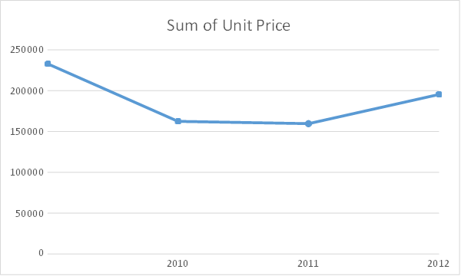
The graph illustrates an analysis of shipping cost, the shipping cost of the company have declined in direct proportion to sale since the company began selling products in the 1990’s.

By analysing data obtained from the superstore, it can be seem that Microsoft excel is capable of analysing data, pre- processing data, and visualizing data. The use of excel can be used to analyse the reasons for the decrease in sales at the superstore and determine the reasons for the change in sales.

PART 2

An explanation of the results from working with Excel

A statistical software application, Excel, is used to analyse and cluster the data. In this study, ice cream.csv was analysed using Excel in order to determine what is contributing to the decline in different flavours of ice cream consumption.

Ice cream flavours
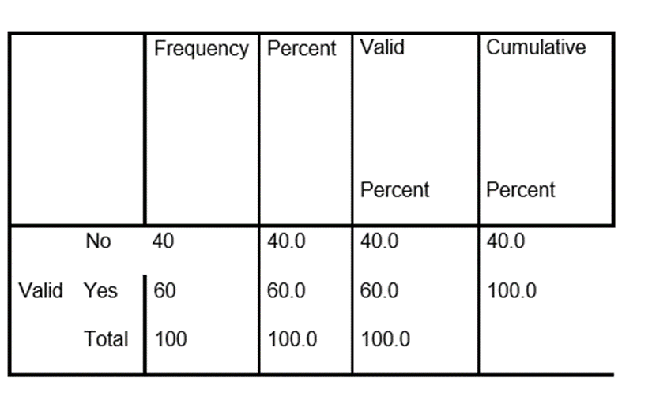
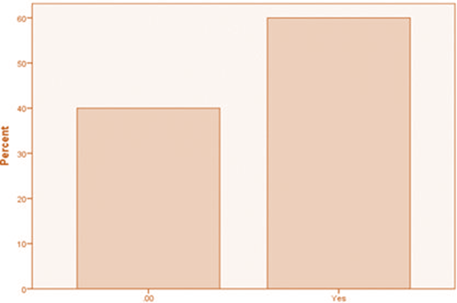
Approximately 60 percent of students out of 200 in the ice cream consumed different chocolates and like vanilla, compared to 40 percent who did not consume vanilla.
There are 109 males and 91 are female’s student.

Gender
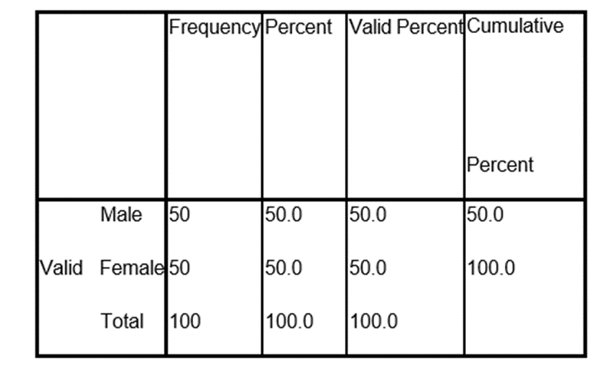

It can be seen from the pie chart above that ice cream has an equal number of male and female customers.
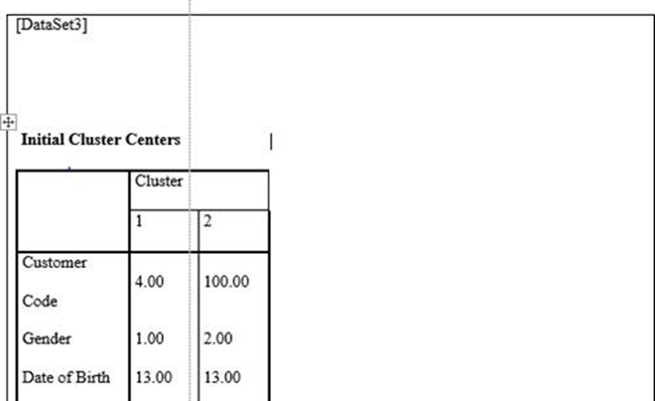

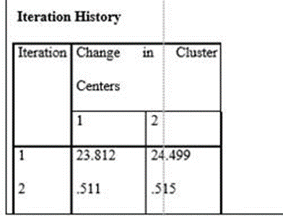

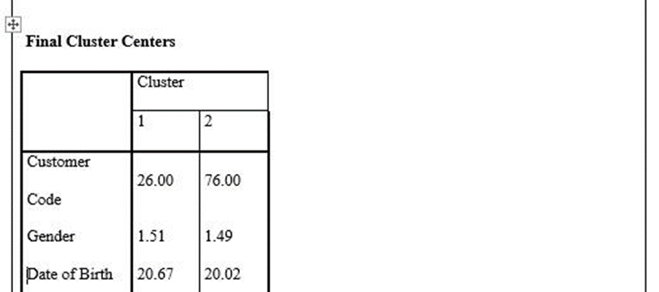
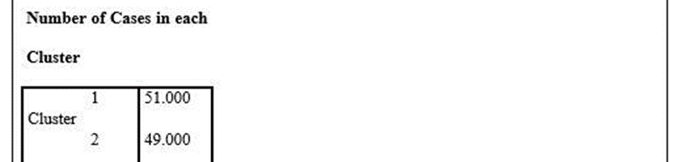


Based on the screenshot above, it is evident that ice cream consumption varies greatly among individuals. According to the cluster analysis, individuals prefer rice offered differently, which has resulted in a decline in sales. There is a substantial increase in vanilla consumption among women, which is indicative of the main reason for the change in ice cream consumption.

Mean and median value of participants

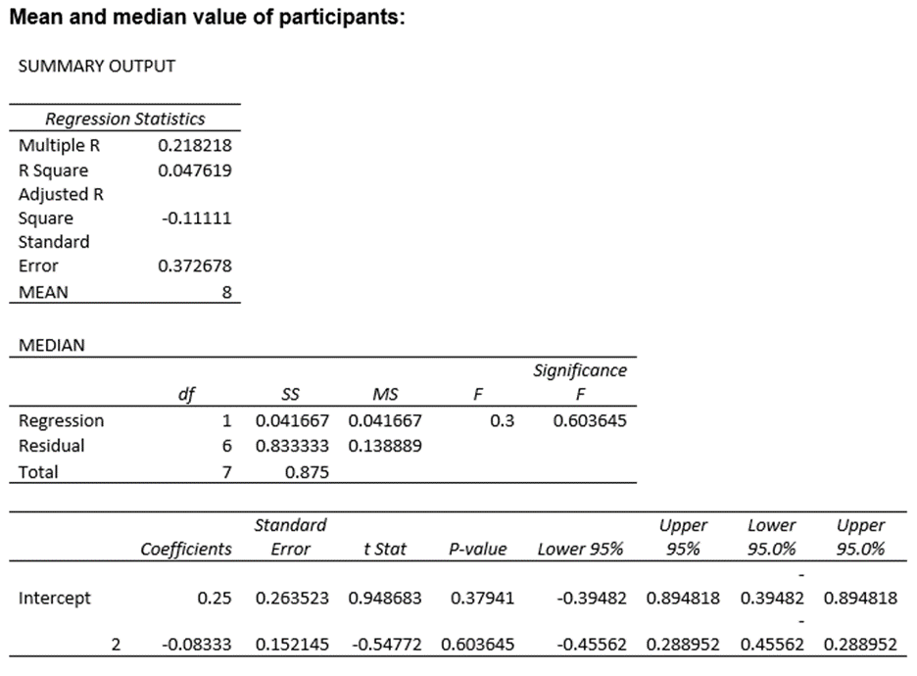

Data mining and text mining

In data mining and text mining, there are a variety of methods to use: as a result of advancements in technology, businesses today have greater access to data than ever before. When dealing with large amounts of data, unstructured data is not an appropriate solution due to its difficulty in implementation (Witten, and Frank, 2002). As a result, unprocessed data cannot be improved in performance. A large amount of data can be evaluated in order to generate new information.
For the purpose of generating new information and data, various tasks need to be completed using data mining. It is possible for companies to benefit from data mining by recognizing patterns in data and making intuitive decisions that are relevant to their needs based on those patterns. This tool is crucial for business intelligence and data science tools (Witten and Frank, 2002), both of which are imperative. In order to evaluate and analyze data, many organizations have employed various data mining techniques. Organizations can benefit greatly from the use of this type of technique when developing their financial data.

Preparation and cleaning of data

Cleaning and preparing data is an essential part of the data mining process. In order to use raw data for various analytics, it is necessary to clean and format it. Processes and cleaning data involve several components, such as data transformation, modeling, and cleaning and integration.
Data that has been cleaned and prepared for use by an organization becomes more useful as a result of their preparation. There are many organizations that use this method of data conversion.
A process of integration, It is a common practice to conduct data mining to identify patterns in organizational data sets. The presence of frequent data deviations is normally recognized when they occur on a regular basis.

Organization
By using this intricate data miming method, individuals are required to group different attributes together into discernible categories.

Clustering
Is a grouping data points in creating partitions based on similarity, a cluster is a set of similar data points or a set of points that are more similar to each other than two points in other clusters.
Clustering does not have a response class, after grouping observations, a human needs to visually look at the clusters and optionally associate meaning to each cluster.

The use of chucks as a method of dividing data into smaller groups is also used in the field of data mining. In order to attain desired results, the results of the data division are analyzed.

Data warehousing

As part of the data mining procedure, structured data is stored in a relational database management system, which allows the analysis of the data to be carried out for basic dashboards and reports, as well as business intelligence. Compared to previous years, cloud data warehouses allow for the storage of large amounts of data, as a result of technological advancements (Witten and Frank, 2002). Advances in data warehouse technology have accelerated the implementation of business intelligence within an organization.

Pivot table against lookup

VLOOKUP is commonly used in Excel formulas. VLOOKUP is not supported by Power Pivot. Data Analysis Expressions (DAX) are not referenced in Power Pivot like they are in Excel. DAX functions can only refer to columns and tables. You should keep in mind that Power Pivot works with relational data. When you look up values in another table, you do not have to create any formulas. In an Excel worksheet, take a PivotTable that analyses sales data from your data model. In this example, you would like to slice the sales data by region according to a Region column in the geography table. The Region field can be easily added to PivotTables to allow them to be customized. No formula is required or anything needs to be looked up. It is necessary to meet a few requirements in order to implement this simple solution: the lookup column Region must be in a connected table, and the geography field cannot be hidden.

As far as advantages and disadvantages are concerned, SPSS has an advantage over Excel
Statistical software programs such as SPSS are commonly used in the preparation of data, modeling, compiling, and analyzing the results of data analysis. SPSS has generated significant interest in the industry.A significant role is played by data analysis in business. The majority of companies conduct their market research using Excel instead of SPSS at the present time. In comparison to other data analysis techniques, SPSS is simple to use and faster to apply. The main reason why SPSS is the most reliable tool for analyzing data is due to this feature. SPSS has several advantages over Excel, as will be discussed in the following paragraphs.
There are several advantages to using SPPS
• A wide variety of charts and graphs are available in SPSS, compared to Excel.
• As well as being easier to use than Excel, SPSS is also much more powerful.
• Due to SPSS's ability to provide faster and more reliable results, statistical data may be accessed more quickly and reliably.

Disadvantages associated with Statistical Process Control (SPSS)

• The use of SPSS may be limited by its lack of advanced functionality, such as programmable coding. Due to its high cost, SPSS cannot be easily accessed
• To exploit the resources available with SPSS, you need training.
• A comparison of SPSS graphing features with those of Microsoft Excel indicates that SPSS graphing features are more complex.

Advantages of Excel

• One of the benefits of Excel is its wide range of formatting options as well as its ability to handle non-data entries (for example, formulas).
• Additionally, it is relatively easier and faster to access basic statistics.
• Both types of tools have their advantages and disadvantages, depending on their intended purpose."

Disadvantages of Excel

• Excel's accuracy is problematic. One incorrect number can completely wreck an Excel spreadsheet, resulting in extensive losses. You can't afford to be inaccurate if you use financial models increasingly.
• The complexity of a model created in Excel is difficult to understand. Using Excel, you are limited to incorporating one or two variables at a time. X-Y models are no longer sufficient for analysing financial data, preparing budgets, and analysing risks.
• When it comes to working with Excel, there are many challenges to overcome. In older versions of Excel, only one user can work on a spreadsheet at a time. The user would email the spreadsheet to another person who would make the necessary changes. Collaborating in this way is inefficient, slow, and ineffective.
• There is a lack of efficiency in Excel when it comes to data entry and template management. The ability to create multiple templates at once made Excel so useful when it first became available. The data could be inputted into a template to complete your financial models.

CONCLUSION

I have read the above report and I have concluded that data mining and business intelligence hold great promise for businesses in the future as these tools make it possible to analyze data and make informed decisions with the assistance of these tools. According to the report, the analysis of data using Excel is also crucial for gaining an understanding of markets. Therefore, analyzing trends in the business can help predict whether a company will be profitable or lose money.

REFERENCES

Balakrishnan, S. and Rahul, R., 2018. Big data in business intelligence. CSI Communications magazine, Volume, (42), pp.21-23.
Bayer, H., Aksogan, M., Celik, E. and Kondiloglu, A., 2017. Big data mining and business intelligence trends. Journal of Asian Business Strategy, 7(1), pp.23-33.
Britos, P., Dieste, O. and García-Martínez, R., 2008, September. Requirements elicitation in data mining for business intelligence projects. In IFIP World Computer Congress, TC 8 (pp. 139-150). Springer, Boston, MA.
Frey, F., 2017. SPSS (software). The International Encyclopedia of Communication Research Methods, 1–2.
Klusáček, D. and Parák, B., 2017, June. Analysis of mixed workloads from shared cloud infrastructure. In Workshop on Job Scheduling Strategies for Parallel Processing (pp. 25-42). Springer, Cham.
Kudyba, S. and Hoptroff, R., 2001. Data mining and business intelligence: A guide to productivity. Igi Global.
Moly, M.I., Roy, O. and Hossain, M.A., 2019. An advanced ETL technique for error free data in data warehousing environment. Int. J. Sci. Res. Eng. Trends, pp.554-558.
Olson, D.L. and Delen, D., 2008. Advanced data mining techniques. Springer Science & Business Media.
Shmueli, G., Patel, N.R. and Bruce, P.C., 2011. Data mining for business intelligence: Concepts, techniques, and applications in Microsoft Office Excel with XLMiner. John Wiley and Sons.
Vercellis, C., 2011. Business intelligence: data mining and optimization for decision making. John Wiley & Sons.

