HPHI5018
History Independent Project

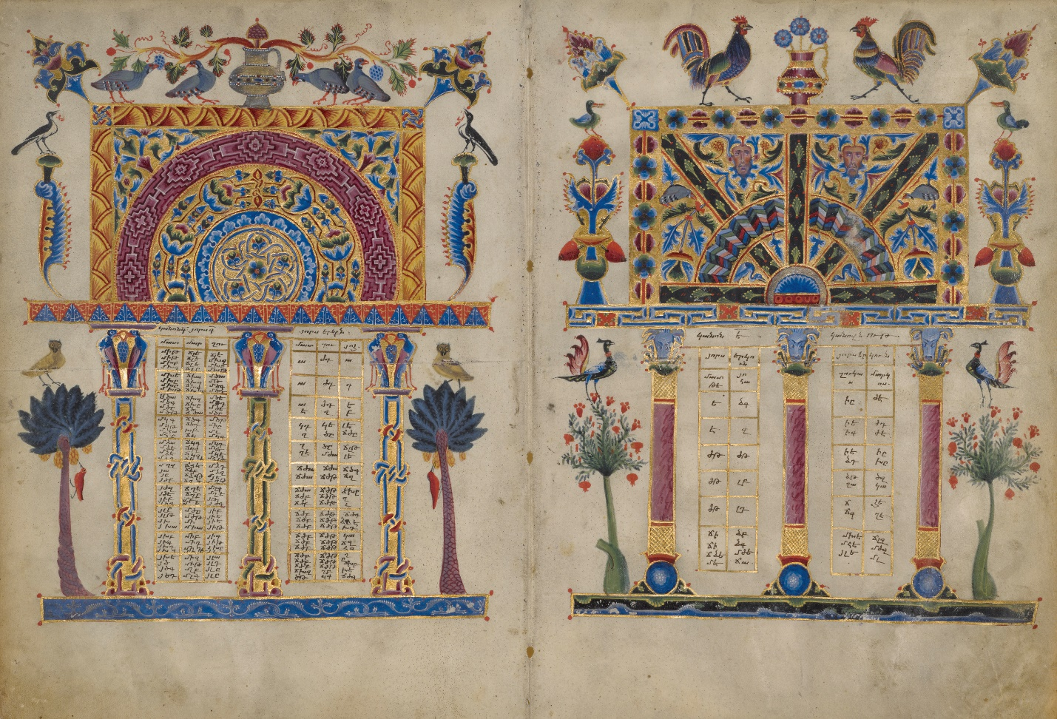
Theories, Methods and Approaches for Historians
2019–2020
Cover image: plates from Zeytun Gospels
MODULE CONVENOR:
Alexander Scott (alexander.scott@uwtsd.ac.uk)

MODULE TUTORS:
Alexander Scott, Harriett Webster, Janet Burton, Lester Mason

LECTURES/WORKSHOPS:
Week 1–3: Monday, Tuesday, Thursday, Friday – 10am, Arts 4
Week 4: Monday – 10am, Arts 4
Week 4: Tuesday, Thursday, Friday – Independent Study in Preparation for Research Proposal

MODULE AIMS:

- To examine important practical, theoretical, methodological and conceptual approaches to the study of the past.
- To enable students to devise and carry out an independent research project that is underpinned by knowledge and application of specific historiographical theories, methodologies and approaches.

MODULE LEARNING OUTCOMES:
Upon the successful completion of this module, students should be able to:

- Demonstrate a secure, detailed understanding and knowledge of their subject of choice.
- Identify, obtain and evaluate critically key primary and secondary sources relating to their subject of choice.
- Identify, appraise and apply historiographical theories/methodologies/approaches as appropriate to their subject of choice.
- Plan, develop and deliver an in-depth independent research project under close supervision, providing a model that can be emulated and expanded upon in Level 6 dissertations.

MODULE DESCRIPTION:
HPHI5018 introduces students to a variety of practical, conceptual, theoretical and methodological techniques requisite for study at Levels 5 and 6. Building on modules studied at Level 4, HPHI5018 encourages students to think critically about the disciplines of history and medieval studies, introducing them to key methods, approaches and ideas within these broad fields. The aim is to equip students with skills, knowledge and understandings necessary for undertaking Level 6 dissertation work, hence assessment tasks students with developing an independent research project.
Teaching on HPHI5018 comprises lectures and workshops on a particular theory/method/approach. A lecturer will present an introductory lecture outlining some of the key ideas associated with a particular theory/method/approach, followed by workshops in which themes associated with the theory/method/approach are probed in greater depth. Workshops are structured around students’ understanding of the module’s lecture topics and assigned readings – but they also encourage students to deploy knowledge and ideas derived from their wider studies. In particular, discussion sessions afford opportunities to think about how a given week’s topic (say, memory or gender) has specific relevance to students’ preferred time-period (e.g. medieval or modern history). This services the goals of encouraging students to ‘take ownership’ of their studies, and to help identify links and commonalities which join different modules.
The assessment for the module comprises of an independent research project. At the end of Block 1, students will submit a 1000-word essay proposal (20% of module grade), which acts as the basis for a 4000-word essay (80% of module grade). The aim is that the lectures will provide inspiration for the independent projects in terms of the critical theories, methods and approaches which students use in the essays.
Overall, the module aims to make students think critically about the ways in which history is written and practiced, thus fulfilling Keith Jenkins’ call that historians should give “an explicit analysis of why the history you are getting is the one you are getting and why you are getting it in the way you are.”

READING AND OTHER PREPARATION:
Students are expected to complete assigned readings and/or other activities in preparation for teaching sessions. Readings and preparatory exercises will be disseminated via Moodle.

MODULE TIMETABLE:
WEEK 1
Tuesday
Hour 1: Introduction to Module (AS)
Hour 2–3: What is History? From Ancient towards Modern History-Writing (AS)
Thursday
Hour 1: What is History? Discussion of EH Carr (AS)
Hour 2-3: Marxism and Empiricism (AS)
Friday
Hour 1–2: Social History (AS)
Hour 2–3: Cultural Studies/Cultural History (AS)

WEEK 2
Monday
Hour 1: Social and Cultural History assigned reading discussions (AS)
Hour 2–3: Gender History and Feminism (AS)
Tuesday
Hour 1: Gender History and Feminism assigned reading discussion (AS)
Hour 2–3: Visual and Material Culture (AS)
Thursday
Hour 1: Visual and Material Culture assigned reading discussion (AS)
Hour 2–3: Harriett’s ‘Show and Tell’: Research Projects from Start to Finish (HW)
Friday
Hour 1: Workshop: Mind-mapping Students’ Initial Ideas (AS)
Hour 2–3: Alex’s Show ‘Show and Tell’: Research Projects from Start to Finish (AS)

WEEK 3
Monday
Literary Theory (HW)
Tuesday
Microhistory (HW)
Thursday
Lester’s Show and Tell: Research Projects from Start to Finish (LM)
Friday
Oral History and Memory (LM)

WEEK 4
Monday
Workshop Session (AS)
Tuesday, Thursday, Friday: Independent Study in Preparation for Essay Proposal

ASSESSMENT:
Assessment for the module is intended to familiarise students with the process of doing independent research. It thus consists of a detailed, extended essay plan and an extended essay based on original research on a topic of students’ choosing. These both act as preparation for final-year dissertations and/or independent projects. An additional stipulation of the essay plan and the extended essay is that students should actively apply one of the methodological/conceptual/theoretical approaches explored during HPHI5018 lectures to their chosen topic.
Please note: students are instructed that they must write their extended essay on a topic that is substantively different to the one that the write their eventual final-year dissertation on. This is to prevent self-plagiarism and duplication of coursework. This may therefore impact upon your decision of what to write about (i.e. you may wish to save a ‘passion project’ dissertation until the final year). Students should therefore enter dialogue with relevant members of staff before pursuing their extended essay.

TASK 1:
- Extended essay plan – 1000 words (plus extra word allocation for bibliography) (20% module grade) – deadline Sunday 13 October 2019, 23.59

Task: Choose a topic within modern or medieval history. Devise an original research question and compose a 1000-word essay plan that applies an appropriate methodological/conceptual/theoretical approach explored in relation to the HPHI5017 syllabus.

Students will produce a detailed plan, supplemented by bibliography, for an extended essay on a subject of their own choosing. Having chosen their topic, students should adopt a particular methodological/conceptual/theoretical approach towards studying it. In most instance, these should relate to one of those approaches explored during lectures listed below (alternative methods, theories and approaches may be used if deemed appropriate after consultation with lecturers):

- Empiricism
- Marxism
- Social history
- Cultural history
- Microhistory
- Gender
- Memory
- Oral history
- Material culture
- Visual culture
- Literary theory

The proposal should be 1000 words in length, and should provide an outline of the following:

- what your topic is;
- what question/‘problem’ you plan to address and how you plan to do so;
- what (both secondary and primary) sources you plan to use and how;
- what historiography and/or other scholarship exists on your proposed topic and how you plan to engage with it;
- how your chosen topic relates to and engages with a particular historical theory/method/approach (e.g. one of the lecture themes);
- what your planned structure is (e.g. suggested section headings or sub-topics to focus on);
- what (provisional) possible conclusions you might find and/or what you hope to achieve in writing the essay;
- how you plan to manage your time in order to complete the essay before the final deadline.

A bibliography should also be included (using correct referencing), but this is not included in the word count. Several formative tasks will be assigned to students over the course of block 1 to prepare students for completing their proposal.
Students are instructed that they must write their extended essay on a topic that is substantively different to the one that the write your eventual final-year dissertation on. This is to prevent self-plagiarism and duplication of coursework, and may therefore impact upon your decision of what to write about (i.e. you may wish to save a ‘passion project’ dissertation until the final year). Students should therefore enter dialogue with relevant members of staff before pursuing their extended essay.

TASK 2:
- Extended essay based on independent research – 4000 words (80% module grade) – deadline Friday 1 May 2020, 23.59

Task: Choose a topic within modern or medieval history. Devise an original research question and compose a 4000-word essay that applies an appropriate methodological/conceptual/theoretical approach explored in relation to the HPHI5017 syllabus.

Students will attend a tutorial with the module convenor and/or relevant members of lecture staff to discuss their extended essay plan. Based on these tutorials, and on written feedback related to their plan, students will be tasked with writing a 4000-word essay. Students will devise their own topic and study questions in consultation with members of staff. The onus is on students to come up with their own topic independently (albeit with advice from members of staff), and this assignment affords them an opportunity to pursue their own particular interests in-depth. This all acts as preparation for the type of skills which will then be harnessed in their final-year dissertation.
Emphasis is placed on the effectiveness of students’ engagement with and application of historiographical theories, methods and approaches; i.e. it is not enough to pay lip service to, say, gender history; students need to engage with gender history scholarship in a concerted manner.
WORD LIMITS:
Word limits exist to encourage concision, rigorous editing and thorough drafting. Students should thus always endeavour to get their coursework as close as possible to the word limit. In addition, in 2019/2020, UWTSD has adopted the following formal penalties where coursework exceeds stipulated word limits:

- Up to 10% above the word limit – No deduction off final mark
- Between 10% and 25% above the word limit – Deduction of 5 marks off final mark*
- Between 25% and 50% above the word limit – Deduction of 10 marks off final mark*
- 50% or more over length – Maximum mark of 40.

Likewise, a failure to meet the maximum word limit may result in lower marks based on the quality of the work because they may not have included the necessary information required for the assessment and met the stated learning outcomes.
* In instances b) and c) deductions will not be applied if the deduction takes the mark beneath the ‘fail’ boundary.

ASSESSMENT CRITERIA:
Coursework will be graded in accordance with the criteria adopted by the Faculty of Humanities and Performing Arts. These criteria are spelled out below:

- ENGAGEMENT WITH LITERATURE
(Including reading, referencing, academic conventions and academic honesty.)

For history students, this implies that a mixture of appropriate primary and secondary sources (plus any other relevant forms of evidence) are used effectively and in a critical manner. Emphasis is also placed on the ability to demonstrate understanding of relevant historiographical issues, and the proper use of quotations and MHRA referencing conventions.

- KNOWLEDGE AND UNDERSTANDING
(Knowledge of the basic underlying concepts and principles of a subject.)

For history students, this implies a sound grasp of the chosen topic and time-period, and that forms of evidence and relevant theories/methods/approaches are used in a critical, reflective manner.

- COGNITIVE AND INTELLECTUAL SKILLS
(Ability to evaluate underlying concepts and principles of a subject and interpret qualitative and quantitative data in order to develop lines of argument and make sound judgements.)

For history students, this implies the ability to formulate, sustain and articulate a coherent evidence-based argument. Particular emphasis is placed on the ability to demonstrate critical analysis as opposed to description/narrative, as well as the ability to situate a topic within broader chronological and scholarly contexts.

- PRACTICAL SKILLS
(Ability to use different approaches to solving problems in particular contexts.)

For history students, this implies the ability to locate and apply relevant forms of evidence via primary and secondary research. Particular emphasis is placed on the ability to devise original insights and arguments, as opposed to those that are derivative of existing literature. The ability to demonstrate an understanding of relevant historiographical issues is also key.

- TRANSFERABLE SKILLS FOR LIFE AND PROFESSIONAL PRACTICE
(Communicate the results of their study/work accurately and reliably, and with structured and coherent arguments; the qualities needed for employment requiring the exercise of some personal responsibility within a structured and managed environment.)

For history students, this implies the ability to communicate their ideas in a logical, legible and coherent manner. Correct spelling and grammar is key, with emphasis also placed on clear presentation and correct formatting. Completing the assigned task – and answering any questions contained within in it – is also essential, as is adherence to particular instructions for coursework tasks. At the same time, creative responses to assigned tasks/questions are valued.

PLEASE NOTE: in addition to the above criteria, on HPHI5018, A PREMIUM WILL BE PLACED ON COURSEWORK THAT ACTIVELY AND SUCCESSFULLY ENGAGES WITH THEORIES, METHODS and APPROACHES EXPLORED IN RELATION TO THE MODULE SYLLABUS. A first-class Independent Project essay would, therefore, be expected to combine original research with a definite theoretical/methodological ‘angle’ (Marxism, gender, postmodernism, etc.) of one sort or another.

