Effective team working and communication
Name: Christopher Nicholas
Student number: 1817904
Assignment title: effective team working and communication
Model code: Bmsw4002
Lecturer: Navami

Contents
Introduction 2
What is communication? 3
Different types of communication 3
Verbal communication: 3
Nonverbal communication 3
Written communication 3
How communication can be made effective in a business 3
Models of communication 4
Challenges and problems of communication in workplace: 6
Solutions to solve the challenges 7
Conclusion 8
Refrences 9

Introduction
The aim of this report is to analyze some important factors of communication and the various different types and models of communication, I will be talking about this by including the challenges at work and how I dealt with them by which type of communication I used and what worked well. I will also include methods that I need to improve on and give a swot analysis on my strengths and weaknesses. I will also be uploading the in class exercise worksheets which helped me a lot through this report, including Maria and Pedro and how their communication broke down due to noise and sound barriers.

What is communication?
Communication is a process that shares information between one and other, or a group of people whether it is through written communication or oral it is to get the message over to the appropriate source. Editorial team, (2019) also the importance of communication is to deliver the correct information and get the main point across to who your audience are.

Different types of communication
- Verbal communication
- Nonverbal communication
- Written communication

Verbal communication: examples of verbal communication is through speaking and listening, interviews and speeches are main examples of this
Nonverbal communication: when we talk about nonverbal communication it doesn’t necessarily mean we have to give a message through speaking you can pass a message through looks and body language example of this is posture and eye contact.
Written communication: written communication is generally in forms of letters, emails etc. where communication is sometimes misunderstood due to not seeing the person or organization who sent the letter/email.

How communication can be made effective in a business
Most successful organizations are built and developed from good communication skills and time management skills if you can communicate with certain members or colleagues then you are on a very impressive track as I will mention next on models of communication this shows how certain communications get lost due to noise and how it can get misinterpreted incorrectly I will explain the different methods and which one helps more in certain situations or challenges you may have to deal with. Another way that can be effective is emails this is so people can understand in a simple format exactly what is happening so if a company is emailing a customer to explain that there delivery is on its way shortly this is a good way to notify them as well as text message. One more is simple wording not using words that are going to be tough for others to understand, this is always a reasonable way of dealing with situations for instance you may write an email and in the main text you mention complex words there recipient on the other end of the email may not totally understand what is being mentioned.

Models of communication
- Berlo model of communication: sender-encoder-channel-noise-decoder-receiver
- Sender: who the message is from
- Encoder: the transmitter that converts the message into signals
- Noise: the distraction from interruption along the way
- Decoder: reception that converts signals into the message
- Receiver: the person who receives the message.


- Shannon and weaver: sender-encoding-channel-decoding-receiver but this is with the element of noise within the channel and is also Feedback model.
- Sender: is the information source who creates the message
- Encoder: is the sender who converts the message into signals
- Channel: Is the medium to send the message
- Decoder: is the receiver
- Receiver: is the destination of the message
- Noise: is the disturbance for example people etc.

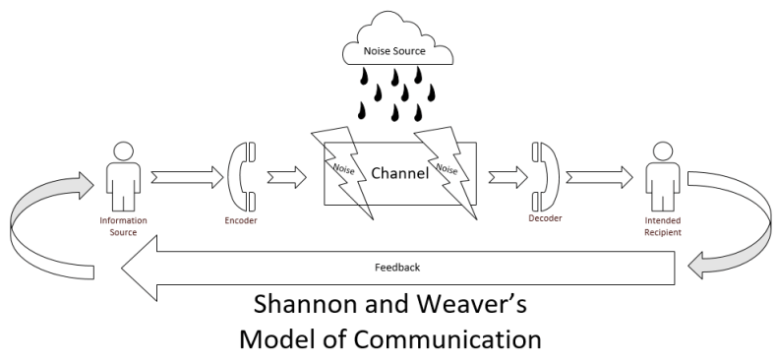

These models of communication have different methods of how communication is used and there varied in shapes schramms is a circular model and Shannon and weaver and Berlo are linear models.
Schramm model: this model of communication is a circular model rather than a linear model and gives feedback.
Sender: who sends the message?
Message: content shared between the conversations
Receiver: the person who decodes
Semantic barriers: how the receiver interprets the message
How does communication work between management and employees?
When working in Tesco's I faced many challenges and I dealt with so many obstacles that I could not face alone, but through communicating on a one to one basis and in group discussions we managed to resolve some issues and we became familiar to difficult stages. there are many ways you can communicate when working in a team in retail firstly there is customer service which is polite communication between yourself and customers verbal communication, another type of communication is through messages which is within a group of colleagues where we receive important information about the organization, our weekly rotas, and also any improvements that need to be addressed we can discuss within the group. I believe that the model used here was most definitely schramms model as opinions were shared back and forth and at the end of the discussions, I received Feedback about the issues we had and how we managed to resolve the issues.
I found out the best way of dealing with the issues were through oral communication rather than through messages and emails because of the language barrier and them not understanding the concept of the message being sent across I would send information over social media and messages and colleagues would misinterpret what I was sending across, this therefore caused many issues and this was down to the level of formality and the barrier in the language that was used I feel that Shannon and weaver model played a big part when noise interfered with the conversations we had either on the phone or face to face because of disturbance of colleagues or phones ringing in the office, there was never just a simple conversation without something complicated.

Challenges and problems of communication in workplace:
When I look back at some of the main challenges I faced in my workplace I can point out three important factors, one of these is language barriers, this is a major concern because when you are dealing with customers or your other colleagues who’s English language is not as fluent as others there can be communication lapses where certain members felt bullied because of the way the management was dealing with certain situations. I think what could be addressed in this situation is maybe have a translator available or phone translator to help any further issues in the future.
Another dispute I faced when I was in Tesco’s was cultural differences this made life difficult because for instance it was Ramadan for those who celebrated that were from an Islamic dissent, the management clearly stated whoever will be off due to this celebration to inform as soon as possible so we can arrange cover. This must have been lost in translation because as that day commenced three members of staff did not turn up, and therefore this caused the business to suffer as only one member was on duty and it caused a really massive effect on the day and the profits we was able to make that day. This was all because of miscommunication and the lack of teamwork and decision making skills, this could of easily been avoided if there was a message sent to the wassap group we created for our work colleagues but this was not accomplished.
Lastly “ego and attitude” is another huge problem we faced. Vdovin, (2017) when you work with people with bad attitudes and big egos this generally adopts issues from the very beginning because others thinking there better than others and telling other members of staff what to do, this also can have a bad effect on customer service when certain members of staff argue with customers because either language barriers or simply being rude.

Solutions to solve the challenges
When we have to face certain situations there many methods that can help with challenges in a workplace you can use the Keys approach which can help you develop some key skills in your communication with whatever the issue is for instance if there is a problem and it’s down to language breakdown then you can use translating if necessary, there was one instance in my workplace where I had three colleagues of different ethnicity and the language barrier was a major issue, all three were feeling unsure of what to do when communication came about, so what they did was download an app on their smart phones which translated from there preferred language to the language that the other spoke. When they realized this was a very good way of helping communicate it helped them get along better both verbally and nonverbally.
Another problem I came across when I worked in Tesco many customers were very upset that the ques were very long and was extremely frustrating as we were short staffed for a long duration of time. As I was supervisor it was my duty to make sure the shop ran smoothly and all went accordingly, so when we had customer complaints I was there to deal with that and make sure all the problems got resolved. What I did in this situation I told my manager to set up a sweet counter with different sweets and chocolates on the counter for customers to take one or two each as they left the premises. I know bribing is not a good way of earning respect but it did help for that short period of time until we recruited more staff. In the longer run we set up a survey for customers who were happy and who were not very happy and for those who were in the middle. I believe that working together as a community hearing different opinions of both customers happiness and the staff as well, the result in the end was that both were left very satisfied and because the customers knew how under staffed we were they set up a petition and contacted the head office through emailing and letters, this really helped matters and we then had new members of staff within two weeks.

Conclusion
In this report we analyzed some really important communication skills and methods on how to deal with situations in everyday life and in a workplace, we also looked at the different models of communication and what each represent, we looked at challenges I faced when I worked in my organization and some of problems I had to deal with and what communication we as a team used and how it helped a bad situation a better situation, we also learnt about the challenges I faced and what solution methods I used to try resolve the problems that arised these were all helpful for future. The in class exercise worksheets will be attached to this report too which helped me a lot through this assignment the use of different communication methods and what model of communication has helped me a lot.

References
https://entrepreneurhandbook.co.uk/what-is-communication/
Vdovin, A. (2019). Top Communication Problems in the Workplace. [Online] Alert-software.com. Available at: https://www.alert-software.com/blog/top-communication-problems-in-the-workplace [Accessed 15 Aug. 2019].

