Dissertation – Proposal
LCBB6000
BA (Hons) Business Management
University of Wales Trinity Saint David (London Campus)

Impact of Influencer and Social Media Marketing on Customer Satisfaction - A study on Zara

Student name: Stoyan Nyagalov
Student ID:2019288
University of Wales Trinity Saint David (London Campus)
Supervisor name:
Afzal Munna
Due Date:

Table of Contents
1.0 Introduction 4
1.1 Background of the research 4
1.2 Significance of the research 4
1.3 Aim and objectives of the research 5
1.4 Research Question 5
2.0 Literature Review 6
3.0 Research Methods and Methodology 8
3.1 Research Philosophy 8
3.2 Research Approach 8
3.3 Research Strategies 9
3.4 Research Choices 9
3.5 Time Horizon 9
3.6 Techniques and Procedures 9
Survey Design 9
Sample Choice 9
Data analysis 9
Considerations for Ethics 10
4.0 Conclusion 11
5.0 References 12

1.0 Introduction

1.1 Background of the research
According to Marchal (2022), social media marketing allows for two-way connection between businesses and their target audiences. While SMM's ability to influence consumer decisions is minimal, the novelty of the phenomenon has ensured that it remains in the limelight. A social group's ability to foster a sense of safety is unaffected by whether or not its members ever actually meet in person (Yadav & Rahman, 2017). A "virtual brand community" is a collection of brand-loyal consumers who share a common online space. According to Seo and Park (2018), customers place equal value on developing relationships with other buyers and experts as they do on making purchases. In order to entice customers, businesses must first understand what drives people to participate in focus groups like this (Wibowo et al., 2020).
Sampetua Hariandja and Sartika (2022) say that 2009 marked the beginning of the influencer age. Before the rise of social media platforms, people would often wait for the opinions of journalists and talk show hosts before making a buying decision. The proliferation of video-editing software, social media platforms, and other tools has led to a "democratization" of influencers and the dissemination of ideas (Rainer and Reinhold, 2012). Video bloggers (vloggers) became popular with the rise of YouTube, claims Bhattacharya and Sen (2013). Influencers may expand their reach by posting on more websites, social media accounts, and blogs. Their work together on branding and content so enhanced. Instagram's meteoric rise allowed influential users to promote their other social media profiles to a wider audience. Customers put their faith in their product recommendations because of their authority (Aimee, 2019).

1.2 Significance of the research
For a number of reasons, the study on the effects of influencer and social media marketing on consumer happiness, notably in the context of Zara, is quite important. Social media platforms have developed into potent instruments for influencing people's attitudes, views, and purchase choices in the Internet Age. It's critical for companies to recognize social media's potential as a platform for advertising and consumer involvement (Yang, Basile and Letourneau, 2018). This study may provide useful insights for companies who depend on digital channels to reach their target consumers by analyzing Zara's social media marketing strategy and its impact on customer satisfaction.

1.3 Aim and objectives of the research
The aim of this study is to analyse and comprehend the impacts of influencer and social media marketing on consumer satisfaction, with a particular emphasis on the well-known fashion company Zara. The study intends to shed light on how social media platforms may be used successfully to interact with target audiences and develop good relationships with consumers by examining Zara's social media marketing strategy and its influence on customer satisfaction. The following are the research's objectives:
- To comprehend the fundamentals of social media marketing and the importance of it for companies like Zara.
- To identify Zara's strategy for using social media for marketing.
- To determine how social media marketing has affected Zara's customer base.
- To examine the impact of influencer marketing on Zara's consumers' satisfaction.

1.4 Research Question
- How does Zara's social media marketing influence the pleasure of its customers?
- To what extent does Zara's use of influencer marketing affect consumer satisfaction?

2.0 Literature Review
According to Zimmerman and Ng (2017), "social media" includes websites like blogs, message boards, forums, and social networks. Social media, which includes all types of mobile and web-based communication, brings people together and organizes them into communities, resulting in very dynamic platforms. Bhattacharya and Sen (2013) state that there are a plethora of websites on the web aimed at various demographics and for various purposes. With the use of social media, the business might develop closer relationships with its clientele. Websites allow for two-way communication and healthy discussion by letting companies and consumers publish content. Customers may voice their approval or disapproval of company messaging with a wider audience (Nyangwe and Buhalis, 2017). It's only been in the last few years that businesses have started using social media for advertising (Shawky et al., 2020). The entertainment and media industries were among the first to embrace social media marketing. To reach a larger audience than would be possible via more conventional means of advertising, businesses may turn to social media marketing, as defined by Bu, Parkinson and Thaichon (2022).
A shift from "trying to sell" to "making connections" with clients is necessary for success in social media marketing, say Smith (2011). As a result, it's clear that developing personal relationships with consumers is essential to boosting revenue and fostering brand loyalty. Due to the large number of potential clients perusing social media platforms, it is easy to keep up a good reputation. In addition, it just takes a few clicks to start a conversation with a consumer on social media. Modern organizations need to be active on several social media channels to keep up with customer demands (Zollo et al., 2020). Social media's broader audience and publicity might be beneficial to companies of all sizes. There are five components to social media marketing that, when combined, will drive more people to a company's website and keep them there longer.
The term "satisfaction" refers to the emotional state a person is in when a result meets or surpasses his or her expectations (Brahma, 2023). The degree to which a person is pleased depends on how well the object they want meets their expectations and how well it really performs. The extent to which a person is satisfied with a product depends on how well it met his or her expectations, as stated by Wang and Kim (2017). Customers are satisfied, according to Silva et al. (2020), when the value they get is commensurate with the price they pay and the cost to acquire new ones.
This contradicts the research of Melewar, Ismail and Nguyen (2018), which showed that satisfied customers brought about more revenue for companies via word-of-mouth and other means. Customers might be polled on how well the service or product they received matches their expectations. A customer's satisfaction with a product or service may be gauged by evaluating it against their own expectations. For customers to report satisfaction with a product or service, their actual experiences must line up with their initial anticipations (Cateora, 2020).
The impact of influencer marketing on customer satisfaction is explained by a number of factors. First and foremost, influencers establish trends by bringing fresh goods and fashions to the public (Nunan et al., 2018; Morgan et al., 2018; Parsons and Lepkowska-White, 2018). Customers depend on the advice of influencers and consider it as reliable information when making judgments about what to buy. Second, the connection and engagement that consumers experience with a brand is facilitated by the content of influencers. Through comments and face-to-face contacts, this interactive component of influencer marketing promotes client happiness (Mcdonald, 2021). Businesses may use social media to better identify and meet client demands (Silva et al., 2020). Businesses may learn more about their consumers' ideas, emotions, wants, and expectations by actively interacting with them via social media marketing. A cohesive message is sent to the target audience by using effective social media marketing methods, which enable businesses to customise their messages and services to specific clients (Heinze et al., 2020). Business and consumers may communicate with each other in two directions thanks to effective social media marketing. It enables prompt replies to client enquiries, the dissemination of knowledge about goods and services, and the communication of exclusive offers and promotions (Siriwardana, 2020). Customers reward businesses that prioritize their requirements, keep them informed about new goods and services, and give good value for their money (Nunan et al., 2018).

3.0 Research Methods and Methodology

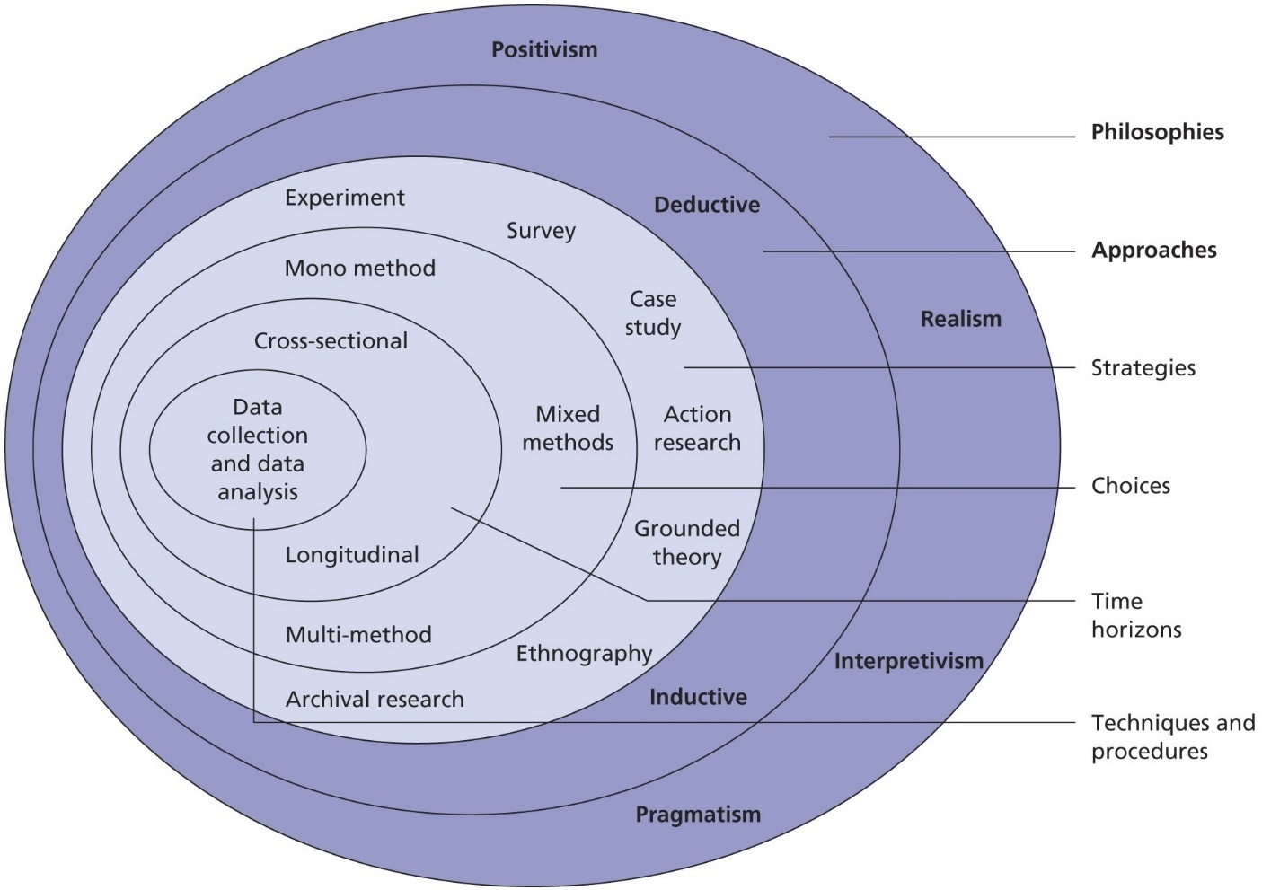
Figure 01: Research Onion
Source: (Rafael, 2016)

3.1 Research Philosophy
In this examination, a positivist research philosophy will be used. According to this philosophical perspective, objective knowledge may be attained by using scientific methods, emphasizing the use of empirical data and logical reasoning (Rahman, Rubin and Keiso, 2017).

3.2 Research Approach
Deductive research methodology will be used in the inquiry. A theory, hypothesis, or generalization about the phenomenon being examined is first developed through deductive research, and it is then put to the test by a thorough analysis of the data (Kruger and Mitchell, 2019).

3.3 Research Strategies
The research approach will be case study technique. This strategy offers a full analysis of how productivity and efficiency are impacted by human management in the context of Zara. It enables a comprehensive examination of several components and their interactions (Ross, 2016)

3.4 Research Choices
The study will use a quantitative research methodology, and Sainsbury's staff will be surveyed to get the data. Researchers may statistically analyse the data and come to a conclusion by using the quantitative technique (Johnson, 2018).

3.5 Time Horizon
The study focuses on a certain time period for data collection and analysis and has a cross-sectional temporal horizon. A sample population is used by researchers performing a cross-sectional study to collect data across a certain time period (Buys and Oberholzer, 2023).

3.6 Techniques and Procedures

Survey Design
The development of a structured online survey will be used to gather quantitative data. Closed-ended survey questions will be used to collect data on consumer contentment, Zara's social media marketing strategy, and the effect of influencer marketing on customer satisfaction. The survey questions will be created based on the preceding study's research goals and research questions.

Sample Choice
A representative sample of Zara consumers who have interacted with the company on social media will be the focus of the poll. Convenience sampling and random sampling strategies will be used to pick the sample. To reach a broad audience of clients, the poll link will be distributed through Zara's official social media accounts and relevant internet channels. It will be a priority to ensure that the sample is varied in terms of age, gender, and employment.

Data analysis
The relevant statistical methods will be used to examine the survey data that has been obtained. To describe the data, descriptive statistics including frequencies, percentages, means, and standard deviations will be computed. Statistical tools like SPSS or Excel will be used to enter, clean, and analyze the survey results as part of the data analysis process.
Gantt chart
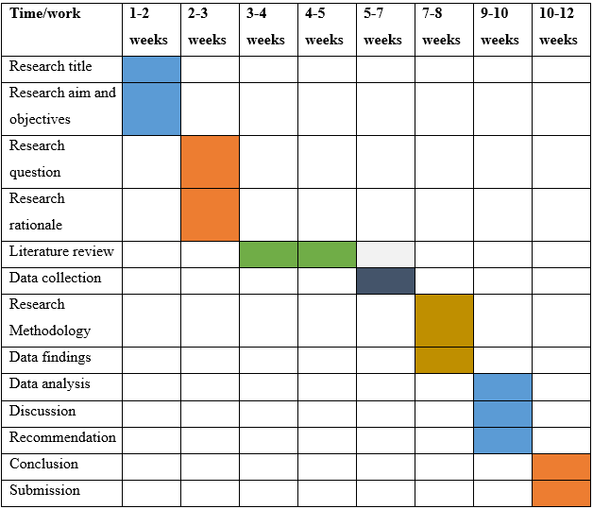

Considerations for Ethics
The study approach will take ethical issues into account at all times. The survey won't gather any personally identifying information, ensuring respondent anonymity and confidentiality. Before the survey begins, informed permission will be gained from the participants, who will be informed of the study's goals and their rights as participants.

4.0 Conclusion
In conclusion, the goal of this study project is to examine how influencer and social media marketing affects client happiness, with a particular emphasis on Zara. The study has a definite path thanks to the established research goals and research questions. Understanding social media's potential as a platform for advertising and customer involvement, as well as the efficiency of influencer marketing in affecting consumer views and overall purchasing experiences, are key takeaways from the study. A structured online survey will be used by the suggested research technique to gather information from Zara consumers who have interacted with the brand on social media. Descriptive and inferential statistical methods will be used in the data analysis to evaluate the connections between variables and test the study hypotheses. This study looks at Zara's social media marketing approach and how it affects customer satisfaction in an effort to provide useful insights for companies who use digital channels to reach their target customers.

5.0 References
Aimee, R.M. (2019). A THOROUGH LITERATURE REVIEW OF CUSTOMER SATISFACTION DEFINITION, FACTORS AFFECTING CUSTOMER SATISFACTION AND MEASURING CUSTOMER SATISFACTION. International Journal of Advanced Research, 7(9), pp.828–843. doi:https://doi.org/10.21474/ijar01/9733.
Bhattacharya, C.B. and Sen, S. (2013). Consumer–Company Identification: A Framework for Understanding Consumers’ Relationships with Companies. Journal of Marketing, 67(2), pp.76–88. doi:https://doi.org/10.1509/jmkg.67.2.76.18609.
Brahma, S. (2023). Impact of Social media on the Fashion Industry 2021. [Online] The Fashion Frill. Available at: https://thefashionfrill.com/fashion/impact-of-social-media/.
Bu, Y., Parkinson, J. and Thaichon, P. (2022). Influencer marketing: Homophily, customer value co-creation behaviour and purchase intention. Journal of Retailing and Consumer Services, 66(0969-6989), p.102904. doi:https://doi.org/10.1016/j.jretconser.2021.102904.
Buys, P.W. and Oberholzer, M. (2023). Business Research. 5th ed. Springer Nature.
Cateora, P.R. (2020). International Marketing. 3rd ed. New York: Mcgrawhill Education.
Johnson, G.L. (2018). Research methodology for economists: philosophy and practice. 2nd Ed. New York: Macmillan; London.
Marchal, S. (2022). Marketing in the Context of COVID-19. International Journal of Marketing, Communication and New Media, 23(22). doi:https://doi.org/10.54663/2182-9306.2022.sn11.1-4.
Mcdonald, J. (2021). SOCIAL MEDIA MARKETING WORKBOOK: how to use social media for business. 5th ed. S.L.: Createspace Indep Pub.
Melewar, T.C., Ismail, A.R. and Nguyen, B. (2018). Impact of perceived social media marketing activities on brand and value consciousness: roles of usage, materialism and conspicuous consumption. International Journal of Internet Marketing and Advertising, 12(3), p.233. doi:https://doi.org/10.1504/ijima.2018.10013343.
Morgan, N.A., Whitler, K.A., Feng, H. and Chari, S. (2018). Research in marketing strategy. Journal of the Academy of Marketing Science, [online] 47(1), pp.4–29. doi:https://doi.org/10.1007/s11747-018-0598-1.
Nunan, D., Sibai, O., Schivinski, B. and Christodoulides, G. (2018). Reflections on ‘social media: Influencing customer satisfaction in B2B sales’ and a research agenda. Industrial Marketing Management, 75(56), pp.31–36. doi:https://doi.org/10.1016/j.indmarman.2018.03.009.
Nyangwe, S. and Buhalis, D. (2017). Branding Transformation through Social Media and Co-creation: Lessons from Marriott International. Information and Communication Technologies in Tourism 2018, 44(54), pp.257–269. doi:https://doi.org/10.1007/978-3-319-72923-7_20.
Panneerselvam, P. (2014). Research Methods for Business Students. 8th Ed. New York: Pearson.
Parsons, A.L. and Lepkowska-White, E. (2018). Social Media Marketing Management: A Conceptual Framework. Journal of Internet Commerce, 17(2), pp.81–95. doi:https://doi.org/10.1080/15332861.2018.1433910.
Rafael, C. (2016). UNDERSTANDING THE RESEARCH ONION: AN ILLUSTRATION. [Online] Nairaproject.com. Available at: https://nairaproject.com/blog/understanding-the-research-onion-methodology.html.
Rahman, R., Rubin, L. and Keiso, W. (2017). Statistical methods for research workers. 4th ed. Delhi: Kalpaz, New Delhi, India.
Rainer, A. and Reinhold, O. (2012). Social Customer Relationship Management (Social CRM). Business & Information Systems Engineering, 4(5), pp.287–291. doi:https://doi.org/10.1007/s12599-012-0225-5.
Ross, J. (2016). Speculative method in digital education research. Learning, Media and Technology, 42(2), pp.214–229. doi:https://doi.org/10.1080/17439884.2016.1160927.
Sampetua Hariandja, E. and Sartika, L. (2022). Effects of brand innovation and marketing dynamic capability on the performance of international hotels. Innovative Marketing, 18(1), pp.63–78. doi:https://doi.org/10.21511/im.18(1).2022.06.
Shawky, S., Kubacki, K., Dietrich, T. and Weaven, S. (2020). A dynamic framework for managing customer engagement on social media. Journal of Business Research, 121(4). doi:https://doi.org/10.1016/j.jbusres.2020.03.030.
Silva, S.C., Feitosa, W., Duarte, P. and Vasconcelos, M. (2020). How to increase engagement on social media using the honeycomb model. Revista de Gestão, 27(2), pp.153–167. doi:https://doi.org/10.1108/rege-02-2019-0030.
Siriwardana, A. (2020). Social Media Marketing: A Literature Review on Consumer Products. SSRN Electronic Journal, 54(32). doi:https://doi.org/10.2139/ssrn.3862924.
Smith, K.T. (2011). Digital marketing strategies that Millennials find appealing, motivating, or just annoying. Journal of Strategic Marketing, 19(6), pp.489–499. doi:https://doi.org/10.1080/0965254x.2011.581383.
Wang, Z. and Kim, H.G. (2017). Can Social Media Marketing Improve Customer Relationship Capabilities and Firm Performance? Dynamic Capability Perspective. Journal of Interactive Marketing, 39(1), pp.15–26. doi:https://doi.org/10.1016/j.intmar.2017.02.004.
Wibowo, A., Chen, S.-C., Wiangin, U., Ma, Y. and Ruangkanjanases, A. (2020). Customer Behavior as an Outcome of Social Media Marketing: The Role of Social Media Marketing Activity and Customer Experience. Sustainability, [online] 13(1), p.189. doi:https://doi.org/10.3390/su13010189.
Yadav, M. and Rahman, Z. (2018). The influence of social media marketing activities on customer loyalty. Benchmarking: An International Journal, [online] 25(9), pp.3882–3905. doi:https://doi.org/10.1108/bij-05-2017-0092.
Yang, J., Basile, K. and Letourneau, O. (2018). The impact of social media platform selection on effectively communicating about corporate social responsibility. Journal of Marketing Communications, 26(1), pp.1–23. doi:https://doi.org/10.1080/13527266.2018.1500932.
Zimmerman, J. and Ng, D. (2017). Social media marketing all-in-one. 5th ed. Hoboken, Nj: John Wiley & Sons, Inc.
Zollo, L., Filieri, R., Rialti, R. and Yoon, S. (2020). Unpacking the relationship between social media marketing and brand equity: The mediating role of consumers’ benefits and experience. Journal of Business Research, [online] 117(1), pp.256–267. doi:https://doi.org/10.1016/j.jbusres.2020.05.001.

