
BSc (Hons) Health and Social Care

BMHP6026

Digital Transformation in the Health and Care Professions

Academic year: 2026

COMPONENT 1:Written Report on NHS App

Internal Verifier Dr Martin svejda

Student Name: Augustine Daniel Ajayi

Student ID: 2321116

Introduction
In England, efforts to modernise the National Health Service (NHS) included the use of "digital-first" alternatives. for all patients and significant digitalisation milestones, including the establishment of full electronic health records
The NHS App was introduced in 2019 as the 'digital front door' to the National Health Service in England, featuring essential functions such as General Practitioner (GP) appointment scheduling, repeat prescription management, patient access to medical information, and subsequently, COVID-19 vaccination certification. Comparable patient portals have been implemented in several formats and varying degrees of success. This longitudinal study (2021–2023) investigated the implementation of the NHS App within the backdrop of the pandemic and its subsequent developments. (Reidy, C. et al. (2025)
The report will use a SWOT analysis framework evaluate the innovation strength, weakness, opportunities and treat in relation to it impact on the workforce and community.

Background
Digital technologies are swiftly acquiring global traction as catalysts for dramatic transformations in healthcare. In England, efforts to modernise the National Health Service (NHS) included the introduction of "digital-first" alternatives for all patients and significant digitalisation objectives, such as the establishment of comprehensive electronic health care records across all NHS trusts by 2025. However The NHS App was first introduce in 2012. The NHS App was launched in 2019 to provide digital access to various primary care services for all general practice (GP)–registered patients in England aged 13 and above. The patient portal provides individuals access to their healthcare information and enables communication with their healthcare providers through features such as viewing GP records, requesting repeat prescriptions, managing GP appointments, assessing symptoms, registering for organ donation, and configuring data sharing preferences . Subsequently, more functionalities have been implemented that facilitate access to immunisation records, receipt of care-related messages, management of secondary care appointments, and observation of hospital waiting times. (Kc et al., 2024)

Workforce
The following are the key features in healthcare workforce
Strength
Improved communication with patient: the GP can have direct engagement with patients and medication management support continuality of care and faster update.
Enhanced data security: The Data Protection Act (2018), abbreviated as the DPA, is a UK parliamentary statute aimed at ensuring the right and responsible collection, storage, and handling of personal data to safeguard individuals' privacy.
Improve access: remote services and on line communication reduce barriers for those with mobility, work, or location challenges.
Efficiency and time savings: digital booking, messaging and prescriptions reduce administrative workload.
Better resources management: reduced miss appointments and improve data sharing help service run effectively and smoothly.

Community
Digital health solutions can enhance healthcare accessibility and results for persons with restricted access to medical services, especially those living in rural regions. In recent years, digital health tools have been pivotal in enhancing access to healthcare practitioners in rural regions . Technology enables patients in remote areas to conveniently obtain consultations, diagnoses, and treatment plans from healthcare specialists without the necessity of travelling significant distances to a medical center.Mathew et al. reported that several patients in distant places favoured telemedicine, as it enabled them to stay within their community and meet their familial and cultural responsibilities. Furthermore, the COVID-19 pandemic underscored the significance of digital health tools for rural populations. Given the ongoing alterations in travel regulations from a distant village to a regional healthcare facility, teleconsultations emerged as a superior alternative for community residents reluctant to travel for medical visits due to concerns about their ability to return home. NHS App enable individuals to effortlessly monitor their vital signs, track symptoms, and engage with healthcare providers in real time, resulting in enhanced disease management, expedited diagnosis, and prompt interventions ( Paulson, M.R. et al. 2022)

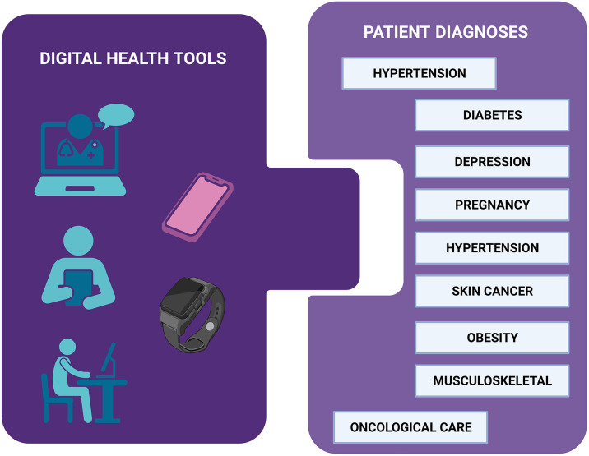
Deployment of digital health initiatives in remote regions. Overview of digital technologies (telehealth, remote monitoring, wristwatch, mobile, tablet) and the principal patient diagnoses discovered in this scoping research. Developed using BioRender Maita et al. - The Permanente Journal.( 2024)

Co-production is a collaborative approach that includes individuals utilising health and care services, carers, and communities as equal participants, engaging them in the first phases of service design, development, and evaluation. Innovation in social care transcends mere idea generation; it becomes a systematic process. This process entails recognising issues and opportunities, collectively developing ideas, designing and testing novel approaches, modifying based on feedback, and disseminating effective solutions. Co-production is essential.
At each phase, it guarantees that innovation is grounded in actual experience, tackles genuine difficulties, and stays adaptable as concepts are formulated, evaluated, enhanced, and expanded Ford et al. (2025)
Collaborative Authority and Decision-Making: Contemporary health frameworks, exemplified by the NHS England Co-production model, regard "lived experience" as equivalent to professional "acquired experience" in the development of new services.
The design of physical and digital environments, such as hospitals and digital tools, is increasingly conducted in collaboration with patients and families to guarantee inclusivity, accessibility, and functionality.

Support for family member
Virtual Support Networks: Online health forums and "CarePartner" mobile applications cultivate a sense of community, enabling family members to exchange practical information and emotional support around the clock.
Remote Monitoring: Wearable sensors and alarm systems enable families to oversee the safety of their loved ones at home, potentially postponing the necessity for institutional care.
Psychological Interventions: Video-conferenced treatment, such as Acceptance and Commitment treatment, has demonstrated efficacy in alleviating anxiety and depressed symptoms among carers.
Impact on public health efforts
Addressing Health Disparities: Integrated care approaches utilise data to recognise and confront broader determinants of health, such housing and social isolation, which cannot be resolved by any single entity independently.
Preventative Services: Co-developed community tools, such social prescribing and local health forums, emphasise early intervention and prevention, hence diminishing long-term expenses for healthcare systems such as the NHS.
Digital Inclusion for Vulnerable Populations: Initiatives such as 100% Digital Leeds supply devices and data to digitally marginalised families, including survivors of domestic violence, enabling them to independently access emergency and support services.
Weaknesses
Workforce
Employees in organisations frequently encounter heightened stress and opposition to new technologies owing to multiple variables. Challenges may encompass the necessity for personnel to acclimatise to new systems, apprehension regarding job security, and the urgency to rapidly acquire new technological skills. The adoption of new technology may provide difficulties for personnel, resulting in resistance and diminished involvement.
Adjustment to Novel Tools and Procedures: Employees may exhibit resistance to change and encounter difficulties in acclimating to new processes.
Security risk with new technologies
In the realm of emerging technology, it is imperative to confront security concerns directly to safeguard your assets and reputation.
By detecting skill deficiencies, companies may focus their upskilling and reskilling initiatives, allowing personnel to swiftly adapt to emerging technologies and market trends. A comprehensive awareness of individual and team competencies enhances collaboration and improves overall operational efficiency.
Enhance Productivity and Efficiency
The implementation of technology in workplaces has enabled organisations to enhance productivity and efficiency swiftly.
Manual and time-intensive processes can now be executed swiftly and efficiently with digital tools, software, and systems Technologies (n.d.)
Community
The utilisation of digital technology by patients and staff has markedly risen in recent years. In 2021, over 10 million additional individuals in the UK utilised NHS websites or digital applications compared to 2020, and NHS App registrations surged from 2 million in 2021 to 30 million in 2023.
Nevertheless, the advantages remain unavailable to all individuals.
Approximately 7% of homes remain without home internet access.
Approximately one million individuals terminated their broadband subscriptions in the past year owing to escalating expenses.
Approximately 10 million adults are projected to possess insufficient foundational digital abilities.
Approximately 30% of individuals who are offline perceive the NHS as one of the most challenging agencies to engage with.
Certain specific populations are at an elevated risk of digital exclusion; these groups also typically experience a greater risk of health disparities, including:
Individuals aged 75 and older
Individuals from socio-economically disadvantaged groups, including those with lower wages or unemployment status
Socially marginalised groups, encompassing individuals experiencing homelessness, asylum seekers, and those interacting with the criminal justice system - referred to as inclusion health groups.
Individuals with disabilities and those with life-altering conditions
Individuals residing in regions with insufficient broadband and mobile data coverage, particularly in rural and coastal locales.
Individuals with little proficiency in comprehending the English language.
Digital exclusion can intensify health disparities by worsening difficulties in accessing healthcare, acquiring skills to utilise services, and obtaining the essential tools for maintaining a healthy lifestyle.
NHS England and integrated care boards are legally obligated to evaluate methods for
diminishing disparities in access to and results from health services. This obligation on health disparities is in conjunction with the public sector equality duty. The NHS must evaluate and implement measures to mitigate the obstacles to digital health encountered by certain demographic groups England (no date b)
.

Opportunities
workforce
The frequently cited advantages of an innovative institution encompass accelerated growth, the encouragement of necessary internal organisational changes, enhanced opportunities for new product development planning, access to cutting-edge technologies, heightened competitiveness, an improved institutional image, superior reputation, and a demonstration of competence. Effective planning, evaluation of the present circumstances, and appraisal of the organization's capabilities are essential to realise the aforementioned advantages and hence substantiate the necessity for innovation.
Technological breakthroughs have profoundly transformed health care, offering digital solutions that improve diagnosis and patient care. Artificial intelligence (AI) is distinguished by its unparalleled powers in data processing, diagnostic assistance, and personalised treatment. Nonetheless, the successful integration of AI into healthcare requires specialised expertise among experts, an area that remains underdeveloped in terms of extensive literature and structured training programs.
A very important role, a business is all about finding better ways to give value to your customers on an existing product. Without innovation customers will eventually get tired of your product Consider a prominent technology firm that effectively incorporated AI into its customer service operations, enhancing productivity and customer happiness. By mitigating staff opposition, delivering comprehensive training, and emphasising security, they maintained a competitive edge and established new industry benchmarks.

Community
The advent of digital health technologies offers a viable solution for mitigating healthcare disparities. Innovations like mobile health
Mobile health (mHealth) applications, telemedicine, and electronic health records (EHRs) are transforming healthcare delivery, especially in situations where conventional methods are unfeasible or fiscally unsustainable.
Research indicates that telemedicine might markedly enhance healthcare accessibility for historically marginalised groups, offering essential assistance in regions affected by geographic and economic isolation
Moreover, new technologies enable scalable solutions that provide healthcare directly to marginalised groups, thereby overcoming physical hurdles that usually hinder access to care
The efficacy of these digital health treatments depends on their congruence with the distinct cultural and contextual realities of the communities they serve. Community engagement is essential; it guarantees that innovations honour local values and traditions, enhancing trust and elevating the probability of adoption (komi et al., 2021).
The integration of mobile health tools, telemedicine diagnostics, blockchain-secured AI-powered records, and community-driven design thinking has commenced the bridging of enduring disparities in health equity. Key insights derived from worldwide case studies and current trends emphasise the necessity of placing communities not solely as recipients but as active partners in the design, implementation, and sustainability of digital health interventions. Community health workers, local leaders, and grassroots organisations have been pivotal in establishing trust, promoting adoption, and ensuring that digital solutions align with local requirements and cultural values.
Threats
Workforce
Integrating AI and automation into the workplace frequently poses three principal psychological and structural risks to employee morale:
Role Erosion and Replacement Anxiety: The "shadow of the machine" engenders a continual apprehension around job displacement. Even in the absence of imminent layoffs, the belief that one's abilities are becoming obsolete may result in "quiet quitting" or a decline in organisational loyalty.
Cognitive Overload and Adaptation Fatigue: The incessant demand for skill enhancement engenders a "treadmill effect." Employees may perceive themselves as perpetually trying to catch up, resulting in burnout and animosity towards the technology designed to aid them.
Algorithmic Management and Dehumanisation: Enhanced automation frequently results in more stringent performance monitoring. When employees perceive evaluation based on metrics rather than merit, or experience a loss of autonomy due to automated workflows, it fosters a feeling of being a "cog in the machine," significantly contributing to turnover.
The paradigm emphasises that the efficacy of any nascent technology relies on the interplay of three critical components: Human, Organisational, and Technological elements. Figure 1 illustrates the identified barriers of AI adoption categorised accordingly.

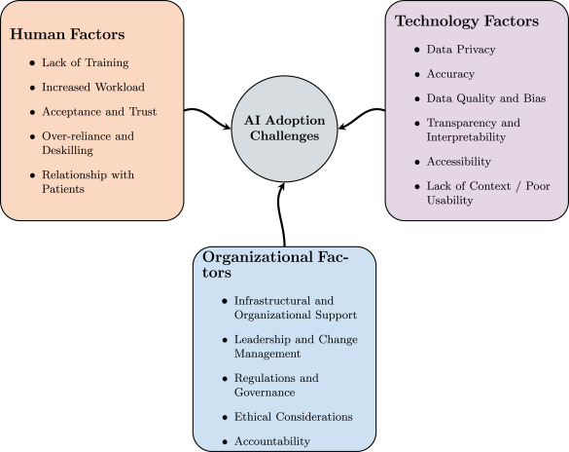
Fig. 1. Categorization of AI Adoption Challenges using the HOT Framework.
Community
Principal Dangers to Health Outcomes
Worsening of Chronic illnesses: Disadvantaged populations (low-income, ethnic minorities) exhibit reduced utilisation of health applications for controlling illnesses such as diabetes, potentially resulting in inferior long-term health outcomes relative to more affluent, technologically adept groups.
Health Data Inequity: Marginalised populations are often inadequately represented in the datasets utilised for training medical AI. This may lead to biased algorithms that misdiagnose or underperform for minority populations, exemplified by AI dermatology models inadequately detecting abnormalities on darker skin tones.

Impeded or Ineffectively Administered Care: Individuals experiencing "digital poverty" face challenges in accessing telehealth and digital health records, resulting in postponed medical
attention, poorly managed treatment regimens, and diminished awareness of preventive strategies.

Conclusion and recommendation
The NHS App was introduced in 2019 as the principal digital platform for the National Health Service in England, facilitating activities such as appointment booking, prescription management, and access to health information, including COVID-19 vaccination certification. This longitudinal study (2021–2023) analyses the app's deployment during the epidemic. A SWOT analysis will evaluate its strengths, weaknesses, opportunities, and threats in relation to its influence on the workforce and community. Embrace a novel technology or methodology, elucidating its significance. When individuals comprehend the rationale for the change, they are more inclined to support it.

.

References
Reidy, C. et al. (2025) “Qualitative evaluation of the implementation and national roll-out of the NHS App in England,” BMC medicine, 23(1). Available at: https://doi.org/10.1186/s12916-024-03842-w.
A plan for digital health and social care. (2022, June 29). GOV.UK. https://www.gov.uk/government/publications/a-plan-for-digital-health-and-social-care/a-plan-for-digital-health-and-social-care#section-2-our-vision-for-a-digital-future
Kc, S., Papoutsi, C., Reidy, C., Gudgin, B., Powell, J., Majeed, A., Greaves, F., & Laverty, A. A. (2024). Differences in use of a patient portal across sociodemographic groups: Observational study of the NHS app in England. Journal of Medical Internet Research, 26, e56320. https://doi.org/10.2196/56320

Francis, B. (2020) “General Data Protection Regulation (GDPR) and Data Protection Act 2018: What does this mean for clinicians?,” Archives of disease in childhood. Education and practice edition, 105(5), pp. 298–299. Available at: https://doi.org/10.1136/archdischild-2018-316057.
Mathew, S. et al. (2023) “Telehealth in remote Australia: a supplementary tool or an alternative model of care replacing face-to-face consultations?,” BMC health services research, 23(1). Available at: https://doi.org/10.1186/s12913-023-09265-2.
Paulson, M.R. et al. (2022) “Telemedicine allows for effective communication between a medically complex cancer patient and his virtual hospital medical team,” Clinical case reports, 10(10), pp. e6456-n/a. Available at: https://doi.org/10.1002/ccr3.6456.
Maita, K. C., Maniaci, M. J., Haider, C. R., Avila, F. R., Torres-Guzman, R. A., Borna, S., Lunde, J. J., Coffey, J. D., Demaerschalk, B. M., & Forte, A. J. (2024). The impact of digital health solutions on bridging the health care gap in rural areas: a scoping review. The Permanente Journal, 28(3), 130–143. https://doi.org/10.7812/tpp/23.134
Ohta, R. (2025) “Bridging the Digital Healthcare Gap in Rural Areas to Strengthen Communities and Enhance Care Delivery,” Curēus (Palo Alto, CA), 17(1), p. e77922. Available at: https://doi.org/10.7759/cureus.77922.
Ford, M., Rahman, T., Wood, P., Rozansky, D., Appleton, G., & Social Care Institute for Excellence. (2025). Shaping change together: co-producing innovation in social care. Social Care Institute for Excellence. https://www.scie.org.uk/app/uploads/2025/11/Shaping-change-together-co-producing-innovation-in-social-care-report_FINAL.pdf
England, N. (n.d.). NHS England » Co-production. https://www.england.nhs.uk/always-events/co-production/
- Drejeris, R. and Drejeriene, E. (2022) “Novel Approach to the Actions for Causes Elimination of Staff Resistance to Innovative Change,” Journal of multidisciplinary healthcare, 15, pp. 1011–1022. Available at: https://doi.org/10.2147/JMDH.S354329.
Technologies, B. (n.d.). The importance and benefits of technology in the workplace. Buchanan Technologies. https://www.buchanan.com/blog/benefits-technology-workplace#:~:text=Improve%20Productivity%20and%20Efficiency,tools%2C%20applications%2C%20and%20systems.
England, N. (no date b) NHS England » Inclusive digital healthcare: a framework for NHS action on digital inclusion. https://www.england.nhs.uk/long-read/inclusive-digital-healthcare-a-framework-for-nhs-action-on-digital-inclusion/.
Komi, L.S., Chianumba, E.C., Forkuo, A.Y., Osamika, D. and Mustapha, A.Y., 2021. Advances in community-led digital health strategies for expanding access in rural and underserved populations. ICONIC Research and Engineering Journals, 5(3), pp.299-301.
Abdelwanis, M. et al. (2026) “Artificial intelligence adoption challenges from healthcare providers’ perspectives: A comprehensive review and future directions,” Safety science, 193. Available at: https://doi.org/10.1016/j.ssci.2025.107028.

