UWTSD
WISA



Don’t Drop the Soapbox second assignment
Integrating Project ACHA4008
Reuben Pearson-Warder (2304115)
Charlie Mainstone (2317065)
Kieran James (2103800)

10/05/2024
Contents
1 Introduction 1
2 Background 2
2
3 Discussion 4
4 Conclusion 6
5 References 7

Figure 1-Kieran's final design 2
Figure 2 CAD drawing of the main body of the soapbox 3

Introduction
For this second part of the assignment, the group was tasked with using CAD to produce the chosen design from the first part. Kieran’s design was chosen as it was a clear drawing, and robust design with a higher success rate of completing the soapbox course in the best time and with a higher chance of surviving. From this point, Reuben used solid works to create a couple of the parts seen in Kieran’s original design.

2 Background
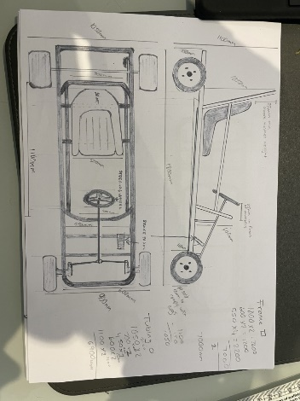

Figure 1-Kieran's final design

The design chosen by the group was what everyone thought to be very suitable for the course. Being based off a Go-Kart frame meant that the design would be agile whilst tackling the corners and also have solid handling being similar to a Go-Kart. However, the design wasn’t the most aerodynamic with the rear roll bar sticking quite far out, and with the lengthy wheel base it could prove a challenge on any quick changes of direction.
As seen in figure 1, Kieran’s design had all the dimensions included in the drawing, meaning Reuben could easily use them when creating parts via CAD. With this, Reuben made the wheels, tyres, frame, rear axle and front and rear roll bars. With these parts now produced, Reuben began working on making an assembly from them. Reuben managed to mate the main frame with the rear axles and put the tyres and wheels on the CAD assembly, as seen in figure 2.
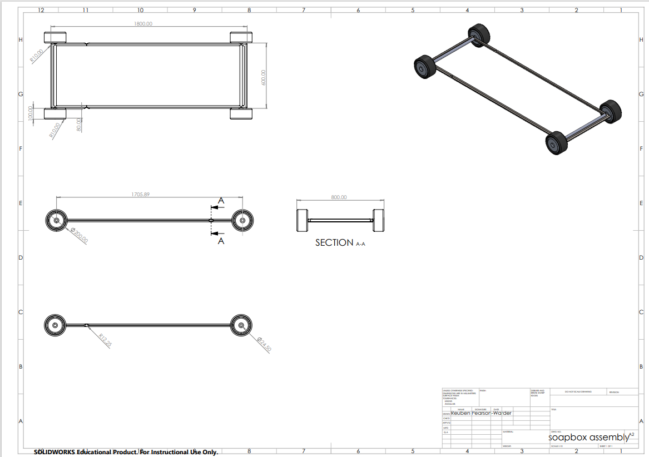
Figure 2 CAD drawing of the main body of the soapbox
As seen in figure 2, the soapbox complies with the Richard’s Castle Soapbox Derby regulations, being within the maximum width of 1500mm, with the soapbox being 1000mm wide, and being within the maximum length of the soapbox of 2500mm, with it being 1800mm in length (Richard’s Castle Soapbox Derby regulations, 2023). After this, Reuben was able to calculate the forces applied to the soapbox and analyse them.

Discussion
There was some key information given which helped assist in the calculations of the forces on the soapbox. Firstly, it states, “Participants can expect to reach 30-40mph” and that the course is “550m long” (Richards Castle Soapbox Derby regulations, 2023). With this, Reuben took the median of this speed and assumed the maximum velocity of the soapbox would be around 35mph, and that it would cross the finish line at this speed. The speed would need to be converted first to kilometres an hour and then to metres per second. 35mph converts to 56km/h, and that equals 15.56m/s. With this information, the following equation was used to calculate the time it might take the soapbox to complete the course:
S=(U+V)T/2
With S being the displacement, U being initial velocity, V being final velocity and T being time. By subbing in values of 550 for S, 0 for U as the soapbox would start from stationary and V being 15.56, rearranging the equation gives T as 70.69 seconds. With the Value of T calculated the acceleration could be calculated with the following equation:
V=U+AT
With A being the acceleration. Subbing in the values used previously and T being 70.69, rearranging the equation gave A to be 0.22m/s^2. Whilst quite a slow rate of acceleration, this would also depend on the angle of decline of the course. This meant a couple of forces could be calculated.
F=ma
Where F is the force, m is the mass of the object and a is the acceleration. With the frame being light weight at around 30kg and assuming the driver is around 60kg, adding this together gives a total mass of 90kg for the soapbox. Multiplying these two values together gives 19.8N of force on the soapbox when it is going in a straight and level line. As the soapbox was going down a descent, another formula was needed.
F=mgsinθ
With F being the force, m being the mass of the object, g being the gravitational pull of 9.81N, and sinθ being the angle of the slope. Reuben looked at several images and videos and saw the slope looked to have quite a small but gradual decline. The angle of decline was then assumed to be around 10 degrees. Subbing the values into the equation it gives the force to be 153.31N. This isn’t an entirely accurate value for the force, as it does not include the friction acting against the soapbox.

Conclusion
In conclusion, the overall design of the soapbox came together well. With Reuben researching and finding very suitable materials for the soapbox that were incorporated into the design, and Kieran producing a good and effective soapbox drawing which was worked on in solid works. This project could have been smoother if there had been better communication between team members and had more time gone into the CAD.

References
Richard’s Castle Soapbox Derby Regulations, 2023

