Core of Ethical and Professional Practice Task 2 – Simulated Interview Evidence Pack
Here is the evidence of the Job Description and Interview Forms being reviewed.
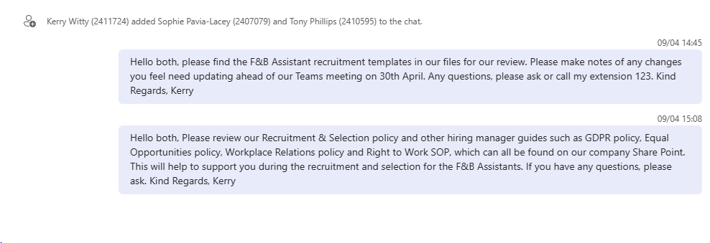
Here is the evidence of the candidates screening.
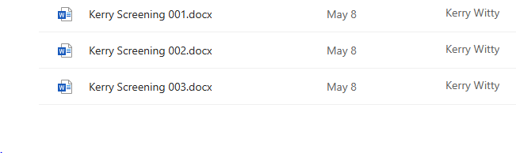

Candidate No. 001 screening matrix.
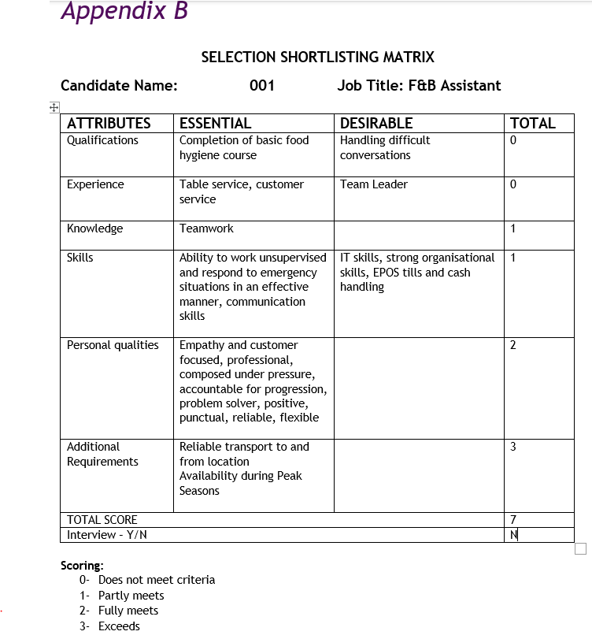

Candidate No. 002 screening matrix.

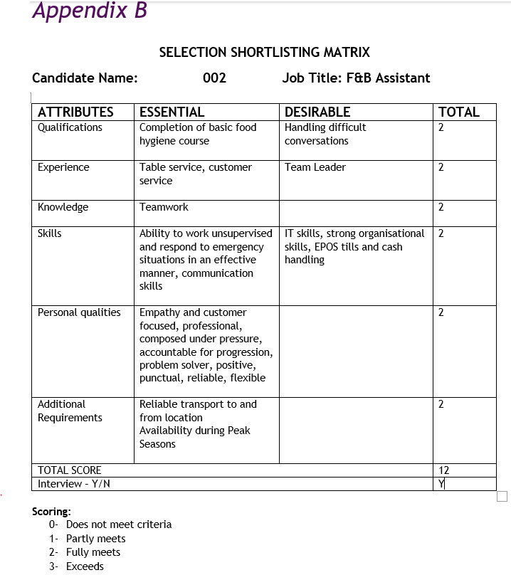

Candidate No. 003 screening matrix.

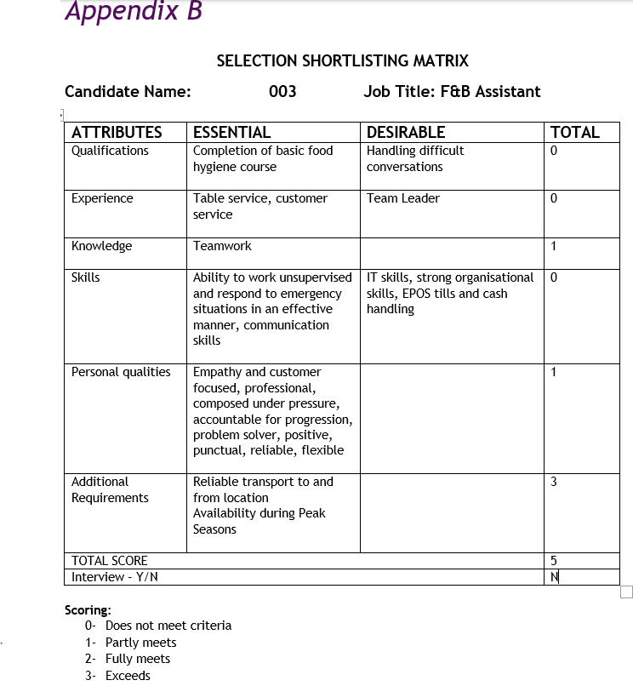
Here is the screening decision and the reasons why this candidate progressed to the interview stage.
Candidate No. 002 was chosen to be interviewed due to scoring the highest by 5 points. The candidate scored the highest being that this was the only candidate that met essential criterion.

Here is the evidence showing the recruitment documents were discussed and adjusted and that the interview was booked and that the candidate was contacted.

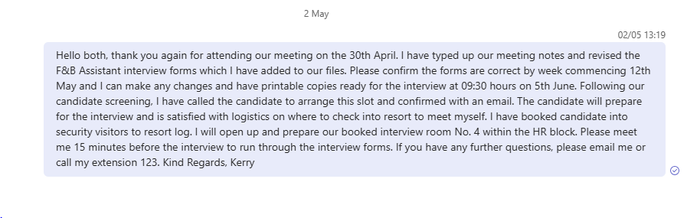Here is the evidence of the completed interview forms.
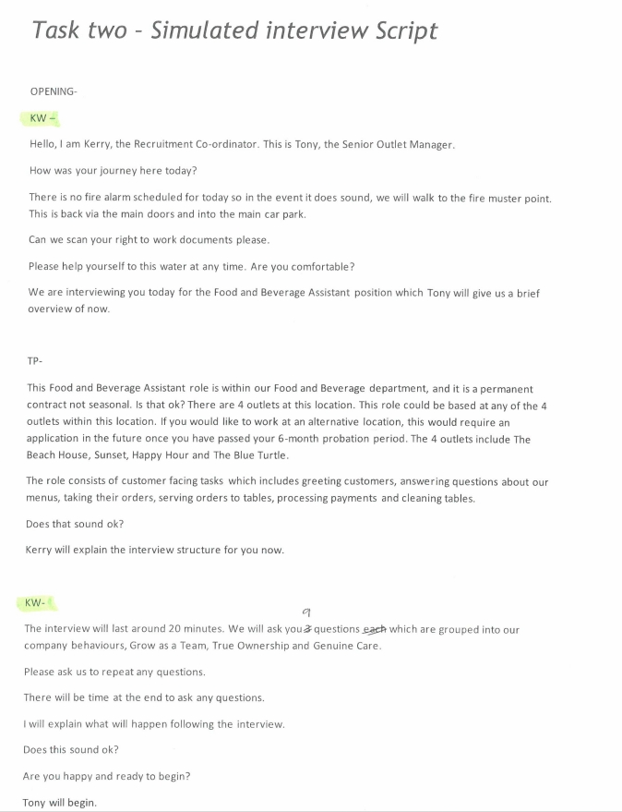
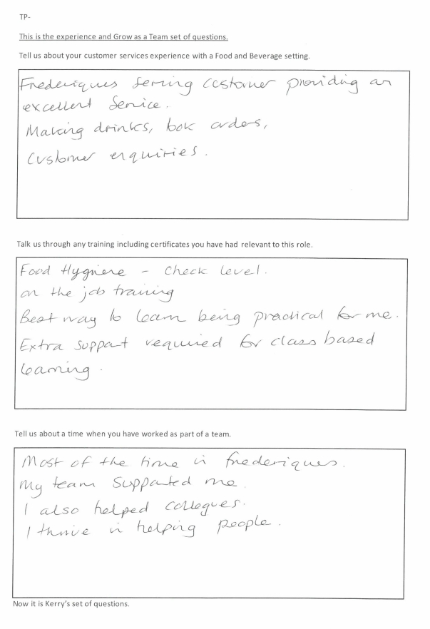
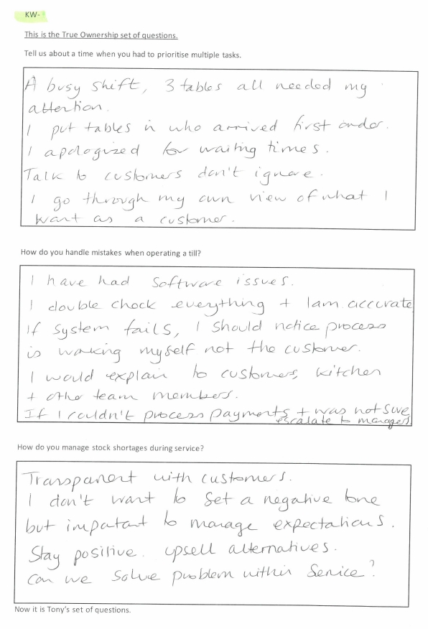
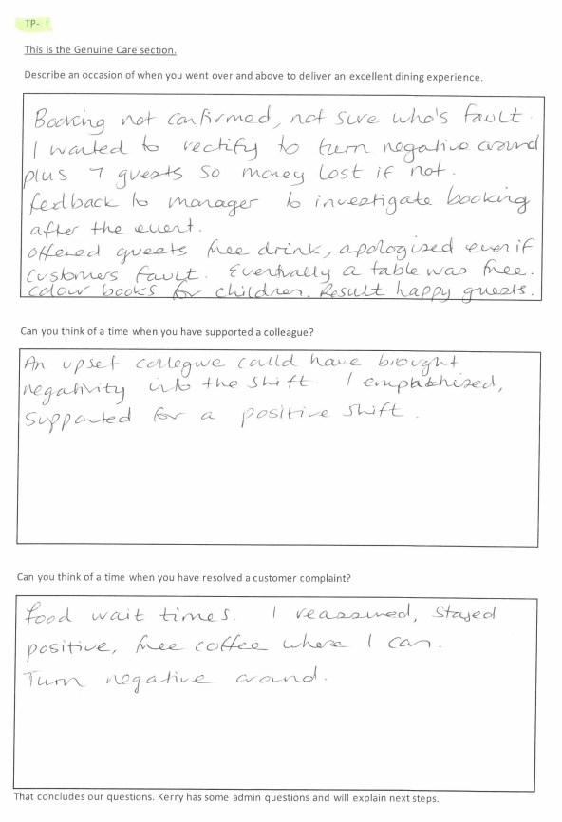
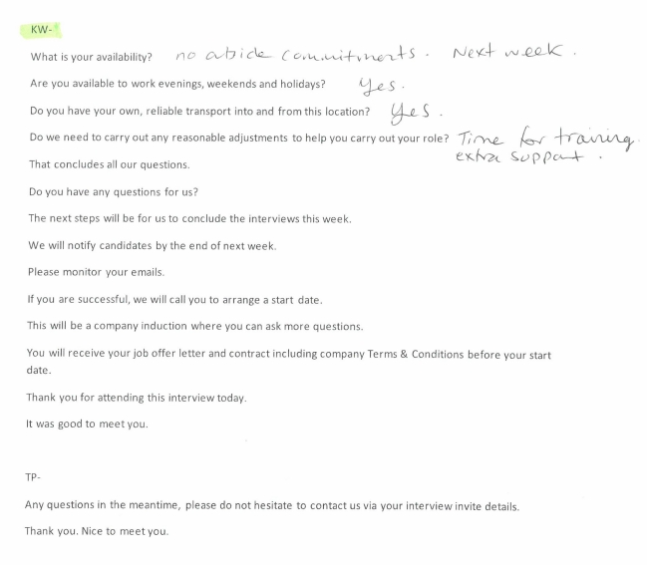
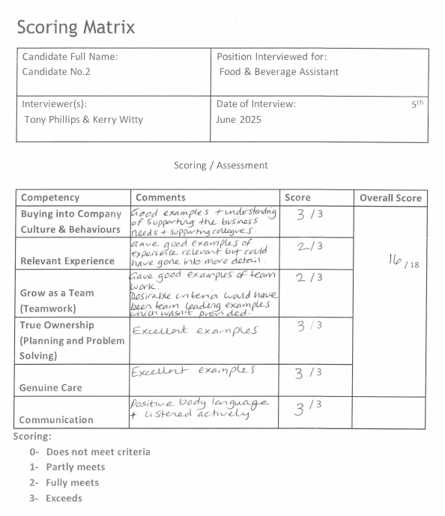
Here is the interview decision.
Candidate No. 002 was successful at interview due to meeting all essential criteria and scoring very well. The candidate has the necessary training required by the position, has prior work experience that is related to the position, demonstrated the necessary technical skills to perform the job successfully and displayed the company values behaviours throughout the interview.
A verbal offer of employment was made to the candidate which the candidate has accepted and a start date of next Tuesday 10th has been agreed.
A formal job offer letter was sent within 24 hours of the verbal offer being made along with the contract with full terms and conditions. This is compliant with the company day one right policy. Due to the candidates request to have training support we have made a note of this in their company induction hand over with our academy team that the candidate may require more time and support to complete the office-based documents and training and that this will be handed over to their line manager on day one. The probation review has been set up for 2-8-16-24 weeks as discussed in the interview.

