If you are doing this on behalf of the end user, you will need their Pin

How to check iPhone / iPad Model
The easiest way to identify the make / model number. You can find it by doing the following:
- Open the Settings app on your iPhone
- Go to General → About
- Find the "Model Number" row, and click on it
Authenticator Compatibility Microsoft Outlook Student Hwb
iPhone Requires iOS 13.0 or later. Requires iOS 14.0 or later. Requires iOS 10.0 or later.
iPad Requires iPadOS 13.0 or later. Requires iPadOS 14.0 or later. Requires iPadOS 10.0 or later.
iPod touch Requires iOS 13.0 or later. Requires iOS 14.0 or later. Requires iOS 10.0 or later.

Manually installing iOS update via iTunes using IPSW Firmware File
Time needed: 10 minutes.
Installing an iOS update manually via iTunes may seem overwhelming at first but it’s actually very simple. Follow the step-by-step guide below to install an iOS firmware on your iOS device in less than 10 minutes.
- Download the correct iOS IPSW firmware file.
Get the iOS firmware appropriate for your iPhone or iPad model and save it to your computer.
go to https://ipsw.me/ to get IPSW firmware for the latest iOS version.
- Open iTunes on your computer.
Download and install iTunes on your Mac or Windows PC. For the purpose of this post, we’ll be using a Windows 10 machine to install iOS firmware via iTunes.
- Connect your iPhone or iPad to the computer.
Get the USB to Lightning cable that came with your iOS device, and use it to connect your device to the computer.
- Allow your computer to access files on your iOS device.
If a “Trust This Computer” pop-up shows on your device’ screen, select “Trust”. You may also get a “Do you want to allow this computer…” pop-up from iTunes, select Continue to let your computer read/write files to your iOS device.
└ If you’re connecting your iPhone to iTunes for the first time. You may get the “Welcome to Your New iPhone” screen, select “Set up as new iPhone” and click on the “Continue” button.
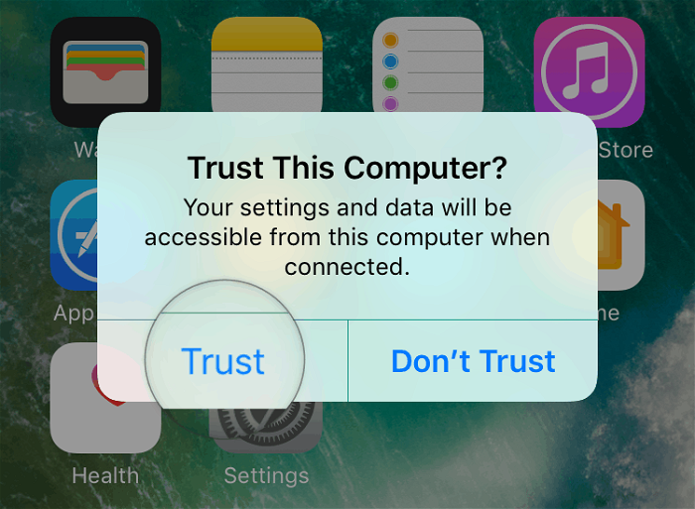

- Press & hold SHIFT and click Update in iTunes.
Once your device appears on the iTunes screen, press & hold the SHIFT key and click the “Check for Update” button in iTunes to select the IPSW firmware file.
└ If you’re on Mac, press and hold the Options key and click on the Update button in iTunes.
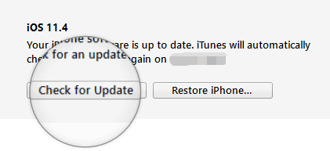
- Select the IPSW Firmware File
Navigate to the folder where you saved the IPSW firmware file for your device and select it.

- Confirm iOS version update.
You’ll get a prompt on PC “iTunes will update your iPhone to iOS (version)..”, hit the “Update” button to continue. iTunes will then start the update process by first extracting the Firmware Image file. You can monitor the progress through the top bar on the iTunes screen.


- Enter your Passcode.
When asked for a passcode, pick up your iPhone and “Enter your Passcode” while keeping it connected to the PC.
- Wait for iTunes to update your iPhone.
iTunes will now update your iPhone. You can monitor the progress through the top bar on iTunes.

- Your iPhone will reboot and continue installation.
Once iTunes part is done, your phone will reboot and continue the installation. You’ll see the Apple logo with a progress bar on your phone’s screen.
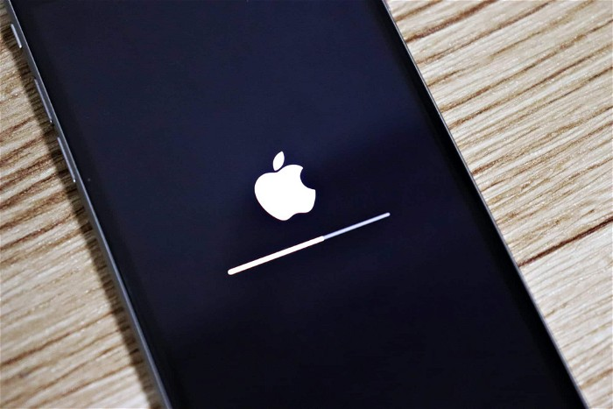
- Update Complete
When installation is finished, your iPhone will reboot into the system, and you’ll be greeted with an “Update Complete” screen on the phone.
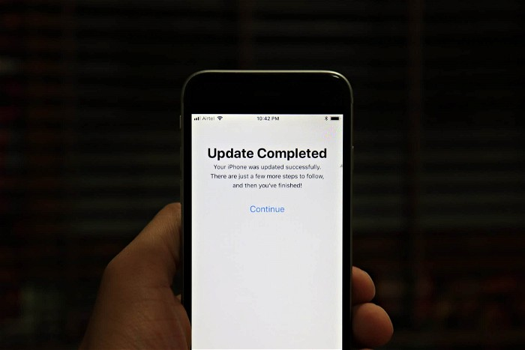
That’s it. Enjoy the new software on your iOS device.

