7/20/2026
Kyle Hall (2533563)
University of wales trinity saint david
Design and Implementation of a Relational Database System
BSc / HND / HNC Computing Portfolio

Table of Contents
Introduction 3
Design Elements 4
Relationship Diagram 7
Normalisation 8
1NF 8
2NF 8
3NF 9
Database Development 9
Design View 9
Validation rules 9
Relationships 11
Datasheet view 11
Database Queries 11
Query 1 – Bikes in use 11
Query 2 – Most used bikes 13
Query 3 – Rentals by rider 14
Query 4 – Maintenance History 15
Concluding the queries 16
Testing the Database 16
Test 1 – Negative cost 16
Test 2 – Return Time Before the Rental Time 17
Test 3 – Field left blank 19
Test 4 – Invalid foreign key 20
Summary and Conclusion 20
Recap of Database 20
Design decisions 20
Challenges 21
Conclusion 21
References 22

Introduction
Eco_Ride having issues with their management is more than likely due to the heavy reliance on paper-based documents and spreadsheets to keep track of data, leaving Eco_Ride with weaknesses that will allow for major errors down the line. The issues with how Eco_Ride run causes issues such as double-bookings, unreturned bikes, and a lack of clear view for which bikes are available, being used, or under maintenance. These issues themselves may appear minor, but they can influence more major issues if not handled properly. Eco_Ride will struggle to provide accurate summaries and will likely be unable to analyse how the service is being utilised.
Many of these problems if not all of them can be solved with a strongly structured relational database. Microsoft state that “A properly designed database provides you with access to up-to-date, accurate information” [1] The database will allow the staff to register riders, keep records of the bikes, have a record of any rental transactions, as well as tracking staff’s maintenance and inspection appointments. This will allow Eco_Ride to have accurate and reliable data for the team to be able to report on.
The database will manage records of riders, bikes, rental transactions and staff appointments. The database is however limited to riders, bikes, rental transactions, and appointments. This is because other utilities such as payment processing, real time tracking or a booking interface would likely be considered outside the requirements of the assignment.

Design Elements
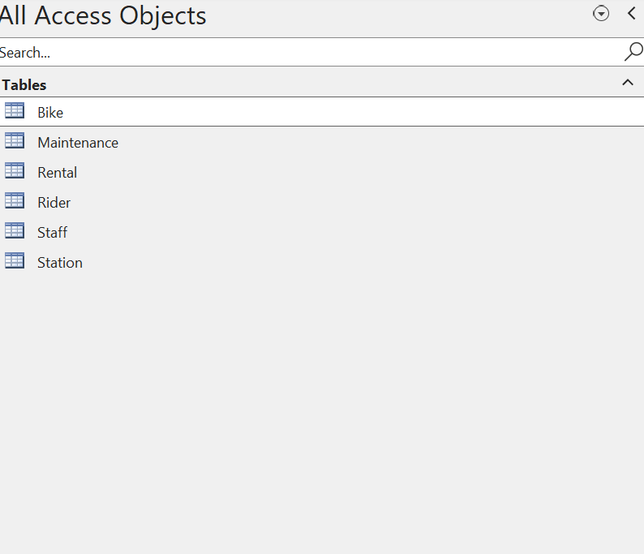
Figure 1: List of Tables
These are the Tables have been created; the entities include ‘Bike’ this will be responsible for showing the bike type, condition, where its located(station) and when it was bought. 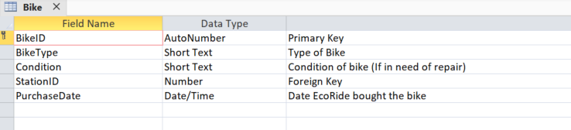
Figure 2: Bike table
This is the bike table filled.
The next table is ‘Station’ This will include the name of the station, location and the type of station it is, it would also be handy to include its capacity and address.
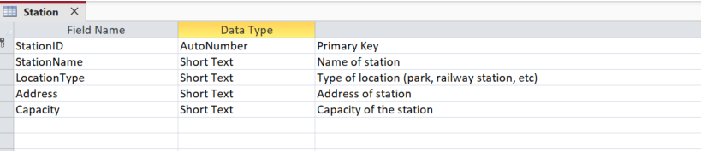
Figure 3: Station table
This is the station table filled.
‘Maintenance’ is the next table, and this will likely have the most foreign keys, it will contain the BikeID and the StaffID for booking maintenance, it will also have a date, service type and I would like to include another field with no restrictions so the staff can add notes.
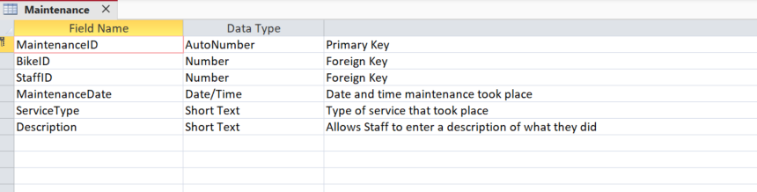
Figure 4: Maintenance table
This is the maintenance table filled.
‘Rental’ will also have 2 foreign keys, this will contain the RiderID as well as the, BikeID, there should also be fields for rental time, which will be the beginning of the rental, and the return time, which is when it needs to be returned, the final field will be for cost.
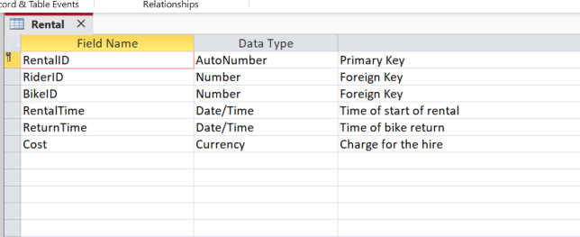
Figure 5: Rental table
This is the rental table filled.
‘Rider’ table will contain RiderID First name, last name, email address, phone, the National ID to scan for bike access and the date they registered.
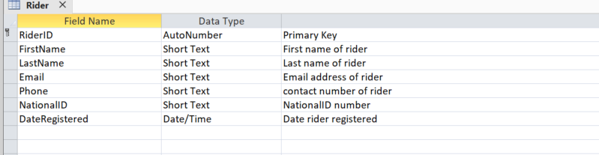
Figure 6: Rider table
This is the rider table filled.

Finally, the ‘Staff’ table, this should contain, their role, name and email address. 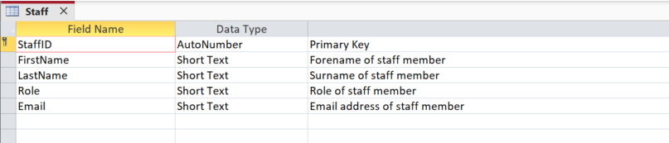
Figure 7: Staff table
This is the staff table filled.
The tables will use foreign keys, since one station will contain many bikes, a rider will have many rentals, a bike could have many maintenance records, and other one-to-many relationships between entities. These relationships enforce referential integrity, helping to ensure that related records can remain valid and will prevent inconsistent data from being entered into the database. [1]

Relationship Diagram

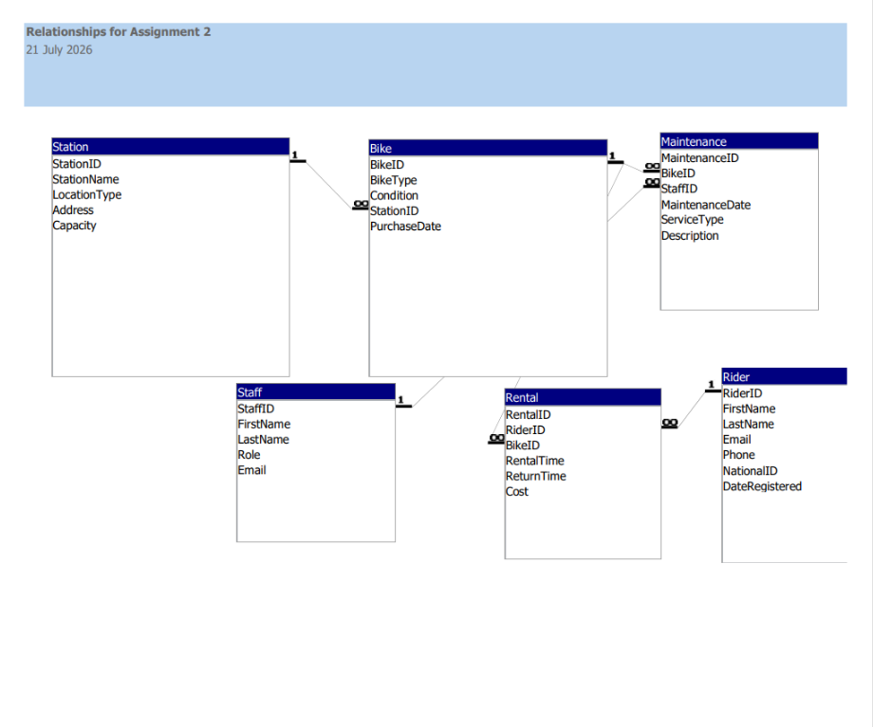
Figure 8: Entity-Relationship Diagram for the Eco_Ride database
Figure 8 shows 6 entities and their connections and relationships in the database. The primary keys uniquely identify each record, and foreign keys create the links between those tables. The ERD is in Crow’s Foot style, the 1 marks the “one” side and the ∞ marks the “many” side of each of the 5 relationships. The relationships are one station – many bikes, one rider – many rentals, one bike – many rentals, one bike – many maintenance records, one staff – many maintenance records.

Normalisation

1NF
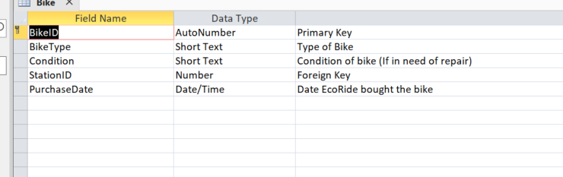
Figure 9: Bike Table 1NF demo
The field in the table holds a singular value, a bike will only have one type, or condition. For example, there isn’t a maintenance history field for the bike table, it exists in a different table. [2]Each table also has its own primary key.

2NF
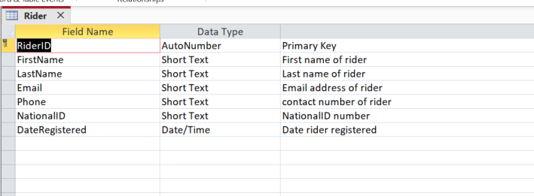
Figure 10: Rider Table 2NF demo
All the tables in the database utilise a single column primary key and not a composite key. When the key is a single field, partial dependency is impossible because there is no partial key for a field to rely on. [2]

3NF
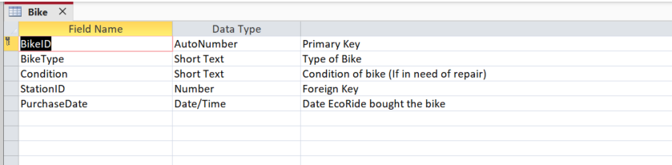
Figure 11: Bike Table 3NF demo
The bike table stores ‘StationID’, it does not contain the station’s name or address. The station address, type, or name can be found in the station table, and will be easy to find since they are linked via key. Storing ‘StationName’ inside ‘Bike’ would be a transitive dependency, this issue has been intentionally avoided. [2]

Database Development
With the design finalised the tables were built and populated. This section will show it implemented.

Design View
See Figure 2 to Figure 7 to see each table has a primary key and contains fields that are set to their best associated data type.

Validation rules
Validation rules were implemented to protect the data’s integrity. For example, using required fields, lookup lists, range checks, date checks, and even a table-level rule to stop a return before the rental date. These rules will attempt to stop invalid data at entry, rather than relying on a user. [1] [2] Please see Figure 12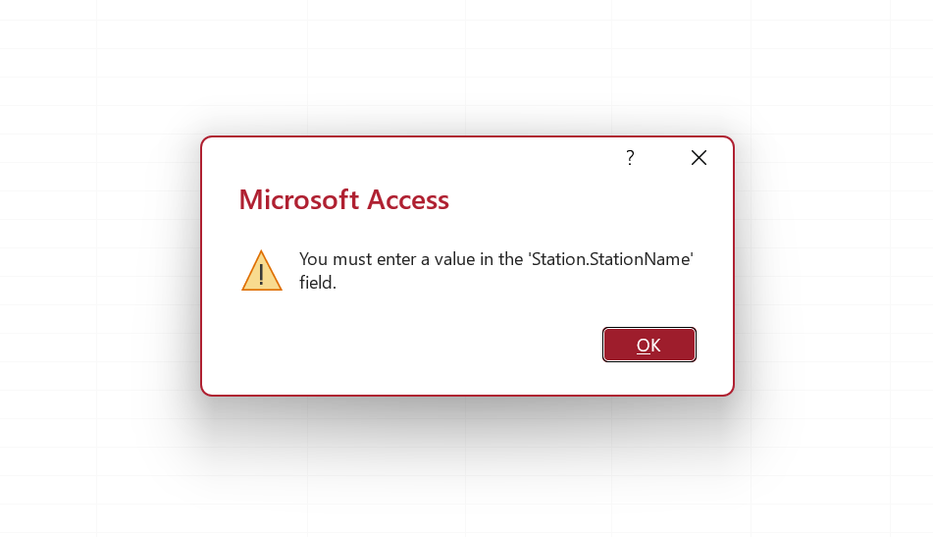
Figure 12: Validation Rule

Relationships
Five one-to-many relationships were created with referential integrity enforced onto them see, figure 13.
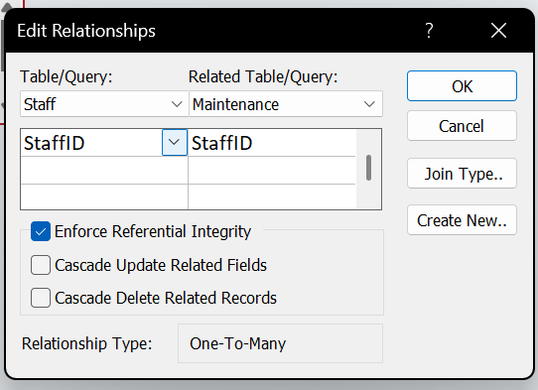
Figure 13: Referential Integrity
Referential Integrity will prohibit a child record pointing to a parent that does not exist. For example, it will prohibit a rental for a non-existent bike.

Datasheet view
Each table has been populated with at least five realistic records within them. The data was first entered into parent tables, so the foreign keys always referenced existing rows. Some of the rentals have a blank return time, this is because they have not yet been returned.

Database Queries
Queries will be created to show how Eco_Ride can retrieve useful information from the database. Each query will provide a real operational question that the paper-based system would have struggled with.

Query 1 – Bikes in use

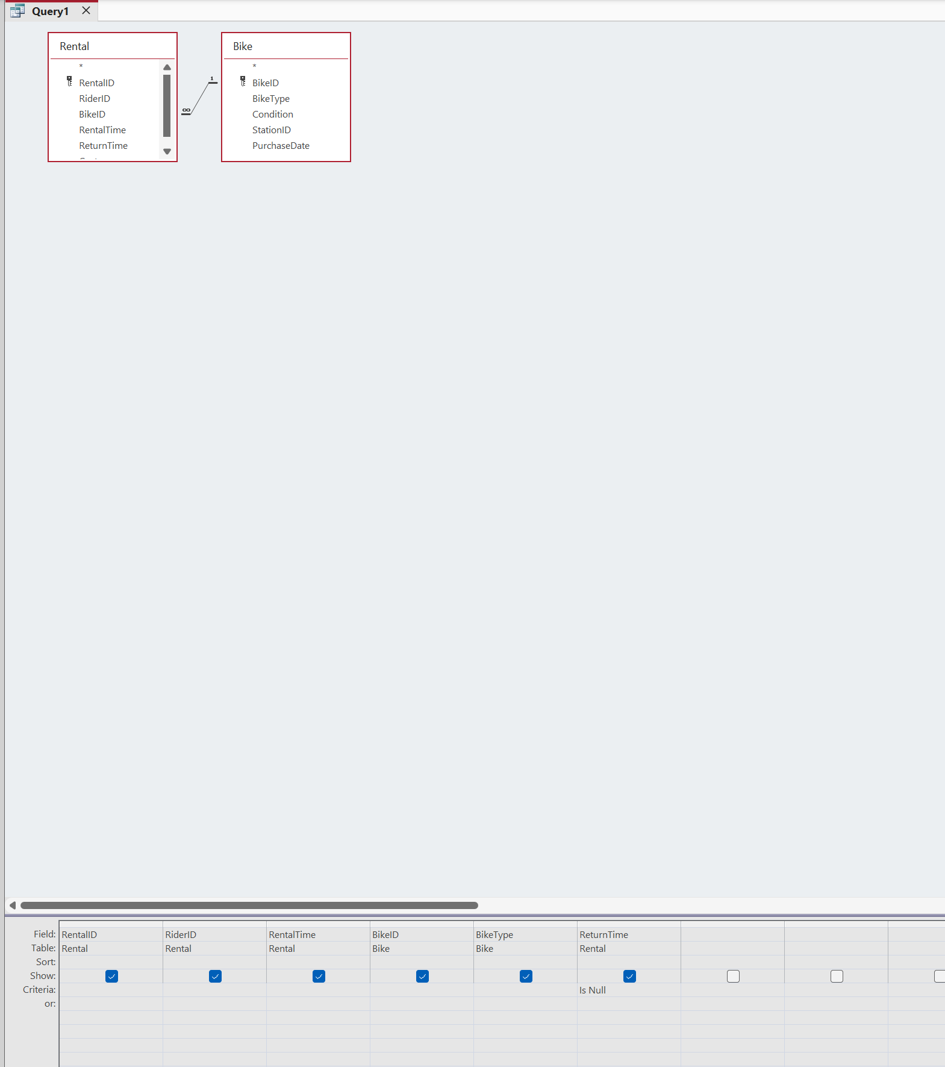
Figure 14: Q1 Design view
This query will provide information on bikes that have currently not been returned, so bikes that are in use. The query will filter the table for records where ‘ReturnTime’ is blank and since the blank return will mean the bike is in use, then we can use this to determine what bikes are in use. The scenario specifically requests a problem of "limited visibility of which bikes are available, currently in use, or undergoing repairs," and this query will fix that issue. 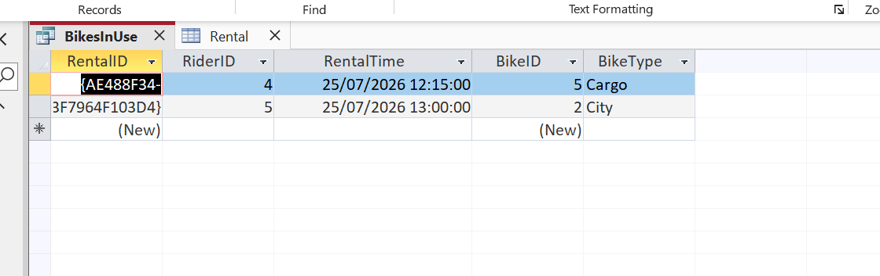
Figure 15: Q1 after query ran
I decided to untick “show” for return as this would always be blank.

Query 2 – Most used bikes
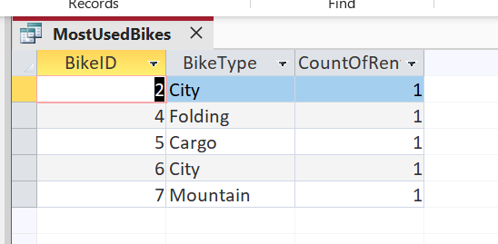
Figure 16: Q2 MostUsedBikes
This query shows which bikes are being used the most, but it will also display the amount of usage. This was achieved by using a totals query having the bike fields as groups, and the rental field set to counts, this allowed me to track which bikes were used the most. This is useful because it will allow staff to identify, rider’s favourite bikes, when new stock is needed, but it can also allow you to service and inspect frequently used bikes, for greater signs of wear.
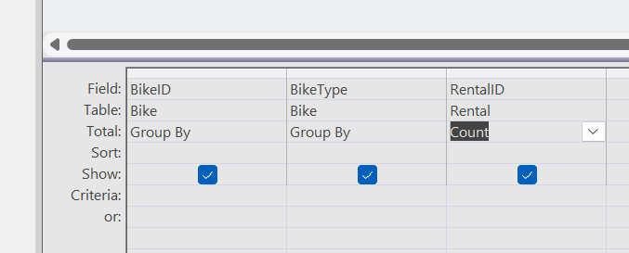
Figure 17: Q2 Totals

Query 3 – Rentals by rider
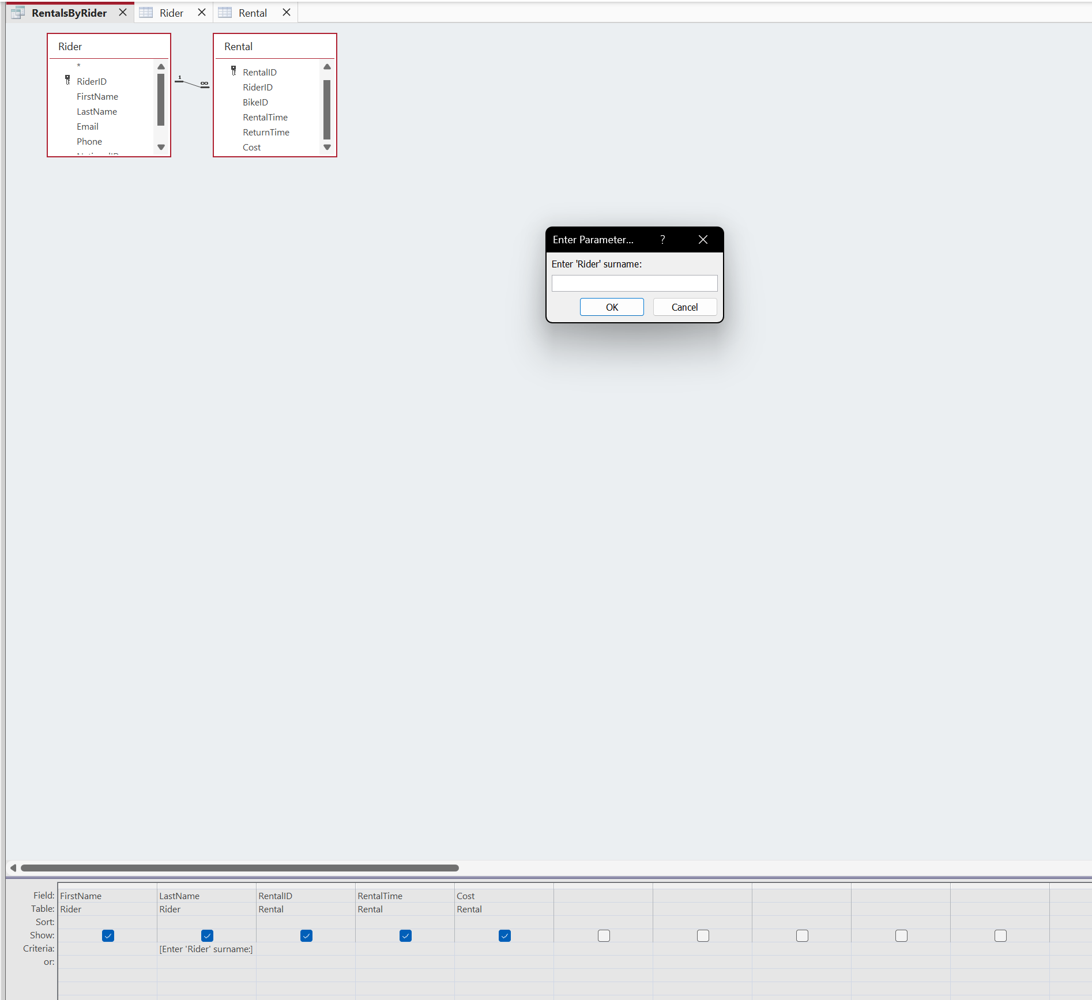
Figure 18: Q3 design view
This will list all the rentals the rider has had, it will provide a pop-up box for you to enter the surname of the rider you want the query to search for. Please see figure 18. This is done by a parameter query, it will prompt a surname and return the rider’s rental history. This will allow staff to quickly review a specific user’s rental history. This could be useful if the rider has outstanding payments that need to be made.

Query 4 – Maintenance History
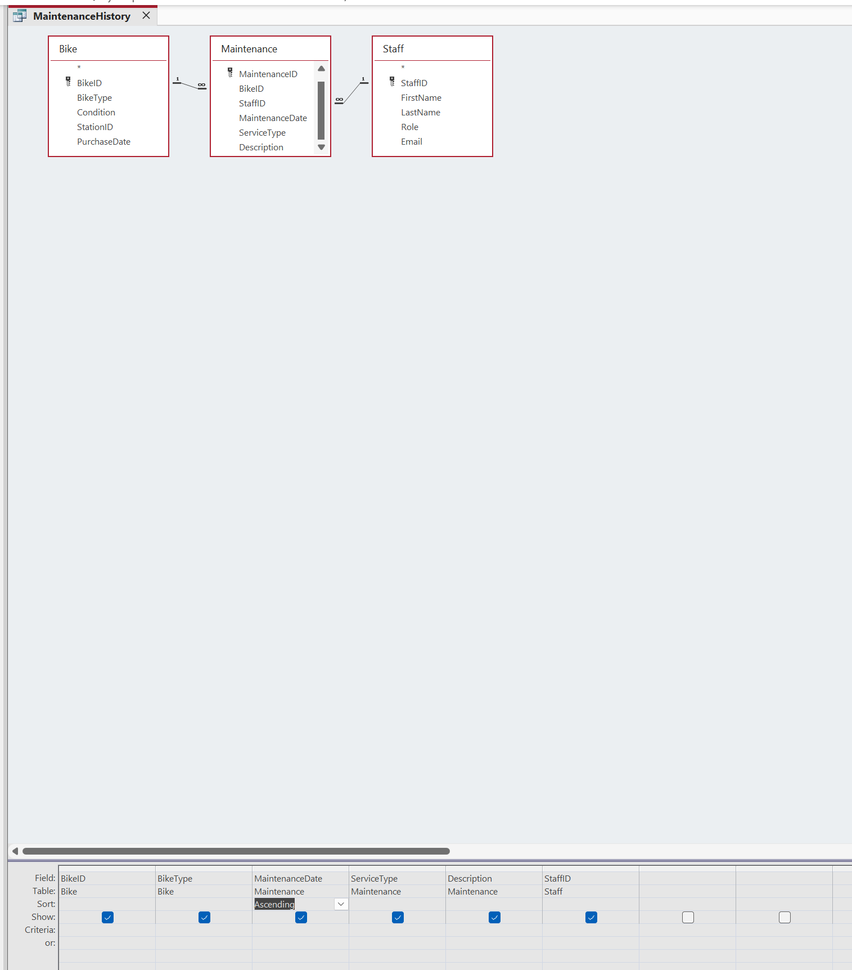
Figure 19: Q4 design view
Query 4 shows what bikes have been serviced, when they were serviced, also in ascending order, the type of bike it was, and which member of staff carried out the work. Joining Bike, Maintenance, and Staff tables were added to the query for all the relevant information. It should give the staff the ability to view the service history of all bikes most recent to least recent, in an efficient manner, which is what the paper-based system also lacked. 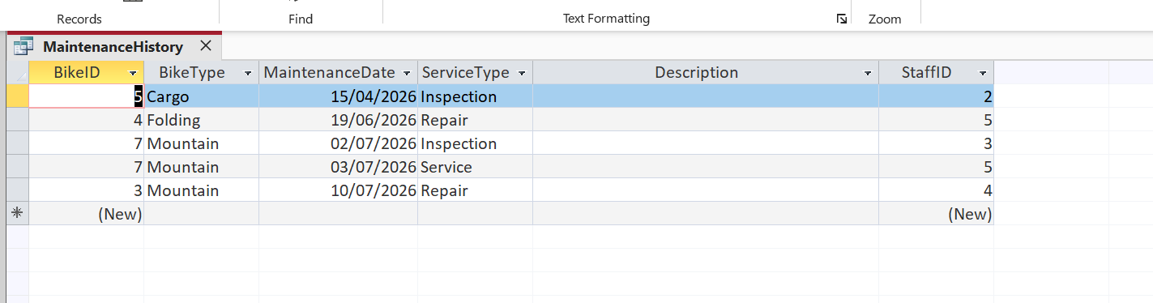

Concluding the queries
The queries created should allow the staff to find answers and information that is stored in the database with maximum efficiency, these queries have been tailored to solve the issues that Eco_Ride’s paper-based system currently face.

Testing the Database
To test the database, it will be validation tested, such as entering a negative cost, putting in the return time before the rental time, leaving fields blank and more. It will also be tested using a referential integrity test. A child record will have a foreign key that does not yet exist.

Test 1 – Negative cost
For the first test a negative cost will be entered into my rental table. I expect the table to return an error, and not allow me to enter that information.
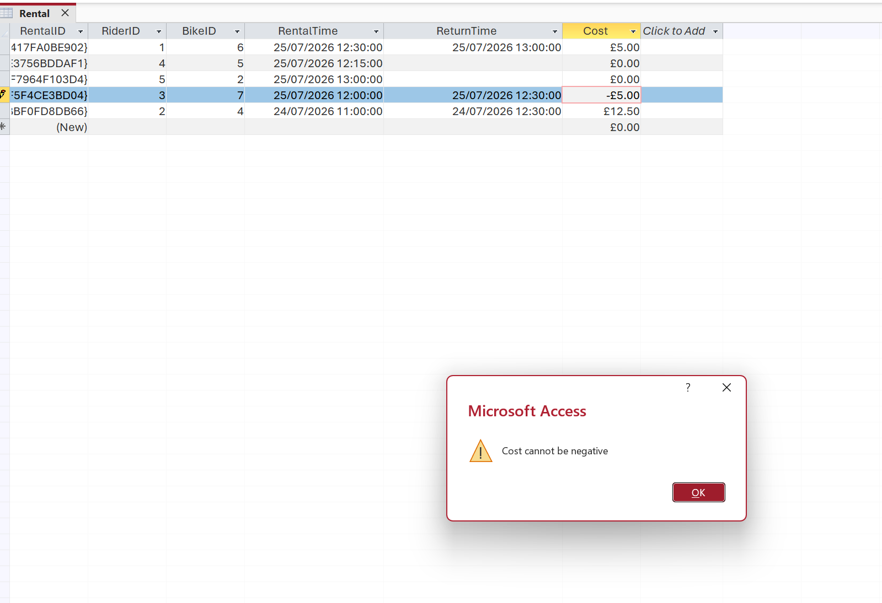
Figure 20: Test 1
An attempted to enter -£5. An error was returned stating the Cost cannot be negative. This test was passed.

Test 2 – Return Time Before the Rental Time
For this test, the return time of the bike, would be before the time of rental. the table should provide an error stating this could not be completed, as a table-level validation rule is in place prohibiting return times to be before the rental time. 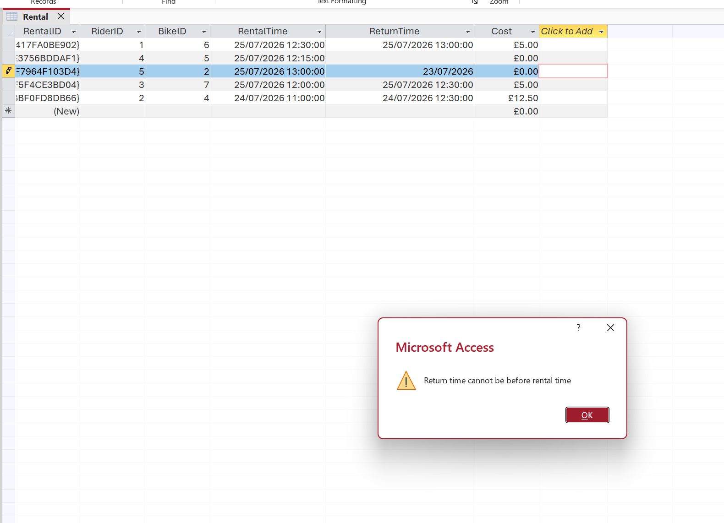
Figure 21: Test 2
This is the outcome of the test and was as expected. The database passed this test.

Test 3 – Field left blank
For this test a field that will always be required will be left blank. The table should reject this as it must be filled by a requirement set in validation. 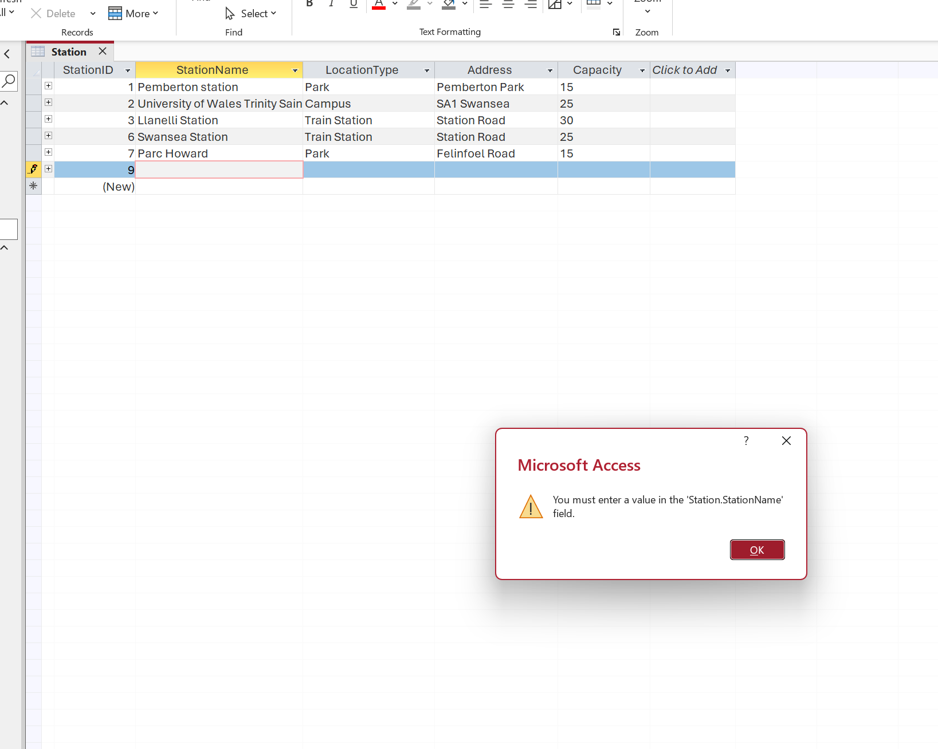
Figure 22: Test 3
The table provided the expected error, and the database has passed this test.

Test 4 – Invalid foreign key
For this test an invalid foreign key will be entered, the aim is to have the database provide an error message due the referential integrity relationship rule. 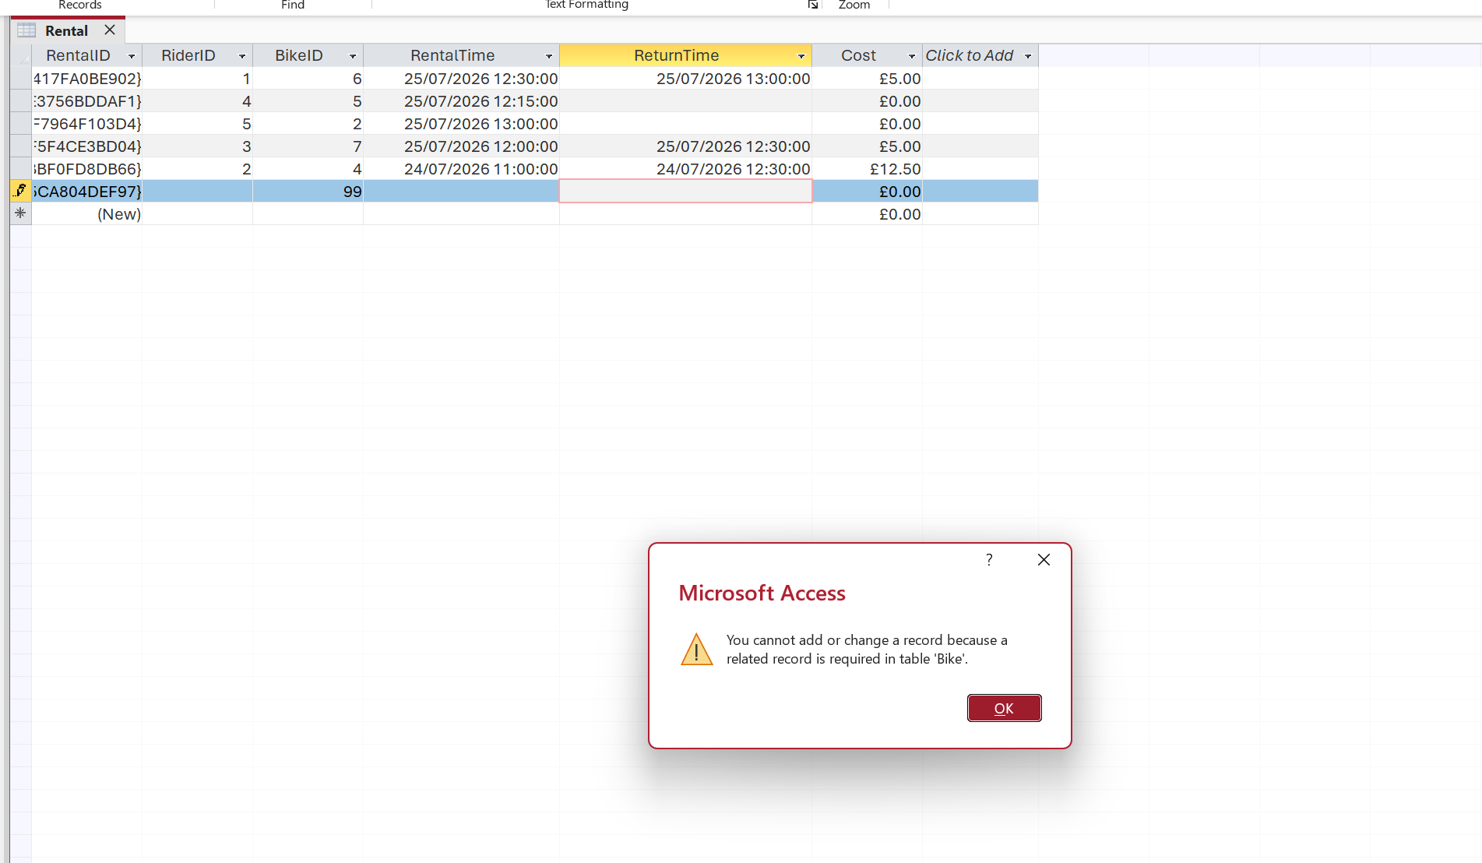
Figure 23: Test 4
The test provided the expected error message and has passed all the tests.

Summary and Conclusion

Recap of Database
The database is designed to manage 6 related tables, it manages riders, bikes, rentals, staff as well as maintenance, it has many validation rules throughout, and it contains enforced relationships, to maintain data integrity.

Design decisions
A few design choices that were made, were for data redundancy reasons. For example, creating a table for station instead of a text field on the bike table, to avoid data redundancy. The duration is not stored in the table, but it is calculated, using return time and rental time instead, this was again done to avoid a derived data redundancy. Next was RentalTime/ReturnTime being set as a data and time instead of dates. This was done because I believed e-bikes were more likely to be used for hours rather than days or weeks. Allowing ReturnTime to be blank was another design choice that was made as it will allow bikes to still be in use, and it could easily be utilised for the query later. The final design choice will be the table-level validation rule. This was about ensuring that the return time was not before the rental started, and it also could not be done with a field rule.

Challenges
The biggest issue that was faced on this database was getting the table level validation correct. At first It was assumed it could be done with the field validation rule, but with a lot of experimenting it began to work, via the table level validation rule. Issues were also experienced with getting the date and time to work. However, that was more of data entry error, as when the calendar was clicked and a date was added, there was no option to enter a time, only when it was entered manually, was it realised that was the way to do it.

Conclusion
The database meets the scenario’s core requirements and would provide Eco_Ride with a more accurate, efficient, and more accessible data, than the manual paper-based system provides.

References

[1] | Microsoft, “Database design basics,” Microsoft, [Online]. Available: https://support.microsoft.com/en-US/Access/database-design-basics. [Accessed 24 July 2026].
[2] | T. C. a. C. Begg, Database Systems: A Practical Approach to Design, Implementation, and Management, Harlow: Pearson Education, 2015.

