Shamsur Rahman Contribution audit
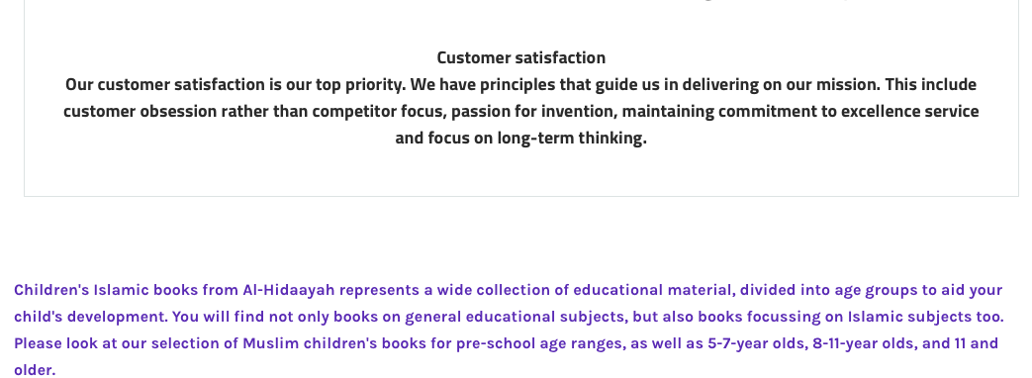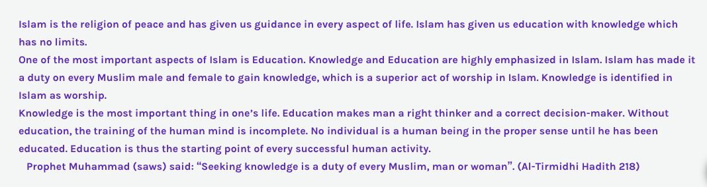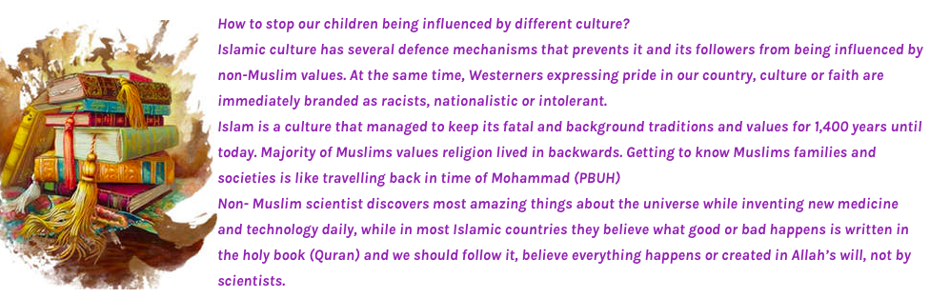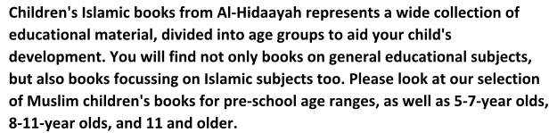

My part in the website was the narrative. I used Primary research and Secondary research. Primary research was writing about our products. I wrote what age group books we sell and what it requires for children.
Brief summary of what is Islam, what Islam teaches us and what are the way to be a good Muslim.
I used secondary research on searching for a quote to show our customers what our prophet said about learning Islam. Also, I researched for, how to help children being influenced by different culture. I also added the customer satisfaction, which is the important part. This will show our mission on how we will satisfy our customer.

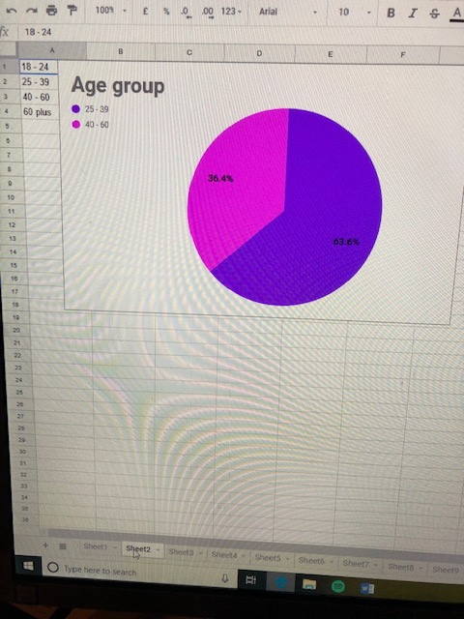

Question 2) what is the age group?
1- 18-24
2- 25-39
3- 40-60
4- 60 plus

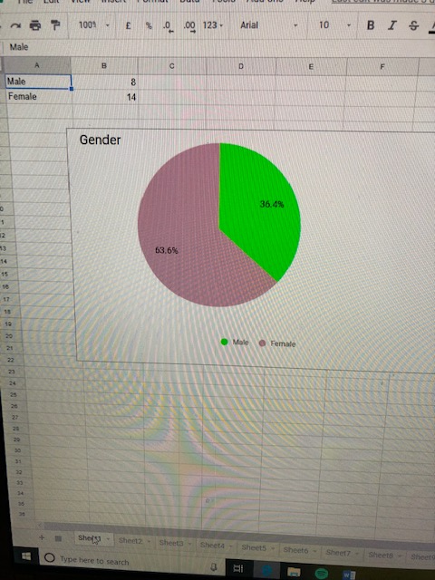

Question 1) what is the gender?
Male
or
Female

