

Module Name: Community Care and Management of Longer-term Conditions
Module Code: LCHS7003
Module Leader Name: Muhammad Khan
Title: COPD: A UK Information Booklet on Long-Term Condition Management for Health and Care Professionals
Student’s Name Akhila Kancharla
Student’s ID 2526734
Words: 3257

Table of Contents
Introduction to COPD as a Long-Term Condition 3
Burden, Prevalence, Risk Factors and Aetiology 3
Burden and prevalence 3
Risk factors and aetiology 4
Impact of COPD on Individuals, Families and Carers 5
Physical impact on individuals 5
Psychological and emotional impact 6
Social impact 6
Impact on families and carers 7
Evidence-Based Treatment and NHS Management of COPD 7
Treatment and symptom control 7
Rehabilitation, exacerbations and continuing care 8
Theoretical Perspectives and Models for Better Outcomes 9
UK model: House of Care 9
International model: Chronic Care Model 9
Implementation of Local and National Political, Health and Social Care Agendas in COPD Management 10
Recommendations for Person-Centred Care, Self-Management and End-of-Life Care 11
Conclusion 12
References 13

Introduction to COPD as a Long-Term Condition
Chronic obstructive pulmonary disease (COPD) is a long-term respiratory disorder that is characterised by ongoing airflow restriction, dyspnea, chronic cough and repeated exacerbations (World Health Organization, 2026). It encompasses emphysema and chronic bronchitis, and it is typically linked with the progressive lung damage that cannot be completely reversed (NHS, 2023; NICE, 2019). Though COPD may be explained in terms of its physical manifestations, it is more accurately a long-lasting disease since it involves constant monitoring, medication, lifestyle assistance and coordinated care throughout life. This renders COPD significant to UK health and care professionals in both the primary and community care setting because managing COPD is not only about breathlessness treatment but also about the care to support daily functioning, prevention and quality of life.
COPD is chosen to feature in this booklet due to its representation of the broader issues of managing long-term conditions in the UK. The disease is both preventable and treatable, yet incurable, which means that care should aim to decrease the number of symptoms, avoiding exacerbations and enabling individuals to lead a full life as they can (WHO, 2026). The NICE guidelines focus on earlier diagnosis, evidence-based treatment and consideration of individual needs, preferences and family situations (NICE, 2019). Thus, COPD is not a disease that only needs biomedical answer but a person-centred response. To practitioners, this implies acknowledging the biological, psychological and social impacts of COPD and collaborating with patients, carers and services to promote long term wellbeing along the illness path and advanced stages.

Burden, Prevalence, Risk Factors and Aetiology

Burden and prevalence
COPD is a significant global health issue, as it is a significant cause of premature mortality, disability, and health care utilization. As Figure 1 demonstrates, despite decreased global age-standardised COPD prevalence, mortality and disability-adjusted life year rates, the absolute number of COPD cases, deaths and DALYs actually grew due to the population growth and ageing (Wang et al., 2025). As of 2026, COPD is the third most common cause of death in the world due to 3.4 million deaths in 2023 and the seventh most significant cause of poor health based on disability-adjusted life years (World Health Organization, 2026). This demonstrates that COPD cannot be considered as a minor respiratory disease but a long lasting disabling condition that has implications on individuals, families, health systems and economies. It is also not distributed equally, with almost 90 percent of deaths in those below 70 years of age in low- and middle-income nations, where exposure to household air pollution, the lack of diagnosis, and the unavailability of treatment aggravate the results (World Health Organizations, 2026).
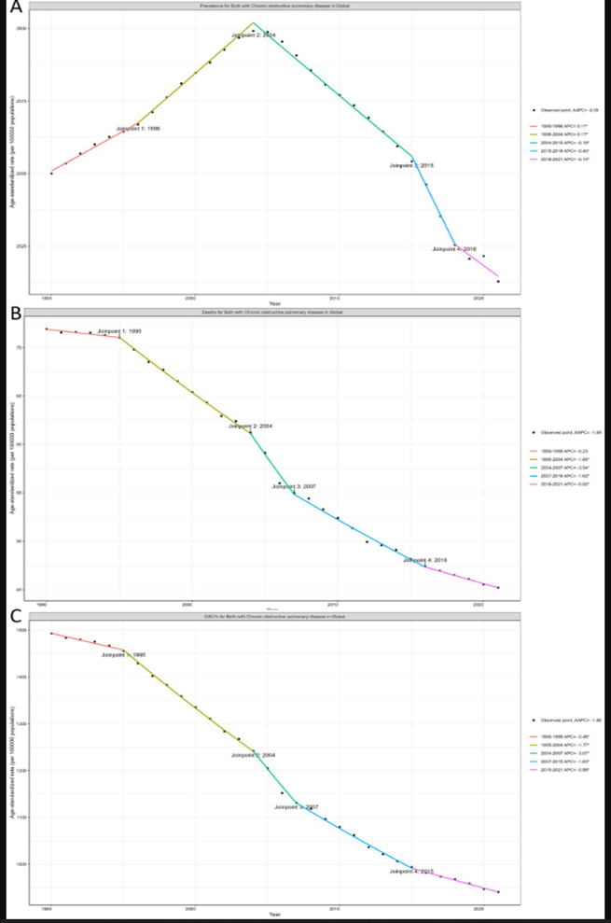

Fig 1: Global trends in COPD age-standardised prevalence, mortality and DALY rates, 1990–2021
Source (Wang et al., 2025)
COPD is a major cause of preventable morbidity and mortality in the UK. It is linked to a high rate of GP visits, emergency visits and high-winter pressures and long-term community care demands. In recent UK reporting, it has been reported that COPD is the cause of over 20,000 deaths annually in England, with the rates of death being significantly higher in the deprived regions (Campbell, 2024). The significance of this inequality lies in the fact that it is indicative of COPD burden to be not only clinical but social. Individuals in the poorer communities might experience greater exposure to smoking, work-related hazards, substandard housing, pollution and limited access to early spirometry (Williams et al., 2022). Thus, UK COPD morbidity is an aspect of broader health disparities, rather than merely individual behaviour.

Risk factors and aetiology
The COPD aetiology is multifactorial. The prevalence of tobacco smoking is the biggest risk factor especially in the high-income nations where tobacco smoking causes more than 70 percent of COPD (World Health Organization, 2026). Nonetheless, COPD is not to be introduced as a strictly smokers disease. GOLD (2025) and Agusti et al. (2022) stress that COPD is developed due to gene-environment interactions throughout the life course. This is to say that biological susceptibility is influenced interactively with long-term contact to harmful particles, lung development and ageing. There are heavy smokers who do not get COPD and there are non-smokers who do, which suggests a more inclusive explanation of causation.
Passive smoking, outdoor air pollution, occupational exposure to dusts, fumes and chemicals, and indoor pollution caused by biomass fuel or poorly ventilated sources of heating and cooking are other risk factors that are important (World Health Organization, 2026). Occupational exposure is also specifically significant in the UK in reference to individuals who have been employed in construction, manufacturing, transport, agricultural or cleaning jobs (Arrandale et al., 2026). Childhood influences are also becoming more appreciated, such as prematurity, underdeveloped growth in the womb, respiratory infections in childhood and childhood asthma, as they can mean people do not reach optimal lung development (Agusti et al., 2022; World Health Organization, 2026).
Other risk factors that are non-modifiable, including age, genetic susceptibility and alpha-1 antitrypsin deficiency, also cause COPD (NICE, 2019). Non-modifiable risks however, when focused on can restrict prevention. A more vigorous public health policy would decrease smoking, enhance air quality, expose workers to fewer dangerous exposures, enhance housing conditions and detect symptoms earlier with spirometry. Hence, the causation of COPD can be most conceptualized in terms of the interplay of individual risk factor, environment, social misery and biological susceptibility.

Impact of COPD on Individuals, Families and Carers

Physical impact on individuals
COPD influences much more than the ability to breathe. Common symptoms include exertional breathlessness, chronic cough, sputum production, wheeze, fatigue, reduced exercise tolerance, night-time breathlessness and weight loss (NICE, 2019). Such symptoms may complicate daily life like washing, dressing, using stairs, cooking, shopping or walking a few short steps (Fettes et al., 2021). Symptoms may be suddenly severe during exacerbations, which sometimes demand some urgent treatment or hospitalization (World Health Organization, 2026). This implies that COPD has the potential to minimise self-reliance and cause individuals to grow more and more dependent on relatives, carers and social services.
The breathlessness-inactivity cycle is one of the foremost issues. When individuals get out of breath during an activity they may minimise their movements to prevent pain. With time, lack of activity may result in muscle weakness, reduced fitness and increased breathlessness on subsequent activity (O’Donnell et al., 2020). This can enhance disability and diminish quality of life. COPD is also commonly comorbid with other long-term illnesses, such as cardiovascular disease, osteoporosis, diabetes, anxiety and depression, leading to higher treatment costs and complicated care (Agustí et al., 2022). Thus, good evaluation must involve day to day functioning, locomotion, food, comorbidities and personal ambitions, other than spirometry.

Psychological and emotional impact
COPD has the potential to induce fear, frustration, anxiety and low mood. Breathlessness can be scary particularly during a flare-up as the affected person might think that he or she cannot breathe or cannot control his or her body. This may cause panic, lack of activity and loss of confidence (O’Donnell et al., 2020). Depression can occur when the individual has fewer areas of independence, exhaustion, withdrawal and indecision about the future. GOLD (2025) acknowledges the need to examine symptoms, exacerbation history and broader comorbidities, which is in favour of a more general approach to COPD management.
COPD has a psychological effect, which is closely connected with the physical experience of the disease. The fear of breathlessness may lead to avoidance of walking, social contact and pulmonary rehabilitation, which leads to greater deconditioning and isolation. Motivation to use inhalers in the correct way, quit smoking, eat healthily or visit an appointment can also be lowered by low mood (Cravo et al., 2022). The lived experience research also presents evidence that people with COPD may experience fear and blame, struggle and feelings of hidden disability (Clancy, Hallet and Caress, 2009). Social, behavioural and medical factors shape anxiety and depression, which supports the holistic assessment approach of GOLD (GOLD, 2025), and non-judgemental care, as shown in figure 2 below.
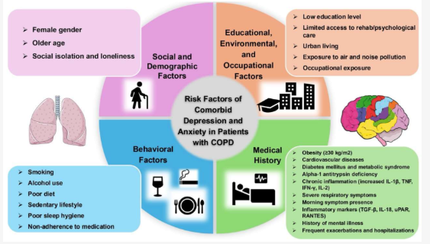
Fig 2: Risk factors for comorbid depression and anxiety in COPD
Source (Buican et al., 2025)

Social impact
COPD may limit social activities and identity. Individuals can avoid social areas due to coughing, shortness of breath, oxygen use, embarrassment or fear of falling ill. It can also influence employment particularly in jobs that require hard work, travelling, dust or fumes or long working hours. As observed by WHO (2026), COPD may impose economic burden due to loss of productivity both at the workplace and home. In the UK, it can be exacerbated by deprivation, inadequate housing, fuel poverty as well as delayed diagnosis or pulmonary rehabilitation (Campbell, 2024; Thomas, 2024).
Other issues of importance are stigma. COPD is commonly linked to smoking, and a part of the patients might be made to feel guilty about their illness (Woo, Zhou and Larson, 2021). This may deter truthful discussion of symptoms, smoking history or need of support. Nonetheless, the risk of COPD is conditioned by broader aspects, such as occupational exposure, air pollution, deprivation, childhood lung development, and genetic susceptibility (Agustí et al., 2022). A just practice must thus not blame but acknowledge the social and environmental circumstances that influence health.

Impact on families and carers
Families and informal carers are also impacted by COPD. Family members can assist with medications, appointments, transportation, household chores, oxygen apparatus, emotional comfort and emergency reactions over the course of exacerbations. Such support can allow the patient to stay at home, yet it might cause an emotional, physical and financial burden. Caregiver burden encompasses the practical and emotional, social and financial pressures of unpaid carers (Liu, Heffernan and Tan, 2020).
The carers can develop anxiety, sleep disturbances, loss of jobs, social isolation and not knowing how to act when breathlessness increases. They also might not be able to reconcile the caring roles and their health needs. NICE (2019) encourages family and carer involvement when it fits, which is significant as carers tend to notice the decline early and support them on a daily basis. On the whole, COPD places a common burden on the patient, family and the broader care system. Physical symptoms, emotional wellbeing, social participation and carer support should thus be incorporated together as part of the management.

Evidence-Based Treatment and NHS Management of COPD

Treatment and symptom control
In the UK, the approach to COPD treatment is aimed at symptom reduction, exacerbation prevention and independence, as opposed to curing the condition. The most crucial intervention in the situation of people who smoke remains smoking cessation, as further smoking worsens the deterioration of lung functions and decreases the effectiveness of other interventions (National Health Service, 2023). Smoking advice is however not enough. Behavioural support, pharmacological assistance and follow-up are frequently required by the patients, particularly when the stress, deprivation or long-term dependence is also connected with smoking (Wei et al., 2022).
Central to the treatment of symptoms are inhaled medicines. Short acting bronchodilators can help relieve episodic dyspnea, whereas long acting bronchodilators can be applied when symptoms are chronic. NICE (2019) suggests dual long-acting bronchodilator therapy to patients whose breathlessness continues or exacerbation occurs despite non-pharmacological treatment. Inhaled corticosteroids can be introduced in selected patients, e.g., those who have asthmatic features or are still experiencing recurrent exacerbations. This gradual method is helpful in that symptoms burden and high risk of exacerbation are connected to treatment. Nonetheless, it is dependent on proper diagnosis, periodic review, and proper inhaler technique. According to Melani (2021), inadequate inhaler technique is a frequent cause of the inability to achieve inhaled treatment efficacy in practice.

Rehabilitation, exacerbations and continuing care
Pulmonary rehabilitation is one of the key evidence-based interventions as it involves supervised exercise, education, and self-management support. It may enhance exercise tolerance, dyspnea, self-confidence and quality of life (NICE, 2019). Its usefulness lies in the fact that it reacts to the breathlessness-inactivity cycle, and not just prescribing medicine. Pulmonary rehabilitation however, is not available equally to all patients. People may miss or drop out of programmes due to transport issues, work commitments, anxiety, frailty, waiting lists and low referral rates (Qin et al., 2025).
Another priority is exacerbation management as flare-ups may accelerate functional decline and result in an emergency admission. NICE (2019) suggests that patients should be taught to be aware of the increasing breathlessness, sputum colour or sputum volume and seek early assistance. Treatment can be pharmacological such as short acting bronchodilators, oral corticosteroids and antibiotics in cases of suspected bacterial infection. Dobler et al. (2020) demonstrate that exacerbation treatment through drugs can be beneficial, however, treatment should be specific since overuse of antibiotics or long-term steroids may be harmful.
The COPD care should also incorporate vaccination, nutrition, oxygen examination and comorbidity assessment. Pneumococcal vaccination and annual influenza vaccination are beneficial in reducing the number of exacerbations related to the infection (NICE, 2019; Huang et al., 2021). Patients with ongoing hypoxaemia can be treated with long-term oxygen therapy, but this should be evaluated thoroughly and with safety precautions, especially when the individual remains a smoker. In general, NHS management must be designed, assessed and customised. Treatment of COPD involves the integration of medications, rehabilitation, prevention, self-management education and follow-up instead of using inhalers alone as illustrated in figure 3 below.
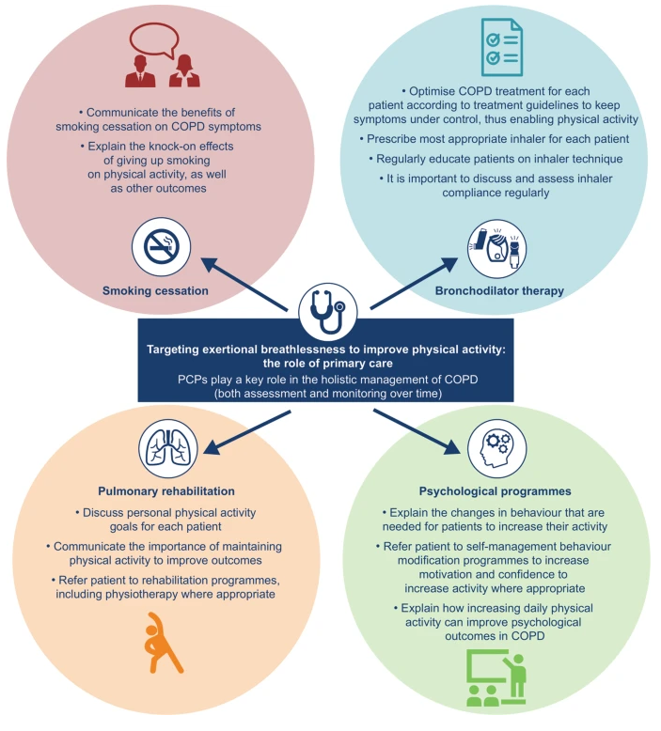
Fig 3: Targeting exertional breathlessness to improve physical activity: the role of primary care
Source (Román-Rodríguez and Kocks, 2021)

Theoretical Perspectives and Models for Better Outcomes

UK model: House of Care
The House of Care model can be applied to COPD as it can help change the current approach of professional-led and disease-centred care to individualised care planning. The model comprises four related components: engaged and informed patients and carers, health and care professionals working in partnership, organisational processes, and commissioning that facilitates coordinated services as illustrated in figure 4 (Coulter, Roberts and Dixon, 2013). In the case of COPD, this implies the patient must not only use inhalers or hospital care during exacerbations, but must also be assisted to learn more about symptoms, taking medicine properly, attending pulmonary rehabilitation, quitting smoking where applicable and future planning of care (Cunha et al., 2024).
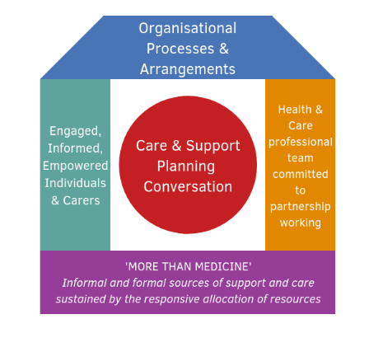
Figure 4: The House of Care Model for long-term condition management
Source (Health and Social Care Alliance Scotland, 2026)
The strength of the House of Care model is that it fits UK priorities around personalised care. According to NHS England, personalised care is a relationship, which underlines the care as founded on what matters to people and on the strengths of individuals, families and communities (NHS England, 2026). This is significant in COPD since two individuals with similar lung functionality could possess vastly different needs based on anxiety, mobility, housing, employment, family backing and health literacy (Ferrera, Labaki and Han, 2021). The model does, however, rely on sufficient consultation time, records that are shared, trained personnel and community services that are available. In the absence of them, the care planning process may turn into a paperwork game instead of a serious shared decision-making process.

International model: Chronic Care Model
The model of Chronic Care created by Wagner is applicable as well, as this model also concentrates on the proactive long-term care rather than on the reactive treatment. It outlines six components of good chronic care; community resources, health system organisation, support of self-management, design of the delivery system, decision support and clinical information systems as shown in figure 5 (Wagner, 1998). These aspects are supportive to frequent review, patient education, evidence-based treatment, data-based follow-up and connection to community rehabilitation or voluntary support in COPD care.
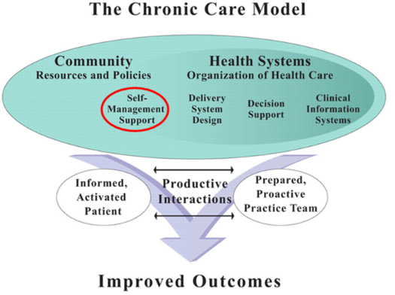
Fig 5: The Chronic Care Model
Source (Kermelly and Bourbeau, 2022)
This model is useful in the fact that COPD should be managed on a daily basis and not just a clinical emergency (Bourbeau and Echevarria, 2020). Bodenheimer, Wagner and Grumbach (2002) suggest that informed patients can experience chronic care better when the practice teams are prepared and proactive. This applies to COPD management where patient confidence, inhaler use, action plans to manage exacerbations and response by a professional in a timely manner dictate the outcome. The constraint is that the model can be biased in its view of social barriers like deprivation, transport issues, digital exclusion and disintegrated health and social care (Gaffney et al., 2022). Thus, the most effective option can be to integrate the person-centred planning of the House of Care with the system-level organisation of the Chronic Care Model.

Implementation of Local and National Political, Health and Social Care Agendas in COPD Management
The management of COPD in England follows national standards of quality improvement that will decrease preventable decline and hospital consumption. The COPD quality standard provided by NICE was most recently updated in 2023, which prioritizes areas like spirometry-confirmed diagnosis, review of inhaler technique, long-term oxygen assessment, pulmonary rehabilitation, non-invasive ventilation and hospital discharge care bundles (NICE, 2023). The usefulness of these priorities is that they address areas of weaknesses of COPD care. Nonetheless, their application relies on the local resources. In case spirometry clinics, respiratory nurses, rehabilitation places and post-discharge reviews are scarce, national guidance can help increase policy language without making the life of patients better.
The national inequalities agenda is pertinent as well. The introduction of Core20PLUS5 was aimed at decreasing healthcare disparity at both national and system level, which is why it suits COPD due to chronic respiratory disease being among its clinical priorities (NHS England, 2021). This policy argument is further reinforced by the deprivation pattern in Figure 6, which demonstrates the respiratory hospital admission by the deprivation quintiles, starting with quintile 1, the most deprived, and progressing to quintile 5, the least deprived (Taskforce for Lung Health, 2024). Since the Taskforce to Lung Health dashboard was based on the Hospital Episode Statistics and Index of Multiple Deprivation data, the visual representation aligns hospital consumption with broader socioeconomic factors and not individual behaviour. This implies that COPD expectation needs to incorporate early diagnosis, smoking elimination, housing, clean air activity, equitable rehabilitation and robust community respiratory services.
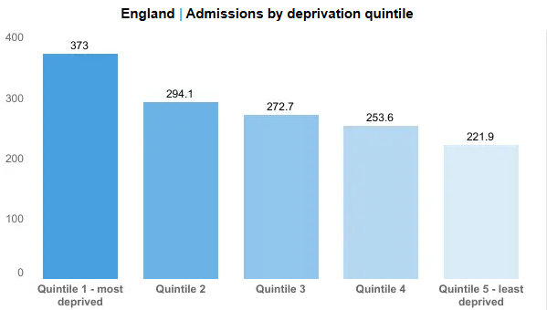
Fig 6: Emergency COPD admissions by deprivation quintile in England
Source (Taskforce for Lung Health, 2026)
Integrated Care Systems were legally introduced in England on 1 July 2022 to bring together the NHS bodies, local authorities, social care, voluntary organisations and other parties around the local need (NHS England, 2022). This agenda is appropriate to COPD, since it is frequently true that good management of the condition involves respiratory treatment, mental health treatment, rehabilitation, housing counseling, welfare support, social care and involvement of carers. The weaknesses are that integration may be constrained by budgets, number of staff and incompatible records and slow referral pathways. Local COPD programs should, therefore, be evaluated based on their quantifiable results, such as earlier diagnosis, reduced emergency hospitalizations, improved rehabilitation and home-based support.

Recommendations for Person-Centred Care, Self-Management and End-of-Life Care
First, COPD services need to enhance access to flexible pulmonary rehabilitation, such as community, home-based, and hybrid. This would ensure that care is person-centred since attendance can be hampered due to transport challenges, anxiety, career and deprivation. As demonstrated by Cravo et al. (2022), self-management and rehabilitation support can enhance quality of life and decrease healthcare use, yet only when accessible and tailored to the personal needs. Consequently, early rehabilitation must be provided, shaped in accordance with the aims of patients, and adhered to throughout the programme to ensure continuity of activity.
Second, a personalised self-management plan based on shared decision-making should be developed in relation to each individual with COPD. Cravo et al. (2022) demonstrate that personalised COPD self-management tends to be more efficient when it is provided along with education, symptom monitoring, action planning and professional support, as opposed to generic guidance. The plan is supposed to encompass inhaler technique, smoking cessation, vaccination, strategies on breathlessness, diet, exercising targets and how to follow clear steps to avoid exacerbations. Involvement of carers where needed should be considered, as they tend to reinforce medicines, appointments and emergency choices.
Third, palliative and end-of-life care ought to be implemented earlier on in advanced COPD. According to Petrova et al. (2021), waiting until death is correctly predicted can postpone treatment, as long-term illness can often be unpredictable. Preferred place of care and carer support, symptom control, earlier advance care planning, and ReSPECT discussions would assist patients in making decisions prior to crisis admissions (Tavares et al., 2023). This is not a substitute to active treatment of COPD; it enhances dignity, comfort and family preparedness.

Conclusion
COPD is a serious chronic disorder that impacts respiratory, autonomy, mood, social and family life. More than just prescribing inhalers is necessary to effectively manage the condition, including early diagnosis, smoking cessation, pulmonary rehabilitation, vaccination, exacerbation planning and regular review. The evidence further demonstrates that COPD treatment ought to be tailored, since patients have varying degrees of breathlessness, anxiety, comorbidity, social support and service access. National and local agendas have the potential to enhance outcomes, however, when executed in a coordinated manner of community care. In general, the evidence-based treatment, self-management support, and carer intervention and timely palliative care should be integrated into COPD management where necessary.

References

Agustí, A., Melén, E., DeMeo, D.L., Breyer-Kohansal, R. and Faner, R. (2022) ‘Pathogenesis of chronic obstructive pulmonary disease: Understanding the contributions of gene–environment interactions across the lifespan’, The Lancet Respiratory Medicine, 10(5), pp. 512–524. Available at: https://doi.org/10.1016/S2213-2600(21)00555-5 (Accessed: 15 June 2026).
Arrandale, V.H., Zhang, Y., Lou, W., Tricco, A.C., Lau, A., Orchanian-Cheff, A., Henneberger, P.K. and Tarlo, S.M. (2026) ‘Vapors, gases, dusts and fumes at work and chronic obstructive pulmonary disease/bronchitis: A systematic review and meta-analyses’, Journal of Occupational Medicine and Toxicology, 21, article 19. Available at: https://doi.org/10.1186/s12995-026-00515-7 (Accessed: 10 July 2026).
Bourbeau, J. and Echevarria, C. (2020) ‘Models of care across the continuum of exacerbations for patients with chronic obstructive pulmonary disease’, Chronic Respiratory Disease, 17, pp. 1–12. Available at: https://doi.org/10.1177/1479973119895457 (Accessed: 10 July 2026).
Campbell, D. (2024) ‘Lung disease patients waiting up to 10 years for diagnosis in poorer areas of England’, The Guardian, 24 March. Available at: https://www.theguardian.com/society/2024/mar/24/lung-disease-patients-waiting-up-to-10-years-for-diagnosis-in-poorer-areas-of-england (Accessed: 19 June 2026).
Cox, N.S., Dal Corso, S., Hansen, H., McDonald, C.F., Hill, C.J., Zanaboni, P., Alison, J.A., O’Halloran, P., Macdonald, H. and Holland, A.E. (2021) ‘Telerehabilitation for chronic respiratory disease’, Cochrane Database of Systematic Reviews, 1, article CD013040. Available at: https://doi.org/10.1002/14651858.CD013040.pub2 (Accessed: 10 July 2026).
Cravo, A., Attar, D., Freeman, D., Holmes, S., Ip, L. and Singh, S.J. (2022) ‘The importance of self-management in the context of personalized care in COPD’, International Journal of Chronic Obstructive Pulmonary Disease, 17, pp. 231–243. Available at: https://doi.org/10.2147/COPD.S343108 (Accessed: 18 June 2026).
Cunha, A.S., Raposo, B., Dias, F., Henriques, S., Martinho, H. and Pedro, A.R. (2024) ‘Management of chronic obstructive pulmonary disease: Constraints in patient pathway and mitigation strategies’, Portuguese Journal of Public Health, 42(2), pp. 93–100. Available at: https://doi.org/10.1159/000535474 (Accessed: 28 June 2026).
Dobler, C.C., Morrow, A.S., Beuschel, B., Farah, M.H. and Majzoub, A.M. (2020) ‘Pharmacologic therapies in patients with exacerbation of chronic obstructive pulmonary disease: A systematic review with meta-analysis’, Annals of Internal Medicine, 172(6), pp. 413–422. Available at: https://doi.org/10.7326/M19-3007 (Accessed: 16 June 2026).
Ferrera, M.C., Labaki, W.W. and Han, M.K. (2021) ‘Advances in chronic obstructive pulmonary disease’, Annual Review of Medicine, 72, pp. 119–134. Available at: https://doi.org/10.1146/annurev-med-080919-112707 (Accessed: 25 June 2026).
Fettes, L., Bone, A.E., Etkind, S.N., Ashford, S., Higginson, I.J. and Maddocks, M. (2021) ‘Disability in basic activities of daily living is associated with symptom burden in older people with advanced cancer or chronic obstructive pulmonary disease: A secondary data analysis’, Journal of Pain and Symptom Management, 61(6). Available at: https://doi.org/10.1016/j.jpainsymman.2020.10.012 (Accessed: 10 July 2026).
Gaffney, A.W., Hawks, L., White, A.C., Woolhandler, S., Himmelstein, D., Christiani, D.C. and McCormick, D. (2022) ‘Health care disparities across the urban-rural divide: A national study of individuals with COPD’, The Journal of Rural Health, 38(1), pp. 207–216. Available at: https://doi.org/10.1111/jrh.12525 (Accessed: 3 July 2026).
Gholami, S., Chinonyerem, D., Cooper, E.J. and Kuwornu, J.P. (2025) ‘Understanding the unmet needs, experiences, and perspectives of COPD caregivers: A scoping review’, COPD: Journal of Chronic Obstructive Pulmonary Disease, 22(1), article 2481260. Available at: https://doi.org/10.1080/15412555.2025.2481260 (Accessed: 10 July 2026).
Global Initiative for Chronic Obstructive Lung Disease (GOLD) (2025) Global strategy for the diagnosis, management, and prevention of chronic obstructive pulmonary disease: 2025 report. Available at: https://goldcopd.org/2025-gold-report/ (Accessed: 24 June 2026).
Health and Social Care Alliance Scotland (2026) The House of Care model. Available at: https://www.alliance-scotland.org.uk/past-work-and-projects/scotlands-house-of-care/the-house-of-care-model/ (Accessed: 3 July 2026).
Huang, H.-H. et al. (2021) ‘The effectiveness of influenza vaccination on chronic obstructive pulmonary disease with different severities of airflow obstruction’, Biomedicines, 9(9), article 1175. Available at: https://doi.org/10.3390/biomedicines9091175 (Accessed: 10 July 2026).
Kermelly, S.B. and Bourbeau, J. (2022) ‘eHealth in self-managing at a distance patients with COPD’, Life, 12(6), article 773. Available at: https://doi.org/10.3390/life12060773 (Accessed: 6 July 2026).
Melani, A.S. (2021) ‘Inhaler technique in asthma and COPD: Challenges and unmet knowledge that can contribute to suboptimal use in real life’, Expert Review of Clinical Pharmacology, 14(8), pp. 991–1003. Available at: https://doi.org/10.1080/17512433.2021.1929924 (Accessed: 21 June 2026).
National Health Service (NHS) (2023a) Chronic obstructive pulmonary disease (COPD). Available at: https://www.nhs.uk/conditions/chronic-obstructive-pulmonary-disease-copd/ (Accessed: 17 June 2026).
National Health Service (NHS) (2023b) Chronic obstructive pulmonary disease (COPD): Treatment. Available at: https://www.nhs.uk/conditions/chronic-obstructive-pulmonary-disease-copd/treatment/ (Accessed: 3 July 2026).
National Institute for Health and Care Excellence (NICE) (2019) Chronic obstructive pulmonary disease in over 16s: Diagnosis and management. NICE guideline NG115. Available at: https://www.nice.org.uk/guidance/ng115 (Accessed: 30 June 2026).
National Institute for Health and Care Excellence (NICE) (2023) Chronic obstructive pulmonary disease in adults. Quality standard QS10. Available at: https://www.nice.org.uk/guidance/qs10 (Accessed: 27 June 2026).
NHS England (2021) Core20PLUS5: An approach to reducing health inequalities – supporting information. Available at: https://www.england.nhs.uk/publication/core20plus5-an-approach-to-reducing-health-inequalities-supporting-information/ (Accessed: 28 June 2026).
NHS England (2022) What is integrated care? Available at: https://www.england.nhs.uk/integratedcare/what-is-integrated-care/ (Accessed: 29 June 2026).
O’Donnell, D.E., Milne, K.M., James, M.D., de Torres, J.P. and Neder, J.A. (2020) ‘Dyspnea in COPD: New mechanistic insights and management implications’, Advances in Therapy, 37, pp. 41–60. Available at: https://doi.org/10.1007/s12325-019-01128-9 (Accessed: 22 June 2026).
Petrova, M., Wong, G., Kuhn, I., Wellwood, I. and Barclay, S. (2021) ‘Timely community palliative and end-of-life care: A realist synthesis’, BMJ Supportive & Palliative Care. Available at: https://doi.org/10.1136/bmjspcare-2021-003066 (Accessed: 1 July 2026).
Qin, H., Jia, P., Yan, Q., Li, X., Zhang, Y., Jiang, H., Yang, H. and Li, L. (2025) ‘Barriers and facilitators to pulmonary rehabilitation in COPD: A mixed-methods systematic review’, BMC Pulmonary Medicine, 25, article 314. Available at: https://doi.org/10.1186/s12890-025-03769-9 (Accessed: 20 June 2026).
Saini, P., Rose, T., Downing, J., Matata, B., Pilsworth, S., Pemberton, A., Comerford, T., Wilson, K., Shaw, M., Harper, L.M., Daras, K. and Barr, B. (2020) ‘Impact of community-based chronic obstructive pulmonary disease service, a multidisciplinary intervention in an area of high deprivation: A longitudinal matched controlled study’, BMJ Open, 10, article e032931. Available at: https://doi.org/10.1136/bmjopen-2019-032931 (Accessed: 22 June 2026).
Taskforce for Lung Health (2024) National deprivation. Available at: https://www.taskforceforlunghealth.org.uk/data-dashboards/health-inequalities/national-deprivation/ (Accessed: 5 July 2026).
Tavares, N., Jarrett, N., Wilkinson, T.M.A. and Hunt, K.J. (2023) ‘Patient-centered discussions about disease progression, symptom, and treatment burden in chronic obstructive pulmonary disease could facilitate the integration of end-of-life discussions in the disease trajectory: Patient, clinician, and literature perspectives – a multimethod approach’, Journal of Palliative Medicine, 26(3), pp. 353–359. Available at: https://doi.org/10.1089/jpm.2022.0028 (Accessed: 10 July 2026).
Thomas, T. (2024) ‘Almost 10m UK households living in “cold, damp, poorly insulated homes”’, The Guardian, 22 February. Available at: https://www.theguardian.com/society/2024/feb/22/almost-10m-uk-households-living-in-cold-damp-poorly-insulated-homes (Accessed: 27 June 2026).
Wang, Y., Han, R., Ding, X., Feng, W., Gao, R. and Ma, A. (2025) ‘Chronic obstructive pulmonary disease across three decades: Trends, inequalities, and projections from the Global Burden of Disease Study 2021’, Frontiers in Medicine, 12, article 1564878. Available at: https://doi.org/10.3389/fmed.2025.1564878 (Accessed: 6 July 2026).
Wei, X., Guo, K., Shang, X., Wang, S., Yang, C., Li, J., Li, Y., Yang, K., Li, X. and Zhang, X. (2022) ‘Effects of different interventions on smoking cessation in chronic obstructive pulmonary disease patients: A systematic review and network meta-analysis’, International Journal of Nursing Studies, 136, article 104362. Available at: https://doi.org/10.1016/j.ijnurstu.2022.104362 (Accessed: 6 July 2026).
Williams, P.J., Cumella, A., Philip, K.E.J., Laverty, A.A. and Hopkinson, N.S. (2022) ‘Smoking and socio-economic factors linked to acute exacerbations of COPD: Analysis from an Asthma + Lung UK survey’, BMJ Open Respiratory Research, 9, article e001290. Available at: https://doi.org/10.1136/bmjresp-2022-001290 (Accessed: 10 July 2026).
Woo, S., Zhou, W. and Larson, J.L. (2021) ‘Stigma experiences in people with chronic obstructive pulmonary disease: An integrative review’, International Journal of Chronic Obstructive Pulmonary Disease, 16, pp. 1647–1659. Available at: https://doi.org/10.2147/COPD.S306874 (Accessed: 4 July 2026).
World Health Organization (WHO) (2026) Chronic obstructive pulmonary disease (COPD). Available at: https://www.who.int/news-room/fact-sheets/detail/chronic-obstructive-pulmonary-disease-(copd) (Accessed: 7 July 2026).

