Assignment ACCA5023
[Company name] | [Company address]
Network Operating Systems and Services
George Quick (2315899)
2026
Task 1 2
Task 2 4
2.1 Hypervisor Selection and Justification 4
2.2.1 Download and Installation 7
2.2.2 Deploy Network Topology 8
2.3 Configure IP Addressing 13
Task 3 17

Task 1

1. Research on Hypervisors
Hypervisors are an important part of virtualisation technology because they let multiple operating systems run on one physical machine by separating hardware resources. There are two main kinds of hypervisors: Type 1 (bare-metal) and Type 2 (hosted) [1]. Type 1 hypervisors run directly on the physical hardware and don't need a host operating system to manage virtual machines. The hypervisor has direct access to system resources like CPU, memory, and storage, which makes this architecture faster, safer, and more flexible. Type 2 hypervisors, on the other hand, run on top of a host operating system and use it to talk to hardware. This adds more work, slows things down and raises security risks because bugs in the host operating system can affect virtual machines such as Windows Server 2022 and VirtualBox.
For the SWANSEA.ACCA domain topology, which includes Windows Server 2022 acting as a domain controller and a Debian Server acting as a DHCP relay and service host, a Type 1 hypervisor is the most suitable choice. Domain controllers require high reliability, performance, and security because they manage authentication, authorisation, and directory services. Type 1 hypervisors provide better isolation between virtual machines, ensuring that if one system is compromised, others remain protected [2]. They also support enterprise features such as resource allocation, snapshots, and live migration, which are important for scalability in enhanced topology environments.
Hardware requirements also influence hypervisor selection. Type 1 hypervisors utilise hardware virtualisation extensions such as Intel VT-x or AMD-V [3], improving efficiency and allowing multiple enterprise operating systems such as Windows Server and Debian Linux to run simultaneously. Additionally, Type 1 hypervisors reduce the attack surface by eliminating the host operating system layer, improving overall security. Therefore, considering the domain environment, security requirements, scalability, and compatibility with both Windows and Debian systems, Type 1 hypervisors provide the most efficient, secure, and scalable solution for the SWANSEA.ACCA infrastructure.

2. IP Addressing Research
IP addressing is a critical component of network communication because it uniquely identifies devices and enables data transmission across networks. When a device sends data, the information is divided into packets containing source and destination IP addresses. Routers examine these addresses and forward packets toward their destination across interconnected networks [4]. Without IP addressing, devices would not be able to locate each other or communicate effectively.
For example, 192.168.1.10 is an IPv4 address written in dotted decimal format. It is a 32-bit number. There are two parts to these addresses: a network part and a host part. But because the Internet has grown, IPv4 addresses are now hard to come by. To fix this, IPv6 was made with 128-bit addresses written in hexadecimal format, like 2001:0db8:85a3::8a2e:0370:7334. IPv6 has a much bigger address space, works better, and is better for modern networks [5].
Subnetting improves network efficiency by dividing large networks into smaller subnetworks [6]. For example, the network 192.168.1.0/24 can be divided into smaller subnets such as 192.168.1.0/26 and 192.168.1.64/26. This improves performance by reducing broadcast traffic and improving network organization. Subnetting also enhances security by separating network segments.

3. Routing Research
Routing is the process of determining the most effective method for data to go between networks [7]. In order to properly forward packets, routers employ routing tables to keep track of available network paths. Routing protocols allow routers to share information and maintain current routing tables. The two main routing techniques are dynamic routing and static routing.
Static routing requires manual route configuration. It provides more security because unauthorised systems are unable to alter routes on their own. It also uses less system resources and provides predictable network activity. Conversely, static routing requires manual updating whenever the network topology changes and is less scalable.
Using protocols like BGP, OSPF, and RIP, dynamic routing automatically locates and maintains routes. This improves scalability and fault tolerance but requires more configuration and processing power. Dynamic routing is typically used in large enterprise networks. [8]
Diagram:
Router → Windows Server → Domain Controller → Debian Server (DHCP Relay) → Client Network
In the SWANSEA.ACCA architecture, static routing works best because the network is small and under control. The Debian server must be able to communicate reliably with the Windows server in order to serve as a DHCP relay. Static routing has the advantages of improved security, simpler debugging, and consistent performance. Dynamic routing would add unnecessary complexity in this situation. Static routing is therefore the safest and most efficient routing choice.

4. Network Services Research
VPN, DHCP, Active Directory Domain Services (AD DS), and Certificate Authorities are core services of networking that help manage and safeguard the integrity of the network. A VPN secures public network remote access by encrypting the data. In the case of this data is protected through the use of encryption protocols called IPsec and SSL [9]. It provides access to users outside of the SWANSEA.ACCA domain without additional risk.
Mistakes made during initial network configuration are reduced through the automation of IP address assignments and network configuration set up by DHCP [10]. In a relay configuration, the Debian Server acts as the DHCP relay, directing client requests to the Windows Server DHCP, which provides all of the relay and configuration services.
Active Directory Domain Services provides centralised authentication and management of users, computers, and network resources [12]. It allows administrators to enforce security policies, manage user access, and provide single sign-on functionality.
Certificate Authorities issue digital certificates that verify identities and enable secure communication. Certificates are used in secure services such as HTTPS, VPN authentication, and secure domain communication. Best practices include protecting private keys, regularly renewing certificates, and securing domain controllers.
These network services improve network security, management, and scalability. They ensure secure authentication, automated configuration, and encrypted communication, which are essential for enterprise network environments such as SWANSEA.ACCA.

Task 2

2.1 Hypervisor Selection and Justification
I picked VMware for the network arrangement because it is a Type hypervisor, which means it operates directly on the hardware instead than on top of another operating system. It manages the computer's resources directly, like the CPU, memory, and storage. This makes it speedier and more stable. Reliability and smart resource use are very crucial because the network has important systems like a Windows Server 2022 Domain Controller and a Debian Server. VMware works better and uses less resources than Type 2 hypervisors like VirtualBox.
Another important reason to choose VMWare was security. Domain controllers are in charge of user authentication and access, so any security problems there could damage the whole network. Because VMware doesn’t rely on a host operating system, it has fewer vulnerabilities and provides stronger isolation between virtual machines.
In short, VMware was selected because it’s secure, efficient, and scalable which is perfect for the current network and future upgrades.
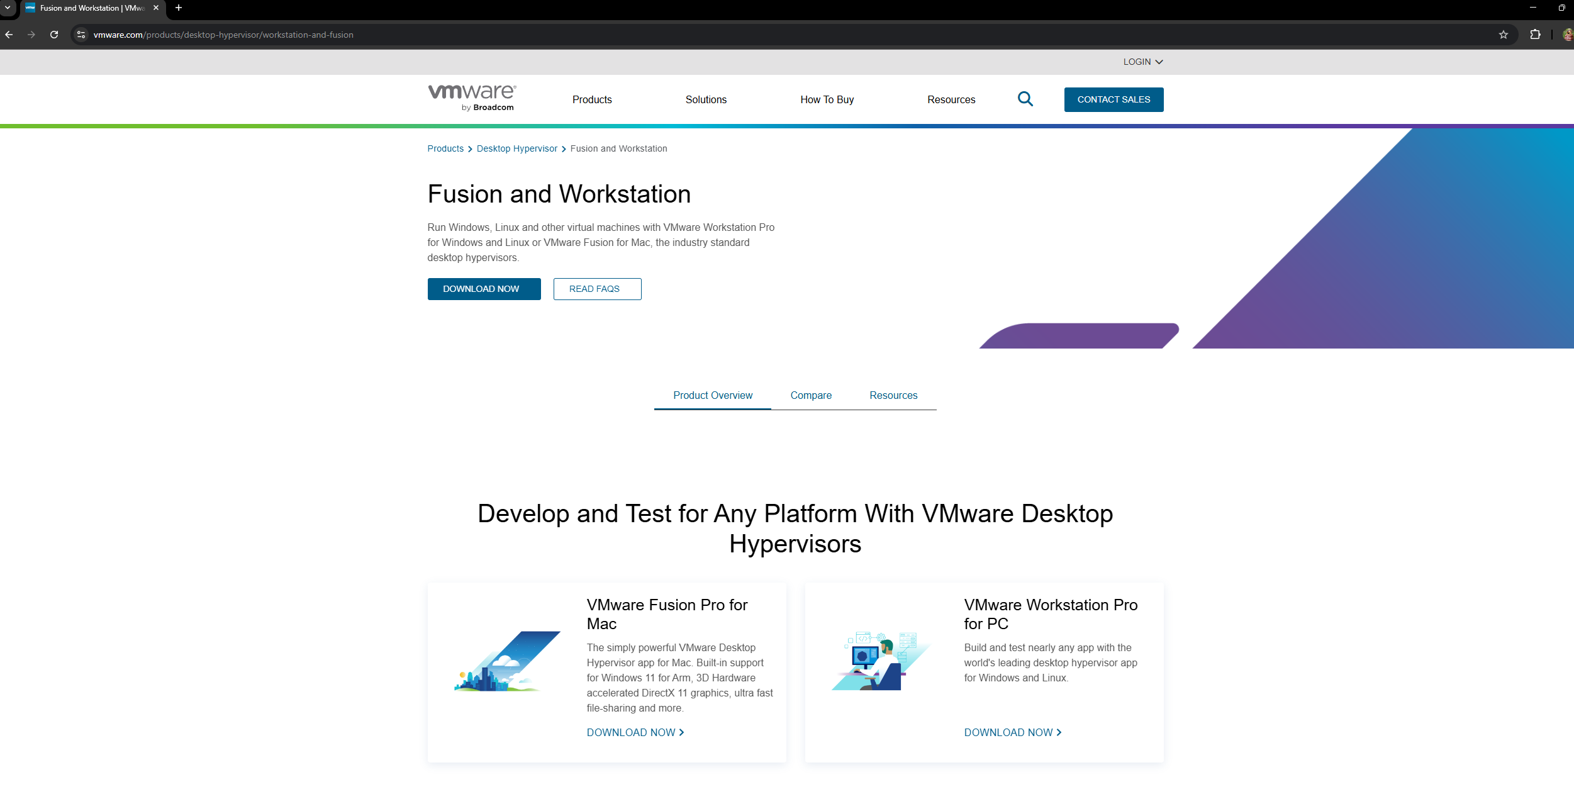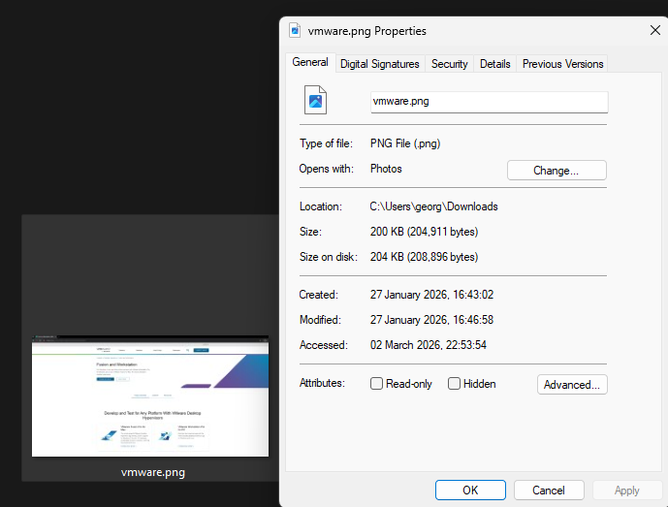
Here is an image of me on the official VMware website downloading the hypervisor software required to create and manage virtual machines for the network setup.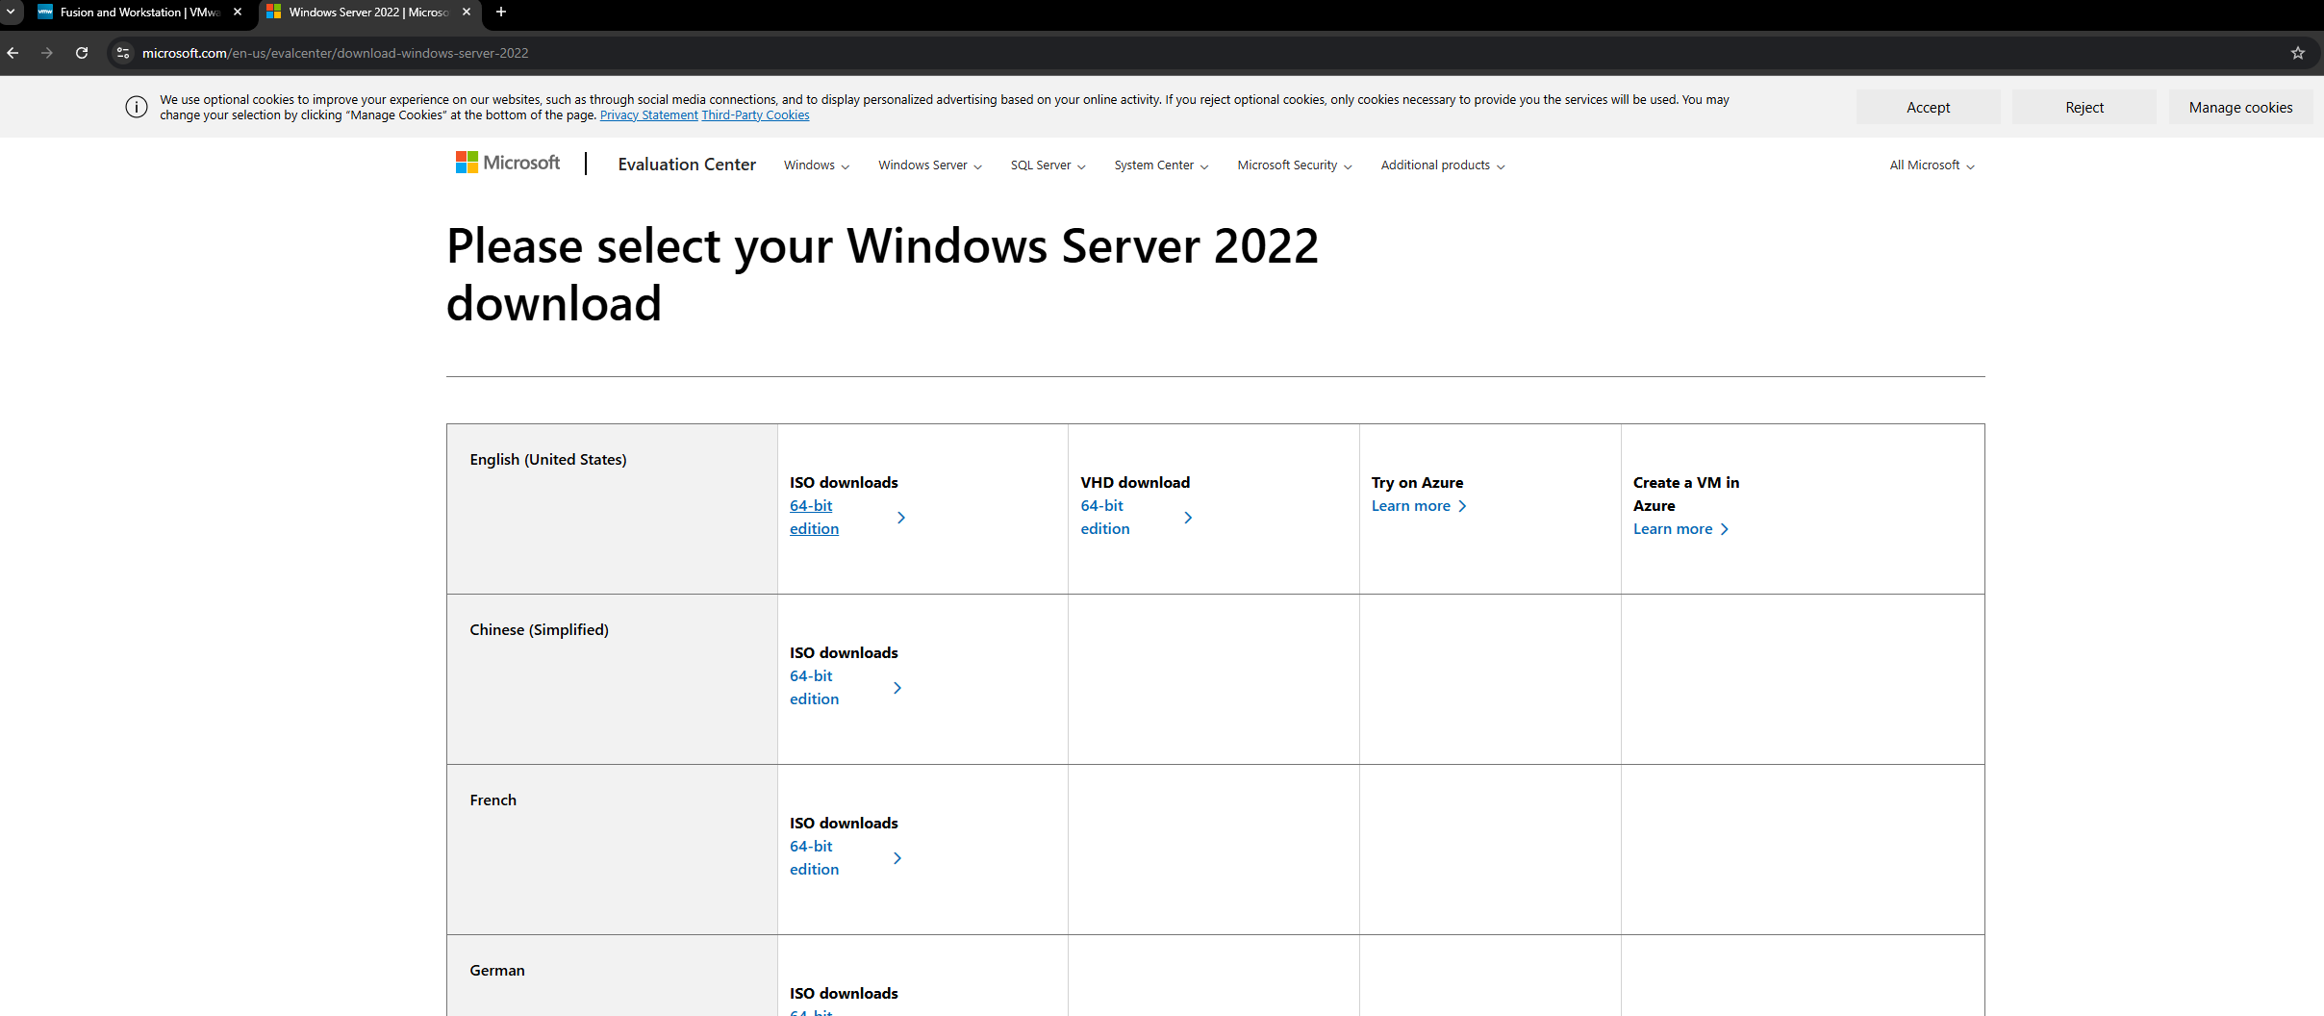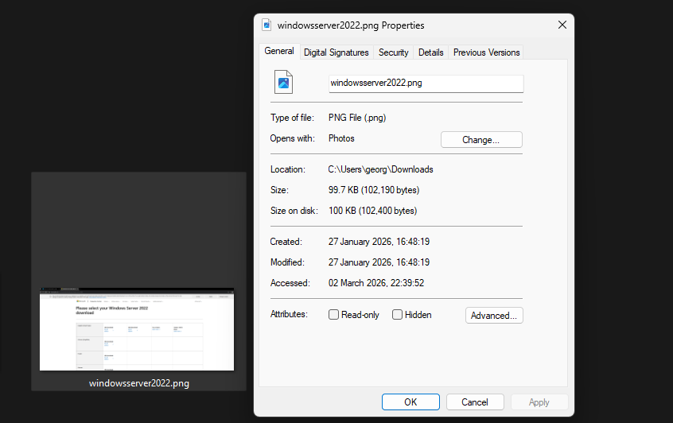
The image above shows me accessing the official Microsoft website to download the Windows Server 2022 installation files used for the server configuration.
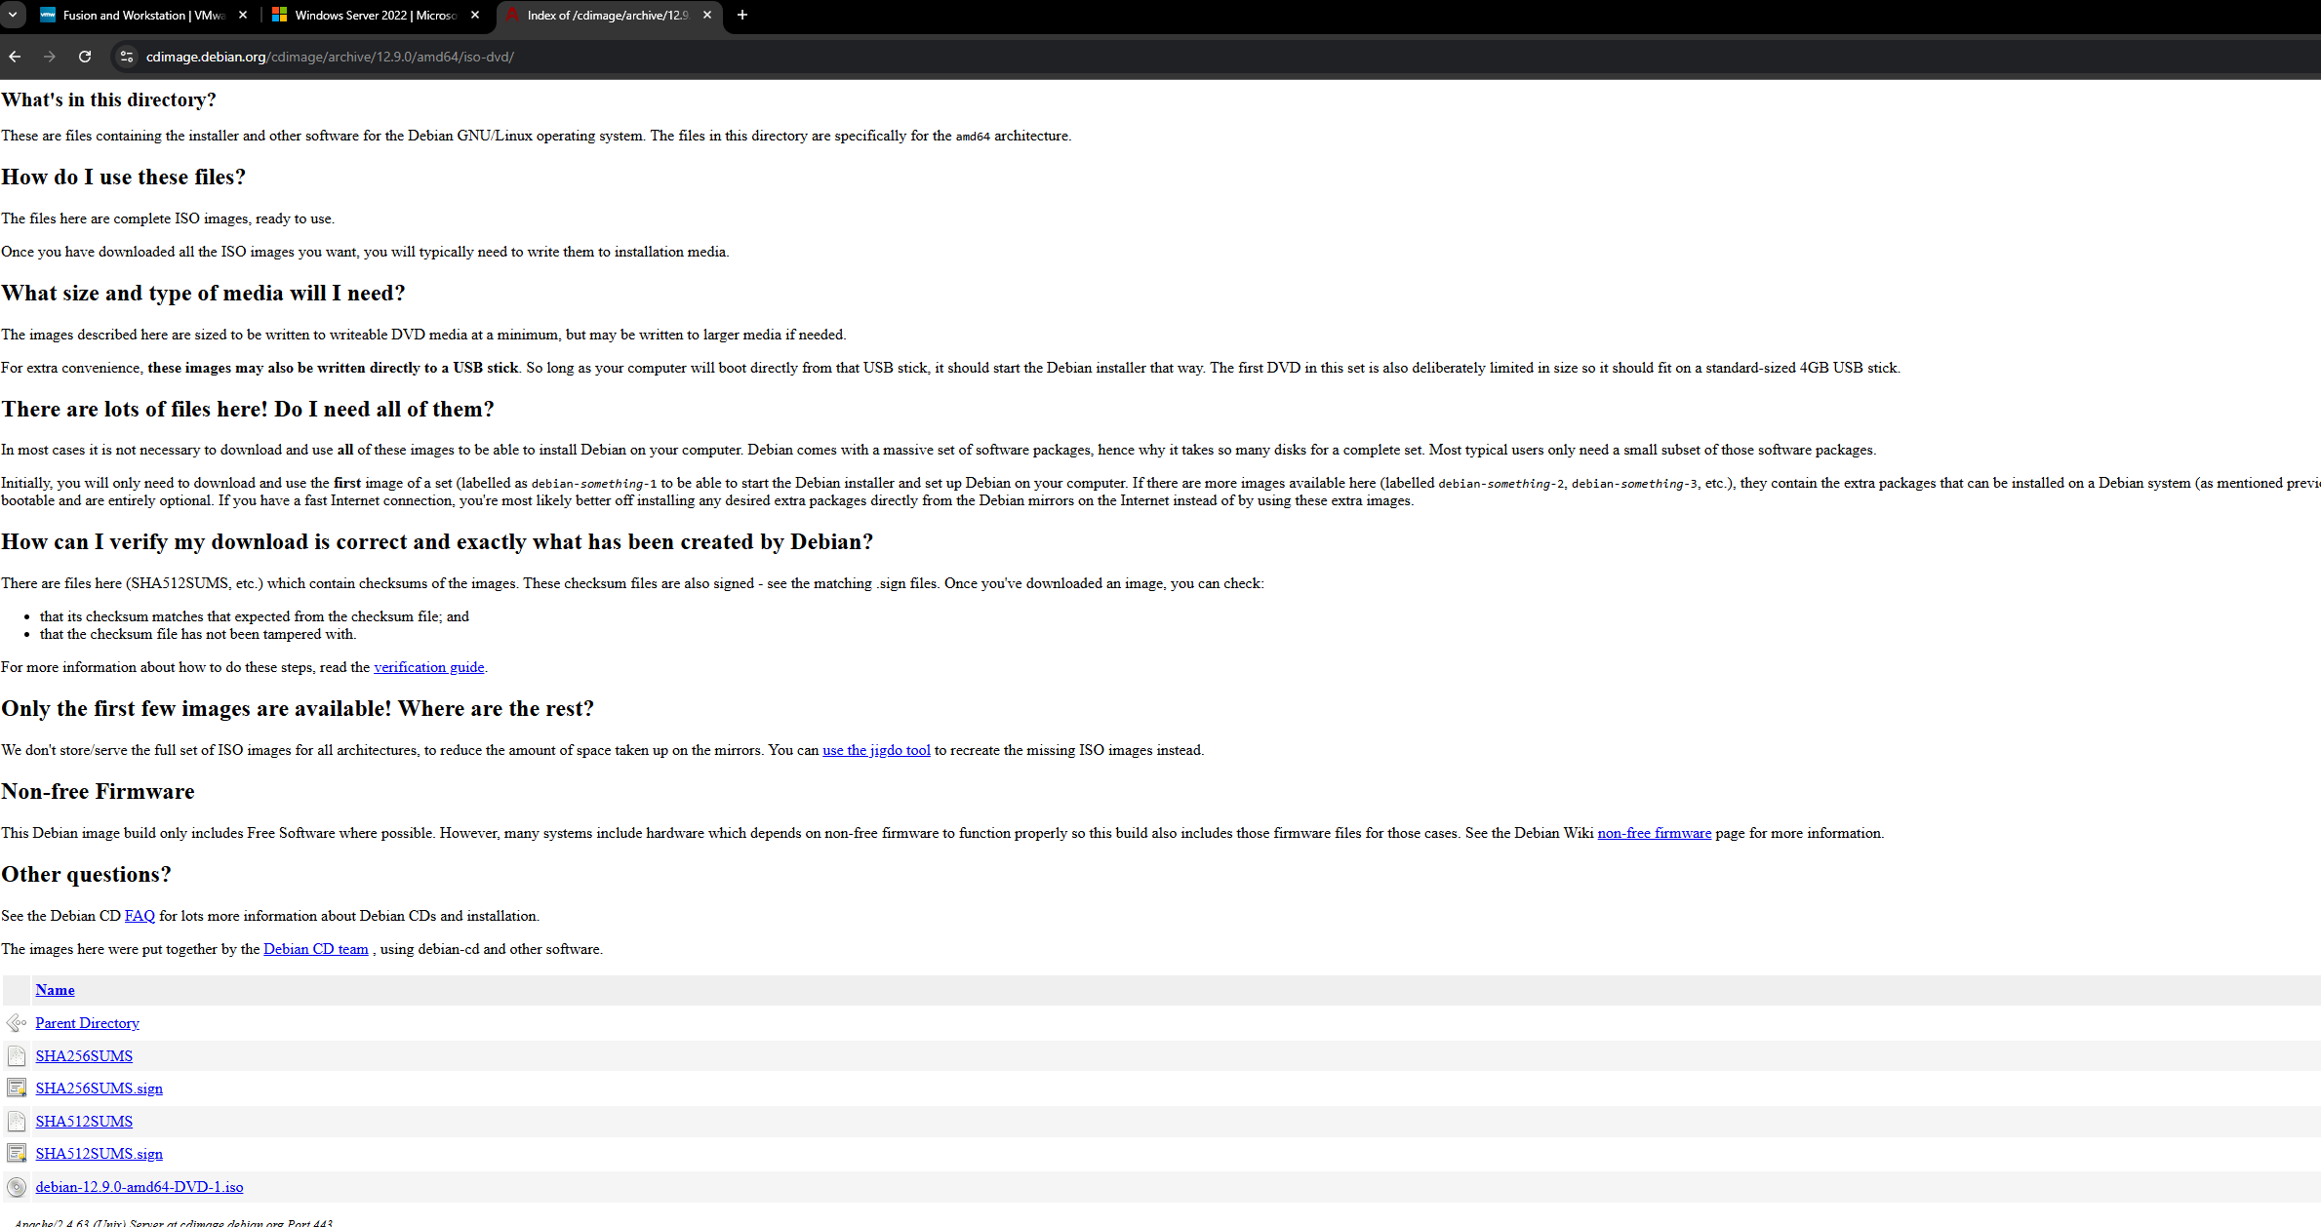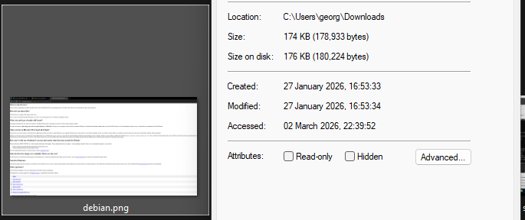

The screenshot above shows me downloading Debian Server version 12.9, which was used in the video examples to follow along with the setup and testing process.

2.2.1 Download and Installation
To ensure authenticity and security, the software components were downloaded from reputable and official sources.
• The official VMware website provided the download for VMware official website.
• The Microsoft Evaluation Center provided the Windows Server 2022 Evaluation ISO.
• The official Debian repository provided the Debian Linux ISO for download.
Software integrity, security upgrades, and enterprise environment compatibility can be trusted when downloading from trusted company websites.

2.2.2 Deploy Network Topology
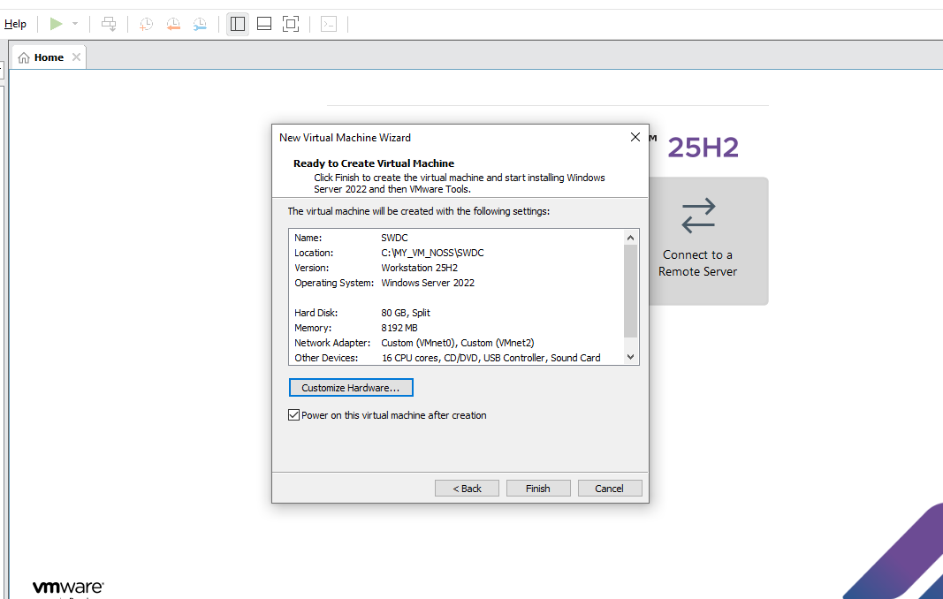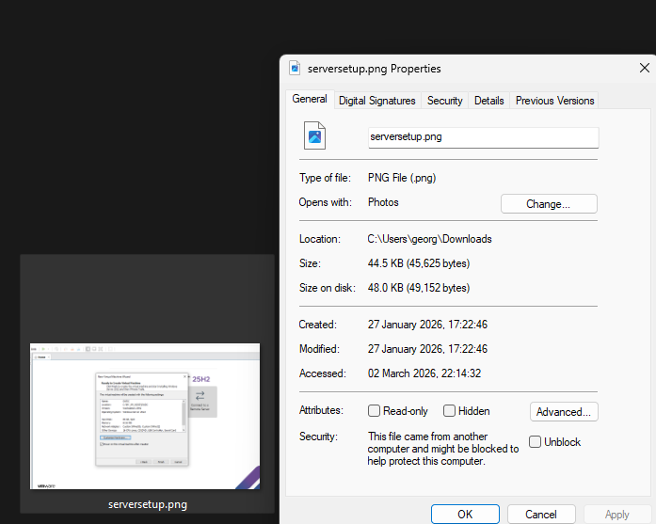
This screenshot shows the server virtual machine being configured with an 8GB hard disk, 8192MB of memory, 16 CPU cores, and network adapters connected to VMnet0 and VMnet2 to support network communication.
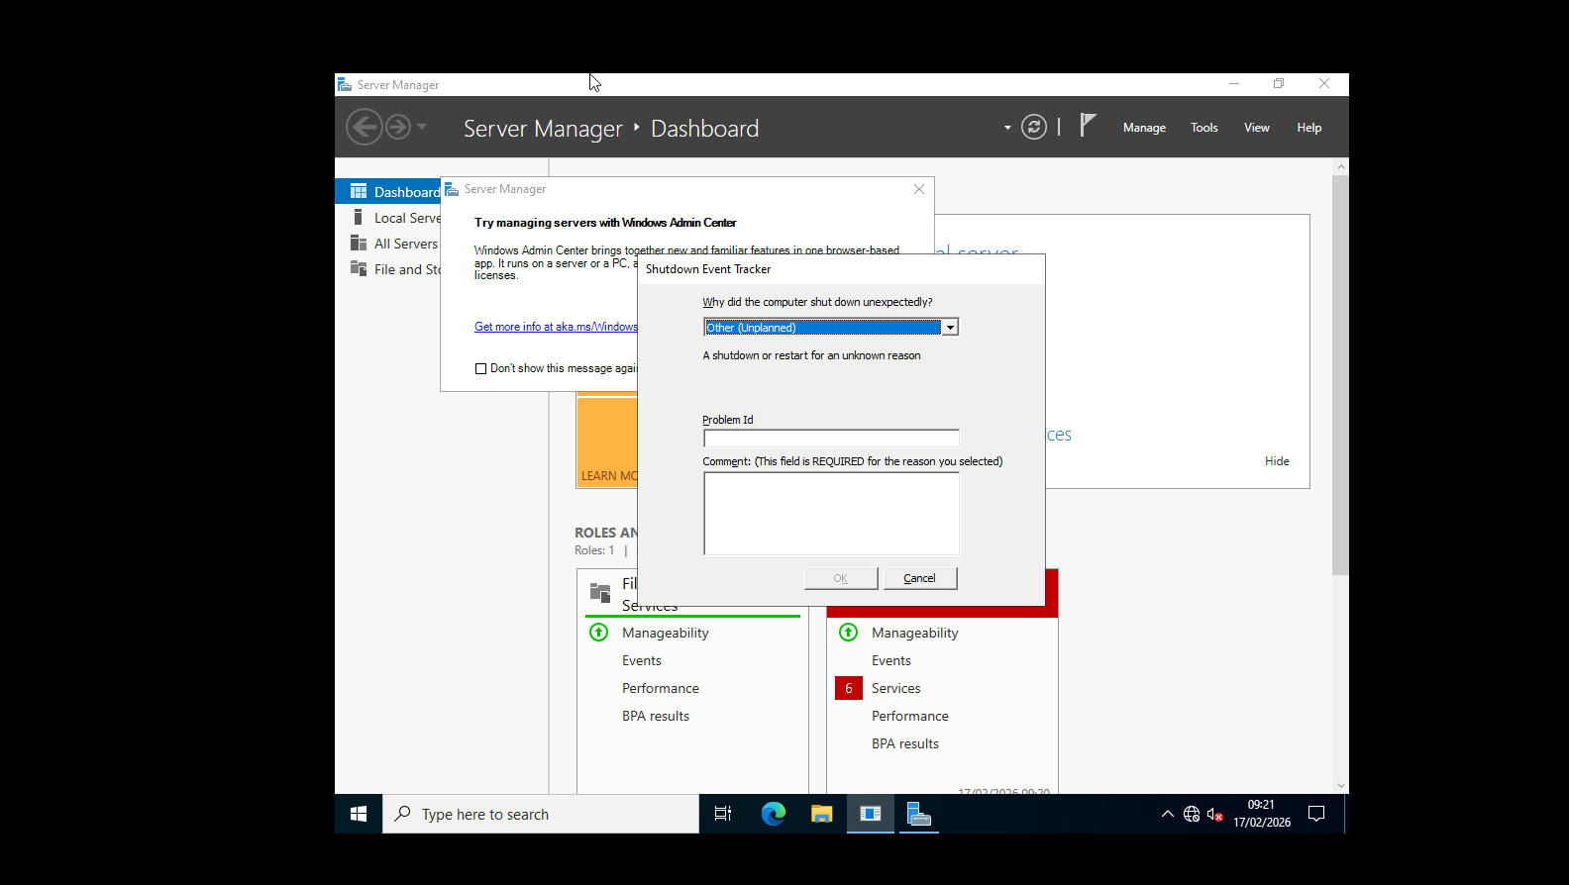
The image above shows me opening the Window server on VMWare.
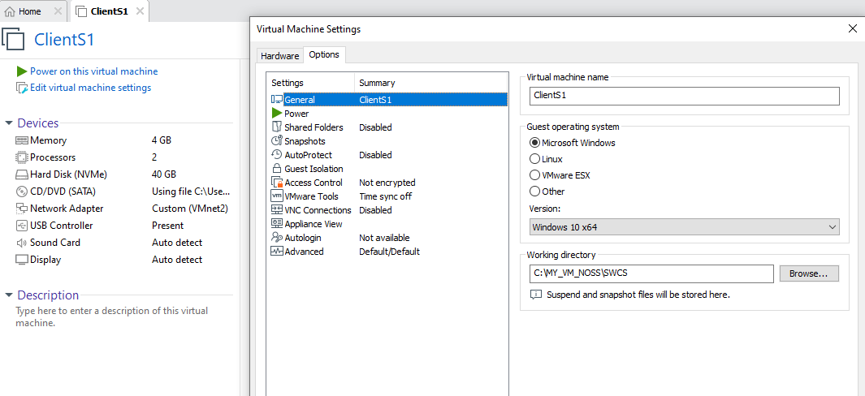
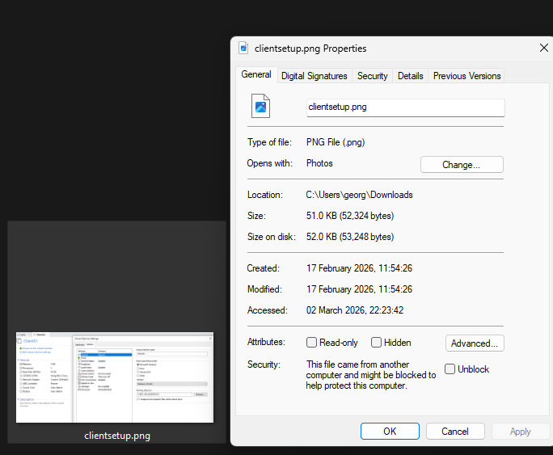
This image above shows the client virtual machine configured with 4GB of memory, 2 processors, a network adapter connected to VMnet2, and running the Windows 10 operating system.
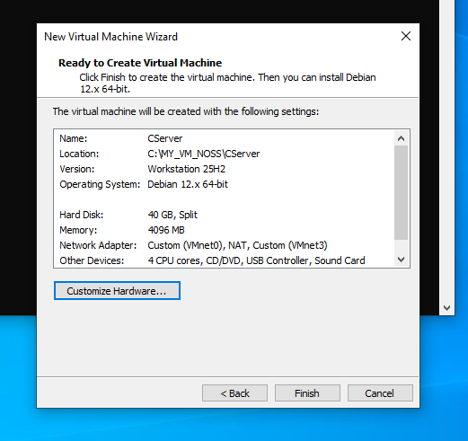
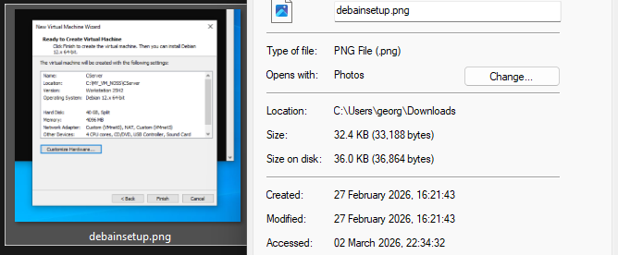
This screenshot shows the Debian server virtual machine configured with a 40GB hard disk, 4GB of memory, 4 CPU cores, running Debian 12, and connected to network adapters VMnet0 and VMnet3.
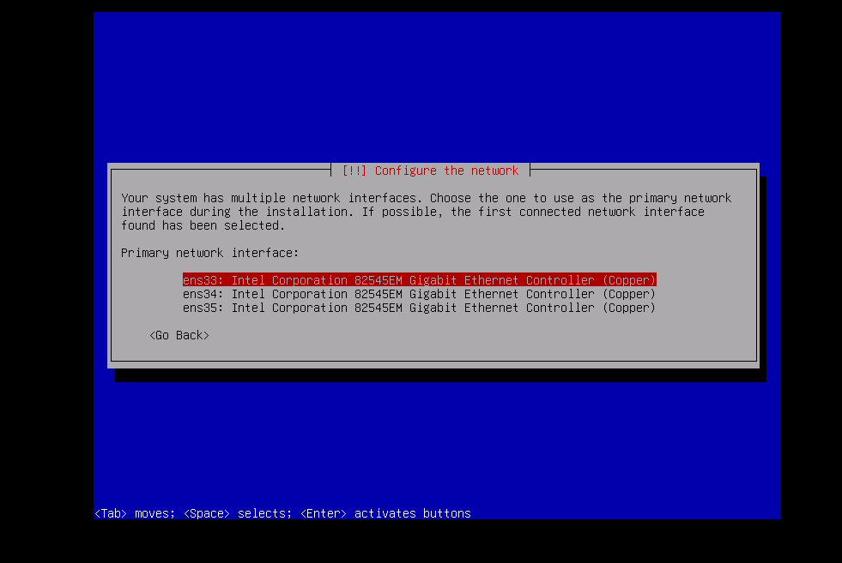
This screenshot shows me configuring the network on the Debian server which was ens35.
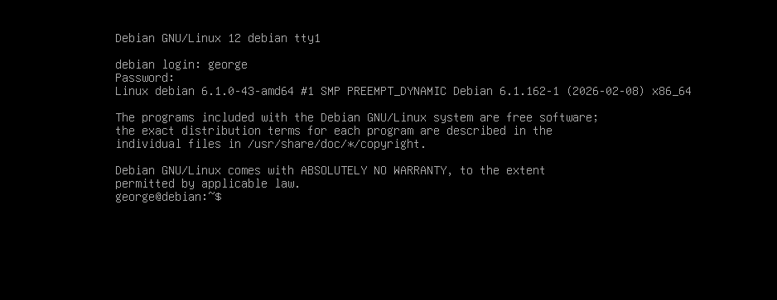
The screenshot above shows a successful login to the Debian system through the terminal using the username “george” which I setup. This means the command line system is ready to be used.
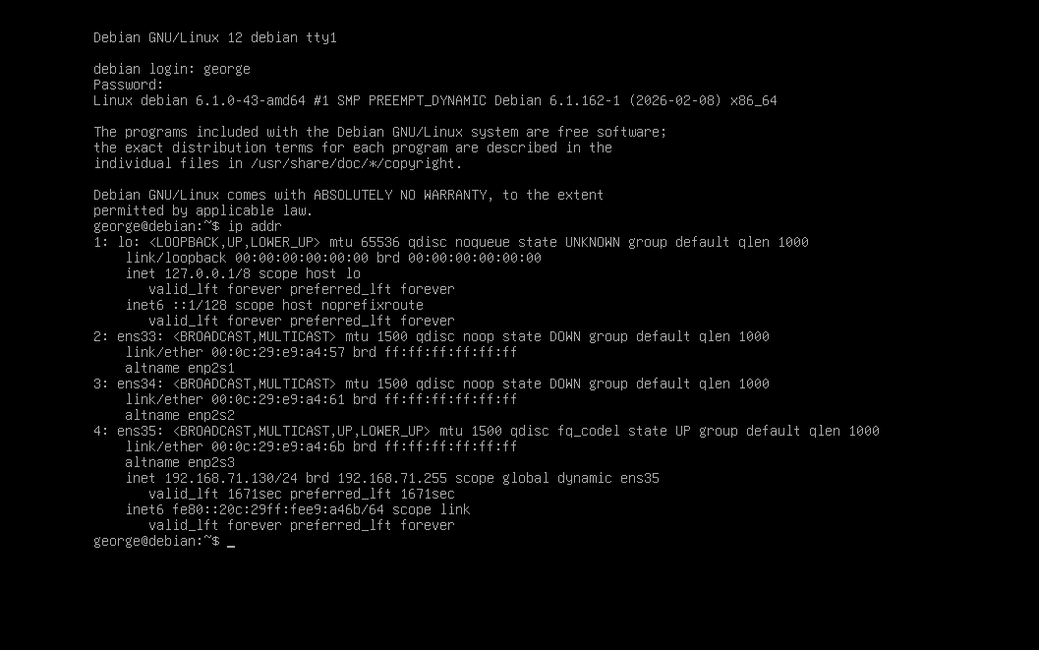
Now the image shows a successful login to a Debian 12 system and the execution of the ip addr command to display network interface details. It confirms that interface ens35 is active with the assigned IP address 192.168.71.130/24.
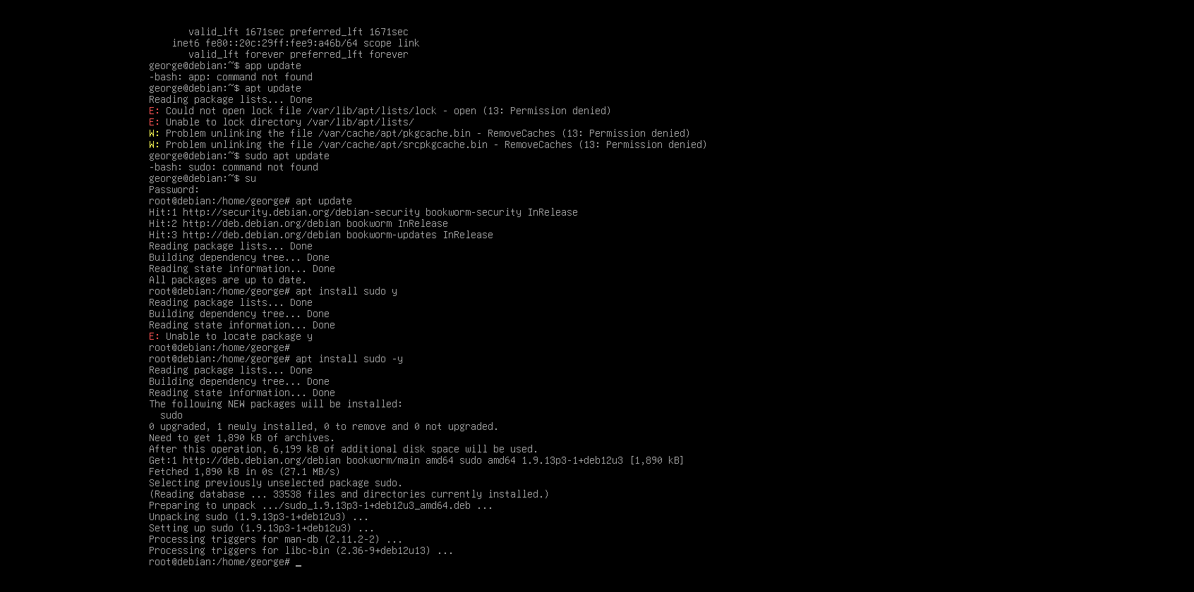
Then the screenshot shows the me attempting to run apt update without sufficient permissions, resulting in “Permission denied” errors. Then I switche to the root account using su, successfully updates the system, and installs the sudo package correctly using apt install sudo -y.

Overall separate virtual machines were made for:
- Windows Server 2022
- Debian Server
- Client Machine
To simulate the network segments, virtual switches were used to connect each system. Resource allocation was set up to maintain effective hardware utilisation while maintaining a steady performance.

2.3 Configure IP Addressing
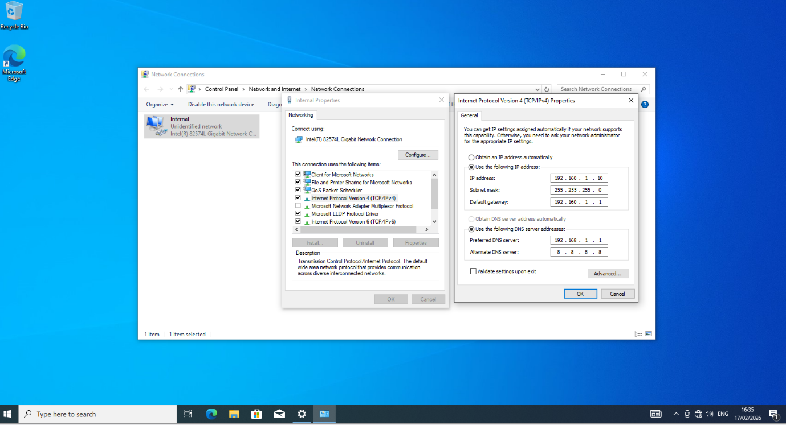
This screenshot shows the manual IPv4 configuration of the client machine where a static IP address, subnet mask, gateway, and DNS server were assigned.
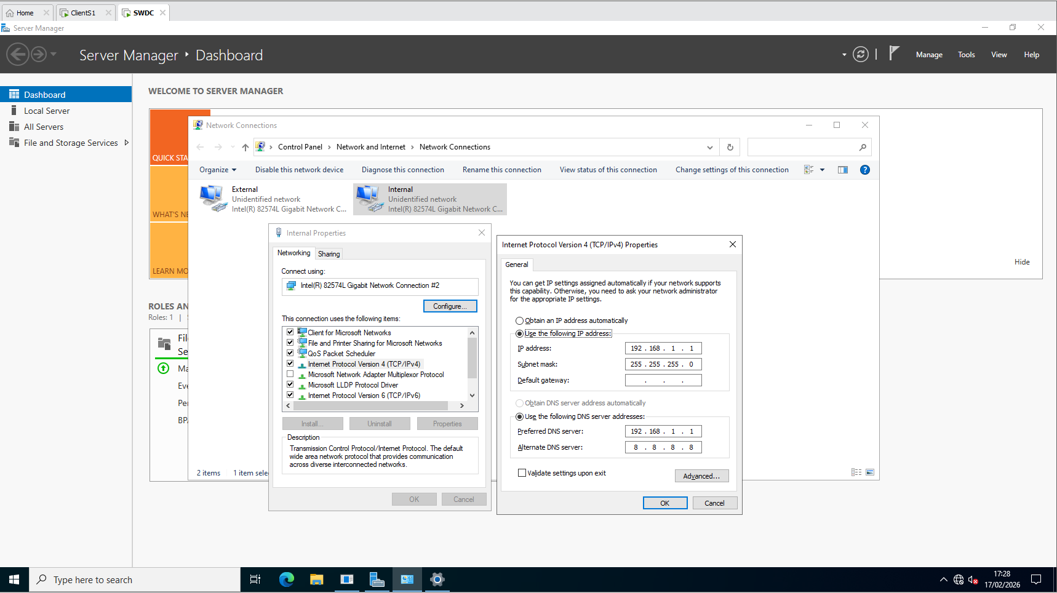
This screenshot shows the Windows Server network adapter configured with a static IP address to act as the internal network server and DNS provider.
The Ip addresses were configured manually using the IPv4 properties within Network Connections to ensure controlled communication between virtual machines. Static addressing was used instead of automatic configuration so that each device maintained a consistent identity within the network.
The server was assigned the address 192.168.1.1 with a subnet mask of 255.255.255.0, allowing it to function as the main network service provider and server. The client machine was configured with the address 192.168.1.10 within the same subnet and used the server’s IP address as its preferred DNS server. The default gateway was also configured to enable future routing functionality.
This configuration ensured both systems were placed within the same network range, allowing connectivity testing to be performed.

2.4 Test and Troubleshooting
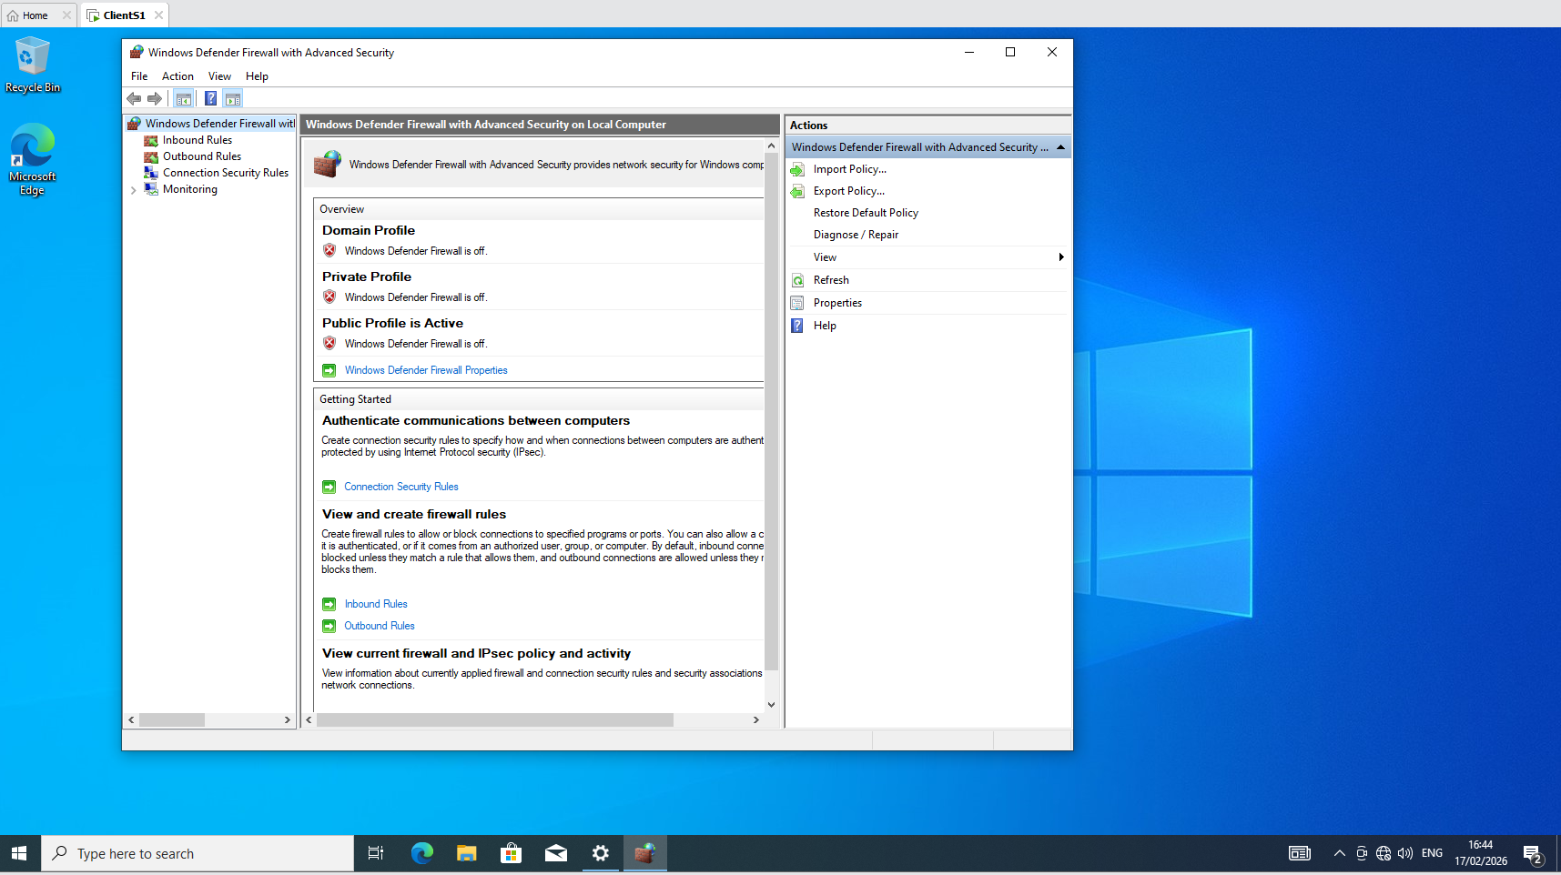
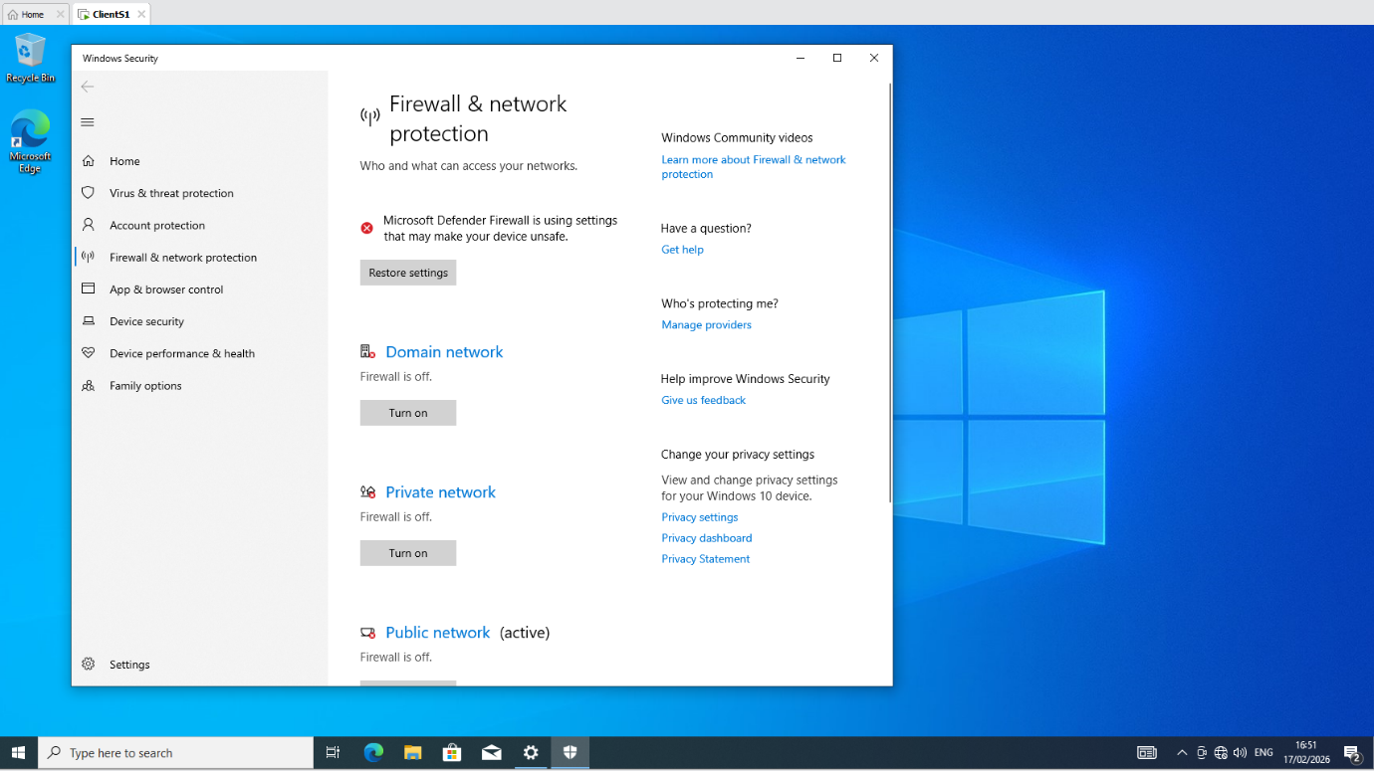
The screenshots shows the client machine’s Windows Defender Firewall being disabled to allow network connectivity testing and troubleshooting.
Connectivity testing was performed using the ping command to verify communication between devices. Initially, connectivity within the same network was unsuccessful even though Ip addressing was correctly configured. After investigation, it was identified that the Windows Firewall was blocking the ping requests, preventing responses.
Firewall settings were disabled to see if the issue persisted. When ping tests were repeated the pings became successful. This confirmed that the firewall configuration was the cause of the failure rather than incorrect network settings.
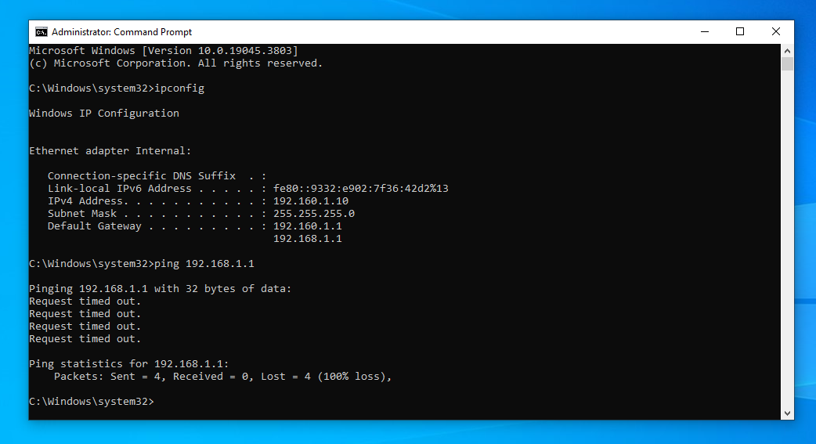
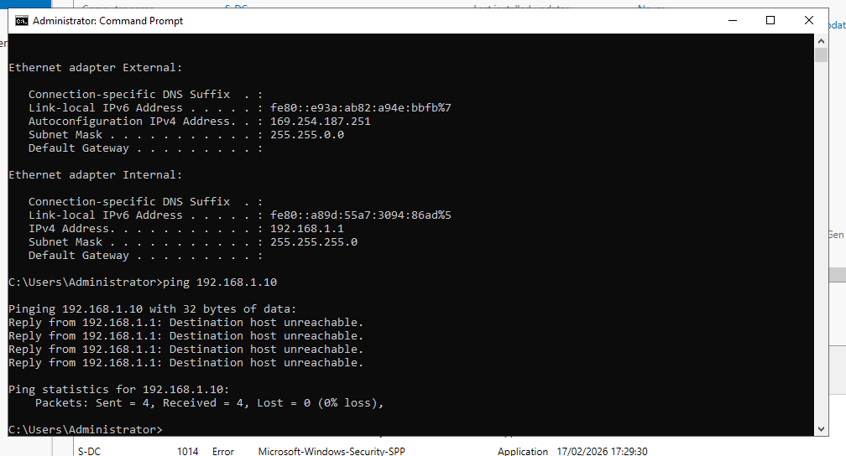
The screenshots above show connectivity failing between the client machine and the Windows Server. The unsuccessful ping results indicate that network communication was not established, suggesting a possible configuration issue such as incorrect IP addressing, firewall restrictions, or network adapter settings
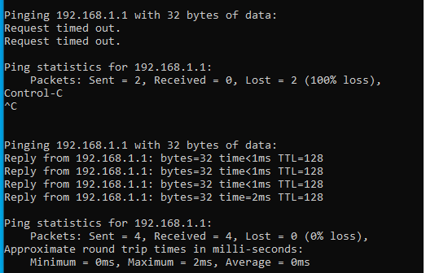
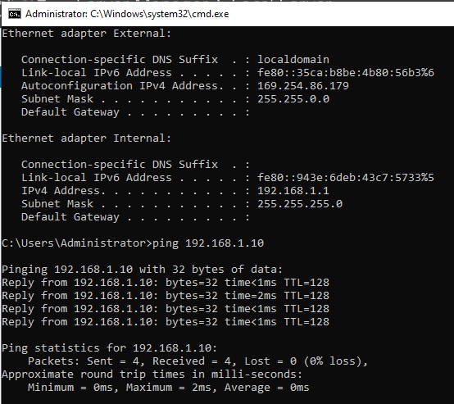
Successful ping responses shown in the images above confirm that the client and server machines are communicating correctly within the same network. The replies indicate that Ip addressing and network configuration have been set up properly, allowing data packets to be transmitted and received without loss. This verifies that basic network connectivity between the client and server is functioning as expected and that there are no issues with routing or network communication.

Task 3
During the network topology setup and testing, multiple deployment issues occurred. The main challenge was getting the virtual machines to communicate after assigning IP addresses. Initial ping tests between devices on the same network failed. I began troubleshooting by using ipconfig to verify IP addresses, subnet masks, and default gateways. This showed me that one machine had an incorrect subnet mask which was placing it on a different network.
However, ping requests were still failing. I then investigated firewall settings on both the server and client virtual machines. The Windows Firewall on both systems was blocking requests, preventing successful ping responses. To figure this out, I disabled all firewall profiles on both the server and client PCs. Once the firewall was turned off, ping tests were successful, confirming that the firewall configuration was the issue. This demonstrated how security settings can directly impact network testing and connectivity.
I was able to put my theoretical networking skills to use in a practical manner thanks to this project. It reinforced how crucial it is to verify setups gradually rather than altering several settings at once. I became more organised and better at managing my time by spreading out the work over several sessions. All things considered, the experience improved my troubleshooting abilities and knowledge of virtualisation and server administration, setting me up for Coursework 2's network expansion.

Citations
[1] “What is a Hypervisor?” https://www.vmware.com/topics/hypervisor
[2] “What is a domain Controller? Definitions, functions, benefits & limitations, and more,” Oct. 20, 2022. https://www.fortra.com/blog/what-domain-controller-definitions-functions-benefits-limitations-and-more
[3] “Hypervisor,” Science Direct. https://www.sciencedirect.com/topics/computer-science/hypervisor
[4] Amazon Web Services, “What is Routing?,” Amazon Web Services, Inc. https://aws.amazon.com/what-is/routing/
[5] “Implementing the network - documentation.” https://docs.rockylinux.org/10/es/books/admin_guide/12-network/
[6] Fastly, “What is a Subnet?,” Mar. 02, 2026. https://www.fastly.com/fr/learning/cdn/what-is-a-subnet
[7] “Network Routing,” Science Direct. https://www.sciencedirect.com/topics/computer-science/network-routing
[8] MikroTik, “BGP vs OSPF vs RIP vs MME - Battle of the Dynamic Protocols,” YouTube. Feb. 11, 2020. [Online]. Available: https://www.youtube.com/watch?v=r8zb-JDBoPI
[9] Amazon Web Services, “What is IPSec?,” Amazon Web Services, Inc. https://aws.amazon.com/what-is/ipsec/
[10] “What are the advantages of DHCP?,” Tencentcloud, Oct. 24, 2025. https://www.tencentcloud.com/techpedia/101149
[11] Robinharwood, “Active Directory Domain Services overview,” Microsoft Learn. https://learn.microsoft.com/en-us/windows-server/identity/ad-ds/get-started/virtual-dc/active-directory-domain-services-overview

