Julia petrencikova

Student number: 2110746
Module Code: BMSW4005_BIRM
Module name: Professional career development
Lecturer’s name: Farah Islam
Title: Reflective Portfolio



CONTENTS

Introduction ……………………………………………………..3
Know yourself……………………………………………………4
Career options…………………………………………………..5
Job research………………………………………………………6
Emerging trends………………………………………………..7
Setting goals and objectives………………………………8
UK Employment law………………………………………….9
Learning theories and self-awareness methods.10
Mock interview and open book assessment…….11
Conclusion……………………………………………………….12
Appendices………………………………………………………13
References……………………………………………………….14

INTRODUCTION

My report aims to reflect on what I have learned in this module and how it helped me in my career development.

It taught me how important it is to be self-aware to choose the right career path. I will be applying analytical tools, such as Johari Window and personality test to make the right career choice in future.

Based on that I will decide to identify my career options and research them using relevant sources, i.e., Linked In, Indeed, not forgetting to be up to date with trends and therefore a strong candidate for a role.

In the last part of my reflective portfolio, I will discuss what I have learned in this module.

KNOW YOURSELF

I have learned that to choose my best career path I need to first have a clear idea about myself and my personality. I need to know my strengths and weaknesses to improve on these. I need to think about when I feel motivated and what are my thoughts and beliefs. This is called self-awareness.

High self-awareness is claimed to lead to better decision-making and is linked to team performance (Harvard Business Review,2015) and authentic leadership (Eriksen, 2009).

Johari Window is a useful tool for identifying our open and hidden areas known or unknown to ourselves and others as well as blind spots and unknown. The idea of the Johari Window is to expand the open area and reduce the unknown. Below is an example of my Johari Window.
 | Known to self | Not known to self
Known to others | Confident  Energetic  Positive  OPEN AREA | Mature  Helpful  Nervous  BLIND SPOT
Not known to others | Sentimental  Organized  Caring  HIDDEN AREA | Adaptable  UNKNOWN

My favourite analytical tool is a personality test.
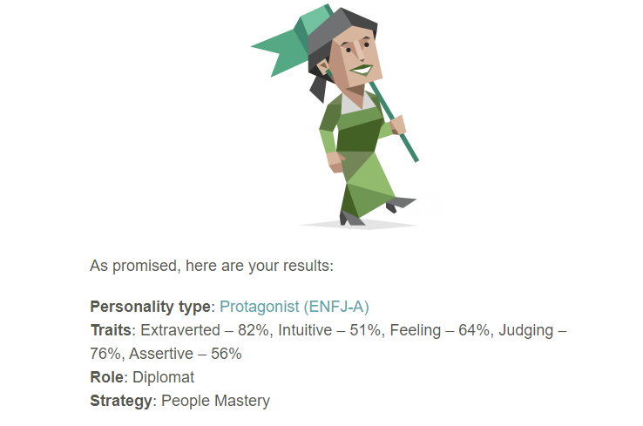

Source: https://www.16personalities.com/enfj-personality

CAREER OPTIONS
According to the results of my personality test, I am going to feel fulfilled in helping people in any work environment. Throughout my career, I have worked in various environments, such as retail, gastronomy, shop floor, and office and currently working from home. I have a passion for helping people and it gives me the drive to do my best.

I have always had a strong desire for development, continuous improvement, and innovation and that is a match for my personality type. I like to feel that I make a difference and I struggle to stay motivated if the work I do is repetitive and inefficient. I also like organization and planning.

My current role is Training Coordinator for LKQ Academy, where I feel fulfilled as I help customers with their training, and I am their first point of contact if they need help.
My manager is very enthusiastic about what we do and that keeps me motivated as well as helping our customers. I feel free to discuss my ideas with the team and I feel listened to and that means a lot to me. We are organising all the training, planning the next year, and keeping up to date with the latest trends in the market, hence why we are number 1 in the UK for delivering training courses for moto industry.

My career development options ranked to my preference are the following:

- Head of Training LKQ Academy- I would like to continue my progression with the current employer and I was clear about my plans with my manager when I applied for my current role. He was happy to hear that, and we discussed my personal development plan as I will need to learn more and develop my skills to meet the requirements for the role, however, once this is satisfied, I believe I will be a strong candidate for the role where enthusiasm, professionalism, good organization skills and expertise are the top requirements. I need to improve especially from the sales point of view, as the ability to sell is important to set a good example and motivation for employees.
- Continuous Improvement Project Coordinator/Manager-due to my personal experience and expertise as well as drive for a change for the better, this role would be attractive and suitable for me. I would feel comfortable applying for this role in our company, where I have a good understanding of processes and therefore my chances to be successful are adequate. I would also consider the opportunity in another company if I felt I match the criteria in the job description.
- Solicitor- ranked as my third desired career path due to lack of expertise and necessary education, however, if I had to choose a new career path I have always had a passion for law. Since high school, the words of Napoleon Bonaparte ‘Liberte, Eternite, Fraternite’ resonated in my mind. I believe if I gained the necessary knowledge, my strong sense of justice would drive me to deliver the best results for my clients.

JOB RESEARCH
I completed a mock interview in Week seven. This was for the role of Business Analyst for LKQ Euro Car Parts (please see the full job description in Appendices).

The role is focused on the branch network in relation to the bonus schemes while working closely with Branch Network, HR, and Finance to build accurate rules for each bonus scheme across the Company. Due to my previous experience as an Operational Trainer, I have a good understanding of the job roles of each individual department and so I would be the right candidate for the role. I am also a good communicator with project planning experience which are the desired skills for the role.

I have started my job research via Indeed, however, I found out that the jobs I am interested in are populated internally, via our internal portal Ecpedia and we also receive our weekly Newsletter called Qlog with job opportunities in LKQ Europe.

I have also researched via LinkedIn where I found some interesting opportunities, however, none of them currently advertised is matching my career paths.

My preferred strategy therefore would be the chat with employers, respectively, my manager. As I mentioned before, I have started my personal development plan in order to progress and achieve my career goals.

Other strategies for finding employment are graduate schemes and internships.

EMERGING TRENDS
It is essential to keep up to date with the latest trends in the job market.
We can call the future our fourth industrial revolution. Automation will be continuously innovated and at some point, it is likely to displace workers, therefore new occupations will be created (Sungsup Ra, et al., 2014).

A powerful tool has been developed for people to understand how they can leverage their talents. It is called Reflective Best Self (RBS) Exercise. The first task is to collect feedback from people inside and outside of work followed by recognizing patterns. Create a table.

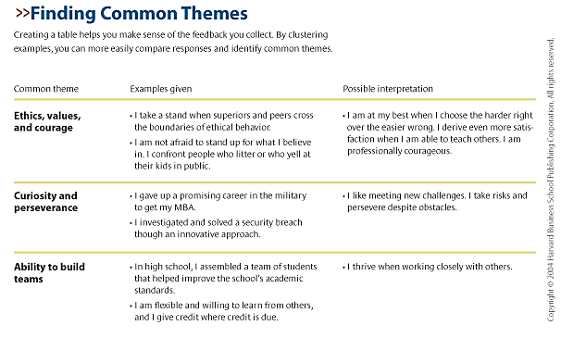
Source: https://hbr.org/2005/01/how-to-play-to-your-strengths.

The last two steps of the RBS exercise are to write a description of yourself summarizing all gathered information and redesign your job description to build on what you are good at (Harvard Business Review, 2019).

A good example of the emerging trend was the situation caused by Covid-19. In Australia, people were forced to find new work. When workers apply leverage in their existing skills, it helps them to face this and many other unexpectable challenges (Dawson, Williams and Rizoiu, 2021).

According to Bakshi et. al., (n.d.) approximately seven in ten people may be uncertain about what will happen in future; however, workforce retraining can help with growth in these occupations.

SETTING GOALS AND OBJECTIVES
I will apply SMART method as a guide for setting goals and objectives.
As mentioned in Criteria for Success, (2018):” The trouble with not having a goal is that you can spend your life running up and down the field and never score.”
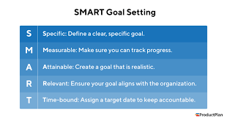
Source: https://www.productplan.com/glossary/smart-goal-setting/

When I started my current role, I have gone through a personal development plan with my manager. I have updated it with what I have learned in this module.

Personal development plan: | Idea: | Progress: | Comments: | Deadline:
Customer visits and Sales Training with Account managers | Increase sales of memberships in my area/ | 3 days with regional account managers next week |  | 31/09/2022
Account manager’s training on how to use LMS | Training of account managers will help me to have more time for continuous improvement/ideas | Planning training sessions in the next quarter. | Challenging to plan it, due to a busy work schedule | 31/12/2022
Visit in ROI and NI | To build a relationship with our colleagues in ROI, NI and increase sales | Completed. | Rapport with ROI improved, and ROI achieved a record in sales. | 31/07/2022
UK EMPLOYMENT LAW
In this module, Week nine was dedicated to getting to know our rights at work as well as the rights of our employer. Work regulations are necessary in order to ensure a fair operation is held in all spheres of business. Without such a law, either employer or employees could face unfavourable treatment, and there would be no remedy to act upon. Therefore, the employment law is an important tool for businesses and employees.

What is covered in employment law?
- age discrimination
- disability
- bullying/harassment
- discrimination
- working hours
- redundancy
- parental leave
- equal pay
- holiday pay
- contract of employment
- dismissal and employee grievance

The rights for employees and workers set out by employment law are slightly different.

As an employee, I have a right to have written terms describing my job description, sick, holiday and parental leave pay as well as the right to claim redundancy after unfair dismissal after two years of service.

The rights of the self-employed are not as complex, however, they are still protected against discrimination or health and safety on a client’s premises (Croner Group,2020).

In my previous job role, as an Operational Trainer, it was my duty to present to our new employees during inductions Health and Safety at Work Act 1974. Employees were therefore trained on the processes and signed off prior to doing their day-to-day job tasks.
New starters were also informed, that if they are not trained to do something, they have a right to refuse work.

SELF-AWARENESS METHODS
I have mentioned in the section Know Yourself Johari Window and personality tests, however, another great tool we have learned about in this module is a Personal SWOT analysis.

SWOT stands for Strengths, Weaknesses, Opportunities and Threats.
Strengths and Weaknesses are internal, and these are the ones you can control or change. Opportunities and threats are external, and you cannot change them, but you can certainly take advantage of the opportunities and protect yourself against threats (Parsons, 2021).

Here is my personal SWOT analysis:

STRENGTHS  TRAINING EXPERIENCE  PROJECT MANAGEMENT EXPERIENCE  ORGANISATION SKILLS  TIME MANAGEMENT SKILLS  ENTHUSIASM | WEAKNESSES  CONCENTRATION  IMPATIENT  LISTENING SKILLS  STUBBORNNESS
OPPORTUNITIES  TRAINING ESTABLISHED IN UK, ROI AND EUROPE  ELECTRIC VEHICLES ARE EXPANDING ON THE MARKET- TRAINING NEEDED | THREATS  COMPETITORS  BREXIT  CRISIS  COVID

LEARNING THEORIES
In Week two, we learned about learning styles. People learn differently and theories are saying that we can be classified by our learning style. I have completed my learning style test and I am a 40% visual learner, 30% tactile and 30% auditory. I have noticed before, that when I am trying to learn something new, I often write it down as it helps me with remembering the information. This is a common thing for the visual learner according to www.educationplanner.org, (n.d).

I will be describing one of the well-known learning style movements.
Kolb’s (1984,1985) learning style is a popular scheme, especially in the United States.
Individuals are differing based on their preferred mode of processing (reflective observation or active experimentation) and preferred mode of perception (abstract or concrete). They are then classified into four categories: divergers (concrete or reflective), convergers (active or abstract), assimilators (reflective or abstract) and accommodators (active or concrete). (Pashler et al., 2008).

MOCK INTERVIEW AND OPEN BOOK ASSESSMENT
I personally enjoy learning by practice. We have had some great opportunities in this module to do that. We started with an open book assessment. At the end of the class in Week three, we have been given a case study to read and reflect on. The following week we had to write 500 words in two hours answering one of the chosen questions. This was done during class time and at the end submitted on Turnitin.

This was a new experience for me as we have never completed an open book assessment in another module. I was worried, that I will be not able to write 500 words answering one question related to the case study, but I believe I have done well in the end. For some, this was the time when they can see how they handle deadlines and work under pressure. I think that this was a good experience for everyone, and I would like to see this in other modules.

In week seven, we had a great opportunity to receive feedback from our lecturer for our mock interviews.

I need to mention, that the date of the interviews was a challenge for me as the day before I sold my vehicle and I had to use public transport to attend. This resulted in me being late. It taught me an important lesson to always plan ahead. I was wearing casual clothes and I expected negative feedback for this, but due to my plans after the interview, I did not have where to change. I would normally choose a smart outfit. I was expecting this interview to last for an hour at least according to my previous experience. It only took a few minutes, which gave me an insight to not assume how long it takes and make the best out of it.
My feedback was mostly positive, there was a comment on thinking prior to talking. This made me smile as I already had this feedback before, so I must work on it. It was priceless to receive this feedback, as I have never received a such detailed response. This experience is very useful for everyone’s career development.

CONCLUSION
Personal career development is one of my favourite modules. I have been able to learn about myself and I used various techniques we have discussed in this module, such as Johari Window, Personal SWOT Analysis and Personality Tests. These tools are priceless when it comes to being self-aware.

Self-awareness is important when it comes to setting goals. I used the SMART method when setting goals and objectives in my personal development plan.

We learned about the employment law, and its purpose. We have experienced how we deal with working under pressure on open book assessment day and finally we have been able to practice with our mock interviews. This module has given us important knowledge and experience for our future success.

APPENDICES

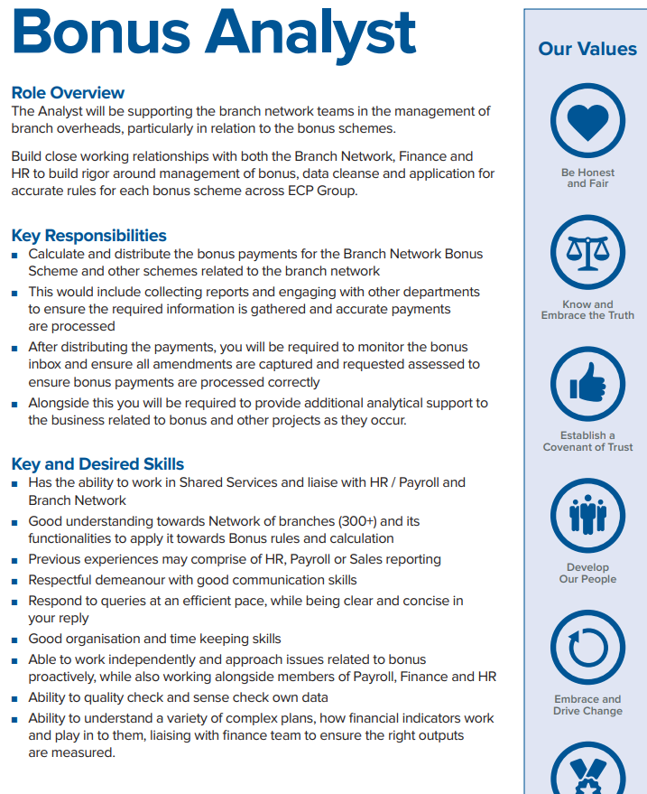
REFERENCES
Criteria For Success. (2018). Let’s Talk Sales! Inspirational Quote by Bill Copeland - Episode 20. [online] Available at: https://criteriaforsuccess.com/lets-talk-sales-inspirational-quote-by-bill-copeland-episode-20/#:~:text=Bill%20Copeland%20Quote&text=Today [Accessed 3 Aug. 2022].

Croner Group (2020). List of Employment Laws in the UK. [online] Croner. Available at: https://croner.co.uk/resources/employment-law/legislation-list/.

Dawson, N., Williams, M.-A. and Rizoiu, M.-A. (2021). Skill-driven recommendations for job transition pathways. PLOS ONE, 16(8), p.e0254722. doi: 10.1371/journal.pone.0254722.

Eriksen, M. (2009). Authentic Leadership. Journal of Management Education, 33(6), pp.747–771. doi:10.1177/1052562909339307.

Harvard Business Review. (2015). Research: We’re Not Very Self-Aware, Especially at Work. [online] Available at: https://hbr.org/2015/03/research-were-not-very-self-aware-especially-at-work.

Harvard Business Review. (2019). How to play your Strengths. [online] Available at: https://hbr.org/2005/01/how-to-play-to-your-strengths.

‌Parsons, N. (2021). What Is a SWOT Analysis, and How to Do It Right (With Examples) | LivePlan Blog. [online] LivePlan Blog. Available at: https://www.liveplan.com/blog/what-is-a-swot-analysis-and-how-to-do-it-right-with-examples/.

‌Pashler, H., McDaniel, M., Rohrer, D. and Bjork, R. (2008). Learning Styles: Concepts and Evidence. Psychological Science in the Public Interest, [online] 9(3), pp.105–119. doi:10.1111/j.1539-6053.2009.01038. x.

Ra, S., Shrestha, U., Khatiwada, S., Yoon, S.W. and Kwon, K. (2019). The rise of technology and impact on skills. International Journal of Training Research, [online] 17(sup1), pp.26–40. doi:10.1080/14480220.2019.1629727.

‌www.educationplanner.org. (n.d.). What’s Your Learning Style? 20 Questions. [online] Available at: http://www.educationplanner.org/students/self-assessments/learning-styles-quiz.shtml?event=results&A=6&V=8&T=6.

‌

‌

