STUDENT: RINA SALIQUE – 1806203
LECTURER: CHRISTOPHER MAFUVA
DATE: 30th APRIL 2019

Why are taxi firms closing down in the UK?
Are the online firms safe and secure?

Abstract
The research is focused to identify the main reasons of closing down of taxi firms over the online services like Uber. The research discussed the various reasons to enhance and expand the market of Uber like e-hails services over the offline taxi firms. The study has conducted primary research with survey to find and conclude the reason of safety and security concerns for the study.

Acknowledgement
I am thankful to my professors and friends to help me conducting the research. I would like to thank to the respondents to help me for conducting the primary research.
Table of Contents
1.0 INTRODUCTION 4
2.0 BACKGROUND 4
2.1 Reasons of decreased rate of taxis 4
2.2 Advantages and disadvantages of online services 5
2.3 Impact of online services on offline taxi firms 5
2.4 Literature gap 6
3.0 AIMS AND OBJECTIVES 6
4.0 METHOD 6
5.0 RESULTS 7
6.0 DISCUSSION 12
7.0 CONCLUSION 13
Reference list 14
Appendices 15
Appendix 1: Questionnaires 15

1.0 INTRODUCTION
The online facilities like Uber have influenced the personal transportation industry like taxis in recent times. The taxi firms are recently closing down as per increased demands of online facilities like Uber (Calo and Rosenblat, 2017). Personal transportation industry in the UK is facing changes as introducing of online applications. Security and safety are considered as well issues for decreased demand of taxis. The issues are found to establish the reasons of closing down and comparison with offline transportation with online transportation (Cramer and Krueger, 2016). The research sheds light on economic failure of taxi industry due to increased demand of Uber. The study will analyse the reasons of closing down of taxis and reasons for Uber’s drastic affect transportation industry in worldwide. The research will focus on issues regarding safety and security of offline taxi industry and expansion of online facility like Uber.

2.0 BACKGROUND

2.1 Reasons of decreased rate of taxis
Price competition and safety concerns have negative impact for offline taxi firms. Low prices for drivers can be considered as main reason to enter e-hail service providence. Safety concerns for online services are more popular than the offline taxi industry, which can be thought as significant reason of closing down. As evidenced by Wallsten (2015), dynamic pricing in the offline taxis are the main reason to decrease the demand in front of online services. New trend for Uber like online industries created challenges to those transport authority, while existing the managing impacts, licences legislation, installing a safe and secure service are considered as a concern of the industry. Online facilities including developed and innovative technological implementation and pricing comparison are developed as main issues to close down by the offline taxi firms (Geradin, 2016). Technological advancements are mentioned as developing the concerns as main resource to get benefits in transportation sector. The pricing strategy and profits are taken as another reason to close down. Safety and security of the taxis are matter of concerns as indicating by the recent study (Rogers, 2015).

2.2 Advantages and disadvantages of online services
Advantages:
Online facilities provide cashless and online transaction, which is considered as great facility by the customers. Instead of chasing any taxi and fixing price with them, it is better to book via mobile phone (Paronda et al., 2017). The e-hail services are more convenient and easy to use for booking cab where required. In the case of offline taxis, exchange of cashes and exact location are matter of concerns while, in e-hail services, it gives facility like cashless and online transactions with bank account. In major cities in the UK, the most of cars are chauffeured and maintained to provide professionalism towards the customers. It is effective to provide a professional approach to attract more customers. The cannot charge extra in any condition as all the details are recorded digitally. As opined by Smith (2016), the current demand of online services makes it famous as the cars and drivers are available in most of areas covering the country. Competitive pricing and safe and flexible riding are the keys advantages of the services. Low rating and unsafe behaviour of drivers has observed and monitored by the authority of online services and they take steps against the drivers. Cheap prices and readily available cars are being the more demanding towards the customer (Chan, 2019).
Disadvantages:
Surge pricing of online services are controversial for most customers. Depending on the increased demand, prices of the e-hail services are decreased by certain percentage at the peak time. Trip cancellation can be a disadvantage for the services while low fare affects driver's earning negatively. Price competition in online facilities like Uber, Lyft and other services are matter of battles to provide cheapest service. The driver of online service only knows the passenger's destination and then the fare starts (Rogers, 2015).

2.3 Impact of online services on offline taxi firms
Since the online services as Uber has launched, the taxi firms is facing economic loss. As per the view of Cheewathanakornkul and Jiratchot (2018), safety concerns and chasing the offline taxis are not preferred by most of the users. Cashless transactions and availability of cars are being preferred by most of the customers. It easy to book online cab in state of chasing them in street where required. Uber like online facilities have negative impact on offline taxi industry due to increasing demand and innovation techniques of the e-hail services. The records of passengers are kept and located by the online applications for safety purposes of the users. Passengers are always able to track the driver's current position and location and they can communicate with each other for necessary situation (Hall, 2018). While the driver accepts the assignments, driver cannot refuse a reject the passenger in any situation.

2.4 Literature gap
The literature is considered to focus on services used and developed of online services in worldwide. Any particular geographic region is not concerned while searching the literature for the study. There has been a gap that overall online taxi industry has been conducted to compare with the offline taxi firms. Comparison with other e-hail services other than Uber has not been chosen to conduct the study.

3.0 AIMS AND OBJECTIVES
The aim of the research study is to identify and focus on the reasons of closing down of uses of offline taxi firms due to increased demands of Uber like online services.
The objectives of the research are:
- To identify the reasons of closing down of most of offline taxi firms
- To analyse the facilities given by Uber like e-hail service with safety and security towards customers
- To recommend the effective strategies for developing service of taxi firms for competing with Uber

4.0 METHOD
The research was conducted to evaluate and establish the research objectives. The research methodology part identifies and considers the research layout to establish and focus on collecting and analysing the data on the current research study (Alvesson and Sköldberg, 2017). In the current research process, positivism philosophy, deductive research approach and descriptive research design were chosen to conduct the study. Research philosophy and approach are essential to identify the research methods how it is evaluated and considered in the context of developing the main reasons of closing down of the taxis. Research designs help to create and develop appropriate research layout and concept for developing and establishing the research study.
Primary data analysis was conducted with participants to conclude the findings for the recent study. Primary research is important for any research to cure and collect raw data and analysing the collected data. Quantitative data analysis including survey was conducted for the study. 30 taxi drivers as sample size were taken to conduct the survey with developing specific questionnaires. Simple random sampling method was conducted to choose the participants for conducting the survey.
The data regarding taxi firms regard the conceptualized for non-commercial purpose. Data and information of respondents are not disclosed for any commercial or different purpose in future. Data protection act was applied and research ensured that any data was not tampered and manipulated. Proper referencing and in texting have been done to develop the study.

5.0 RESULTS
Q1. Uber is more preferable than offline taxis.

Options | Number of respondents | Total number of respondents
Strongly agree | 10 | 30
Agree | 15 | 30
Neutral | 2 | 30
Disagree | 2 | 30
Strongly disagree | 1 | 30
Table 1: Uber is more preferable
(Source: Created by Author)
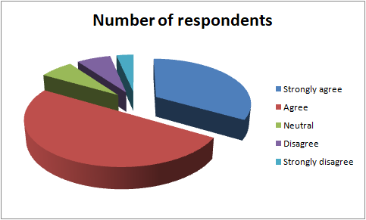
Figure 1: Uber is more preferable
(Source: Created by Author)
Q2. What is reason of closing down of taxis?

Options | Number of respondents | Total number of respondents
Price | 5 | 30
Unavailability of cars | 6 | 30
Cash exchange | 2 | 30
Security and safety | 17 | 30
Table 2: reason of closing down of taxis
(Source: Created by Author)
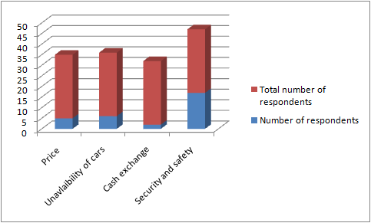
Figure 2: reason of closing down of taxis
(Source: Created by Author)
Q3. Is Uber dominating the transportation industry in the UK?

Options | Number of respondents | Total number of respondents
Yes | 19 | 30
No | 2 | 30
Maybe | 9 | 30
Table 3: Uber dominating the transportation industry
(Source: Created by Author)
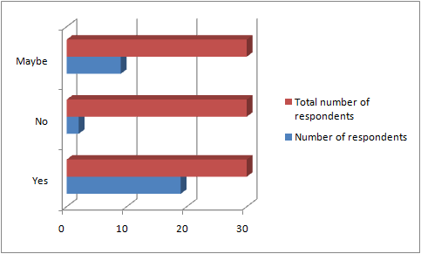
Figure 3: Uber dominating the transportation industry
(Source: Created by Author)
Q4. Uber like other online services are expanding and grabbing the personal transportation industry in recent times.

Options | Number of respondents | Total number of respondents
Strongly agree | 5 | 30
Agree | 18 | 30
Neutral | 5 | 30
Disagree | 1 | 30
Strongly disagree | 1 | 30
Table 4: Uber like other online services are expanding
(Source: Created by Author)
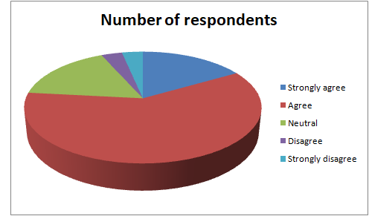
Figure 4: Uber like other online services are expanding
(Source: Created by Author)
Q5. Why is Uber becoming so popular?

Options | Number of respondents | Total number of respondents
Technological advancements | 6 | 30
Easily available | 8 | 30
Safe and secured | 10 | 30
Cashless and online transaction | 5 | 30
Better professionalism | 1 | 30
Table 5: popularity of Uber
(Source: Created by Author)
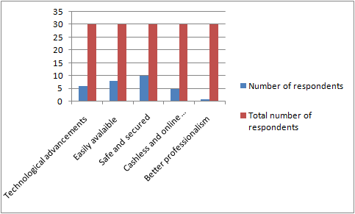
Figure 5: Popularity of Uber
(Source: Created by Author)

6.0 DISCUSSION
From the above results, it is clear that Uber is more preferable among users than the offline taxis. From the figure 1, it is found that 15 out of the respondents agree with the question while 1 out of 30 respondents strongly disagreed with the question. It is more popular among the users because it has the advantage over the offline taxi industries. It is clear that the closing down of taxis have some accurate reasons including pricing, unavailability of cars, security and safety and cash exchange issues which have been identified. From the table 2, it is clear that safety and security is considered as main reason of closing down the taxi. 17 out of 30 respondents considered security and safety option as highest concerns of closing down of the taxi. It can be said that the offline taxi firms are closing down due to insufficient security, cash problem and unprofessionalism of the drivers. From the above result, it can be said that Uber like online facilities have become so popular and people are liking the online services more than the offline taxi. From the figure 3, it is clear that Uber is dominating the transportation industry mainly in the UK. 19 out of 30 respondents said yes that the Uber is dominating the transportation industry. 2 out of 30 respondents said no to this question. Due to the increased growth, popularity and demand of online facilities, offline taxi industry is facing economic loss currently. From the table 4, it can be said that Uber like online services are expanding nowadays. From the result, it can be said that 18 out of 30 respondents agreed that the Uber is expanding and grabbing the personal transportation industry. 5 out of 30 respondents strongly agreed with the question as they think online services like Uber and others applications are expanding and grabbing the sector over traditional taxi firms. From the table 5 it is clear that Uber is becoming so popular due to technological advancements, easily availability, cashless and online transaction facility, safe and secured journey and better professionalism to attract more customers. From this figure, it can be said that am out of 30 respondents think that safety and security is the main factor for Uber being popular. 8 respondents think that easily availability of the cars are the reason for the popularity of Uber like services. 6 respondents think that technological advancement is the reason for Uber to become popular.

7.0 CONCLUSION
From the study, it can be concluded that a combination of factors are responsible to close down of taxi firms and to face the economic challenges over the e-hail services. In recent times the e-hail services are becoming popular and famous due to giving the extra facility and support for the users by attracting the users. As a concern of safety and security, it is clear that taxi firms are closing down in compare to e-hails service like Uber.
The taxi firms can be recommended that
- They can offer online payment mode as option besides the offline payment for attracting more customers.
- Taxi firms can reduce the price over the online services in personal transportation industry.

Reference list
Alvesson, M. and Sköldberg, K., (2017). Reflexive methodology: New vistas for qualitative research. Sage.
Calo, R. and Rosenblat, A., (2017). The taking economy: Uber, information, and power. Columbia Law Review, 17(2), pp.1623-1690.
Chan, N.K., (2019). “Becoming an expert in driving for Uber”: Uber driver/bloggers’ performance of expertise and self-presentation on YouTube. New Media & Society, p.1461444819837736.
Cheewathanakornkul, C. and Jiratchot, C., (2018). Customer satisfaction and word of mouth towards online taxi providers: a case study of Grab and Uber. Journal of Supply Chain Management Research and Practice, 12(1), pp.66-76.
Cramer, J. and Krueger, A.B., (2016). Disruptive change in the taxi business: The case of Uber. American Economic Review, 106(5), pp.177-82.
Geradin, D., (2016). Online Intermediation Platforms and Free Trade Principles–Some Reflections on the Uber Preliminary Ruling Case. Available at SSRN 2759379.
Hall, J., (2018). Digitalization of Facility Management: Financial Incentives.
Paronda, A.G.A., Regidor, J.R.F. and Gaabucayan-Napalang, S., (2017). An Exploratory Study on Uber, GrabCar, and Conventional Taxis in Metro Manila. University of the Philippines.
Rogers, B., (2015). The social costs of Uber. U. Chi. L. Rev. Dialogue, 82, p.85.
Smith, J.W., (2016). The Uber-all economy of the future. The Independent Review, 20(3), pp.383-390.
Wallsten, S., (2015). The competitive effects of the sharing economy: how is Uber changing taxis. Technology Policy Institute, 22(3).

Appendices

Appendix 1: Questionnaires
Q1. Uber is more preferable than offline taxis.
- Strongly agree
- Agree
- Neutral
- Disagree
- Strongly disagree
Q2. What is reason of closing down of taxis
- Price
- Unavailability of cars
- Cash exchange
- Security and safety
Q3. Is Uber dominating the transportation industry in the UK?
- Yes
- No
- Maybe
Q4. Uber like other online services are expanding and grabbing the personal transportation industry in recent times.
- Strongly agree
- Agree
- Neutral
- Disagree
- Strongly disagree
Q5. Why is Uber becoming so popular?
- Technological advancements
- Easily available
- Safe and secured
- Cashless and online transaction
- Better professionalism

