The uncomfortable chaos
2400853
Graphic design BA(Hons)
Word count = 1,500
Donna Williams

For this assessment, I confirm that I have NOT used Generative AI to support me in structuring my submission, including creating a draft argument structure, identifying parts and headings. I confirm that I have not used Generative AI to create text for my submission. I confirm that I have not used Generative AI for creative materials, such as images.

The uncomfortable chaos
This exhibition is an exploration of how chaos can be used within art to evoke feelings of uncomfortableness and unease. Often throughout our lives we live in a constant state of comfort, especially nowadays in a contemporary world full of phones, self-checkouts, and uber eats, Living in the comfort zone. Occasionally we try to escape the chaos of the world around us, it will never disappear so it must be embraced. As Elizabeth Grosz states, art comes from the feeling of disruption and instability, which is where chaos becomes a rich component that creates new sensations and experiences rather than something purely negative (Grosz, 2008). Similarly, Martin Meisel says that people try to organise and control the world, but underneath this there’s a persistent awareness of disorder and unpredictability that artists often seek to visualise (Meisel, 2016). Regarding this, the selection of works I have chosen each have their own stories, evoking different feelings but with the same message.

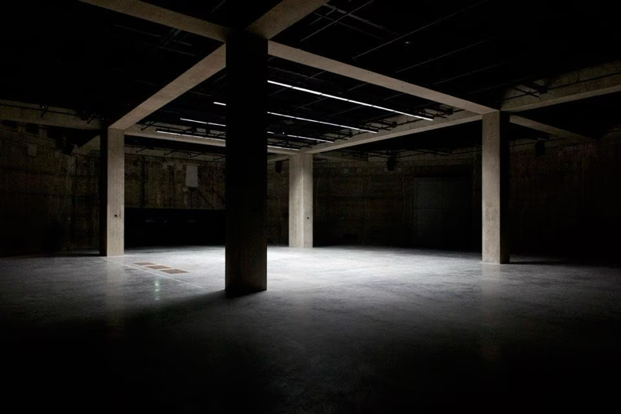
Figure 1, (The Tate modern, 2016, The Tanks)

The exhibition will be held in the Tate Modern on floor 0, the tanks which is quite a dark and eerie space. There is no natural lighting which will enhances the artefacts emotional intensity for its viewers. The absence of natural light and an enclosed atmosphere make the space perfect for provoking strong emotional and sensory responses for my exhibition. According to Claire Bishop. She argues that installation art often aims to disrupt the viewers comfort, she states that they “address the viewer directly as a literal presence in the space” (Bishop, 2005, p.10).

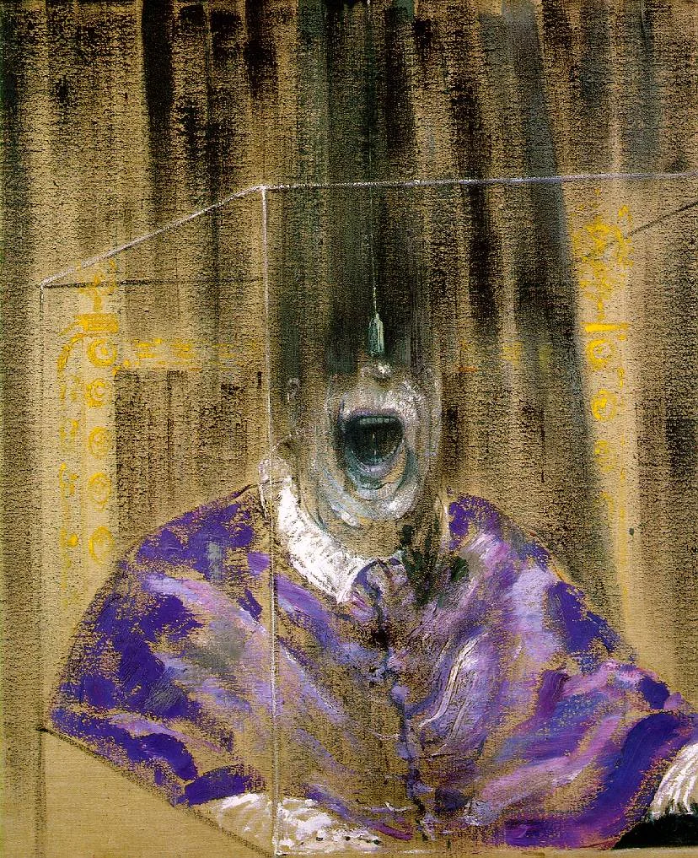
Figure 2, (Francis Bacon, 1949, Head VI)

To open the exhibition with this piece helps give viewers an insight into what’s in store for the rest of their artistic chaotic feast. It draws the viewer in and for some people they might take a long glance at it and others may look away. It’s uncomfortable to look at, at a first glance it almost looks like the figure is screaming out of the painting. Historically, ‘Head VI (1949) is linked to the aftermath of World War 2 and during this time many artists started rejecting the traditional ideas of beauty and realism, eventually they started using distortion to express anxiety about what was to come for the modern world at this time. Francis Bacon became known for his disturbing, fragmented figures that reflect what David Sylvester describes as a desire to capture the “brutality of fact” rather than idealised human representation (Sylvester, 1987). The distorted figure creates a sense of psychological tension and discomfort due to the stressed paint marks and lack of human form. It certainly captures my theme well through the feeling it gives to anyone’s sight it captures.

Philosopher Gilles Deleuze argues that Bacon’s work is not about storytelling but about producing a direct emotional and physical response, he describes it as “painting the sensation” rather than representation (Deleuze, 2003). This explains why the distorted face and screaming wide mouth creates such a strong feeling of discomfort and tension. This could be very unsettling to younger people as “children are more vulnerable to fear responses because they have not yet fully developed the cognitive ability to distinguish between representation and reality” (Gerrig and Zimbardo, 2002). This is relevant for my exhibition as a whole, not just this singular art piece.
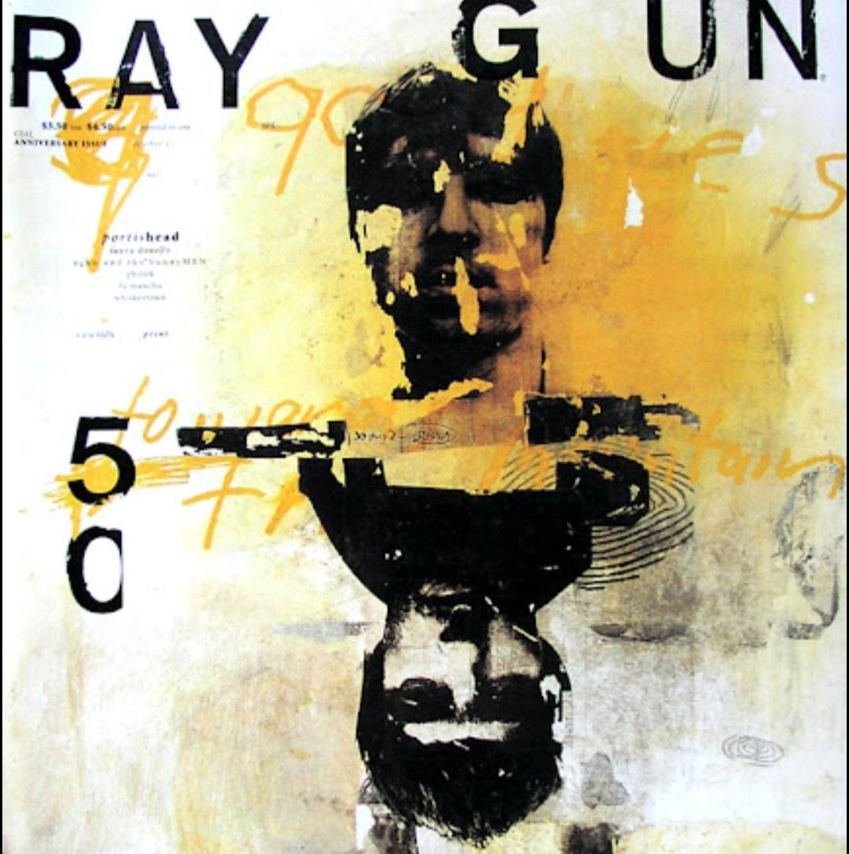
Figure 3, (David Carson, 1992, Ray Gun magazine spread)

This second piece was created for the magazine Ray Gun by David Carson; it reflects contemporary mixed media and graphic design and has clearly been influenced by post modernism. Carson is very well known for rejecting traditional design rules and he instead embraces what he describes as “intuitive design” (Carson and Blackwell, 2000). In this piece the face is partially obscured as well as distorted, which creates a sense of visual chaos and instability. On top of this, the use of layered textures, imagery and text suggests possible themes of identity fragmentation and media influence which relates to contemporary art and the post-modernism era.

Furthermore, this artwork uses misalignment, layering, and abstraction to create the feeling of discomfort and confusion which indicates how identity and meaning can become unstable in at times a chaotic media-driven world (Poynor, 2003). I think the world often strives for perfection and control leaving little room for chaos and the uncomfortable to really thrive. This is often portrayed through beautiful glamorous models, social media influencers, and the government, reflecting what Jean Baudrillard describes as a culture of “simulacra”, where representations replace reality (Baudrillard, 1981). Another aspect of this design that stands out is that it looks dirty with the texture that has been used as well as colour. The limited palette of black and white, and a muted yellow creates a sense of decay and unease in the work. As well as this the rough layered textures give the surface a distressed almost dirty appearance. This disrupts visual clarity, reinforcing instability and fragmentation, and as Rick Poyner states, postmodern design “breaks the rules of clarity and coherence”, embracing disorder to reflect contemporary culture (Poynor, 2003).
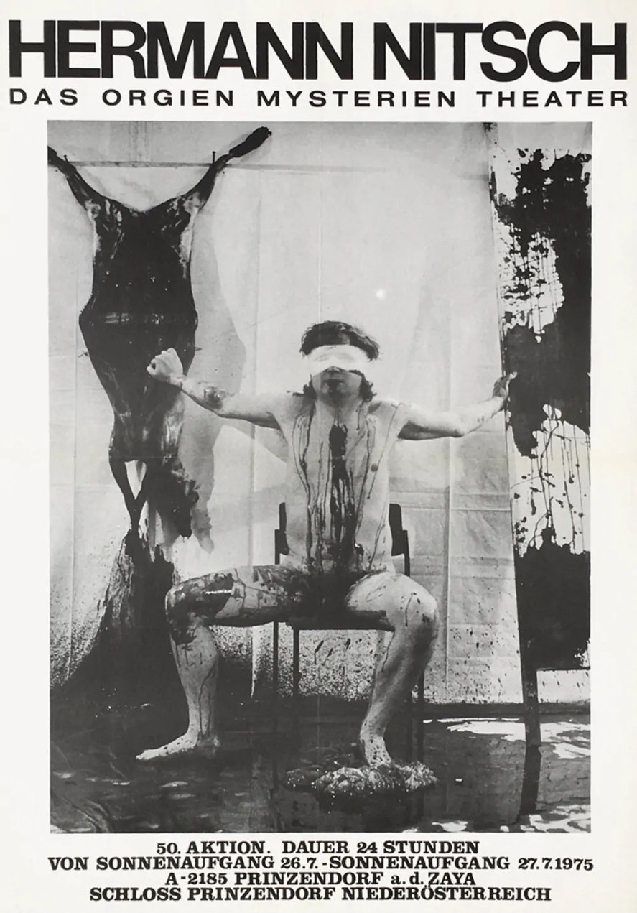
Figure 4, (Hermann NITSCH, 1975, EXPO 75)

At a first glance, this is both shocking and unsettling, forcing the viewers into an immediate emotional reaction before even thinking about interpreting it, this poster is extremely provocative. The figure firstly invites the viewer’s gaze by being blindfolded and with very little clothing on. This poster is made for a performance as part of Das Orgien Mysterien Theater by Hermann Nitsch. John Beger states, “seeing comes before words”, which proposes that the viewers immediate visual reaction is greater than their mental interpretation (Berger, 1972). This is particularly relevant, as the shocking and uncomfortable imagery pushes the viewer into an instinctive emotional response before they’re able to rationalise what they are seeing. For the viewer when they look at this, I feel there would be this feeling of avoiding eye contact with the poster due to its horrific nature. I felt this when I discovered the poster and sat uncomfortably with it. There’s nothing appealing or nice about a person with a blindfold sat in what looks like a pool of blood. There might be emotions that arise for the viewers that they might not want to encounter, such as sadness, remorse, disgust, or even anger. For me, I felt disgust and concern looking at the figure. What has happened to this person, have they been tortured, what are they feeling. Without context we truly cannot know and can only assume the worst.

The use of the blindfold shows a loss of control and vulnerability in the figure, which reinforces the uncomfortable dynamic between the viewer and the poster. The figure in the poster has a lack of clothing as well as a stressed posture which I believe is intentional to capture its audience. In doing so the themes of exposure and sacrifice are brought to light which are central to Nitsch’s practice, connecting the poster to the performance. As Amelia Jones argues, “Body art is specifically geared toward the de-sublimation of the art object…and the articulation of the body as a site of subjectivity” highlighting how it creates a more direct experience for the people seeing it (Jones, 1998).
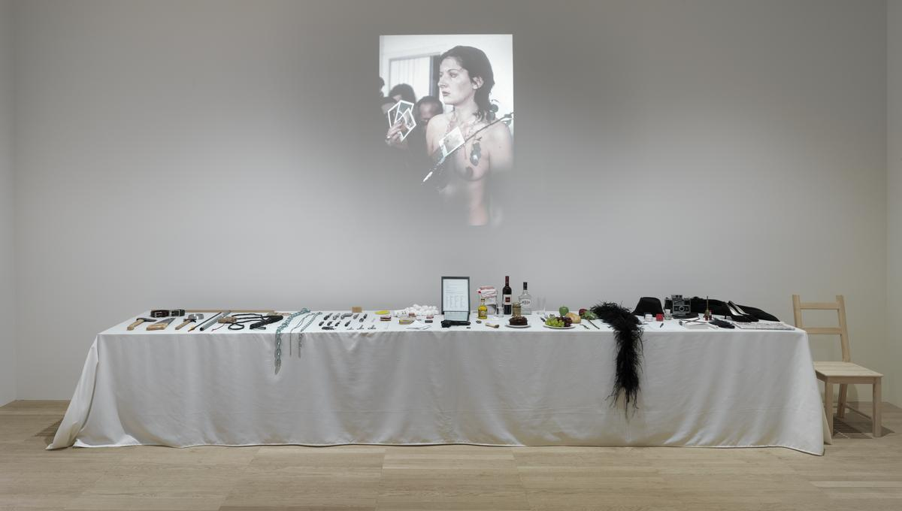
Figure 5, (Marina Abramovic, 1974, Rhythm 0)
Over six hours Marina Abramovic created a performance that now remains one of the most well-known yet dangerous experimental art piece in history. By allowing the audience to use objects on her body without consequence, Abramovic removed the boundary between artist and viewer, demonstrating how fast passive observation can turn into active participation. As Claire Bishop states, “Participatory art seeks to collapse the distinction between performer and audience.” (Bishop, 2012), Which is evident as viewers became responsible for the outcome of her work. This piece exposes the darker aspects of human behaviour, Abramovic states, ‘the audience can kill you if the opportunity is given.’ (Abramovic, 2016). When people are told they can do whatever they like to a person especially a woman in this case I believe people would and do. It reveals how lack of accountability can lead to violence. In relation to this Amelia Jones says that “the body is the primary site of meaning” (Jones, 1998). This suggests how Abramovics physical presence becomes the medium through which power vulnerability and control are explored.
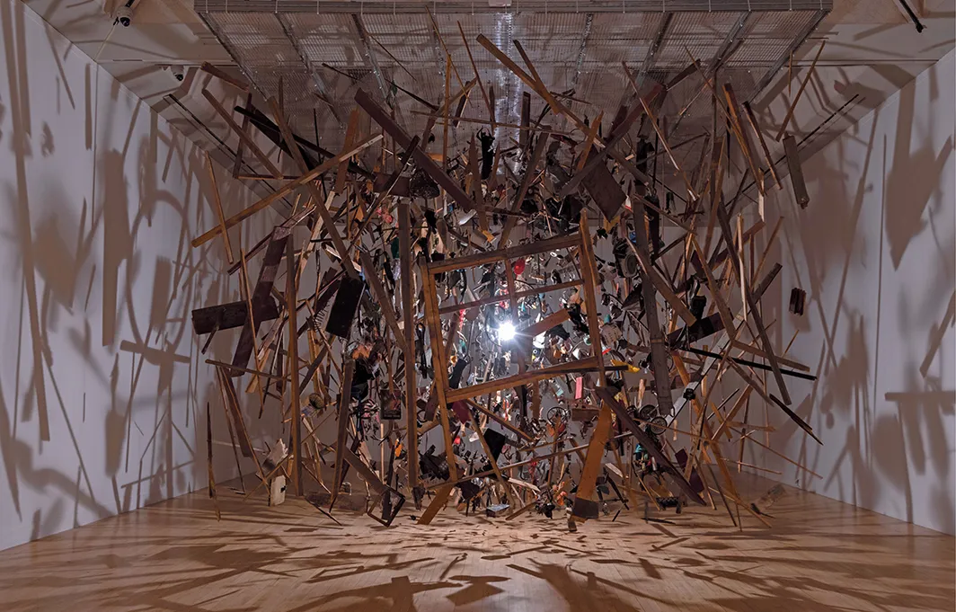
Figure 6, (Cornelia Parker, 1991, Cold Dark Matter: An exploded view)

To close the exhibition, I chose this final piece which I feel is quite beautiful despite what others might think, such as chaotic, random objects, or even boring. However, there is a much deeper meaning into this piece, and I chose it primarily for this reason. This artwork is made from wood, metal, plastic, ceramic, paper, textile, and wire but comes from much more than these materials. In combination and put together hung in the air this piece is messy and all over the place. Parkers practice is with the idea of transformation through violence where ordinary objects are altered to reveal new meanings. As parker states, she is interested in “the moment of transformation”, capturing the instant where an object shifts from one state to another (Parker, cited in Tate, 2015).

These found objects are destroyed yet resurrected through the act of destruction rather than being restored to their original function or value. This reflects what Roland Barthes describes as the “death” of the original object or meaning, leaving room for new interpretations to come about (Barthes, 1977). The violent explosion represents uncontrollable chaos, while Parkers intricate arrangements of the fragments introduce order and structure to this explosive work. Eizabeth Grosz argues, art often frames chaos in a way that makes it meaningful, which transforms disorder into an aesthetic experience (Grosz, 2008). Overall, this section of my exhibition invites its viewers to reflect on themes of transformation and the tension between chaos and order.

The outcome of this essay is to help people to remember that there is somewhere outside of their comfort zones. If we simply allow ourselves to feel fear, discomfort, and chaos occasionally it is easier to appreciate and feel the good around us. These visually delicious fearful feasts have a deeper meaning than being chaotic and emotional messiness, they remind us that we are human and that imperfection is something positive not negative.

Bibliography
- Barthes, R. (1977) Image, Music, Text. Fontana Press.
- Baudrillard, J. (1981) Simulacra and simulation. Editions Galilee.
- Berger, J. (1972) Ways of seeing. BBC/Penguin.
- Bishop, C. (2005) Installation Art: A Critical History. Tate publishing.
- Bishop, C. (2012) Artificial Hells: Participatory Art and the Politics of Spectatorship. Verso.
- Carson, D. and Blackwell, L. (2000) The end of print: The Graphik Design of David Carson. Laurence King publishing.
- Deleuze, G. (2003) Francis Bacon: The Logic of sensation. Continuum.
- Gerrig, R.J. and Zimbardo, P.G. (2002) Psychology and Life. 16th edn. Ally and Bacon.
- Grosz, E. (2008) Chaos, Territory, Art: Deleuze and the Framing of the Earth. Columbia University Press.
- Jones, A. (1998) Body Art: performing the subject. University of Minnesota Press.
- Poynor, R. (2003) No More Rules: Graphic design and Postmodernism. Laurence King Publishing.
- Sylvester, D. (1987) The Brutality of Fact: Interviews with Francis Bacon. Thames and Hudson.
- Tate (2015) Cornelia Parker. Available at : https://www.tate.org.uk/whats-on/tate-britain/cornelia-parker/exhibition-guide
- Tate (2023) The Tanks at Tate Modern. Available at https://www.tate.org.uk/visit/tate-modern/display/tanks
List of figures
Figure 1: The Tanks, The Tate modern, 2016. Available at https://privateevents.tate.org.uk/spaces/the-tanks/
Figure 2: The Head VI, Francis Bacon, 1949. Available at: https://mikenewtonartist.com/blog/2018/7/7/francis-bacon
Figure 3: David Carson, Ray Gun magazine spread, 1992. Available at http://www.designishistory.com/1980/ray-gun/
Figure 4: Hermann Nitsch, EXPO 75 – SCHLOSS PRINZENDORF – DAS ORGIEN MYSTERIEN THEATER (Expo 75 – Prinzendorf Castle – The Orgies Mysteries Theatre), 1975. Available at https://place-des-arts.com/de/artist/Hermann-NITSCH/zrkvSBvoTYHpDMqtw/Expo-75-Schloss-Prinzendorf-Das-Orgien-Mysterien-Theater/QK8ZS5NHrzKBd6N3Q
Figure 5: Marina Abramovic, Rhythm 0, 1974. Available at https://www.tate.org.uk/art/artworks/abramovic-rhythm-0-t14875
Figure 6: Cornelia Parker, 1991, Cold Dark Matter: An exploded view. Available at https://www.artforum.com/features/hal-foster-on-cornelia-parker-252289/

