Student Name: Rena Begum
Student Number: 1712108
Module Name: Developing workplace critical thinking
Module Code: BMSK5001
Assessment Title: How individual’s beliefs, attitudes and values impact on workplace behavior.
Assessment Component: 1
Tutor: Ernest Ovia

Content

Introduction ………………………………………………………………………………….……. 3
Values, Beliefs and Attitudes ………………………………………………………….…..…… 4
The NHS ………………………………………….………………………………………………… 6
NHS Values, Beliefs and Attitudes …………….……………………………………….……… 8
My opinion on NHS and beliefs, values and attitudes …….………….…………………… 10
Frederick Winslow Taylor’s Theory …..………….……………………………….……..…… 11
The Management Theory Principles …..………….……………………………….……..…... 13
Views and Criticisms of the Management Theory……………………………….………..... 15
Practical example of how it’s been applied and how it’s useful in the workplace …….17
My opinion on the theory …..……………………….……………………………….……..…....18
Conclusion ……………………………………………………….……………………………..…. 19
Reference ...…………………………………………….………………………………………….. 20

Introduction
All behaviours, decisions and actions are influenced by people’s beliefs, values and attitudes. During interactions between all roles, the individual’s beliefs, values and attitudes play the part of determining what an individual would say or how they would act depending on the situation and the other interacting person. An individual’s choice of actions would differ depending on whether they are interacting with peers, friends, family or teachers etc. people tend to get along better with the people who share similar values, beliefs and attitudes, and harmonising the value systems is what makes the relationship successful (Kumar, 2018).

Values, Beliefs and Attitudes
Values, beliefs, and attitudes are theoretically and empirically connected to each other. Attitude refers to an individual’s favorable/unfavorable analysis of a situation. Belief represents the information and knowledge the individual has about the situation. An individual’s belief tends to be shaped by the internalization of value formed through past experiences/evaluations. Value are preferences for certain outcomes which, evolves from circumstances and experiences throughout the individuals lives which can change overtime. Once a value has been internalized, it becomes a norm for developing and maintaining belief towards relevant objects and situations. Value, belief and attitudes all work together to form a system as value is the key determining factor of attitude through the mediating role of belief (Dinev et al. 2009).
Values are important for people throughout their lives as it helps them grow and develop, allowing them to work towards a future they want to create. BVC, 2019 emphasizes on 4 different types of values, individual values, relationship values, organizational values and lastly societal values. Individual values are following the principles the individual lives by. Relationship values are how other are treated and how an individual communicates with people who are connected to them. Organizational values are how an individual represents themselves and their workplace organization to the world. Societal values are how an individual portrays themselves for future generations and how they treat the environment around them.
The concept of beliefs is naming different thought processes depending on how they are viewed. Beliefs are a method of portraying and representing assumptions and opinions that one makes regarding a certain phenomenon or event. Beliefs appear to be set deeply within humans, from which values are stemmed out of (Moise 2014). Majority of people outline beliefs as mental convictions or as feelings of certainty of the meaning and significance of certain occurrences, Bennett (2009) also suggests that beliefs are mental and emotional and are imbedded in the mind as well as the heart. Beliefs are mental attitudes that can be occasionally true, however if an individual believes in themselves, it will enable them to open endless possibilities in their lives. Actions and behavior rely on the individual’s beliefs alongside helping to establish their reactions to other’s behaviors and retaining themselves to prevent one’s fears and self-doubt in order to create self-esteem and self-confidence.
Attitudes are similar to values as they make each individual unique. They are rooted within an individual’s beliefs and impact on actions and behavior, depending on the situation, the results can be positive or negative. Julie (2018) suggests that positive attitude along with positive thinking reflects on what an individual does and makes them appear to be a further productive employee. This can govern how well the individual completes projects alongside how others perceive them. The demonstration of good attitude extends the chances of promotions/raises, if individuals are able to prove themselves to be a positive role model for their peers. Attitude is a way of expressing oneself, therefore it is up to the individual to decide whether they want to be optimistic and positive or critical and pessimistic with a negative outlook in the workplace.

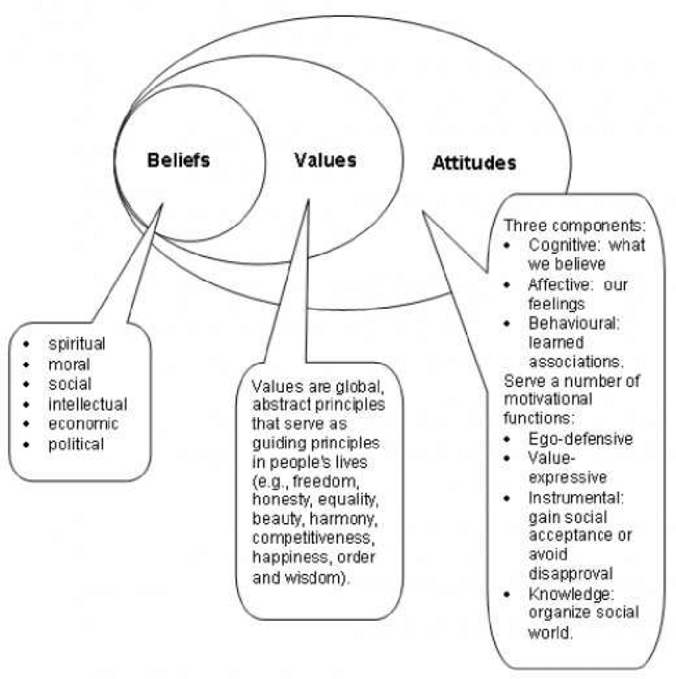

The NHS
The NHS is a health care and medical service made for people living in Great Britain and is funded by the government. The Full Fact Team (2017) also support this suggesting that, the NHS which is also known as the ‘National Health Service’, is a government-funded medical and health care provision that is available for all UK residents, without having to pay the full price of the service the receive. The services consist of visiting a doctor or nurse at a doctor’s surgery, getting treated at a hospital if injured or unwell, seeing an obstetrician or midwife during pregnancy and getting urgent help from healthcare professionals within the ambulance facilities when experiencing any serious or fatal injuries or health problems. The NHS service has been succeeded from the UK government and is widespread throughout Great Britain. The Medic Portal (2019) elaborate on this suggesting that the NHS is made up of four components/semi-independent systems, NHS England, NHS Scotland, NHS Wales and Health and Social Care in Northern Ireland, also suggesting that the founding principles of the NHS are that service must be free when used, funded by general taxation, obtainable to all including those who are temporarily living in the UK).
The NHS first issued their text to the public at the start of 1948. It provided information about all dental, medical and nursing care. Everyone could use it and there were no charges, excluding special items. There were no insurance credentials, however it was not considered charity as everyone was contributing for it, primarily as taxpayers (SHA. 2018). This is supported by The Kings Fund (2017) as they suggest that the funding NHS receive is from contributions of general taxation and national insurance. They also expand on the change in national insurance rates in 2001, because an intensification to national insurance charges was made in order to increase the proportion of funding for the NHS. Some funding of the NHS is gathered from user charges. For example, charges for prescription, dental treatment and glasses, these charges only credit for a minor proportion of the NHS income. Alongside this, the NHS also gathers income from through other sources such as parking charges and land sales.

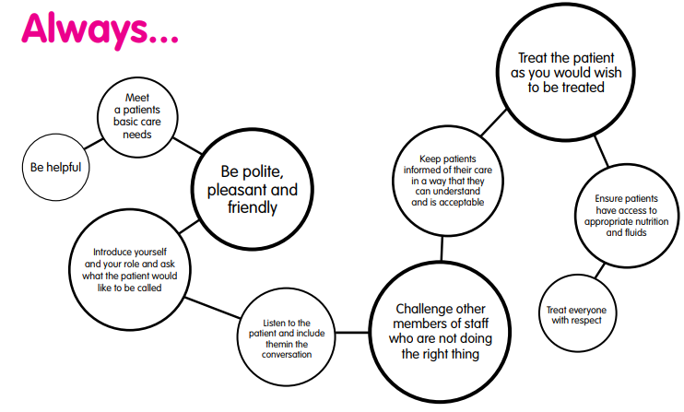
The Airedale Trust (2017) suggest that the above behaviors have been developed with staff across the trust and describe what they all need to demonstrate and develop as they are all Right Care Leaders. They all need to take responsibility for delivering safe, high quality patient care and experience and will recruit, appraise, manage, develop and reward people based on their values and behaviors. This therefore suggests that the NHS employees work towards a goal of always keep their patients as top priority and making them satisfied. The employers always keep this concept in mind when employing staff as they expect all their employees to work towards their ultimate goal.

NHS Values, Beliefs and Attitudes
Lancashire Care (2016) display the key values of NHS, which are improving lives, compassion, commitment to quality of care, working together for patients, respect and dignity and everyone counts and is equal. e-Learning for Healthcare (2019) also supports that there are six key values of the NHS. Commitment to quality of care suggests that NHS strives to achieve the best levels of excellence when providing extraordinary-quality care in a secure, operative and attentive manner for the patients to have a good experience. The provision of high-quality care is reliant on feedback therefore, organizations that work upon feedback from patients and staff are able to identify and progress in certain areas of enhancement. The value of ‘working together for patients’ is based around offering health services. Patients must always be put before everything for the NHS. The NHS system should work together in the benefits of patients, always putting a patient’s interest before the organizations interests. Alongside working with one another, health service organizations and providers should also include staff, carers, patients and local communities to ensure that they are providing services focused and tailored to local needs. Individuals who come into contact with the NHS must always be treated with ‘respect and dignity’, regardless of their position in the organization. This value ensures that organizations value and respect different needs, aspirations and priorities when designing and delivering services. Compassion is alike to respect and dignity, both suggesting that patients, carers and relatives must all be treated with sensitivity and kindness. The NHS must make people feel valued, recognizing that their apprehensions are important. Improving lives defines that the NHS aim to progress the health and welfare of patients, communities and its staff through professionalism, innovation and excellence in care. The value ‘everyone counts’ suggests that the NHS has the responsibility to maximize the advances they obtain from NHS resources, ensuring it is dispersed fairly to those most in need. Everyone should be handled with equal respect and importance, without any discrimination.
Attitudes and beliefs build up an individual’s personality and makes them who they are. It impacts their thinking and the method they choose to complete certain task. Such attitudes and beliefs affect an individual’s judgement on different task and situations (The Care Certificate, 2016). Setting the highest quality of care depends on every employee working within NHS and social care systems. The attitude of employees towards patients and their work is what enables them to earn trust from others, striving to give quality service and assisting patients to receive their basic rights such as confidentiality, professional and managerial integrity, safety, dependable service, accountability and good communication is what assures patients that they are being served and treated well without being deprived of any rights (NHS 2019).
The BFWH NHS Foundation Trust (2015) suggest that the NHS always considers that all individuals have their own religious, cultural and personal beliefs. It is understood that some patients consider that practicing specific rituals bring them a sense of peace, therefore NHS employees always attempt to avoid restricting patients from practicing their faith and try their best to respect their religious and cultural practices and needs.

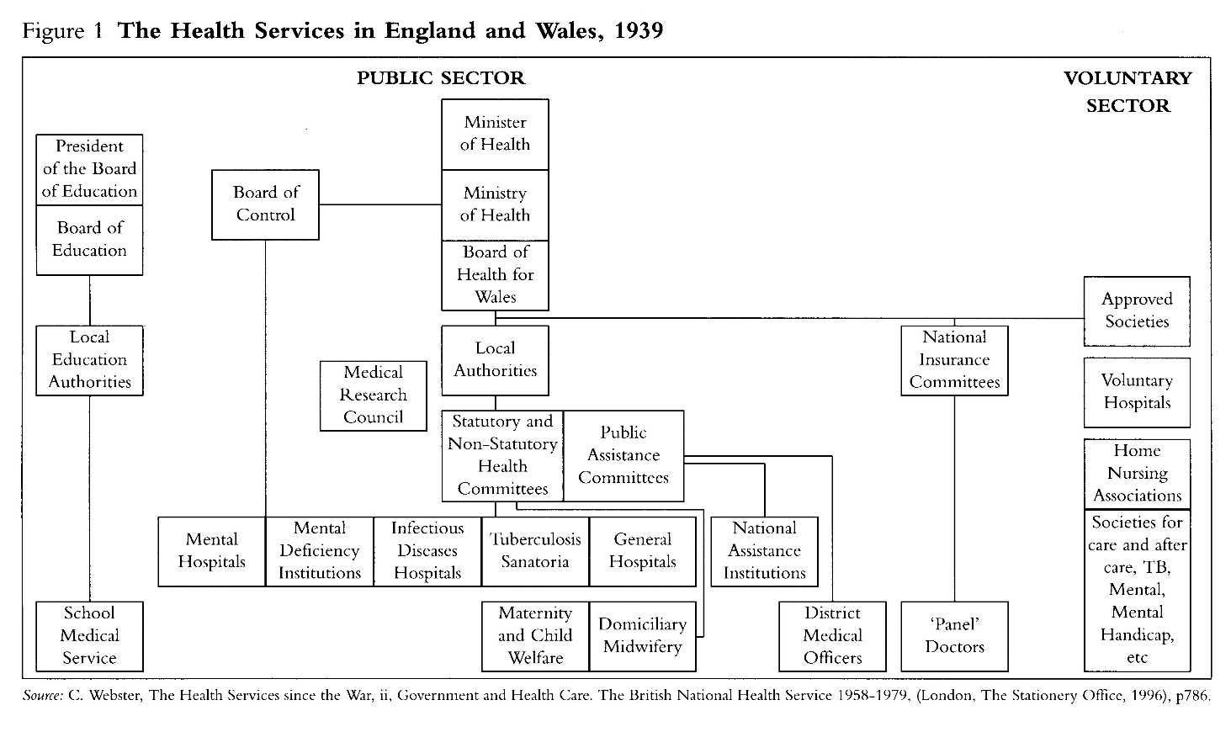

My opinion on NHS and beliefs, values and attitudes
In my opinion the values, beliefs and attitudes of the NHS are similar to those that I follow in my job as an interpreter. My interpreting job involves translation and interpretation of conversations for people of different cultures who have a language barrier and struggle to speak English. Throughout this job I come across a variety of people, which is where the similar core values, beliefs and attitudes of the NHS appear. For example, I must always maintain confidentiality at all times and treat all my client equally. As an input of my own personal values, beliefs and attitudes, I try my best not to cause any further barriers or problem for my clients and therefore I continuously practice my languages wherever possible, and I also use a friendly but formal manner of speech when interpreting in order to prevent any chances of misunderstanding within the conversations.
As part of my job, my clients are asked to give feedback regarding the interpreting session they have with me. Upon receiving positive feedback to a certain level, the manager would reward me for the good work and satisfied clients, by either giving a pay rise or gift vouchers. This reward system was created in order to motivate the workers to work more efficiently and follow the values, beliefs and attitudes as precisely as possible.

Frederick Winslow Taylor’s Theory
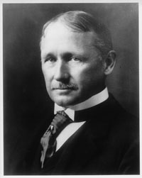
Fredrick Winslow Taylor was the youngest child born into an economically established old Philadelphia Quaker family. Taylor gained entry to Harvard University however, after passing his entrance examinations with honors, he suffered severe eyestrain that precluded his attendance. As advised by eye doctors, he went to work for a small machine shop in Philadelphia, where he learned the trades of pattern maker and machinist. Soon after which, he took a position at the Midvale Steel Works in 1878 where he eventually became the foreman of the machine shop, with expert knowledge on the work floor. Throughout this experience Taylor figured that workers tended to do less work than their potential and so he wanted to increase their productive capacity. Initially workers resisted his efforts however gradually after three years, Taylor was able to succeed in raising production through constant managerial pressure. He then spent the next decade at Midvale carefully examining the problem of production and worker resentment as he wanted to increase output without having to constantly force workers (Encyclopedia of World Biography, 2004).
Taylor was an American inventor and engineer, while some people gave credit to Taylor’s abilities, others credited his wealthy family, who were friends with the owners of the steel establishment for his quick progression in work. Some people recognized Taylor for his important steel-tool findings, as he invented the Taylor-White procedure for moderating steel, which transfigured metal cutting techniques through which he secured multiple medals. However, he was mostly known by people for his shop-management philosophies, he also merited the designation, "Father of Scientific Management" due to these philosophies (Sniderman 2012). Taylor presented `Scientific Management' (Taylorism) in his seminal work, in which the principles of scientific management varied from customary `Initiative and Incentive' systems of management. Taylor’s main theory was the ‘Scientific Management’, in which his ideas were a buildup of his life's work and comprised his own life examples from his workplace (British Library, 2013).
Taylors management theory broke up industrial production into small and highly regulated phases and consisted that workers obey the managers instructions on how to properly perform these specific steps. He determined these steps through cautious scientific observations, he then used these observations to compare the speed at which the different workers completed tasks. Taylor's system of management segregated workers from each other and the workers in his system were given highly detailed work instructions that Taylor's scientific studies had determined to be the best and most efficient way to perform the task. Workers became elements of a larger machine and were expected to understand that their interests were in accordance with their managers interests. Taylor believed that this "mental revolution" of interests was the most significant contribution of scientific management, as it reduced management-worker conflict. (Encyclopedia of World Biography, 2004).

The Management Theory Principles
Taylors theory had four principles, the development of science of the job with strict rules and standardization for every motion of each worker, the careful and scientific selection and successive training of the workforce to transform them into specialized workers, attentive management and paying each individual for working fast and following instructions precisely and fair and equal division of work and responsibility among workers and management, with managers assisting and encouraging the workers.
The first principle addresses the development of a true science in the field of management. This can be applied to the art of bricklaying, as the bricklaying process would be more efficient through the perfection and standardization of all implements and working conditions which, would ensure that the bricks are of uniform size and shape. This would then result in enhanced efficiency of the bricklaying process. Employees tend to work better if the management implements mechanisms to motivate them. Money is one major medium of motivation; employees need to receive value for their labor by being compensated adequately. There are also other factors that may motivate employees, which is where science comes in. Organizations may need to plan policies and rules that would encourage efficiency in the services rendered by employees.
The second principle is the scientific selection and training of the workers. The success of all organizations depends on the selection of their workers. As a result of this many organizations ensure that only the best talent is selected and hired their vacant job. Some organizations also develop their human resource departments so that they are effective in the staffing process. This critical task may be made easier by using scientific methods in the selection of the employees. Organizations, therefore, draft various ways of selecting the right person for the job. This includes careful inspection of the professional and academic qualifications of all employees, which is then lead by an interview of the shortlisted candidates for the post before accepting the most qualified individual. Taylor stresses that it is the responsibility of the employer to guide and train all employees and ensure they are fit to handle the responsibilities assigned to them.
The third principle calls for the workers scientific education and development. It is the organization’s responsibility to ensure that employees remain pertinent at their jobs. It is vital that all employees carry out their duties in accordance with the principles set for them, so that the organization could remain profitable.
The fourth principle puts forward the cooperation between employees and the management. Taylor explains that this principle is for a division of labor between the workers and the management. He states that it is likely to determine the best way to perform a task to maximize efficiency through a scientific study. This is done by analyzing the series of operations needed while doing the work under investigation, alongside understanding the tools which are used and using a stopwatch to measure the required time for each of the steps to select the fastest way of doing each step. Then eliminate all slow, and useless movements and collect the quickest, most efficient movements and implement them into one sequence. The division of labor is the central position in Taylor's fourth principle as cooperation between employees and management provides a suitable working environment for distribution of tasks among the employees in accordance to their skills and qualifications (Huang et al. 2013)
EPM (2018) suggest that Taylor’s Scientific Management was made to find methods to make performing tasks more efficient. Taylor believed that there were universal principles which dominated efficiency suggesting that these laws were self-regulated from human judgment. The ultimate goal of his Scientific Management Theory was to find the most efficient method of performing tasks. As Taylor’s Motivation Theory suggests employees should just follow their managers commands, it is significantly related to an authoritarian style of leadership and therefore, also similar to Douglas McGregor’s Theory X model of management, in which it is considered that employees are fundamentally unmotivated. They also suggest that during the commencement of the 20th century Taylor’s work had started to heavily influence production methods and developed the base upon which Henry Ford presented his mass-production practices to the manufacturing of automobiles.
This is supported by The Saylor Foundation (2013) who suggest that Henry Ford assigned Taylor to scrutinize his employees and regulate the most effectual, time-saving approaches for expanding the establishment’s productivity. After Taylor’s report on Ford’s employees, Ford considered Taylor’s observations and commenced his theory into his manufacturing techniques during 1908. Upon executing Taylor’s theory and strategy in Fords work, the production process had significantly become faster however, it was not considered sufficient to meet Ford’s ambition of producing cars at peak levels efficiently.

Views and Criticisms of the Management Theory
Although Taylor created his management theory to increase the efficiency of workers and their outcomes, there were many criticisms against his theory. Akrani (2011) lists a several criticisms against Taylors theory. For example, ‘Exploitation of Workers’, the theory appears to put inessential pressure on employees to execute duties faster as significance was only given to productivity and cost-effectiveness which occasioned in manipulation of employees. Another criticism was that the management theory is too much of a ‘Mechanical Approach’, in which he gave an excessive importance to efficiency, without regarding the human element, he reduced human workers to machines that could speed up the work at any cost. Another criticism he suggested was the ‘Problem of Separation of Planning from Doing’. Taylor theory attempts to segregate planning from doing, however in reality, planning and doing cannot be separated. In order to make accurate strategies for the organization, the planners should also be engaged in doing. ‘Another criticism pointed out was that the theory is an ‘Individualistic Approach’, it appears to give excessive importance to individual working exhibition rather than team performance. However, the success of an organization depends on teamwork rather than just individual performance. Taylor’s theory was also criticized for making ‘Wrong Assumptions’, suggesting that Taylor assumed that financial gains were workers only motivation. However, workers are not only motivated by financial inducements but also by societal needs and personal egos. Chand (2015) add to this, suggesting that employees criticized the theory because it ‘Reduces the Worker to A Machine’ as it separates the function of thinking from the worker, the intellectual or the preparation aspect is taken over by the management. She also suggested Exploitation of Workers as a criticism of Taylors theory suggesting that the profits of enhanced yield are not equally shared between the workers.
Reddy (2016) suggests that the scientific management theory has many advantages, for example, Enhanced production due to concentration on stable enhancements in business operations. Good ability to control, as managers are able to have good control over production as employees become specialists in their fields from continuously doing the same task. Decreases inaccuracy as employees are given tasks that they are good at doing. Cost of production is decreased because there is greater production at a bigger scale so there is a reduction in per unit cost of production. Best use of resources and development because with the methodical procedures followed, there is better application of resources which leads to greater productivity. Less production time as management theory helps to complete work in lesser time. Good working conditions as the theory allows to develop a proper atmosphere for working. Owners and financiers are profited because large-scale production alongside enhanced productivity move towards enhanced turnovers and more profit for investors and overall efficiency is increased which is beneficial for the nation, e.g. increased production and reduced fee of production, industrial agreement and peace, society is able to meet a high standard of living, the national income is boosted and there is also rapid industrial expansion with this theory.
Reddy (2016) also lists some disadvantages, e.g. necessitates vast capital as the formation of work study, planning department, training of workers, and adjustment requires more money. Administration takes control, as the managers take up control of the employees, it causes them to lack creativity. Planning reduces productivity as planning ahead makes work uncompromising and ridged and may lead to inattentiveness and dissatisfaction which would direct to less productivity. Overly bureaucratic because a strict organization may cause employees to feel dissatisfied. Mechanistic as this approach treats workers like machines. Not suitable for teams as there is no scope for individual preference with this theory. Unemployment as fewer employees are required because workforces are substituted by machineries leading to redundancy. Wrong assumption as Taylor’s theory of motivation suggests that workers engrossed and inspired by financial achievements, however employees are not only motivated by financial aspects but also by non-finance incentives such as social needs. Follows narrow application as it is applied only at times and in factories where there is a measurable determination of employees. Time-consuming, when adopted the theory appears to need more time for adjustment, training and specialization, or else during the time of reestablishing, the workers may suffer.
The US were able to utilize Taylor’s theory at a faster speed in comparison to UK. Holmes et al. (2016) suggests that US had greater acceptance by employers and managers to Taylor and his followers management philosophy, who appeared least concerned regarding the effect on workers from the rationalistic management, and this continued to cause differences in the growth in consultancy and businesses in the US compared to the UK. Therefore, it was mainly used by the US as they neglected the impact on workers in order to grow their businesses faster.

Practical example of how it’s been applied and how it’s useful in the workplace
Although Taylor’s management theory has been criticized in several aspects there are still some organizations that use the principles of Taylor’s theory in their practice. UKEssays (2018) suggest that Taylors ‘Time and Motion Study’ is practiced by managers of a huge fast food restaurant with many branches known as ‘McDonalds’. The study was invented to lessen the quantity of motions in executing tasks to increase productivity. McDonalds use one standardized process for tasks like making a burger which all workers have to follow. This standardized process and the 5 principles of scientific management have been combined and proved to be the best way for such organizations to reach their ultimate productivity as they are one of the world’s leading fast food chains. The McDonalds branches in places such as Dubai and India, customers are guaranteed to receive their food within 60 seconds of their order, and this guarantee can only have come from the application of Taylor’s Time and Motion study, as their workers are trained enough to be able to complete their daily tasks within a time limit.
Taylor’s 'Time and Motion Study' is also used by the NHS as Beynon (2017) explains that the study consisted breaking down mechanisms of manual tasks in manufacturing settings and timing and investigating each measure so that the best way to accomplish each duty could be found. Such specialized facilities are provided within the NHS, and these organizational techniques could be convenient in areas when reviewing productivity and improvements.
Taylor’s theories can be used in all types of work industries and organizations, alongside food and healthcare organizations Taylorism is used in famous motor companies such as Toyota. Takeuchi et al. (2008) suggests that the Toyota company uses Taylorism however, they improvise their own ideas into it, which is why they have become a successful company. Toyota states that efficiency unaided by other techniques cannot assure success, they do not interpret workforces just as pairs of hands but as knowledgeable workers who consist of wisdom and experience. Toyota therefore invests profoundly in people and organizational competences, and considers everyone when gathering ideas, they garner ideas from everyone everywhere, whether it’s on the shop floor, the office or anyone working within the field.

My opinion on the theory
In my opinion, Taylor’s management theory only suited the time it was invented as there were fewer experienced and skilled workers working in the industries. As Taylor used his theory on unskilled workers of agricultural backgrounds and trained them into becoming skilled workers and craftsmen within the industrial society, his theory would be considered advantageous for the unskilled workers of that time. However, in the current industrial society, workers pay is dependent on the profit and piece rate of each item as well as the amount of time the worker spends working on it, therefore in this case following Taylor’s theory would cause unnecessary stress and pressure on workers when completing their tasks. Taylors theory could be a disadvantage for certain workers with disability or illnesses as their work pace may be slower than other workers and following Taylor’s theory could cause them to lose their jobs as spending too much time on tasks is not considered efficient, therefore there would be a higher rate of unemployment, depriving people from occupation due to certain heath problems or due to lower production rate. Also the theory increases the workload of managers as they would have to complete their own tasks alongside having to supervise the rest of the workers working in their field and it also increases the empowerment of the managers as the workers would just have to follow the managers commands. This could cause a lack of communication and therefore start to have a negative affect on the teamwork amongst the workers and managers.

Conclusion
As a result of writing this report I have concluded that values, beliefs and attitudes whether it is personal or professional, they all greatly impact our thoughts and actions. An organization can only run successfully if there is good trust between the employees and employers, and they all share and communicate similar values, believes and attitudes as a shared system of thoughts allows people to get along and have a positive relationship with one another. Taylors theory is good in terms of training employees to work towards a specific goal to increase efficiency, however it is quite unfair and disadvantageous when it comes to teamwork as it only gives the managers superiority and treats the workers like machines. The NHS has some core values that appear to be similar to Taylor’s theory, for example the experienced staff always keep an eye out for the newcomers and trainees despite their own workload, they are always looking out for opportunities to help them whenever they can in order to improve the healthcare services to meet the patient’s needs.

Reference
- Airedale Trust. (2017). Our Right Care Behaviors. Available: http://www.airedale-trust.nhs.uk/wp/wp-content/uploads/2017/06/Airedale-Values-and-Behaviours-Booklet.pdf [Last accessed 19th July 2019].
- Akrani, G. (2011). Criticism of Taylor's Scientific Management - Limitations. Available: https://kalyan-city.blogspot.com/2011/06/criticism-of-taylor-scientific.html [Last accessed 19th July 2019].
- Bennett, T. (2009). The True Definition of Belief. Available: https://tybennett.com/the-true-definition-of-belief/ [Last accessed 30th June 2019].
- Beynon, C. (2017). Management models and theories associated with motivation, leadership and change management, and their application to practical situations and problems. Available: https://www.healthknowledge.org.uk/public-health-textbook/organisation-management/5c-management-change/basic-management-models [Last accessed 21st July 2019].
- BFWH NHS Foundation Trust. (2015). Religious And Cultural Beliefs. Available: https://www.bfwh.nhs.uk/wp-content/uploads/2015/07/Religious-And-Cultural-Beliefs.pdf [Last accessed 14 July 2019].
- Boehlke, Julie. (2018). "Importance of Good Attitude at Work." https://careertrend.com/importance-of-good-attitude-at-work-4900634.html [Last accessed 13th July 2019].
- British Library. (2013). Frederick Winslow Taylor. Available: https://www.bl.uk/people/frederick-winslow-taylor [Last accessed 16th July 2019].
- BVC. (2019). Why Values are Important. Available: https://www.valuescentre.com/values-are-important/ [Last accessed 30th June 2019].
- Chand, S. (2015). Criticism of Scientific Management: by Workers, Employers and Psychologists. Available: http://www.yourarticlelibrary.com/scientific-management/criticism-of-scientific-management-by-workers-employers-and-psychologists/25833 [Last accessed 19th July 2019].
- Dinev et al. 2009, "Information Privacy Values, Beliefs and Attitudes: An Empirical Analysis of Web 2.0 Privacy", IEEE, pp. 1.
- e-Learning for Healthcare. (2019). About the NHS Values Tool. Available: https://www.e-lfh.org.uk/programmes/nhs-values-tool/ [Last accessed 14th July 2019].
- Encyclopedia of World Biography (2004). "Frederick Winslow Taylor." 2nd ed., vol. 21, Gale, 2004, pp. 400-402.
- EPM. (2018). Taylor’s Motivation Theory – Scientific Management. Available: https://expertprogrammanagement.com/2018/05/taylors-scientific-management/ [Last accessed 19th July 2019].
- Full Fact Team. (2017). What is the NHS? Available: https://fullfact.org/health/what-is-the-nhs/ [Last accessed 16th July 2019].
- Haden, S.S., Humphreys, J.H., Cooke, J. & Penland, P. 2012, "Applying Taylor's Principles to Teams: Renewing a Century-Old Theory", Journal of Leadership, Accountability and Ethics, vol. 9, no. 4, pp. 11.
- Holmes et al. (2016), Re-Tayloring Management: Scientific Management a Century On, New edn, Routledge Ltd, Abingdon.
- Huang et al. 2013, "A REVIEW AND CRITICAL ANALYSIS OF THE PRINCIPLES OF SCIENTIFIC MANAGEMENT", International Journal of Organizational Innovation (Online), vol. 5, no. 4, pp. 78.
- Kumar, M. (2018). The Relationship Between Beliefs, Values, Attitudes and Behaviours. Available: https://owlcation.com/social-sciences/Teaching-and-Assessing-Attitudes [Last accessed 21st July 2019].
- Lancashire Care. (2018). How do our values influence our behavior? Available: https://www.lancashirecare.nhs.uk/media/Publications/Temporary%20Staffing/Induction%20Matrerials/Trust%20Values.pdf [Last accessed 14th July 2019].
- Moise, C. (2014). Importance of Beliefs, Attitudes and Values in the Frame of Human Resource Motivation. Available: https://www.researchgate.net/publication/319228393_Importance_of_Beliefs_Attitudes_and_Values_in_the_Frame_of_Human_Resource_Motivation [Last accessed 30th June 2019].
- NHS. (2019). NHS Core Values. Available: https://eput.nhs.uk/about-us/nhs-constitution/nhs-core-values/ [Last accessed 14th July 2019].
- Reddy, C. (2016). Scientific Management Theory: Advantages and Disadvantages. Available: https://content.wisestep.com/advantage-disadvantage-scientific-management-theory/ [Last accessed 20th July 2019].
- SHA (2018). The start of the NHS 1948. Available: https://www.sochealth.co.uk/national-health-service/the-sma-and-the-foundation-of-the-national-health-service-dr-leslie-hilliard-1980/the-start-of-the-nhs-1948/ [Last accessed 19th July 2019].
- Sniderman, D. (2012). Frederick Winslow Taylor. Available: https://www.asme.org/topics-resources/content/frederick-winslow-taylor [Last accessed 21st July 2019].
- Takeuchi et al. (2008). The Contradictions That Drive Toyota’s Success. Available: https://hbr.org/2008/06/the-contradictions-that-drive-toyotas-success [Last accessed 21st July 2019].
- The Care Certificate. (2016). Understand your role. Available: https://www.google.com/url?sa=t&rct=j&q=&esrc=s&source=web&cd=16&ved=2ahUKEwjW8NOUrrTjAhXIi1wKHQ_ICSUQFjAPegQIBhAC&url=https%3A%2F%2Fwww.iow.nhs.uk%2FDownloads%2FEducation%2520Centre%2FClinical%2520Ed [Last accessed 14th July 2019].
- The Kings Fund. (2017). How the NHS is funded. Available: https://www.kingsfund.org.uk/projects/nhs-in-a-nutshell/how-nhs-funded [Last accessed 19th July 2019].
- The Medic Portal. (2019). The NHS. Available: https://www.themedicportal.com/application-guide/the-nhs/ [Last accessed 16th July 2019].
- The Saylor Foundation. (2013). Scientific Management Theory and the Ford Motor Company. Available: https://resources.saylor.org/wwwresources/archived/site/wp-content/uploads/2013/08/Saylor.orgs-Scientific-Management-Theory-and-the-Ford-Motor-Company.pdf [Last accessed 20th July 2019].
- UKEssays. (2018). To what extent is Taylor’s theory of scientific management still useful in todays business. Available: https://www.ukessays.com/essays/business/is-taylors-theory-of-scientific-management-still-useful-today-business-essay.php [Last accessed 21st July 2019].

