Learning in the digital era

Table of contents

E-portfolio task 1:
Visual branding
Online portal

E-portfolio task 2: composition collaboration
Beginning
Roles and contributions
Making the song
Final song

E-portfolio task 3: virtual collaboration
Beginning
Making process
Final song

E-portfolio task 4:
Biography
Pitch proposal
Final song

One drive link: N/A

Youtube link: https://www.youtube.com/watch?v=mUK_4jZVRX8&feature=youtu.be

Soundcload: https://soundcloud.com/donte-mather

E-portfolio task 1:

Visual branding

Coming up with a logo for the brand was difficult because I wasn’t sure how I was going to approach this so I decided to make a template for most of the designs but would change around it if I felt the design needed it.
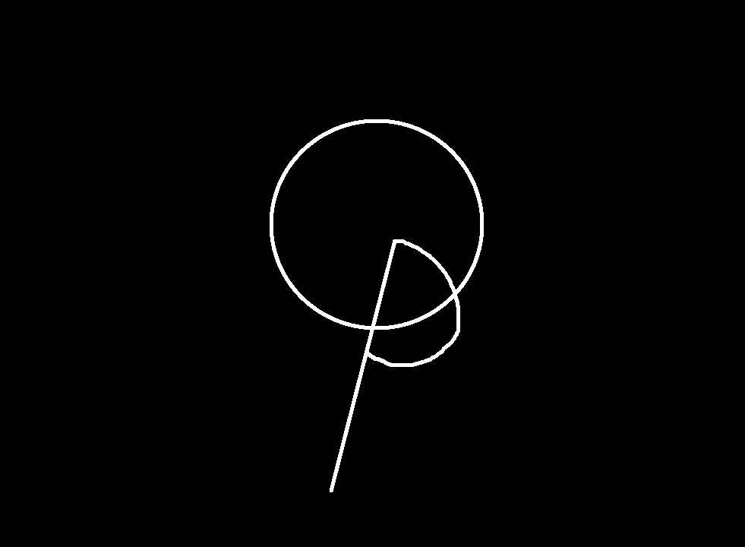

After making the first template I decided to try a whole new design however after making it I felt like that there was too much going on so I decided to stick with the template that I made before hand as I prefer the simplicity of the previous design but would also go about changing it for the future ones. 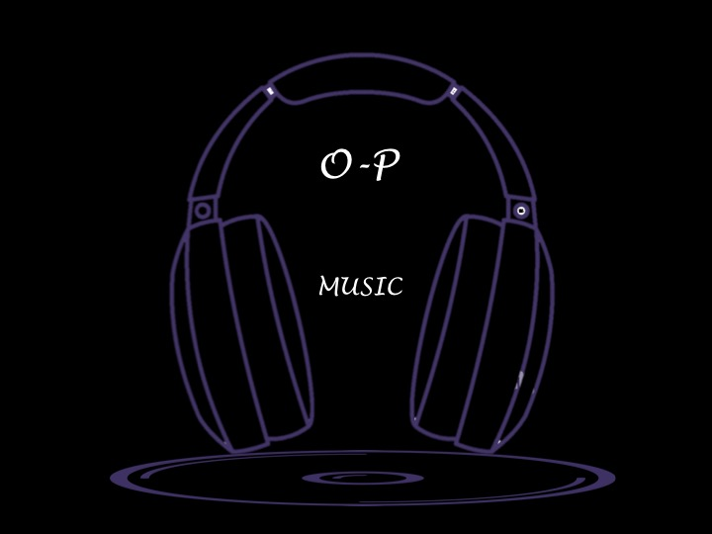

After making the previous one I would go and create another one based on the original design I created. This one is the one I decided to use, as it was the one I preferred out of the five. The reason for this is because I prefer simplicity but also it is a design that I made before hand and is the one I use currently for YouTube and sound cloud.
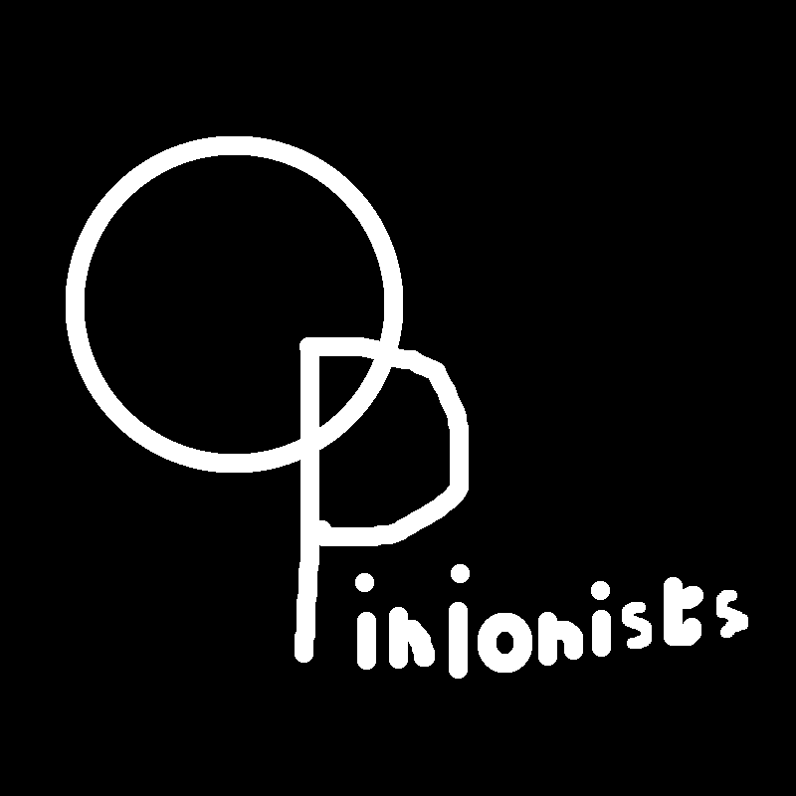

The reason I created this was because I wanted to try something different with the design instead of having black background. I decided to try and make a patchy colour design in the back and have black text over it but it didn’t work. I found the design to be too much so I decided to not use it.
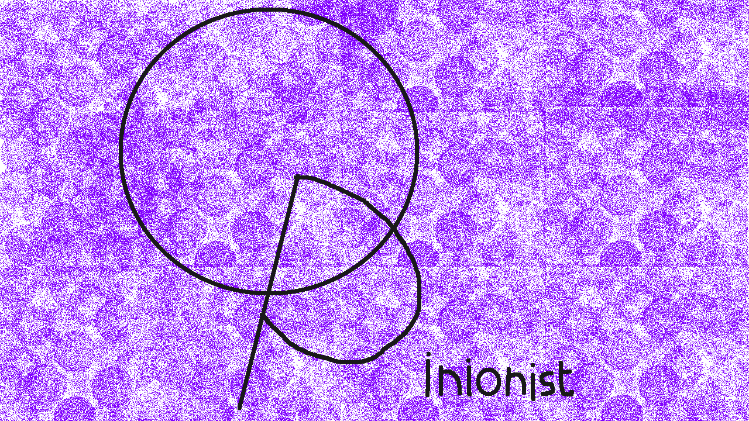
after coming up with those for the last design I made I decided to invert the colours of the 3rd design to see what it would look like but I didn’t like the look of it. It felt less bold then the 3rd and it also felt empty to me. Also because of the white background it felt like nothing was happening and looks like there should be more compared to the 3rd one.

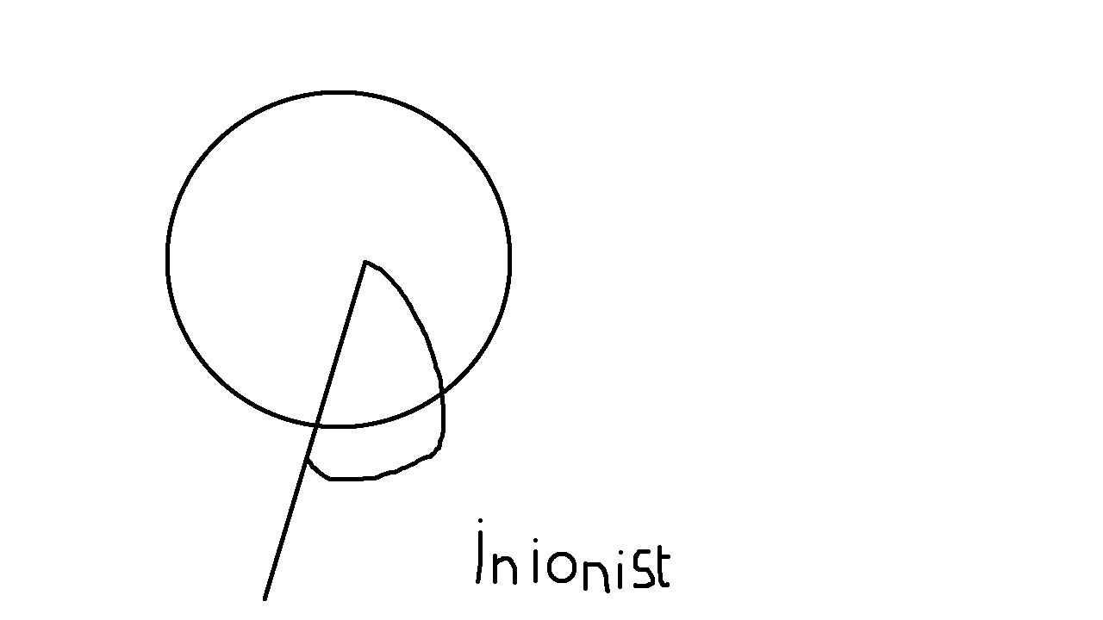

online portal

I created the sound cloud page and used the logo as a front logo and then would create a banner for it and would upload the work there.
https://soundcloud.com/donte-mather

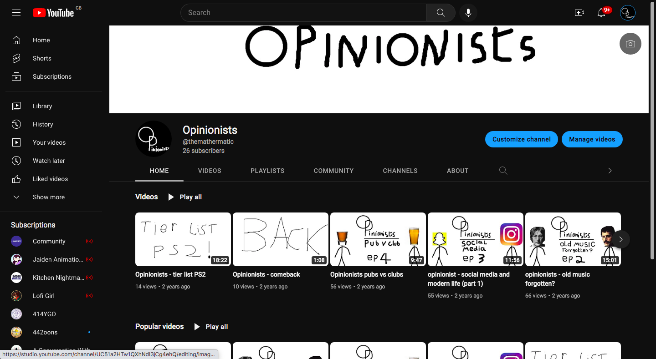
And videos that I make for my music will also be uploaded to the YouTube page.

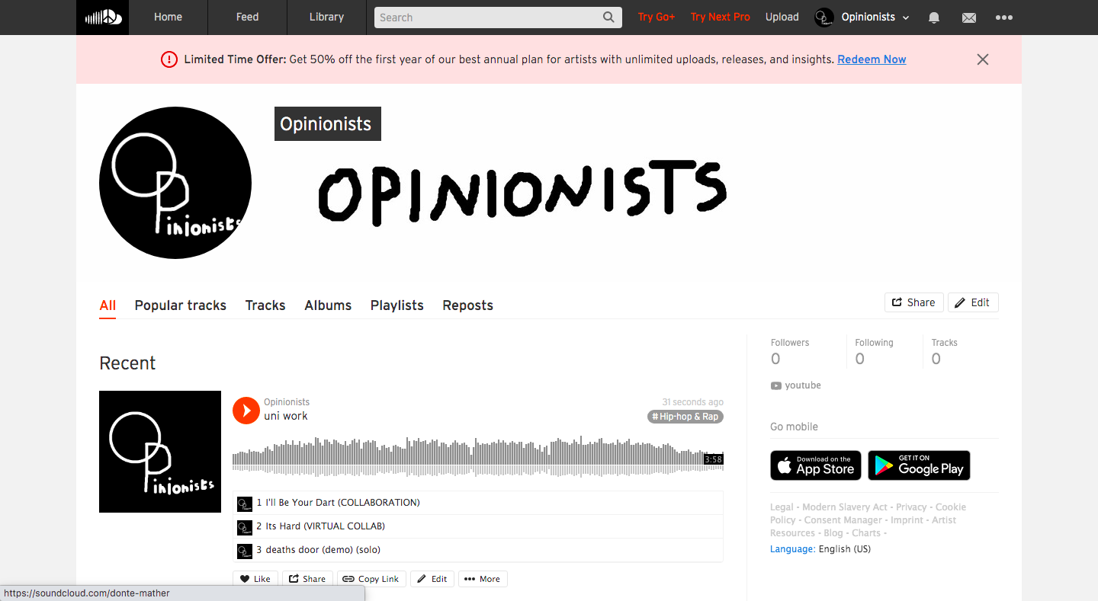
E-portfolio task 2: composition collaboration

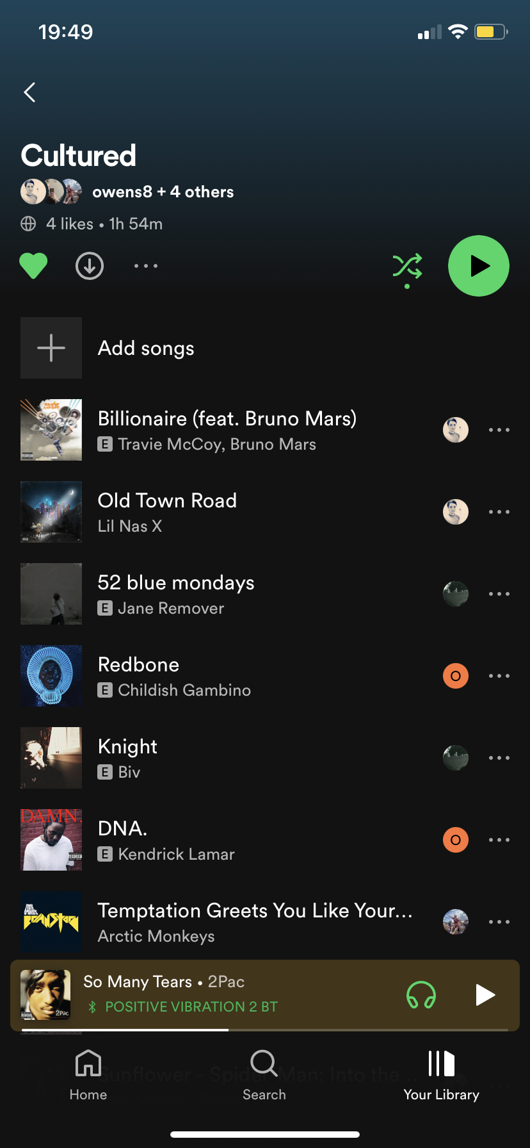
- Beginning
The team I was put into was me, Apollo, Alex, Brook, Andreas and Luke (who would join later) and to start with we decided to talk about the genres that we enjoyed and how we could merge the styles and what roles that we could take.
We created a Spotify playlist and would each add songs on genres we like but also what we could make and how we could go about it. We also decided to target songs like pop/ hip hop song genres in the playlist. things like childish Gambino, lil nas x and Bruno mars songs specifically to help us come up with a style to go with.
We ended up deciding on something like a mix of country rap but it would more evolve as the track went on when Luke would join and add his style.

- Roles and contributions
When making the track we could of used more direction in the beginning because even though we were able to divide the roles up and take direction we didn’t have someone taking charge to get things going as we did struggle to decide on things at the beginning.

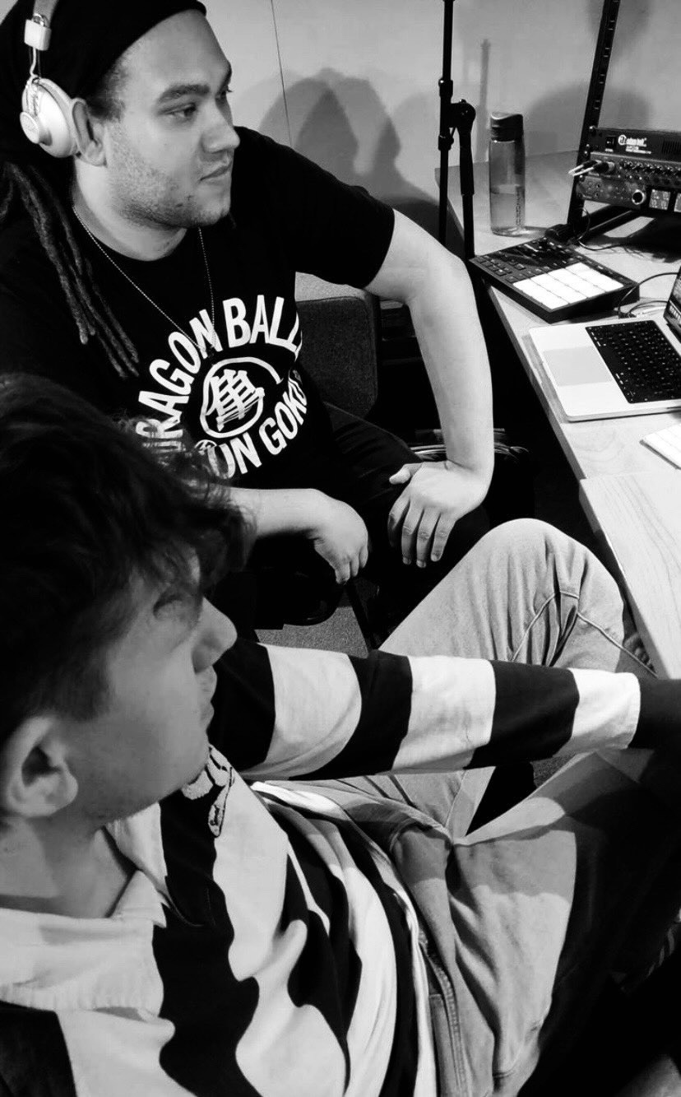
Apollo and Alex took more of a production standpoint and Alex also played bass and guitar for the track, brook played guitar, wrote lyrics and provided vocals. I would write lyrics and provide vocals for the track and do a bit of mixing for the track. Luke would play saxophone and provide drum machine for the track. Andreas is also helping with the mixing of the track.

- Making the song
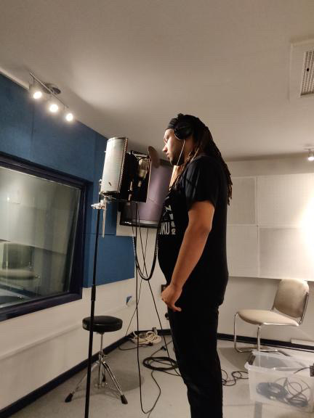
The early process of making the song we started with recording several guitar parts and bass to see which ones would work and what bpm we wanted to record with. After that Luke would then join and he would record his saxophone. That would give us a different feel for the song and that allowed us to add other elements. We started adding synths and vocals after that brook would go first with the chorus and I would follow after adding backing vocals. I would also record a verse after this and so would brook we would change the order going forth. Once everything recorded I would then go about mixing elements of the song I would add different amps to the string instruments, reverb, EQ and many other elements to help bring different sounds. Microphones that where used are the C-414s for vocals. Shure 57 for the saxophone. (could have been another microphone however I know that it was a condenser mic. As we needed to use phantom power.) we also would plug the bass and guitar into the interphase to record directly and change the amp with the DAW.

- Final song
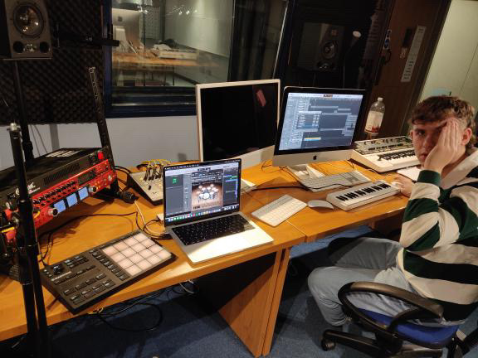
I titled the song I’ll be your dart and can be heard on my sound cloud. The song I felt came out really good and everyone was able to contribute something and was also able to speak their own mind and was also able to input when they didn’t like something but also say what they wanted to add so I believe that when it came to that we communicated well. Overall the group was able to perform well and came together top get the song done in the end.

(https://soundcloud.com/donte-mather/ill-be-your-dart-collaboration?si=89449dcaf2674524afb5d4e92b411104&utm_source=clipboard&utm_medium=text&utm_campaign=social_sharing )

E-portfolio task 3: visual collaboration

- Beginning
At the start the group was fast to communicate and get going but I would get in touch with Luke and start talking about what we wanted to make. He showed me a beat that he had made and I would also share something that I had written on piano and even though it didn’t work with what he had we decided that the beat that he ad made would be a good started point. We would message the other members about what we could do but communication between some wasn’t the best so most of the work came down between Luke and me.

- Making process
Once I got the beat I would start by adding some vocals to it. I would use a c-414 for this. I recorded a verse and then would listen and repeated the process till I had something I liked. After that I realized that the beat wasn’t long enough to cover the length needed. I would then go about adding effects and extending the beat where needed. I would also gate and side chain it so that It wouldn’t play without a new drum beat in the back making it cut in and out giving it a good effect. I would keep the original intro and have it cut after it played out. I would then add a chorus but taking my first few words from the verse cut and repeated them for a good effect. By adding different drums beneath I would get different sounds and melodies that would bring a new element so I would go about doing it through different areas. After that I would add two new verses and make an outro for the song and that is how it finished out. I would share this to Luke so that he could make some changes to his own version.

- Final song
I believe that it made it hard to make virtually and also that communication is a big part for this but without it makes it almost impossible to do. With the people I was working with only one was able to make that possible while the other barley contributed and one never spoke or reached out. I think the song itself is interesting but not the best or something I would listen to on a regular basis as I feel that with different people or better communication we could have gotten something more viable and maybe even something worth exploring more into. It made it hard to get invested into this project compared to the others but I still learnt that working virtually is worth but communication is the biggest factor for this.

Link to song: https://soundcloud.com/donte-mather/its-hard-virtual-collab?si=89449dcaf2674524afb5d4e92b411104&utm_source=clipboard&utm_medium=text&utm_campaign=social_sharing

E-portfolio task 4:

- Biography
Growing up and born in Wolverhampton England, Donte Mather, would see and experience a lot in his younger days. In dovecotes Pendeford, though the name would suggest a peaceful area when hearing it first, he would see and experience a lot of trouble. The area is known to be rough and that would be the start of his troubles. Family life would also make it rough for the young man as his mother would get arthritis when he was just 12-13 years old meaning he would grow up quick helping her.

Music would be his escape for him listening at all times of the day and taking in the melodies and lyrics he would hear, and his friends would comment that it would be strange to see him without headphones on.

His main inspirations would be artists such as Biggie Smalls (THE Notorious B.I.G.), mobb deep, Eminem and many more. But these incorporate the style that he wishes to make and the story that he wishes to tell.

- Pitch proposal for festival
The song that I created is I the genre of rap/ hip hop and is titled deaths door I consider the finish project to be a demo more than anything, as I believe that I can improve it if I give it a different beat or maybe spent more time on it. But I think that’s why it should be shown as this is my capability at this point but it will inspire me to become better I want to gain skills and make more music that will tell my story but I haven’t done that yet but this song is a stepping stone to get to that.

- Process and Final project
I started with drums and bass using the drum machine in the logic daw to get a simple beat going and then after that made a bass rhythm in it to get a feel on what I could add. After that I would add a sub bass following the original bass and also a piano rhythm to the chorus. After that I grabbed a c-414 and put some vocals over it for a verse and chorus but because I couldn’t think of any lyrics in time I kept the same verse for the first and second. I would and some atmospheric bells underneath to give some ambiance and also a gate, reverb and other plugins to it to make my vocals pop.

This song while I don’t think is the best shows that I am capable of making something and that I will get better with time if I’m patient. I enjoyed making it and while I did manage to get into it and make it I always struggled with lyrics and the beat as I always felt like I was conflicting with myself but it always made it interesting to find solutions.

The video and music was uploaded to my YouTube page and the link is here: https://youtu.be/mUK_4jZVRX8

