

Managing People Assessment 2: Written Assignment
Student ID: 2122365
Student Name: Elena Ivanova Goranova
Course ID: LCBB5004
Subject Name: Managing People

Executive Summary
Recently the NHS has been reported to struggle with the delivery of care to patients across the United Kingdom because of increasing staff vacancies and a steadily increasing rate of attrition among nursing professionals. This report outlines the key causes of the proliferating attrition of nurses and their impacts on the Nursing industry of the UK to the Head of Human Resources-NHS UK. This report is produced from the perspective gained by the Human Resources Consultant specialised in Employee Retention within the Nursing Industry. Along with identifying existing problems, the report devises strategies of solve the issue of nurse attrition within the healthcare sector.

Table of Contents
Introduction 4
Analysing the causes and effects of employee attrition within the UK’s Nursing Industry 4
Identifying and critically evaluating 5 monetary and 5 non-monetary retention schemes that NHS uses for Nursing professionals 6
Recommendations for improving nurse retention and decreasing the rate of attrition in the short and long terms in the UK 9
Conclusion 10
References 11

Introduction
In the given case study of the NHS it has been found that there is a growing rate of attrition among nursing staff in the United Kingdom. As of 2022, almost 40,365 nurses under NHS were reported to leave their active service in England turning the rate of leavers to 11.5 per cent (The Nuffield Trust, 2022). It has been revealed that the growing rate of attrition can be largely attributed to young nurses leaving the profession rather than retiring. The vacancy rate in June 2022 in the NHS was found to be 11.8 per cent in the group of registered nurses (NHS choices, 2022). This report is produced with the aim of identifying causes of attrition and recommending solutions for increasing the retention of nursing professionals across the UK as a Human Resources Consultant.

Analysing the causes and effects of employee attrition within the UK’s Nursing Industry
Poor recruit
One of the main problems in the NHS contributing to a large percentage of attrition is the poor recruitment process. Foremost, the process of recruitment and selection in the National Health Service in the UK has been found to be slow (Knowlson and Torgerson, 2020). The method of hiring in the nursing industry of the UK has been analysed to be extremely complex while it is actually meant to improve the quality of care. Checking references and compliance takes a long time in recruiting an employee. Besides that, the process of application has been evaluated to be long-winded and complicated that consumes enough time. The process of hiring includes additional assessments after the application along with compliance measures which delay the overall process (The Guardian, 2021). Apart from that the recruitment procedure of the NHS is quite poor because of strategic weaknesses. The job description of the NHS often lacks clarity which attracts staff who are not specifically skilled in the tasks. Moreover, the hiring and selection process of the NHS also has a general approach lacking specificity in terms of experience and skills. Consequently, staff recruited by organisations in the nursing industry are often found to lack enough skills and knowledge in alignment with the proficiencies required in the role. Furthermore, the nursing industry has been investigated to practise reference-based hiring practices which is a major challenge for the organisation to find the right staff. Aside from these issues, recruiters in hospitals and nursing homes are unable to provide any lucrative offer to convince employees to join the industry.
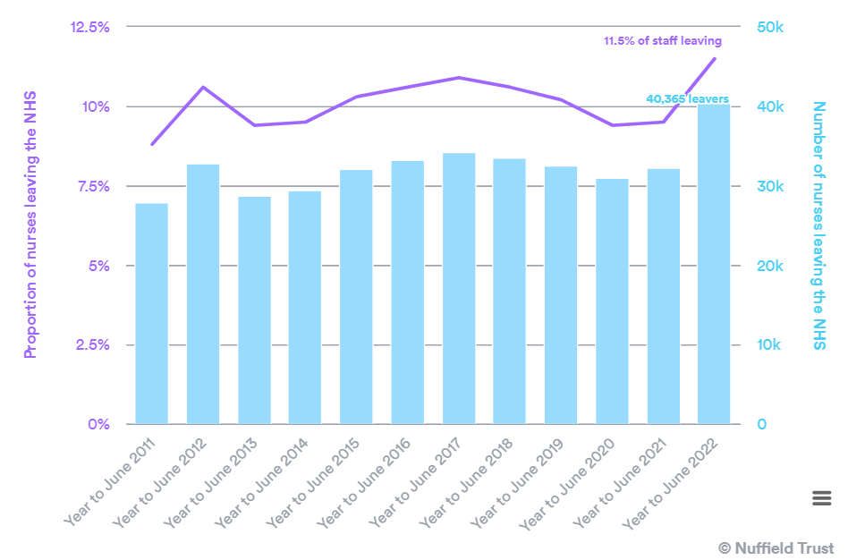
Figure 1: Leavers in the nursing profession in the UK
Source: (The Nuffield Trust, 2022)
Work pressure
The biggest challenge in the nursing industry has been found to be the high pressure of work. The NHS is infamous for exhausting its workforce which has increased further during the pandemic. The nursing industry in the United Kingdom is currently understaffed and hence there is immense work pressure on the existing nurses. There are many records of nurses reporting their health complexities due to working extra hours (The Guardian, 2022). A high rate of sickness absence and reduced staff morale have been witnessed in the sector. There are also complaints of feeling disregarded and undervalued within the industry which impacts the level of care nurses give to their patients. There are also claims of a lack of support within the hierarchical workplace that disregards the opinions and expectations of workers and makes them work relentlessly. According to a report published by The Guardian, burnout and exhaustion from work have been impacting the ability of care providers to deliver the best quality care to patients in the NHS. Sickness absence due to work pressure among health and social care staff in the UK has been found to be 46 per cent higher compared to the UK average (Ravalier et al., 2020). Around 40 per cent of the overall sickness absence of staff within the NHS has been revealed to be due to stress from work costing the National Health Services almost 400 million GBP annually. Further reports from HSE have revealed that more than 15.4 million days of work were lost because of anxiety, stress, and depression between 2017 and 2018 which accounted for almost 57 per cent of total days lost in sickness absence (Ravalier et al., 2020).
Low pay
According to the opinion of Müller, (2019), remuneration remains an important criterion of job attraction. Any organisation failing to pay employees adequately in a competitive environment is likely to experience high attrition. NHS has been postulated to pay its nursing staff low compared to the industry average standard. Many of its staff are underpaid while they work extra hours. According to a recent report, staff in the NHS have been found to be paid below the Living Wage making it difficult for them to survive in times of inflation. As per the survey conducted by the Royal College of Midwives, 4 out of 5, nurses have claimed that the primary reason for their possible job attrition would be low pay (RCM, 2022). Nursing is an extremely stressful profession that requires nurses to be highly skilled and committed to the job. However, the low wage and daily burnout have been curtailing their motivation to deliver the best effort to their roles. Compared to other professions, remuneration in nursing has been evaluated to be quite low across the United Kingdom (Müller, 2019). On the other hand, the cost of living in the country has been accelerating rapidly. As a result, the attraction to the nursing profession has been reduced among modern employees. It has been observed that many nursing professionals across the UK have been leaving their jobs for other industries causing the rate of leavers to increase in the industry.

Identifying and critically evaluating 5 monetary and 5 non-monetary retention schemes that NHS uses for Nursing professionals
Monetary schemes
Deals and discounts
Staff at NHS receives national discounts such as the Blue Light Card providing a wide range of in-store and online discounts and they also receive a 10% discount in Asda stores (NHS choices, 2022). Along with that, further deals and national discounts include Health Service Discounts and Fleet Home Electronics in collaboration with Curry's allowing the staff to purchase advanced technology by spreading the expense over 1 to 2 years. Employees working in the NHS and public health sector receive supermarket loyalty schemes from Asda, Sainsbury's, Lidl, Waitrose, Morrisons, and Tesco. It helps them save a great deal of money while purchasing essential items.
Travel
The government’s campaign called Help for Households provides varied forms of economic support for individuals who are eligible that also include transportation costs. Fleet solutions is a car lease scheme dedicated to people working in the NHS along with other organisations in the public sector. NHS also offers free car parking for staff working the night shifts between 7.30 pm to 8 am. Furthermore, Blue Light Card holders are eligible to apply for accessing discounts on free Esso fuel cards at UK’s Esso stations collecting Nectar loyalty points. Money Saving Expert guides on affordable MOTs and for drivers, RAC offers quick tips on saving money.
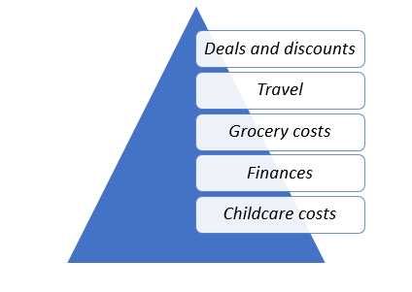
Figure 2: Monetary schemes for nurses
(Source: Developed by the author)
Grocery costs
As per the campaign of the government’s Help for Households, Campaign staff are allowed a broad range of discounts. Each of the schemes includes set income support, bills, housing, travel, disability, and benefits. Asda, Morrisons, and Sainsbury's provide offers and discounts for employees working in the NHS and other public sector institutions.
Finances
NHS workers are allowed free telephonic consultations from MoneyHelper which offers details regarding pensions, benefits, savings, and money problems. Besides that, the nursing staff can directly claim their job expenses from HRMS in terms of tools, uniforms, working from home, and so on. Learning Disability England offers accessible resources on the cost of living while National Databank facilitates free mobile calls, data, and texts to individuals in need through the community partner network of the Good Things Foundation. Healthcare workers can receive grants of upto 1000 GBP in case they require financial help (NHS choices, 2022).
Childcare costs
The Help for Households campaign facilitated by the UK government provides different kinds of financial support including childcare costs for people who are eligible. Grandparents caring for children while their parents are working can also apply for credits via the Specialist Adult Childcare scheme and The charity Healthcare Workers' Foundation offers economic childcare support of 1000 GBP per year.
Non-monetary schemes
Employee assistance programme
Nurses working in organisations under the NHS should be offered an EAP service for confidential 24/7 support to address a variety of issues like financial problems, relationships, discrimination, stress, legal concerns, and bereavement (NHS choices, 2022).
NHS England supports
NHS employees can receive 24/7 text support to address worries, overwhelming feelings, and in case they need to talk to someone. NHS staff are also offered free access to well-being apps for a certain time period.
Mental health and financial advice
NHS services have a cost of living page offering details on maintaining mental well-being as well as controlling bill costs.
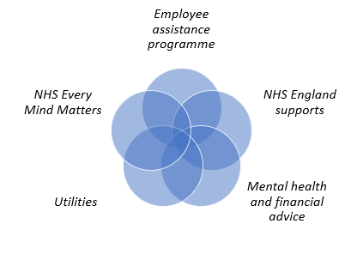
Figure 3: Non-monetary schemes for nurses
(Source: Developed by the author)
Utilities
The government of the UK has a Help for Households campaign that offers information helping staff with their energy bills including an online tool to save energy at home on the basis of property details. There is also Citizens Advice dedicated to helping people with energy and water bills along with Money saving experts guiding staff on savings for energy bills (NHS choices, 2022). Energy Saving Trust offers advice on energy at home to reduce bill amounts while Ofcom gives details on cheaper packages of broadband and phone for individuals with low income. Taking charge is a campaign offering accessible interactive webinars for free to help individuals in health and social care to save money on bills of energy.
NHS Every Mind Matters
This campaign facilitates expert advice along with practical tips to help NHS employees to care for their mental well-being and health.

Recommendations for improving nurse retention and decreasing the rate of attrition in the short and long terms in the UK
Continuous Training and development
NHS as the primary healthcare system in the United Kingdom should launch the practice of continuous training and development. A CPD or continuous professional development programme can ensure that employees in the nursing profession find consistent growth in their careers and continue to pursue advancement through training and skills development (Andrade et al., 2019, p. 107). It can also improve the workforce capabilities altogether and make nurses in the UK more competent to deliver standard care.
Nursing graduate scheme
The government should introduce a nursing graduate scheme in collaboration with NHS-affiliated institutions where individuals are encouraged to pursue the degree at an affordable cost. Besides that, scholarships for nursing students should be introduced to increase the number of graduates pursuing nursing as their career.
Increase Pay
NHS should increase the wage level of employees working full-time as well as part-time. The government should make more stringent policies to review the remuneration system of the NHS to ensure that nurses receive wages according to the National Living Wage standard. It can make the career more competitively attractive.
Flexible working arrangement
Nurses should be given a more flexible environment to work within the Nursing Industry. Allowing them to choose their day and shift with clearly laid out policies of work can improve the working condition and reduce the instances of absenteeism (Devi et al., 2021, p. 67).
Healthy work environment
A crucial reason for the growing attrition rate has been found to be the excessive pressure of work in the nursing profession (Marufu et al., 2021, p. 305). Hence, the NHS should strive to cultivate a healthier environment for work. The management should avoid forcing employees to work overtime and instead aim to increase recruitment to fill up vacancies. Nurses should be given proper care to address burnout at work.
Increase communication
The NHS is a hierarchical organisation where employees find the little right to voice their expectations. The system should develop a process of two-way communication with a regular feedback system to enhance employee-employer communication that can resolve employee issues quickly (Marufu et al., 2021, p. 307).

Conclusion
To conclude, the above study has analysed the causes of employee attrition at the NHS from a consultant perspective. It has further provided suggestions for addressing these problems. In addition, the report has outlined the existing schemes and policies in the NHS for offering monetary as well as non-monetary support to staff working in the nursing industry in the UK.

References
Websites
NHS choices (2022) NHS choices. NHS. Available at: https://digital.nhs.uk/data-and-information/publications/statistical/nhs-vacancies-survey/april-2015---june-2022-experimental-statistics (Accessed: March 28, 2023).
NHS choices (2022) NHS choices. NHS. Available at: https://www.england.nhs.uk/supporting-our-nhs-people/support-now/financial-support/supporting-our-staff-to-help-money-go-further/#finances (Accessed: March 28, 2023).
Ravalier, J.M., McVicar, A. and Boichat, C. (2020) Work stress in NHS employees: A mixed-methods study - researchgate, Research Gate. Available at: https://www.researchgate.net/publication/344216023_Work_Stress_in_NHS_Employees_A_Mixed-Methods_Study (Accessed: March 28, 2023).
RCM (2022) Four out of five NHS staff say pay is main reason they would quit their jobs, RCM. Available at: https://www.rcm.org.uk/media-releases/2022/june/four-out-of-five-nhs-staff-say-pay-is-main-reason-they-would-quit-their-jobs/ (Accessed: March 28, 2023).
The Guardian (2021) NHS workforce recruitment challenges in healthcare industry, The Guardian. Guardian News and Media. Available at: https://recruiters.theguardian.com/advice/nhs-recruitment-challenges (Accessed: March 28, 2023).
The Guardian (2022) NHS workforce recruitment challenges in healthcare industry, The Guardian. Guardian News and Media. Available at: https://recruiters.theguardian.com/advice/nhs-recruitment-challenges (Accessed: March 28, 2023).
The Nuffield Trust (2022) Peak leaving? A spotlight on nurse leaver rates in the UK, The Nuffield Trust. Available at: https://www.nuffieldtrust.org.uk/resource/peak-leaving-a-spotlight-on-nurse-leaver-rates-in-the-uk (Accessed: March 28, 2023).
Journals
Andrade, B.R.P.D., Barros, F.D.M., Lúcio, H.F.Â.D., Campos, J.F. and Silva, R.C.D., 2019. Training of intensive care nurses to handle continuous hemodialysis: a latent condition for safety. Revista brasileira de enfermagem, 72, pp.105-113. https://www.scielo.br/j/reben/a/TcD9CRf6T4pWCrX94YMKmVM/abstract/?lang=en
Devi, R., Goodman, C., Dalkin, S., Bate, A., Wright, J., Jones, L. and Spilsbury, K., 2021. Attracting, recruiting and retaining nurses and care workers working in care homes: the need for a nuanced understanding informed by evidence and theory. Age and ageing, 50(1), pp.65-67. https://academic.oup.com/ageing/article-abstract/50/1/65/5851503
Knowlson, C. and Torgerson, D.J., 2020. Effects of rapid recruitment and dissemination on Covid-19 mortality: the RECOVERY trial. F1000Research, 9. https://www.ncbi.nlm.nih.gov/pmc/articles/PMC7783530/
Marufu, T.C., Collins, A., Vargas, L., Gillespie, L. and Almghairbi, D., 2021. Factors influencing retention among hospital nurses: systematic review. British Journal of Nursing, 30(5), pp.302-308. https://www.magonlinelibrary.com/doi/abs/10.12968/bjon.2021.30.5.302
Müller, T., 2019. She works hard for the money: tackling low pay in sectors dominated by women–evidence from health and social care. ETUI Research Paper. https://www.etui.org/sites/default/files/2021-02/WP%202019.11%20She%20works%20hard%20for%20the%20money%20M%C3%BCller%20WEB.pdf

