Usability Engineering
Assignment 1

Jamie Thomas (261948)

Project submitted as part of the requirements for the award of BSc (Hons) Applied Computing
March 2020
Contents
Contents
Introduction 3
Usability Engineering 3
Design Principles 3
Ben Schneiderman 3
Jakob Nielsen 4
Alan Dix 6
Donald A. Norman 7
Design Principles Comparisons 7
Principles Considered 8
Usability Engineering Life Cycle 8
Task Analysis 10
Initial User Requirement Identification 10
Hierarchy Overview 11
Full Hierarchy 16

Application Flowchart 17
Task Analysis Conclusion 18
System Prototype Design 18
Human Factors 28
Conclusion 31



Introduction

The content of this report will form the evidence for Assignment 1 of the Usability Engineering in the BSc Applied Computing course at NPTC Group.

Area of Interface Design - Enrolment Kiosk

This report will cover the design of an enrolment kiosk for a college. The idea is that kiosk can provide a means for people to self-enrol on to a course of their choice at the college, this reduces the load on staff members by automating as much as the process as possible. All inputs and outputs will be considered, for example, the production of ID cards and a means for the user to pay money into the system. Once all processes have been considered, a paper prototype version of the system will be developed.

Usability Engineering

Usability Engineering is the process of improving the usability of interactive systems. The role of a usability engineer is to be fully aware of the usability engineering process and to deploy those techniques in the systems they work on. Usability engineers are not concerned with minor details like image or button placement, that is the role of designers, instead, engineers focus more on implementing frameworks developed through decades of research and prototyping. [1]

Design Principles

A number of academics have provided valuable information and theories to the field of usability engineering. These vital principles are still used by Usability Engineers today.

Ben Schneiderman

Ben Schneiderman is an American computer scientist who has written extensively about Usability Engineering. Schneidermans book, Research-Based Web Design & Usability​ Guidelines, lays out the following principles for Usability Engineering.

Provide Useful Content [2]

- Provide content to the target user that is both useful and appropriate.
- Do not waste precious resources by providing access to the wrong type of content.
- Studies suggest that content on a website is more important than navigation, design, functionality and interactivity.

Establish User Requirements [3]

- User every available resource to develop a thorough and accurate understanding of the user requirements.
- Meetings and discussions with the potential users of a system should be held prior to development.
- Develop ‘use cases’ based on meetings and discussions with potential users

Understand and Meet User’s Expectations [4]

- Develop a system which meets user expectations in the form of consistent navigation options, information presentation and design choices.
- Understand what expectations the target users of a system have, for example, if implementing an upgraded system, considering how the old system functions.
- Stick to common design conventions so the user feels comfortable and familiar with the system.

Involve Users in Establishing User Requirements [5]

- It is essential that the target users are involved in the process of establishing user requirements.
- One of the cornerstones of user-centred design is to make the users the continual focus of the project, from the very beginning in the user requirements phase, all the way to final deployment.

Set and State Goals [6]

- Throughout the project life cycle, clear and concise goals should be set out.
- The primary goals of the system should be identified prior to the beginning of research and development.

Focus on Performance Before Preference [7]​

- If the intended system needs to run as efficiently as possible, key functionality should be developed before visual design is considered.
- This is the process of focusing heavily on the performance and speed of the website and considers visual graphics only if performance is not impacted.

Consider Many User Interface Issues [8]

- Think outside of the box when it comes to considering the user interface issues which may arise.
- Focus not only the system itself, but the users. What experience does the user have? How will they connect to the system? Is the system responsive and usable across a wide variety of devices?

Set Usability Goals [9]

- Set specific goals related to usability performance.
- Goals include the speed in which users can complete tasks, relative to either the system which will be replaced or prior prototypes of the current system.
- Setting specific usability goals can aide in the development of a system by providing clarity to the usability objectives of the system.

Use Parallel Design [10]

- Be willing to work with a group of independent developers who propose designs.
- Take the best elements from each design and combine them into a cohesive system.
- Consider a wide variety of independent solutions before coming to a final decision.

Use Personas [11]

- Develop hypothetical personas to help ensure every member of the team has a developed understanding of the type of users.
- The persona should be believable so that developers and designers accept said persona.
- Information such as name, age, personal information and computer proficiency should
be considered.

Jakob Nielsen

Jakob Nielsen is a Danish web usability consultant who holds a Ph.D. in human-computer interaction. Nielsen developed Ten Usability Heuristics which have been studied worldwide.

Visibility of system status

- The system should be provided to users which provides appropriate feedback within a reasonable and expected timeframe.
- Nielsen’s idea behind creating a visible system is that providing control to the user often results in better translation and decision making on the user’s end.

Match between system and the real world

- Systems should strive to speak the user’s language, using language and concepts that are familiar to the user.
- This includes the following of real-world conventions, like presenting information in a structured and ordered manner.

User control and freedom

- Users should be provided with the means to have control and freedom of the system where acceptable.
- Users should not be fully restrained as this removes control and could lead to compromised decision making or lack of proper translation between user intentions and system results.

Consistency and standards

● Consistent conventions should be implemented throughout the application to ensure users are not left wondering the meaning of phrases or actions.

Error prevention

- Systems should strive to prevent any errors occurring in the first place, through the use of intuitive and well design systems.
- Systems should not wait for the user to make an error before informing them. Instead, systems should be designed to stop the user from being able to make an error in the first place.

Recognition rather than recall

- The users should be provided with choices which require them to recognise information, rather than recall it.
- Recall is the process of a user having to recall a piece of information, for instance, the answer to a security question.
- Recognition is the process of the user recognising a piece of information from a predetermined list, like a required option on a drop-down menu.
- Systems should be designed to reduce the need for the user to recall information as much as possible.

Flexibility and efficiency of use

- The system should be designed to be flexible and efficient.
- Both those who are proficient with computers and those who are inexperienced should be able to efficiently use the system.

Aesthetic and minimalist design

- Only the necessary information should be presented to the user, as not to clutter the system.
- The information which is irrelevant or rarely needed should be disregarded as to contribute to an aesthetically pleasing design.

Help users recognize, diagnose and recover from errors.

- Any error messages which are presented to the user should be present in plain language, avoiding using any codes which developers may be used to seeing.
- At a minimum, a further explanation containing more information and a possible solution should be provided alongside a code should be provided to the use This enables recovery from errors by the user.

Help and documentation.

- It may be required to provide documentation to users of the proposed system.
- This help and documentation should contain detailed information regarding any common errors, offering step-by-step, easy to understand solutions.

[12]

Alan Dix

Alan Dix is a Welsh researcher, university professor and author who focuses on human-computer interaction. Alongside three co-authors, Dix worked on Human-Computer Interaction, a book taught at universities across the United Kingdom. In this book, Dix laid out his 7 key design principles for usability engineering.

Predictability

- Enable the user to make logical predictions about how a portion of the system operates.
- This can be done by using consistent design features and principles.

Synthesizability

- The user must be able to assess the results of prior actions, to see the changes which have been made to the system based on their actions.
- This relies on the system being honest to the user when something happens which changes the internal operations of the system, the user must be able to see this or at least be informed.

Familiarity

- When a new user uses a system, they often bring with them a wealth of experience and understanding of prior software solutions.
- It is important that a system has familiarity so that the user feels comfortable.
- Where possible, common design practices conventions should be implemented to make the system as familiar as possible to as many users as possible.

Generalizability

- Generalizability can be seen as a form of consistency. It focuses on understanding how the user extends their understanding of known systems, to unknown systems.
- One example of this is the Microsoft line of products, all of which follow near-identical user interface design principles. Because of this, users often feel more confident and comfortable using similarly designed software.

Consistency

- Consistency refers to the similarities that happen within a system. This can be something as simple as a green button meaning progress, or something more complex like navigation design.
- Users should feel like the system they are using is cohesive and consistent, based on prior knowledge and experience of other systems.

[13]

Donald A. Norman

Donald A. Norman is an American academic, professor and author who is best known for his books on design and design theory. His most famous book is ‘The Design of Everyday Things’.

Visibility

Function within a system should be as visible as possible so that it is more likely users are able to tell exactly what they have done or are expected to do. Functions should not be kept out of sight to the users.

Feedback

The system should provide an adequate level of feedback to the user. This can come in a wide variety of forms, such as an auditory trigger to the user, or a change in an icon on the screen to insinuate the development of a process.

Affordance

User interface mechanisms in a system should be designed with a logical approach. Affordance references the process of providing a clue to the user.
One example is a radio button, whereby only one option is selected. The presence of a radio button gives a clue to the user that a multiple-choice question has been presented.

Mapping

Actions within a system should be mapped to the correct object. An example of this is how the page up and page buttons on a keyboard do exactly as expected, moving the page up and down respectively.

Constraint

User interactions within the system should be restricted to reduce the number of errors that a user can make.
Applications should be structured in a manner which provides the user with a clear and structured path towards meeting their goals.

Consistency

Throughout the system, the interface design choices should be consistent not only within itself but also with common design conventions.
Using similar inputs/outputs throughout the system provide the user with more comfort and control.

[13]

Design Principles Comparisons

The four usability engineers outlined all contribute to providing a comprehensive list of design principles to consider. Across all four lists of principles, there are many similarities and differences. Many of the principles follow similar thinking but use altered terminology. While Nielsen defines a principle of “Visibility of system status”, referring to offering feedback to the user, Norman refers to the principle simple as “Feedback”. Norman’s principle for developing consistent interfaces is simply called Consistency, while Schneiderman refers to the principle as “parallel design”.

Much of the concepts and theory behind the developed principles come from a similar place, and when developing a system, it may be wise to consider all principles. It’s difficult to say which set of principles is the best or most suitable, the field of design is and what is good or bad is subjective. That is why it is vital to have a solid understanding of a wide variety of design principles from different academics.

Principles Considered

This is a list of the key principles which are to be considered during the design phase of this enrolment system. Later, evidence for the implementation of these principles within the proposed system will be shown.

- Consistency
- Familiarity
- Aesthetics and Minimal design (white space)
- Provide useful content
- Visibility of system status
- Metaphors (semiotics and symbols)

Usability Engineering Life Cycle

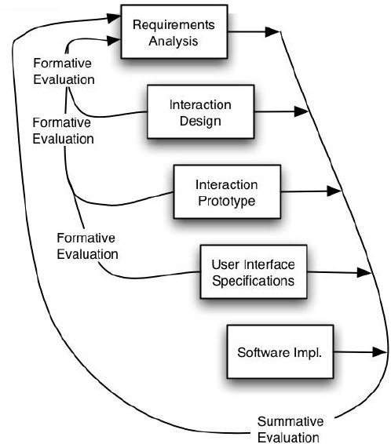
[14]

The usability engineering life cycle was created to provide a clear and concise framework for considering usability when developing applications. The overall aim of the usability engineering life-cycle is to implement a structure early on in the project which focuses on the usability of the application .There are six main categories which are included in the life-cycle, all of these focus heavily on developing a system whereby the user has lots of input and is included in development through prototypes and tests.

The six main categories [14]

- Requirement Analysis
- Interaction Design
- Interaction Prototype
- User Interface Specifications
- Software Implementation
- Evaluation

What is Human-computer interaction?

All of the design principles developed by academics over previous decades have contributed heavily to the field of Human-Computer Interaction. As the name suggests, the field of human-computer interaction studies the way in which humans and computers interact. HCI focuses on software engineering and system design.

Human-computer interaction encompasses three main disciplines.

- Computer science - for the development of technical software solutions.
- Human factors engineering - for the understanding of how humans physically interact with the system
- Cognitive science - for the understanding of how humans think when they are using systems.

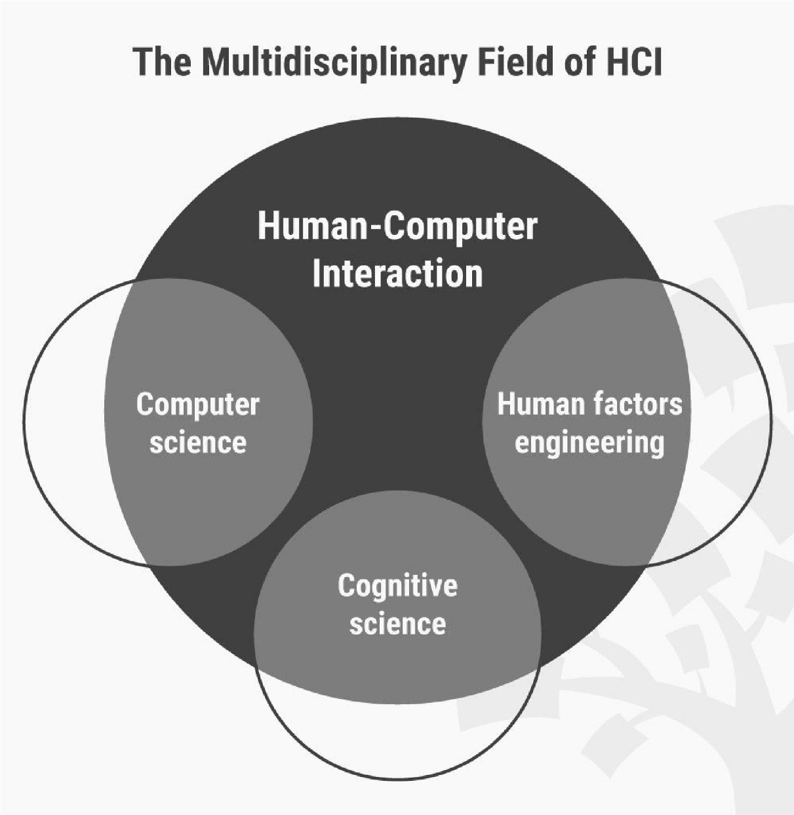
https://www.interaction-design.org/literature/topics/human-computer-interaction

Task Analysis

User Requirement | System Requirements
The user needs to be able to input biographical data. | The system needs to provide the user with a means to input biographical data, and then that data needs to be securely stored.
The user needs to be able to scan academic certificates to verify grades. | A scanner needs to be included in the system so the user can scan their certificates. The software needs to be implemented to assign an academic certificate to a user.
The user needs to be able to have their picture taken by the system. | A camera must be included in the system so the user can have their photo taken.
The user needs to be able to scan a form of official identification. | The scanner used in the system must be able to scan official identification documentation.
The user needs to be able to have the means to pay money for enrolment. | The system must have a means for the user to pay for the services used, in the form of both cash and card.
The user needs to be provided with a printed copy of their enrolment summary. | A printer must be included in the system to provide the user with a printed copy of their enrolment information.

Initial User Requirement Identification

The following is an initial list of both user requirements and system solutions based off the brief provided.

Hierarchy Overview

This is the hierarchy overview for the NPTC Self-Enrolment Systems. It contains all vital tasks the system is required to perform.

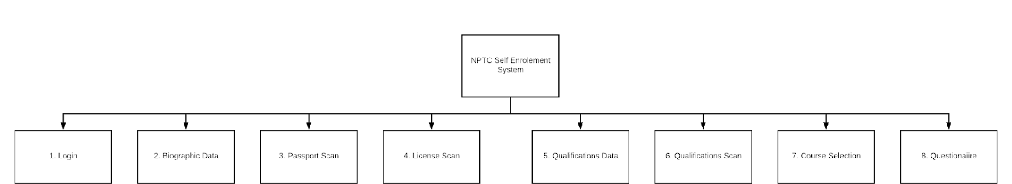

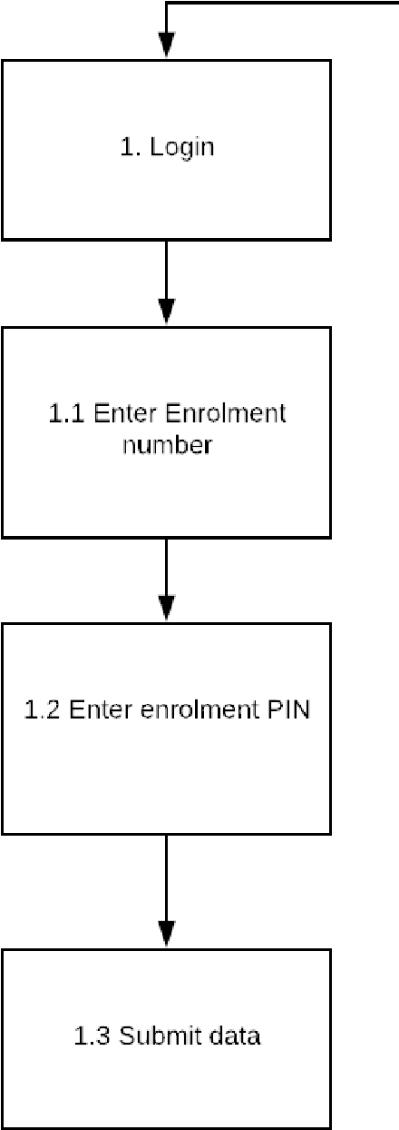
Task 1 - Login

Users will be asked to enter their enrolment number and enrolment pin

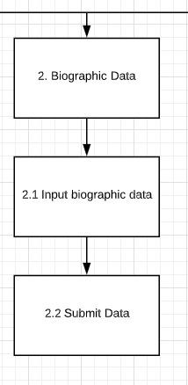

Task 2 - Biographic Data

Users are asked to enter their biographic data (name, date of birth, gender etc)

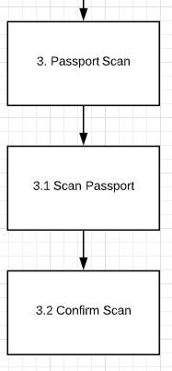
Task 3 - Passport Scan

Users are promoted to scan their passport. A diagram is shown on screen showing how to position their passport.
Users take the mage and then confirm the scan has worked.

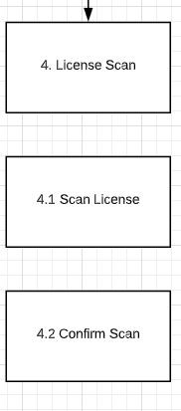

Task 4 - License Scan

Users are promoted to scan their passport. A diagram is shown on screen showing how to position their passport.
Users take the mage and then confirm the scan has worked.

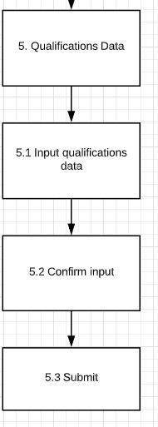
5 - Qualifications Data

Users are asked to manually input their qualification titles and grades. Prior to submitting, users are asked to confirm the input.

Task 6 - Qualifications Scan

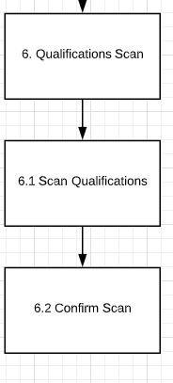

After entering their qualification information, users are asked to scan the certificates or evidence for their qualifications.

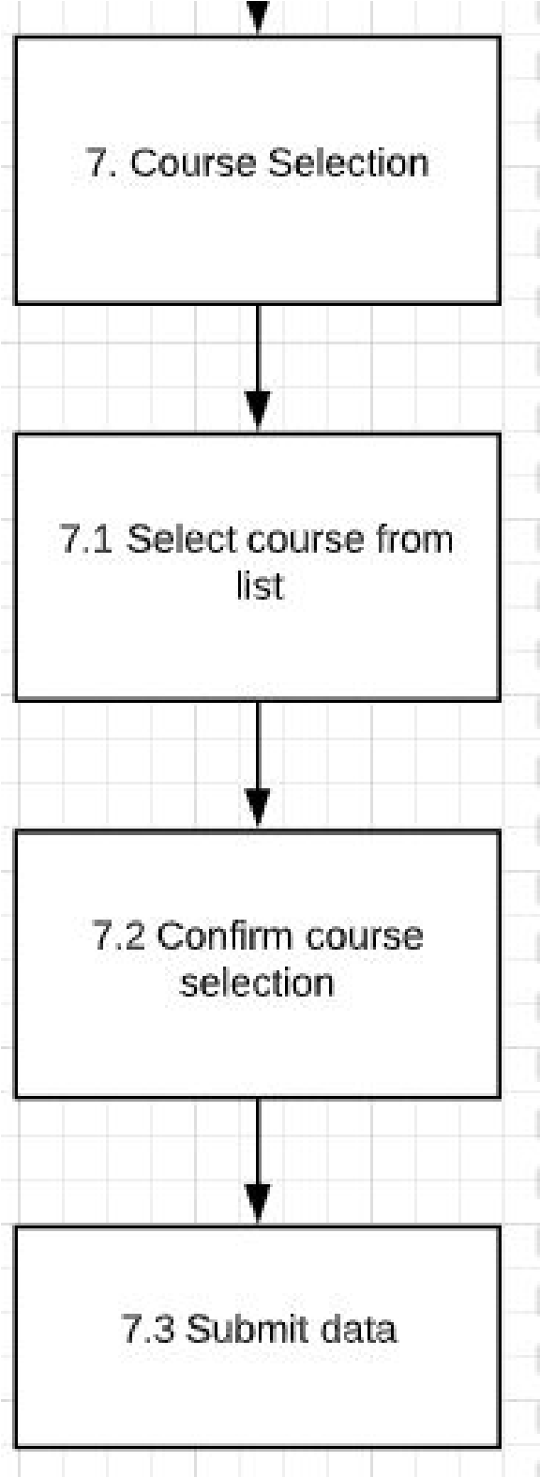

Task 7 - Course Selection

Users are provided with a list of courses they qualify for based on their scanned data. Users then select a course from the list, confirm the course selection and submit the data.

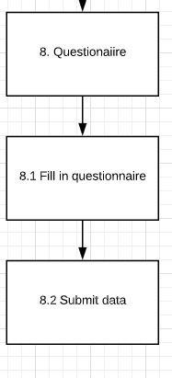

Task 8 - Questionnaire

Users are asked to fill in a questionnaire regarding the experience. Once the questionnaire has been completed, the data is then submitted.

Full Hierarchy

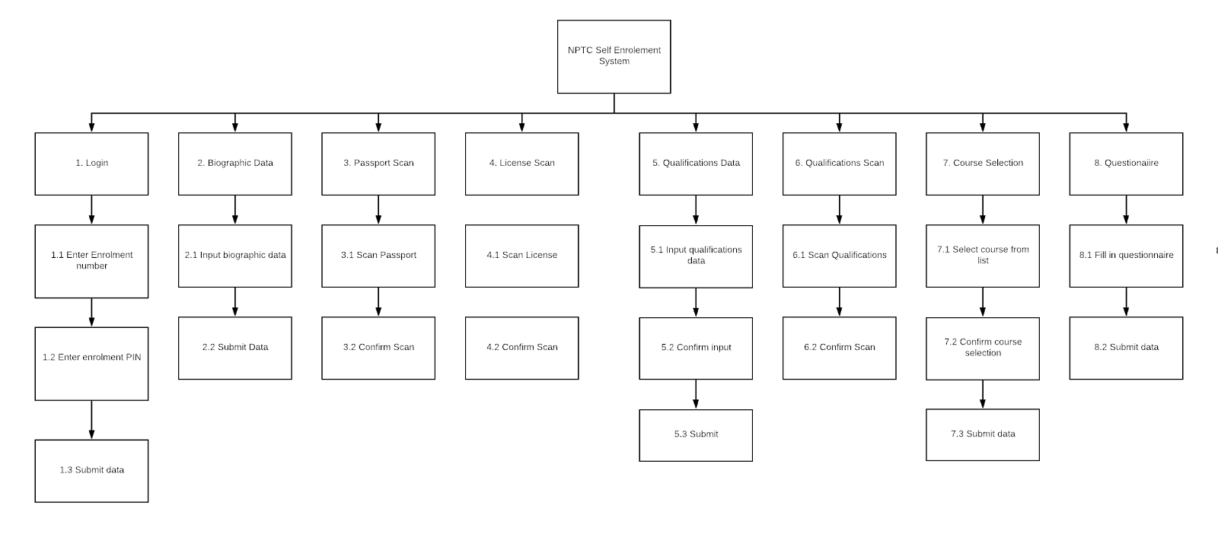

Application Flowchart
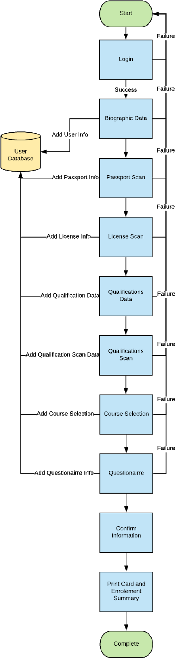

Task Analysis Conclusion

The process of researching and developing a hierarchical task analysis and flowchart diagram has provided added clarity to the needs of the system. Breaking down each section of the proposed system into a hierarchical format has resulted in an increased understanding of the user and system requirements. Looking at the system in such a way has identified some flaws which should be considered. The first is a lack of a welcome screen. NPTC Group is a multi-lingual campus which should be considered in the system using a language selection function. There is also no clear endpoint for the application, after the user has submitted their final data, they are presented with a printed identification card and an enrolment summary. A new final screen will be added to ensure it is clear to the user that the system has finished.

System Prototype Design

These screenshots show a prototype version of the developed system. This prototype has been developed using Microsoft PowerPoint and contains a limited amount of functionality. All information gathered from the completed hierarchical task analysis and flowchart creation, combined with research regarding design principles in prior sections, makes for a well informed and comprehensive self-enrolment system.

The first slide in the system is a simple login form. The use of white space and minimal design has been used in line with design principles research earlier on.
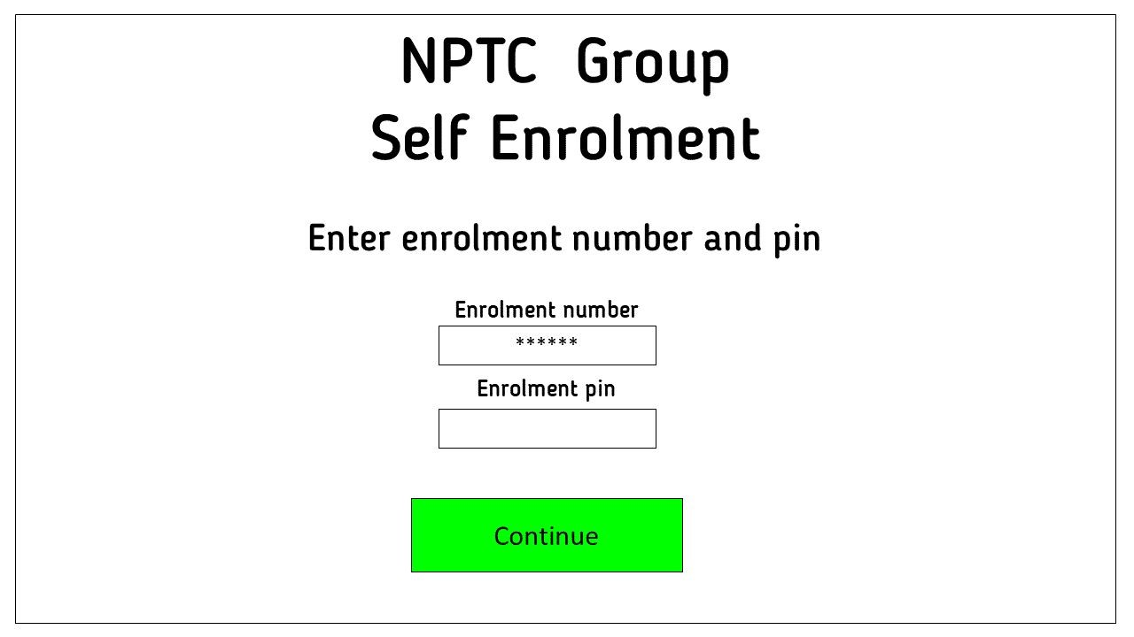

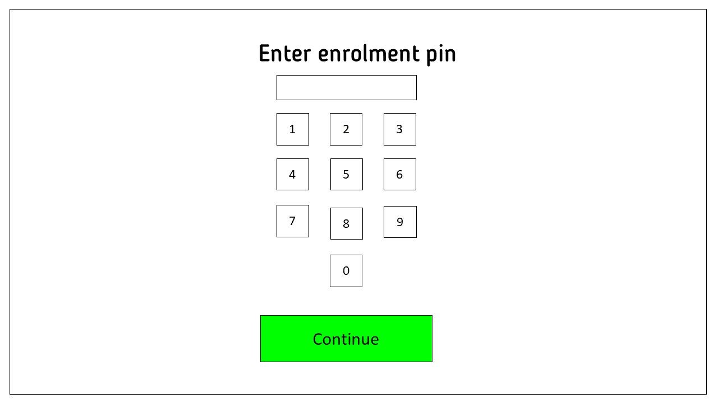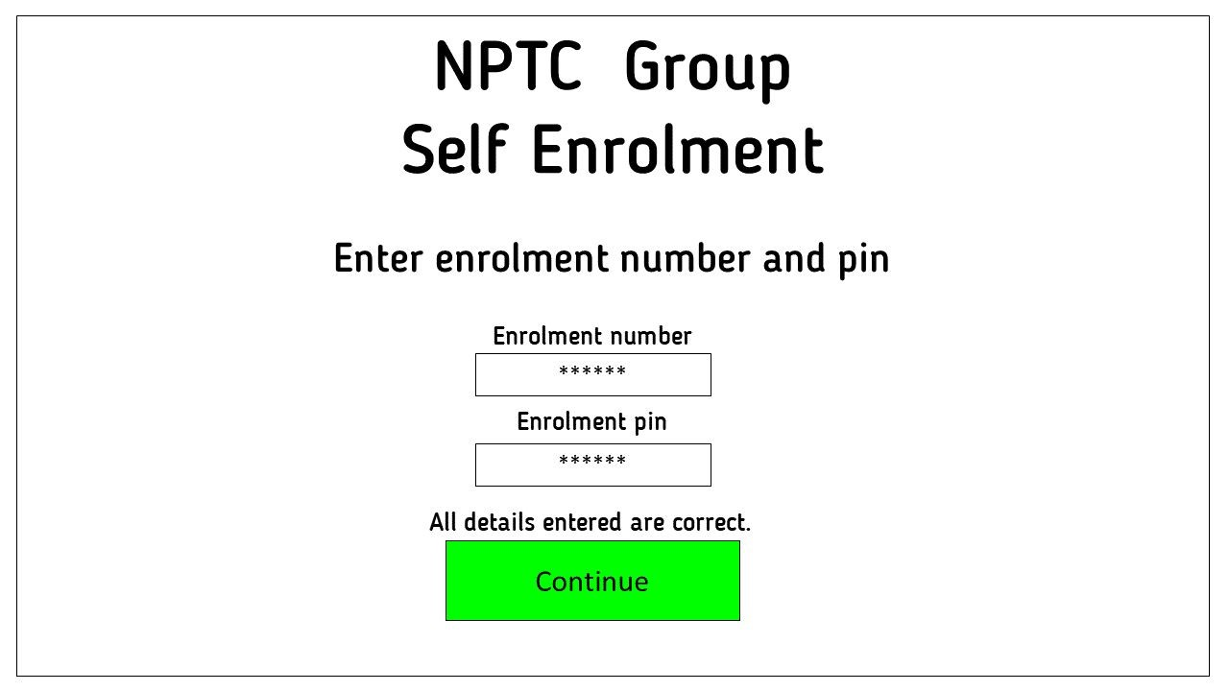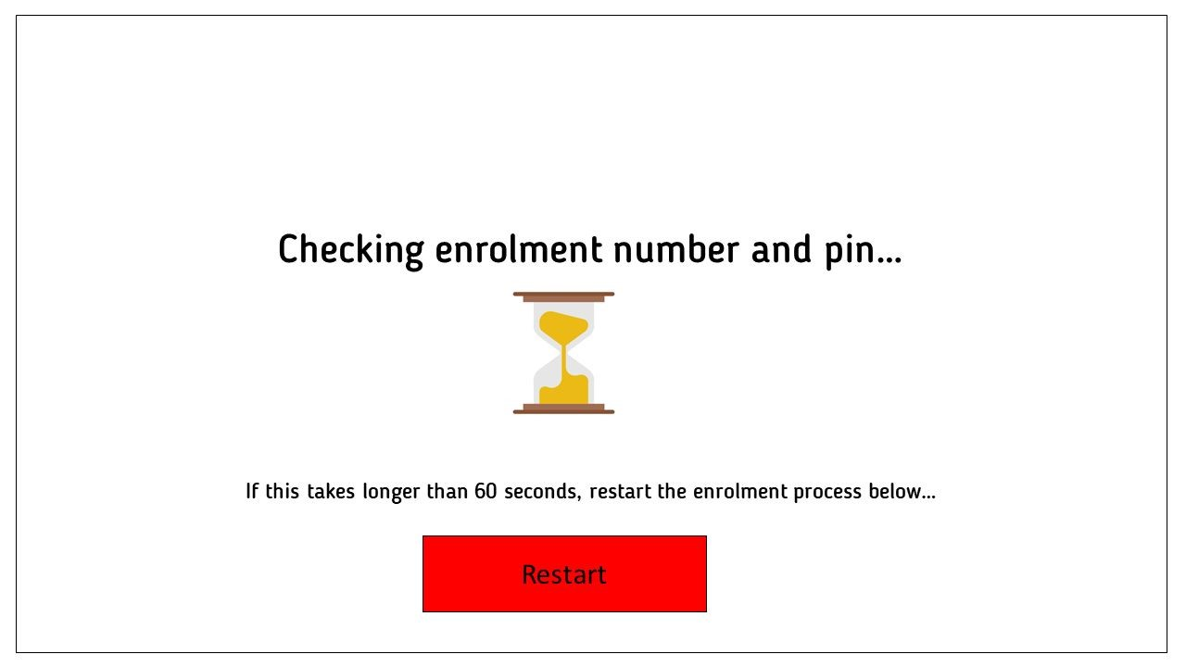
Iconography is used in the loading screens throughout the system to give the user feedback. The user knows now that their request has been successful and the system is currently checking their enrolment details
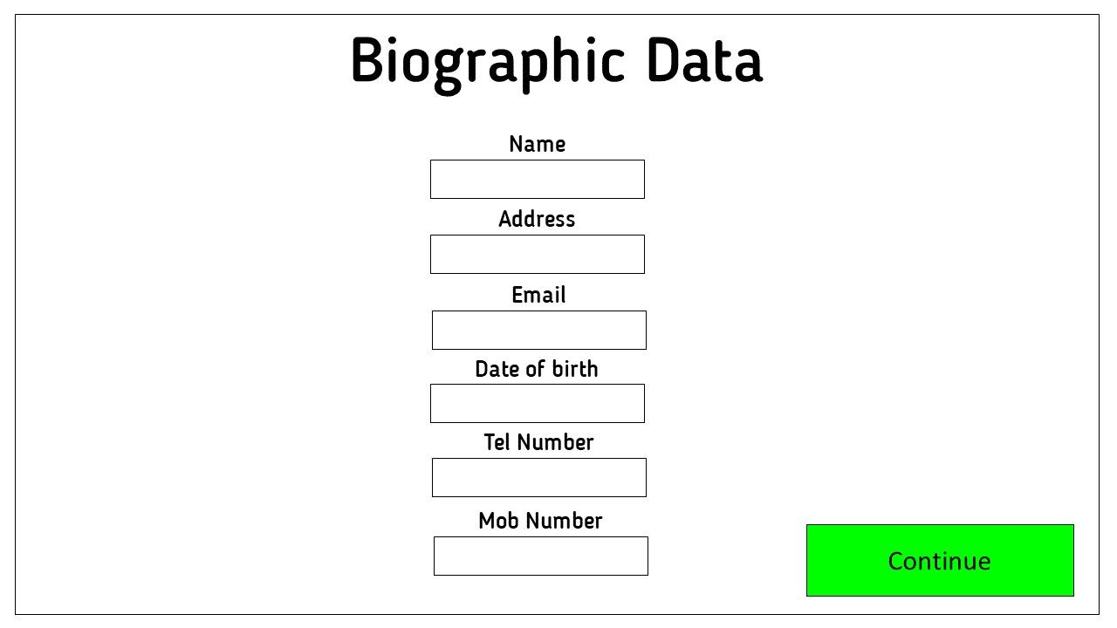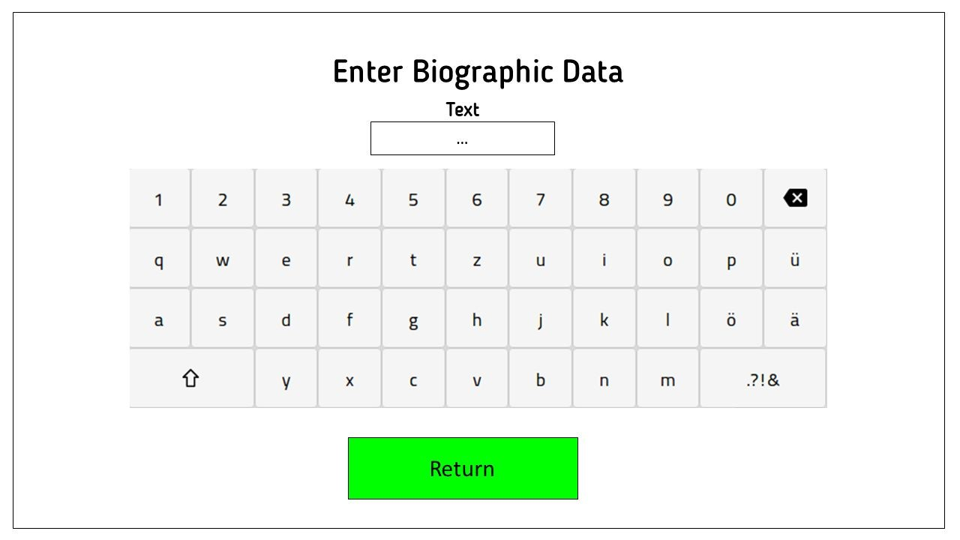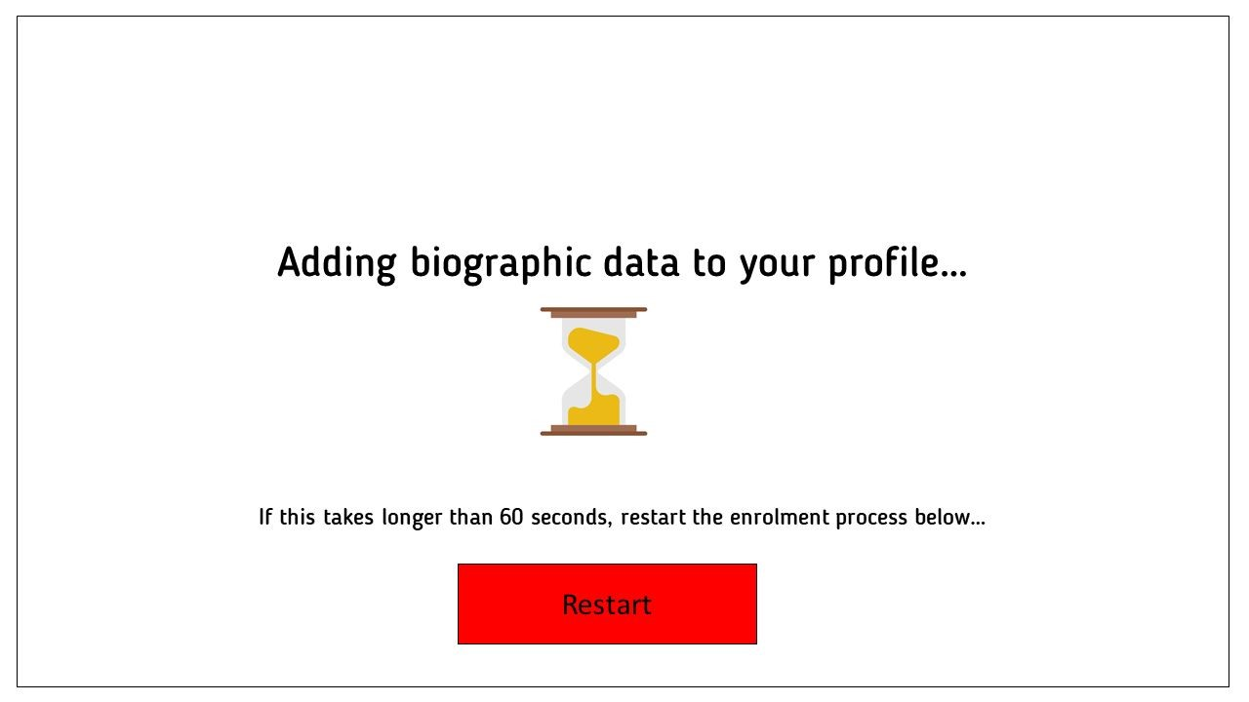
A large touch screen keyboard is used rather than a physical keyboard. This makes the keyboard more accessible as language selection could be used in the future.
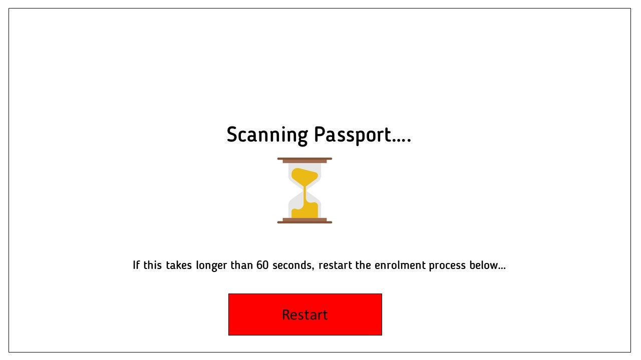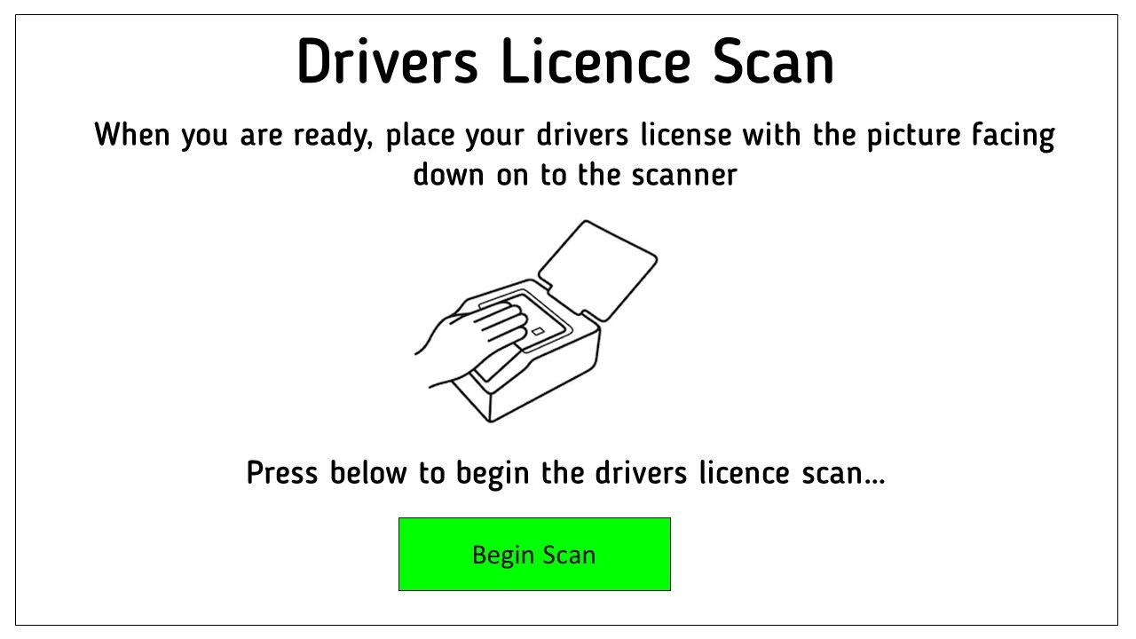
Iconography is once again used to show the user how to scan their passport.

A consistent colour scheme with buttons is used throughout. Green means submit data or begin process, red means restart or cancel
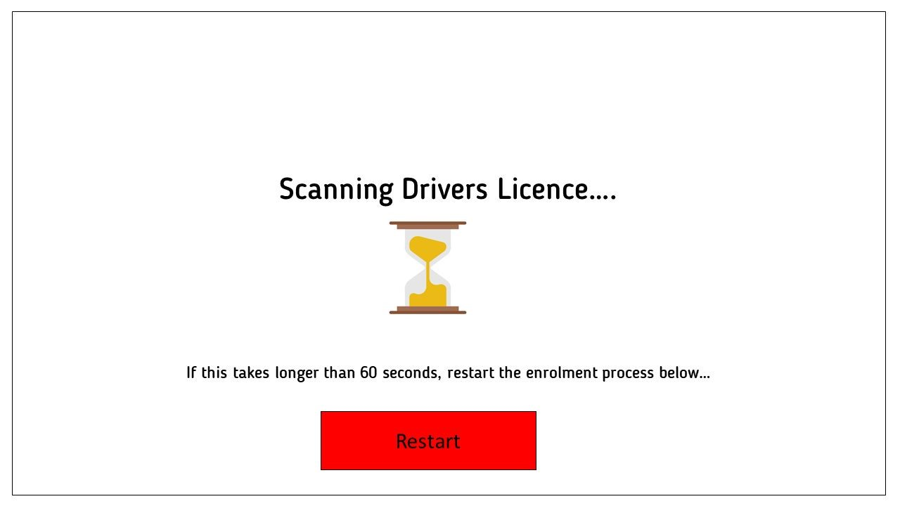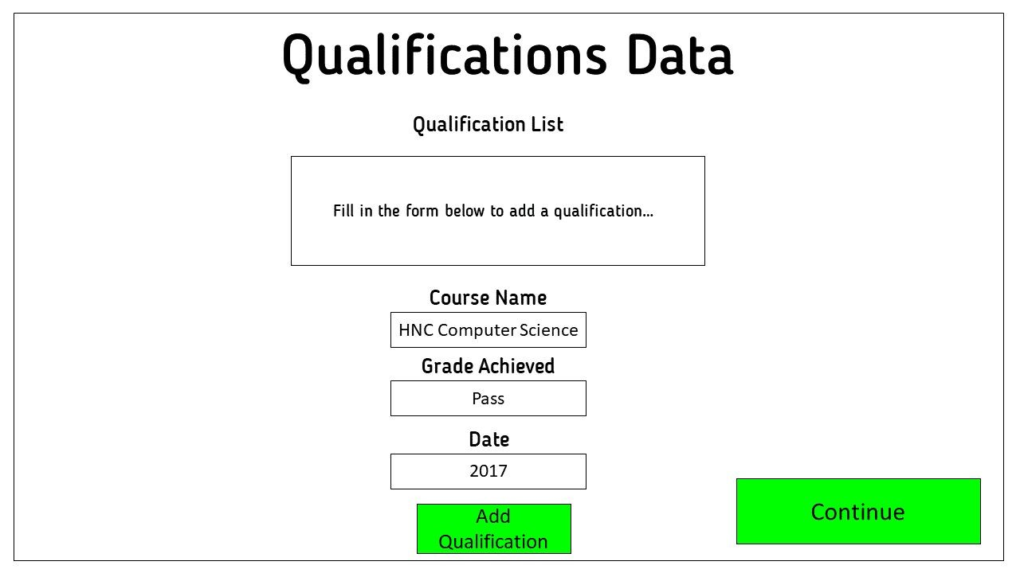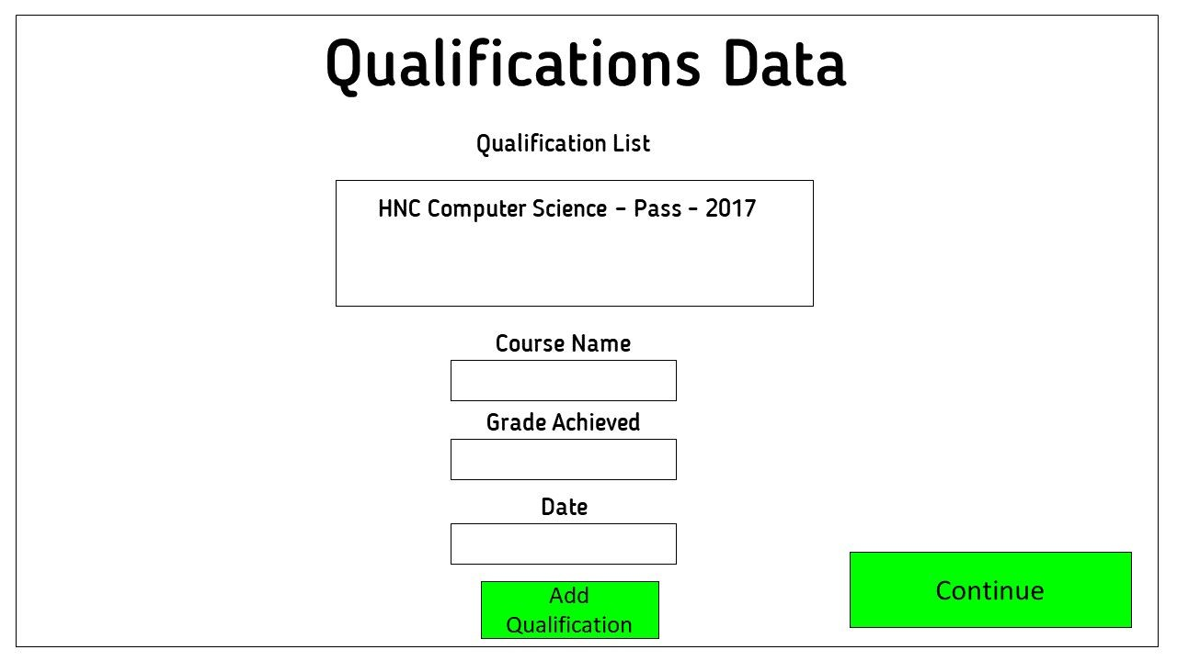
When the user is entering qualifications, a list of the qualifications that have been entered is shown to them.

This gives the user confidence that they have correctly added a qualification and can move on to the next task.
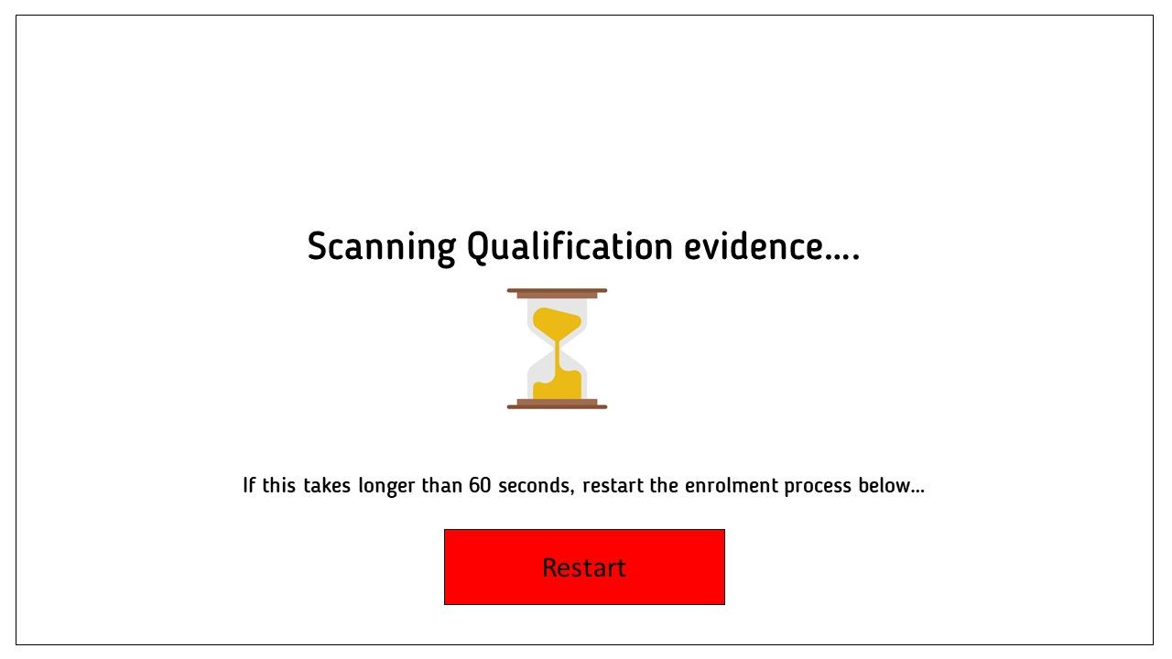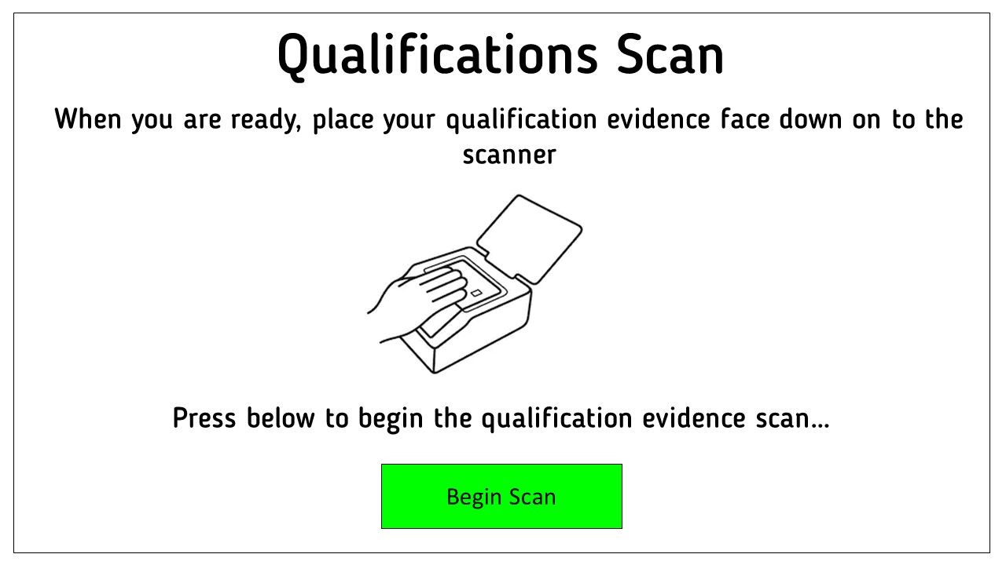
The system considers error management, by giving the user a clear solution to issues.

In this screen, the user is told that if the process takes longer than 60 seconds, press restart and try again.
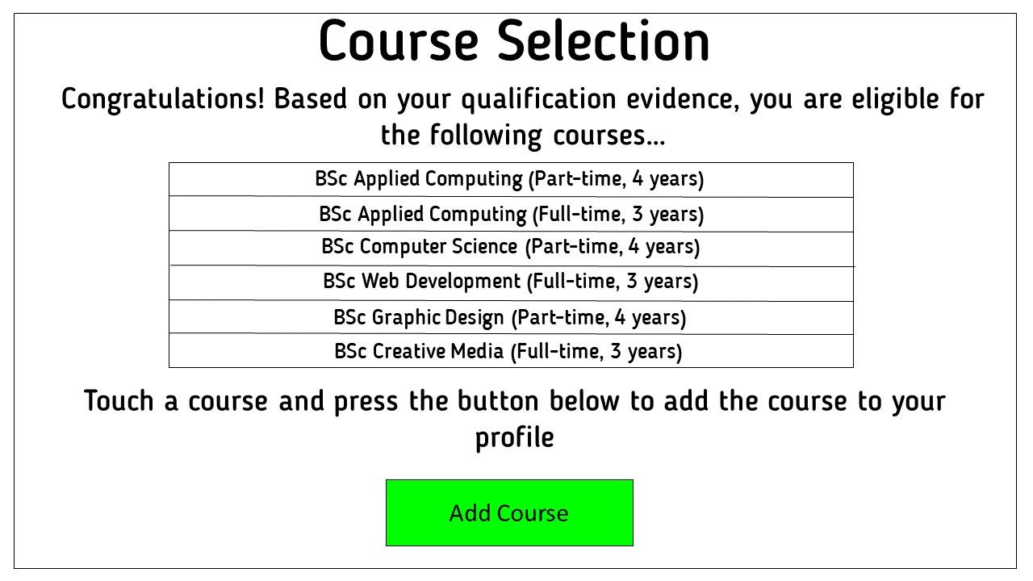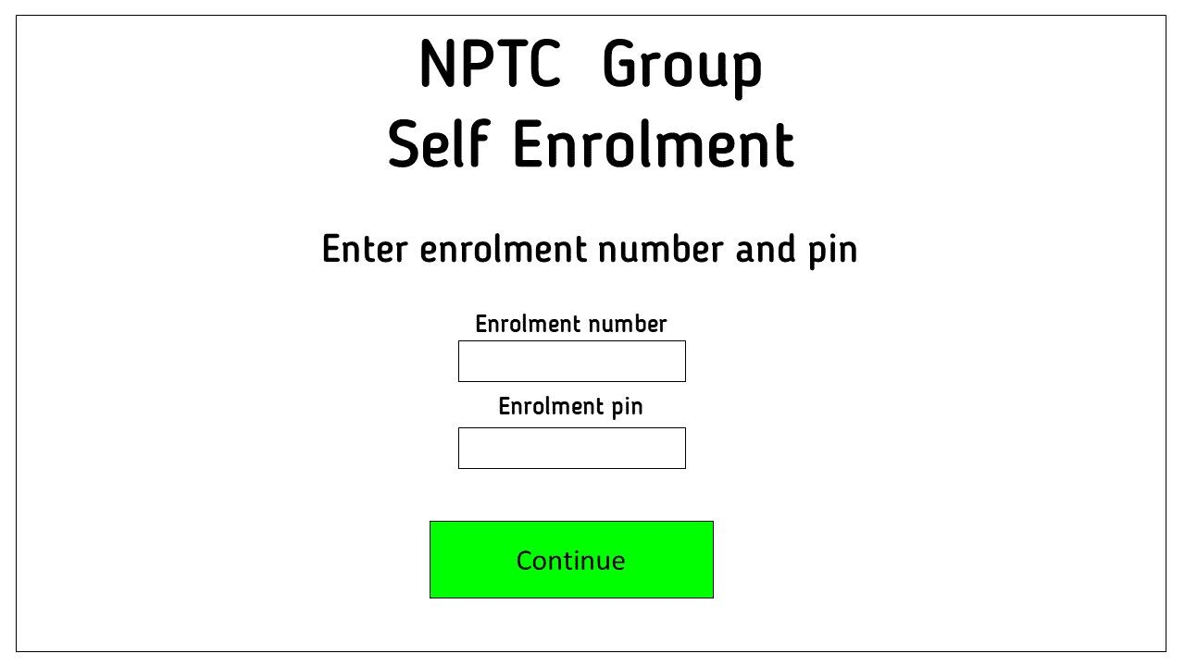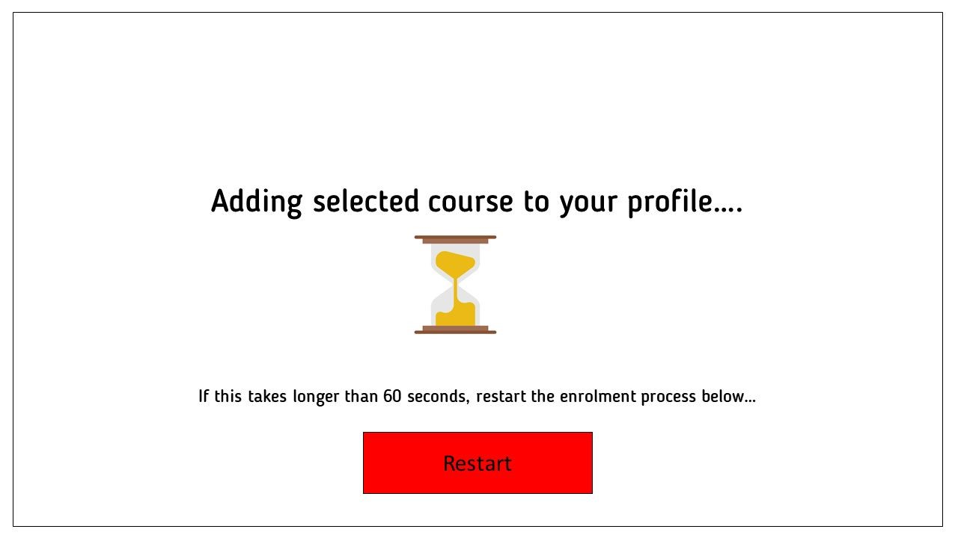
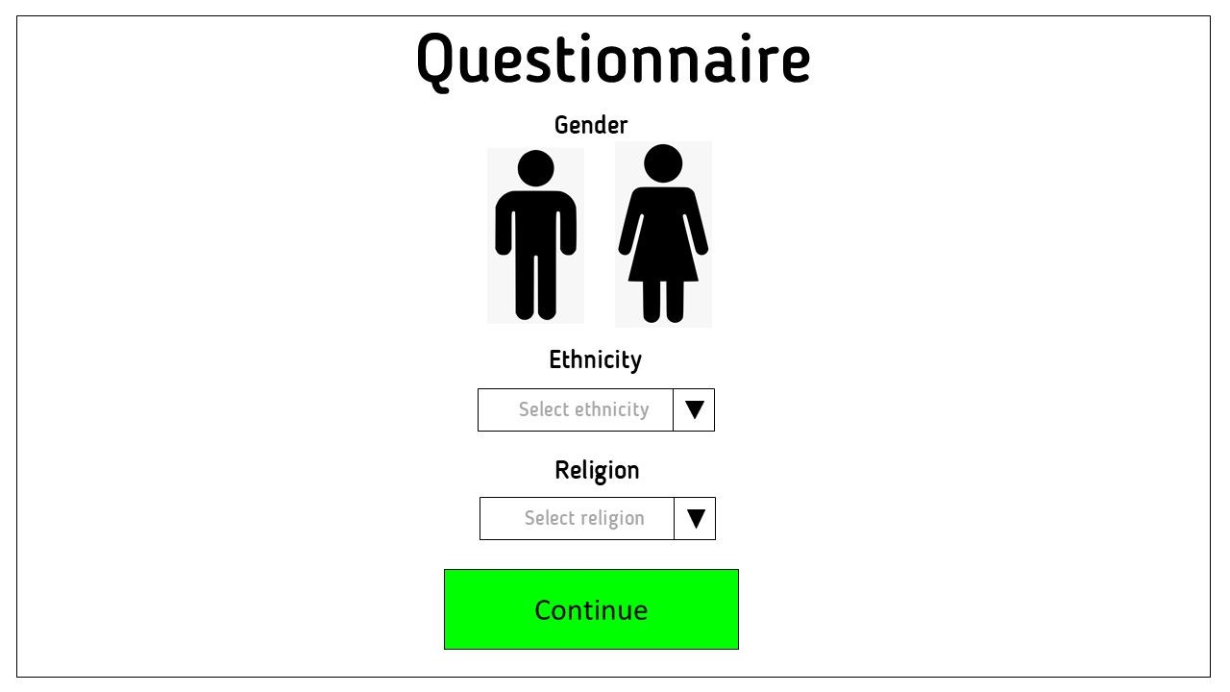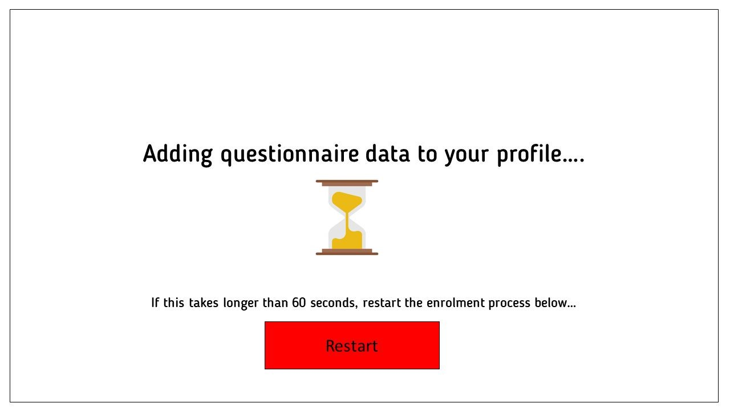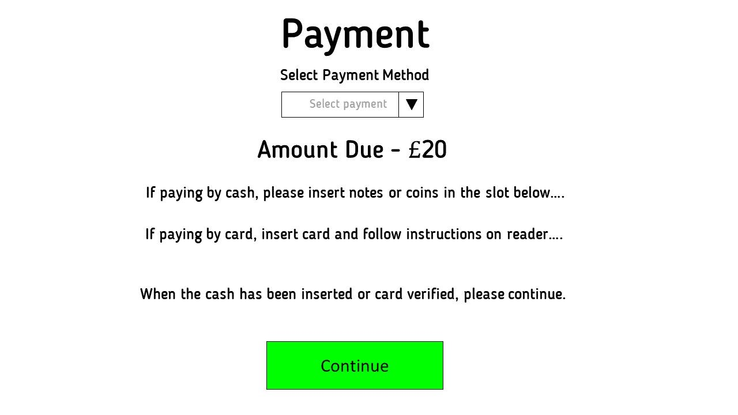
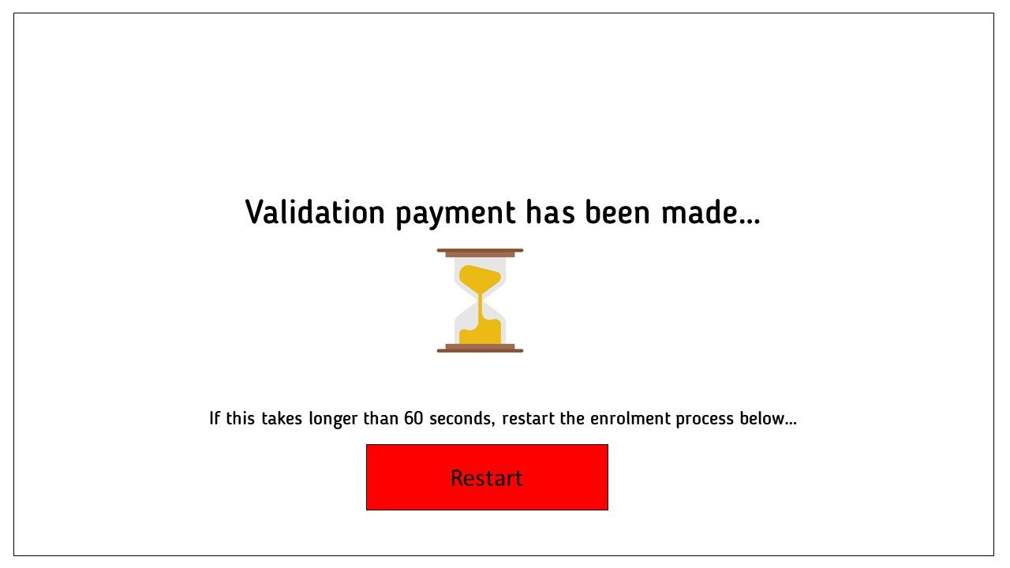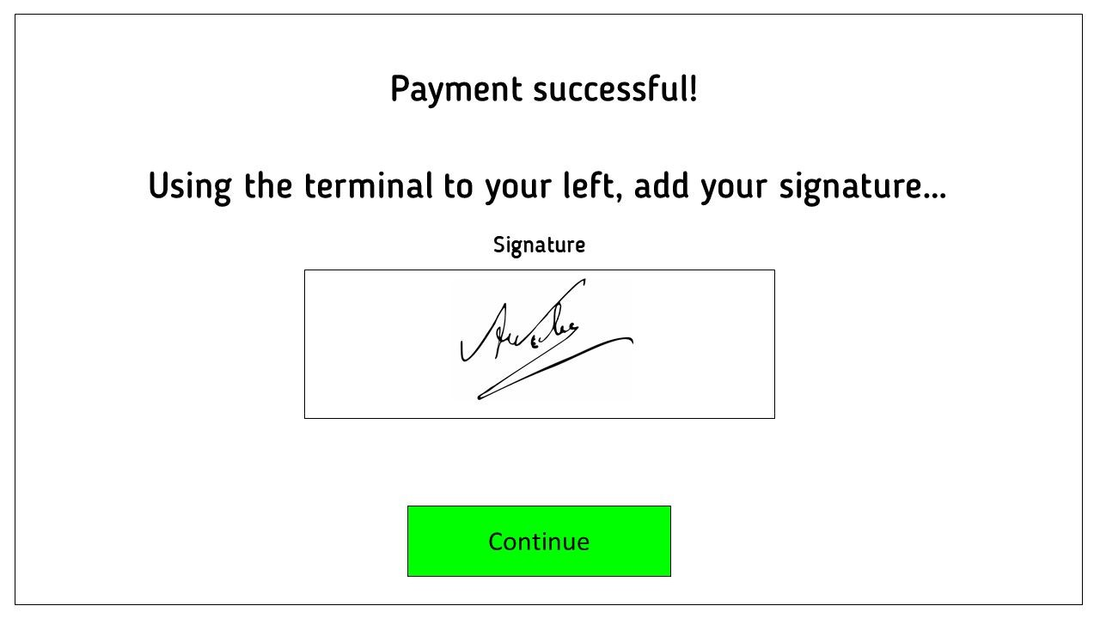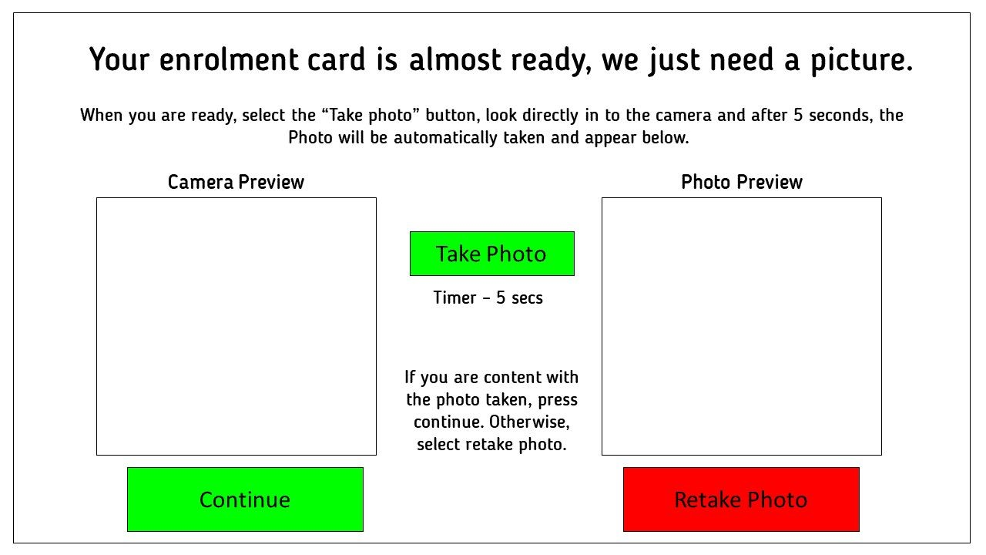
The user is presented with a camera preview and a photo preview, this reduces any errors by making sure the user can fix the problem themselves. A retake photo button is included to facilitate this.

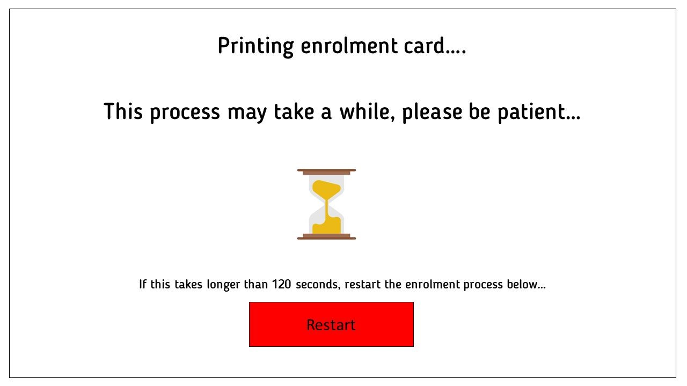
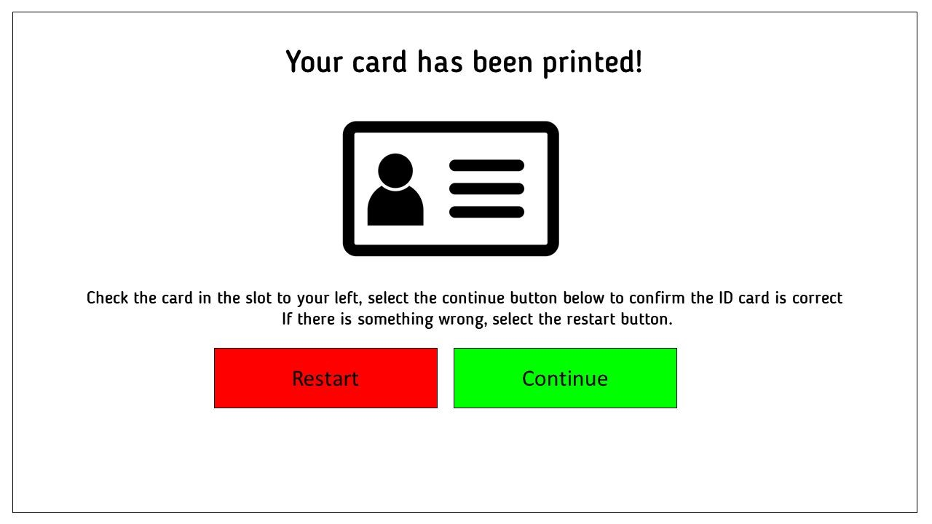

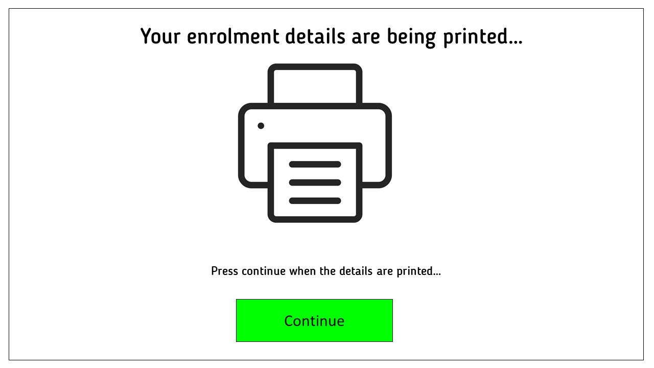
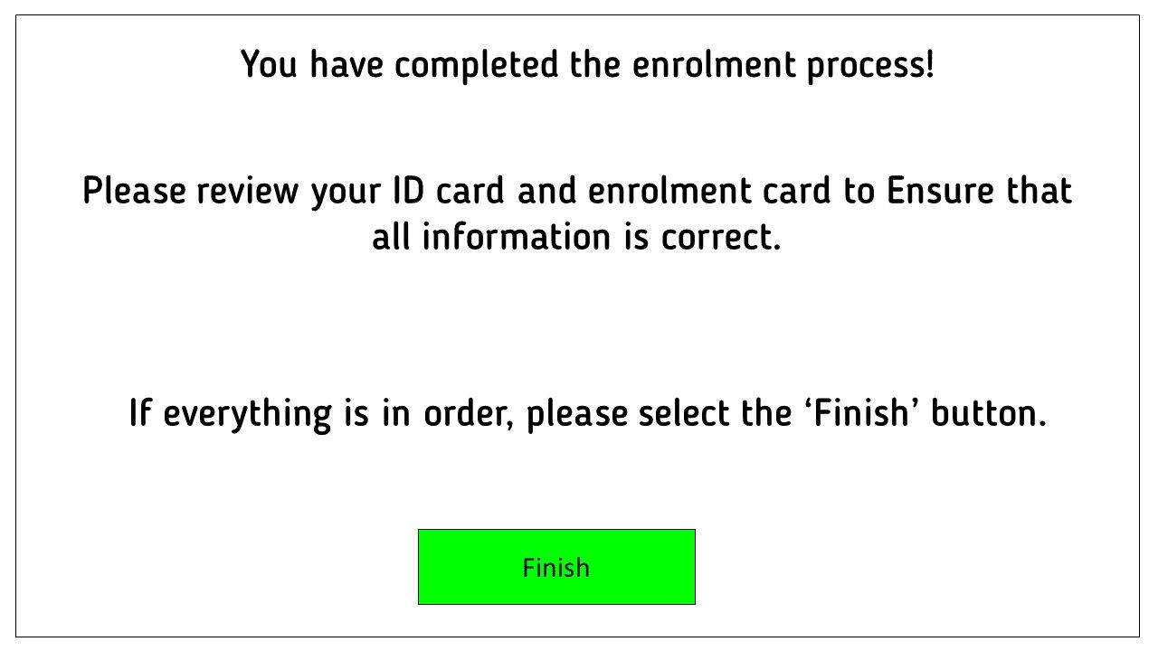
The user is given a clear indication that the process has been completed. They are again asked to review their ID card and enrolment card, before finally having the option to finish the process.

Human Factors

Human Factors refers the physical and psychological characteristics that humans have, many of which are highly relevant when it comes to developing software or a system. The way in which humans think and act will contribute massively to how successful a system can be.

Visual

The way in which humans perceive things through their eyes is one of the most important senses, and that is no different when it comes to considering human factors within a system. Systems must be developed to look appealing to users, as well as making logical sense and following the conventions humans are used to. [15]

Hearing

The hearing system within humans can play a huge role in the ability to communicate from human-to-human as well as human-system. Auditory feedback is often used within systems to give confidence or confirmation to the user that a task is being undertaken, or has completed. Auditory feedback should be implemented alongside a visual counterpart to ensure those who are deaf or hard of hearing can still get the required feedback. [15]

Cognition

The information gathered by our visual and hearing systems ultimately effects the way humans think, and the brain is key in processing all the data gathered by human factors. It’s important to consider the way humans often think, or don’t think, when developing a system. This is not always so clear, but in some cases it is. It is almost universally accepted that the colour green signifies go or safety, while the colour red signifies stop or danger. This is a cognitive trait of many humans without realising and should be considered when implementing a system. On the auditory side, human ears tend not to like aggressive or uncomfortable sounds, so it would be wise to implement inoffensive auditory feedback. [16]

Memory

Human memory operates many ways the same as a computer does. Humans have a limited short-term memory, too much information to process can result in things being forgotten or overlooked, or, in the context of a computer, dumped from RAM and replaced with new data. Computers can store large amounts of data long-term, and humans are the exact same, our long-term memory tends to have more capacity. This should be considered when presenting information to the user, too much information and too fast a pace could result in users forgetting or overlooking things. [17]
Practical Prototype

A practical prototype provides a means to develop a simple and low budget prototype based on our designs. Doing this can provide some much-needed feedback on the system, assisting the developer in making design decisions going forward. In this scenario, the basic navigation and positioning of elements was laid out on a large whiteboard. Two people were then invited to go through a step by step process of the system. The two people being tested were provided with props such as a passport for scanning and a credit card for paying. After the completion of the prototype test, those being tested were asked to fill in a short evaluation.
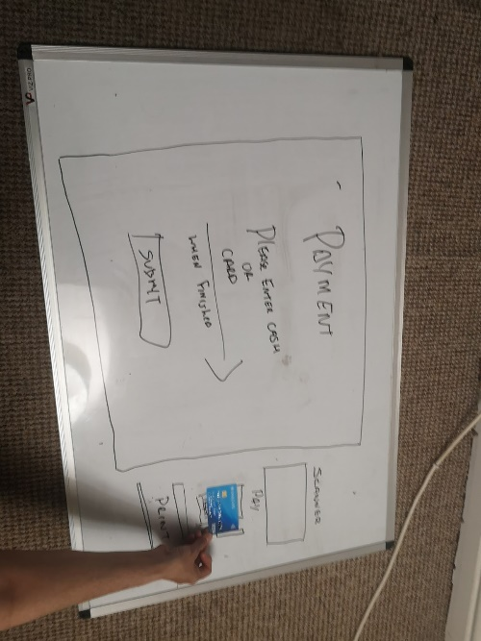
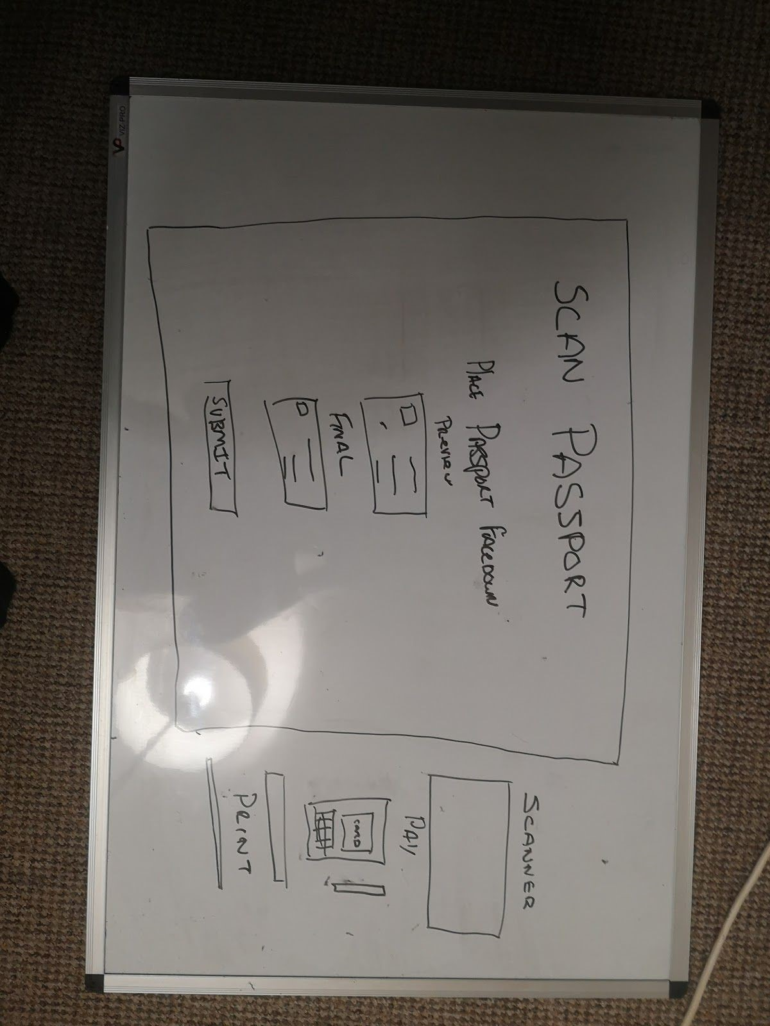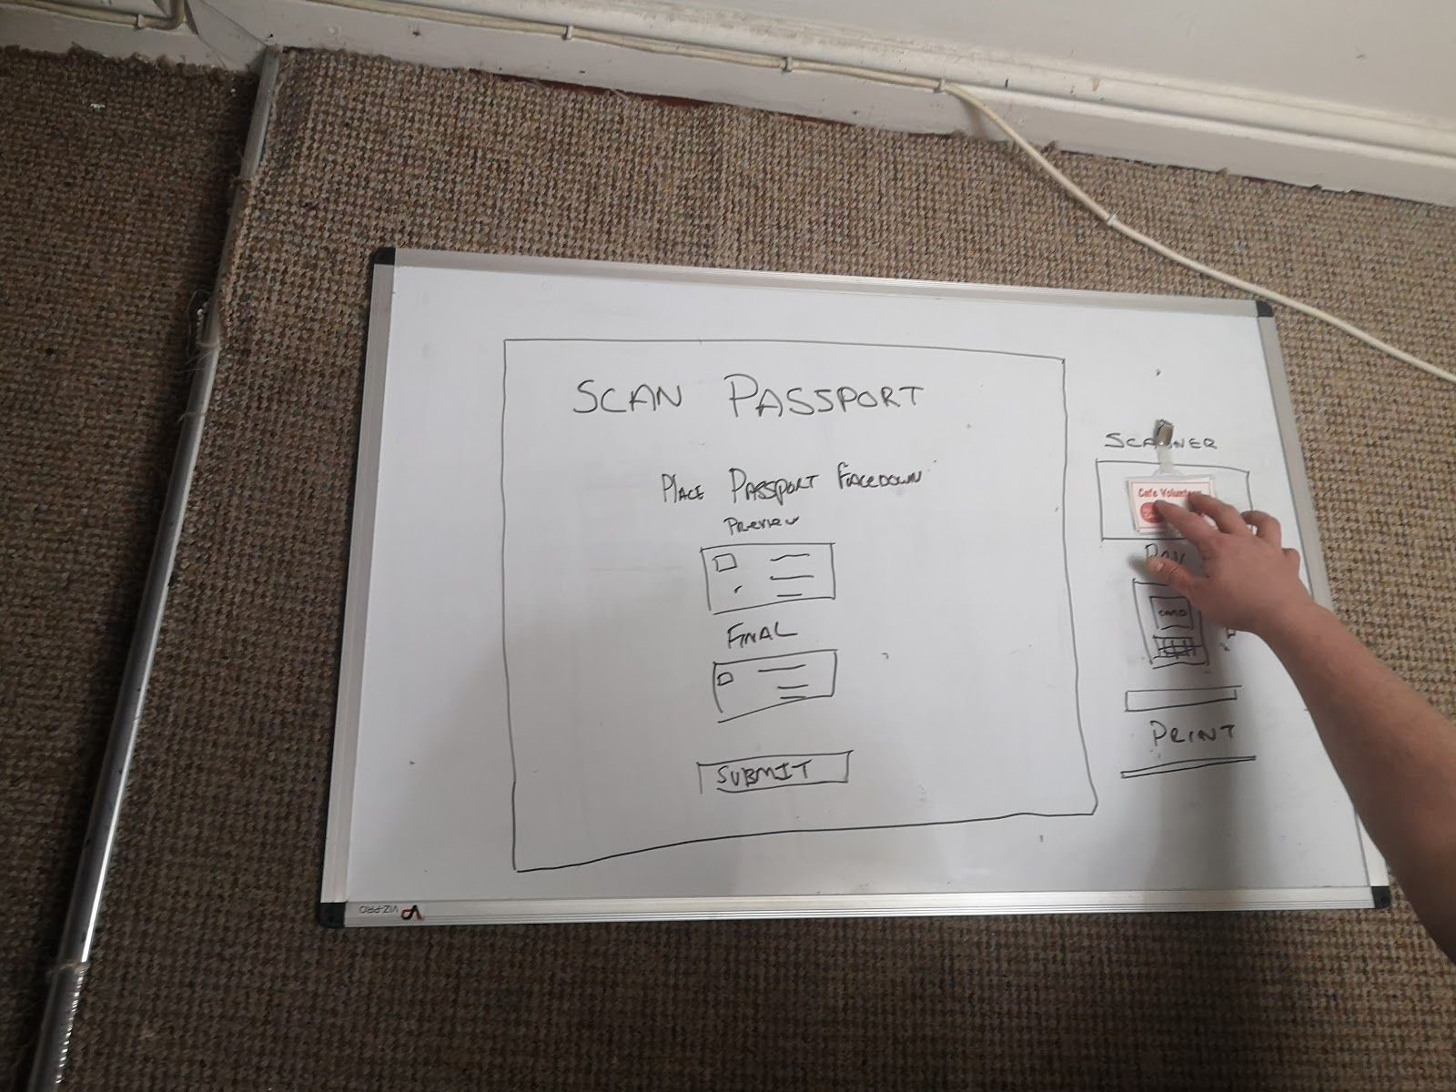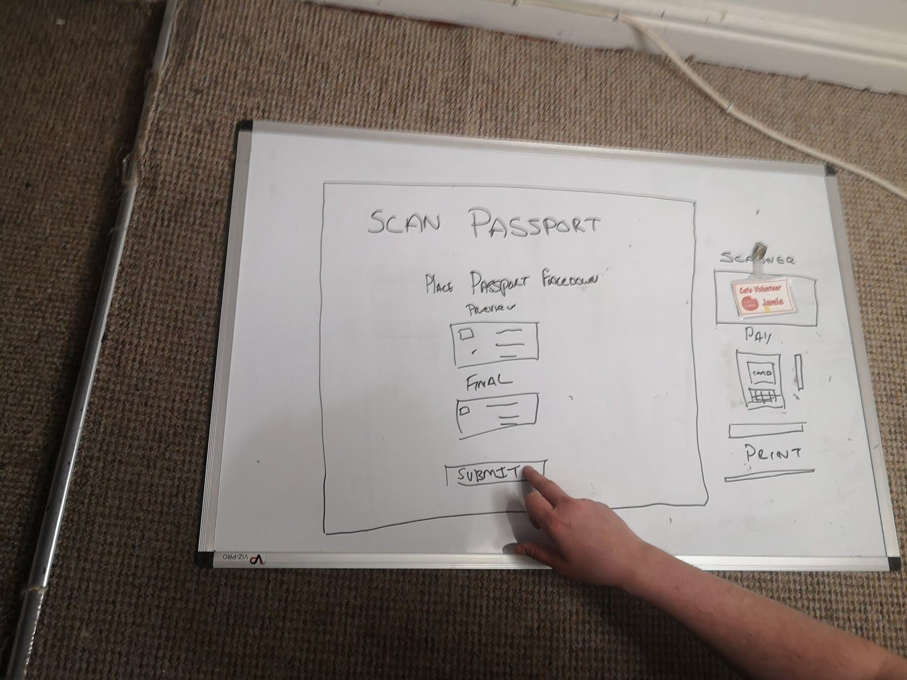

Test Questionnaire
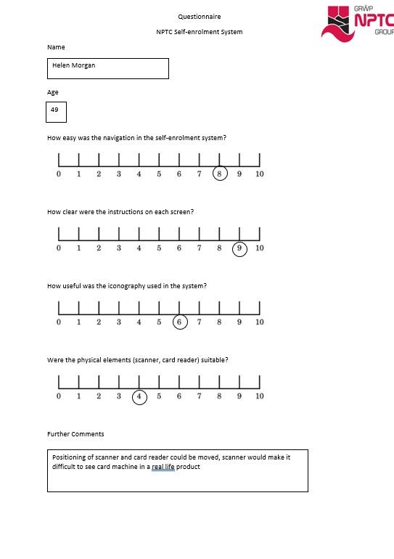
The nest stage in the prototype stage was to present a questionnaire to the two people who took part in the test. This will provide some valuable feedback and should shape the way the system is developed in its next iteration.

Questionnaire 1

Conclusions

- User felt like the navigation options in the system were good.
- Instructions were clear and concise on each screen.
- Iconography was useful but more could be use.
- The scanner and card reader positioning should be changed to ensure all systems are accessible.

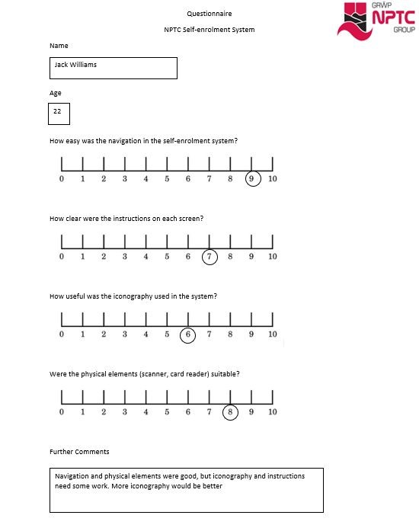
Questionnaire #2

Conclusions

- Navigation of system was extremely easy and clear to use
- Instructions on screen were above average
- Iconography used was good but could use some work.
- This user found no issue with the positioning of the physical elements.

Reflections

It is made clear from the prototype test that there is still work that could be done on the system. Valuable feedback was gathered from two people with differing computer proficiency. This is valuable as it gives us a wider range of ages and variables and should hopefully give differing feedback.

One of the strongest points that bot users agreed was that the system contained a strong navigation system. This refers to the way in which the user could move between screens, in menus and opening widgets like the software keyboard or camera tool. Both users felt like the navigation system was one of the best qualities of the systems. This is a big strong point moving forward, as the navigation within the prototype was one of the more difficult aspects to develop.

Both users felt like the information and instructions displayed on the screen were strong points of the system. The use of white space within the menu screens, combined with black text and concise language has led the instructions portion of the system to be another strong point. The effectiveness of this portion should make the system more efficient overall, as users understand what they need to be doing and at which point.

Both users felt like the iconography used within the system was only slightly above average, rating it a 6 out of 10. The users felt like the system had some suitable iconography, specifically the scanner diagram and sand-timer icon. Feedback suggested that more icons should be used as well as animations to give more specific feedback to the user. One implementation of this could be in the use of icons to aide navigation through tasks, such as arrows to indicted forward or backward.

A flaw was identified in the positioning of the physical elements of the system. That is the scanner, payment method and printing mechanism. It was pointed out by one user that in a real-world scenario, the scanner would likely cover up the card machine making it inaccessible. For this reason, the positioning of these elements should be changed so the card reader is on top of the scanner.

Overall, the process of developing a physical prototype has proved to be extremely valuable. The tests conducted with both users generated feedback which can be used to build a foundation for development in the future.

Software

Microsoft PowerPoint

PowerPoint was used to develop the software prototype due to it’s easy to user interface and general user friendliness. Rather than build an application and code the back end, with Microsoft PowerPoint I could easily create an interface and navigation without having to worry about coding anything. In the long run, using PowerPoint saved a huge amount of time. Any errors in the prototype are easily identified and changed. On top of that, PowerPoint offers a wide range of customisable options.

There are alternatives to Microsoft PowerPoint such as Google Sheets which offer similar functionality. For a more detailed prototype and designs, it may be wise to move to a coded system, especially if there is potential for this project to be implemented in the real world. Visual Basic offers an extensive of tools for both design and development of software systems.

Evaluation

Interface Design Research

The interface design research phase of this project is one which I am most proud of. I have extensively studied four of the world’s most important usability engineers to gather a thorough understanding of the principles they have researched. Isolating these principles helped me gather a good understanding of the many design principles, how they compare with one another and how those principles should be implemented within a system. The study of human-computer interaction was also conducted to increase my understanding of how humans interact with computers. This knowledge became important when developing more detailed mock-ups as more variables were considered.

The task analysis conducted helped me to gather a wider understanding of the suggested system. Breaking down each essential task into smaller tasks helped to make the project more manageable and appear less daunting. The analysis of these tasks helped break the project down in to small sections which could then be implemented. This saved huge amounts time when it came to implementing the system, as I had a large hierarchy laid out in front of me, containing all the vital tasks a user must complete.

The process of developing a paper prototype and then testing that prototype with users was extremely beneficial. As discussed in prior sections, the feedback generated from the paper prototype tests will form the foundation for further development.

The final software prototype is a system which could be improved. The feedback calls for the better use of iconography in the system, as well as paying more attention to how the physical side of the system should be implemented. Users were happy with the navigation and information elements of the system, which could be considered a bulk of the work. The details regarding iconography and positioning of physical elements can be changed easily, but it would be much more difficult to change the navigation structure.

Overall, I believe that the system which has been implemented contains a lot of positives and is a good starting block for a future system. More iterations of this process would lead to a system which is more in line with user requirements and ultimately satisfies the need of the client.

Conclusion

Using research into acclaimed usability engineers, their writings and principles, I have successfully implemented self-enrolment system which adequately satisfies the needs of the brief. Task analysis has been used to get a developed and clear understanding of which tasks are most essential, and in turn, which tasks should be included in the final system. The research into the way in which humans, see, hear, perceive and memorise data have helped implement a system which has clear and concise navigation (according to feedback). The use of a paper-prototype and tests conducted with users has allowed me to generate valuable feedback to make changes. One of which, the positioning of physical elements, was changed immediately after consideration. All the above have contributed greatly to developing a system which I believe adequately meets the needs of the brief, while also having scope for improvement and further development.

References

1.
What is Usability Engineering?. The Interaction Design Foundation. UX courses; 2020 [cited 2020 Mar 25]. Available from: https://www.interaction-design.org/literature/topics/usability-engineering
2​ . Research-Based Web Design & Usability Guidelines. Design Process Page 2. Ben Shneiderman. 2007. [cited 2020 Mar 25]
3​ . Research-Based Web Design & Usability Guidelines. Design Process Page 2. Ben Shneiderman. 2007. [cited 2020 Mar 25]
4​ . Research-Based Web Design & Usability Guidelines. Design Process Page 3. Ben Shneiderman. 2007. [cited 2020 Mar 25]
5​ . Research-Based Web Design & Usability Guidelines. Design Process Page 4. Ben Shneiderman. 2007. [cited 2020 Mar 25]
6​ . Research-Based Web Design & Usability Guidelines. Design Process Page 5. Ben Shneiderman. 2007. [cited 2020 Mar 25]
7​ . Research-Based Web Design & Usability Guidelines. Design Process Page 5. Ben Shneiderman. 2007. [cited 2020 Mar 25]
8​ . Research-Based Web Design & Usability Guidelines. Design Process Page 6. Ben Shneiderman. 2007. [cited 2020 Mar 25]
9​ . Research-Based Web Design & Usability Guidelines. Design Process Page 7. Ben
Shneiderman. 2007. [cited 2020 Mar 25]
10​ . Research-Based Web Design & Usability Guidelines. Design Process Page 8. Ben
Shneiderman. 2007. [cited 2020 Mar 25]
11. Ten Usability Heuristics by Jakob Nielsen [Internet]. Available from: https://tfa.stanford.edu/download/TenUsabilityHeuristics.pdf ​ [cited 2020 Mar 26]
12​ . Human-Computer Interaction. Alan Dix, Janet Finlay, Gregory D.Abowd, Russel
Beale. Principles to support usability. Page 271. [cited 2020 Mar 26]
- The Design Of Everyday Things. Donald A. Norman. Preface. Page 8. [cited 2020
Mar 26]
- Ripple: An Event Driven Design Representation Framework for Integrating Usability and Software Engineering Life Cycles - Scientific Figure on ResearchGate. Available from:
https://www.researchgate.net/figure/Usability-engineering-life-cycle_fig1_225870600 [accessed 27 Mar, 2020]
15. Human Factors in Software Engineering. Andreas Schmidt: What does “Human Factor” mean? Page 2. 2012 [cited 2020 Mar 26]
16. Human Factors in Software Engineering. Andreas Schmidt: What does “Human Factor” mean? Page 4. 2012 [cited 2020 Mar 26]
17. Human Factors in Software Engineering. Andreas Schmidt: What does “Human Factor” mean? Page 5. 2012 [cited 2020 Mar 26]

