

A HYBRID DEEP LEARNING FRAMEWORK WITH ATTENTION MECHANISM FOR REAL-TIME CYBER-THREAT DETECTION IN CLOUD COMPUTING ENVIRONMENTS

Date: 04/06/2026
Supervisor: Alireza Esfahani
Student Name: Riya Rameshbhai Kalal
Programme: MSc Cybersecurity and Digital Forensics

Abstract
Cloud computing is now a kind of core utility for most organisations, yet its distributed virtualized, multi tenant design ends up bringing real cybersecurity hurdles. The problem is that classic intrusion detection systems tend to lean on static signatures, and predefined rules, so they struggle when attacks are unfamiliar, fast changing, and massive in volume. Machine learning and deep learning can be more “adaptable” in practice, but a lot of past work stays stuck in offline model testing only, it doesn’t really show how a trained model becomes an actually usable cyber security system. This dissertation aims to cover that gap, by building , creating, and assessing a web based cyber threat detection dashboard for cloud computing settings.
The work follows a quantitative experimental system development approach, using the CICIDS2017 dataset stored in Parquet format. The dataset includes labelled traffic, with benign samples plus malicious activity such as DDoS , DoS, Botnet, Brute Force, Infiltration, PortScan, and Web Attack. Preprocessing involved merging the datasets, dealing with missing values, handling infinite values, removing duplicates, cleaning corrupted labels, selecting numeric features, encoding labels, scaling features, and also re checking class imbalance. For the baseline, a Random Forest classifier was chosen as the practical starting point, mainly because it fits structured network flow data well, it runs efficiently, it can be interpreted, and it is straightforward to deploy. Even though the broader research direction is guided by CNN LSTM Attention ideas, the implemented detection pipeline uses Random Forest for now, and the hybrid deep learning version is treated as a future upgrade.
After training, the model was wired into a Flask backend API, and connected to a frontend dashboard written with HTML, CSS, JavaScript, and Chart.js. The platform supports single traffic prediction, batch dataset uploading, analytics views, prediction history stored in SQLite, model performance inspection, and downloadable CSV reporting. The system reached an overall accuracy of 99.75% , but the evaluation also suggests this number needs a careful reading. In particular, class imbalance hurt performance on smaller or rarer attack types like Infiltration, SQL Injection, and XSS. So, it becomes clear that accuracy alone is not enough for intrusion detection, and class level precision, recall, F1 score, plus confusion matrix analysis are more informative.
Overall, the dissertation adds value by showing how a machine learning intrusion detection model can be turned into an operational decision-support platform. For future efforts, it would be ideal to bring in CNN LSTM Attention , integrate live network flow extraction, use explainable AI , push a proper cloud deployment, and strengthen the handling of class imbalance, so detection stays reliable even when threats appear less frequently.
Table of Contents
Abstract 2
List of figures 9
List of tables 10
Acknowledgement 11
CHAPTER 1: INTRODUCTION 12
1.0 Introduction 12
1.1 Background of the Study 12
1.2 Problem Statement 12
1.3 Aim of the Study 13
1.4 Research Objectives 13
1.5 Research Questions 14
1.6 Scope of the Study 14
1.7 Significance of the Study 15
1.8 Overview of the Implemented System 15
1.9 Ethical Considerations 16
CHAPTER 2: LITERATURE REVIEW 17
2.1 Introduction 17
2.2 Cloud Computing Security and Threat Landscape 18
2.2.1 Cloud Architecture and Vulnerabilities 18
2.2.2 Types of Cyber Threats in Cloud Environments 19
2.2.3 Challenges in Cloud Intrusion Detection Systems (IDS) 19
2.3 Intrusion Detection Systems (IDS): Traditional vs Modern Approaches 20
2.3.1 Traditional Intrusion Detection Systems 20
2.3.2 Machine Learning-Based Intrusion Detection Systems 22
2.3.3 Deep Learning-Based Intrusion Detection Systems 23
2.4 Evolution of Intrusion Detection Systems 24
2.4.1 Traditional Intrusion Detection Systems 24
2.4.2 Machine Learning-Based Intrusion Detection Systems 25
2.4.3 Deep Learning-Based Intrusion Detection Systems 25
2.5 Deep Learning Techniques in Intrusion Detection Systems 26
2.5.1 Convolutional Neural Networks (CNN): Spatial Learning 26
2.5.2 Recurrent Neural Networks (RNN, LSTM, GRU): Temporal Learning 26
2.5.3 Autoencoder-Based Models 27
2.6 Sequential and Advanced Models 27
2.7 Attention Mechanism in Deep Learning 28
2.7.1 Concept 28
2.7.2 Benefits 28
2.7.3 Gap in IDS Research 28
2.8 Real-Time Cyber-Threat Detection 28
2.9 Review and Synthesis of Existing Studies 29
2.9.1 Insights from Survey Studies 29
2.9.2 Key Limitations Across Literature 29
2.10 Research Gap 29
2.11 Chapter Summary 30
CHAPTER 3: RESEARCH METHODOLOGY 31
3.0 Introduction to the Chapter 31
3.1 Methodological Purpose and Justification 31
3.2 Research Philosophy and Approach 32
3.2.1 Research Philosophy: Positivism 32
3.2.2 Research Approach: Deductive 33
3.3 Research Design 33
3.4 Dataset Description 35
3.4.1 Dataset Selection 35
3.4.2 Dataset Files Used 36
3.4.3 Dataset Suitability for Cloud IDS 36
3.5 Data Preprocessing 37
3.5.1 Preprocessing Pipeline 38
3.5.2 Parquet File Loading and Dataset Merging 38
3.5.3 Missing and Infinite Value Handling 38
3.5.4 Duplicate Removal 38
3.5.5 Label Cleaning 39
3.5.6 Numeric Feature Selection 39
3.5.7 Label Encoding 39
3.5.8 Feature Scaling 39
3.5.9 Class Imbalance Review 40
3.5.10 Summary of Preprocessing Decisions 40
3.6 Proposed System Framework 40
3.6.1 Frontend Component 41
3.6.2 Backend Component 42
3.6.3 Prediction Engine 42
3.6.4 Database and Reporting Component 42
3.7 Machine Learning Model 43
3.7.1 Random Forest Model Logic 43
3.7.2 Critical Justification for Random Forest 43
3.8 Model Training Procedure 44
3.8.1 Train-Test Split 45
3.8.2 Feature Scaling 45
3.8.3 Label Encoding 45
3.8.4 Random Forest Parameters 45
3.8.5 Model Evaluation Metrics 46
3.8.6 Model Serialisation 46
3.9 System Development Tools 46
3.10 Ethical Considerations 47
3.10.1 Use of Secondary Dataset 47
3.10.2 Cybersecurity Ethics 48
3.10.3 False Positives and False Negatives 48
3.10.4 Data Protection and Privacy 48
3.10.5 Responsible Use of AI Tools 48
3.11 Chapter Summary 49
CHAPTER 4: SYSTEM DESIGN AND IMPLEMENTATION 50
4.0 Introduction 50
4.1 System Overview 50
4.2 System Architecture 51
4.3 Project Folder Structure 52
4.4 Model Implementation 53
4.5 Backend Implementation 56
4.6 Prediction Engine Implementation 57
4.7 Database Implementation 57
4.8 Frontend Implementation 58
4.9 Batch Upload and Report Generation 60
4.10 Dashboard Analytics Implementation 61
4.11 Model Performance Page 63
4.12 System Testing 63
4.13 Implementation Challenges 64
4.14 Chapter Summary 64
CHAPTER 5: RESULTS, EVALUATION AND DISCUSSION 65
5.0 Introduction 65
5.1 Model Performance Results 65
5.2 Classification Performance by Attack Type 66
5.3 System Functionality Evaluation 66
5.4 Discussion of Findings 66
5.5 Evaluation Against Research Objectives 67
5.6 Limitations 67
5.7 Future Improvements 67
5.8 Chapter Summary 68
CHAPTER 6: CONCLUSION AND RECOMMENDATIONS 69
6.0 Introduction 69
6.1 Summary of the Study 69
6.2 Achievement of Research Objectives 69
6.3 Main Findings 70
6.4 Contribution of the Study 70
6.5 Limitations of the Study 71
6.6 Recommendations 71
6.7 Final Conclusion 72
References 74

List of figures
Figure 1: Core architectural layers and vulnerability points in cloud environments 16
Figure 2: Major cyber-threat categories affecting cloud computing systems 17
Figure 3: Operational logic of signature-based and rule-based intrusion detection systems 18
Figure 4: Machine learning-based IDS pipeline highlighting dependence on feature engineering 20
Figure 5: Deep learning-based IDS demonstrating hierarchical feature learning and hybrid architectures 21
Figure 6: Deterministic logic of signature- and rule-based intrusion detection systems 22
Figure 7: Research Design Workflow 32
Figure 8: End-to-End System Architecture 39
Figure 9: Model Training Pipeline 43
Figure 10: End-to-End System Architecture. 49
Figure 11: Project Folder Structure in Visual Studio Code. 50
Figure 12: Model Training Execution 52
Figure 13: Saved Model Artefacts 53
Figure 14: Flask Backend Running 54
Figure 15: Backend API Status Page 55
Figure 16: Prediction History Page 56
Figure 17: Home Page of the Web Application 57
Figure 18: Scanner Page Before Prediction 57
Figure 19: Scanner Page After Prediction 58
Figure 20: Upload Dataset Page 58
Figure 21: Batch Prediction Result 59
Figure 22: Dashboard Analytics Page 60

List of tables
Table 1: Dataset Scope and Attack Categories 13
Table 2: Significance of the Study 14
Table 3: Overview of the Implemented Cyber-Threat Detection System 14
Table 4: Methodological Alignment with the Research Problem 31
Table 5: Research Design Components 33
Table 6: CICIDS2017 Dataset Files and Attack Categories 35
Table 7: Critical Evaluation of the CICIDS2017 Dataset 36
Table 8: Data Preprocessing Summary 39
Table 9: Critical Evaluation of Random Forest for this Study 43
Table 10: Evaluation Metrics 45
Table 11: System Development Tools 45
Table 12: Main System Functionalities 49
Table 13: System Architecture Layers 50
Table 14: Project Folder Structure 52
Table 15: Backend API Endpoints 55
Table 16: Frontend Pages and Functions 57
Table 17: Dashboard Metrics 61
Table 18: System Testing Summary 62
Table 19: Summary of Model Performance 64
Table 20: Achievement of Research Objectives 66
Table 21: Summary of Key Findings 69

Acknowledgement
I would like to express my sincere gratitude to my project supervisor for the guidance, feedback, and academic support provided throughout this dissertation. Their advice helped me refine the research direction, strengthen the technical implementation, and critically evaluate the limitations of the cyber-threat detection system.
I am also grateful to my lecturers and the Computing department for providing the knowledge, resources, and learning environment that supported the development of this project. The skills gained during the programme were essential in completing the machine learning, backend, frontend, and evaluation components of the system.
I would like to thank my family and friends for their encouragement, patience, and support during the completion of this dissertation. Their motivation helped me remain focused throughout the research and development process.
Finally, I acknowledge the developers and researchers behind the publicly available CICIDS2017 dataset and the open-source tools used in this project, including Python, Scikit-learn, Flask, SQLite, HTML, CSS, JavaScript, and Chart.js. These resources made it possible to develop and evaluate the cyber-threat detection dashboard presented in this dissertation.

CHAPTER 1: INTRODUCTION

1.0 Introduction
Cloud computing has become a central infrastructure for modern digital services, because it enables organisations to store, process, and access data using scalable and distributed environments. However, the same characteristics that make cloud computing so useful—virtualisation, multi-tenancy, distributed resources, elasticity, and remote.
Cyber-threat detection in cloud computing is a critical research topic. Cloud environments are exposed to DDoS attacks, botnet activity, brute-force attacks, port scanning, infiltration attempts, malware behaviours, privilege escalation, and web-based attacks.
Traditional Intrusion Detection Systems (IDS) are often built on signatures or predefined rules. However, deep learning introduces high compute cost , black-box decision-making, susceptibility to class imbalance and there is often limited evidence about real world deployments [4], [8].
This dissertation looks at the design and implementation of a cyber-threat detection dashboard for cloud environments. The practical implementation uses the CICIDS2017 and a Random Forest as a baseline.

1.1 Background of the Study
Cloud computing has changed how organisations manage digital infrastructure. This pattern improves flexibility and cost efficiency, though it also introduces new cybersecurity problems.
One of the main cybersecurity tools for safeguarding such environments is an Intrusion Detection System. IDS technologies monitor network or system behaviour to spot suspicious activity.
Machine learning has been brought into IDS research to reduce those limitations. Instead of depending purely on manually defined rules, machine learning models learn patterns from historical traffic data.
Even with these advances, there is still a big gap between IDS work in academia and actual deployment. This leads to a practical weakness: the model may look great in a training script but remain hard to operate in real security monitoring.

1.2 Problem Statement
Cloud computing environments require intrusion detection systems that are accurate, scalable, adaptive, and practically deployable. However, existing IDS approaches still face several limitations.
First, traditional signature-based IDS cannot reliably detect unknown or evolving cyber-attacks because they depend on predefined attack signatures [12]. Second, many machine learning models rely heavily on dataset quality and feature engineering, which can limit their generalisation to real-world cloud environments [3].
This creates a gap between model performance and practical cybersecurity use. A cyber-threat detection model should not only produce classification results; it should also support user interaction, risk interpretation, prediction history, dashboard analytics, and reporting. Without these functions, the model remains an.
This dissertation therefore addresses the problem by developing a web-based cyber-threat detection dashboard trained on the CICIDS2017. The system uses a Random Forest as an implemented baseline and provides a foundation for future integration of CNN-LSTM-Attention models.

1.3 Aim of the Study
The aim of this study is to design, develop, and evaluate a ML-based cyber-threat detection dashboard capable of classifying malicious network traffic and supporting practical decision-making in cloud environments.

1.4 Research Objectives
The objectives of the study are:
- To critically review existing intrusion detection approaches, including traditional IDS, machine learning IDS, deep learning IDS, and attention-based IDS.
- To identify key limitations in current cloud-based cyber-threat detection, including weak real-time deployment, class imbalance, computational cost, and interpretability challenges.
- To prepare and preprocess the CICIDS2017 for supervised cyber-threat classification.
- To train and evaluate a Random Forest as a baseline machine learning model for intrusion detection.
- To develop a Flask backend API for cyber-threat prediction, batch upload, dashboard statistics, scan history, model metrics, and report download.
- To design and implement a frontend web dashboard that allows users to scan traffic, upload datasets, view analytics, check history, review model performance, and download reports.
- To critically evaluate the implemented system in terms of model performance, usability, limitations, and future improvement.
- To propose future enhancement through CNN-LSTM-Attention architecture for improved spatial, temporal, and feature-prioritised threat detection.

1.5 Research Questions
The main research question is:
How can a ML-based cyber-threat detection system be designed and implemented to classify malicious network traffic and support practical decision-making in cloud environments?
The supporting research questions are:
- What are the limitations of traditional, machine learning, and deep learning intrusion detection systems in cloud environments?
- How can the CICIDS2017 be prepared and used for supervised cyber-threat classification?
- How effective is a Random Forest in detecting benign and malicious network traffic?
- How can a trained machine learning model be deployed through a backend API and frontend dashboard?
- What are the limitations of the implemented baseline system, and how can future CNN-LSTM-Attention integration improve it?

1.6 Scope of the Study
This study focuses on the design and implementation of a local web-based cyber-threat detection dashboard. The system uses the CICIDS2017 in Parquet format and trains a Random Forest to classify network traffic into benign and attack categories. The implementation includes model training.
The project covers the following attack categories:
Table 1: Dataset Scope and Attack Categories
Dataset Category | Threat Type
Benign-Monday | Benign traffic
Botnet-Friday | Botnet
Bruteforce-Tuesday | Brute Force
DDoS-Friday | DDoS
DoS-Wednesday | DoS
Infiltration-Thursday | Infiltration
Portscan-Friday | PortScan
WebAttacks-Thursday | Web Attacks
The study does not implement live packet capture, real-time cloud telemetry ingestion, or production cloud deployment. It also does not implement the full CNN-LSTM-Attention model in the current version. Instead, CNN-LSTM-Attention is discussed as a future enhancement. The implemented model is Random.

1.7 Significance of the Study
This study is significant because it addresses both theoretical and practical gaps in intrusion detection research. Theoretically, it contributes to the discussion on cloud-based IDS by critically examining the limitations of traditional, machine learning, and deep learning approaches. Practically, it contributes by.
The significance of the study can be understood in four ways.
First, it demonstrates how real cybersecurity data can be used to train a supervised machine learning model for cyber-threat classification. Second, it shows how the trained model can be deployed through a backend API and connected to a frontend dashboard.
Table 2: Significance of the Study
Area | Significance
Academic | Contributes to IDS research by connecting model development with deployment
Technical | Implements a working ML-based cyber-threat detection dashboard
Practical | Provides prediction, risk level, recommendation, history, analytics and reporting
Critical | Shows why high accuracy must be interpreted alongside class-level metrics
Future research | Provides a foundation for CNN-LSTM-Attention enhancement
This study is therefore useful for students, researchers, and practitioners interested in applied cyber-threat detection, machine learning deployment, and cloud security.

1.8 Overview of the Implemented System
The implemented system consists of five main components: dataset, machine learning model, backend API, frontend dashboard, and database/reporting module.
Table 3: Overview of the Implemented Cyber-Threat Detection System
Component | Description
Dataset | CICIDS2017 Parquet files containing benign and malicious network traffic
Model | Random Forest trained for multi-class threat detection
Backend | Flask API that handles prediction, upload, dashboard, history and reports
Frontend | HTML, CSS and JavaScript dashboard for user interaction
Database | SQLite storage for scan history
Reporting | CSV export for batch prediction outputs
The system allows the user to interact with the trained model through a browser interface. When a user submits a scan request, the frontend sends data to the Flask backend. The backend processes the data through the prediction engine and returns the.

1.9 Ethical Considerations
The project is defensive in nature. It does not involve hacking, unauthorised scanning, exploitation, malware execution, or collection of private organisational traffic. The dataset used is a publicly available benchmark dataset. No human participants are recruited, and no interviews, questionnaires, observations, audio.
The main ethical issues concern responsible use of cybersecurity knowledge, false positives, false negatives, and interpretation of machine learning results. A false positive may incorrectly classify benign traffic as malicious, while a false negative may fail to detect an actual attack. Both.
Data protection risk is low because the system does not intentionally collect personal data. The SQLite database stores only prediction-related outputs such as prediction label, confidence, risk level, recommendation, scan type, and timestamp.

CHAPTER 2: LITERATURE REVIEW

2.1 Introduction
Cyber-threat detection in cloud computing is all about spotting harmful behaviour inside very distributed, virtualised, and multi-tenant setups, where information keeps getting produced, handled, and relayed at huge scale. So, in practice, solid intrusion detection in the cloud is no longer just a fixed , sort of once-and-done problem but more like something that should constantly adapt.
Most traditional intrusion detection systems (IDS) , especially those relying on signatures and rules, are pretty constrained in these environments. They cant really generalise well to never-seen attack patterns and they also have trouble with large volume heterogeneous data flows, especially when everything comes in at the same time. Machine learning helps to a point, but there is still a heavy dependence on manual feature crafting and.
Because of that, deep learning models have become a dominant approach, mainly thanks to their ability to do automatic feature extraction and representation learning. This also pushed the development of hybrid deep learning frameworks, where several models are merged together so detection quality can improve under different, shifting network conditions.
Still, an important limitation stays around: most hybrid models lean on static feature processing and dont really have a way to dynamically rank or prioritise features, which can cause computational drag and weaker robustness, particularly when data is high-dimensional. But, as the literature suggests, attention mechanisms inside hybrid intrusion detection frameworks are still not used in a fully mature way. Accordingly, this chapter attempts to evaluate intrusion detection approaches that already exist, links relevant theoretical perspectives, and highlights research gaps that collectively support the need for a hybrid attention-based framework tailored for real-time cloud environments.

2.2 Cloud Computing Security and Threat Landscape

2.2.1 Cloud Architecture and Vulnerabilities
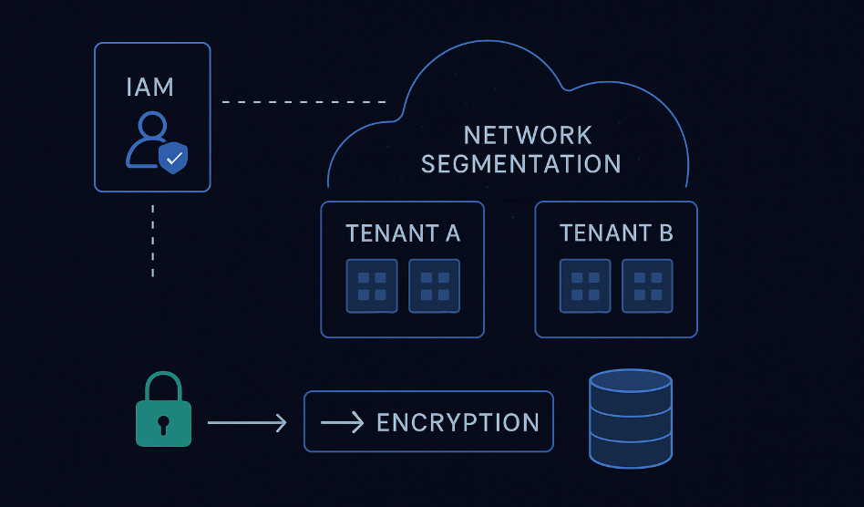
Figure 1: Core architectural layers and vulnerability points in cloud environments
Cloud computing environments sort of get “defined” structurally by multi-tenancy, virtualisation, and a distributed setup, each one adding its own kind of systemic security weakness. Multi-tenancy lets several users share the same real-world hardware, which is great for efficiency, but it also quietly invites cross-tenant data leakage and side-channel attacks, especially when those isolation mechanisms don’t work as expected [14].
On top of that distributed cloud systems lean on geographically dispersed nodes and interlinked services, so the whole thing ends up more reachable to network based intrusions, and also to boring but real configuration mistakes. Compared with older centralized systems, cloud environments don’t have a super clear security perimeter, so monitoring and control become more tangled, less straightforward. In other words cloud architecture shifts security away from a tightly bounded, controlled model and into something… distributed, more scattered.

2.2.2 Types of Cyber Threats in Cloud Environments
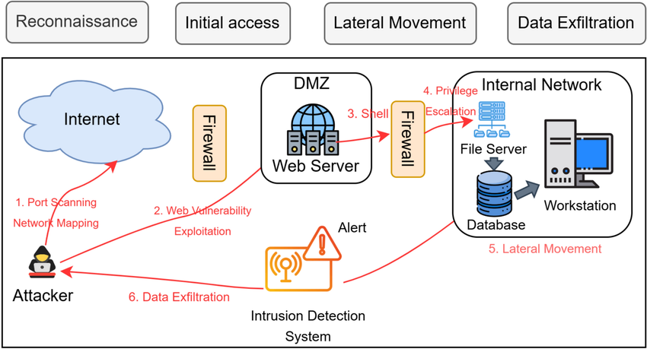
Figure 2: Major cyber-threat categories affecting cloud computing systems
Cloud environments deal with a pretty broad set of cyber threats, and they often show up at the same time , kind of like they gang up, while also taking advantage of architectural weak spots. Distributed Denial-of-Service (DDoS) attacks usually push cloud resources beyond their limits, and they do this by exploiting the very scalability that clouds advertise, so the outcome is service disruption. In practice, volumetric DDoS can climb into the high hundreds of Gbps, which is a clear signal about the scale these cloud systems have to withstand defensively [10].
Malware attacks , ransomware included, spread quickly across virtualised setups, mainly because the underlying infrastructure is shared and reused, while intrusion attacks take aim at weaknesses in APIs, authentication mechanisms, and services that are just misconfigured in the first place. On top of that, data exposure or data leakage is still a top-tier concern, and it’s frequently caused by sloppy access rules or storage setup errors, especially when you have multi-tenant systems where boundaries get blurred [7].

2.2.3 Challenges in Cloud Intrusion Detection Systems (IDS)
Cloud-based IDS have some core limitations, almost baked into the environment. First , cloud platforms create high-volume and high-velocity data streams, which means real-time analysis becomes computationally heavy, and not in a theoretical way. Second , the infrastructure is dynamic and elastic, so resources are continuously resized, spun up, or moved around , and because of that, static detection models get outdated fast or just do not fit. Third, there is the strict requirement for real-time decision making .
Empirical results suggest that a lot of IDS models are tested in offline, controlled or lab-style settings , so they do not really mirror what happens in the real cloud [8]. Also, even if hybrid deep learning approaches can raise detection accuracy, they may still come with high computational overhead , and that makes large scale deployment pretty hard or impractical [11].
From a more quantitative angle, modern cloud systems can handle millions of network events each second, so any IDS framework has to keep running under tight latency constraints while still holding onto high detection accuracy. Traditional intrusion detection systems are, in a sense, structurally misaligned with cloud environments , not because the idea is wrong, but because they cannot scale cleanly with huge data volumes, they struggle to adapt when the infrastructure changes on the fly, and they often fail to perform well enough under real time constraints. This mismatch points to a clear need for smarter, adaptive frameworks, frameworks that can blend scalability, feature prioritisation, and real-time responsiveness into one cohesive design.

2.3 Intrusion Detection Systems (IDS): Traditional vs Modern Approaches

2.3.1 Traditional Intrusion Detection Systems
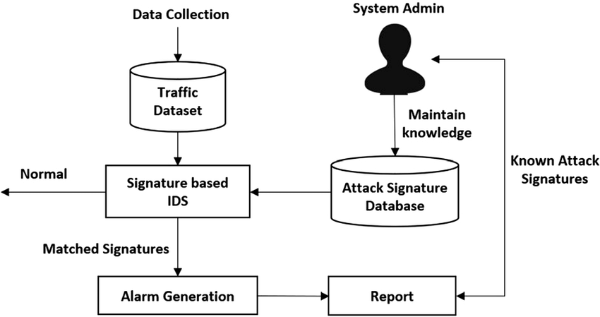
Figure 3: Operational logic of signature-based and rule-based intrusion detection systems
Traditional intrusion detection systems (IDS) are basically built on signature based, and rule based ideas, where you only really notice something when the observed behaviour kinda matches the predefined attack patterns. In practice, they do look quite precise for threats that are already known. But then again, their whole approach is kinda reactive, so their usefulness gets capped in a structural way. They often can’t catch zero-day attacks, or threats that are evolving midstream.
More importantly, these systems implicitly expect network behaviour to stay stable and predictable. Which is… not what cloud environments do. Cloud setups are dynamic, distributed, and high volume by nature, so that assumption doesn’t fit well at all. And as attackers get more sophisticated, and the payloads turn polymorphic, signature based detection starts missing more things. Resulting in more false negatives, and honestly it makes the systems feel pretty inadequate for today’s cybersecurity needs. From a critical point of view, traditional IDS aren’t simply just “limited”, they’re kind of architecturally stale for cloud environments. They can’t properly adapt to variability, scale, or the real-time operational demands that modern systems require, and that’s where the mismatch really shows up.

2.3.2 Machine Learning-Based Intrusion Detection Systems
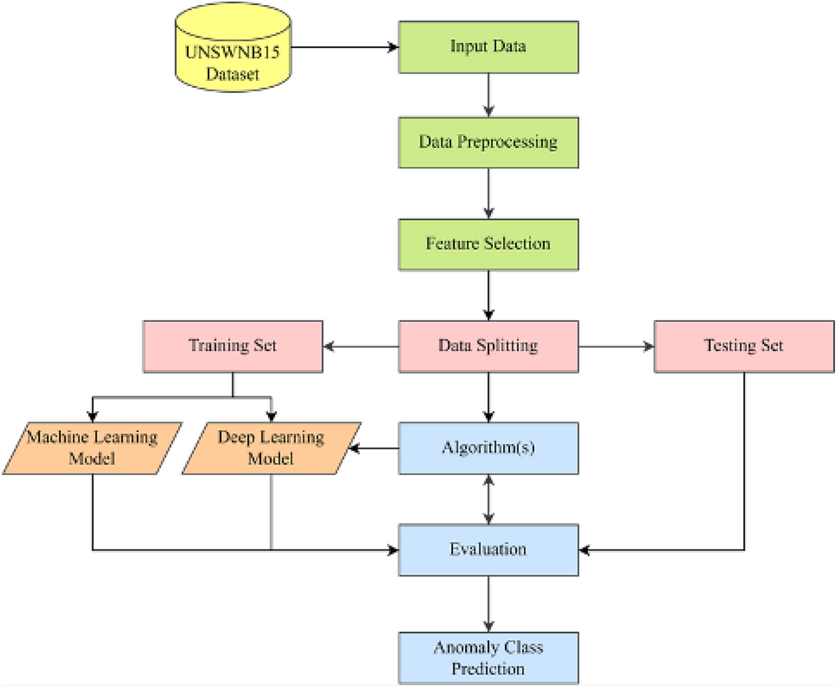

Figure 4: Machine learning-based IDS pipeline highlighting dependence on feature engineering
ML-based IDS kinda shift the whole thing from rule driven detection to something more pattern recognition, you know, data-driven. In practice, they often use models like Random Forest and Support Vector Machines (SVM) to detect anomalies, and also to sort out network behaviour. On paper, this can boost detection capability, especially when it comes to partially unknown threats. Still, they are basically limited by how much they depend on manual feature engineering, which is not a great foundation.
That kind of dependency brings a big constraint: the real effectiveness of an ML model isn’t so much about the model as it is about how good the engineered features are. If those features are incomplete or not accurate enough, the whole system gets weaker, and this happens a lot when trying to capture the full complexity of high-dimensional cloud data [8]. Also, ML models often have trouble dealing with both non-linear relationships and temporal dependencies, so their ability to catch sophisticated multi-stage attacks stays restricted. And honestly, the scalability issue is still there, it doesn’t go away. As cloud environments produce more complex, and more massive volumes of data, these models tend to degrade in performance and lose generalisability, especially when they are deployed beyond the kind of controlled datasets they were trained on. So overall, ML approaches look more like an incremental improvement rather than a structural fix, meaning they don’t really meet the full requirements of modern cloud security.

2.3.3 Deep Learning-Based Intrusion Detection Systems

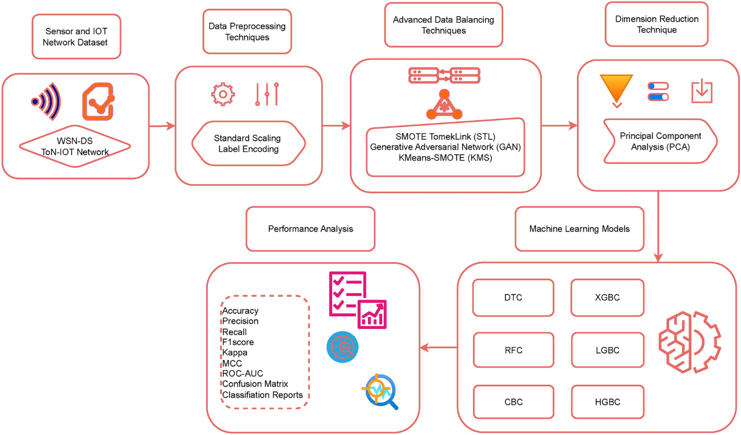
Figure 5: Deep learning-based IDS demonstrating hierarchical feature learning and hybrid architectures
Deep learning (DL) based IDS have been popping up as a dominant paradigm because they can do automatic feature extraction, plus hierarchical representation learning, which kinda sidesteps the issues that come with manual feature engineering. In particular, architectures like CNNs and RNNs allow the modelling of spatial along with temporal dependencies, and this usually boosts detection accuracy a lot in complicated datasets [8], even when the data is messy.

Still, adopting deep learning brings its own structural challenges. First, yes DL models do improve detection capability, but they often do it at the expense of computational efficiency, so deploying in real time—especially in cloud environments—becomes difficult. Even hybrid deep learning models, although they improve performance, often do not tackle feature prioritisation and computational optimisation at the same time. As a result, you get inefficiencies in large scale environments [11], where every extra cost adds up, quickly.
The move from traditional to machine learning, and then to deep learning based IDS, basically signals a shift from static detection toward adaptive learning systems. But that progress isn’t a full answer. While deep learning reduces the weaknesses of earlier approaches, it also brings in fresh constraints tied to computational complexity, scalability, and interpretability. So, this points to a core tension in IDS research. When detection accuracy improves, it’s frequently counterbalanced by lower efficiency and reduced practical usability. Therefore, there’s a strong need for integrated frameworks that can balance accuracy with efficiency and also maintain real time capability, which is why it makes sense to explore hybrid deep learning models that are enhanced using attention mechanisms.

2.4 Evolution of Intrusion Detection Systems

2.4.1 Traditional Intrusion Detection Systems
Figure 6: Deterministic logic of signature- and rule-based intrusion detection systems
Traditional intrusion detection systems (IDS) mostly depend on signature matching and some rule based logic, so the whole detection part is tied to predefined attack patterns. While they can be very accurate for known threats, the thing is that their effectiveness is basically locked in by what people already know, so they cannot really see zero-day stuff or attacks that keep changing [12].
At the same time, these systems kinda assume that network behaviour stays still and predictable, which is not a true thing anymore in modern cloud setups, with dynamic workloads and threat vectors that show up and morph continuously. Because of that, traditional IDS often end up missing attacks, especially when dealing with polymorphic or obfuscated behaviours [5].
So from a critical view, traditional IDS are not only limited but rather structurally outdated, since the detection logic can’t really generalise beyond those fixed signatures, and then it just fails in adaptive and large scale cloud environments.

2.4.2 Machine Learning-Based Intrusion Detection Systems
Machine learning (ML)-based IDS, including Support Vector Machines (SVM) and Random Forest, is more like a step towards data driven detection. they aim to spot patterns and anomalies inside network traffic, rather than only checking rules. In practice, this improves detection compared to traditional systems, in particular when threats are only partially known [8].
But, this improvement comes with a real catch: it still depends on manual feature engineering, and that reduces how well the models can represent complex, high dimensional relationships inside cloud traffic [3] Also, ML models can be pretty dataset dependent, where performance on benchmark datasets often does not carry over smoothly to real environments, because the data distributions shift [12]. Critically, ML based IDS don’t really solve the big issues of scalability and adaptability. Sure, they can do better in controlled situations, but they’re still representation constrained systems, meaning they can’t fully capture evolving, non linear attack behaviours in large scale cloud settings.

2.4.3 Deep Learning-Based Intrusion Detection Systems
Deep learning (DL)-based IDS bring automatic feature extraction and hierarchical representation learning. models like CNN, LSTM, and GRU can learn complex spatial and temporal patterns directly from data [8]. This feels like a meaningful leap over older ML approaches, especially with high dimensional datasets, and with catching more advanced attack patterns.
However, these gains also create new structural problems. First, DL models are computationally heavy, so real time deployment in cloud environments gets tricky [11]. Second, they work like black box systems, so interpretability is weak and that becomes a concern in security critical scenarios [3]. Third, many architectures stay functionally specialised, they tend to capture either spatial OR temporal features but not both at once, and the result is kind of incomplete modelling.
So yes, DL boosts detection capability, but it also brings constraints around efficiency, scalability, and explainability, meaning it cannot really be a full answer on its own.
The move from traditional IDS to machine learning and deep learning based IDS basically represents a shift from static rule based detection to adaptive, data driven modelling. Still, this change doesn’t remove the core limits, it just reshapes them. Deep learning may improve accuracy and adaptability, but it also adds major issues related to computational costs, scalability, and interpretability [11]. This ongoing trade off suggests the need for integrated and optimised frameworks, frameworks that can balance detection performance with efficiency, and keep real time applicability in mind for cloud environments.

2.5 Deep Learning Techniques in Intrusion Detection Systems

2.5.1 Convolutional Neural Networks (CNN): Spatial Learning
Convolutional Neural Networks (CNNs) are broadly used in IDS because they can do spatial feature extraction, basically spotting patterns inside structured network data. They let the system learn hierarchical features on its own, so you don’t have to rely so much on manual feature engineering [8]. But CNNs are kinda stuck, they don’t do temporal modelling, so they’re not great for attacks that keep changing over time. Since many intrusions show sequential behavior , CNN based models only offer a partial view of system behaviour [3]. Importantly, CNNs can boost detection accuracy, yet they miss the more moving, dynamic side of cyber-attacks .

2.5.2 Recurrent Neural Networks (RNN, LSTM, GRU): Temporal Learning
Recurrent Neural Networks (RNNs), including LSTM and GRU , are built to capture temporal dependencies, which helps them detect sequential and even multi-stage attacks [8]. In practice, these models improve the analysis of evolving attack patterns within network traffic .
Still, their use is limited by heavy computational cost and tricky training, especially when you scale to big cloud environments [11]. Also, RNN variants don’t automatically highlight the most relevant features, so they can struggle to separate critical signals from the usual noise.
So yes, RNNs strengthen temporal modelling, but they can be inefficient and kind of incomplete for real time IDS needs.

2.5.3 Autoencoder-Based Models
Autoencoders are commonly used for unsupervised anomaly detection, meaning they can spot unknown attacks by learning what “normal” looks like and then flagging deviations. This is really handy when labelled data is scarce [3]. However, empirical results show autoencoder-based IDS often end up with high false positive rates. They can’t consistently tell benign anomalies apart from malicious activity . That drops their real world usefulness a lot . Critically, even though autoencoders widen detection reach, they weaken precision and reliability, so they’re not ideal as standalone detection systems. Across deep learning approaches, one repeating limitation shows up, each model has its own specialty but none really becomes fully comprehensive. CNNs handle spatial characteristics, RNNs model temporal dependencies, and autoencoders catch anomalies , however none merges all those strengths into one unified framework. This kind of split points to a core problem in IDS research: when you improve one dimension, it often causes a weakness in another. That’s why intrusion detection needs integrated approaches, combining spatial , temporal, and anomaly detection, but also dealing with computational efficiency and scalability issues, especially under demanding deployments [
2.6 Sequential and Advanced Models
Newer intrusion detection systems (IDS) suggest a move toward sequential and hybrid deep learning architectures, trying to raise detection performance in more complex settings. And yeah, this trade-off becomes extra difficult in cloud settings where responses must be near real time .
In a similar way, hybrid models aimed at IoT settings by Markkandeyan (2024) mix deep learning with optimisation procedures to raise classification accuracy. But these models are tied to context, because IoT traffic patterns are quite different from cloud infrastructures. So generalisability becomes limited, meaning gains in one domain don’t automatically carry over to wider use.
Also, the GRU–BiLSTM model suggested by Ghani and Alasadi (2025) shows strong temporal learning, reaching detection accuracy above 98% across multiple datasets. Yet, it doesn’t really provide spatial feature extraction , so network behaviour modelling is still incomplete. Critical insight: these methods often tune specific dimensions—like robustness, contextual precision, or temporal understanding— but they still don’t achieve integrated performance across accuracy, efficiency, and scalability, which is what cloud based IDS actually needs.

2.7 Attention Mechanism in Deep Learning

2.7.1 Concept
The attention mechanism basically lets deep learning models give more weight to certain input features, so the model can kind of selectively “look at” what matters most. In contrast to older architectures that treat every input similarly, attention adds this more flexible feature prioritisation. It helps a lot with high-dimensional data [13] ,even if the process feels a bit more “guided” than before.

2.7.2 Benefits
For IDS, attention mechanisms bring a few clear benefits. They cut down noise by filtering out irrelevant features, and they can raise detection accuracy because the model concentrates on critical patterns. On top of that, they add interpretability, since they expose feature importance during the decision process [3]. These advantages seem even more meaningful in cloud setups, where the data is typically large in scale and heterogeneous, kind of a mixed bag all the time.

2.7.3 Gap in IDS Research
Even with all that, attention mechanisms are still not used enough in IDS research. Work like Azar et al. (2023) and Hore et al. (2024) tends to lean toward hybrid and sequential architectures. But they do not really include adaptive feature weighting, instead they lean on static feature selection or on choices inside the model design, which makes things less adaptive to changing conditions.
Critical argument: Attention mechanisms handle a core constraint in IDS by enabling adaptive, context-aware feature prioritisation. Yet because they are barely integrated into existing systems, inefficiencies show up and performance can drop in demanding environments.

2.8 Real-Time Cyber-Threat Detection
Real-time cyber-threat detection matters especially in cloud environments, because attacks can spread really fast across distributed systems. So IDS has to run under low latency and high throughput, while also processing huge amounts of data continuously, not “sometimes”, but all the time.
That said, a big gap appears when comparing experiments to real deployment. A lot of deep learning based IDS papers are tested on benchmark datasets in offline settings, rather than inside real time contexts [4]. Yes, those tests can look very strong accuracy wise, but they don’t capture practical constraints like data velocity, system scalability, and processing delays.
Also, more advanced models, including those by Hore et al. (2024), bring computational complexity, which reduces their suitability for real time usage. So there is still a lasting trade-off between detection quality and operational efficiency, even if we want both at once. Critical argument: Real-time suitability remains under-examined and not validated enough, which shows a disconnect between theoretical progress and the actual needs of cloud security.

2.9 Review and Synthesis of Existing Studies

2.9.1 Insights from Survey Studies
Survey papers, especially Li et al. (2024), give a broad overview of deep learning uses in IDS. They point out trends like hybrid models gaining traction, and benchmark datasets being used more often. However, these surveys also point to persistent challenges such as data imbalance, missing standardised evaluation metrics, and limited verification in real-world conditions. Critically, even though surveys organise and summarise what has been done, they do not fix the underlying structural issues, so gaps remain for practical implementation.

2.9.2 Key Limitations Across Literature
Across the reviewed studies, the same limitations keep showing up. First, there is limited use of attention mechanisms, which constrains adaptive feature prioritisation [1]. Second, there is a persistent trade-off between accuracy and computational efficiency, which limits scalability [8], and this part keeps repeating in different disguises. Third, many works rely too heavily on benchmark datasets, which do not truly mirror real cloud behaviour. Strong synthesis: Overall the literature looks fragmented, where improvements in one dimension create new constraints in another. This prevents the field from building a fully integrated IDS solution.

2.10 Research Gap
The critical analysis identifies three key research gaps, and they basically connect to each other.
Gap 1: There is no effective integration of hybrid deep learning architectures with attention mechanisms, which means the resulting systems still struggle with adaptive feature prioritisation [13].
Gap 2: Existing models often fail to balance accuracy, computational efficiency, and real time detection. Frequently they optimise one dimension while the others suffer [8] .
Gap 3: Most IDS models are not designed specifically for cloud environments, so their applicability drops for distributed, large-scale systems [10]. There is a lack of an integrated framework that merges hybrid deep learning architectures with attention mechanisms, in order to enable accurate, efficient, and real time cyber-threat detection in cloud environments.

2.11 Chapter Summary
In this chapter, traditional, ML, deep learning, hybrid, and attention-based IDS approaches were reviewed. The chapter indicated that existing methods can improve detection, but they stay constrained by scalability limits, computational overhead, interpretation challenges, and weak evidence of deployment readiness. This supports the need for an integrated and deployable framework.
The analysis also showed that even when advanced models target specific limitations, they still do not deliver an integrated overall performance. At the same time, attention mechanisms remain underutilised, and real-time validation is not explored enough.
Taken together, these points justify the need for a new IDS framework that combines hybrid deep learning with attention mechanisms, helping achieve efficient, accurate, and real-time threat detection in cloud environments.

CHAPTER 3: RESEARCH METHODOLOGY

3.0 Introduction to the Chapter
This chapter lays out the methodology used to design, develop, and assess the cyber threat detection system. It stays implementation oriented, because it builds a working web platform, with a real cybersecurity dataset, machine learning training, backend deployment, frontend interaction , database storage, dashboard analytics, and report generation. In other words, it is not just a theory walk through it actually gets something running.
The methodological direction is anchored in the research gap noted in Chapter Two. Prior intrusion detection work suggests that classic signature based systems are becoming less suitable for dynamic cloud settings, because they depend on known attack patterns, and they can struggle when threats evolve, or when the threats are not previously seen [12].
Machine learning, including deep learning models, has been suggested as an alternative, since these models can learn patterns from historical network traffic data, instead of only following manually written rules [3], [8]. Still, the studies also indicate that many intrusion detection models are constrained by offline evaluation and weak real time validation, plus a class imbalance aspect that is often not handled well . A critical methodological distinction has to be made between the proposed theoretical framework and the system that is actually implemented. In this work the implemented system uses a Random Forest as the baseline machine learning model, rather than only discussing the idea of model selection in abstract terms. Overall, the chapter covers methodological justification, research philosophy and approach, research design, dataset description, and the preprocessing procedures.

3.1 Methodological Purpose and Justification
The purpose of the methodology is to explain, in a clear and systematic way, how the research question is tackled, so that the process remains reproducible. The central research question is focused on how a ML-based cyber threat detection system can be designed and implemented to classify malicious network traffic, while also supporting practical decision making in cloud environments.
To address that, this study uses a methodology built around three linked layers. The first layer is the data layer, which prepares the CICIDS2017 dataset for supervised learning. The second layer is the machine learning layer, which trains and evaluates a Random Forest . The third layer is the system implementation layer, which deploys the trained model to the platform.
This approach is methodologically appropriate, because the literature highlights a recurring mismatch between experimental intrusion detection models and security tools that can really be deployed. A number of studies achieve strong accuracy on benchmark datasets , however they do not clarify how the model can be used by an end user or a security analyst in practice [4], [6].
Table 4: Methodological Alignment with the Research Problem
Research Problem | Methodological Response | Critical Rationale
Traditional IDS struggle with evolving attacks | Use supervised machine learning | Machine learning can identify patterns from labelled traffic rather than relying only on fixed rules [3].
Cloud traffic is large-scale and high-dimensional | Use CICIDS2017 network-flow features | CICIDS2017 provides labelled benign and malicious traffic suitable for cyber-threat classification [11].
IDS research is often limited to offline evaluation | Deploy the trained model through a Flask backend | The model is operationalised as a usable prediction service rather than remaining only as a training script.
Overall accuracy can be misleading | Evaluate precision, recall, F1-score, and confusion matrix | Class-level metrics reduce the risk of overclaiming performance under class imbalance [4].
Users need decision support, not only prediction labels | Provide confidence score, risk level, and recommendation | This makes the output more useful for cybersecurity response and interpretation.
The methodology is therefore both technical and critical. Cyber-threat detection must be evaluated through model performance and practical usability. A strong model has limited value if it cannot be deployed or interpreted, while a dashboard has limited value if it is not connected to a real trained model.

3.2 Research Philosophy and Approach

3.2.1 Research Philosophy: Positivism
This study adopts a positivist research philosophy. I t’s suitable because the research focuses on quantifiable cybersecurity data and the objective performance of the model. Here, network-flow records are handled as observable datapoints, while the attack labels are treated as measurable outputs or endpoints. So the model’s capability to recognise or classif y traffic can be checked through, actual empirical results.
A positivist stance matches intrusion detection research, because IDS performance is usually assessed with real world measurement rather than subjective reading of results [3], [5]. In other words, the study doesn’t lean on personal views to decide if the system works. Instead it uses tagged network traffic and measurable prediction outcomes. Still, positivism can be limiting. So this study uses positivism primarily for technical evaluation while also recognising that machine learning outputs should complement, and not replace, expert cybersecurity judgement.

3.2.2 Research Approach: Deductive
The research follows a deductive approach. A deductive approach starts with existing theory then applies it to a particular research question. Chapter Two already explained that traditional IDS methods struggle in changing or dynamic environments, whereas machine learning and deep learning can provide more adaptive detection capability [3], [8], [12]. The current.
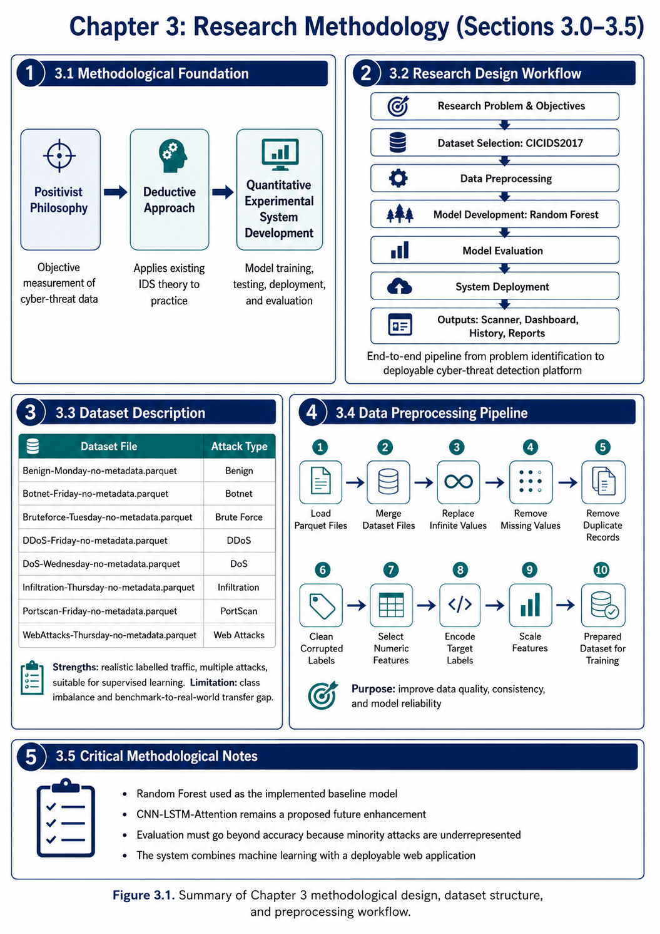
The deductive approach is appropriate because the study does not attempt to generate theory from interviews or open-ended qualitative data. Instead, it tests an implementation derived from existing IDS and machine learning literature. This supports a systematic and evidence-based research process.

3.3 Research Design
The research design follows a structured machine learning and software development lifecycle. The process begins with problem identification and dataset selection, then proceeds through preprocessing, model training, model evaluation, backend deployment, frontend development, database integration, and reporting.
The design was selected because cyber-threat detection requires both analytical reliability and practical usability. A model that performs well in a training environment has limited value if it cannot be deployed. Likewise, a dashboard has limited academic value if it is not connected to a real trained model. This research design therefore integrates both components.
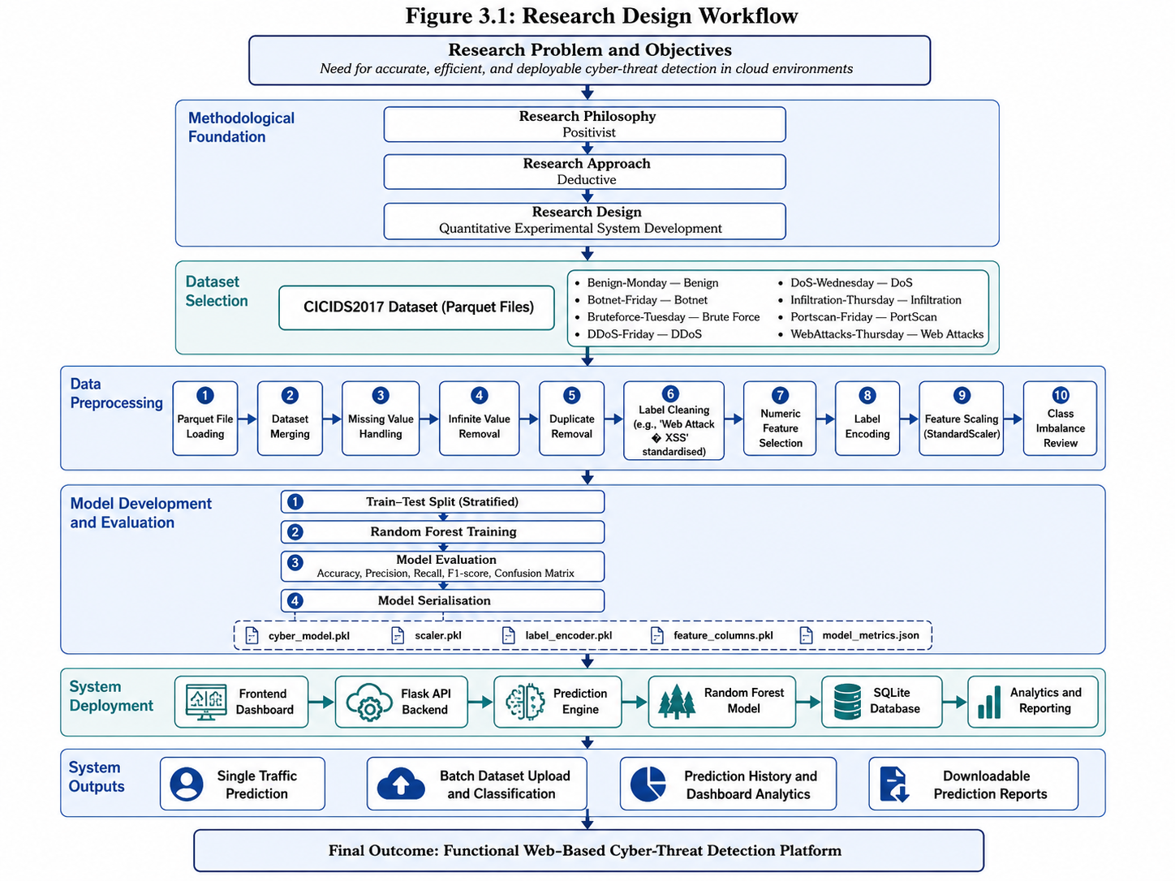
Figure 7: Research Design Workflow
Table 5: Research Design Components
Stage | Activity | Tool / Method | Output
Problem definition | Identify IDS limitations in cloud environments | Literature review | Research gap and objectives
Dataset selection | Use CICIDS2017 Parquet files | Public benchmark dataset | Real labelled traffic data
Data preparation | Clean and transform dataset records | Pandas, NumPy | Cleaned dataset
Feature preparation | Select numeric features and scale values | StandardScaler | Standardised feature matrix
Label preparation | Convert attack labels to numerical classes | LabelEncoder | Encoded target variable
Model training | Train cyber-threat classifier | Random Forest | Trained baseline model
Model evaluation | Assess model performance | Accuracy, precision, recall, F1-score, confusion matrix | Evaluation results
Model storage | Save reusable model artefacts | Joblib and JSON | .pkl and metrics files
Backend development | Expose model through API | Flask and Flask-CORS | Prediction endpoints
Database integration | Store scan history | SQLite | Persistent prediction records
Frontend development | Build user interface | HTML, CSS, JavaScript, Chart.js | Interactive dashboard
Reporting | Export prediction results | CSV report generation | Downloadable prediction report
The strength of this design is operationalisation and honestly it kind of, shows in practice. It responds to a limitation that many IDS studies stay offline and do not demonstrate deployment [6]. The backend API, dashboard, database , and reporting system show how a trained model can become a working platform. The design is still limited because it does not do live packet capture or direct cloud telemetry ingestion. It is a deployable detection dashboard and an experimental platform, not a fully autonomous, production-grade cloud IDS.

3.4 Dataset Description

3.4.1 Dataset Selection
The study uses the CICIDS2017, which is a widely used benchmark dataset for intrusion detection research. It contains labelled benign and malicious network traffic, so it works well for supervised machine learning classification. The dataset was picked because it includes several attack categories that are relevant for today’s network and cloud security, including DDoS and DoS.
CICIDS2017 is more appropriate than older datasets like KDD99, because older IDS datasets have been criticised for outdated attack types, artificial traffic patterns, duplication issues, and limited realism [12]. CICIDS2017 offers more contemporary network-flow features and a broader variety of attack scenarios, so it forms a stronger ground for evaluating cyber-threat detection models.
The version used in this project is provided as Parquet files. Parquet is a columnar storage format that is efficient for large datasets, since it improves loading speed and reduces storage overhead. This helps in cybersecurity research, because network-flow datasets can be computationally demanding.

3.4.2 Dataset Files Used
Table 6: CICIDS2017 Dataset Files and Attack Categories
Dataset File | Attack / Traffic Type | Role in the Study
Benign-Monday-no-metadata.parquet | Benign | Provides the normal traffic baseline.
Botnet-Friday-no-metadata.parquet | Botnet | Represents automated malicious traffic from compromised systems.
Bruteforce-Tuesday-no-metadata.parquet | Brute Force | Represents repeated authentication attack behaviour.
DDoS-Friday-no-metadata.parquet | DDoS | Represents distributed denial-of-service traffic.
DoS-Wednesday-no-metadata.parquet | DoS | Represents denial-of-service attack patterns.
Infiltration-Thursday-no-metadata.parquet | Infiltration | Represents unauthorised system compromise.
Portscan-Friday-no-metadata.parquet | PortScan | Represents reconnaissance and scanning behaviour.
WebAttacks-Thursday-no-metadata.parquet | Web Attacks | Represents attacks against web applications.

The use of several attack categories supports multi class classification rather than simple binary classification ,and yes it matters. If traffic is only labeled as “safe” or “unsafe” that s not enough for a meaningful cybersecurity response. Different threats need different responses, and that s basically the whole point. For example, DDoS detection may require traffic filtering and rate limiting, while brute-force detection might need another playbook.

3.4.3 Dataset Suitability for Cloud IDS
The CICIDS2017 is suitable for this study because cloud environments face diverse network traffic behaviours and multiple attack types. Cloud systems are vulnerable due to things like multi-tenancy, virtualisation , distributed services, and also because there is no clearly defined network perimeter [7], [14]. Under these circumstances you really need automated cyber-threat detection ,not just manual triage.
The dataset supports this need because it provides labelled examples of normal and malicious traffic. In practice these examples allow the model to learn the connections between network-flow features and attack categories. So, it becomes a reasonable fit for building a baseline cyber-threat classification system.
However, CICIDS2017 is not a perfect stand-in for live cloud telemetry. It s a benchmark dataset, not traffic collected directly from the researcher’s own cloud deployment. Real cloud environments can include encrypted traffic, API calls, containerised workloads, hybrid infrastructure, and even organisation-specific user behaviour. Because of that, CICIDS2017 provides a strong experimental starting point, but it doesn’t fully replicate the operational cloud context.
Table 7: Critical Evaluation of the CICIDS2017 Dataset
Evaluation Area | Strength | Limitation
Realism | Contains realistic benign and attack traffic. | It is still not identical to live cloud traffic.
Attack diversity | Includes DDoS, DoS, Botnet, PortScan, Brute Force, Infiltration, and Web Attacks. | Some classes are underrepresented.
Supervised learning suitability | Provides labelled records for classification. | Labels may require cleaning and standardisation.
Reproducibility | Publicly available and widely used in IDS research. | Benchmark performance may not generalise to all environments.
Data format | Parquet improves loading efficiency. | Requires compatible libraries such as PyArrow.
Practical relevance | Supports IDS model training and evaluation. | Does not provide full real-time cloud deployment context.
The most important limitation is class imbalance or, like, not really equal representation, yes. Benign traffic and some attack categories pretty much take over the dataset, while minority attacks such as SQL injection and infiltration show up way less often. Because of that , there’s a real risk the model can end up with high overall accuracy , but still miss rare yet serious threats. For.

3.5 Data Preprocessing
Data preprocessing was a critical phase of the methodology. cybersecurity datasets are rarely ready for direct machine learning use. Network-flow datasets can include missing values, infinite values, duplicated rows , inconsistent labels, corrupted characters, non-numeric fields, and imbalanced class distributions. If these issues are not handled carefully, the trained model may generate outcomes that look plausible but are misleading or not very trustworthy.

3.5.1 Preprocessing Pipeline
This preprocessing sequence was necessary since the model needed clean numerical, and consistently labelled input data. Each stage added strength to the reliability of training. Not in a magical way, just step by step, basically.

3.5.2 Parquet File Loading and Dataset Merging
The dataset files were loaded using Python and Pandas. Each Parquet file was read from the dataset folder and placed into a dataframe. Those separate dataframes were then merged into one combined dataset. Merging was required because the attack categories were spread across separate files. A single combined dataset meant the Random Forest could learn from benign traffic and several attack types within one multi-class classification task. But merging also brings a methodological risk. When one class has far more records than another, the combined dataset becomes imbalanced. That can push the model toward majority classes. So, class imbalance was reviewed after preprocessing, and then it was considered during model evaluation.

3.5.3 Missing and Infinite Value Handling
Missing values were removed , since most machine learning algorithms require complete numerical feature vectors. Infinite values were handled too. Network-flow data often includes rate-based features such as flow bytes per second and flow packets per second. Those values can become infinite when the denominator is zero, or extremely tiny.
This cleanup step improved technical reliability. Still, dropping rows can shrink the dataset size, mainly if minority classes contain invalid values. That turns into a trade-off between data quality and data retention. In this project, reliability was prioritised because invalid values can mess up both feature scaling and model training.

3.5.4 Duplicate Removal
Duplicate records were removed to reduce evaluation bias. If repeated records show up in both the training and testing subsets, the model can look more accurate than it truly is. This is a known thing in benchmark-based intrusion detection research, because duplicated records can inflate performance estimates [12]. Duplicate removal helps with credibility. But it can also reduce the number of available examples in minority classes. That’s why class-level evaluation still matters after preprocessing, even after all this cleaning.

3.5.5 Label Cleaning
A special preprocessing issue involved corrupted web attack labels. Some labels came with encoding errors, which made the output harder to interpret. This step was needed because readable and consistent labels matter for a cybersecurity dashboard. A user or analyst must understand the predicted threat category fast. If labels are poorly formatted, the system feels less professional and the results lose interpretability.

3.5.6 Numeric Feature Selection
Only numeric features were kept for model training because the Random Forest needs numerical input. Network-flow datasets include many numeric variables, such as flow duration, packet counts, byte counts, packet lengths, packet rates, and other traffic statistics. Non-numeric fields were excluded to simplify training and avoid unnecessary encoding complexity. This choice fits a baseline machine learning implementation. However, the limitation is that some non-numeric or contextual fields might carry useful information if encoded correctly. So, numeric-only feature selection supports efficient development, but it may still miss some predictive signals.

3.5.7 Label Encoding
The target labels were converted into numerical form using LabelEncoder. This was necessary because supervised machine learning models require target classes to be represented computationally.
The label encoder was saved after training, because the backend must convert numerical predictions back into readable threat labels. Without saving it, the deployed system would not translate model outputs into meaningful cybersecurity categories in a reliable way.

3.5.8 Feature Scaling
Feature scaling was performed using StandardScaler. Standardisation transforms feature values so that they are centred around a mean of zero and scaled according to standard deviation. Although Random Forest is less sensitive to feature scaling than models such as Support Vector Machines or neural networks, scaling was included to maintain a consistent preprocessing pipeline. This is also important because the proposed future CNN-LSTM-Attention model would be more sensitive to differences in feature scale [8], [13].

3.5.9 Class Imbalance Review
Class imbalance was reviewed because CICIDS2017 contains unequal numbers of records across attack categories. Benign traffic and some attack classes dominate, while rare attacks such as infiltration and SQL injection have fewer examples.
This is a major methodological concern. A classifier can achieve very high overall accuracy by performing well on majority classes while failing to detect rare attacks. In cybersecurity, rare attacks can still cause severe damage. Therefore, this study treats accuracy as only one indicator of performance. Precision, recall, F1-score, macro.

3.5.10 Summary of Preprocessing Decisions
Table 8: Data Preprocessing Summary
Preprocessing Step | Purpose | Critical Justification
Parquet loading | Load dataset efficiently | Suitable for large network-flow data
Dataset merging | Combine benign and attack traffic | Enables multi-class threat classification
Missing value handling | Remove incomplete records | Prevents model instability
Infinite value handling | Remove invalid rate calculations | Avoids scaling and training errors
Duplicate removal | Reduce repeated-record bias | Prevents inflated performance estimates
Label cleaning | Standardise corrupted attack names | Improves interpretability and dashboard output
Numeric feature selection | Retain machine-learning-compatible inputs | Simplifies model training
Label encoding | Convert text labels into numerical classes | Required for supervised learning
Feature scaling | Standardise feature distributions | Supports stable pipeline and future deep learning
Class imbalance review | Identify uneven class distribution | Prevents misleading interpretation of accuracy
Overall, preprocessing was not merely a technical preparation step; it was a validity safeguard. Without careful preprocessing, the model could produce high but unreliable results. The preprocessing process therefore strengthens the credibility of the model training, system deployment, and evaluation stages

3.6 Proposed System Framework
The proposed system framework was designed to transform cyber-threat detection from an offline machine learning experiment into a deployable web-based security application. This matters because a major limitation in intrusion detection research is that many models are evaluated only on benchmark datasets and are not converted into usable systems that support interaction, reporting, and decision-making [4], [8].
Although the broader conceptual direction of the dissertation is informed by hybrid deep learning and attention mechanisms, the implemented framework uses a Random Forest as a baseline model. This decision was made to prioritise a stable and functional end-to-end system. The framework follows the structure shown below.

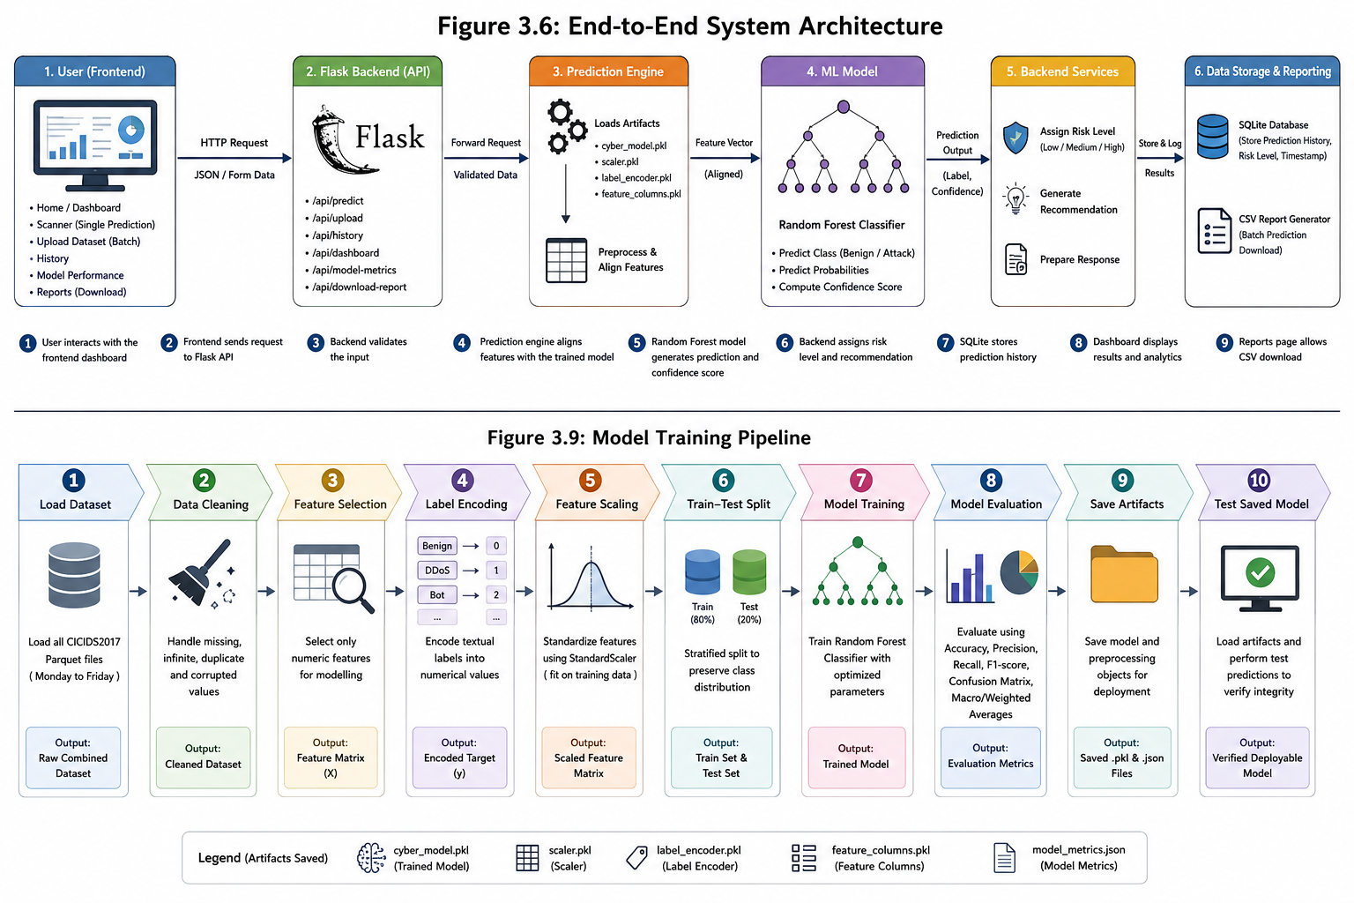
Figure 8: End-to-End System Architecture
This architecture is kinda methodologically significant because it directly tackles the real-time deployment gap that pops up in the literature. In Chapter Two, it was shown that a lot of deep learning IDS studies can look really strong in experiments but they tend to stay weak when it comes to practical deployment and real time validation. So the proposed framework kind of responds to that weakness by making the whole flow more operational, not just “try it in a notebook”.

3.6.1 Frontend Component
The frontend was developed with HTML, CSS, JavaScript, and Chart.js. Overall, it gives the user a friendly, if slightly straightforward interface for using the cyber-threat detection system. It includes several pages: Home, Scanner, Upload Dataset, Dashboard, History, Model Performance, Reports, and About.
On the Scanner page, users can enter network-flow values and get a prediction back. The Upload Dataset page lets users upload CSV or Parquet files for batch classification. Meanwhile the Dashboard page visualises scan statistics, threat distribution, risk levels, and also recent predictions. The History page then shows previous predictions that are stored in SQLite, and the Reports page supports downloading prediction outputs.
Importantly, the frontend is not only decorative. It actually helps operationalise the model by translating outputs into labels like “Safe”, “Unsafe”, “High Risk”, and “Recommendation”. This matters because IDS outputs only become useful when they’re understandable, so non-specialist users can interpret results and take action, not just stare at raw numbers.

3.6.2 Backend Component
The backend was implemented using Flask and Flask-CORS. In practice, Flask works as the application programming interface between the frontend and the machine learning model. It receives requests, validates the incoming data, calls the prediction engine, saves results, and finally returns structured JSON responses.The backend is important because it separates machine learning logic from user interface logic. That separation improves maintainability and should make future extensions less painful. For instance, later the Random Forest model could be replaced with a CNN-LSTM-Attention setup without needing to fully redesign the frontend, which is kinda the point.

3.6.3 Prediction Engine
The prediction engine loads the saved model artefacts, including feature_columns.pkl. This part is especially important because it is common that real deployment systems fail on feature alignment, and in cybersecurity this gets even more serious. If features are interpreted wrong, the system may produce false reassurance or trigger unnecessary alerts, and either outcome can undermine trust.

3.6.4 Database and Reporting Component
SQLite is used for storing prediction history. In the database, you store the prediction label, confidence score, status, risk level, recommendation, timestamp, and scan type. Because of this, the History and Dashboard pages can show past predictions, and they can generate summary analytics.
For reporting, batch prediction results are exported into CSV. This supports auditability, and also lets users review classification outputs outside the application. From a cybersecurity viewpoint, reporting matters because detection systems should not only detect and label threats, but they should also preserve evidence for later review.

3.7 Machine Learning Model
The machine learning model used in this project is a Random Forest, more or less straightforward, but it still needs to be said upfront. This is because the theory section in Chapter Two discusses hybrid deep learning models, while what was actually built here uses Random Forest as a baseline, not the hybrid approach. Random Forest was chosen since CICIDS2017 is a structured tabular network-flow dataset, you know, the kind with columns that are already nicely organized. Random Forest is also commonly used for classification because it blends several decision trees and tends to reduce overfitting compared with a single decision tree, even in cases where the data is tricky [3]. In addition, it is usually more interpretable than deep neural networks, which.

3.7.1 Random Forest Model Logic
Random Forest is an ensemble method, in the sense that it trains several decision trees during learning, then it merges the outputs by majority voting. Each individual tree learns its own decision rules from different subsets of data and features. So, the end result is basically the class chosen by the majority of the trees. That’s it, but it works.

3.7.2 Critical Justification for Random Forest
Random Forest made sense for this implemented system, mostly for four reasons, and they all kind of connect back to the dataset and deployment needs.
First, it handles structured tabular information well. CICIDS2017 includes numeric flow-based signals like packet counts, byte counts, flow duration and packet length statistics. Random Forest fits this sort of feature arrangement pretty directly.
Second, Random Forest is computationally more practical than deep learning systems. CNNs and LSTMs usually need longer training cycles, more memory, and more careful hyperparameter tuning than most simpler baselines [8], [11]. For something meant to run in a deployable web application, a lighter model means faster development, easier integration , and less operational hassle.
Third, interpretability is better than for many deeper neural systems. Even though Random Forest is still an ensemble model, it remains comparatively less of a black box than CNN-LSTM-Attention style architectures. That part matters in cybersecurity, because analysts often want to reason about model behaviour, not only accept outputs blindly, or blindly follow alerts.
Fourth, Random Forest gives a baseline that is actually defendable. A baseline is helpful because it shows the system can work end-to-end before introducing heavier and more computationally complex models, later on.
Still, Random Forest is not perfect. It does not explicitly model temporal dependencies in network traffic. It also does not do adaptive feature prioritisation the way attention mechanisms can. Because of this , it cannot fully handle the issues mentioned in Chapter Two about temporal modelling and dynamic feature weighting. For that reason, the CNN-LSTM-Attention framework stays as a future enhancement.
Table 9: Critical Evaluation of Random Forest for this Study
Strength | Limitation
Effective on structured tabular data | Does not model temporal sequences directly
Faster to train than deep learning models | Less suitable for complex sequential attack patterns
Easier to deploy in Flask backend | Does not include attention-based feature prioritisation
More interpretable than deep neural networks | May still struggle with rare minority classes
Provides strong baseline performance | Not the final proposed advanced framework

3.8 Model Training Procedure
The model training procedure followed a systematic machine learning pipeline. The aim was to ensure that the model was trained using real data, evaluated objectively, and saved in a form that could be loaded by the backend application.
Figure 9: Model Training Pipeline

3.8.1 Train-Test Split
The dataset got divided into training and testing subsets. Stratified splitting was used so the class distribution stays pretty much the same in both parts. This matters , because CICIDS2017 is imbalanced. If you don’t do stratification, the minority classes might end up underrepresented in the test set. That weakens the reliability, of the whole performance evaluation, even if the scores look ok at first glance.
Also , stratification is necessary but not sufficient. It makes sure the minority classes are present in training and testing, but it doesn’t invent new samples or really fix the imbalance issue itself. So macro-averaged metrics stay important, because they don’t let the majority classes dominate the result.

3.8.2 Feature Scaling
The model pipeline used StandardScaler. Standardisation was applied for numerical consistency, across features. Random Forest is less sensitive to scaling than some other methods, yet the scaler was still saved and reused in the backend to keep training and prediction aligned. This is methodologically important because prediction-time preprocessing has to match training-time preprocessing. If deployment uses a different scaling setup, the model can see inconsistent inputs, and then results drift. Not always dramatically, but enough to be risky.

3.8.3 Label Encoding
LabelEncoder converts textual threat categories into numerical labels so the model can train. After prediction, the same encoder maps the numerical outputs back into readable categories for people. Saving the label encoder prevents interpretation mistakes in the deployed system. Otherwise, outputs may come back as raw numbers, without any clear meaning for users or analysts.

3.8.4 Random Forest Parameters
The implemented model used a Random Forest with parameters picked to balance performance and training efficiency. These choices were kind of pragmatic. If the number of trees increases , performance may improve, but training time and model size also go up. Limiting the tree depth can reduce overfitting risk, but could also reduce performance when the patterns are more complex. So the selected values end up reflecting a trade-off between accuracy, efficiency, and deployment practicality.

3.8.5 Model Evaluation Metrics
The model was evaluated using multiple metrics instead of relying only on accuracy. This is essential, because intrusion detection datasets are often imbalanced. Accuracy can end up hiding poor detection of rare attacks [4].
Table 10: Evaluation Metrics
Metric | Meaning | Relevance to IDS
Accuracy | Overall proportion of correct predictions | Useful but can be misleading under imbalance
Precision | Proportion of predicted attacks that are correct | Important for reducing false alarms
Recall | Proportion of actual attacks detected | Important for avoiding missed attacks
F1-score | Balance between precision and recall | Useful for imbalanced datasets
Confusion matrix | Shows class-by-class errors | Helps identify weak attack classes
Macro average | Treats all classes equally | Highlights minority-class performance
Weighted average | Weights by class size | Shows overall performance under real distribution
The critical issue is that a model may achieve high accuracy while performing poorly on minority classes. In cybersecurity, this is dangerous because rare attacks may be highly damaging. Therefore, the evaluation strategy must treat minority-class recall as an important indicator of security reliability.

3.8.6 Model Serialisation
After training, the model and supporting objects were saved using Joblib and JSON. This allowed the backend to load the trained model without retraining. Model serialisation is essential for deployment because the backend requires stable access to the trained model and preprocessing objects. It also improves reproducibility because the same trained model can be tested and reused.

3.9 System Development Tools
The system was developed using open-source and freely available tools. The tools were selected to support machine learning, backend development, frontend interaction, database storage, and visual analytics.
Table 11: System Development Tools
Tool / Technology | Purpose | Justification
Python | Machine learning and backend logic | Widely used for data science and cybersecurity experimentation
Pandas | Dataset loading and preprocessing | Efficient handling of structured datasets
NumPy | Numerical operations | Supports data cleaning and array processing
Scikit-learn | Machine learning model training | Provides Random Forest, preprocessing, and evaluation tools
Joblib | Model saving and loading | Enables deployment of trained model artefacts
Flask | Backend API | Lightweight and suitable for ML model integration
Flask-CORS | Frontend-backend communication | Allows browser requests to backend API
SQLite | Prediction history storage | Simple local database for lightweight deployment
HTML | Frontend structure | Defines web pages
CSS | Frontend styling | Provides professional dashboard appearance
JavaScript | Frontend interactivity | Sends requests to backend and updates pages dynamically
Chart.js | Dashboard visualisation | Displays charts for threat distribution and analytics
VS Code | Development environment | Supports integrated coding, terminal use, and extensions

The use of these tools is appropriate because the research is trying to deliver a working local web application not a massive enterprise security platform. Flask and SQLite seem suitable for academic implementation because they are light weight, fairly transparent, and easy to test . Still, for production deployment, the system would need more robust options. This critique matters since tool selection can really shape system capability. Overall, the selected tools are ok for a dissertation implementation, but any future work that targets real world cloud security monitoring would likely need more scalable technologies.

3.10 Ethical Considerations
Ethical considerations are important because cybersecurity research can create risk if methods, tools, or outputs are misused. In this case the study is defensive, so it does not involve hacking, unauthorised scanning, exploitation, malware execution, or collection of private organisational traffic.

3.10.1 Use of Secondary Dataset
This study uses the publicly available CICIDS2017. No human participants are recruited, and there are no interviews, questionnaires, observations, or personal data collection activities. That lowers ethical risk, because the work doesn’t directly affect participants or intrude on personal privacy. However, benchmark cybersecurity data still needs responsible use. The dataset should only be used for defensive model development and academic evaluation. The research does not try to recreate attacks against live systems.

3.10.2 Cybersecurity Ethics
The project centres on defensive intrusion detection. The intent is to spot malicious traffic not to enable offensive cyber activity. This boundary is ethically important because many cybersecurity techniques are dual-use. A detection model could be framed badly or repurposed, for harmful purposes, if it isn’t presented responsibly.

3.10.3 False Positives and False Negatives
False positives and false negatives are especially relevant for IDS ethics. A false positive happens when benign traffic is incorrectly labelled as malicious. That can disrupt legitimate users and consume security resources unnecessarily. A false negative happens when malicious traffic is labelled as benign, and that one is more dangerous since attacks may continue without being noticed. Because of this, the system provides confidence scores and recommendations rather than presenting predictions as absolute truth. This is important because cybersecurity decision-making should stay human-supervised, particularly in high risk environments.

3.10.4 Data Protection and Privacy
The system does not intentionally collect personal data. The SQLite database stores only prediction related outputs such as prediction label, confidence, risk level, recommendation, scan type, and timestamp. It does not store names, email addresses, usernames, passwords, personal identifiers, or any participant records.
That said, real world deployment would require stronger data protection controls. If live network traffic were captured, it might include IP addresses or other identifiers. Those could count as personal data under data protection law. So, future deployment would need anonymisation, tight access control, secure storage, sensible retention policies, and formal ethical approval.

3.10.5 Responsible Use of AI Tools
AI based tools can help with coding, debugging, text drafting, and figure generation. But they shouldn’t be used to fabricate data, produce incorrect results, or replace researcher judgement. In this study, model performance has to come from the actual implemented system and the actual CICIDS2017 outputs. Any AI assisted writing or content still needs to be reviewed, corrected, and critically evaluated by the researcher.

3.11 Chapter Summary
This chapter described the positivist, deductive, and quantitative system-development methodology. It outlined the use of CICIDS2017, preprocessing, Random Forest training, deployment architecture, the tools, and the ethical considerations. Together, these parts set up the basis for implementation and evaluation.
The chapter also explained that CICIDS2017 was chosen because it offers labelled benign and malicious network traffic, which supports supervised cyber-threat classification. It then detailed the preprocessing steps used to prepare the dataset, including Parquet loading, merging datasets, handling missing and infinite values, duplicate removal, label cleaning, numeric feature selection, label encoding, feature scaling, and a review of class imbalance.
After that, the proposed system framework was presented, to show how the frontend dashboard, Flask backend, prediction engine, Random Forest model, SQLite database, and reporting functions work together. This separation is important for academic credibility, since the implemented system shows practical feasibility, while the proposed deep learning framework is treated as the next development step.
Finally, the chapter discussed the training process, the system tools, and the ethics. The methodology should support Chapter Four, where the detailed system design and implementation will be presented.

CHAPTER 4: SYSTEM DESIGN AND IMPLEMENTATION

4.0 Introduction
This chapter presents the design and implementation of the cyber-threat detection dashboard developed for this study. While Chapter 3 explained the methodological process, this chapter demonstrates how the proposed system was translated into a working software application. The implementation combines machine learning, backend API development, frontend dashboard design, database storage.
The system was developed to address a key limitation identified in the literature: many intrusion detection systems are evaluated only as offline models and are not converted into usable real-time or semi-real-time platforms. Therefore, this implementation does not stop at model training; it deploys the trained model through a Flask.
The implemented system uses the CICIDS2017 and a Random Forest. This must be clearly distinguished from the wider proposed theoretical framework.

4.1 System Overview
The developed application is a local web-based cyber-threat detection platform. It allows users to interact with a trained machine learning model through a browser-based dashboard. The system supports single traffic prediction, batch dataset upload, dashboard analytics, prediction history, model performance viewing, and report download.
The system follows a practical workflow. First, the user submits traffic data through the frontend.
This implementation is significant because it converts machine learning output into usable cybersecurity decision support. In IDS research, accuracy alone is insufficient if the result cannot be interpreted or acted upon by users. Existing literature shows that machine learning can improve intrusion detection but also warns that operational deployment remains.
Table 12: Main System Functionalities
Functionality | Description | Implementation Value
Single traffic scanner | Allows the user to enter selected traffic features and receive a prediction | Demonstrates frontend-to-backend-to-model integration
Batch dataset upload | Allows CSV or Parquet files to be uploaded and classified | Supports larger-scale cyber-threat analysis
Dashboard analytics | Displays scan totals, safe/threat distribution, confidence and recent scans | Converts individual predictions into visual insight
Prediction history | Stores scan results in SQLite | Provides traceability and review capability
Model performance page | Displays model evaluation results | Supports transparency and critical interpretation
Reports page | Allows downloading prediction outputs | Enables offline documentation and analysis
Backend API | Handles requests, prediction, dashboard statistics and reports | Operationalises the trained model
SQLite database | Stores prediction history | Maintains persistent system records
The system therefore functions as an applied cyber-threat detection dashboard rather than a standalone machine learning script.

4.2 System Architecture
The system uses a layered architecture consisting of the frontend interface, Flask backend API, prediction engine, trained Random Forest model, SQLite database, and reporting module. This structure separates presentation, logic, prediction, storage, and output generation. Separation of responsibilities is important because it makes the system easier to maintain, test, and extend.
Figure 10: End-to-End System Architecture.
Table 13: System Architecture Layers
Layer | Technology Used | Function
User interface layer | HTML, CSS, JavaScript | Provides user interaction through web pages
Visualisation layer | Chart.js | Displays dashboard charts and analytics
API layer | Flask and Flask-CORS | Receives frontend requests and returns JSON responses
Prediction layer | Python, Scikit-learn, Joblib | Loads model artefacts and performs prediction
Machine learning layer | Random Forest | Classifies traffic as benign or attack traffic
Storage layer | SQLite | Stores prediction history and timestamps
Reporting layer | CSV export | Generates downloadable batch prediction reports
The architecture was designed so that the model can be replaced in future without rebuilding the entire system. For example, the Random Forest model can later be replaced with a CNN-LSTM-Attention model if the new model is saved in a compatible deployment format. This supports the long-term research direction of integrating spatial, temporal, and attention-based learning [8], [13].

4.3 Project Folder Structure
The project was organised into separate folders for dataset files, model scripts, backend code, frontend pages, reports, screenshots, and system execution files. This structure improves maintainability and makes the system easier to demonstrate.
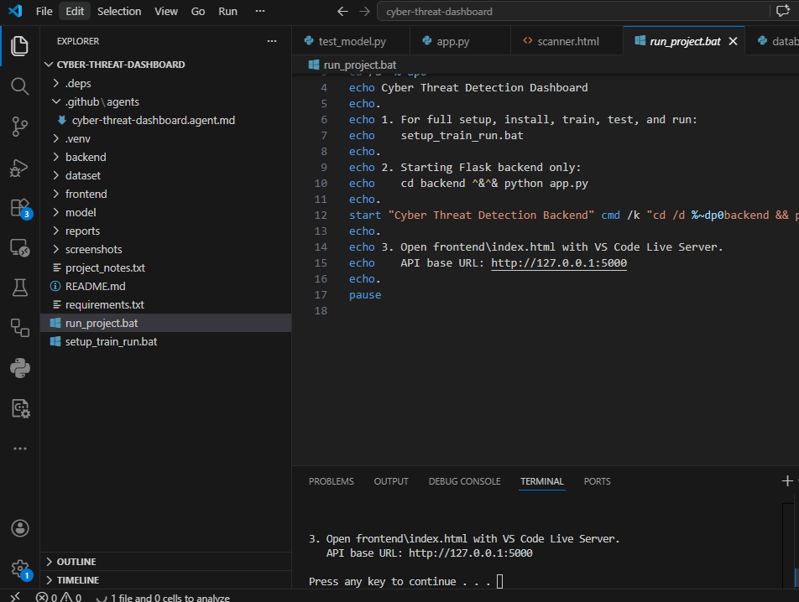
Figure 11: Project Folder Structure in Visual Studio Code.

Table 14: Project Folder Structure
Folder / File | Purpose
dataset/ | Stores CICIDS2017 Parquet dataset files
model/train_model.py | Loads data, preprocesses records, trains and evaluates the model
model/test_model.py | Tests the saved model using a real dataset record
model/cyber_model.pkl | Stores the trained Random Forest
model/scaler.pkl | Stores the fitted StandardScaler
model/label_encoder.pkl | Stores the encoder used to convert labels
model/feature_columns.pkl | Stores the exact feature names and order used during training
model/model_metrics.json | Stores model performance metrics
backend/app.py | Main Flask application
backend/prediction.py | Prediction engine and risk logic
backend/database.py | SQLite database functions
backend/uploads/ | Stores uploaded files and generated reports
frontend/ | Contains HTML pages, CSS, JavaScript, and assets
screenshots/ | Stores implementation screenshots for the dissertation
run_project.bat | Automates dependency installation, model testing and backend startup
The structure separates model development from system deployment. This matters because the trained model must first be validated before being loaded into the backend. It also supports reproducibility because each file has a defined function.

4.4 Model Implementation
The machine learning model was implemented in model/train_model.py. The script loads the CICIDS2017 Parquet files, merges them into one dataset, cleans invalid values, standardises labels, selects numeric features, encodes the target labels, scales features, splits the dataset, trains a Random Forest, evaluates model performance, and saves the deployment artefacts.
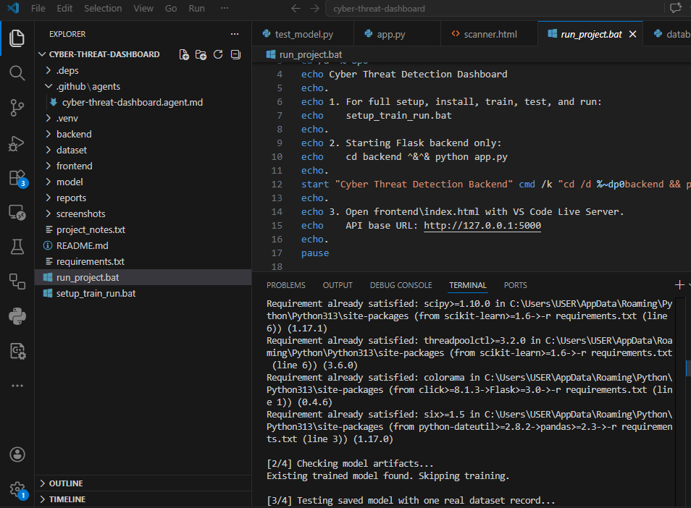
Figure 12: Model Training Execution

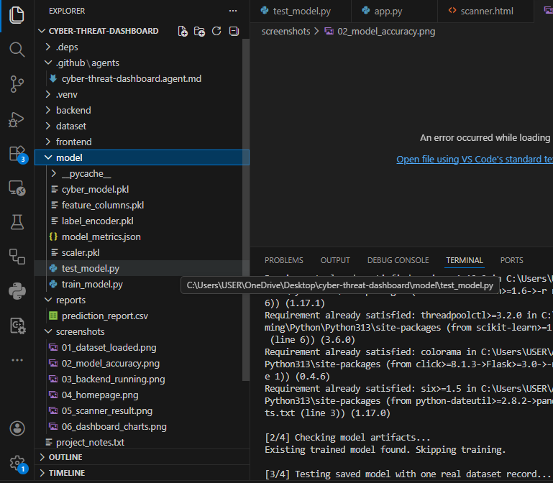
Figure 13: Saved Model Artefacts
The inclusion of feature_columns.pkl is particularly important. Machine learning models are sensitive to feature order and feature availability during deployment. If the backend receives input columns in a different order from training, predictions may become unreliable. The saved feature-column list therefore protects prediction consistency between training and deployment.
Random Forest was chosen because it is effective for structured tabular datasets such as CICIDS2017. It combines multiple decision trees and produces predictions through ensemble voting [3]. However, it does not explicitly model temporal attack sequences and does not include attention-based feature weighting. Consequently, it is suitable as a deployable.

4.5 Backend Implementation
The backend was implemented using Flask. It acts as the communication layer between the frontend and the trained machine learning model. The backend receives API requests, validates input, calls the prediction engine, stores scan history, provides dashboard statistics, and returns structured JSON responses.
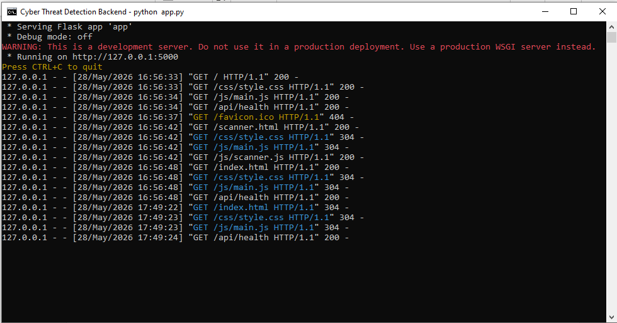
Figure 14: Flask Backend Running
Table 15: Backend API Endpoints
Endpoint | Method | Function
/ | GET | Confirms that the backend API is running
/api/health | GET | Checks backend, database and model status
/api/predict | POST | Performs single traffic prediction
/api/upload | POST | Performs batch prediction on uploaded files
/api/history | GET | Retrieves prediction history
/api/dashboard | GET | Returns dashboard analytics
/api/model-metrics | GET | Returns saved model evaluation metrics
/api/download-report | GET | Downloads the latest prediction report


Figure 15: Backend API Status Page
The backend is essential because it turns the trained model into a usable service. Without the backend, the model would remain a local artefact and would not support frontend prediction, batch processing, dashboard statistics, or reporting. This implementation responds to the practical deployment weakness often observed in IDS research [4], [8].

4.6 Prediction Engine Implementation
The prediction engine was implemented in backend/prediction.py. It loads the trained model and preprocessing artefacts, aligns incoming features, scales the input, performs prediction, calculates confidence, assigns risk level, and generates a recommendation. This risk logic improves the usability of the system. A raw predicted class alone is not enough for cybersecurity decision-making. Users also require a risk interpretation and an appropriate response suggestion.

4.7 Database Implementation
SQLite was used to store prediction history. The database is created automatically when the backend starts. Each single prediction is stored with its scan type, predicted label, confidence score, status, risk level, recommendation, and timestamp.
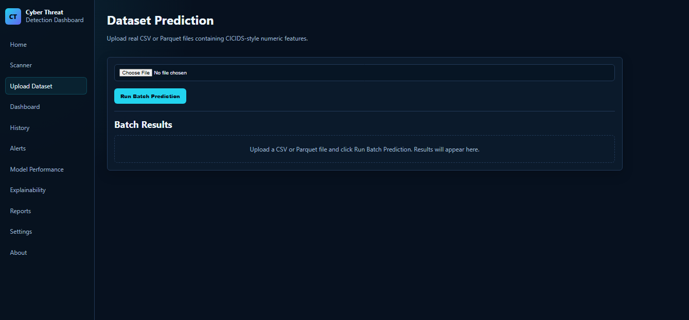
Figure 16: Prediction History Page
The database supports traceability. Instead of displaying results temporarily and then losing them, the system stores scan outcomes for later review. This matters because cybersecurity analysis often depends on historical evidence and repeated behaviour patterns.

4.8 Frontend Implementation
The frontend was implemented using HTML, CSS, JavaScript, and Chart.js. It provides the visible interface through which users interact with the system. The frontend includes navigation links, forms, result cards, tables, badges, charts, and error messages.
Table 16: Frontend Pages and Functions
Page | Function
Home | Introduces the system and provides navigation
Scanner | Allows single traffic prediction
Upload Dataset | Allows batch classification of CSV or Parquet files
Dashboard | Displays analytics and charts
History | Shows stored prediction history
Model Performance | Displays model evaluation results
Reports | Allows downloading prediction reports
About | Explains system aim, methodology, limitations and future work


Figure 17: Home Page of the Web Application
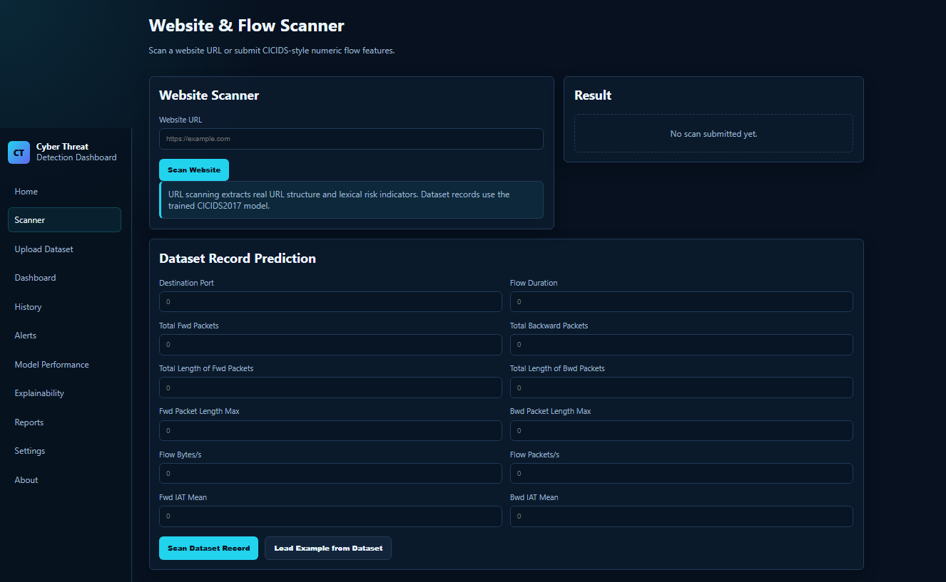
Figure 18: Scanner Page Before Prediction
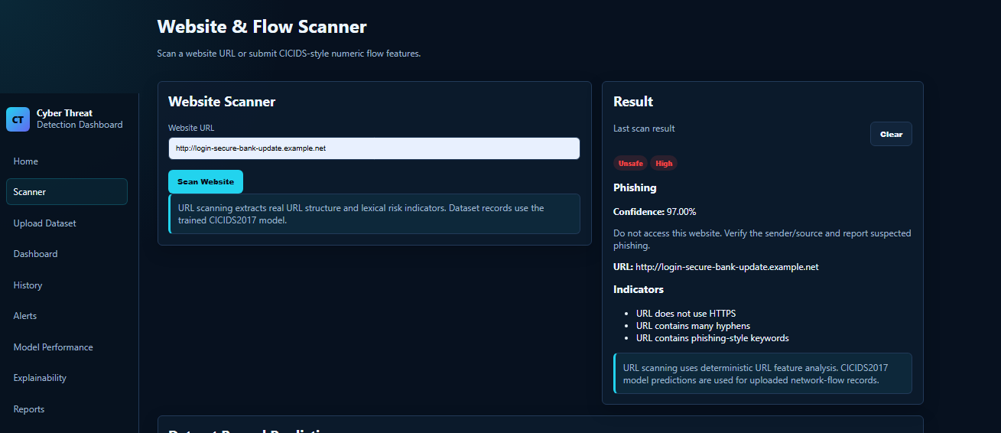
Figure 19: Scanner Page After Prediction
The frontend is significant because it makes the system understandable to users. A model output such as a class number or raw probability is not sufficient. The dashboard translates prediction results into threat labels, confidence values, risk categories, and recommendations.

4.9 Batch Upload and Report Generation
The Upload Dataset page allows users to upload CSV or Parquet files for batch prediction. After upload, the backend reads the file, aligns its features with the trained model, classifies each record, adds prediction-related columns, and saves a downloadable CSV report.
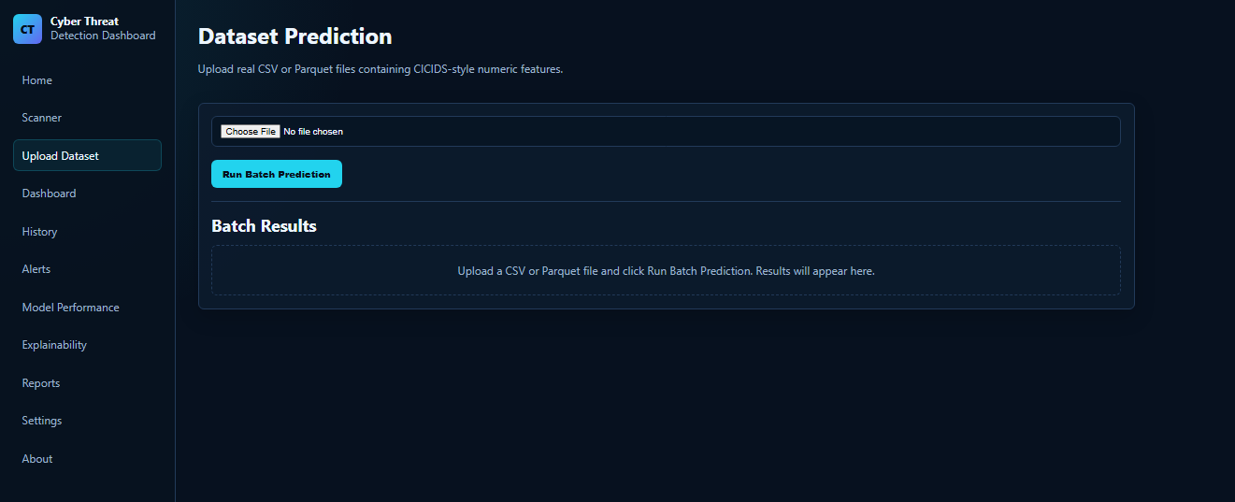
Figure 20: Upload Dataset Page
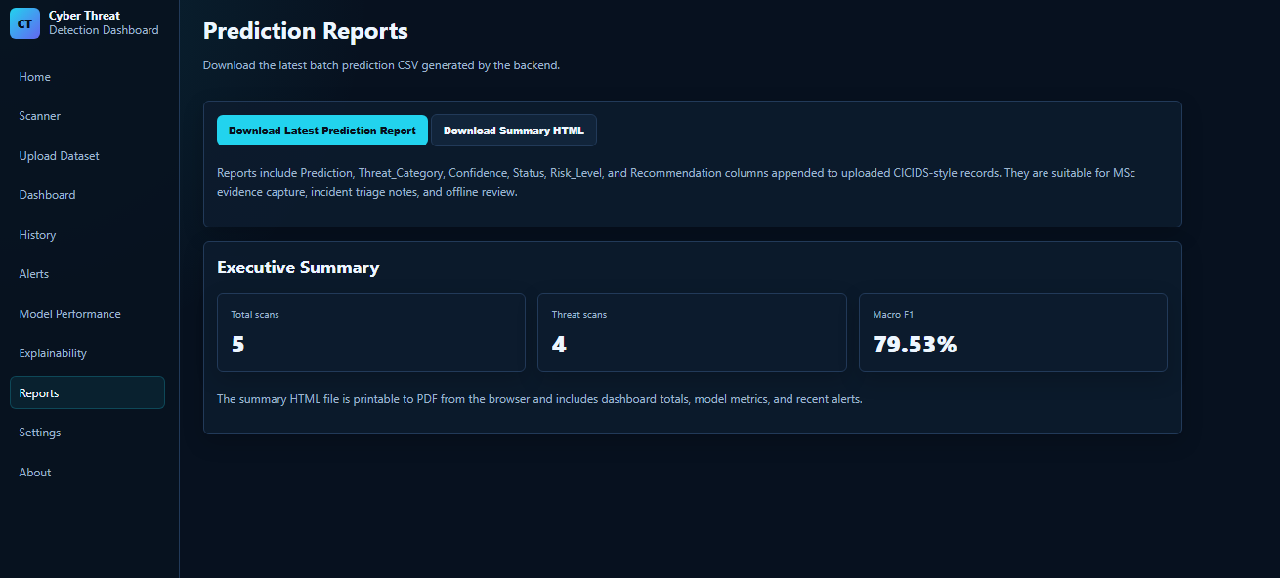
Figure 21: Batch Prediction Result
Batch prediction improves system usefulness because cyber-threat analysis usually involves many records rather than single inputs. The report function also supports documentation and offline review.

4.10 Dashboard Analytics Implementation
The Dashboard page uses data from the /api/dashboard endpoint and visualises it using Chart.js. It displays total scans, safe scans, threat scans, high-risk scans, average confidence, threat distribution, risk distribution, and recent scan records.
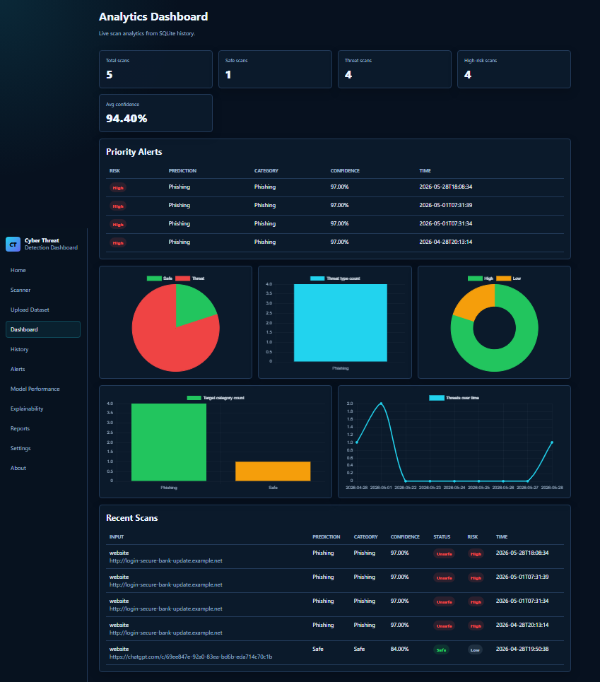
Figure 22: Dashboard Analytics Page
Table 17: Dashboard Metrics
Metric | Purpose
Total scans | Shows total number of prediction requests
Safe scans | Shows benign classifications
Threat scans | Shows malicious or suspicious classifications
High-risk scans | Shows serious threat classifications
Average confidence | Shows average model certainty
Threat type counts | Shows distribution of predicted classes
Risk distribution | Shows low, medium, high and critical risk categories
Recent scans | Shows latest prediction activity
The dashboard converts individual predictions into broader analytical insight. This matters because cybersecurity users need patterns and summaries, not just isolated outputs.

4.11 Model Performance Page
The Model Performance page displays evaluation information from model_metrics.json. It includes model name, dataset information, accuracy, macro precision, macro recall, macro F1-score, weighted F1-score, feature count, class list, and classification report.
The page includes a critical interpretation of model performance. This is necessary because high overall accuracy can be misleading in imbalanced intrusion detection datasets. A model may perform strongly on majority classes such as benign traffic while performing weakly on rare classes such as SQL injection or infiltration [4]. Therefore.

4.12 System Testing
System testing was conducted to confirm that each component worked independently and as part of the integrated application. Testing covered model training, saved model testing, backend status checking, frontend prediction, database storage, dashboard analytics, batch upload, and report download.
Table 18: System Testing Summary
Test | Expected Result | Outcome
Model training test | Model artefacts are generated | Successful
Saved model test | Real dataset record is predicted | Successful
Backend API test | API returns active status | Successful
Single scan test | Frontend displays prediction result | Successful
History test | Prediction is stored and displayed | Successful
Dashboard test | Statistics and charts are displayed | Successful
Batch upload test | Dataset is classified successfully | Successful
Report download test | CSV report downloads successfully | Successful
Testing confirmed that the application functions as an integrated system rather than disconnected files. This is a central contribution of the implementation.

4.13 Implementation Challenges
Several challenges were encountered during development. These challenges show that cyber-threat detection implementation involves data engineering, model deployment, backend integration, frontend design, and system testing. These challenges demonstrate that IDS development is not only a classification problem. A working cyber-threat detection platform requires reliable preprocessing, consistent deployment artefacts, API communication, storage, reporting, and user-centred presentation.

4.14 Chapter Summary
This chapter presented the implemented dashboard architecture, including Random Forest, Flask, SQLite, frontend pages, analytics, upload, history, and reports. It showed that the project moves beyond offline evaluation while acknowledging limitations such as no live packet capture and minority-class weakness.
The chapter showed that the implementation moves beyond offline model evaluation by providing a usable platform. It also clarified that Random Forest was the implemented baseline, while CNN-LSTM-Attention remains future work.
The system supports single prediction, batch upload, dashboard analytics, history, model performance viewing, and downloadable reports. Remaining limitations include no live packet capture, benchmark-data dependence, and weaker minority-class detection.

CHAPTER 5: RESULTS, EVALUATION AND DISCUSSION

5.0 Introduction
This chapter evaluates the results of the implemented cyber-threat detection system. The evaluation focuses on two areas: the performance of the Random Forest machine learning model and the functionality of the web-based dashboard. The purpose is not only to report whether the system worked, but to critically assess how reliable.
The system was trained using the CICIDS2017 and deployed through a Flask backend connected to a frontend dashboard. This distinction is important because the current system demonstrates implementation feasibility, but it does not fully achieve the temporal and attention-based learning capabilities discussed in the literature [8], [13].

5.1 Model Performance Results
The trained Random Forest model achieved a high overall accuracy of 99.75%. At first, this appears to indicate very strong performance. However, this result must be interpreted critically because intrusion detection datasets are often imbalanced. In this case, majority classes such as benign traffic and DDoS were detected very well.
Table 19: Summary of Model Performance
Metric | Result | Critical Interpretation
Overall accuracy | 99.75% | Very high, but influenced by dominant classes
Macro average F1-score | Approx. 0.73 | Shows weaker performance across minority classes
Weighted average F1-score | Approx. 1.00 | High because majority classes dominate the dataset
Strong classes | Benign, DDoS, DoS Hulk, FTP-Patator | These classes had enough data for reliable learning
Weak classes | Infiltration, SQL Injection, XSS | Performance limited by very small sample sizes
The key finding is that overall accuracy alone is not sufficient for evaluating an IDS model. A model may appear highly accurate while still failing to detect rare but serious attacks. This is a major problem in cybersecurity because rare threats can still cause severe damage. Therefore, macro-average F1-score and.

5.2 Classification Performance by Attack Type
The model performed very well on high-volume and well-represented classes. Benign traffic, DDoS, DoS Hulk, FTP-Patator, and several DoS classes achieved strong precision and recall. This indicates that Random Forest can effectively learn structured network-flow patterns when sufficient training examples are available.
However, the model performed poorly on rare classes. Infiltration and SQL Injection achieved very weak or zero detection in the reported results. XSS detection was also weak. This does not necessarily mean the model is useless; rather, it shows that the dataset distribution limits the model’s ability to generalise to minority attacks. This result confirms a known challenge in IDS research: benchmark datasets often contain uneven class distributions, and models trained on them may become biased toward majority classes [4], [12]. Therefore, the model is reliable for common traffic patterns but less reliable for rare attack detection.

5.3 System Functionality Evaluation
The implemented web application successfully integrated the trained model into a usable system. The backend loaded the saved model, scaler, label encoder, and feature columns. The frontend sent requests to the Flask API, and the backend returned predictions, confidence scores, risk levels, and recommendations. The system therefore achieved its core implementation goal. It moved beyond offline model training by providing a working interface for prediction, analytics, history tracking, and reporting. This matters because many IDS studies remain limited to model evaluation and do not demonstrate operational use [6], [8].

5.4 Discussion of Findings
The findings show that Random Forest is a strong baseline model for structured cyber-threat detection. It performs especially well where attack classes have enough training examples. The high performance on benign, DDoS, and DoS traffic suggests that flow-based features in CICIDS2017 are suitable for supervised classification.
However, the model’s weakness on minority attack classes is significant. In real cybersecurity contexts, missing rare attacks can be more serious than misclassifying common traffic. For example, failing to detect SQL Injection or Infiltration may expose systems to data theft or unauthorised access. Therefore, the model should not be presented as a complete production IDS.
The dashboard implementation is a major strength of the project. It improves practical usability by showing not only predictions but also confidence scores, risk levels, recommendations, history, and reports. This makes the system more useful than a model-only experiment. Nevertheless, the system still depends on uploaded records or manually entered.

5.5 Evaluation Against Research Objectives
Table 20: Achievement of Research Objectives
Objective | Achieved? | Evidence
Review IDS literature | Yes | Chapter 2 identified gaps in traditional, ML, DL and attention-based IDS
Use real cybersecurity dataset | Yes | CICIDS2017 Parquet files were used
Preprocess dataset | Yes | Missing values, infinite values, duplicates and labels were handled
Train ML model | Yes | Random Forest was trained
Evaluate model | Yes | Accuracy, precision, recall, F1-score and confusion matrix were produced
Deploy model | Yes | Flask backend loaded saved model artefacts
Build frontend dashboard | Yes | Web pages were implemented for scanning, dashboard, history and reports
Support reporting | Yes | Batch prediction report export was implemented
Implement CNN-LSTM-Attention | No | This remains a future enhancement
The objectives were mostly achieved. The main exception is that the advanced CNN-LSTM-Attention model was not implemented. This is acceptable if clearly explained as a future enhancement, but it must not be falsely presented as part of the working system.

5.6 Limitations
The system has several important limitations.
First, the model was trained on a benchmark dataset rather than live cloud traffic. This means that performance may not fully generalise to real production environments. These limitations do not invalidate the project. Instead, they define the boundary between a successful academic implementation and a production-ready cyber defence system.

5.7 Future Improvements
Future work should focus on improving both the model and the system deployment. The most important improvement is to implement the proposed CNN-LSTM-Attention model. CNN could support spatial feature extraction, LSTM could support temporal sequence learning, and attention could help prioritise important features [8], [13]. The system could also be improved by integrating live packet capture, cloud log ingestion, SHAP explainability, authentication, role-based access, and cloud deployment.

5.8 Chapter Summary
This chapter evaluated the Random Forest-based system. Accuracy was high, but minority-class performance was weaker; therefore, the main contribution is the working end-to-end platform rather than the headline score alone.
The main contribution is not the accuracy score alone, but the working end-to-end platform. Future work should add CNN-LSTM-Attention, live traffic capture, cloud deployment, explainable AI, and stronger class-imbalance handling.

CHAPTER 6: CONCLUSION AND RECOMMENDATIONS

6.0 Introduction
This chapter basically wraps up the dissertation by summarising the findings, assessing the objectives, highlighting the contributions, and giving recommendations for what could be improved later. It also makes clear the boundary of the study, because yes, there is a wider research context. While the wider research was informed by hybrid deep learning and attention-based intrusion detection, the actual implemented system used a Random Forest as its baseline model. That difference matters, since the project shows an end-to-end deployable intrusion detection platform, but.

6.1 Summary of the Study
The study was driven by an increasing need for adaptive cyber-threat detection in cloud environments. Cloud systems get exposed, mainly because they lean on distributed infrastructure, virtualisation, multi-tenancy, remote access, and high-volume data communication. Taken together, these features broaden the attack surface and make conventional rule-based intrusion detection systems less useful when attacks keep changing.
The literature review suggested, signature-based IDS approaches have constraints because they depend on known attack patterns. At the same time, it also became clear that many more sophisticated IDS models still struggle with computational overhead, weak real-time validation, class imbalance, limited interpretability, and the fact that they do not get deployed into something genuinely usable.
So, as a response, this study built a practical cyber-threat detection dashboard using the CICIDS2017 dataset. The implemented approach trained a Random Forest to separate network traffic into benign versus attack classes, and then connected that output into the dashboard workflow.

6.2 Achievement of Research Objectives
Overall, the research objectives were met to a large extent. The study managed to review the relevant intrusion detection literature, prepare the CICIDS2017 dataset, train a machine learning model, roll out the model through a backend API, design a frontend dashboard, and evaluate the system in a critical way.
The main gap in objective achievement is that the more advanced CNN-LSTM-Attention model was not implemented. Still, this does not necessarily weaken the project, because the chosen Random Forest model functioned as a practical starting point. It was also useful for proving the full system workflow end-to-end. In that sense, the study stays transparent by distinguishing the implemented baseline from the deep learning framework that is proposed for later work.

6.3 Main Findings
The study produced three main findings. First, the Random Forest delivered strong overall performance on the CICIDS2017 dataset, reaching an overall accuracy of about 99.75%. This indicates that structured network-flow features can support dependable supervised cyber-threat classification.
Second, the evaluation also makes it clear that accuracy alone is not enough for intrusion detection. This supports the idea that class imbalance is still a big obstacle in cyber-threat detection, even when the model appears strong on headline metrics.
Third, the implementation confirmed that a trained machine learning model can be pushed into a practical dashboard system. The Flask backend, the frontend pages, SQLite database, the dashboard visualisations, and the report generation routines collectively show that cyber-threat detection can shift from offline experimentation into an actual decision-support instrument.
Table 21: Summary of Key Findings
Finding | Interpretation
Random Forest achieved high overall accuracy | The model is effective for well-represented traffic classes
Minority-class detection was weaker | Class imbalance limits reliability for rare attacks
Web dashboard worked successfully | The system demonstrates practical deployment feasibility
SQLite history supported traceability | Predictions can be stored and reviewed
Batch upload improved usability | The system can classify multiple records, not only single inputs
Accuracy required critical interpretation | Macro F1-score and class-level recall are essential in IDS evaluation
CNN-LSTM-Attention was not implemented | Advanced temporal and attention-based learning remains future work

6.4 Contribution of the Study
In this study, the key contribution is the creation of an end-to-end cyber threat detection platform that kind of bridges machine learning with real system deployment. A lot of IDS work stops after training, or then it just does evaluation on the side, but here the project actually takes the trained model and plugs it into a functioning web app. So, it is not only “a model”, it is more like a usable service.
Overall, the contribution can be described in three areas, not in a very tidy way but still clearly. First, there is a technical contribution: a machine learning pipeline built using CICIDS2017 data. The system loads Parquet files , cleans the dataset, encodes labels, scales features , trains a Random Forest, stores model artefacts, and pushes everything through a backend deployment. Second, there is a practical contribution, because the dashboard is doing more than a quick demo. It supports single inference, batch prediction, scan history, analytics, model performance display, and even report download. This makes the whole system more approachable than a notebook based model that nobody really wants to run in daily work. Third, there is a critical contribution, in the sense that it highlights the limitations of accuracy driven IDS evaluation. The model achieved high accuracy overall, but the rare attack categories were weak, like noticeably underperforming. That result points toward the need for class level evaluation, better imbalance handling, and some future enhancements with deeper learning approaches.

6.5 Limitations of the Study
Even though the project met the main implementation goals, there are still several limitations.
First, the system relies on a benchmark dataset rather than genuine live cloud traffic. CICIDS2017 is handy for experiments, but real cloud setups may involve encrypted communication, API calls, containerised workloads, dynamic routing, and patterns that are specific to a given organization. So the “environment gap” is real. Second, the model is affected by class imbalance. Some attack classes include only a small number of samples, which reduces detection strength. This is troubling, because rare attacks can still create serious security consequences even when they appear infrequently. Third, the implemented model is Random Forest, not CNN-LSTM-Attention. Random Forest works well with structured tabular data, but it does not directly represent temporal attack sequences, nor does it provide attention based prioritisation of features. Fourth, the system currently does not include live packet capture or real time traffic ingestion. Users can scan manually entered features, or they can upload datasets, but it does not automatically observe live network flows. Fifth, the deployment is local. It has not yet been moved into a cloud environment, and it has not been tested under high throughput, real time conditions. These limitations do not basically cancel the value of the project. Instead, they define what is in scope for the current implementation, and they also set up clear directions for what to improve next.

6.6 Recommendations
Based on the findings and the limitations, several recommendations are proposed.
First, future work should implement the suggested CNN-LSTM-Attention model. CNN parts could extract “spatial style” feature signals, LSTM parts could capture temporal dependencies, and attention could emphasise the important features. That should align the build process more closely with the dissertation’s theoretical framework.
Second, the system should include live traffic capture or flow extraction. Systems like CICFlowMeter, Zeek, Suricata, or cloud native logging could be integrated to produce live network flow features. Third, class imbalance should be handled with more advanced techniques. Possible options include oversampling, undersampling, SMOTE, class weighted learning, focal loss, or anomaly based detection approaches for those rare attacks. Fourth, explainable AI should be added. SHAP or LIME can show which features influenced a prediction. This would increase trust, transparency, and decision support for analysts. Fifth, the system should be deployed and tested in a real, or at least simulated, cloud environment. This enables evaluation of scalability, latency, throughput, and overall operational reliability. Sixth, access control should be built into the production workflow. A production version should include authentication, role based access control , encrypted storage, audit logs, and safe handling for secure uploads.

6.7 Final Conclusion
This dissertation designed and implemented a web-based cyber-threat detection dashboard using the CICIDS2017 and a Random Forest. The project successfully demonstrated that a trained machine learning model can be integrated into a working application that supports prediction, dashboard analytics, history tracking, model performance viewing, batch processing, and report generation.
The model achieved high overall accuracy, but the evaluation showed that this result must be interpreted critically because minority attack classes were weaker. This finding is important because intrusion detection systems must be judged not only by overall accuracy but also by their ability to detect rare and high-risk attacks.
The project’s main achievement is the development of a complete end-to-end system rather than a model-only experiment. It shows how machine learning can be operationalised into a practical cybersecurity dashboard. However, the system remains a baseline implementation. Future work should extend the system through CNN-LSTM-Attention modelling, live network-flow extraction, explainable.
Overall, the study demonstrates that machine learning can support cyber-threat detection in cloud computing contexts, but it also confirms that practical IDS deployment requires more than high model accuracy. A reliable system must combine data quality, model performance, interpretability, real-time capability, secure deployment, and human-centred decision support.

References
[1] A. Alharbi, W. Alosaimi, and H. Alyami, “Hybrid deep learning model for intrusion detection in cloud environments,” Journal of Cloud Computing, vol. 12, no. 1, pp. 1–18, 2023. Available: https://journalofcloudcomputing.springeropen.com/articles/10.1186/s13677-023-00421-7https://journalofcloudcomputing.springeropen.com/articles/10.1186/s13677-023-00421-7
[2] A. T. Azar, A. E. Hassanien, and M. Elhoseny, “Optimised hybrid deep learning models for intrusion detection systems,” Neural Computing and Applications, vol. 35, no. 4, pp. 2567–2583, 2023. Available: https://link.springer.com/article/10.1007/s00521-022-07645-3
[3] A. L. Buczak and E. Guven, “A survey of data mining and machine learning methods for cyber security intrusion detection,” IEEE Communications Surveys & Tutorials, vol. 18, no. 2, pp. 1153–1176, 2016. Available: https://ieeexplore.ieee.org/document/7307098
[4] P. Chinnasamy, P. Deepalakshmi, and J. J. Ranjani, “Deep learning-based network intrusion detection systems: A systematic review,” Array, vol. 20, p. 100312, 2025. Available: https://www.sciencedirect.com/science/article/pii/S2405959525000050
[5] P. Garcia-Teodoro, J. Diaz-Verdejo, G. Macia-Fernandez, and E. Vazquez, “Anomaly-based network intrusion detection: Techniques, systems and challenges,” Computers & Security, vol. 28, no. 1–2, pp. 18–28, 2009. Available: https://www.sciencedirect.com/science/article/pii/S0167404808000692
[6] N. A. Ghani and S. A. Alasadi, “Intrusion detection using GRU-BiLSTM deep learning model,” Engineering, Technology & Applied Science Research, vol. 15, no. 2, pp. 10666–10673, 2025. Available: https://etasr.com/index.php/ETASR/article/view/10666
[7] K. Hashizume, D. G. Rosado, E. Fernández-Medina, and E. B. Fernandez, “An analysis of security issues for cloud computing,” Journal of Internet Services and Applications, vol. 4, no. 1, pp. 1–13, 2013. Available: https://jisajournal.springeropen.com/articles/10.1186/1869-0238-4-5
[8] S. Hore, R. Kumar, and B. B. Gupta, “Sequential deep learning model for intrusion detection in network security,” Computers & Security, vol. 138, p. 103546, 2024. Available: https://www.sciencedirect.com/science/article/pii/S0167404824002311
[9] Y. Li, X. Zhang, and H. Wang, “Deep learning for intrusion detection systems: A comprehensive survey,” ACM Computing Surveys, vol. 56, no. 3, pp. 1–36, 2024. Available: https://dl.acm.org/doi/10.1145/3688574
[10] S. Markkandeyan, “Hybrid deep learning model for IoT malware detection and classification,” Array, vol. 21, p. 100345, 2024. Available: https://www.sciencedirect.com/science/article/pii/S2772918424000419
[11] N. Shone, T. N. Ngoc, V. D. Phai, and Q. Shi, “A deep learning approach to network intrusion detection,” IEEE Transactions on Emerging Topics in Computational Intelligence, vol. 2, no. 1, pp. 41–50, 2018. Available: https://ieeexplore.ieee.org/document/8066291
[12] R. Sommer and V. Paxson, “Outside the closed world: On using machine learning for network intrusion detection,” in Proc. IEEE Symposium on Security and Privacy, 2010, pp. 305–316. Available: https://ieeexplore.ieee.org/document/5504793
[13] A. Vaswani et al., “Attention is all you need,” in Advances in Neural Information Processing Systems, vol. 30, pp. 5998–6008, 2017. Available: https://arxiv.org/abs/1706.03762
[14] Q. Zhang, M. Chen, L. Li, and Y. Yang, “Security and privacy in cloud computing: A survey,” Future Generation Computer Systems, vol. 28, no. 2, pp. 391–399, 2010. Available: https://www.sciencedirect.com/science/article/pii/S0167739X11002561
[15] I. Sharafaldin, A. H. Lashkari, and A. A. Ghorbani, “Toward generating a new intrusion detection dataset and intrusion traffic characterization,” in Proc. 4th International Conference on Information Systems Security and Privacy (ICISSP), 2018, pp. 108–116. Available: https://www.unb.ca/cic/datasets/ids-2017.html
[16] L. Breiman, “Random forests,” Machine Learning, vol. 45, no. 1, pp. 5–32, 2001. Available: https://link.springer.com/article/10.1023/A:1010933404324
[17] F. Pedregosa et al., “Scikit-learn: Machine learning in Python,” Journal of Machine Learning Research, vol. 12, pp. 2825–2830, 2011. Available: https://jmlr.org/papers/v12/pedregosa11a.html
[18] M. Waskom, “Seaborn: Statistical data visualization,” Journal of Open Source Software, vol. 6, no. 60, p. 3021, 2021. Available: https://joss.theoj.org/papers/10.21105/joss.03021
[19] W. McKinney, “Data structures for statistical computing in Python,” in Proc. 9th Python in Science Conference, 2010, pp. 56–61. Available: https://conference.scipy.org/proceedings/scipy2010/mckinney.html
[20] C. R. Harris et al., “Array programming with NumPy,” Nature, vol. 585, pp. 357–362, 2020. Available: https://www.nature.com/articles/s41586-020-2649-2
[21] M. Grinberg, Flask Web Development: Developing Web Applications with Python, 2nd ed. Sebastopol, CA, USA: O’Reilly Media, 2018.
[22] SQLite Consortium, “SQLite documentation,” 2026. Available: https://www.sqlite.org/docs.html
[23] Chart.js Contributors, “Chart.js documentation,” 2026. Available: https://www.chartjs.org/docs/latest/
[24] Microsoft, “Visual Studio Code documentation,” 2026. Available: https://code.visualstudio.com/docs
[25] Python Software Foundation, “Python 3 documentation,” 2026. Available: https://docs.python.org/3/
[26] Pallets Projects, “Flask documentation,” 2026. Available: https://flask.palletsprojects.com/
[27] Scikit-learn Developers, “RandomForestClassifier,” Scikit-learn Documentation, 2026. Available: https://scikit-learn.org/stable/modules/generated/sklearn.ensemble.RandomForestClassifier.html
[28] Scikit-learn Developers, “StandardScaler,” Scikit-learn Documentation, 2026. Available: https://scikit-learn.org/stable/modules/generated/sklearn.preprocessing.StandardScaler.html
[29] Scikit-learn Developers, “LabelEncoder,” Scikit-learn Documentation, 2026. Available: https://scikit-learn.org/stable/modules/generated/sklearn.preprocessing.LabelEncoder.html
[30] D. Dua and C. Graff, “UCI Machine Learning Repository,” University of California, Irvine, School of Information and Computer Sciences, 2019. Available: https://archive.ics.uci.edu/

