Cloud Based Web Services

Author: Kai Strand-Regan

Module Code: ACCA6024

Tutor: Mike Dacey and Time Bashford

Date Submitted:

Abstract

The following report will give an overview of the different web services available along with contrasting and comparing their features. This report looks to give the reader a good understanding of the features each service offers along with the disadvantages they have.
Contents
Abstract 2
1. Introduction 4
2. Web Services 4
2.1. (SOAP) 4
2.2. Rest 4
2.2.1. Uniform Interface 5
2.2.2. Stateless 5
2.2.3. Caching 5
2.2.4. Layering 5
2.2.5. Code on Demand 6
2.2.6. Representation 6
2.3. GraphQL 6
2.3.1. Components 6
2.3.2. Libraries 6
2.3.3. Example of GraphQL 7
3. Comparison of Services 7
3.1. SOAP vs Rest 7
3.2. REST vs GraphQL 8
4. Conclusion 8

Introduction
This report will compare and contrast three web services, SOAP, REST and GraphQL. The benefits and drawbacks of each service will be investigated so as to understand the best use case for each service and if one stands out above the rest.

Web Services
The definition of a web service is “a software system designed to support interoperable machine-to-machine interaction over a network” [1].
This section will introduce the three web services that will be compared to give an understanding of the individual benefits and use that they offer. Below is an image which displays the basic structure of what all web services are used fore, the differences come with how the client and the server communicate.
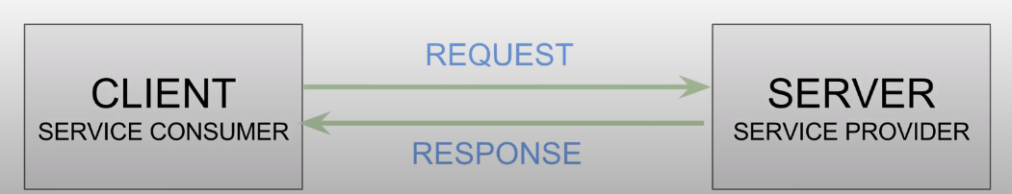

(SOAP)
SOAP used to stand for Simple Object Access Protocol an although this expansion is no longer used the acronym has stayed the same. The SOAP web specification standards at a basic level are SOAP, WSDL and UDDI. The SOAP is a set of rules and definitions on how 2 applications communicate with each other over the web. In order for the client to communicate with the server a common format must be used, SOAP uses XML as a common format which consists of a SOAP structure. The structure includes an envelope (root element), header (optional) and the body. The envelope includes all the elements of the message such as the header and body. The header is there to provide information about the message additionally it can include authentication and other routing information. The body contains the request parameters.

Rest
A REST web service is an abbreviation of Representational State Transfer which is also known as a restful service. The idea of a restful service is in principle, like any other web service. That is to say that it exchanges information between 2 applications, what makes it different from another web service is that it uses REST architecture/principles to facilitate the applications connection. This is the broad definition, to further understand REST it is important to breakdown the principles of REST.
The following is a list of constraints/principles of REST:
- Uniform Interface
- Stateless
- Cacheable
- Layered System
- Code on Demand (optional)

Uniform Interface
The aspects of a UI include the resources which refers to basically any part of data or module that can be given a name.
A Uniform Resource Identifier (URI) is the second component, this is essentially an address to locate different data that is stored. An example of a URI for a animal data base could be http://animals.com/dogs if the user wants to find the breed they may type http://animals.com/dogs/breed this allows access to the different dog breeds.
HTTP is used in REST with the main benefit being the CRUD [2] methods, these methods allow access for all the resources on the database.
The message requests are self-descriptive which means that in addition to the data being sent there is further information about if the data should be cached, the authentication requirements and so on.

Stateless
All the client-side communications are stateless, this means that all the data needed to handle a request is done by the client to the server so that there is no need to store any of the session state on the server. The request from the client is an entity of itself as it is independent of any other request/call.
The best example of this is when a user adds items to their shopping cart on a website e.g. Amazon. The state of the shopping cart is only sent and saved on the client side. This improves the web server performance as it does not have to save more data then is totally necessary.

Caching
Caching data is used to help with the client’s state, the server gives back the response with the data along with the metadata. This includes whether the server needs to cache the data or not, this is saved in the header. Cache-Control and Last-Modified are the headers which indicate whether the data should be cached or not.

Layering
Layering can refer to HTTP Intermediaries which are used between the client and the server of which there can be multiple. These can be used to improve performance with caching or to send message transactions.
Another example would be proxy and gateways which are used for security and reduce the chance of a data breach. A proxy is chosen by the client and the gateways are chosen by the server both of which can have multiple.
Caching can also be stored as a layer, an example of this would be that the client may add an item to their basket without completing the purchase. The request will be saved at the intermediary layer and if nothing is triggered for an hour then the cache is deleted.
Layering improves scalability for a website by improving the internet size requirements, the loading of the website is therefore improved for users and allows the company to spend less on server processing.

Code on Demand
This is an optional principle which provides the option to download an executable file upon request on the client side. A common example of this would be Java Applets which are great for offering features such as bar charts animations and other useful additions to a website. Code on demand can also be used for security reasons to “encrypt communication” [3].

Representation
To summarise, the rest architecture allows access to both the data and the description of the current data state. A good example of this is with an image file as running GET request for the image in JPEG (assuming this is it’s format) will return the image, whereas a GET request on the state will ask for the xml, json etc and should return the image description such as resolution and image name.

GraphQL
The final web service that will be looked at is GraphQL, the basic structure is still the same as the previous web services the difference is once again in how the service achieve communication between the client and server.
GraphQL looks to improve upon the REST api service by adding targeted queries to retrieve predictable results opposed to possible unwanted information.
GraphQL is designed by Facebook but this does not mean that Facebook has to be associated to the implementation in any way which if that was the case might be an issue for some people.

Components
There are two primary components to GraphQL the client component and server component and it is not uncommon to only need the code for one of the components. If the api already has a server which uses GraphQL there is no need to implement any of the server component and allows the designer to just focus on the client side.
There are many GraphQL implementations available in most of the languages used including Java, PHP, Python etc. Additionally, each language has multiple choices for implementation which allows for great flexibility when designing the structure.

Libraries
What is the GraphQL server? The idea of the server is to take in the api which the developer has created with all the type definitions which is the shape of the data and the resolvers which can be the queries set to retrieve certain data. The server uses this information to expose it to an endpoint which is where the data exists, usually GraphQL only needs one endpoint and the query then finds the data required, this endpoint is usually named /graphql.
Along with server libraries there are client-side options available including Facebook an Apollo which are JavaScript focused but other languages are available and cross platform.

Example of GraphQL
The highlight of GraphQL is detailed queries which provide information specified to what the client wants without any additional data.
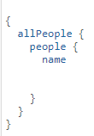
If the aim was to retrieve data from ma book api and all that was needed was the book and author, the following code would be an example:
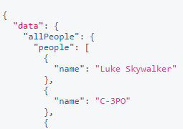

The code on the left points to the people data base and looks in the people field and asks to display those names. The code below shows how simple it is to add more data by adding the field in this case the date of birth.
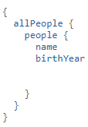
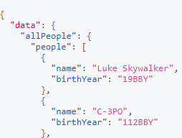

This code was created in GraphiQL [4] which allows someone to run example queries which is great for practising.

Comparison of Services
The three services offer several unique benefits along with having many similarities, not service is ‘wrong’ and the reason for choosing a service come down to what project is being developed. However, it is important to look at these differences to understand which service is best suited to a project.

SOAP vs Rest
This section will look at the advantages and disadvantages of SOAP when compared with REST.
SOAP is “Language, platform, and transport independent” [5] in contrast REST only works on HTTP. This is useful to a developer who does not want to use that protocol is able to still link to an API. SOAP is standardized unlike REST along with this it does not assume a direct endpoint. This makes SOAP more flexible and is therefore the choice of high security businesses that perform complicated transactions.

REST is much easier to use from a technical and practical view, there is no costly web tools required. The language is less complex as it is closer to other web technology design layouts. This makes REST a great middle ground for both beginners and small businesses additionally it does not require a large amount of processing which intern requires less hardware and provides smoother experience.

REST vs GraphQL
After looking at how SOAP and REST match up it is clear that they are catered to different users.
The main advantage that GraphQL has over REST is the ability to post the exact request from the user instead of the full data set. This is great for project specific features and can offer a better experience. The issue with using GraphQL when compared with REST is that REST is an industry standard and API’s are much more likely to be available for REST.

Conclusion
After looking at the feature of each web service, they all offer some clear advantages for API interaction. REST appears to be the most rounded of the three as it offers a comprehensive library of compatible API’s without demanding complex language and advanced web tools. SOAP clearly offers great security to large enterprises which is not likely to change. GraphQL offers an exciting prospect of tailored data which can provide the exact query requests without overloading data.

Bibliography

[1] | “Web Services Architecture,” W3C, 2004. [Online]. Available: https://www.w3.org/TR/2004/NOTE-ws-arch-20040211/#relwwwrest. [Accessed 12 12 2020].
[2] | Codecademy, “What is CRUD?,” Codecademy, [Online]. Available: https://www.codecademy.com/articles/what-is-crud. [Accessed 13 12 2020].
[3] | R. T. F. d. -. C. o. demand, “What is the code-on-demand constraint, and why is it an optional constraint?,” restcookbook.com, [Online]. Available: https://restcookbook.com/Basics/codeondemand/. [Accessed 14 12 2020].
[4] | GraphiQL, “GraphiQL,” GraphiQL, [Online]. Available: https://graphql.github.io/swapi-graphql/?query=%7B%0A%20%20allPeople%20%7B%0A%20%20%20%20people%20%7B%0A%20%20%20%20%20%20name%20%0A%20%20%20%20%20%20birthYear%0A%20%20%20%20%20%20%20%20%0A%20%20%20%20%20%20%0A%20%20%20%20%7D%0A%20%20%7D%0A%7D. [Accessed 15 12 2020].
[5] | Smartbear, “SOAP vs REST. What's the Difference?,” Smartbear, [Online]. Available: https://smartbear.com/blog/test-and-monitor/soap-vs-rest-whats-the-difference/. [Accessed 15 12 2020].

