HUMAN RESOURCE MANAGEMENT OF UK AND THE IMPACT OF BREXIT AND COVID-19 ON LABOR MARKET
Name: AMIR ALI BOORANI
ID: 2124612
Table of Contents
1. Introduction 2
2. The changes in the labour market conditions in the Post Covid-19 and Post Brexit period in the UK 2
2.1 Concept of labour Market 2
2.2 Impacts of Covid-19 on the labour market of the UK 3
2.3 Impact of Brexit on the Labor market of the UK 5
2.4 The economical process that is accounted for through labour market differentiation 6
3. HRM perspectives in the process of maintaining the labour market 7
3.1 Recommended changes that are needed in the human resourcing strategies in the modern times 7
3.2 Ways of implementation of the changed processes in the current scenario in the UK as an HR manager 10
4. Conclusion 12
5. Reference List 14

1. Introduction
The labour market is one of the main factors that can assist the development of companies, which can assist to gain the effective rise of the economy through employability as well. There is a direct relationship between organisational performance and the resourceful people working under their shed for the sake of development. The mentioned description will encompass the utility of the labour market and the impact of the Brexit and pandemic on the process of maintaining the employability rate. As noted by Rauf et al. (2020), the pandemic has a severe issue in retaining the efficacy and management of employee integration. Therefore, certain factors to gain efficacy are mainly done for the side of the companies as well.

2. The changes in the labour market conditions in the Post Covid-19 and Post Brexit period in the UK

2.1 Concept of labour Market
The labour market is considered the main factor that can assist in maintaining employability scale and the economical standards of the companies eminently in a region. The labour market efficiency is the sole contributor to managing the employability rate of the country that can handle the efficiency of the companies.
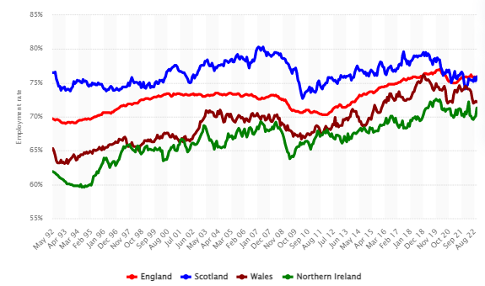
Figure 1: The employment rate in various parts of the UK
(Source: Statista, 2022)
Therefore, the deviation in the different parts in different timelines is mainly related to the deviation that is being faced due to the loss of employability issues and labour market diversity. It is noted that England has a steep rise in labour integration and the employability scale, which proves the effective methods of integrating people in the working environment. It is observed that the change occurred from 69.7% to 75.9% in England (Statista, 2022). As a result, a significant development in labour integration is observed in the process as well. Apart from that, the increase in economic development and increasing customer satisfaction are also maintained by the companies of the UK. This is because of the cultural variation that is seen in the country. As per the argument of Wang et al. (2021), individualism and indulgence are mainly maintained in the workplace in the UK. Therefore, training and maintaining efficacy accordingly which can determine the skill and training process is also seen typically in the UK.

2.2 Impacts of Covid-19 on the labour market of the UK
The Covid-19 strike is one of the main factors that hindered the development of the companies and shut down many outlets in European countries. Such an impact is also faced by the UK where populous areas like Scotland, London, Wales and the Southeastern side were being impacted hugely through the process. As per the argument of Sim et al. (2020), frontline labours were prone to infection during the pandemic, which was the main issue that is faced by UK companies eminently as well. The closure of many retail shops is another major observation that is seen in the case of the UK.
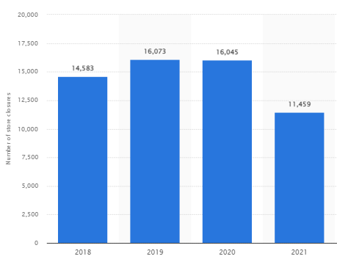
Figure 2: Shop closure of the retail industry in the UK due to the pandemic
(Source: Statista, 2022)
It should be noted that the issues related to the integration of the laborers are mainly faced by the labour market due to the digitalization of the retail industry and the compelled decision of the social distancing that is being done from the side of the UK government. It is noted that around 11459 shops were merely seen opened in the UK in the year 2021 as well (Statista 2022). Therefore, a significant issue in labour integration is faced by UK companies due to the advent of the pandemic as well.

2.3 Impact of Brexit on the Labor market of the UK
Jobs in European countries are one of the main factors that can assist the development of the British people to make their stability the financial side as well. It is noted that a significant involvement in jobs is seen among the British people in different UK countries eminently.
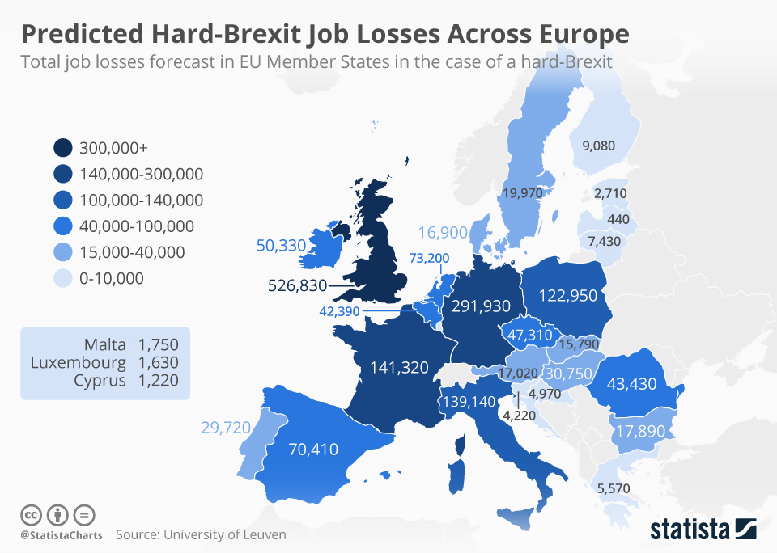
Figure 3: The job losses faced due to the hard Brexit hit
(Source: McCarthy, 2019)
It is noted that the use of Brexit is one of the key factors that caused the changes in the orientation of the people involved in its job processes in the EU. It is noted that the United Kingdom can lose around 500,000 jobs due to the Brexit process (McCarthy, 2019). On the other hand, issues related to the development of the companies and the inter-relations hamper are also faced eminently due to the hard Brexit. As noted by Škare et al. (2021), the travel industry change and loss of employability are also seen in the case of the UK where the issues related to the development of the companies are also seen eminently as well. Therefore, hampering the skills and using the different cross-border people are also faced by the UK due to the Brexit process.

2.4 The economical process that is accounted for through labour market differentiation
The loss of the labour market efficacy due to the pandemic is also a major factor affecting other economic growth of the UK. For example, the inflation rise is one of the main issues that are seen in the process of Brexit that affected the buying behaviours and salary of the employees in the UK as well. It is noted that Brexit is responsible for increasing the cost of the cost of living in the UK by 1.1%, which is around 52% more than normal processes (Economics and Political Science, 2022). Therefore, the process is also considered the major factor that increased the inflation rate of the UK eminently.
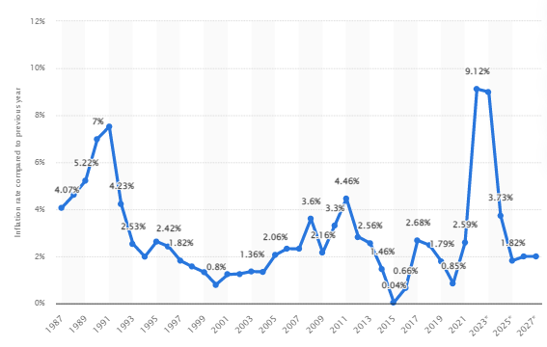
Figure 4: Inflation rise in the UK economy
(Source: Statista, 2022)
In 2022 it is estimated that inflation will reach 9.12% which is the motor is seen in the past decade in the UK (Statista, 2022). Therefore, the rise of the monetary demands to meet the commodity purchase and fulfilling their needs is also seen eminently as well.

3. HRM perspectives in the process of maintaining the labour market

3.1 Recommended changes that are needed in the human resourcing strategies in the modern times
Workplace collaboration for the sake of training employees
Workplace collaboration is an eminent method that can assist the overall development of the internal structure of the companies. As per the argument of Dittes et al. (2019), workspace collaboration is one of the eminent resource management strategies that can assist in gaining talent interaction and improving the learning culture in an organisation. Integration is another important factor seen among workplaces in recent times due to the consecutive impact of Brexit and the pandemic in the UK. Therefore, utilising online integration that can assist in the development is considered the main factor that can retain the development of the workplace culture. Therefore, integrationist skilled labour is one of the key factors that can be utilised by the UK. On the other hand, it is noted that the individual culture along with high indulgence is mainly seen in the case of the workplace in the UK. Therefore, the development of the companies based on their efficacy is mainly dependent on the workplace culture eminently.
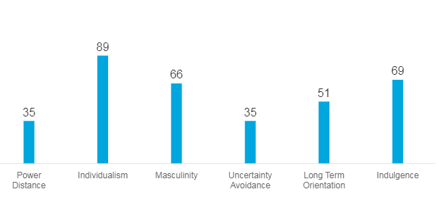
Figure 5: The workplace culture of the UK in the process of gaining efficacy
(Source: Hofstede Insights, 2022)
It is noted that the score is around 89 and 69 in the case of individualism and indulgence in the case of the UK (Hofstede Insights, 2022). Therefore, to gain the learning culture and utilise the independence of the employees and gain efficiency in learning culture the use of effective strategies were mainly used by the companies.
Talent management strategies
Talent management strategies in the process of utilising employees are another important factor that can assist in the development of the companies. It is noted that different kinds of the sector utilise the different kinds of talents and skills that are present in the employees eminently. As per the argument of Omotunde and Alegbeleye (2021), talent management strategies are mainly dependent on the training processes and the use of the motivational process that can assist in the development of the companies. Especially in the case of the UK, customer customization and precision have significant importance in the market as well. Eminent companies and providing luxury are one of the main factors that are provided by companies in the UK like Rolls Royce, The Body Shop, Unilever, Tesco and many others. On the other hand, the use of non-store retailing is mainly used in the UK, which can assist in revenue generation and the retailing process.
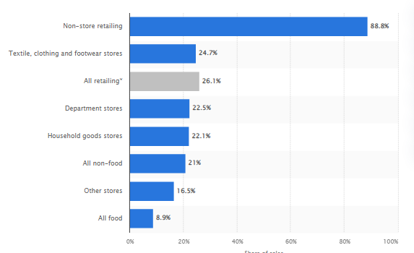
Figure 6: The consumer behaviour of the UK people in the retailing process
(Source: Statista, 2022)
It is noted that the use of online communication and talents related to digitalization is mainly seen among the retail industry of companies eminently. It is noted that 88.8% of the overall people are in favour of using non-retailing methods (Statista, 2022). Therefore, talent management strategies to maximise the digital process of the communication and customer journey are mainly utilised by the business operations in the UK as well.
Motivation development through internal campaigns and leadership
Employee motivation is the major factor that can assist in the overall development of the companies and gain a competitive edge in the market as well. This is because motivation can address the enhancement and engagement of the companies that can assist in the development of companies. As noted by Dirani et al. (2020), the use of leadership practices is mainly governed by the development of HRM practices. Therefore, the integration of the motivational factors should be the main comfort for the companies of the UK in this scenario. It is noted that a drastic change in inflation will not be seen in the case of the UK. Therefore, to control the economic condition of the UK, the use of innovation to retain the profit margin of the commodity companies. The use of transformational leadership should be also used in the case of the mentioned process. As noted by Lootah et al. (2020), it should be noted gaining agility in the leadership processes should be the primary factor that can develop the efficacy of the companies eminently. Therefore, handling the work pressure stress during the Brexit and pandemic issues can be handled eminently through the process as well. Therefore, HRM is one of the main factors that can assist in the development as well.

3.2 Ways of implementation of the changed processes in the current scenario in the UK as an HR manager
Initiative for implementing group assignment processes
The group assignment process is an important factor that can assist in the overall development of the companies. As per the argument of Siddiqui and Sahar (2019), it is noted that the initiative of making communication through retaining the effective development of the companies can assist to increase the interrelations among members. Therefore, the process can assist companies to gain efficiency in workplace communication increase eminently. On The other hand, inter-relational development can also assist in gaining development through increasing the efficiency of the companies. Therefore, the process can assist to counter the negative issues faced by the UK companies in the process of gaining efficacy as well.
Improved project management strategy development
Improved project management software and strategies are other important factors that can assist the development of the companies. It is noted that digital development and the online presence of the people have mainly increased during the time of the pandemic and Brexit in the UK.
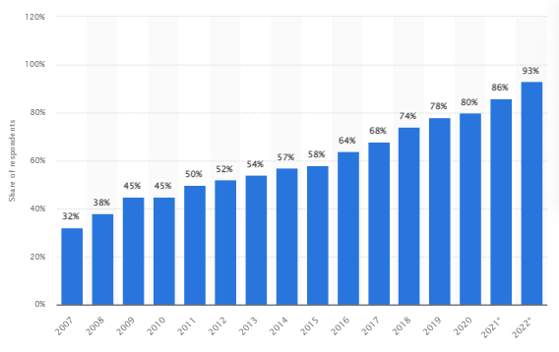
Figure 7: Online banking users of the UK
(Source: Statista, 2022)
It is noted that around 93% of people have online banking accounts in the UK and therefore online transaction is mainly favoured by people as well (Statista, 2022). Therefore, project management processes to gain the security and the development of the companies are mainly used by the companies. The use of HRM policies to manage the utility of the digitalization of the workplace is therefore an eminent method that can assist it and support the customer eminently as well. As per the argument of Hu and Gong (2020), the use of PMS software to gain the efficacy of the companies is another important factor that can assist in the development of the companies as well. Airtable, Confluence and Teamwork are the basic software that can assist to gain the efficacy of the companies and provide the performance loopholes to the managers eminently as well.
The implication of the AI and chatbot facility that can assess the communication gaps
The use of AI is also considered a major factor that can assist the development of UK business processes. This is because customer support is mainly done through the process of addressing the customers 24/7. As per the argument of Agarwal et al. (2021), the use of the chatbot facility and AI-powered decision-making can gain customer feedback and develop the efficacy to handle the competition more eminently. Therefore, the process can assist to gain the efficacy of the company development and addressing loopholes, consumer satisfaction and the technology implication in the business processes. It is observed that around 55% of the customer executive services in the UK are aligned to use AI-backed chatbot facilities in the process of gaining efficacy (Statista, 2022). Therefore, the process can assist the companies to gain efficacy and has a significant development.
Incentivising performance processes
The incentivising performance process is one of the main motivational processes that can address the increase in the retention process of the employees and increase the volume of the work with the quality as well. It is noted that the reward system is one of the basic developments that can assist in the development of the companies and provide the employees with eminent requirements. Based on the operational flow the quality and quantity incentives are provided to the continues that can develop the efficacy of the companies as well. As per the argument of Zhang et al. (2020), workplace incentives are the main factors that can boost the workforce and bring forth the efficiency of the companies. As a result, HRM practices can be done through the process as well. The referral method is also considered the main process that can assist the development of the companies as well. The referral method can assist employees to find suitable candidates for companies. As per the argument of Tikhonov (2019), the process of the referral recruitment method is one of the main factors that can assist to delegate the hiring pressure among organisational members. The process has an aftermath of increasing the methods that can assist in the development of the inter-relations stations in the organisation.

4. Conclusion
It is to be noted that many of the factors like the supply chain, the HRM and the internal and external policies have been impacted eminently in the UK companies due pandemic and Brexit. Especially in the case of the labour market, job loss, the lack of motivation and inappropriate work delegation are mainly seen eminently through the process as well. As a result, the issues and impacts are mainly reflected in the report eminently which can assist in the development as well? The process is mainly done through implication for h s different kinds of the strategies and graphical representation to promote the argumentative side of the report and clarify the discussion with logical approaches as well.

5. Reference List
Agarwal, A., Singhal, C. and Thomas, R., 2021. AI-powered decision making for the bank of the future. McKinsey & Company.–2021.–March.–URL: https://www. mckinsey. com/~/media/mckinsey/industries/financial% 20services/our% 20insights/ai% 20powered% 20decision% 20making% 20for% 20the% 20bank% 20of% 20the% 20future/ai-powered-decision-making-forthe-bank-of-the-future. pdf (дата обращения 15.04. 2021).
Dirani, K.M., Abadi, M., Alizadeh, A., Barhate, B., Garza, R.C., Gunasekara, N., Ibrahim, G. and Majzun, Z., 2020. Leadership competencies and the essential role of human resource development in times of crisis: a response to Covid-19 pandemic. Human Resource Development International, 23(4), pp.380-394.
Dittes, S., Richter, S., Richter, A. and Smolnik, S., 2019. Toward the workplace of the future: How organizations can facilitate digital work. Business Horizons, 62(5), pp.649-661.
Economics and Political Science, L.S. (2022) By the end of 2021, Brexit had already cost UK households a total of £5.8 billion in higher food bills – new LSE research, London School of Economics and Political Science. Available at: https://www.lse.ac.uk/News/Latest-news-from-LSE/2022/l-December-22/By-the-end-of-2021-Brexit-had-already-cost-UK-households-a-total-of-5.8-billion-in-higher-food-bills-–-new-LSE-research.aspx (Accessed: January 4, 2023).
Hofstede Insights (2022) Country Comparison - Hofstede Insights, Hofstede Insights. Available at: https://www.hofstede-insights.com/country-comparison/ (Accessed: January 4, 2023).
Hu, X. and Gong, X., 2020. Experimental and numerical investigation on thermal performance enhancement of phase change material embedding porous metal structure with cubic cell. Applied Thermal Engineering, 175, p.115337.
Lootah, S.E., Mansoor, W. and Worku, G.B., 2020. A Conceptual Exploration of Factors Affecting Agility in Organizations. International Journal of Management (IJM), 11(7).
McCarthy, N. (2019) Infographic: Predicted Hard-Brexit Job Losses Across Europe, Statista Infographics. Available at: https://www.statista.com/chart/18962/total-job-losses-forecast-in-eu-member-states-in-the-case-of-a-hard-brexit/ (Accessed: January 4, 2023).
Omotunde, O.I. and Alegbeleye, G.O., 2021. Talent management practices and job performance of librarians in university libraries in Nigeria. The Journal of Academic Librarianship, 47(2), p.102319.
Rauf, A., Abu-Izneid, T., Olatunde, A., Ahmed Khalil, A., Alhumaydhi, F.A., Tufail, T., Shariati, M.A., Rebezov, M., Almarhoon, Z.M., Mabkhot, Y.N. and Alsayari, A., 2020. COVID-19 pandemic: epidemiology, etiology, conventional and non-conventional therapies. International Journal of Environmental Research and Public Health, 17(21), p.8155.
Siddiqui, D.A. and Sahar, N., 2019. The impact of training & development and communication on employee engagement–A study of banking sector. Sahar, N. and Siddiqui, DA (2019). The Impact of Training & Development and Communication on Employee Engagement–A Study of Banking Sector. Business Management and Strategy, 10(1), pp.23-40.
Sim, M.R., 2020. The COVID-19 pandemic: major risks to healthcare and other workers on the front line. Occupational and environmental medicine, 77(5), pp.281-282.
Škare, M., Soriano, D.R. and Porada-Rochoń, M., 2021. Impact of COVID-19 on the travel and tourism industry. Technological Forecasting and Social Change, 163, p.120469.
Statista (2022) Chatbot ability in customer service U.S., Canada & U.K. 2019 | Statista, Statista. Available at: https://www.statista.com/statistics/1015841/customer-service-chatbot-ability-us-canada-uk/ (Accessed: January 4, 2023).
Statista (2022) Great Britain: online share of retail sales by sector 2022 | Statista, Statista. Available at: https://www.statista.com/statistics/280655/proportion-of-retail-sales-made-online-great-britain-by-retail-sector/ (Accessed: January 4, 2023).
Statista (2022) Online banking users Great Britain 2022 | Statista, Statista. Available at: https://www.statista.com/statistics/286273/internet-banking-penetration-in-great-britain/ (Accessed: January 4, 2023).
Statista (2022) Retail store closures UK 2022 | Statista, Statista. Available at: https://www.statista.com/statistics/1356731/retail-store-closures-uk/ (Accessed: January 4, 2023).
Statista (2022) Topic: Brexit and the EU-UK travel industry, Statista. Available at: https://www.statista.com/topics/4895/brexit-and-the-eu-uk-travel-industry/ (Accessed: January 4, 2023).
Statista (2022) UK employment rate 2022, by country | Statista, Statista. Available at: https://www.statista.com/statistics/622588/uk-employment-rate-by-country/ (Accessed: January 4, 2023).
Statista (2022) United Kingdom - Inflation rate 2027 | Statista, Statista. Available at: https://www.statista.com/statistics/270384/inflation-rate-in-the-united-kingdom/ (Accessed: January 4, 2023).
Tikhonov, A.I., 2019. The use of networking in staff recruitment: recommendations and referral programs. Amazonia Investiga, 8(19), pp.521-528.
Wang, P., Kuah, A.T., Lu, Q., Wong, C., Thirumaran, K., Adegbite, E. and Kendall, W., 2021. The impact of value perceptions on purchase intention of sustainable luxury brands in China and the UK. Journal of Brand Management, 28(3), pp.325-346.
Zhang, Z., Song, F. and Song, Z., 2020. Promoting knowledge sharing in the workplace: Punishment v. reward. Chaos, Solitons & Fractals, 131, p.109518.

