Name: Oliver Shopland

Student Number: 2404045

WORKSHEET 5 – TESTING (Pointless)

For this worksheet, there are several possible approaches to the problem.
Create your own test set to show the strengths and/or limitations of your solution. Use as many of the boxes below as you need.

Test: User enters "Cardiff" (with uppercase C)

Screenshot(s) of output: 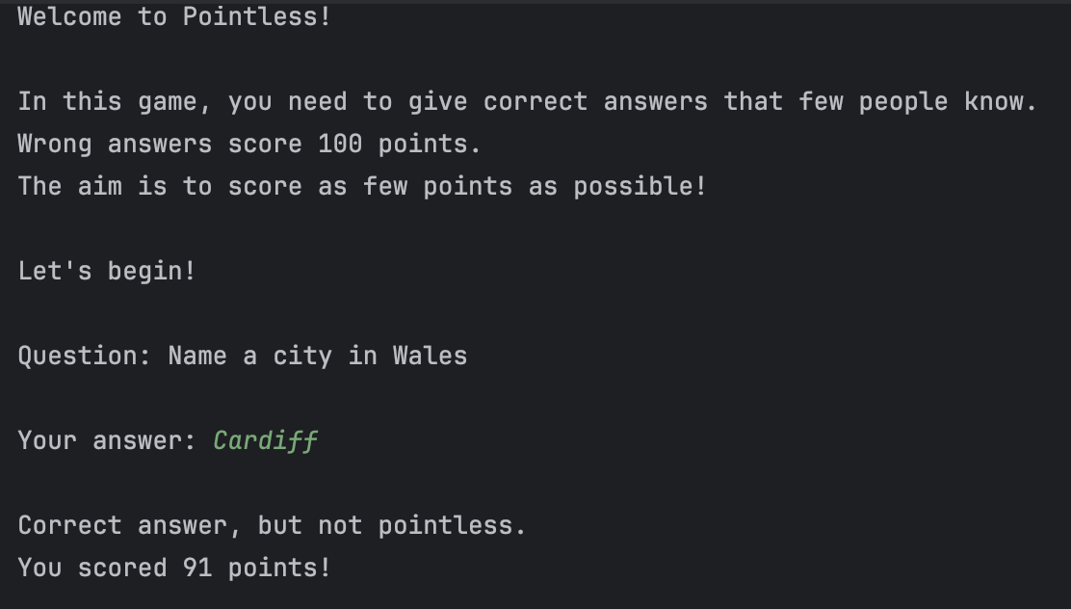

Result: Did the programme behave as expected ie syntactically and logically correct?
YES

Test: User enters "BANGOR" (in all caps)

Screenshot(s) of output:
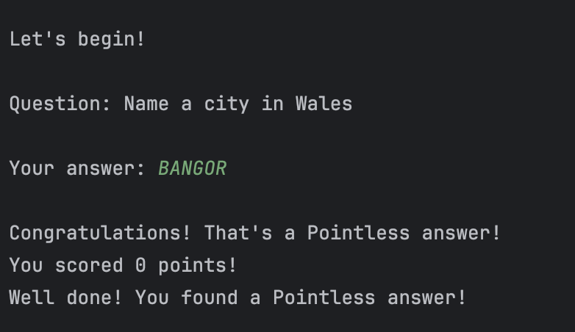
Result: Did the programme behave as expected ie syntactically and logically correct?
YES

Test: User enters "Aberystwyth" (not in the dictionary)

Screenshot(s) of output:
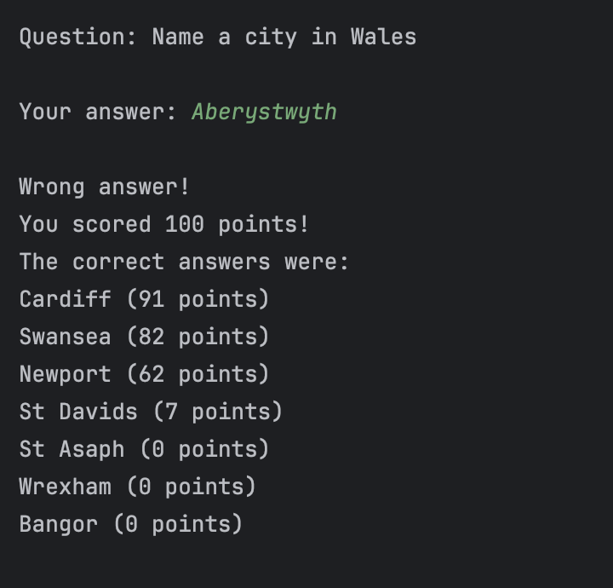
Result: Did the programme behave as expected ie syntactically and logically correct?
YES
Test: User enters " st davids " (with leading/trailing spaces)

Screenshot(s) of output:
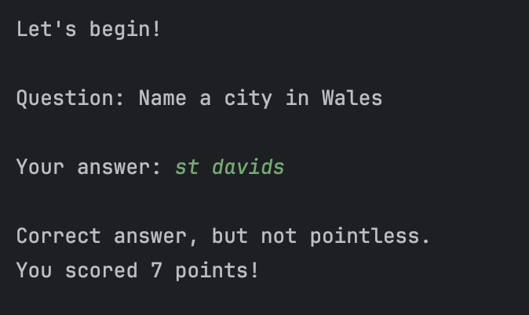
Result: Did the programme behave as expected ie syntactically and logically correct?
YES

Test: User enters "Swansea"

Screenshot(s) of output:
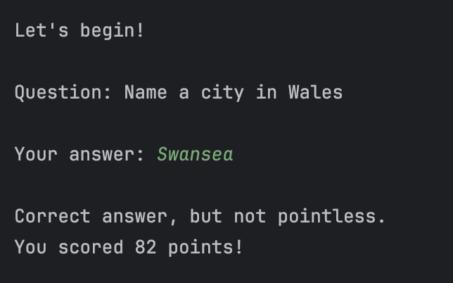
Result: Did the programme behave as expected ie syntactically and logically correct?
YES

Final code:

[Copy and paste your code here – note, do not use a screenshot. Note that there is no “before” and “after” code for this Worksheet because it is “Open” – not done in class. Therefore just post your final code below]

def check_answer(answer):
# Dictionary of valid answers and their scores
cities = {
'cardiff': 91,
'swansea': 82,
'newport': 62,
'st davids': 7,
'st asaph': 0,
'wrexham': 0,
'bangor': 0
}
# Convert answer to lowercase for case-insensitive comparison
answer = answer.lower()
# Check if the answer is in our dictionary of valid answers
if answer in cities:
score = cities[answer]
if score == 0:
return score, "Congratulations! That's a Pointless answer!"
else:
return score, "Correct answer, but not pointless."
else:
return 100, "Wrong answer!"
def play_pointless():
print("Welcome to Pointless!")
print("\nIn this game, you need to give correct answers that few people know.")
print("Wrong answers score 100 points.")
print("The aim is to score as few points as possible!")
print("\nLet's begin!")
print("\nQuestion: Name a city in Wales")
# Get player's answer
answer = input("\nYour answer: ")
# Check the answer and get score
score, message = check_answer(answer)
# Display results
print("\n" + message)
print(f"You scored {score} points!")
if score == 0:
print("Well done! You found a Pointless answer!")
elif score == 100:
print("The correct answers were:")
print("Cardiff (91 points)")
print("Swansea (82 points)")
print("Newport (62 points)")
print("St Davids (7 points)")
print("St Asaph (0 points)")
print("Wrexham (0 points)")
print("Bangor (0 points)")
# Start the game
play_pointless()

