ECAD4007-C: Cycle 1 Core Studies:
The Learner: Who am I teaching?

Student Number: 1901545 Lowri Johnson

Using the pupil profile given, identify how specific aspects of the child’s holistic development could be met within an educational setting. Underpin this with references to relevant theories, research and examples of excellent practice.

Introduction

Throughout this assignment I will identify effective approaches that will meet the diverse needs of Ella. I have an understanding of the holistic approach to child development, that the concept sees every child as a whole person – physically, emotionally, socially, intellectually and spiritually. However, I will talk in depth specifically about Ella’s emotional, intellectual and social development. It is very important that a teacher has extensive knowledge on child development as It will allow the teacher to make the most appropriate decisions and expectations for the individual. It also allows the teacher to understand the best way to engage the student with the lessons, and how to push them to grow emotionally, academically and socially. As noted by The Children’s Commissioner for Wales, “everyone who works with children should always do what is best for each child” (article 3).

Main Body

To begin, I will be discussing cognitive development and where I think Ella Is at in her personal development. From discussions in university I have learnt that cognitive development is the development of knowledge, skills, problem solving and dispositions, which help children to think about and understand the world around them. Therefore, it is increasingly important that teachers understand those aspects and identify where interventions can be placed to help develop skills further.
From the pupil profile Ella seems to have ‘difficulty understanding how decisions may affect herself and others.’ From discussions in university and extended reading from (Linda Pound, 2005) book on How children learn, I have read up on Piaget’s theory of cognitive development 1936, that he linked to the age of the child (see appendices 1). His four stage theory places Ella at the preoperational stage as it applies to children ages 2 to 7 years. As Ella is currently 4, this developmental stage applies to her. From what I have read, one of the characteristics found in this stage suggests that children struggle to see things from the perspective of others. Implying that from Piaget’s theory, this aspect of Ella’s development is where It should be for an average 4-year-old.
To help Ella progress and overcome this aspect of her development, I observed many interventions that could be beneficial to her. The most useful strategy I observed was the teachers adopting a Restorative Justice approach. Whereby if there was conflict between two pupils, they would discuss what happened together and how the issue can be resolved. This may be useful for Ella as she would be able to see how her actions affect someone else. This strategy style is proved to be effective in Vygotsky’s Social Development theory. As one of his 3 key elements is language. From reading (Linda Pound, 2005, page 52-53) Vygotsky’s theory stated that “language plays a central role in mental development” and that “children talking to adults is crucial for awareness of thinking and interpreting their own experiences.” This suggests to me that adopting strategies like Restorative Justice will help pupils like Ella as it allows children to express their feelings and actions to an adult. As a result, this can make children more aware of their behaviour and consequences that arise from their behaviour.
From the pupil profile Ella has ‘difficulty following classroom routines’ and ‘appears confused when instructions are given’. J.B Watson 1913 theory of behaviourism (appendices 2) lead to his belief that remembering depended on “frequency and recency” (class presentation). This piece of research highlighted to me that maybe Ella is struggling to remember what the teacher tells her. Watson advocated that individuals must ensure that information is recalled and used frequently, as each recall fixes the learning more firmly into the long-term memory. To aid this, from my bridging experience the teachers would often ask the pupils at the end of the day what they had learnt. Similarly, around the classroom were posters and displays of work that the pupils had created, which acted as a visual reminder of what they had achieved during the year.
Overall, I believe that Ella needs additional help with her cognitive development as it is clear in some aspects she is falling behind for her age. Although Piaget states that Ella Is where she should be for an average 4 year old, psychologists such as Bruner and his Spiral Curriculum (1960) suggests that children vary in stages in which they develop and that children “can move between different levels of complexity and sophistication of thought” (Linda Pound, 2005, page 65). Interventions such as focus activities and adopting a growth mindset can help Ella to develop her intellectual skills and allow her to understand what is expected of her.

I will now be discussing Ella’s social development. According to (Pamela Minett,2010 page 161) social development is the “process of learning the skills and attitudes which enable individuals to live easily with other members of their community.”
The pupil profile states that Ella is a ‘popular’ member of her class, implying that she is liked and admired by others. However, she ‘plays on her own a lot, and doesn’t appear aware of peers’. According to Mildred Parten (1932) who researched the development of social play, Ella is showing signs of solitary play (Markham Stouffville Hospital 2013). Parten’s theory suggests that solitary play is linked to children aged from birth to 2 years old. Therefore, implying that Ella’s social development is below for her age. As Ella is 4 years old, Parten suggests that she should be playing with other children and starting to involve herself in groups, which falls under her associative/social play developmental stage. To encourage Ella to play with new children and involve herself with other groups, a teacher could pair Ella up with another child who shares similar interests to Ella. This could give Ella the confidence and push she needs to interact and make friends with other pupil’s in her class. Similarly, another interesting intervention that I observed that might be useful for Ella, is giving her a role or responsibility, such as a line leader or someone that holds the door open for everyone. These are simple jobs that will encourage Ella’s positive self-esteem and confidence around her peers. I
According to the profile, Ella plays ‘pretend’, but is ‘reluctant to share resources during play activities with others.’ Tina Bruce, a psychologist who created a theory on play suggests that play gives children a chance to understand their relationships, feelings and thoughts and that specifically imaginative play, allows them to try out various aspects of their own personality (reference.com). Within her twelve features of play Bruce also suggests that children have a “personal play agenda, which may or may not be shared” (appendices 3). This contrasts with Mildred Parton’s theory as she is stating that children’s own personal choice of play is allowing them to form and identify their own personalities and create their own relationships This links to a section in a book created by Linda Pound called ‘learning through play (page 100)’. It suggests that during play children are able to “meet their own needs and make sense of their own confusing world” and that if an adult takes over, it stops feeling like play to the child. These two pieces of research imply that adults and teachers shouldn’t force or lead play but could guide play and provide accessible resources and toys that could help spark a child’s imagination and motivation to play.
A teacher’s role is very important in this aspect of development. Similar to what I talked about above, their professional role is to help students learn how to interact with one another in productive and collaborative ways. It is clear that play is an important way to develop a child’s social development and so by reading about ‘learning through play’ a teacher can ensure that the classroom offers open-ended resources and sufficient space in which to move around. Understandably, in some cases this isn’t achievable in some schools, but allowing children to have extended periods of time to develop their play outdoors can still contribute to their social development. Lastly, it is very important that a teacher creates an emotional climate which allows the children to have support and encouragement in their chosen play. These aspects can help Ella to express herself and build relationships with other children.

Lastly, I will be talking about emotional development. According to Pamela Minett’s (2010) book on Child Care and Development (page 165), emotional development is the “development of a child’s ability to recognise and control their feelings”.
It is increasingly important that teachers have an understanding on each pupil’s emotional development as they are the one’s able to monitor and assess the needs of that child. School is one of the primary contexts in which children learn to function independently without the presence of their families.
In relation to Ella and the pupil profile, she is ‘not always happy to separate from her mum in the morning’. This shows clear attachment issues. John Bowlby studied how children bond with adults, and their reaction to separation from adults and in 1969 published his first book about attachment theory. Bowlby believed that children’s attachment to a small number of adults is normal and a universal part of child development. Similarly, Mary Ainsworth devised an assessment technique called the Strange Situation Classification (SSC) (appendices 4) and her “findings showed empirical evidence for Bowlby’s attachment theory.” (simply psychology, 2018) Her findings suggest that “securely attached children develop a positive working model of themselves.” This evidence indicates that this aspect of Ella’s development is normal and part of her development for her age.
During my bridging experience I observed pupil’s in a similar situation to Ella and the teachers put useful interventions in place to overcome this issue. One being, home visits, whereby Ella would have a visit from her class teacher in the comfort of her own home, amongst her family. This allows the teacher to become familiar with Ella, as well as Ella getting to know the teacher. Similar to this, transition days also seemed useful, which is where pupils like Ella would visit the school with their parents and have a tour around, visit the classroom and have the opportunity to meet the teacher in a different setting. Doing this can positively impact Ella’s anxiety of entering an environment that she isn’t familiar with as she would have some reassurance of her school, and the teacher.
Bowlby and Ainsworth both agree that attachment with a primary caregiver is a normal aspect of child development. However, some research from Benjamin Spock disagrees. In 1946 he published a book called ‘The Common-Sense Book of Baby and Child Care’ (Wikipedia) which advocated that showing affection would not prepare children to be strong independent individuals. This piece of research can be used to make sense of Ella’s pupil profile where it states that ‘she uses gestures to communicate her needs, although she can be very reluctant to do so’. It is clear that Ella is struggling to voice her feelings and so could possibly be lacking independence. During my bridging experience it was clear that the school promotes high self-esteem in their pupils. Which they develop through the teachers having positive language towards the students, praise and proud stickers. This enables the child to recognise their success and gain the confidence that they need within themselves.

Conclusion

To conclude, my recommendations for Ella’s development is to try and help her engage with other pupils and gain more confidence. This could be achieved through adopting an environment inspired by Rudolf Steiner. This could be beneficial because the pupil profile states that Ella enjoys role play. Steiner Kindergarten is designed to be a friendly and warm place with a homelike environment. This can make Ella feel more comfortable, safer and allow her to express her creativity. Similarly, a Montessori method could also be beneficial to Ella as it allows her the freedom to choose what interests her, whilst also adopting a homelike environment. Ella needs to become more vocal and express her needs and feelings. So, a teacher can try and implement this in the class through circle time and by asking the pupils questions. This can also help Ella feel more comfortable with the other pupils in her class, as she may realise that other people are similar to her.

Appendices

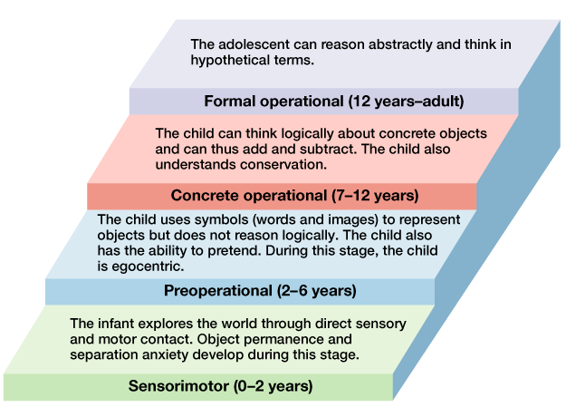

- Piaget. L (1936) ‘Piaget’s stages of cognitive development
Diagram of Piaget’s stages of cognitive development’
https://courses.lumenlearning.com/boundless-psychology/chapter/theories-of-human-development/
[Accessed: 11th December 2019]

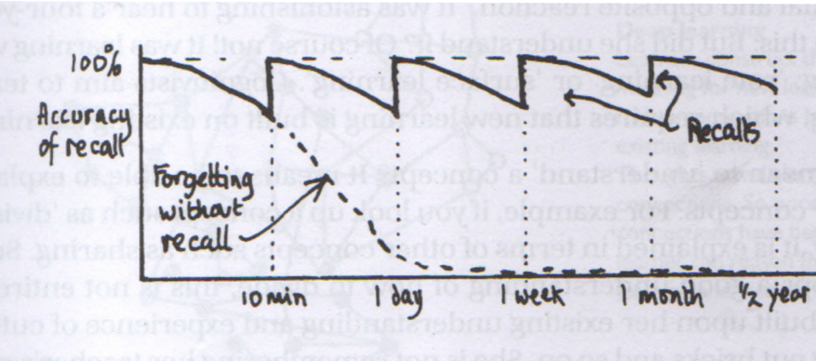
- class presentation by Tom Cox

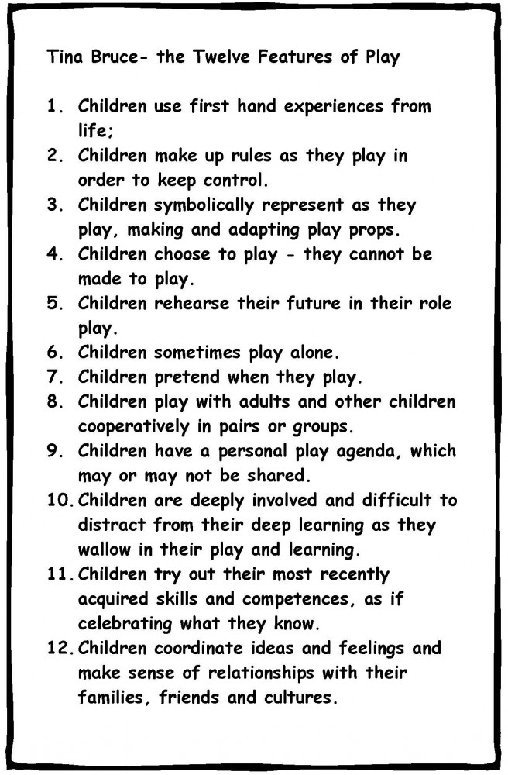
- Bruce, T (1991) ‘Tina Bruce theory of Play. Diagram of Twelve Features of Play’
https://www.littlebeehivenursery.co.uk/blog/play-the-foundations-of-education
[Accessed: 12th December 2019]

- Ainsworth, M (1969) ‘Mary Ainsworth, attachment styles. Diagram of The Strange Situation Chart’ https://www.simplypsychology.org/mary-ainsworth.html
[Accessed 10th December 2019]
References

Children’s Commissioner for Wales (2015) Know Your Rights! [Online] Available from: https://www.childcomwales.org.uk/about-us/ [ Accessed: 12th December 2019]

Reference. (2019) what is Tina Bruce’s Theory on Play? [Online] Available from:
https://www.reference.com/world-view/tina-bruce-s-theory-play-505755d8a4722f4b[Accessed: 10th December 2019]

Markham Stouffville Hospital, Children development programs (2013) Stages of Development Social Play. [Online] Available from: https://childdevelopmentprograms.ca/elearning-modules/the-power-of-play/story_content/external_files/Developmental%20Milestones%20of%20Social%20Play%20and%20Sharing.pdf [ Accessed: 12th December 2019]

Minett, P. (2010) Child Care & Development. Edition – 6. London: British Library Cataloguing in Publication Data.

Pound, L. (2005) How children learn. London: Practical Pre-School Books.

Simply Psychology (2018) Mary Ainsworth, The Strange Situation. [Online] Available from: https://www.simplypsychology.org/mary-ainsworth.html [Accessed: 10th December 2019]

Wikipedia (2019) The Common-sense Book of Baby and Child Care. [Online] Available from: https://en.wikipedia.org/wiki/The_Common_Sense_Book_of_Baby_and_Child_Care [Accessed: 12th December]

