

RESEARCH PROPOSAL

Phishing Website Detection using Ensemble Approach

NAME: RASITHABANU ABDHUL RAHIM
STUDENT NO: 2415470
LECTURER: Dr. SEENA JOSEPH

Table of Contents

1.Introduction 4
1.1 Context and Background 4
1.1.1 Detailed Overview 4
1.1.2 Current Developments 4
1.2 Research Problem 5
1.2.1 Problem Statement 5
1.2.2 Current Challenges 5
1.2.3 Gaps in Existing Research 5
1.3 Research Aim and Objectives 6
1.4 Significance of the Research 6
1.4.1 Potential Applications 6
2. Literature Review 7
2.1 Key Contributions and Gaps 8
2.2 Theoretical and Technical Frameworks 8
2.3 Relation to Your Study 9
3. Research Design and Methodology 9
3.1 Selected Research Approach – Design Science Research (DSR) 9
3.1.1 Justification for Choosing DSR 10
3.2 Research Methods 10
3.2.1 Research Method: Quantitative Approach 10
3.2.2 Research Strategy: Experimental Research 10
3.3 Materials 11
3.3.1 Data Analysis and Evaluation 12
3.3.2 Software and Tools 12
3.3.3 Hardware Requirements 12
4. Expected Outcome 13
4.1 Limitations 13
4.2 Conclusion 13
5. Timeline 13
6. Reference 14

1.Introduction
Phishing is a form of cybercrime where attackers impersonate legitimate organizations to deceive individuals into providing sensitive information. A phishing website is a fraudulent site designed to mimic a legitimate one, tricking users into entering personal data. This research focuses on phishing website detection using ensemble methods [1], which combine multiple machine learning algorithms to improve detection accuracy. By analysing various features such as URLs, SSL certificates [2] , and user behaviour, the ensemble approach enhances the system's ability to identify new phishing threats effectively. The project aims to deliver a robust solution that not only protects users and organizations from phishing attacks but also demonstrates the effectiveness of ensemble methods in the field of cybersecurity.

1.1 Context and Background
Phishing attacks are a major threat to online security, where fake websites steal sensitive information. Traditional detection methods are becoming less effective as phishing tactics evolve. Machine learning (ML) offers a solution by analysing features like URLs, domain details, and SSL certificates to improve detection accuracy. This research focuses on using ML to identify phishing websites, aiming to provide a more reliable, real-time detection system to protect users [3].

1.1.1 Detailed Overview
In the future, detecting phishing websites will be crucial in cybersecurity and artificial intelligence. Phishing sites are fraudulent platforms that mimic legitimate ones to trick users into giving confidential information. As online activities increase, users face greater phishing risks [4].
Cybersecurity aims to protect systems and data from attacks. Artificial intelligence, particularly machine learning (ML), will automate phishing detection by analysing web data to distinguish between legitimate and malicious sites based on features like URL structures and user behaviour.
Rather than using traditional methods, smart phishing detection will develop adaptive ML models that learn from new phishing attempts, providing real-time user protection and enhancing cybersecurity resilience [5].

1.1.2 Current Developments
Recent developments in phishing detection indicate a shift towards intelligent, automated systems using machine learning. Traditional methods like URL blacklisting and manual reporting are inadequate due to the sophistication of phishing websites.
Modern machine learning techniques, including Random Forest Classifiers, SVM, and Deep Neural Networks, classify websites based on URL and HTML features, as well as behaviour-based indicators. Some researchers utilize NLP to analyse website text for suspicious language patterns.
Further advancements involve Convolutional Neural Networks for visual phishing detection, [6] recognizing fake sites by comparing visual elements. Real-time detection tools, such as browser extensions, are becoming common, employing lightweight ML models for instant website analysis.
Public phishing datasets like Phish Tank and Open Phish help researchers create more accurate models. Future phishing detection systems will likely use online learning models to adapt to evolving strategies without frequent updates.

1.2 Research Problem

1.2.1 Problem Statement
Phishing attacks account for over 80% of cybersecurity incidents, leading to substantial financial losses and compromised sensitive data. The potential impact of a successful phishing attack can lead to millions in losses, reputational damage, and legal repercussions for organizations. The problem here is that current detection methods are inadequate; traditional blacklist systems overlook emerging threats, while heuristic approaches are inflexible and reactive. Machine learning (ML) solutions often rely on outdated datasets, resulting in high false positive rates and challenges in real-time detection. Phishing website detection using ensemble methods represents a significant challenge for organizations [7].

1.2.2 Current Challenges
Dynamic Nature of Phishing Websites
Phishing websites change quickly, using tricks like hiding URLs and fake SSL certificates to avoid detection. [8] say that traditional systems have a hard time with these changes because blacklists become outdated fast. [9] point out that traditional systems can't keep up with new phishing tricks.
False Positives and Negatives
Current models often have many false positives and negatives, which can hurt user trust. [10] found that false positives block real sites, while false negatives put users at risk. Many machine learning models are not set up for real-time detection, leading to many mistakes.
Lack of Real-time Detection
Traditional systems use slow methods, letting phishing attacks continue. stress the need for real-time updates to reduce risks. [11]
Limited Use of Advanced Features
Current systems often use simple features, which are not enough for complex phishing tricks. Deep learning models can find subtle patterns, [12] as shown by which can improve accuracy.
Scalability and Adaptability
As the internet grows, detection systems find it hard to scale and adapt. [13]say that models need to keep learning from new phishing sites to stay effective.

1.2.3 Gaps in Existing Research
This section points out weaknesses in current phishing detection research, like outdated datasets and high false-positive rates, which need fixing for better protection. Even though machine learning shows promise, there are still gaps:
- Lack of Comprehensive Datasets
Current models are limited by incomplete datasets like [14] say this limits machine learning's ability to work well in different phishing situations.
- Insufficient Real-time Adaptation
Current models are not flexible and can't adjust to new threats. [15]highlight the need for systems that can learn and improve accuracy.
- Limited Integration of Multiple Features
Models often use narrow features. [16] suggest a broader approach that combines many features to improve detection accuracy.

1.3 Research Aim and Objectives
Research Aim
The primary aim of this research is to develop a system for detecting phishing websites using ensemble method. This system employs a hybrid approach to effectively detect phishing websites.
Objectives:
- To gather and preprocess a comprehensive dataset of phishing and legitimate websites.
- To identify and extract key features that effectively differentiate phishing websites from legitimate ones.
- To utilize ensemble methods to train and evaluate machine learning models for phishing website detection.
- To assess the performance of the ensemble models in various scenarios to ensure robustness.

1.4 Significance of the Research
Phishing attacks are a major cause of cybersecurity problems, with over 70% of data breaches linked to phishing. This research creates a machine learning system that can detect phishing in real-time and adapt to new tactics. The new system improves detection accuracy and is scalable, marking a big step forward in cybersecurity. As cyber threats change, the need for new solutions is more important than ever.

1.4.1 Potential Applications
- Enterprise Cybersecurity:
The system can be integrated into security software (firewalls, browser extensions) to provide real-time protection, preventing data breaches and enhancing defences in sectors like banking and e-commerce.
- Browser & Email Protection:
By identifying phishing URLs in emails and websites, this research can improve user safety, particularly for non-technical users.
- National Cybersecurity Frameworks:
The system can be adopted by governments for continuous monitoring of emerging phishing threats, enhancing national cybersecurity.
- Advancing Phishing Detection Theories:
This work provides insights into integrating multiple features for better accuracy in phishing detection, advancing the theoretical understanding of cyber threat detection.
- Raising Consumer Awareness:
By helping users recognize phishing attempts, this research promotes cyber awareness, contributing to a safer online environment.

2. Literature Review
The literature review is organized to highlight the evolution of phishing detection methods, from traditional approaches to machine learning and real-time solutions, while identifying critical gaps in current research.
- Traditional Phishing Detection Methods
Phishing attacks have changed a lot, requiring better ways to detect them. Early methods, like blocking certain URLs, didn't work well because they depended on known threats. Heuristic methods also had trouble keeping up with new phishing sites. Recent research shows that machine learning can help find patterns and spot unusual activity quickly [17]. Teaching users about phishing is also very important, as mistakes by people can help these attacks succeed. Using multi-factor authentication can lower the chances of falling for phishing attempts. Working together and sharing information about threats can improve detection. In summary, a mix of technology and user education is key to preventing phishing. Future studies should aim to create systems that can adapt to new phishing methods [18].
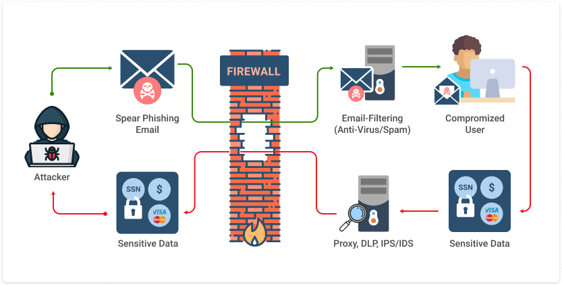

- Machine Learning in Phishing Detection
Machine learning has changed cybersecurity, especially in detecting phishing. mention that methods like Random Forests and Support Vector Machines (SVM) help find harmful activities. Deep Learning [19] point out, makes detection systems more adaptable. Feature engineering is important, with URL checks and SSL validation helping to improve accuracy HTML extraction also helps in the detection process. However, [20]note that there are still challenges in adjusting these models for real-time use. Ongoing research is needed to solve these problems and improve phishing detection systems. Using these advanced techniques can greatly reduce false positives, leading to safer online environments [21].
- Real-time Phishing Detection and Adaptation
Real-time detection tools are important for fighting phishing. They use browser extensions and AI software to keep users safe. These tools find phishing sites while users browse the web, offering quick protection [22]. Online learning models help these systems adjust to new threats, making them effective against changing tactics from cybercriminals. However, it is challenging to balance quick performance with high accuracy [23]. As online threats change, research is needed to improve these tools. Their effectiveness affects user trust and security online. Future improvements in AI and machine learning [24] will likely make real-time detection systems even better. The aim is to create a safer online experience for everyone. Despite advances, false positives and negatives [25] continue to be a challenge, and limited access to diverse datasets affects the effectiveness of machine learning models. There is also a gap in integrating various detection features, such as visual and behavioural analysis, which could enhance phishing detection.

2.1 Key Contributions and Gaps
Key contributions include the use of machine learning for phishing detection and real-time tools. However, gaps remain in reducing false positives, adapting to new phishing techniques, and integrating features like visual and behavioural analysis for better accuracy.
- Early studies laid the foundation with traditional techniques, but they were limited in terms of adaptability and real-time detection capabilities.
- More recent work has shown the potential of machine learning in improving phishing detection, particularly by leveraging complex data analysis and behavioural features. Notable contributions include studies that used deep learning models to better capture the visual similarities between phishing and legitimate websites.
However, major gaps remain:
- The need for comprehensive datasets that can be used to train models on various phishing attack strategies.
- Insufficient real-time adaptation, where existing systems cannot keep up with constantly evolving phishing tactics.
- Lack of integration between multiple detection features (e.g., combining visual, textual, and behavioural data), which could provide a more holistic detection model.

2.2 Theoretical and Technical Frameworks
The theoretical framework in phishing detection research centres on cybersecurity principles, machine learning theories, and detection algorithms. Technical frameworks focus on applying these theories, such as feature extraction, model training, and real-time system deployment, to create effective phishing detection systems.
Key machine learning techniques used in phishing detection include:
- Supervised learning models like Random Forests and Support Vector Machines (SVM), which classify websites based on features such as URL structure and SSL certificates.
- Advanced models like Deep Neural Networks (DNNs) and Convolutional Neural Networks (CNNs), which help detect complex patterns in webpage content and layout.
Theoretical models focus on two main areas:
- Feature-based detection, analysing both static features (e.g., URL structure) and dynamic features (e.g., user behaviour, page content).
- Behavioural analysis, identifying distinct patterns in how phishing sites behave compared to legitimate websites.

2.3 Relation to Your Study
The existing research on phishing detection provides valuable insights into feature selection, algorithmic approaches, and system integration. By examining these areas, this study aims to build on current findings, addressing gaps and enhancing real-time phishing detection. The research will refine methodologies and integrate effective techniques, ensuring its contribution to the ongoing development of robust detection systems.
This research will build upon existing work in phishing website detection by:
- Integrating multiple detection features such as URL analysis, SSL certificate validation, and user behaviour into a unified machine learning model.
- Focusing on real-time detection and adaptation to new phishing tactics, addressing a major gap in current solutions.
- Introducing an adaptive learning model that continuously improves detection accuracy based on incoming data, making the system more resilient to new phishing techniques.
By doing so, this research aims to offer new insights into the integration of multiple features and real-time learning in phishing detection, contributing to the ongoing advancements in the field.

3. Research Design and Methodology
This research uses a quantitative approach to detect phishing websites using machine learning models. The study will collect data from publicly available phishing datasets and apply feature engineering to enhance them. Models like Random Forests and Support Vector Machines will be trained on these datasets, focusing on features such as URL structure and SSL certificates. Model performance will be evaluated using metrics like accuracy and precision, ensuring reliable and adaptable results.

3.1 Selected Research Approach – Design Science Research (DSR)
This research follows the Design Science Research (DSR) approach because it focuses on designing and building a practical solution to a real cybersecurity problem detecting phishing websites using machine learning. DSR is suitable when the research goal is to create and evaluate an innovative artifact, such as a working software system or model. In this project, the artifact is a smart machine learning-based phishing detection model.
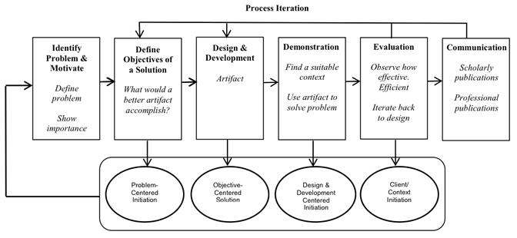

3.1.1 Justification for Choosing DSR
The reason for choosing DSR is that phishing is a constantly changing threat. Traditional methods like blacklists or rule-based filters cannot keep up. So, we need an intelligent and adaptive system that can detect phishing websites in real time using machine learning. This kind of solution requires designing, testing, and improving an actual system not just theory. DSR provides the right structure to build, test, and refine this system in an iterative and evidence-based way.

3.2 Research Methods
In this research, we 3will use ensemble methods Bagging, Boosting, and Stacking to enhance the accuracy of phishing website detection. These techniques will combine multiple machine learning models to make more reliable predictions. By leveraging the strengths of individual models, ensemble methods will help reduce false positives and improve detection rates.
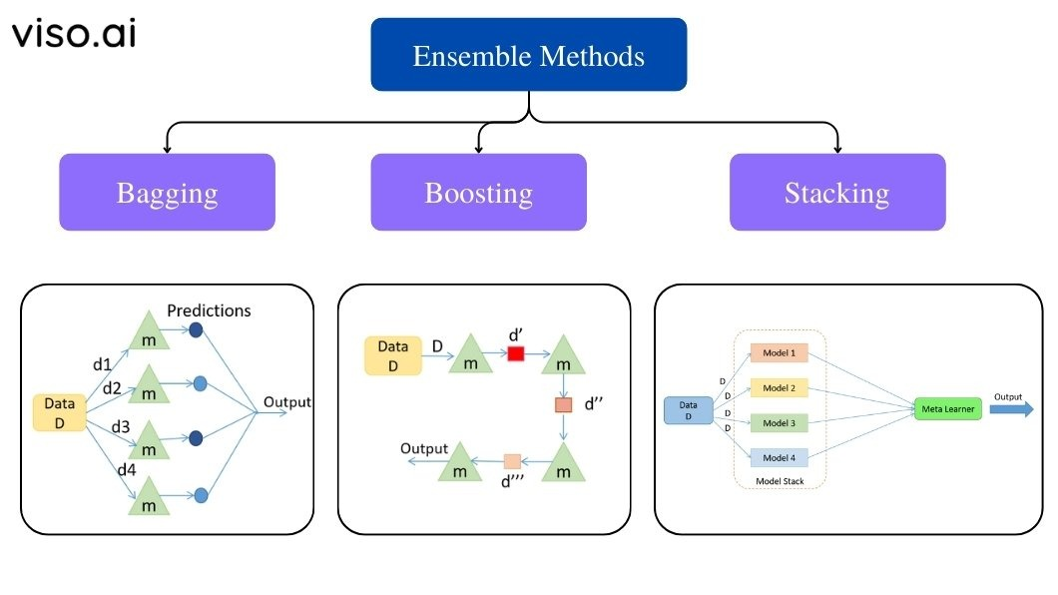

3.2.1 Research Method: Quantitative Approach
This research will adopt a quantitative approach because the project involves collecting numerical data, training machine learning models, and evaluating performance using statistical metrics. This approach is appropriate for this study since phishing detection requires measurable data patterns to build accurate models.

3.2.2 Research Strategy: Experimental Research
The chosen research strategy is experimental, as it focuses on building and testing machine learning models on phishing and legitimate website datasets. Through controlled experiments, the effectiveness of different algorithms like Random Forest, Logistic Regression, and Support Vector Machines (SVM) will be compared. This strategy suits the topic because it allows real-world testing of model performance and accuracy.

System Architecture/Design
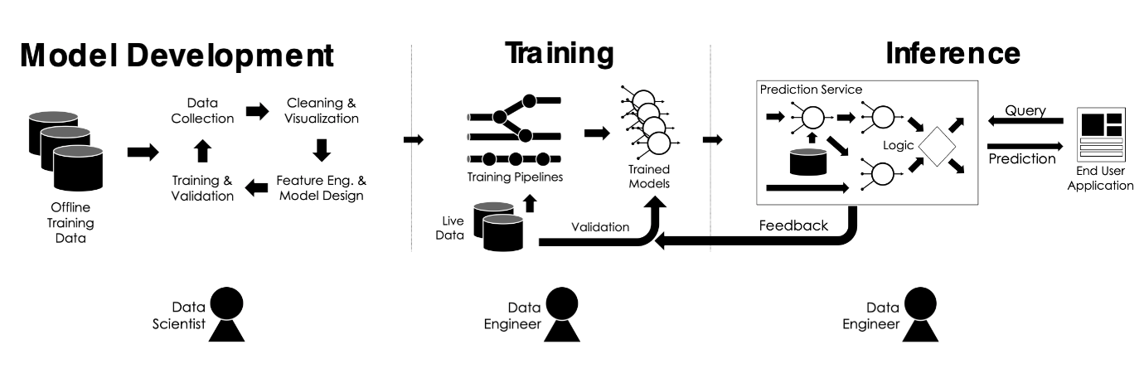
The system will follow a layered architecture:
- Model Development: Data scientists collect offline training data, clean and visualize it, then perform feature engineering and model design.
- Training: Data engineers set up training pipelines to process live data and train models, which are validated before use.
- Inference: Trained models are deployed in a prediction service that handles queries and generates predictions.
- End-User Interaction: Users send queries to the system and receive predictions through an application interface.
- Feedback Loop: Prediction outcomes are fed back into the system for continuous improvement and model retraining.
This architecture ensures modularity, scalability, and adaptability of the system to new phishing patterns.

3.3 Materials
Materials are the resources needed for the research, such as datasets, software tools, and hardware. In machine learning, datasets are used for training, while software like Python or TensorFlow aids in model implementation.
Research Data:
- Data Source: Public datasets such as Phish Tank, Open Phish, and UCI Phishing Websites Dataset will be used.
- Data Collection Method: The datasets will be downloaded from trusted repositories in CSV format. No manual scraping or private data collection will be required.
- Justification: These datasets are widely used in academic and industry research. They contain labelled samples (phishing vs legitimate) with relevant features like URL length, domain name, SSL usage, and more making them ideal for training machine learning models.
Ethical Considerations
- Only publicly available and anonymised data will be used.
- No personal, sensitive, or confidential user data will be collected.

3.3.1 Data Analysis and Evaluation
Data Splitting:
- We will split the dataset into 80% training and 20% testing sets.
- The training data will go through 5-fold cross-validation to fine-tune the model and evaluate its generalization ability.
Evaluation Metrics:
- Accuracy: Will measure how often the model predicts correctly.
- Precision: Will show how many of the predicted phishing sites are actually phishing.
- Recall (Sensitivity): Will reflect how well the model identifies actual phishing websites.
- F1-Score: Will provide a balanced view between precision and recall.
- AUC-ROC: Will help evaluate performance under class imbalance.
- Confusion Matrix: Will give a clear view of true/false positives and negatives.
Validation Focus:
- We will aim for high recall to ensure phishing websites are detected effectively.
- We will focus on high precision to avoid flagging legitimate sites.
- The model will be evaluated on its ability to reduce both false positives and false negatives.

3.3.2 Software and Tools
- Programming Language: Python
- Libraries:
  - scikit-learn for model training and evaluation
  - pandas and NumPy for data preprocessing
  - matplotlib and seaborn for visualization
- Platform: Jupyter Notebook (for development and analysis)
- Other Tools: GitHub (for version control), Google Colab (for remote training if required)

3.3.3 Hardware Requirements
- A personal computer with:
  - Minimum 8GB RAM
  - Intel i5 or equivalent processor
- Optional: Cloud computing resources (e.g., Google Colab with GPU support) will be used if model training becomes computationally intensive.

4. Expected Outcome
The expected findings will have both practical and academic impact:
- Practically, the solution can help users, organizations, and security systems identify phishing websites in real-time, reducing financial and personal data loss.
- The model may be integrated into browser extensions, email gateways, or security applications to enhance user protection.
- Academically, the project will contribute to the existing body of knowledge by exploring the effectiveness of different ML algorithms on phishing detection and highlighting key feature combinations that improve performance.
- It will also offer a reproducible framework that other researchers can build upon for future improvements or apply to other types of cyber threat detection.

4.1 Limitations
- Model performance depends on dataset quality.
- May struggle with zero-day phishing attacks.
- Training complex models can be time-consuming without high-performance GPUs.
- Evolving nature of cyber threats challenges model accuracy.

4.2 Conclusion
This research aims to improve phishing website detection using machine learning, addressing the limitations of traditional methods. By integrating advanced algorithms and real-time detection, [26] it seeks to enhance accuracy, reduce false positives, and provide scalable solutions to evolving phishing tactics. The outcomes will contribute to developing more effective cybersecurity tools.

5. Timeline
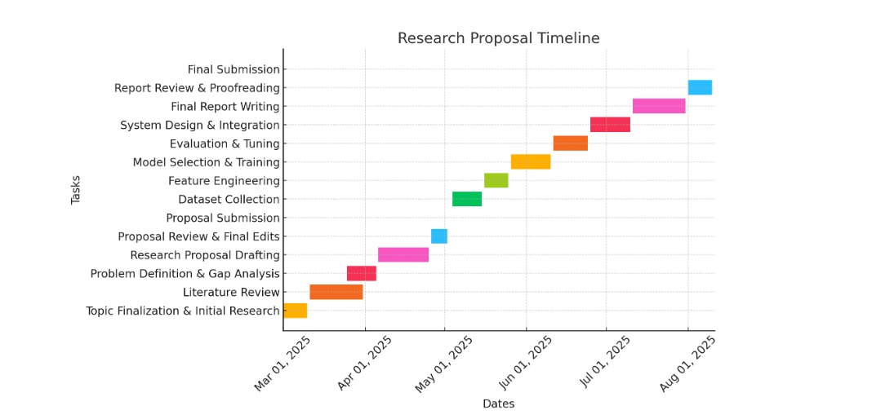

6.References

[1] | T. G. Dietterich, “Ensemble methods in machine learning,” Dietterich, Thomas G. "Ensemble methods in machine learning." International workshop on multiple classifier systems. Berlin, Heidelberg: Springer Berlin Heidelberg, 2000..
[2] | N. B. e. a. Doğan, “Dual-Layered Approach for Malicious Domain Detection,” Doğan, Nadide Bilge, et al. "Dual-Layered Approach for Malicious Domain Detection." 2024 9th International Conference on Computer Science and Engineering (UBMK). IEEE, 2024., 2024 .
[3] | U. e. a. Zara, “"Phishing website detection using deep learning models.",” Zara, Ume, et al. "Phishing website detection using deep learning models." IEEE Access (2024)., no. IEEE, 2024.
[4] | F. S. A. A. A. a. N. A. Alsubaei, “Enhancing phishing detection: A novel hybrid deep learning framework for cybercrime forensics.",” Alsubaei, Faisal S., Abdulwahab Ali Almazroi, and Nasir Ayub. "Enhancing phishing detection: A novel hybrid deep learning framework for cybercrime forensics." IEEE Access 12 (2024): 8373-8389., no. IEEE, 2024.
[5] | J. A. V. S. a. S. H. A. Yu, “Leveraging machine learning for cybersecurity resilience in industry 4.0: Challenges and future directions.,” Yu, Jia, Alexey V. Shvetsov, and Saeed Hamood Alsamhi. "Leveraging machine learning for cybersecurity resilience in industry 4.0: Challenges and future directions." IEEE Access (2024)., no. IEEE, 2024.
[6] | A. O. a. M. S. Ige, “State-of-the-art in 1d convolutional neural networks,” Ige, Ayokunle Olalekan, and Malusi Sibiya. "State-of-the-art in 1d convolutional neural networks: A survey." IEEE Access (2024)., 2024.
[7] | A. e. a. Quraishi, “"Employing Deep Neural Networks for Real-Time Anomaly Detection and Mitigation in IoT-Based Smart Grid Cybersecurity System,” Quraishi, Aadam, et al. "Employing Deep Neural Networks for Real-Time Anomaly Detection and Mitigation in IoT-Based Smart Grid Cybersecurity Systems." 2024 Third International Conference on Distributed Computing and Electrical Circuits and Electronics (IC, no. IEEE, 2024.
[8] | F. J. S. J. R. a. L. C. J. N. H. Zhang, “A Survey of Phishing Website Detection Techniques Using Machine Learning and Data Mining," IEEE Transactions on Information Forensics and Security,” H. Zhang, F. J. S. J. Ramos, and L. C. J. Nunes, "A Survey of Phishing Website Detection Techniques Using Machine Learning and Data Mining," IEEE Transactions on Information Forensics and Security, vol. 19, no. 4, pp. 2100-2114, Apr. 2023. doi: 10.1109/TI, no. IEEE , 2023.
[9] | R. Bansal, “Bansal, R., The Future of Web Security: XSS Detection through Machine Learning.”.
[10] | N. a. S. L. A. Tatipatri, “A comprehensive review on cyber-attacks in power systems: Impact analysis, detection, and cyber security,” Tatipatri, Naveen, and S. L. Arun. "A comprehensive review on cyber-attacks in power systems: Impact analysis, detection, and cyber security." IEEE Access 12 (2024): 18147-18167., no. IEEE , 2024.
[11] | K. D. O. Ofoegbu, “"Real-Time Cybersecurity threat detection using machine learning and big data analytics: A comprehensive approach,” Ofoegbu, Kingsley David Onyewuchi, et al. "Real-Time Cybersecurity threat detection using machine learning and big data analytics: A comprehensive approach." Computer Science & IT Research Journal 4.3 (2024)., no. IEEE, 2024.
[12] | P. K. A. K. a. A. S. Roy, “Advanced Learning for Phishing URLs Detection to Secure Consumer-Centric Applications,” Roy, Pradeep Kumar, Abhinav Kumar, and Ashish Singh. "Advanced Learning for Phishing URLs Detection to Secure Consumer-Centric Applications." IEEE Transactions on Consumer Electronics (2024)., no. IEEE, 2024.
[13] | L. e. a. Xie, “A scalable phishing website detection model based on dual-branch TCN and mask attention,” Xie, Lixia, et al. "A scalable phishing website detection model based on dual-branch TCN and mask attention." Computer Networks 263 (2025): 111230., 2025.
[14] | I. a. M. K. Skula, “A framework for preparing a balanced and comprehensive phishing dataset,” Skula, Ivan, and Michal Kvet. "A framework for preparing a balanced and comprehensive phishing dataset." IEEE Access (2024), no. IEEE, 2024.
[15] | H. O. A. B. I. a. M. N. A. Bello, “Adaptive machine learning models: concepts for real-time financial fraud prevention in dynamic environments,” Bello, Halima Oluwabunmi, Adebimpe Bolatito Ige, and Maxwell Nana Ameyaw. "Adaptive machine learning models: concepts for real-time financial fraud prevention in dynamic environments." 12.02 (2024): 021-034., no. World Journal of Advanced Engineering Technology and Sciences, 2024.
[16] | J. H. e. a. Bernardo, “Continuous Integration Practices in Machine Learning Projects,” Bernardo, João Helis, et al. "Continuous Integration Practices in Machine Learning Projects The PractitionersPerspective." arXiv preprint arXiv:2502.17378 :(2025)., no. The PractitionersPerspective." arXiv preprint arXiv:2502.17378 , 2025.
[17] | M. A. e. a. Sayed, “COMPARATIVE ANALYSIS OF MACHINE LEARNING ALGORITHMS FOR PREDICTING CYBERSECURITY ATTACK SUCCESS: A PERFORMANCE EVALUATION.,” Sayed, Md Abu, et al. "COMPARATIVE ANALYSIS OF MACHINE LEARNING ALGORITHMS FOR PREDICTING CYBERSECURITY ATTACK SUCCESS: A PERFORMANCE EVALUATION." The American Journal of Engineering and Technology 6.09 (2024): 81-91., 2024.
[18] | J. A. V. S. a. S. H. A. Yu, “Leveraging machine learning for cybersecurity resilience in industry 4.0: Challenges and future directions.,” Yu, Jia, Alexey V. Shvetsov, and Saeed Hamood Alsamhi. "Leveraging machine learning for cybersecurity resilience in industry 4.0: Challenges and future directions." IEEE Access (2024)., no. IEEE , 2024.
[19] | O. K. E. B. a. E. K. Sahingoz, “ Deep learning based phishing detection system,” Sahingoz, Ozgur Koray, Ebubekir BUBE, and Emin Kugu. "Dephides: Deep learning based phishing detection system." IEEE Access 12 (2024): 8052-8070., no. IEEE , 2024.
[20] | M. R. I. e. a. Bhuiyan, “Leveraging Machine Learning for Cybersecurity: Techniques, Challenges, and Future Directions,” Bhuiyan, Mohammad Rakibul Islam, et al. "Leveraging Machine Learning for Cybersecurity: Techniques, Challenges, and Future Directions." Edelweiss Applied Science and Technology 8.6 (2024): 4291-4307., 2024.
[21] | J. A. V. S. a. S. H. A. Yu, “Leveraging machine learning for cybersecurity resilience in industry 4.0: Challenges and future directions,” Yu, Jia, Alexey V. Shvetsov, and Saeed Hamood Alsamhi. "Leveraging machine learning for cybersecurity resilience in industry 4.0: Challenges and future directions." IEEE Access (2024)., no. IEEE , 2024.
[22] | F. S. A. A. A. &. A. N. (. Alsubaei, “Enhancing phishing detection: A novel hybrid deep learning framework for cybercrime forensics.,” Alsubaei, F. S., Almazroi, A. A., & Ayub, N. (2024). Enhancing phishing detection: A novel hybrid deep learning framework for cybercrime forensics. IEEE Access, 12, 8373-8389., no. IEEE , 2024.
[23] | C. a. J.-L. C. Ahmadi, “Enhancing Phishing Detection: A Multi-Layer Ensemble Approach Integrating Machine Learning for Robust Cybersecurity.,” Ahmadi, Candra, and Jiann-Liang Chen. "Enhancing Phishing Detection: A Multi-Layer Ensemble Approach Integrating Machine Learning for Robust Cybersecurity." 2024 IEEE Symposium on Computers and Communications (ISCC). IEEE, 2024., no. IEEE, 2024.
[24] | M. e. a. Ozkan-Okay, “A comprehensive survey: Evaluating the efficiency of artificial intelligence and machine learning techniques on cyber security solutions,” Ozkan-Okay, Merve, et al. "A comprehensive survey: Evaluating the efficiency of artificial intelligence and machine learning techniques on cyber security solutions." IEEe Access 12 (2024): 12229-12256., no. IEEe , 2024.
[25] | J. A. e. a. Pawar, “Enhancing network security: Leveraging isolation forest for malware detection.,” Pawar, Janardan Adinath, et al. "Enhancing network security: Leveraging isolation forest for malware detection." 2024 2nd International Conference on Advancement in Computation & Computer Technologies (InCACCT). IEEE, 2024., no. IEEE, 2024.
[26] | M. I. A. A. a. A. R. A. K. Khan, “The most recent advances and uses of AI in cybersecurity.,” Khan, Muhammad Ismaeel, Aftab Arif, and Ali Raza A. Khan. "The most recent advances and uses of AI in cybersecurity." BULLET: Jurnal Multidisiplin Ilmu 3.4 (2024): 566-578., 2024.

