The
Big
Pit-
Blaenavon
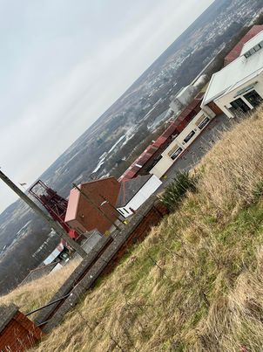
Introduction

During the course of this assignment, I will be looking at The Big Pit in Blaenavon and seeing how it was affected by the industrial evolution. I will be looking at how and when it started, why it started and why it ended. I will provide some background history and some pictures from our recent trip there. I will be taking a look at the main players that were involved in the revolution such as workers and their families, companies etc. I will have a look into any social issues that may have affected it and how the economy both local and national was at the time.
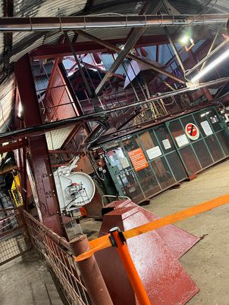

So, The Big Pit in Blaenavon was one of a few collieries that was operated and used in the area and at some stage had over 1500 employed members of staff working underground. The Big Pit was operated between 1880 and 1980. It was first opened in 1860 when it was 200ft deep but then was extended to 300ft deep by 1880. Big Pit was originally known as Kearsley’s Pit in 1860 and then after it was sunken in 1880 which is when it became known as the Big Pit.

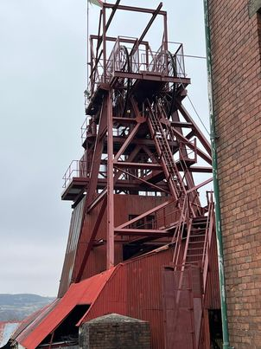

The Big Pit was a working coal mine for over 100 years before it was eventually closed in 1980 only to open 3 years later as a museum. The Big Pit employed many people from the local area and built houses around it so the employees had somewhere to live. It was renamed The Big Pit due to the shape and dimensions of the shaft with them being 18 ft by 13 ft. It was one of the first and largest coal mines in the UK. When it first opened it was first used as an open mine for coal and ore which then could simply be dug out of the hillside before then being bought by Blaenavon Iron and Coal Company and then being sunk to 300ft to be able to reach the coal further down. (Heather 2021).
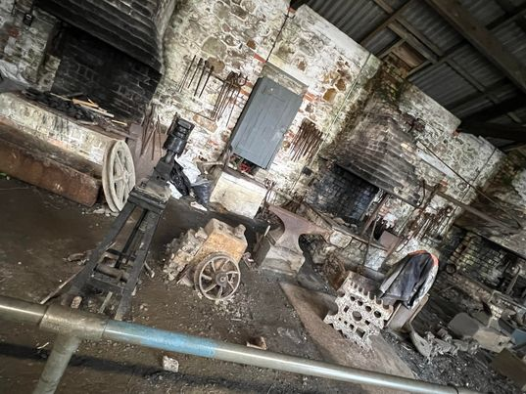

In the late nineteenth century the rein of ‘King Coal’ came to Wales. Welsh steel then became very important but so did a growing demand for coal to be used as a fuel for ships, trains, factories and houses. This is when many towns including Blaenavon worked together to make sure there was enough coal to keep up with the growing demand. During 1880 and 1913 was when the coal industry was at its highest in South Wales with some heading to South America. In 1913 Wales recorded a highest coal production of 57,000,000 tons by nearly quarter of a million coal miners. Blaenavon was one of the mines with the highest employment rate with over 1300 members of underground staff. The coal was even used for the Great Western Railway for fuel for its trains and engines.
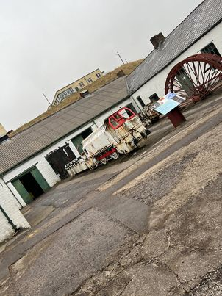

As with many mines there were a number of accidents as the work was very dangerous one being in 1913 a fire broke out in the mine luckily everyone managed to escape unharmed but then when three of its officials when down to inspect how the fire started they died from the fumes of the fire. The three officials were named three officials, Messrs Tucker, Jenkins and Bond. The workers of the mine formed bonds like no other so when news broke out of the three deaths an army of volunteers went to go and retrieve their bodies with a son of one of the officials having to be held back and stopped from entering when the accident happened.
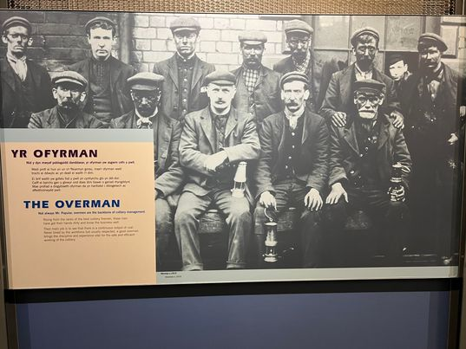

During the twentieth century big changes came to the Big Pit with the extra of miners baths which made a huge impact to miners lives. They had lockers with dirty and clean sides so they would enter one side take off their dirty equipment then go for a bath or shower then head to the clean side and put on their clean uniforms waiting for them in their clean side lockers.
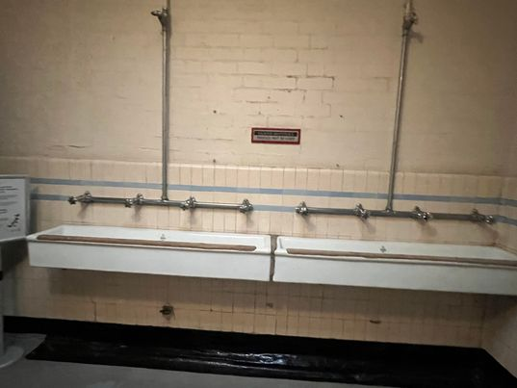

In the 1970s-1980s a lot of mine closures affected the miners and their families in the local communities as they relied heavily on their work to support their families. The Big Pit was closed to workers in February 1980 and at this time it employed over 250 members of staff as it was still classed as an important source of employment in the area. In 1983 the Big Pit opened as a museum and was instantly popular amongst tourists and visitors. Underground tours are also available with you being given a pack which includes a torch and a mask just in case of a cave in.

Since 1983 over three million visitors have been to see the site. The Big Pit was given the World Heritage Status in 2000 and has gone from strength to strength since as beforehand it was struggling, and its future was undecided many of times. The site had major reconstructive work in 2004 when it was given Heritage Lottery Funding, Funding from the Welsh Assembly government and the Welsh Tourist Board.

References

Heather. (2021). A guide to big pit and the Blaenavon industrial landscape of south Wales. Available: https://www.heatheronhertravels.com/big-pit-blaenavon-industrial-landscape-wales/. Last accessed 21st February 2022.

Other references taken from Anthony Burns in our lecture notes.

Photos taken by me after our recent fieldtrip to Blaenavon.

