Report
Abstract
This report is researching and discussing the use of Bring your own devices (BYOD) in a network and how/ if it could improve the network for the company.

Table of Contents
Introduction 2
BYOT 3
BYOT Software 5
Policy 6
Data Flow Diagram 7
Mobile Device Management Software 8
Coffee Capulus enterprise computer Network Design………………………………………………………….9
Conclusion and Recommendation………………………………………………………………………………………10

Introduction
The Company Coffee Capsules have hired me to research and recommend a network for the company. One of my tasks was to create a security policy for the company that states what the policy is set for working online and offline and also includes working at the workplace and also working from home.
I also am going to research and then recommend a Mobile Device Management for the company so their staff can bring their own technology to work on. I am going to try and recommend the best Mobile Device Management that works within the companies policy.
I will show the information that I have found and gathered to present my case to how the network could be improved to allow staff and customers to use their own device within the companies network.
In this report I will be discussing and explaining who to integrate BYOT into the companies network with the advantages and disadvantages about it use while also showing the new policy for this network for staff members to follow to keep the high level of security within the company network to keep data safe. I will also show a mock-up of the new network with Packet Tracer to show how the network will look link and also how all the devices will link up to it.
I will also discuss the positives but also the negatives about Mobile Device Management Software and how this software will impact the company and how it is used by staff members and also customers that want to connect there wireless device to the companies networks.
This report will also answer certain questions and other queries about allowing personal mobile devices to be able to connect to the network and the server of the company.
There will also be a discussion in this report about the counter measures that will be put in place on the network to make sure that the network remains secured and as restrict access to users who should not be on the network at all but also not displaying important company data to users of the network unless they have permission to access the data. There will also be a discussion on the restriction of device that access the web when they are using service such as e-mail and other kinds of social media.
There will also be a Data Flow Diagram in the report that shows how a new wireless personal device will connect to the companies network and what happens if the users device does not have the correct the information and rights to connect to the network and what they need to gain connection to the network.

BYOT
What is BYOT
BYOT stands for Bring Your Own Technology which means that the members of staff in the company can bring their own devices to use in there workplace. These devices include smartphones, tablets and laptops. They are able to do their tasks needed in their jobs by having their own devices connected to the companies server through either Wi-Fi or cable to create a local area network. The connection between the companies network and the staff members wireless device is set up by first connecting the wireless device to the companies SSID and then sign the device in using the staff members username and password so it can establish an connection to the server and the Wi-Fi connection by making sure that the user of the wireless device is authorised and making sure that the certificate is issued to show that this devise is allowed to connect to the server and the Wi-Fi. After the certificate and software is installed the device is allowed to connect and access the network. During this procedure if any details is missing the device will be denied access to the network. This method of working from the staff members own device is mostly used for jobs that are done by staff members who work at home so they can access their data from their work place at home on their own device. This method also allows work to be carried over from the workplace to other locations because the staff members can access the server by connecting to the workplace server through the Wi-Fi. Using BYOT means that the staff members device is personalized to their own settings.
Advantages
There are many advantages of companies using BYOT to allow their staff members to use their own devices. One advantage is that this method allows the company to save a lot of money because they will not need to buy a computer for all the staff members as all staff members can bring in their own device do work on. Another advantage of this is that it also allows new staff member to only need to have a username and password crated an no new device have to be bought for them to be able to work.
Another advantage of using BYOT is that because the staff members of this company is using their own device it allows them to understand how to use it and do not need to be taught how to use a new device with saves time and money. This is show by people who use different operating systems on their devices like, for example, Apple, Windows, Linux and other operating systems will not have to learn a new one because most companies only use one operating system so staff members who use their own devices that they can already use and understands.
The advantage of being able to use devices at home and still being able to use the companies data by connection to their device to the server is a big advantage. This is because staff can do their job in many different places away from the workplace. It also allows staff members to only need one device for use at home and also using at work which also limits the use of external drives to bring data from one device to at work to back home. Also, the use of BYOT also data from the server to be accessed through Wi-Fi by the devices connected to it from anywhere with an internet connection.
Another advantage is that with staff members being able to use their own device there will be an increase of productivity. This is because staff members will be more comfortable on there own devices and will work quicker because of it. Another way that this method increase productivity is the ability for the staff member to be able to take there work and other data that they need from the companies network back home so they can work there so they can complete tasks while not at work. This also leads to the advantage of if the company needs to close the working building it will allow staff members to carry on working from home.

Disadvantages
However, there are some disadvantages to having staff members using their own devices at work. One example of a disadvantage is that if the devices are damaged within the working environment the employee would have to pay for it, not the company which would annoy employees as they will have to pay for device that are damaged in the work environment.
Another disadvantage is that the many devices that would be on the network will all have different capabilities and programs on them. This means that the employer will have to get the correct programs to be able to do certain task on many different kinds of devices with different sets of programs while also making sure that all the devices have the capability of run the programs. Add to that all the systems that the staff member wants to use of work will have to be connected to the network and will also have to adhere to the policy of the company.
The biggest issue with the BYOD is security. This is because even though the company itself will spend a lot of money for security for there systems but most staff members will have more basic security on there device that are not as good as the more expensive security that the company has installed so there is more of a risk to get hacked and have data stolen. Another example of a security risk that BYOD enables is that when a staff member leaves the company they could keep all the data that has been stored on the device even if there profile is deleted so they cannot access the companies server. This data could then be sold and would affect the company. However, this is also true to the staff members because when the their device is connected to the companies network is allows them to see what they are doing on it which they may feel invades their privacy.

BYOT Software
There are many different pieces of software that can be used for companies to use allow staff members to be able to connect to the companies network. Out of all the BTOT software that I have researched I advise the use Mobile Device Manager Plus. This is because the software has app management to allow the company to mange the apps available to its staff and the software also includes the ability to manage the profiles and accounts on the network while also having secure data access as a security measure. It also has secure e-mails access that will keep data sent between encrypted or security.
Another reason why I recommend this software is because it works on both iOS and Android and also other web-based devices allow more device to be able to connect and work on the network. It is also compatible with over software packages. It is £80 a month for cloud storage and server and £600 for a on-site network.

Policy
Staff access to the network
Staff members will have access to the network with a username and password and using these to connect their devices to the company network. These usernames and password must not be shared to people outside the company.
Using Network resources
Network resources can be installed on the staff members device to allow tasks to be completed on them.
Security
Usernames and passwords must be told to others. If the device that is worked on it must be told to the network manager so the profile can be removed from it so data cannot be taken from the company.
Backing up files
Files including company data and work must be backed up in a minimum of four different places. The device, the network and a server in a separate location. The data will also be saved on the cloud.
Access to the Internet
Staff members of the company can access the internet on the network. The user must not download data onto the network unless allowed by the network management.
Remote Login
The devices that are connected to the company network will have remote access to the server from home so work can be complete there if the company building cannot be accessed or work is agreed to be computer at a staff members home.

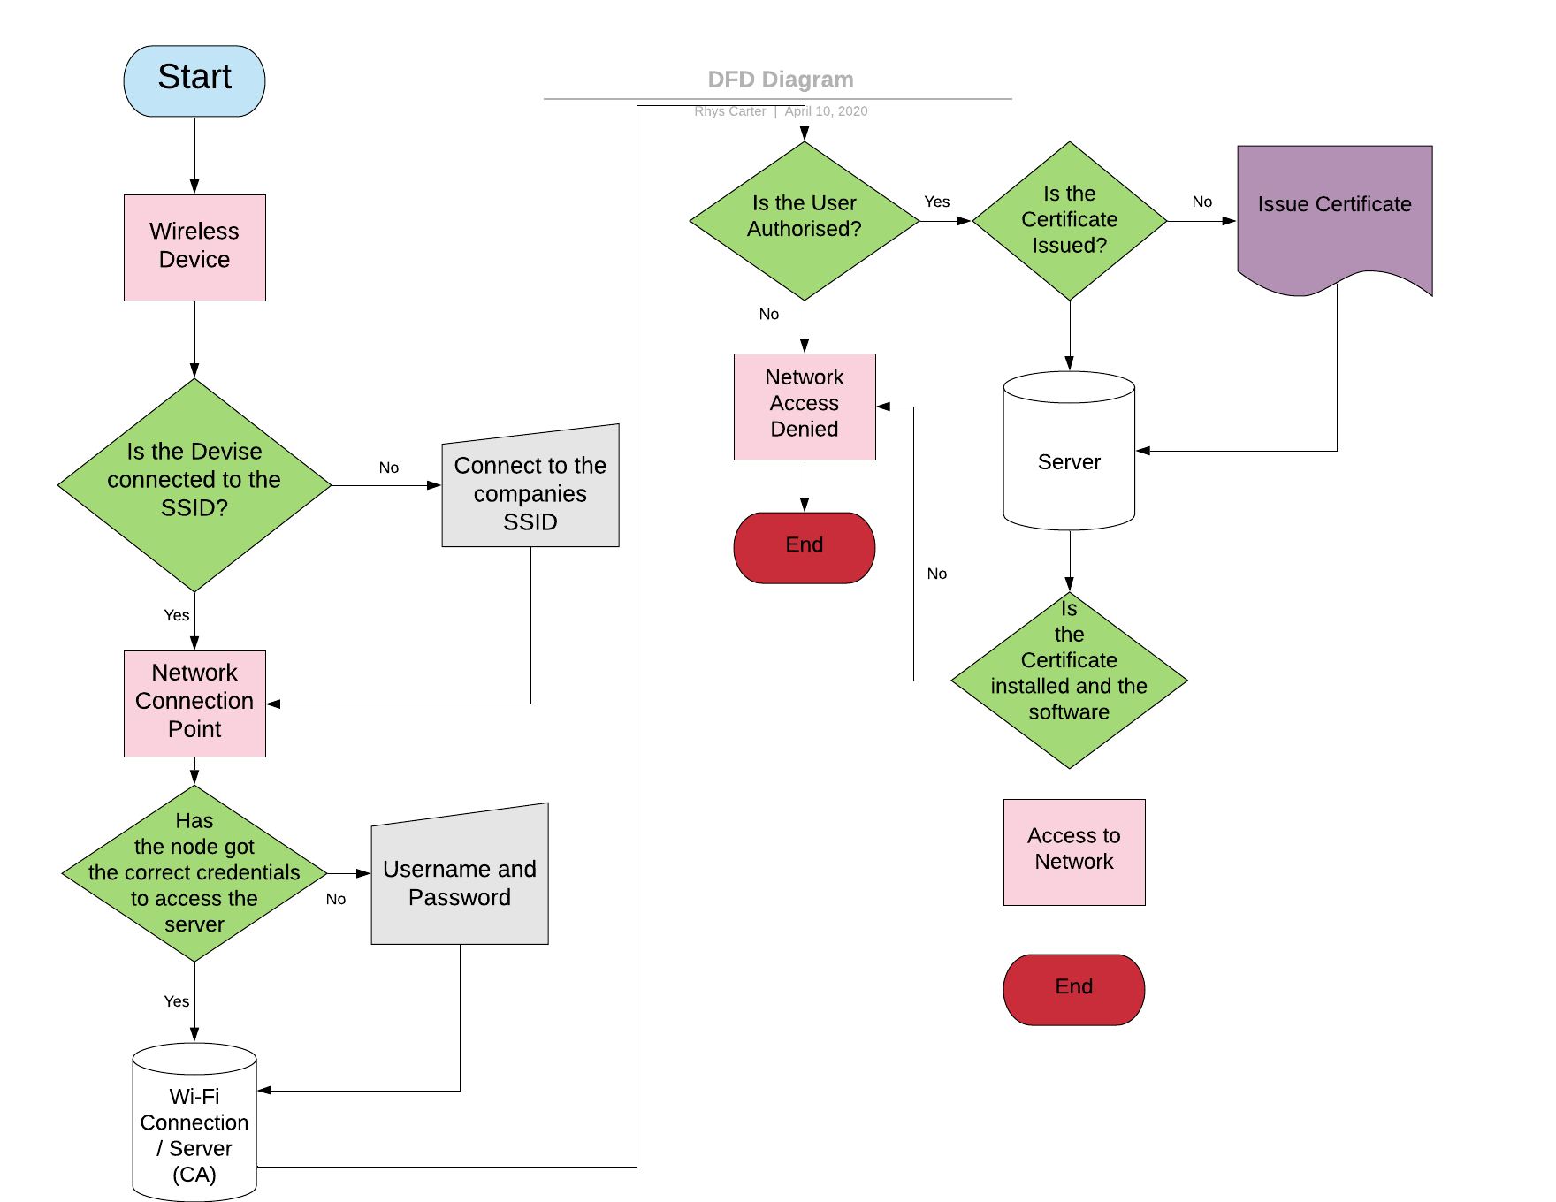
Data Flow Diagram

Mobile Device Management Software
Mobile Device Management Software is used by companies to allow users own device on the companies network and having access to the company server.
Advantages
One advantage of using Mobile Device Management Software is that the network manager can have remote access to the device on the network. This is important because this method will make it that the risk of a security breach is lowered because the management will be able to remotely go onto the device and remove the threat. It will also allow the network manager to see what is being downloaded and sent through the network.
Another advantage is that this method this method allows data that is on the network to be back up within the network so if a device is lost the data is still safe backup on the company network.
Another advantage is that this software will allow the company to save money because they can just have their own staff members use there own device instead of the company buy device for them to work on. This is good because it means less money spent and users on the network are already comfortable on there own devices.

Disadvantages
However, there are some disadvantages to using Mobile Device Management Software.
One example of an disadvantage of using this kind of software is even though being able to access devices that are on the network is good for stopping security issues there is the issue of privacy for the users on the network as what they do on there own devices is being watch and can be remotely accessed.
Another disadvantage of using Mobile Device Management Software is it requires each device that wants to connect to the network to all have the correct details like usernames and passwords and certificates to show that the devices is allowed on the network which is very time consuming to create for every user of the network.
Another disadvantage is that it will slow down the bandwidth speed of the network. This is because with all the devices that will be connected to the network via Wi-Fi that the speed of downloading files and up loading them is be reduced meaning more time will have to be spent waiting for them to download reducing productivity. The speed of accessing websites will also be reduced if many users are trying to access websites as the same time which reduces work time.

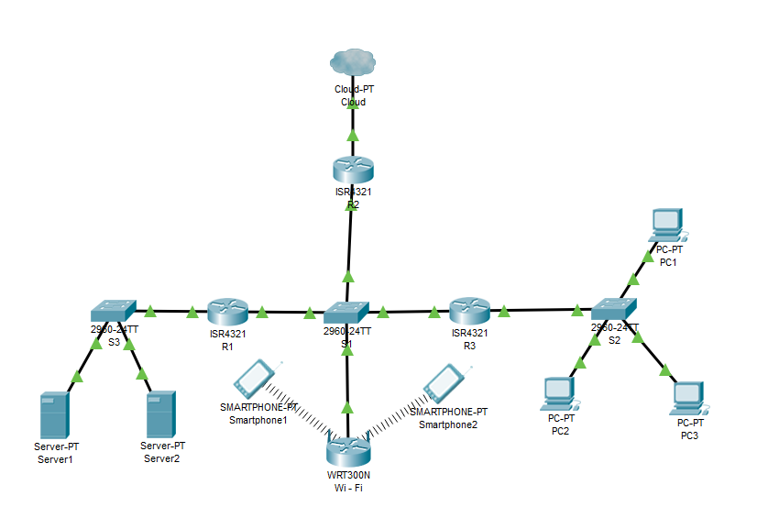
CoffeeCapulus enterprise computer Network Design

Conclusion and Recommendation
In Conclusion the use of allowing staff members of the company to bring their own devices to complete tasks within the company will be a great advantage for the company with many advantages that will massively improve the network. It will improve the output of the company and increase productivity of staff members as they will be better when working on their own devices.
Altogether I recommend setting up an network that allows staff members to bring their own devices to work on allowing more work to be done because of the staff members are familiar to there device. The other advantage is letting customs also connect to complete purchases from the company.
To build this network I would recommend the design that I create displayed earlier in the report so wireless devices can connect the network which is also connected to the cloud so the data in the servers can be access on the devices with the correct credentials and username and password for security. I would also recommend the use of the software ‘Mobile Device Manager Plus’ which would allow devices to connect to the company network with there mobile devices. It will allow them to take and share data between them, access the internet while also having security in mind and also being able to work anywhere with an internet connection via the cloud.
Altogether I recommend Coffee Capsules to upgrade there network so these features can be implanted to increase productivity and ease ability to use the device to work and also send less on the network.

marking criteria and Student FEEDBACK

This section details the assessment criteria. The extent to which these are demonstrated by you determines your mark. The marks available for each criterion are shown. Lecturers will use the space provided to comment on the achievement of the task(s), including those areas in which you have performed well and areas that would benefit from development/improvement.

Common Assessment Criteria Applied (Assignment 1) | Marks available | Marks  awarded
1. Engagement with Literature Skills
Extent of research and/or own reading, selection of credible sources, application of appropriate referencing conventions.
No references or in-text citation. Need to improve this area by using peer reviewed articles by utilising the university online resources and journals. Did not demonstrated diversity of sources and materials used. (Grade mark: 33.33%) | 15 | 5
2. Knowledge and Understanding Skills
Extent of knowledge and understanding of concepts and underlying principles associated with the discipline.
See comment above. Need to demonstrate knowledge and understanding through your research. You have not used the IEEE report format. (Grade mark: 36.67%) | 15 | 5.5
3. Cognitive and Intellectual Skills
Analysis, evaluation and synthesis; logic, argument and judgement; analytical reflection; organisation of ideas and evidence
Your report explain the relevant areas for this assignment; policy, detailed DFD, MDM, etc. and a written conclusion. Number, name and refer to your figures within the report. See comment within your report to improve your abstract, conclusion and other areas. (Grade mark: 52.50%) | 40 | 21
4. Practical Application Skills
Deployment of methods, materials, tools and techniques; application of concepts; formulation of innovative and creative solutions to solve problems.
Your practical design did not take into consideration countermeasures on your core devices such as switches and routers. Ping test works with the LAN. (Grade mark: 40.00%) | 20 | 8
5. Transferable Skills for Life and Professional Practice
Attributes in professional practice: individual and collaborative working; deployment of appropriate media; presentation and organisation.
Your report could be aligned justified. Writing need improvement (try to read more peer reviwed articles and emulate the writing style). Avoid writing in first person tense. See report for more comments. (Grade mark: 48.00%) | 10 | 4.8

Assignment Mark (Assessment marks are subject to ratification at the Exam Board. These comments and marks are to give feedback on module work and are for guidance only until they are confirmed. ) | Late Submission Penalties (tick if appropriate) |  | 44%
 | Up to four weeks late |  | 44%
 | First Attempt? |  | 44%

