Assessment-2
HTML & CSS Web Development

Student Name: Sadaf Yusufzai
Student ID: 2513631
Module Code: ACCA4023
Lecturer: Suresh Shanmugasundaram

Date: 24th April 2026

Table of Contents
Introduction 2
Requirements 3
Implementation 4
Evaluation 9
Conclusion 11
References 12
Appendices 13

Introduction
For this assignment, I will present the design and development of an accessible website named Second Life of Objects. My website explores what happens to everyday items after their original use, focusing on how objects can be reused, repaired, or recycled instead of being disposed of. To develop this website, I will use HTML and CSS to structure and style the content. The aim of this assignment is to create a clear and responsive website that promotes independent thinking through simple and practical approaches.
My website consists of five main pages: Home, Journeys, Systems, Your Impact, and About. Each page explores a different aspect of the topic, enabling users to understand how the reuse process works, as well as the role individuals can play in reducing waste. The design has been kept clean and consistent across all pages to support clear navigation and ease of reading.
In this report, I will outline the requirements, describe the implementation process, and evaluate the final product. I will also reflect on some of the challenges I encountered during development, including layout issues and linking errors, and explain how I addressed them. Overall, I applied web standards and design principles to develop a functional, accessible, and user-friendly website.

Requirements
I aimed to make my website, Second Life of Objects, stand out by focusing on everyday items and how they can be used after their original purpose. The website focuses on reuse, repair, and recycling, aiming to show that many objects do not need to become waste immediately after use.
I organised my website into five main pages, with each page covering a particular area of the topic. The Home page introduces the subject and provides access to the rest of the site. The Journeys page explains how different objects move through stages such as reuse and recycling. The Systems page focuses on the processes that enable these stages, including collection and sorting. The Your Impact page shows how individual actions can influence outcomes, and the About page explains the purpose and design of my website.
The target audience for my website is a general audience, specifically students and young adults. I designed the content to be straightforward to understand, without requiring any specialist knowledge. A clean layout and straightforward language were used to ensure that users can easily access information and move between pages without difficulty.

Implementation
My website was created using HTML and CSS, with each page designed individually and then linked together through a navigation bar. I focused on building the structure first, followed by applying styling to improve the overall appearance and usability of the site. All files were created and edited using Visual Studio Code, which made it easier to organise my website and manage its different pages.
I initially used HTML to build the structure of my website and organise the content across each page. Different elements such as headings, paragraphs, images, and links helped present information in a clear and organised way. To illustrate, heading tags separated sections, while paragraph tags displayed the main content. Navigation links were added using anchor tags to connect all pages of the website, which allows users to move between sections easily. Images were included using image tags to support the content visually. Structural elements such as the header, main, and footer also helped organise each page in a consistent manner.
I applied CSS to enhance the appearance of my website and improve the overall layout. After the HTML structure had been created, CSS was used to style the pages so that they appeared consistent and visually organised. It was used to adjust text size, spacing, colours, and alignment, as well as to manage the positioning of images and content. CSS also helped ensure that the design remained consistent across all pages, which improved the overall professionalism and usability of my website.
During development, I encountered several issues. One of the main problems was linking the CSS file correctly, as the styles were not initially being applied due to an incorrect file path. I resolved this by organising the files into folders and using the correct relative paths. I also had an issue with images not displaying, which was caused by incorrect file names and extensions. I fixed this by carefully checking the file names and making sure they matched exactly.
I also faced some layout challenges, particularly with images appearing too large or stretched. I improved this by adjusting the image sizes using CSS and applying properties such as object-fit to maintain their shape. I also adjusted the spacing between sections to make the content easier to read and more visually balanced.
Screenshots of the completed website pages are shown below to demonstrate the final layout and design.

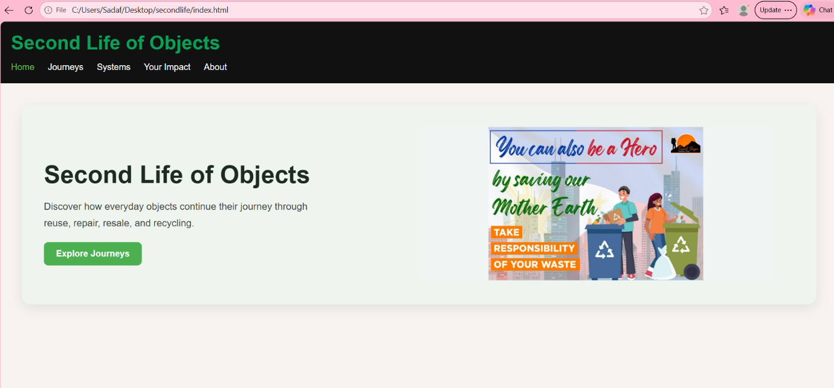
Figure 1: Home page showing the main introduction and navigation.

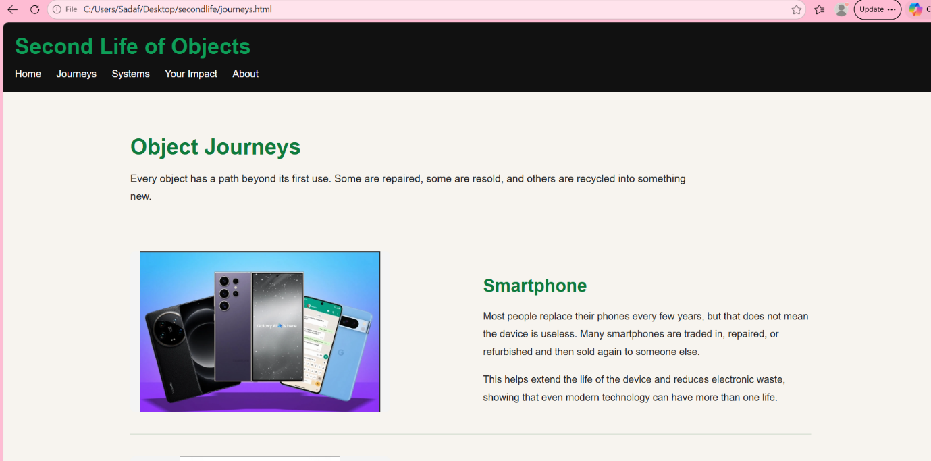
Figure 2: Journeys page showing how objects move through reuse, and recycling stages.

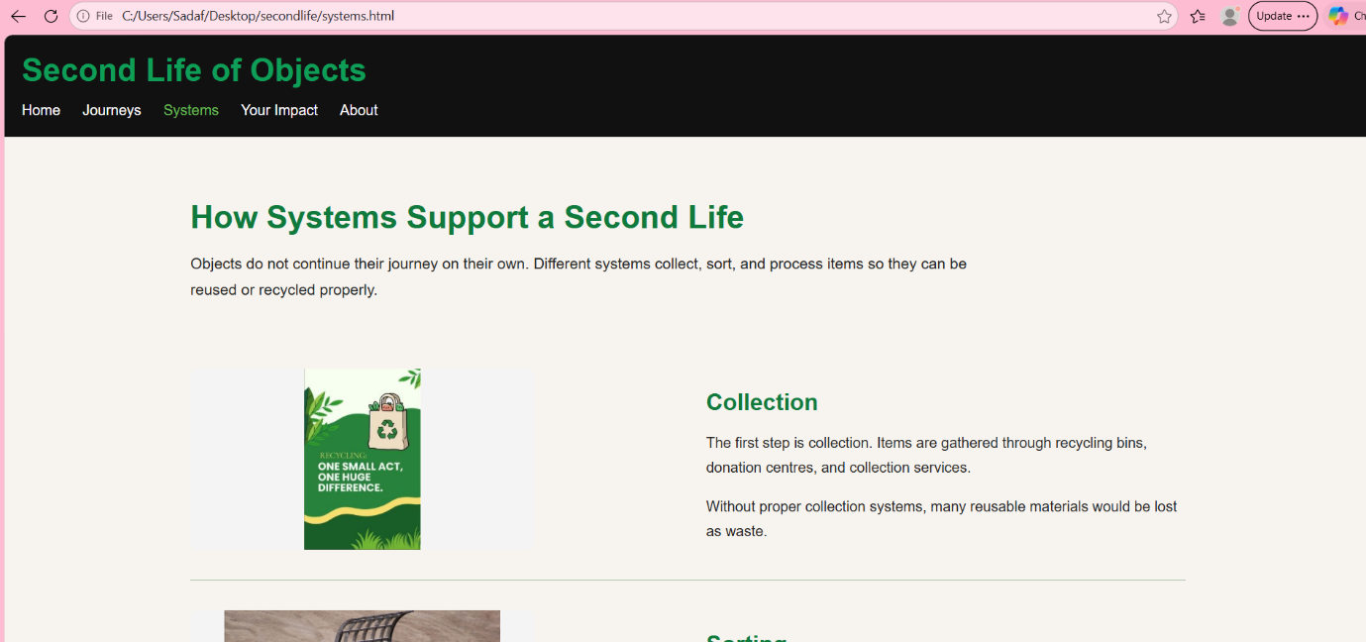
Figure 3: Systems page the process involved, such as collection and sorting.

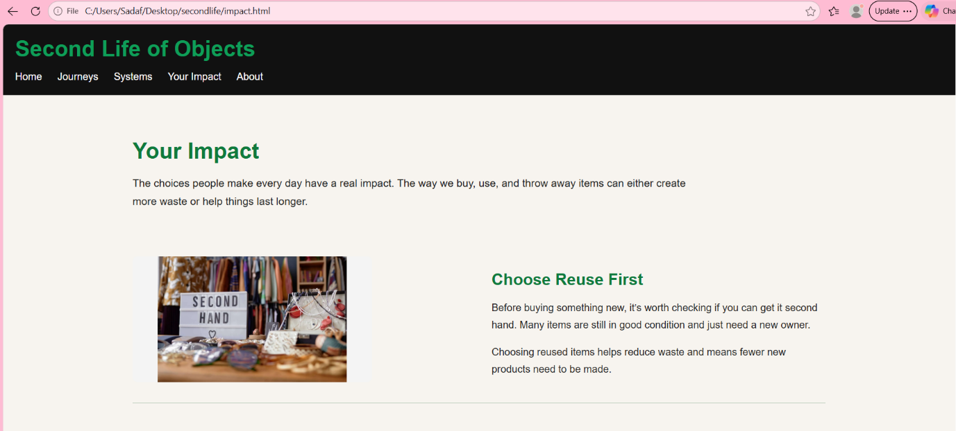
Figure 4: Your impact page showing how individual actions can influence outcomes.

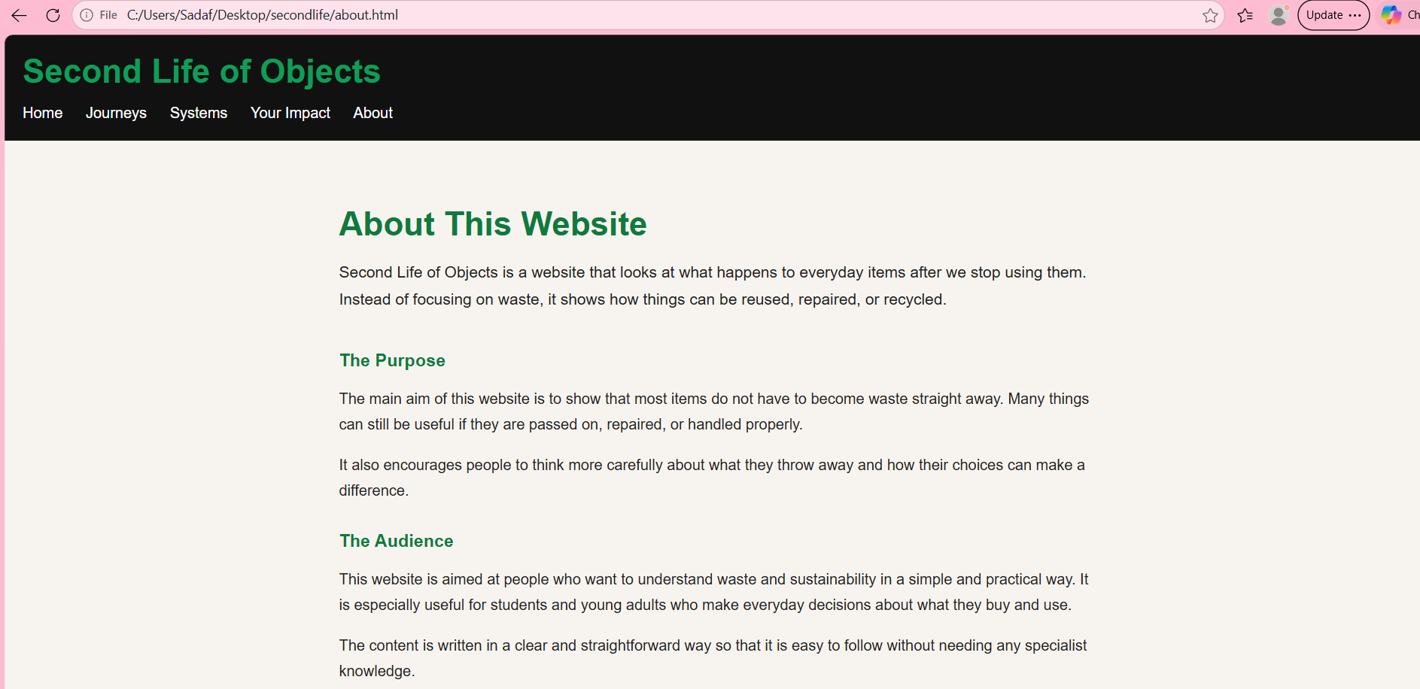
Figure 5: About page showing the purpose and design of my website.

To make sure my website was working correctly, I used validation tools to check for any errors in the code. I checked the HTML of my Home page using the W3C HTML Validator and checked my main CSS file using the W3C CSS Validator.
During validation, I found a few errors in my HTML. These included an extra closing div tag, a paragraph tag being closed without being opened, and a section tag being closed in the wrong place. These issues were primarily caused by mistakes in how I structured the HTML and matched the opening and closing tags.
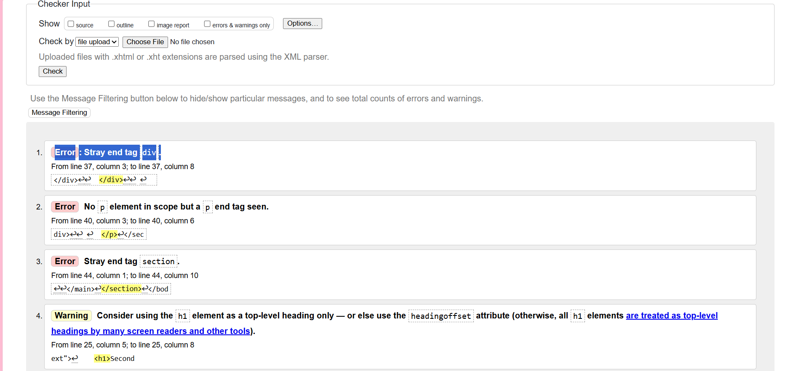
Figure 6: W3C HTML Validator showing error in HTML.

I fixed these problems by going through my code carefully and making sure each element was opened and closed accurately. I also corrected the paragraph structure so that all text was properly placed inside <p> tags. After making these changes, the validation results improved and there were no major errors left.
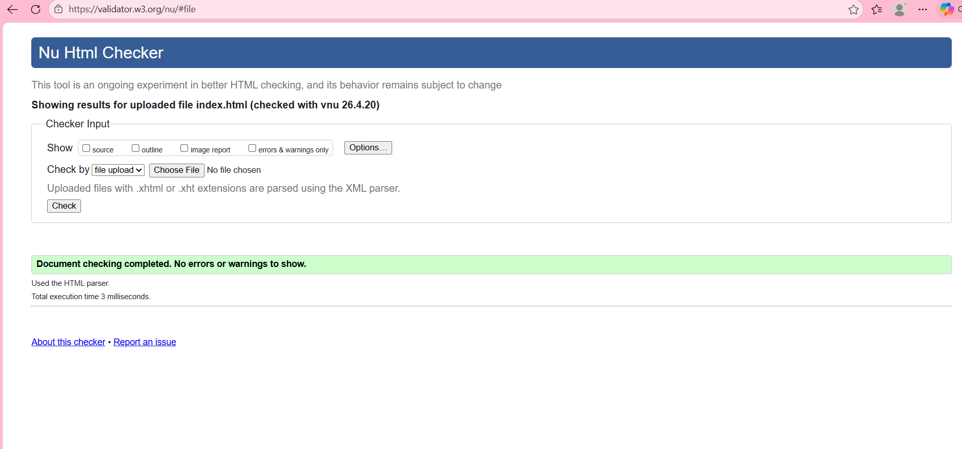
Figure 7: HTML Working with no errors.
In summary, the validation process helped me spot mistakes in my code and improve the structure of my website. It also made the website more reliable and easier to maintain.
I also checked my CSS using the W3C CSS Validator to make sure everything was working correctly. The results showed no issues, which confirmed that the stylesheet was linked and applied properly. CSS was used to control spacing, colours, layout, and image sizes, helping keep the design consistent and easy to use.
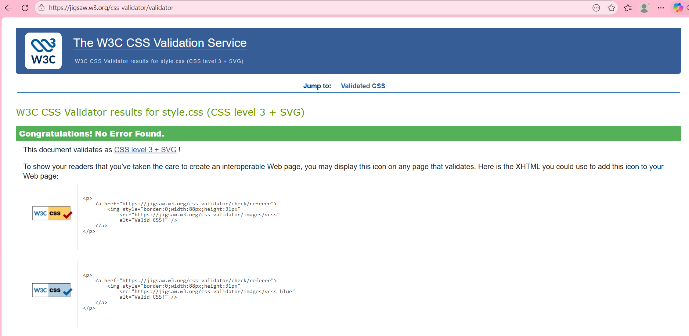
Figure 8: CSS Validation result after checking my stylesheet.

Evaluation
a)
When developing my website, I considered three key areas: usability, accessibility, and search engine optimisation. These are important because a website should be easy to use, clear to understand, and structured in a way that works well for both users and search engines.
Usability is about how easy the website is to navigate and understand. When creating my website, I kept the layout simple and consistent across all pages. I used a clear navigation bar and followed the same structure throughout, which makes it easier to move between sections without confusion. Studies shows that simple layouts and clear navigation improve the overall user experience [1]. This is why I chose to keep my design simple and easy to follow.
Accessibility is about making sure the website can be used by as many people as possible, including those with different needs. When creating my website, I focused on using clear headings, readable text, and adding alt text to images so the content is easier to understand. I also kept the layout simple so users can follow the information without difficulty. Studies shows that accessible design helps remove barriers and improves how users interact with websites [2]. This is why I made sure my website is clear, easy to read, and simple to use.
Search engine optimisation is about how well a website can be understood by search engines. When creating my website, I used clear page titles, heading tags, and descriptive alt text to organise the content properly. Studies shows that well-structured content improves how websites are understood and displayed by search engines [3]. This is why I made sure my pages were clearly organised and easy to follow.
In general, these three areas influenced how I designed my website. I aimed to keep the layout simple, the content easy to follow, and the structure organised so that the site is user-friendly and works successfully.

b)
When evaluating my website, I looked at how useful it is, how it performs in terms of SEO, and how accessible it is for different users. This helped me understand what works well and what could be improved.
In terms of usefulness, I think my website is easy to use and straightforward to navigate. The layout is simple, and each page follows a similar structure, which makes it easier to move between sections. The navigation bar helps users find information quickly without getting confused. The content is relevant and clearly presented, so it is easy to understand. However, I could improve this further by adding more detail or examples to make the pages more engaging.
For search engine optimisation, I used basic techniques when building my website. I included clear page titles, heading tags such as h1 and h2, and added alt text to images. This organises the content and make the structure easier to understand. Even though the website is simple, these features still support how the pages are presented.
In terms of accessibility, I considered the main ideas from WCAG 2.1. My website is perceivable because the text is clear and images include alt text. It is operable because users can move through the site using clear links. It is understandable because the content is written in simple language and the layout stays consistent. It is also robust, as the pages work without errors. I focused on keeping the design simple so that it can be used by a wide range of people.
To compare my website with real examples, I looked at BBC News and GOV.UK. Both are well-known websites with strong design. In terms of usability, GOV.UK is very simple and well structured, which makes it easy to find information. BBC News includes more content and images, which can sometimes feel less clear. For accessibility, both follow good practices, but GOV.UK stands out because of its clean layout and readable text. In terms of SEO, both websites use clear headings and organised content. For mobile use, both sites adapt well to smaller screens, although GOV.UK is easier to navigate. Overall, I think GOV.UK performs better because it is clearer and more straightforward to use.
In conclusion, my website works well in terms of layout and structure, but there are still areas that could be improved, such as adding more detailed content and refining the design further. This evaluation helped me understand what I did well and what I can improve in future work.
At the beginning, I found HTML coding difficult, but over time I improved by watching YouTube videos and practising regularly.

Conclusion
This assignment helped me develop a better understanding of how websites are planned, built, tested, and evaluated. By creating Second Life of Objects, I was able to use HTML to structure my pages and CSS to control the layout, colours, spacing, and overall design.
I also learnt the importance of testing during development. Some issues appeared with file paths, image sizes, and HTML validation, but fixing these helped me improve the final website. The validation process made me more aware of how important correct code structure is.
The final website meets the main requirements because it includes five linked pages, a consistent design, responsive layout, images, navigation, and accessible features such as alt text and clear headings. If I developed the website further, I would add more interactive features, more detailed examples, and possibly a search or filter option.
Overall, I am satisfied with the outcome because the website is clear, functional, and easy to use.

References

[1] | J. Nielsen, Usability Engineering, San Diego, CA: Academic Press, 1994.
[2] | O. K. H. Petrie, “The relationship between accessibility and usability of websites,” in SIGCHI Conference on Human Factors in Computing Systems, 2007.
[3] | B. G. E. W. J. Beel, “Academic search engine optimisation,” Journal of Scholarly Publishing, vol. 41, no. 2, p. 176–190, 2010.

Appendices

index.html code:
<!DOCTYPE html>
<html lang="en">
<head>
<meta charset="UTF-8">
<meta name="viewport" content="width=device-width, initial-scale=1.0">
<title>Second Life of Objects</title>
<link rel="stylesheet" href="css/style.css">
</head>
<body>

<header>
<h1>Second Life of Objects</h1>
<nav>
<a href="index.html">Home</a>
<a href="journeys.html">Journeys</a>
<a href="systems.html">Systems</a>
<a href="impact.html">Your Impact</a>
<a href="about.html">About</a>
</nav>
</header>

<main>
<section class="hero-split">
<div class="hero-text">
<h2>Second Life of Objects</h2>
<p>
Discover how everyday objects continue their journey through reuse,
repair, resale, and recycling.
</p>
<a href="journeys.html" class="btn">Explore Journeys</a>
</div>

<div class="hero-image">
<img src="images/hero.jpeg" alt="Illustration about protecting the Earth through responsible waste disposal">
</div>
</section>

</main>
</body>
</html>

journeys.html code:
<!DOCTYPE html>
<html lang="en">
<head>
<meta charset="UTF-8">
<meta name="viewport" content="width=device-width, initial-scale=1.0">
<title>Second Life of Objects | Journeys</title>
<link rel="stylesheet" href="css/style.css">
</head>
<body>

<header>
<h1>Second Life of Objects</h1>
<nav>
<a href="index.html">Home</a>
<a href="journeys.html">Journeys</a>
<a href="systems.html">Systems</a>
<a href="impact.html">Your Impact</a>
<a href="about.html">About</a>
</nav>
</header>

<main class="journeys-page">
<section class="page-intro">
<h2>Object Journeys</h2>
<p>
Every object has a path beyond its first use. Some are repaired, some are resold,
and others are recycled into something new.
</p>
</section>

<section class="journey-row">
<div class="journey-image">
<img src="images/smartphone.jpeg" alt="Used smartphone ready for reuse or resale">
</div>
<div class="journey-text">
<h3>Smartphone</h3>
<p>
Most people replace their phones every few years, but that does not mean the device is useless.
Many smartphones are traded in, repaired, or refurbished and then sold again to someone else.
</p>
<p>
This helps extend the life of the device and reduces electronic waste, showing that even modern
technology can have more than one life.
</p>
</div>
</section>

<section class="journey-row">
<div class="journey-image">
<img src="images/hoodie.jpeg" alt="Hoodie being reused through donation or resale">
</div>
<div class="journey-text">
<h3>Hoodie</h3>
<p>
Clothing is often thrown away too quickly, even when it is still wearable. A hoodie that is no
longer wanted can be donated, sold, or given to someone else.
</p>
<p>
Instead of becoming waste, it continues to be used by another person, which reduces the need for
new clothing to be produced.
</p>
</div>
</section>

<section class="journey-row">
<div class="journey-image">
<img src="images/bottle.jpeg" alt="Plastic bottle being recycled">
</div>
<div class="journey-text">
<h3>Plastic Bottle</h3>
<p>
A plastic bottle is usually only used once, but its journey does not have to end there. When it is
placed in the correct recycling bin, it can be collected and processed.
</p>
<p>
The material is then cleaned and turned into something new, such as packaging or clothing fibres.
This shows how even short-use items can still have a second life if handled properly.
</p>
</div>
</section>
</main>

<footer>

</footer>

</body>
</html>

systems.html code:
<!DOCTYPE html>
<html lang="en">
<head>
<meta charset="UTF-8">
<meta name="viewport" content="width=device-width, initial-scale=1.0">
<title>Second Life of Objects | Systems</title>
<link rel="stylesheet" href="css/style.css">
</head>
<body>

<header>
<h1>Second Life of Objects</h1>
<nav>
<a href="index.html">Home</a>
<a href="journeys.html">Journeys</a>
<a href="systems.html">Systems</a>
<a href="impact.html">Your Impact</a>
<a href="about.html">About</a>
</nav>
</header>

<main class="systems-page">

<section class="page-intro">
<h2>How Systems Support a Second Life</h2>
<p>
Objects do not continue their journey on their own. Different systems collect,
sort, and process items so they can be reused or recycled properly.
</p>
</section>

<section class="system-row">
<div class="system-image">
<img src="images/recycle.jpeg" alt="Recycling collection system">
</div>
<div class="system-text">
<h3>Collection</h3>
<p>
The first step is collection. Items are gathered through recycling bins,
donation centres, and collection services.
</p>
<p>
Without proper collection systems, many reusable materials would be lost as waste.
</p>
</div>
</section>

<section class="system-row">
<div class="system-image">
<img src="images/waste.jpeg" alt="Sorting waste materials">
</div>
<div class="system-text">
<h3>Sorting</h3>
<p>
After collection, items are sorted by type and condition. This ensures that
each material can be processed correctly.
</p>
<p>
Proper sorting improves efficiency and increases the quality of recycled materials.
</p>
</div>
</section>

<section class="system-row">
<div class="system-image">
<img src="images/furniture.jpeg" alt="Repair and processing stage">
</div>
<div class="system-text">
<h3>Processing</h3>
<p>
Materials are cleaned, repaired, or broken down into raw components so they can
be reused or transformed into new products.
</p>
<p>
This stage is essential in giving objects a second life.
</p>
</div>
</section>

<section class="system-row">
<div class="system-image">
<img src="images/shop.jpeg" alt="Second hand shop">
</div>
<div class="system-text">
<h3>Redistribution</h3>
<p>
Finally, items are redistributed through resale, donation, or reuse systems.
</p>
<p>
This allows products to continue being used instead of becoming waste.
</p>
</div>
</section>

</main>
<footer>

</footer>

</body>

impact.html code:
<!DOCTYPE html>
<html lang="en">
<head>
<meta charset="UTF-8">
<meta name="viewport" content="width=device-width, initial-scale=1.0">
<title>Second Life of Objects | Your Impact</title>
<link rel="stylesheet" href="css/style.css">
</head>
<body>

<header>
<h1>Second Life of Objects</h1>
<nav>
<a href="index.html">Home</a>
<a href="journeys.html">Journeys</a>
<a href="systems.html">Systems</a>
<a href="impact.html">Your Impact</a>
<a href="about.html">About</a>
</nav>
</header>

<main class="impact-page">

<section class="page-intro">
<h2>Your Impact</h2>
<p>
The choices people make every day have a real impact. The way we buy, use,
and throw away items can either create more waste or help things last longer.
</p>
</section>

<section class="impact-row">
<div class="impact-image">
<img src="images/shop.jpeg" alt="Second-hand shopping">
</div>
<div class="impact-text">
<h3>Choose Reuse First</h3>
<p>
Before buying something new, it’s worth checking if you can get it second hand.
Many items are still in good condition and just need a new owner.
</p>
<p>
Choosing reused items helps reduce waste and means fewer new products need to be made.
</p>
</div>
</section>

<section class="impact-row">
<div class="impact-image">
<img src="images/hoodie.jpeg" alt="Clothing reuse">
</div>
<div class="impact-text">
<h3>Look After What You Own</h3>
<p>
Taking care of your things can make a big difference. Simple things like cleaning,
storing items properly, or fixing small issues can help them last much longer.
</p>
<p>
When items last longer, they don’t need to be replaced as quickly, which reduces waste.
</p>
</div>
</section>

<section class="impact-row">
<div class="impact-image">
<img src="images/recycle.jpeg" alt="Responsible recycling">
</div>
<div class="impact-text">
<h3>Recycle Responsibly</h3>
<p>
Recycling only works when items are put in the right place. Taking a moment to sort
waste correctly can make sure it actually gets reused.
</p>
<p>
Doing this properly helps materials go through the system and become something useful again.
</p>
</div>
</section>

<section class="impact-tips">
<h3>Simple Actions You Can Take</h3>
<ul>
<li>Donate clothes and books instead of throwing them away.</li>
<li>Repair small faults before replacing an item.</li>
<li>Use second-hand shops and resale platforms.</li>
<li>Check local recycling rules before disposing of materials.</li>
<li>Think about durability before making a purchase.</li>
</ul>
</section>

</main>

<footer>

</footer>

</body>
</html>

about.html code:
<!DOCTYPE html>
<html lang="en">
<head>
<meta charset="UTF-8">
<meta name="viewport" content="width=device-width, initial-scale=1.0">
<title>Second Life of Objects | About</title>
<link rel="stylesheet" href="css/style.css">
</head>
<body>

<header>
<h1>Second Life of Objects</h1>
<nav>
<a href="index.html">Home</a>
<a href="journeys.html">Journeys</a>
<a href="systems.html">Systems</a>
<a href="impact.html">Your Impact</a>
<a href="about.html">About</a>
</nav>
</header>

<main class="about-page">

<section class="page-intro">
<h2>About This Website</h2>
<p>
Second Life of Objects is a website that looks at what happens to everyday
items after we stop using them. Instead of focusing on waste, it shows how
things can be reused, repaired, or recycled.
</p>
</section>

<section class="about-text-block">
<h3>The Purpose</h3>
<p>
The main aim of this website is to show that most items do not have to become
waste straight away. Many things can still be useful if they are passed on,
repaired, or handled properly.
</p>
<p>
It also encourages people to think more carefully about what they throw away
and how their choices can make a difference.
</p>
</section>

<section class="about-text-block">
<h3>The Audience</h3>
<p>
This website is aimed at people who want to understand waste and sustainability
in a simple and practical way. It is especially useful for students and young
adults who make everyday decisions about what they buy and use.
</p>
<p>
The content is written in a clear and straightforward way so that it is easy to
follow without needing any specialist knowledge.
</p>
</section>

<section class="about-text-block">
<h3>The Design</h3>
<p>
The website uses a clean and simple layout so that the information is easy to read.
The pages follow a similar structure, which makes it easier to move between them.
</p>
<p>
Images are used across the website where needed, but they are kept small and spaced
out so they do not distract from the content.
</p>
</section>

<section class="about-highlight">
<h3>Why It Matters</h3>
<p>
Giving objects a second life can help reduce waste and make better use of the
things we already have. Even small changes, like reusing or repairing something,
can have a positive impact over time.
</p>
</section>

</main>

<footer>

</footer>

</body>
</html>

style.css code:
body {
margin: 0;
font-family: Arial, sans-serif;
background-color: #f7f4ef;
color: #222;
}

header {
background-color: #111;
color: white;
padding: 20px;
}

header h1 {
margin: 0 0 15px 0;
font-size: 2.2rem;
}

nav a {
color: white;
margin-right: 20px;
text-decoration: none;
font-weight: 500;
}

nav a:hover {
color: #6bbf59;
}

main {
padding: 40px;
}

.hero-split {
display: flex;
align-items: center;
justify-content: space-between;
gap: 40px;
background-color: #eef5ee;
border-radius: 16px;
padding: 40px;
box-shadow: 0 8px 24px rgba(0, 0, 0, 0.08);
}

.hero-text {
flex: 1;
}

.hero-text h1 {
font-size: 2.8rem;
margin-bottom: 15px;
color: #1d2a1f;
}

.hero-text p {
font-size: 1.1rem;
line-height: 1.7;
margin-bottom: 20px;
color: #444;
max-width: 520px;
}

.hero-image {
flex: 1;
}

.hero-image img {
width: 100%;
height: 280px;
object-fit: contain; /* KEY CHANGE */
background-color: #eef5f3;
border-radius: 12px;
}

.btn {
display: inline-block;
background-color: #4caf50;
color: white;
text-decoration: none;
padding: 12px 22px;
border-radius: 8px;
font-weight: bold;
}

.btn:hover {
background-color: #388e3c;
}

/* mobile */
@media (max-width: 768px) {
.hero-split {
flex-direction: column;
text-align: center;
}

.hero-text p {
margin-left: auto;
margin-right: auto;
}

.hero-image img {
max-height: 200px;
}
}
.journey-image img {
width: 100%;
height: 180px; /* controls size */
object-fit: contain; /* stops stretching */
}
h1, h2, h3 {
font-weight: bold;
color: #0e9e58; /* dark green */
}
.journeys-page {
max-width: 1100px;
margin: 0 auto;
padding: 40px 20px 60px;
}

.page-intro {
margin-bottom: 40px;
}

.page-intro h2 {
font-size: 2.2rem;
margin-bottom: 12px;
color: #0f7a3c;
font-weight: 700;
}

.page-intro p {
max-width: 900px;
font-size: 1.05rem;
line-height: 1.7;
color: #222;
}

.journey-row {
display: flex;
align-items: center;
gap: 40px;
padding: 35px 0;
border-bottom: 1px solid #b8cbb8;
}

.journey-row:last-of-type {
border-bottom: none;
}

.journey-image {
flex: 1;
}

.journey-image img {
width: 100%;
max-width: 420px;
height: 260px;
object-fit: contain;
display: block;
background-color: #f4f4f4;
border-radius: 8px;
}

.journey-text {
flex: 1;
}

.journey-text h3 {
font-size: 1.8rem;
margin-bottom: 18px;
color: #0f7a3c;
font-weight: 700;
}

.journey-text p {
font-size: 1rem;
line-height: 1.8;
color: #222;
margin-bottom: 16px;
}

.journey-text p:last-child {
margin-bottom: 0;
}

@media (max-width: 768px) {
.journey-row {
flex-direction: column;
align-items: flex-start;
gap: 20px;
}

.journey-image img {
max-width: 100%;
height: 220px;
}

.journey-text h3 {
font-size: 1.5rem;
}
}
.systems-page {
max-width: 1100px;
margin: 0 auto;
padding: 40px 20px;
}

.system-row {
display: flex;
align-items: center;
gap: 40px;
padding: 30px 0;
border-bottom: 1px solid #b8cbb8;
}

.system-row:last-child {
border-bottom: none;
}

.system-image {
flex: 1;
}

.system-image img {
width: 100%;
max-width: 380px; /* smaller images */
height: 200px; /* controlled height */
object-fit: contain;
display: block;
background: #f4f4f4;
border-radius: 8px;
}

.system-text {
flex: 1;
}

.system-text h3 {
font-size: 1.6rem;
margin-bottom: 12px;
color: #0f7a3c;
font-weight: bold;
}

.system-text p {
line-height: 1.7;
margin-bottom: 10px;
color: #222;
}

@media (max-width: 768px) {
.system-row {
flex-direction: column;
align-items: flex-start;
gap: 20px;
}

.system-image img {
max-width: 100%;
height: 180px;
}
}
.impact-page {
max-width: 1100px;
margin: 0 auto;
padding: 40px 20px 60px;
}

.impact-row {
display: flex;
align-items: center;
gap: 40px;
padding: 30px 0;
border-bottom: 1px solid #b8cbb8;
}

.impact-row:last-of-type {
border-bottom: none;
}

.impact-image {
flex: 1;
}

.impact-image img {
width: 100%;
max-width: 380px;
height: 200px;
object-fit: contain;
display: block;
background: #f4f4f4;
border-radius: 8px;
}

.impact-text {
flex: 1;
}

.impact-text h3 {
font-size: 1.6rem;
margin-bottom: 12px;
color: #0f7a3c;
font-weight: bold;
}

.impact-text p {
line-height: 1.7;
margin-bottom: 10px;
color: #222;
}

.impact-tips {
margin-top: 40px;
background-color: #eef5ee;
padding: 25px;
border-radius: 10px;
}

.impact-tips h3 {
margin-bottom: 15px;
color: #0f7a3c;
}

.impact-tips ul {
padding-left: 20px;
}

.impact-tips li {
margin-bottom: 10px;
line-height: 1.6;
color: #222;
}

@media (max-width: 768px) {
.impact-row {
flex-direction: column;
align-items: flex-start;
gap: 20px;
}

.impact-image img {
max-width: 100%;
height: 180px;
}
}
.about-page {
max-width: 800px;
margin: 0 auto;
padding: 40px 20px;
}

.about-text-block {
margin-top: 30px;
}

.about-text-block h3 {
color: #0f7a3c;
margin-bottom: 10px;
font-weight: bold;
}

.about-text-block p {
line-height: 1.7;
color: #222;
margin-bottom: 10px;
}

.about-highlight {
margin-top: 40px;
padding: 20px;
background-color: #eef5ee;
border-radius: 8px;
}

.about-highlight h3 {
margin-bottom: 10px;
color: #0f7a3c;
}

.about-highlight p {
line-height: 1.7;
color: #222;
}

