Huw Morgan (1750078)

Quantitative Research Methods (BMDP7009)
What are the factors that impact upon choristers’ wellbeing and lifelong learning?

Table of Contents
Table of Figures 2
Abstract (200-300 words): 289 3
Keywords: 4
Introduction 4
Literature Review 6
The Current Study 11
Methodology: Research Design 12
Methodology: SPSS 13
Methodology: Hypotheses 14
Results 17
Hypothesis 1 18
Hypothesis 2 19
Hypothesis 3 20
Hypothesis 4 21
Hypothesis 5 23
Hypothesis 6 25
Hypothesis 7 27
Hypothesis 8 28
Discussion 30
Response Rate and Participant Demographics 30
Age and Motivation to Attend (Hypotheses 2, 6 & 7) 31
Age and Attendance (Hypothesis 3 & 6) 31
Music Reading Ability and Participation (Hypotheses 4, 5 & 8) 32
Limitations 32
Conclusions 36
Recommendations 37
APPENDIX 1: Hypothesis Summary Table 39
CITATIONS 40

Table of Figures
Figure 1: Chorister gender 18
Figure 2: Gender Statistics of Age and Histogram of Combined Ages 19
Figure 3: Independent T-Test of Age Differences 19
Figure 4: Association between choristers' age and reason for attendance 20
Figure 5: Chi-Square Test & Cramer's V Result 21
Figure 6: Oneway ANOVA Test on Age and Rehearsal Attendance 22
Figure 7: Notation readers by age 23
Figure 8: ANOVA Test on if reading musical notation is a significant factor 24
Figure 9: Descriptive data of how many additional hours are practiced by notation readers, non-readers and learners 25
Figure 10: ANOVA Test and Simple Boxplot of how many Additional Hours are Practiced by Choristers 26
Figure 11: Scatter plot of Choristers age by personal benefits of attending choir (Bonshor, 2017) 27
Figure 12: ANOVA Test of Age and Personal Benefits 28
Figure 13: Conductors feedback 28
Figure 14: Does Conductors Positive Feedback Help Choristers musical development? 29
Figure 15: One-Way ANOVA of the impact on rehearsals non-notation readers have 29

Abstract
This research sought to interrogate data collected from a number of choirs in south-west Wales to help inform their recruitment and retention policies and provide evidence to help their musical directors to be more effective during rehearsal time. The data gathered related to investigating perceived advantages in terms of lifelong learning and wellbeing of being a chorister in these particular community groups and focused on evidencing perceived personal advantages of membership for individuals. The original research included piloting an initial questionnaire and developed further opportunities for quantitative and qualitative data to be collected in the final questionnaire, including the use of some open-ended questions. However, some of the questionnaire provided the opportunity for choristers to provide information that could be statistically analysed, both descriptively and inferentially, in this assignment. This study explored how gender, age, notation ability, and motivations influence wellbeing and lifelong learning in adult choirs in southwest Wales. Based on responses from 184 participants, findings revealed that choirs mainly comprise older adults, especially retirees, with differing motivations by age. The study underscores the value of inclusive, experiential learning and supportive leadership in adult choral education. Positive feedback from musical directors enhanced learning, highlighting the need for supportive leadership and accessible rehearsal strategies in mixed-ability choirs. Three recommendations were made: to support non-readers with informal tools; to tailor workshops by age; to offer regular positive feedback; that could be shared with any choir committees, music directors and other like-minded groups looking at maximising the wellbeing and lifelong learning benefits that members enjoy. This study may also inform other such amateur music ensembles to develop similar strategies, which may be of interest to governments and funding agencies in Wales and further afield. Future research should explore motivations and wellbeing through mixed methods and long-term studies.

Keywords:
Choristers : Wellbeing : Lifelong Learning : Age : Factors

Word Count:
7640

Introduction
Wales' population is projected to grow by 5.9%, reaching 3.32 million by mid-2032, and by 10.3%, reaching 3.46 million by 2047 (Welsh Government, 2024). This marks a significant increase compared to the 2.0% growth observed in the decade leading up to mid-2022. Within this increase, the number of people aged sixty-five and over is expected to rise by 17.8%, reaching 784,000. Additionally, those aged seventy-five and over will see a 24.2% increase, reaching 381,000 (ONS, 2022). This increase is mirrored worldwide, with the global population expected to continue rising over the next 50 to 60 years, reaching a peak of around 10.3 billion by the mid-2080s (United Nations, 2024). By 2030, one in six people worldwide will be aged 60 or older, rising from 1 billion in 2020 to 1.4 billion. By 2050, this figure will double to 2.1 billion, while the number of those aged 80 and over is projected to triple, reaching 426 million (United Nations, 2024a). Noto (2023) argues that governments, national and regional arts organisations, and community groups such as choirs, which primarily serve older adults, must take proactive steps to address the needs of an ageing population.

Fang & Sim (2024) state that understanding the literature on lifelong learning and the wellbeing of older adults (Mäki-Opas, 2023) is essential for developing effective and sustainable provision. Research consistently highlights the importance of lifelong learning in promoting cognitive, emotional, and social wellbeing for older adults (Molina & Schettini, 2021), and engaging in educational activities, such as choir participation, can significantly improve mental health by reducing feelings of isolation and enhancing social connections (Hendry, et al., 2022). Choirs provide a unique environment where older adults can continue to develop new skills, engage with their community, and experience the emotional and cognitive benefits of music (Pentikäinen, et al., 2023). Johnson, et al. (2020), note that this is particularly important as many older individuals face challenges related to mobility, health issues, and loneliness. Furthermore, the structure of choirs, which encourages regular attendance, collaboration, and mutual support, aligns with principles of lifelong learning by fostering a sense of purpose and community (Bonshor, 2020).

This assignment will predominantly explore whether there are lifelong learning and wellbeing benefits associated with choir membership, particularly focusing on how these benefits manifest in older adults. The secondary data set chosen is of particular interest to this researcher due to their dual roles of delivering adult education and being a musical director of a choir. These roles provide valuable insight into how choirs can contribute to cognitive, emotional, and social wellbeing. By integrating the most relevant research on lifelong learning and wellbeing, governments, funding bodies, and community music organisations can develop targeted programmes that effectively address the evolving needs and aspirations of older adults (McQuade & O’Sullivan, 2021). This study will add to the limited literature and provide some additional evidence to ensure that choir-based initiatives remain inclusive, accessible, and impactful, benefiting individuals and communities across Wales. This study aims to answer the research question: what are the factors that impact upon choristers’ wellbeing and lifelong learning?

Literature Review
The existing literature on the wellbeing and lifelong learning of older adults through choral music is limited. Nevertheless, Cohen et al. (2002) suggest that participation in choral activities may enhance older adults' wellbeing, while Lehmberg and Fung (2010) highlight clear benefits for healthy older individuals. Hays (2005) argues that gerontologists should recognise the potential wellbeing advantages of engaging in choral activities to better leverage these benefits. Perkins and Williamon (2014) identify six measurable ways in which learning music supports healthy ageing:
- Personal enjoyment and pleasure;
- Improved social connections;
- Meaningful musical engagement in everyday life;
- Achievement of musical goals;
- The ability to actively participate in music-making;
- A sense of accomplishment through musical development.
Lamont et al. (2018) further emphasise the importance of building social connections, discovering personal value and experiencing a sense of accomplishment, aligning with Perkins and Williamon’s (2014) findings. Thus, conducting a study that incorporates evidence from the researcher’s own community music practice to contribute to this area of literature would be valuable.

Research by the World Health Organization (2015) suggests that active engagement in educational settings that promote active learning plays a vital role in helping retirees and others remain physically, socially, and psychologically active. Further work has established the Healthy Ageing Collaborative (WHO, 2022), a collaborative network involving multiple sectors and stakeholders, including non-governmental organisations such as community choirs, aimed at driving forward the implementation of the United Nations (UN) Decade of Healthy Ageing (2021–2030). In Wales and beyond, such findings have prompted the Welsh Government (2017a, p. 2) to acknowledge that “learning is a lifelong activity”. Additionally, it recognises that adult learning enhances overall health and wellbeing while serving as a powerful driver of social connection and inclusion (Hendry, et al., 2022). Older adults who maintain physical and social activities through lifelong learning experience enhanced self-esteem, argues Jang (2020). Specifically, learning in a choral setting is believed to foster improved health and social engagement among older adults (Hallam & Creech, 2016).

However, there is a lack of research exploring the benefits of community-based group singing in relation to positive wellbeing and quality of life (Hendry, et al., 2022). Research relating to age differences between females and males in older adult mixed choirs is also extremely limited; however, a study by Maury & Rickard (2018) reported that female choristers had a mean age of 65.73, whilst Johnson et al. (2020) reported that female and male choristers had a mean age of 71.3 years, suggesting that male participants may be older. Creech et al. (2013) suggest that choir participation spans various age groups, each exhibiting distinct patterns of engagement. Ververis & Marshall (2018) report that 92% of London Welsh Male Voice Choir members are over 55, with an average of 35.72 years of choral experience, indicating sustained engagement among male older adults. Shim and Sim (2020) discuss how working adults aged 30–59, averaging 45 years, often attend rehearsals more than twice weekly, reflecting strong commitment. Additionally, Jang (2020) observes that older participants in intergenerational choirs experience enhanced emotional health and a sense of purpose through weekly rehearsals.

It appears that older adults (55+) often seek emotional well-being, social connection, and spiritual fulfilment through choir membership (Davidson & Faulkner, 2014), experiencing improvements in cognitive health, combating loneliness and enhancing memory (Kim & Kim, 2024). Middle-aged adults (30–55) are motivated by personal growth and lifelong learning (Lamont, et al., 2018), while Davidson & Faulkner (2014) report that they benefit from stress relief, emotional expression, and a sense of personal fulfilment. Young adults (18–30) appear to value social interaction and skill development (Hallam & Creech, 2016) and gain social benefits and stress reduction through creativity and the associated sense of community (Clift & Hancox, 2010). Intergenerational choirs enhance wellbeing by fostering empathy and social bonds, benefiting all participants (Kim & Kim, 2024). Jang (2020) argues that intergenerational choirs also enhance mutual respect and shared experiences across age groups, and understanding these varied motivations helps design inclusive, engaging choral programmes that support participants’ wellbeing, creativity, and development at different life stages.

Choir participation enhances educational standards across age groups, fostering cognitive, social, and emotional growth. For older adults, choirs support cognitive function and memory (Pentikäinen, et al., 2023), while younger and middle-aged participants develop critical thinking and pattern recognition (Chorus America, 2003). Choirs also promote social and emotional learning, essential for academic success, particularly in teamwork and communication (Clements-Cortes, 2015), with intergenerational choirs fostering mutual learning, benefiting all participants and improving educational outcomes through diverse experiences (Jang, 2020).

Chaddock-Heyman et al. (2021) suggest that the ability to read music notation significantly impacts choristers' practice habits, thus improving efficiency and depth of learning. Gumm (2018) reports that music notation enhances autonomy, enabling choristers to independently work on their parts and refine techniques. It also improves time management during rehearsals, allowing for faster learning and more productive practice (Chaddock-Heyman, et al., 2021). Additionally, notation supports musical interpretation, helping choristers express phrasing, dynamics, and emotional depth and promotes cognitive engagement, improving retention and focus, with Carter (2017) adding that proficiency in music notation also strengthens sight-reading and fosters long-term musical growth, essential for mastering complex repertoire. Clements-Cortés (2014) note that reading musical notation improves pitch and rhythm accuracy, supporting ensemble unity and serves as a memory aid in complex works. This proficiency allows for greater independence in learning (Carlson, 2023), improving rehearsal productivity (Creech & Hallam, 2015), and facilitates better cohesion in ensemble settings (Davidson & Faulkner, 2010). The ability to read music notation also builds confidence, enabling greater focus on musical expression (Hendry, et al., 2022), and supports lifelong musical engagement, ensuring a higher quality in performance.

Positive feedback from musical directors is noted by Bonshor (2017) as playing a key role in supporting diverse learners in amateur choirs. It boosts confidence and motivation, particularly for beginners or those without formal training, encouraging further engagement and progress (Bonshor, 2020). By acknowledging individual strengths, positive feedback bridges gaps in experience and fosters an inclusive environment, enhancing group cohesion, strengthening teamwork, and encouraging continuous learning and development (Molińska & Rajchert, 2024). Tebyani (2024) describes how positive reinforcement also supports emotional wellbeing by providing a safe, supportive space for personal growth, and ensures that all members feel valued, contributing to a productive and enjoyable musical experience.
Within this under-researched area, there are clear gaps which provide a niche in which this particular research can sit. Therefore, investigating the factors that impact upon choristers’ wellbeing and lifelong learning will add evidence in this field and calls attention to the purpose of the current study.

The Current Study
The purpose of this study is to explore the thoughts and feelings of older individuals, rather than students or children, who participate in weekly rehearsals as members of community choirs in south-west Wales. This region has been historically characterised by vibrant communities, once supported by amenities such as libraries funded by local mineworkers, steelworkers and other manual professionals (Baggs, 1995), working men’s clubs (Waring, 2019), institutes promoting social and cultural life (Nash, et al., 1995) and a high level of attendance in local chapels (Matthews, 2018). All were accessible through extensive public transport networks, and these facilities provided lifelong opportunities for fellowship, learning, social engagement and a sense of belonging (Johnes, 2013). Today, however, these former industrial towns face significant social deprivation (Mason, 2017). Community entertainment and social venues are scarce (Cherrington, 2018), opportunities for both formal and informal learning are limited (Higgs, 2017), and chapel attendance has plummeted (Jones, et al., 2022). This study seeks to understand how participation in a community choir provides a space for lifelong learning and social connection within this context. It will also contribute to the expanding body of research on the advantages of music-making for older adults (Maury & Rickard, 2018), especially with regard to community choral participation (Making Music, 2024).

Methodology: Research Design
This assignment requires a quantitative research approach - to quantify data and analyse it statistically in order to identify patterns, relationships, or trends. This method is particularly valuable for testing hypotheses and examining cause-and-effect relationships (Creswell & Creswell, 2017). It allows for large-scale data collection, often through surveys or experiments, enabling generalisation to broader populations (Babbie, et al., 2022). The objectivity of quantitative methods reduces researcher bias as data is analysed numerically, ensuring replicable and reliable results (Khoa, et al., 2023). Additionally, quantitative research facilitates the comparison of groups, measurement of variables, and establishment of correlations, making it ideal for studies that require precision and statistical validation (Schweinsberg, et al., 2023). By focusing on numerical data, it provides a clear, structured approach to research, allowing for the testing of theories and contributing to evidence-based decision-making, which is especially suitable when seeking to measure the extent of phenomena or to generalise findings to larger populations (Bogenschneider & Corbett, 2021).

This study aims to explore the motivations of amateur choristers in South Wales, specifically focusing on the impact of regular choir attendance on their wellbeing and lifelong learning. A survey of over 300 choir members in south Wales was obtained, exploring choristers’ motivations for attending choir regularly and its perceived impact on their wellbeing and lifelong learning. The survey included questions about gender, age, length of service, reasons for joining the choir, and preferred learning methods. The survey combined both multiple-choice and open-ended questions, with all responses capable of being quantified for analysis. The data collected provides a robust foundation for identifying key trends in participants’ experiences. For example, responses to questions regarding the reasons for joining a choir could shed light on motivations such as social interaction, personal enjoyment, or musical development. Similarly, data on preferred learning methods (e.g., visual, auditory, or hands-on learning) could reveal how choristers engage with musical content and the factors that support their continued participation.

Methodology: Positionality
This study will adopt a post-positivist ontological position (Cohen, et al., 2017), assuming that the benefits of choir participation in relation to wellbeing and lifelong learning exist as observable realities but can only be understood imperfectly (Creswell & Creswell, 2017). Using quantitative methods such as t-tests, ANOVA, and Chi-Square aligns with a positivist epistemology, where knowledge is gained through measurable evidence and hypothesis testing (Cohen, et al., 2017). The assumption is that participants’ self-reported experiences reflect underlying truths that can be objectively analysed (Muijs, 2010). Although statistical methods aim for objectivity, this approach also recognises potential limitations, including sampling bias and imperfect measurement (Bergin, 2018). Quantitative research has proven effective in evaluating musical engagement and wellbeing outcomes (Hallam, et al., 2016) providing a robust foundation for analysing community choir participation through statistical comparison.

Methodology: SPSS
Statistical Package for the Social Sciences (SPSS) now known as IBM SPSS Statistics was used in this research due to its specialised statistical analysis capabilities, reliability, and ease of use (Pallant, 2020). While Excel is a versatile spreadsheet tool, SPSS is designed specifically for statistical analysis and offers a wide range of statistical tests such as ANOVA, regression analysis, factor analysis, and non-parametric tests (Pallant, 2020). This researcher will therefore perform analyses with greater accuracy and efficiency in SPSS, reducing the risk of errors. SPSS will enable efficient data management through its variable view, and data will be labelled, coded and defined accurately. Unlike Excel’s overreliance on cell references, Salcedo & McCormick (2020) state that using SPSS reduces the likelihood of inconsistencies. The user-friendly interface SPSS provides simplifies statistical procedures without requiring extensive programming knowledge, vital in this research given the authors unfamiliarity with such a large data set (Mayers, 2013). SPSS output reports will be included and discussed, including tables and charts, ensuring transparency and reproducibility in this research. Excel, in contrast, does not provide the same level of detailed statistical outputs, making it less reliable for complex research studies (Pallant, 2020).

Methodology: Hypotheses
An analysis of the dataset provided will be conducted methodically and thoroughly to gain an initial understanding, and a check will be undertaken as to whether the choir dataset comes with a README file, metadata, or any other documentation that explains the data, its structure, and variables (Naeem, et al., 2023). Each variable will need to be understood as well as what each column represents, the type of data it is (categorical, numerical, time-series, etc.), and whether they relate to each other. Whether there are any null values or missing entries in the dataset will also need to be considered (Bergin, 2018). This researcher is familiar with the origin of the dataset - who collected it and for what purpose - which may be helpful to frame the scope and limitations of the analysis, and Heumann & Shalabh (2024) suggest considering any potential biases or limitations inherent in the dataset that may impact the analysis or conclusions.

Before starting any analysis, the development of several hypotheses that the dataset can answer is necessary to guide the analysis and to ensure that the variables available in the dataset are relevant to the research questions (Naeem, et al., 2023). An Exploratory Data Analysis will be undertaken to obtain a sense of the distribution of data, its range, and any patterns or anomalies. For numerical variables, calculating means, medians and standard deviations will enable the creation of basic visualisations like histograms, boxplots, or scatterplots to identify trends, outliers, and relationships between variables (Imai, et al., 2021). Heumann & Shalabh (2024) state that such activity can identify data quality inconsistencies, such as incorrect values, outliers, duplicates, or missing values. This may require the dataset being cleaned, addressing missing values (e.g., imputation, removal), removing duplicates, and standardising the data, e.g., normalisation. Creating new features from existing data may be necessary, which could include creating categorical variables, combining columns, or transforming variables. A check for data type issues will be undertaken, ensuring that each variable is correctly formatted (e.g., that dates are recognised as date types and categorical variables as factors) (Black, 1999).

Eight statistical tests will be undertaken using IBM SPSS Statistics (IBM Corp., 2021). Given the dataset’s wide and partly superfluous scope, complexity, and differing research objectives, focused hypotheses will be set, allowing this researcher to explore different aspects in terms of choral wellbeing (Clements-Cortés, 2014) and life-long learning (Kaynak, 2018) in amateur choirs. To test these hypotheses, t-tests, ANOVA and Chi-squared will be employed. An important element for this researcher, unfamiliar to statistical data analysis, will be to keep detailed notes on each step, including decisions made about how the data is treated, the reasons behind those particular methods and how the results are interpreted (Pallant, 2020).

To ensure reliability, all results will be double-checked for consistency and robustness, ensuring that the findings are interrogated and stable across different methods. If unexpected patterns or issues are uncovered, refining the methods employed will be necessary and further analysis undertaken (Salcedo & McCormick, 2020). When interpreting the results, to contextualise the findings, relating the results back to the research question (What are the factors that impact upon choristers’ wellbeing and lifelong learning?) and also to the existing literature will be key. Furthermore, acknowledging the limitations of the dataset and the methods used will be of interest, with a consideration of how they may affect any conclusions (Bergin, 2018). When interpreting this third-party dataset, several ethical protocols will need to be observed including ensuring that all data is anonymised by removing any identifying information to protect participants and each choir’s privacy (BERA, 2024). This researcher will also confirm that participants in the original study gave informed consent for their data to be used in research. This includes understanding how their data would be used, stored, and shared. The data will be stored securely, with appropriate encryption and restricted access to prevent unauthorised use (Kitchin, 2024).

Methodology: Analysis
T-tests, ANOVA, and Chi-Square tests will be selected to analyse the relationships between choristers’ wellbeing, lifelong learning, and demographic factors because these statistical tools are well-suited for interrogating group differences and associations in educational research (Babbie, et al., 2022). T-tests allow comparison of means between two groups (Field, 2024), such as difference in age between females and males, while one-way ANOVA (Pallant, 2020) enables the examination of differences across more than two groups, such as age groups and revealing whether older and younger adults report varying benefits from choir participation. The Chi-Square test helps assess associations between categorical variables (Salcedo & McCormick, 2020), such as age and motivation for joining, providing a non-parametric option for exploring patterns in chorister participation. Together, these tests support robust hypothesis testing, aligning with quantitative research standards (Creswell & Creswell, 2017), offering a rigorous foundation for evaluating lifelong learning in musical contexts (Bryman, et al., 2022).

Results
Within the data analysed, there was an unknown response rate given that it was anonymised secondary numerical data relevant to this researcher's field of interest. It is estimated that 300 choristers were invited to complete the questionnaire, with 184 completed. This 61% completion rate follows the gradual rise in the average response rate identified by Holtom et al. (2022), but may also reflect the work of Bryman et al. (2022), where social influences, peer pressure, visibility and the opportunity to complete the survey in rehearsal may have increased the number of participants. It has been assumed by this researcher that those choristers who did not complete the questionnaire may have been deterred by its length, lack of perceived benefit or privacy concerns (Babbie, et al., 2022) while, if any questionnaires were incomplete, they may well have been omitted prior to the data set being prepared. The results presented are, it is assumed, an accurate and robust reflection of the participants’ views, with the results analysed being based on the responses of n=122 females and n=62 males.
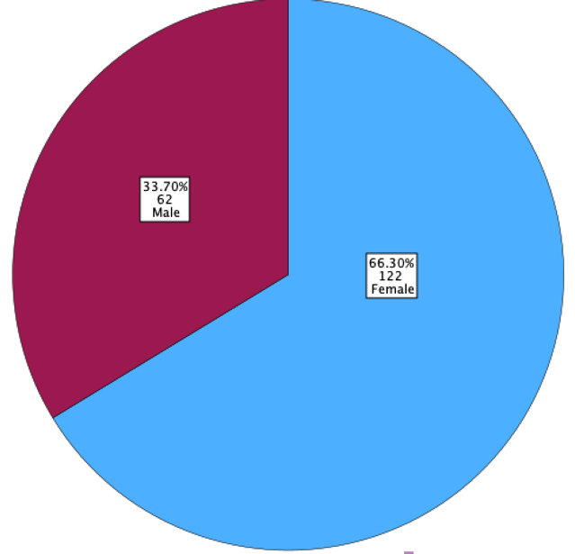
Figure 1: Chorister gender

Hypothesis 1
Pickering (2017) suggests that age may influence behaviour, preference, experience or understanding differences between males and females; thus, capturing this distinction may be useful in deeper analysis. This could be most pertinent in female- or male-only choirs, where different learning and wellbeing opportunities may be apparent (Pentikäinen, et al., 2023). Therefore, an independent t-test was run on the complete sample of 186 choral participants to determine whether there were differences in age of female members compared to their male counterparts. The following hypothesis was formed:
- Null Hypothesis H₀: There is no significant difference in age between females and males, and any observed difference is due to chance;
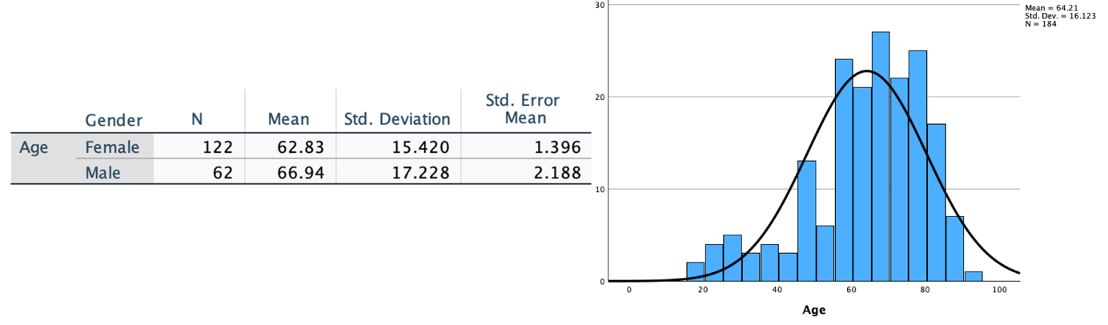
- Alternative Hypothesis H₁: There is a significant difference in age between females and males.

Figure 2: Gender Statistics of Age and Histogram of Combined Ages
The statistics shown in Figure 2 show that female choristers had slightly lower average age (m=62.83 yrs) compared to male choristers (m=66.94 yrs), indicating a four-year difference between genders. This compares with choir members average (m=64.21). The results (Figure 3) indicated a t-value of -1.583 with 111.462 degrees of freedom, and a p-value of 0.116. 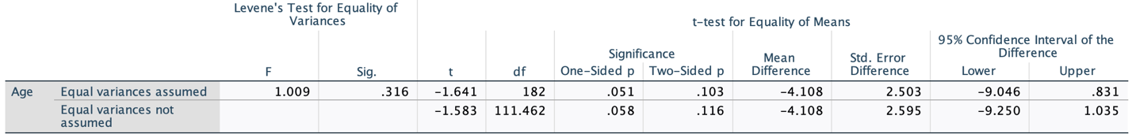
Figure 3: Independent T-Test of Age Differences
The negative t-statistic also indicates that the mean age of females is lower than the mean age of males in the choirs. The p-value exceeded the conventional threshold of 0.05, we can conclude that there is no statistically significant difference between the mean ages of females and males in the choir sample at the common significance levels. As a result, we fail to reject the null hypothesis.

Hypothesis 2
Understanding the motivations (Figure 4) behind choir participation, as discussed by Maury, et al. (2022), can provide valuable insights into how different age groups derive personal benefits from this activity.
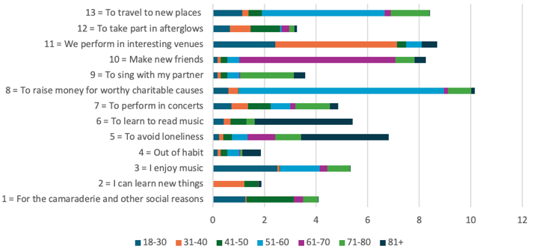
Figure 4: Association between choristers' age and reason for attendance
To explore this relationship, the following hypothesis was formed:
- Null Hypothesis H₀: There is no association between choir members’ reasons for attending and their age group;
- Alternative Hypothesis H₁: There is an association between choir members’ reasons for attending and their age group.
The Chi-Square Statistic (χ²) was 79.169 with the p-value (Asymptotic Significance) of 0.442 (Figure 5), which is greater than the common significance level (α = 0.05), thus failing to
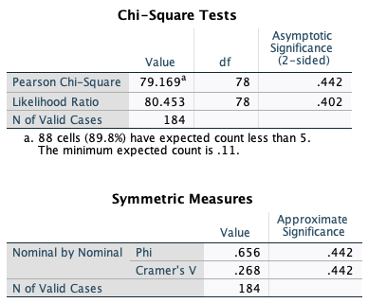
Figure 5: Chi-Square Test & Cramer's V Result
reject the null hypothesis. There is no strong statistical evidence to suggest that age group and reasons for attending choir are associated and the observed differences in reasons for attending among different age groups could be due to random chance rather than a true relationship. When calculating Cramér’s V to measure the strength of association between age group and reasons for attending a choir, the score of 0.268 suggests a weak-to-moderate association between age group and reasons for attending.

Hypothesis 3
Assuming that there is no significant difference in age between females and males, and that any observed difference is due to chance, age-related data was combined for the subsequent hypotheses testing. Rehearsal attendance was considered, looking at eight age groups: 18-30, 31-40, 41-50, 51-60, 61-70, 71-80 and 81+. Using ANOVA to compare attendance levels across the age groups simultaneously rather than performing multiple t-tests, which increases the risk of Type I errors, the following hypothesis was tested:
- The Null Hypothesis H₀ is: There is not a significant difference between participants’ age and attending rehearsals;
- The Alternative Hypothesis H₁ is: There is a significant difference between participants’ age and attending rehearsals.
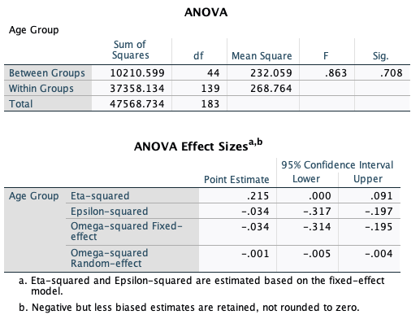
Figure 6: One-way ANOVA Test on Age and Rehearsal Attendance
The data (Figure 6) indicates that the p-value is 0.708 which indicates the probability that the observed differences occurred by chance as the p-value is greater than 0.05. This suggests that the differences between the groups are not statistically significant at the 5% significance level. The critical value for F at the 5% significance level is .863 and, since the calculated F value is more than the critical value, this researcher fails to reject the null hypothesis.

Hypothesis 4
Davidson & Faulkner (2010) states that the ability to read music notation is a valuable skill for choristers in adult choirs, significantly impacting their musical performance and learning efficiency. Adults who engage in choral singing often experience cognitive benefits, including improved verbal flexibility and enhanced neural processing (Pentikäinen, et al., 2023). Additionally, the social and emotional benefits of choir participation, such as increased feelings of togetherness and peer support, can further motivate choristers to develop their music reading skills at whatever level they perceive themselves to be (Bonshor, 2020).
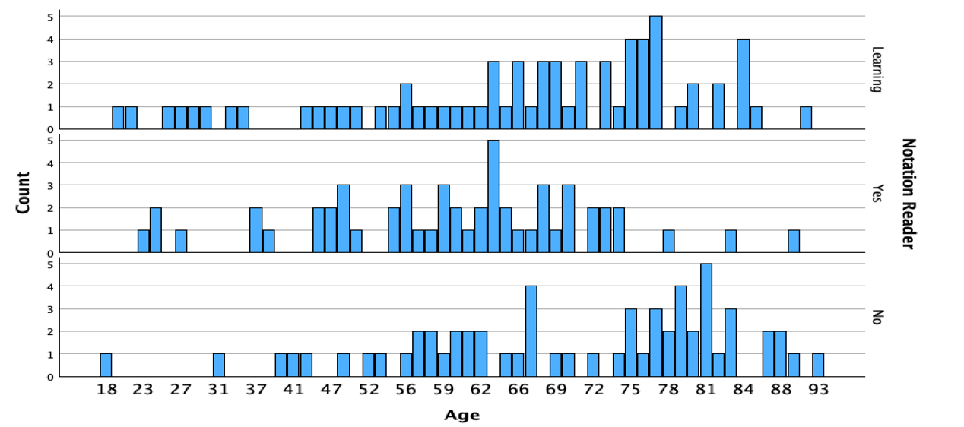
Figure 7: Notation readers by age

Figure 7 shows, by age, the number of participants who can read musical notation, are learning it and those who cannot. Understanding this relationship, if learning to read music is a motivating factor to joining a choir or maintaining choir membership, is essential for choir directors, including for this researcher, to tailor their teaching methods and optimise enjoyment levels and learning outcomes for choristers. To establish this relationship:
- The Null Hypothesis (H₀) is: learning to read musical notation is not a significant factor in joining and continuing in a choir;
- The Alternative Hypothesis (H₁) is: learning to read musical notation is a significant factor in joining and continuing in a choir.
A one-way ANOVA test (Figure 8) was conducted to determine whether learning to read musical notation is or is not a significant factor in a chorister joining and continuing in a choir.
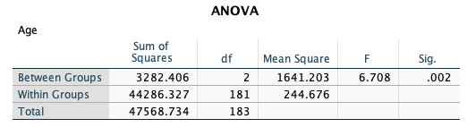
Figure 8: ANOVA Test on if reading musical notation is a significant factor

The F-value of 6.708 indicates the ratio of the variance between the groups to the variance within the groups, suggesting a greater difference between the groups compared to within the groups. The significance value (p-value) of .002 is less than the common alpha level of 0.05, indicating that the results are statistically significant. Since the p-value (.002) is less than 0.05, the null hypothesis (H₀) is rejected and we can accept the alternative hypothesis (H₁). This means that learning to read musical notation is a significant factor in joining and continuing in a choir.

Hypothesis 5
The ability to read music is a fundamental skill that can significantly impact a chorister's practice habits (Carlson, 2023), as music reading proficiency allows choristers to interpret and understand musical scores more efficiently, leading to more productive practice sessions. This skill can reduce the time spent on deciphering notes and rhythms enabling
choristers to focus on refining their performance and mastering complex pieces (Coffman, 2018). Choristers who can read music may also experience greater confidence and motivation during practice as they can approach new pieces with a clear understanding of the musical structure (Kaynak, 2018). This can lead to increased practice frequency and longer practice durations as they are more likely to engage deeply with the material. Conversely, choristers who do not read music or are still learning may face challenges in interpreting scores, which can hinder their practice efficiency and reduce their motivation to practice regularly. These choristers might spend more time struggling with basic notation, potentially leading to shorter and less frequent practice sessions (Arthurs & Petrini, 2023). Therefore:
- The null hypothesis (H₀) is: Non-music notation readers do not practice more than those who read music;
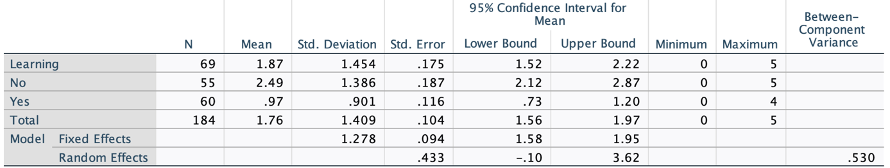
- The alternative hypothesis (H₁) is: Non-music notation readers do practice more than those who read music.

Figure 9: Descriptive data of how many additional hours are practiced by notation readers, non-readers and learners
Figure 9 shows that the mean practice hours are highest for those who cannot read music (No – 2.49), followed by those who are learning to read music (Learning – 1.87), and lowest for those who can read music (Yes – 0.97). The standard deviation indicates the variability in practice hours within each group. The group learning to read music shows the highest variability (Learning: 1.454), while the group that can read music shows the lowest variability (Yes: 0.901). The confidence intervals provide a range within which the true mean practice hours are likely to fall, with 95% confidence. The intervals for the "No" group are higher (No: 2.12 to 2.87 hours) and do not overlap with the "Yes" group (Yes: 0.73 to 1.20 hours), suggesting a significant difference in practice hours. The range of practice hours shows that some participants in each group do not practice at all, while the maximum practice hours vary slightly among the groups.

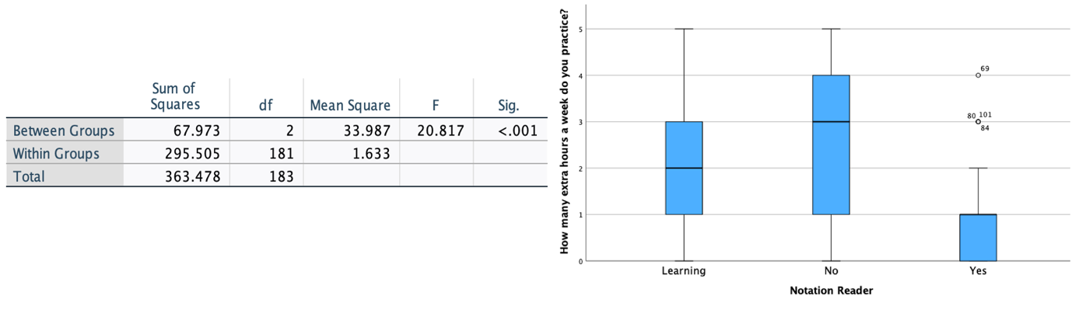

Figure 10: ANOVA Test and Simple Boxplot of how many Additional Hours are Practiced by Choristers

ANOVA was used to compare the means of practice durations among different groups of choir members based on their music reading ability (Figure 10). The table provides the results of the analysis of variance for the number of extra hours choir members practice per week, categorised by their music reading ability (Learning, No, Yes). The between-groups sum of squares (n=67.973) represents the variability due to the differences between the groups, while the within-groups sum of squares (n=295.505) represents the variability within each group. The between-groups degrees of freedom is (n=2), the within-groups degrees of freedom is (n=181) and the between-groups mean square (n=33.987) is much larger than the within-groups mean square (n=1.633). This indicates greater variability between the groups compared to within the groups. The F-value of 20.817 indicates a greater likelihood that the observed differences between group means are statistically significant. The Boxplot illustrates learners practice between 1 and 3 extra hours (m=2), non-readers between 1 and four (m= 3) and notation readers practice between 0 and 1 (m=1) extra hours per week. A p-value of less than .001 suggests that the differences between the group means are highly significant. This means that there is strong evidence to reject the null hypothesis.

Hypothesis 6
Hallam & Creech (2016) state that age can play a significant role in the personal benefits that individuals derive from participating in a choir. As people progress through different stages of life, their motivations, needs and experiences evolve, influencing how they perceive and benefit from choir membership. Understanding the link between age and the personal benefits of choir participation (Figure 11) can help tailor choir programs to meet the diverse needs of members.
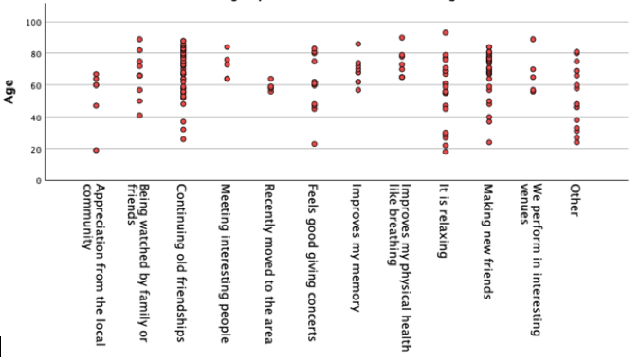
Figure 11: Scatter plot of Choristers age by personal benefits of attending choir (Bonshor, 2017)
The following hypothesis was formed:
- The Null Hypothesis (H₀) is: Age does not have an impact on the personal benefits derived from participating in a choir;
- The Alternative Hypothesis (H₁) is: Age does have an impact on the personal benefits derived from participating in a choir.
An ANOVA test was carried out (Figure 12), finding that, between groups, the sum of squares (SS) is 7964.419 with 11 degrees of freedom (df). The mean square (MS) is 724.038. Within groups, the sum of squares is 39604.315 with 172 degrees of freedom, with the mean square being 230.258. The total sum of squares is 47568.734 with 183 degrees of freedom. The F-value is 3.144 and the significance level (Sig.) is less than 0.001, indicating that there is a statistically significant difference between the age groups. Therefore, the null hypothesis (H₀) can be rejected.
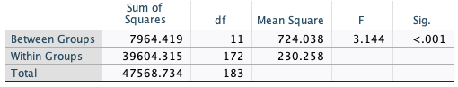
Figure 12: ANOVA Test of Age and Personal Benefits

Hypothesis 7
Bonshor (2017) states that positive feedback from a musical director can benefit participants to develop musical understanding. Evaluating this link (Figure 13), may help conductors meet the diverse learning needs of choir members.
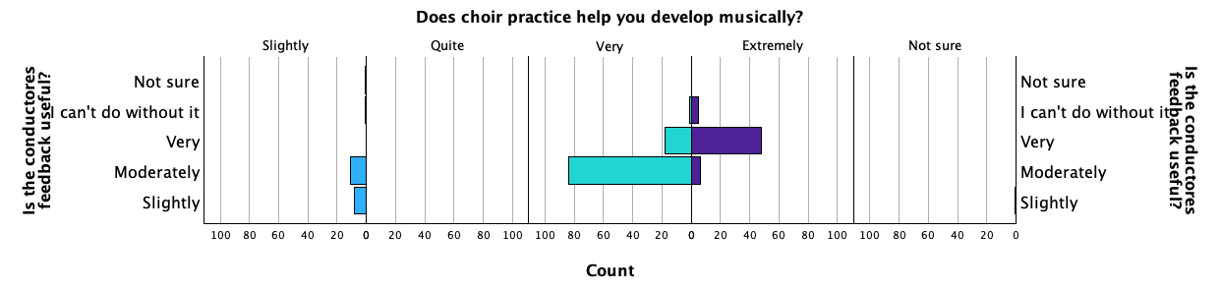
Figure 13: Conductors feedback
The following hypothesis was formed:
- Null Hypothesis (H₀): Positive feedback has no impact on the musical development of choristers;
- Alternative Hypothesis (H₁): Positive feedback has an impact on the musical development of choristers.
A One-Way ANOVA test was undertaken (Figure 14), finding between groups that the sum of squares was 62.545 with 4 degrees of freedom, the mean square was 15.636, the F-value was 33.929 and the significance level is less than 0.001, indicating that a statistically significant difference can be seen in the data. Therefore, the null hypothesis (H₀) can be rejected.
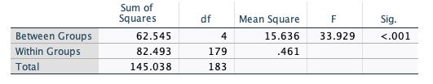
Figure 14: Does Conductors Positive Feedback Help Choristers musical development?

Hypothesis 8
Some choir members report their frustration that rehearsal time is often taken up with ‘note-bashing’ for those who cannot read music notation and that more could be achieved if all the choristers could do so (Rosenbaum, 2017). Therefore, the following hypothesis was formed:
- Null Hypothesis (H₀): The ability to read music amongst choristers does not have an impact in reducing rehearsal time to understand and learn the music to be performed;
- Alternative Hypothesis (H₁): The ability to read music amongst choristers does have an impact in reducing rehearsal time to understand and learn the music to be performed.
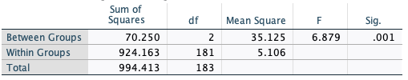
Figure 15: One-Way ANOVA of the impact on rehearsals non-notation readers have
A One-Way ANOVA (Figure 15) test was undertaken, finding, between groups, that the sum of squares (SS) was 70.250 with 2 degrees of freedom (df). The mean square (MS) was 35.125. Within groups, the sum of squares was 924.163 with 181 degrees of freedom, with the mean square being 5.106. The total sum of squares is 994.413 with 183 degrees of freedom. The F-value was 6.879, and the significance level (Sig.) was 0.001, indicating that a statistically significant difference can be seen in the data. Therefore, the null hypothesis (H₀) can be rejected and the alternative hypothesis (H₁) accepted.

Discussion
This study sought to explore the impact of gender, age, notation ability, and motivations for participation on any perceived wellbeing improvements and lifelong learning opportunities of choristers in several choirs located within south-west Wales. Drawing upon survey data from 184 participants, the findings, as summarised in Appendix 1, provide some useful insights into the demographic makeup of adult choirs and the ways in which various factors interact to influence participation and experience.

Response Rate and Participant Demographics
The estimated 61% response rate aligns with the work of Holtom et al. (2022) suggesting a reasonable level of engagement with the survey. The setting - where participants were likely given the opportunity to complete the survey during rehearsal - may have increased the rate of completion, a phenomenon discussed in Bryman et al. (2022). Nonetheless, the absence of identifiable data and the use of a pre-existing anonymised dataset limits the ability to assess non-response bias, a factor acknowledged by Gideon (2012) as potentially significant in survey research. Demographically, the data reveal a predominance of older adults (mean age = 64.2 years), supporting the argument that choirs are particularly attractive to retirees or those seeking meaningful later-life engagement. This aligns with the work of both Redman (2016) and Moss (2018), who suggest that lifelong learning and arts engagement in later life can offer cognitive, emotional, and social benefits. The slightly younger average age of female participants may indicate gendered differences in health, social engagement, or retirement patterns, but the lack of statistical significance (p = .116) means that no firm conclusions can be drawn on this point.

Age and Motivation to Attend (Hypotheses 2, 6 & 7)
Interestingly, while Cramér’s V (.275) suggested a weak-to-moderate association between age group and motivations for choir participation, the chi-square test (p = .3149) did not yield statistically significant results. This suggests that motivational factors may be consistent across age groups, reinforcing the idea that communal singing holds a universally appealing set of benefits. However, the ANOVA test in Hypothesis 6 (p < .001) demonstrated that the type of personal benefit reported does significantly vary by age, suggesting that, while motivations to attend may be broadly similar, the perceived outcomes differ across life stages. This supports the work of Maury, et al. (2022), who note that younger participants may be more focused on skill development or socialising, whereas older participants may derive greater psychological or health-related benefits. Hypothesis 7 adds an important pedagogical layer by showing a strong association for all ages between positive feedback from musical directors and perceived musical development (p < .001), agreeing with the work of Bonshor (2017). This reinforces the literature around adult learning and motivation as articulated by Sobol (2019), underscoring the importance of positive reinforcement in adult music education.

Age and Attendance (Hypothesis 3 & 6)
While the ANOVA results of Hypothesis 3 indicate no significant corelation between choristers’ age and their attendance at rehearsals, with a p-value is 0.708, it would seem reasonable to believe that older participants may have more flexible schedules post-retirement, potentially leading to higher attendance rates (Zhan, et al., 2025). A larger sample or longitudinal data may confirm this trend. Hypothesis 6 also adds the suggestion that age has an impact on the personal benefits derived from participating in a choir, inviting further research on the advantages of attendance for participants of all ages.

Music Reading Ability and Participation (Hypotheses 4, 5 & 8)
One of the clearest findings in this study concerns the role of music reading ability. Hypothesis 4 established that learning to read music is a statistically significant factor in joining and continuing in choir (p = .002), which aligns with the work of (Garisi, 2024). This is further reinforced by the ANOVA results in Hypothesis 5 (p < .001), which found that those who cannot read music practice for significantly more hours than proficient readers. This supports conclusions reached by Carlson (2023), who notes that non-readers must compensate with additional effort and may experience more anxiety or preparation stress. Similarly, Hypothesis 8 found, like in the work of Rosenbaum (2017), a significant relationship between music reading ability and perceptions of rehearsal efficiency, with those unable to read music contributing to more time spent on ‘note-bashing’. This supports anecdotal feedback and could influence future rehearsal structures devised by music directors and support mechanisms, such as the use of practice tracks or sectional rehearsals (Carter, 2017).

Limitations
Several important challenges that this researcher encountered need to be considered when interpreting the findings. The dataset used in this document may vary in terms of data accuracy, completeness and reliability, possibly containing errors, missing values, or inconsistencies that may affect the analysis and conclusions made (Bergin, 2018). Using anonymised data meant that some contextual or follow-up information (e.g., non-response reasons, chorister experience levels) could not be explored (Bryman, et al., 2022). Furthermore, the reliance on self-reported data may introduce bias but, nevertheless, the robust sample size and statistical methods provide a meaningful snapshot of choir participation and the reasons behind it. Conducting an exploratory data analysis to identify missing data, outliers, or inconsistencies mitigated this somewhat as third-party datasets may come with inadequate documentation or missing data (Rumsey, 2016). This lack of information did cause some difficulties in terms of understanding the way in which the data was collected from the choral participants, and whether all of it was suitable for this research. Perhaps before using a dataset that a researcher has not collected themselves, ensuring access to sufficient documentation is vital or, as an alternative, having the opportunity to clarify issues with the dataset provider would be helpful (Cohen, et al., 2017).

It is acknowledged that the dataset did not align perfectly with the objectives of the research, with much of the data collected for promotional material rather than understanding information about wellbeing and lifelong learning. Evaluating more carefully whether this dataset was appropriate for SPSS testing would align with the work of Salcedo & McCormick (2020). Furthermore, perhaps using data manipulation techniques to adapt the dataset could have been used, but caution would need to be exercised by introducing accidental bias in altering or amending the dataset (Baker & Hawn, 2021). It is unclear whether the dataset included inherent biases or ethical issues based on the way they were collected (BERA, 2024). However, there were no known ethical issues as the data did not include personally identifiable information or other sensitive data (Creswell & Creswell, 2017), nor was it subject to any licensing agreements or copyright restrictions that dictated how the data could be used, shared, or redistributed. While using this dataset, which provided some valuable insight on which to base results and conclusions in terms of wellbeing and lifelong learning amongst choir members, it is acknowledged for future research that it will be essential to address the challenges previously listed to ensure that any analysis is valid, reliable, and ethically sound (Andersson, et al., 2024).

Whilst Panchenko & Samovilova (2020) acknowledge that using secondary data can be an effective way to conduct research, this researcher finds of interest their discussion concerning statistical software. Interrogating the data set with SPSS software proved challenging to this researcher for several reasons. Whilst acknowledging that SPSS is a powerful tool for statistical analysis (Mayers, 2013), its complexity felt overwhelming to this researcher with very limited quantitative research experience. Aligning with difficulties Field (2024) addresses, issues encountered by this researcher included navigating its user interface; inputting data; trawling menus and choosing correct tests, and interpreting the output was a steep learning curve. While comprehensive, its use felt unintuitive to this researcher who is unfamiliar with statistical software (Pallant, 2020). Additional time was given to double and triple checking data preparation, coding variables or handling missing data, which could have led to inaccurate results. Mastering SPSS will be highly beneficial in future research in this area, as it will provide a wider range of advanced statistical techniques that are essential for many fields of research not undertaken within this research (Salcedo & McCormick, 2020). With additional training, practice and a dataset more suited to statistical analysis, future research could be more robust by using SPSS more efficiently and extensively to conduct robust statistical analyses and interpret complex data more effectively.

Furthermore, it is noted that, despite its increasing prevalence and popularity, this researcher preferred the Harvard referencing system for its familiarity. Although the APA referencing style is increasingly used in academic writing, particularly in the social sciences, psychology, and education (APA, 2020), it was thought by this researcher that learning the SPSS programme was enough of a challenge, without adding the additional learning journey required adopting a new referencing system. However, as more institutions and journals adopt the APA style, it is important for this researcher to familiarise themself with its rules and guidelines to ensure that future work aligns with current academic standards (Pears & Shields, 2022). Future research in this area could benefit from a mixed-methods approach, incorporating interviews or focus groups to add depth to the statistical findings. Longitudinal studies may also capture changes over time in motivation, wellbeing, or skill development.

Conclusions
This study set out to investigate how gender, age, notation ability, and motivations influence perceived wellbeing and lifelong learning among choristers in south-west Wales. Demographically, the study confirmed that adult choirs in this region are primarily composed of older participants, particularly retirees, with an average age of 64.2 years. While female participants skewed slightly younger, gender did not significantly influence participation patterns. Motivations to attend rehearsals appeared consistent across age groups, but the perceived benefits varied significantly by age. Younger participants leaned toward social and developmental motivations, while older individuals tended to emphasise wellbeing and emotional fulfilment, aligning with Ververis & Marshall (2018) and Shim & Sim (2020) on adult learning and later-life engagement.

A key contribution of this study was the nuanced understanding of music reading ability. Participants who could not read music invested significantly more hours in practice, highlighting a pedagogical imbalance and the additional burden placed on those with lower levels of formal musical literacy, as discussed by Rosenbaum (2017). Another finding was the importance of musical directors in shaping the learning experience of their choristers. Along with Bonshor (2017), strong associations were found between receiving positive feedback and the perception of musical development, reinforcing the importance of supportive leadership in adult education. Furthermore, perceptions of rehearsal inefficiency linked to music reading difficulties illustrate the need for more accessible rehearsal strategies, particularly in amateur or mixed-ability groups such as the participants in this research (Coffman, 2018).

However, several limitations temper the strength of these conclusions. The use of a third-party anonymised dataset limited the researcher’s control over variable selection, data completeness, and contextual insights (Heumann & Shalabh, 2024). This means that it is difficult to assess and make judgements upon whether the methods used to generate the data were reliable and/or valid. Some variables were originally collected for promotional purposes, potentially misaligning with the study’s focus. Additionally, the researcher’s limited experience with the statistical analysis tool SPSS may have constrained the depth of analysis (Field, 2024). Nonetheless, the study provides a foundation for further exploration and highlights important pedagogical and policy-related considerations in adult choral engagement.

Recommendations
- Prioritise Informal Learning in Rehearsals
Choir directors should support non-readers with tools like audio tracks or visuals, reducing “note-bashing” and enhancing inclusivity (Cooper, 2017).
- Implement Age-Differentiated Support Strategies
Recognising age-related needs, choirs could offer optional workshops on wellbeing for older adults (Trost, 2022) and skill-building for younger singers (Chapman & Morris, 2021), aligning with individual goals and motivations.
- Strengthen Positive Reinforcement Practices
Musical directors should give regular feedback to boost progress, motivation, and belonging, especially for less confident singers (Bonshor, 2017).
Future research could combine surveys with interviews or focus groups to better understand the motivations and wellbeing impacts of choir participation, with longitudinal studies revealing how these experiences develop over time (Pentikäinen, et al., 2023).

APPENDIX 1: Hypothesis Summary Table
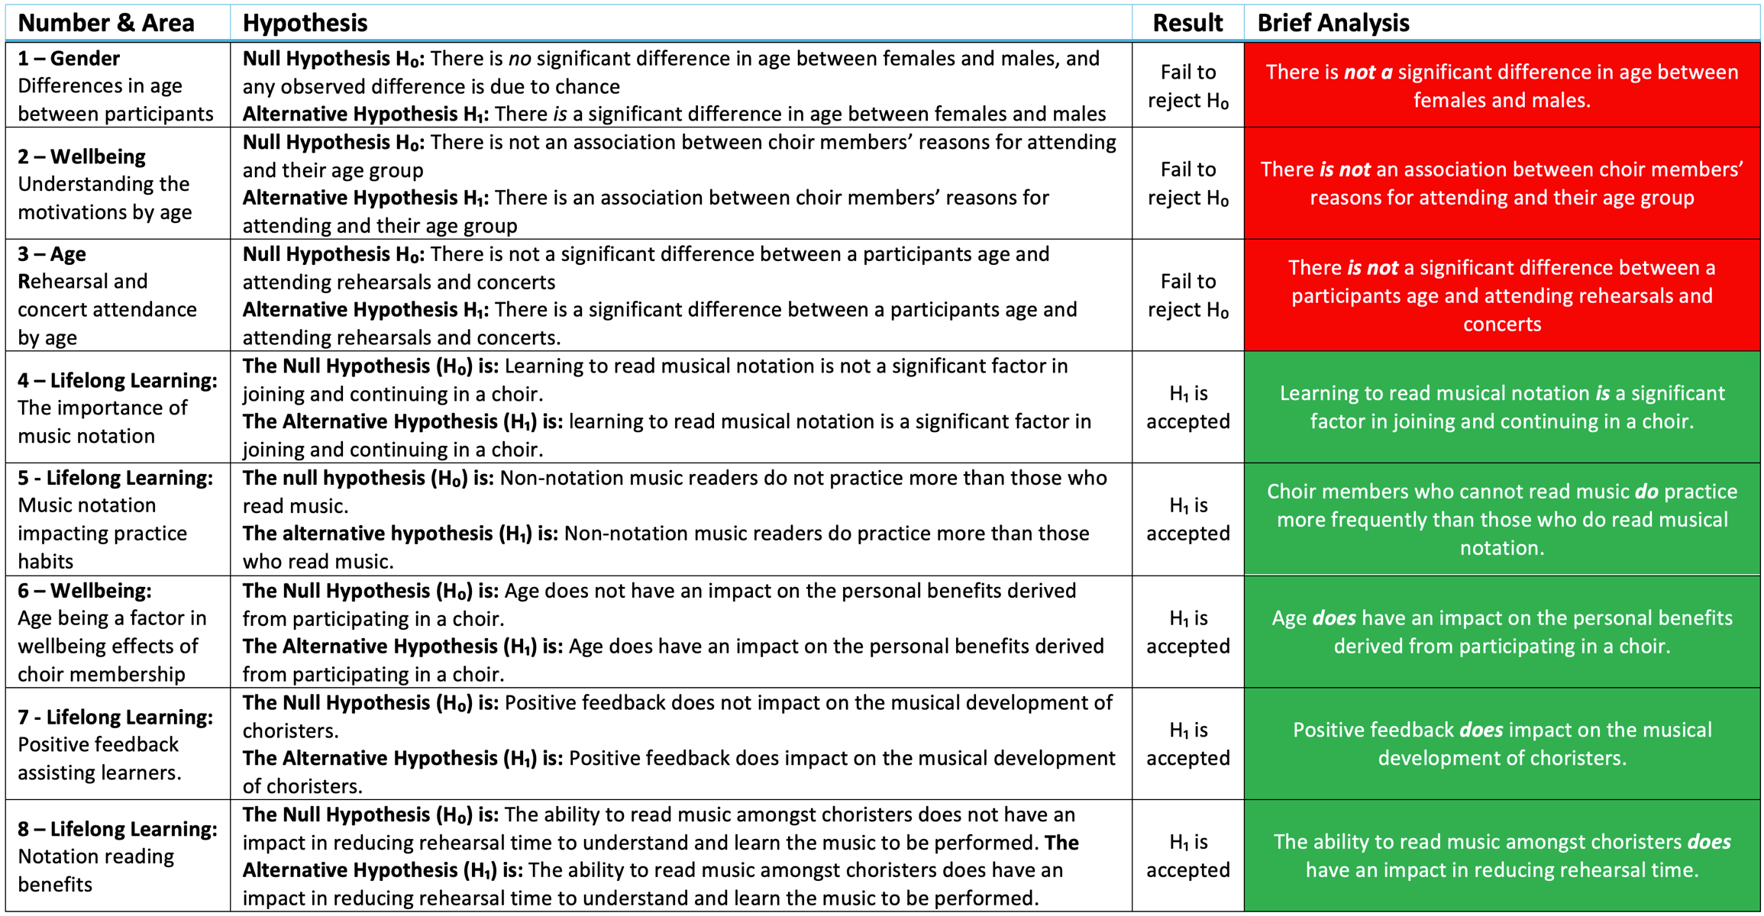

CITATIONS

