  Component One:  What are the key skills required when working in the housekeeping team? 750 words (+/- 10%)  Contribution to Overall Module Assessment: 25% | Student No: | Adriana Petran  2210809
 | Module Title: | Operating Hotel Facilities
 | Module Code: | BMIH4006
 | Lecturer: | Lisa-Marie Bassler
Introduction:
It takes a certain set of important talents to work in the housekeeping team in the hospitality business to guarantee cleanliness, guest happiness, and efficient operations. In this diary entry, I want to outline what I have learned and how I have been thinking about thlIe essential abilities needed for the cleaning crew. I will also go over how important this subject is to the hospitality sector and how theoretical knowledge may be use in real-world business situations.
Key Skills for the Housekeeping Team:
During my research and study about the key skills needed for the housekeeping team, I have discovered a few crucial abilities that support efficient functioning. To maintain lofty standards for cleanliness, paying close attention to detail is crucial. To guarantee that all spaces are pristine and attractive, Jones (2010) emphasizes the importance of precision in cleaning methods. Additionally, effective communication skills are necessary for working with coworkers and responding quickly to visitor requests or complaints (Wood, 2013). Additionally essential to ensuring that housekeeping duties are accomplished within allotted time constraints is the capacity to work quickly and manage time effectively (Fallon & Rutherford, 2010). Moreover, physical endurance and stamina are crucial for housekeeping jobs because they frequently entail demanding tasks like carrying heavy objects or standing for extended periods of time (Raghubalan & Raghubalan, 2016). Finally, it is critical to safeguard visitor respect and confidentiality of their personal space by acting with professionalism and honesty (Mullins & Dossor, 2013).
Personal Reflections:
I have gained an appreciation for the significance of these essential skills via the experiences that I have had personally while working with the cleaning crew. A great deal of attention to detail has been necessary to ensure that every area has been thoroughly cleaned and that no aspects have been overlooked. Interacting with customers and collaborating with coworkers to provide prompt responses to customers' requests and expectations have provided me with the opportunity to learn about the significance of effective communication. My talents to manage my time have made it possible for me to prioritise my responsibilities, complete them in a timely manner, and ensure that all the rooms are ready for guests to check in without any delays. My ability to bear the physical demands of domestic chores and successfully complete my work is directly correlated to the level of physical stamina I possess. In addition, I have been successful in gaining the trust of guests and maintaining the positive reputation of the hotel by maintaining an elevated level of professionalism and integrity.
Application of Theoretical Knowledge in industry:
My performance on the housekeeping team has improved because of my increased capability to put into practise the theoretical knowledge I have gained through academic resources and industry research. For instance, by reading the instructions that Ferdinand and Kitchin (2017) offer in their book on the management of events, I have gotten a deeper understanding of the significance of maintaining cleanliness standards throughout a variety of hotel events. I have been able to identify potential problems and ensure that the cleaning team is prepared to manage the specific demands of each event by utilising this experience, which has allowed me to do so.
Importance of the Topic:
The hotel industry places a great emphasis on the discussion of the essential capabilities of the cleaning staff, and this conversation is given an elevated level of importance. A hotel's profitability and reputation are impacted by fundamental aspects like the cleanliness of the premises and the satisfaction of its guests. When guests have expectations that the space, they are staying in is immaculately clean, any failure to live up to those standards can result in negative reviews, a reduction in customer loyalty, and even significant financial losses. By acquiring the fundamental skills that have been discussed, housekeeping staff will be able to deliver consistently high-quality services, go beyond what customers anticipate, and contribute to an outstanding overall experience for guests.
Conclusion:
The fundamental skills that must be possessed by members of the housekeeping staff play an important part in the hotel industry's ability to maintain a clean environment, satisfy guests' needs, and run efficiently. I have gained a deeper understanding of the importance of professionalism, efficient time management, careful attention to detail, and clear and concise communication in my line of work because of both introspection and the actual application of academic knowledge. These qualities are required to preserve the hotel's reputation while adhering to stringent requirements for the hotel's cleanliness and the satisfaction of its guests. I aim to make a positive contribution by continually improving and expanding upon these skills.
References:
Fallon, M. & Rutherford, D. (2010) Hotel Management and Operations. London: Pearson.
Ferdinand, N. and Kitchin, P. (2017) Events Management - An International Approach. 2nd ed. London: SAGE Publications Ltd.
Jones, T. (2010) Professional Management of Housekeeping Operations. London: Wiley.
Mullins, L. and Dossor, P. (2013) Hospitality Management and Organisational Behaviour. 5th ed. Harlow: Pearson.
Raghubalan, G. and Raghubalan, S. (2016) Hotel Housekeeping - Operations and Management. 3rd ed. India: Oxford University Press.
Wood, R. (2013) Key Concepts in Hospitality Management. London: Sage.
Word Count | 768

Component Two:
Contribution to Overall Module Assessment: 25%
In this scenario – You have just been promoted to team leader for a floor within the hotel. A guest complained that on their arrival, their room had not been properly cleaned. Create an action plan and answer the following questions.

Problem | Why did it happen? | What are you going to do? | How will you prevent this from happening in the future? | What measures would you introduce to improve team effectiveness?
The issue in this case is that a visitor has expressed dissatisfaction over the state of their room upon arrival. | I need to go into the underlying reasons of the problem to comprehend why the room was not cleaned thoroughly. Probable causes could be:  a) Miscommunication: There could have been a misunderstanding about the condition of the room between the front desk staff and the housekeeping crew. (Jones, 2010).  b) Time constraints: There may have been a high number of check-ins that overwhelmed the housekeeping personnel, causing hurried cleaning operations. (2010) Fallon and Rutherford.  c) Insufficient training: It is possible that the team members in charge of cleaning the room were not properly instructed on the requirements for cleanliness at the hotel. (2016) Raghubalan and Raghubalan.  d) Lack of oversight: To make sure that the cleaning procedure was thorough, there may not have been adequate supervision or quality control procedures in place. (2013) Mullins & Dossor. | I must confront the problem right away and take the necessary steps to make things right as the team leader. The subsequent actions will be taken:  a) Express regret and sympathy: I will express my personal regret to the guest for their inconvenience and reassure them that their issues will be addressed.  b) evaluate the room: I will physically evaluate the room to determine the degree of the cleaning error and to spot any other problems that require attention.  c) Correct the cleaning issue: I will decide for the room to be fully cleaned and to satisfy the hotel's standards for cleanliness.  d) Offer the guest appropriate restitution or acts of kindness to win back their confidence and happiness, such as a complementary lunch or an upgrade. | I am going to put the following precautions into effect to stop such occurrences from occurring again:  a) Improved communication: I will do this by putting in place an organized system for sending information about guests' requests and the status of their rooms to the front office and the housekeeping team (Jones, 2010).  b) Training and development: I will give the hotel's housekeeping staff in-depth instruction on the standards of cleanliness, practices, and attention to detail. Sessions of refresher training will be held frequently to reinforce these requirements (Raghubalan and Raghubalan 2016).  c) Quality control checks: To make sure that rooms are consistently cleaned to the necessary standards, I will institute routine quality control checks. This can involve using technology to monitor and track cleaning operations, checklists, or random inspections (Mullins & Dossor 2013).  d) Comments and improvement loop: I will promote open dialogue within the team so that members can share comments on difficulties or potential areas for development. Using the comments, I have received as a guide, I will develop a framework for ongoing improvement. | I will introduce the following measures to increase team effectiveness:  a) Clearly defined roles and duties: I will make sure that everyone in the team is aware of their specific obligations and expectations (Fallon and Rutherford 2010)  b) Regular team meetings: I will hold regular team meetings to talk about goals, share updates, handle difficulties, and promote cooperation among team members. (Jones, 2010).  c) Training and professional development: To help the team members improve their abilities and expertise, I will offer chances for continued training and professional development.  I am confident that by putting these steps into place, we will be able to satisfactorily handle the guest's issue, avoid similar problems in the future, and improve the general effectiveness of the housekeeping team.

Component Three:
Contribution to Overall Module Assessment: 50%
Your task is to create and prepare a presentation following the detailed scenario provided below.

As the floor housekeeping manager and given the recent guest complaints you need to put together a basic training presentation for your colleagues within the housekeeping team to get the best out of them, ensure that brand standard is being achieved and that Health and Safety procedures are also being followed.

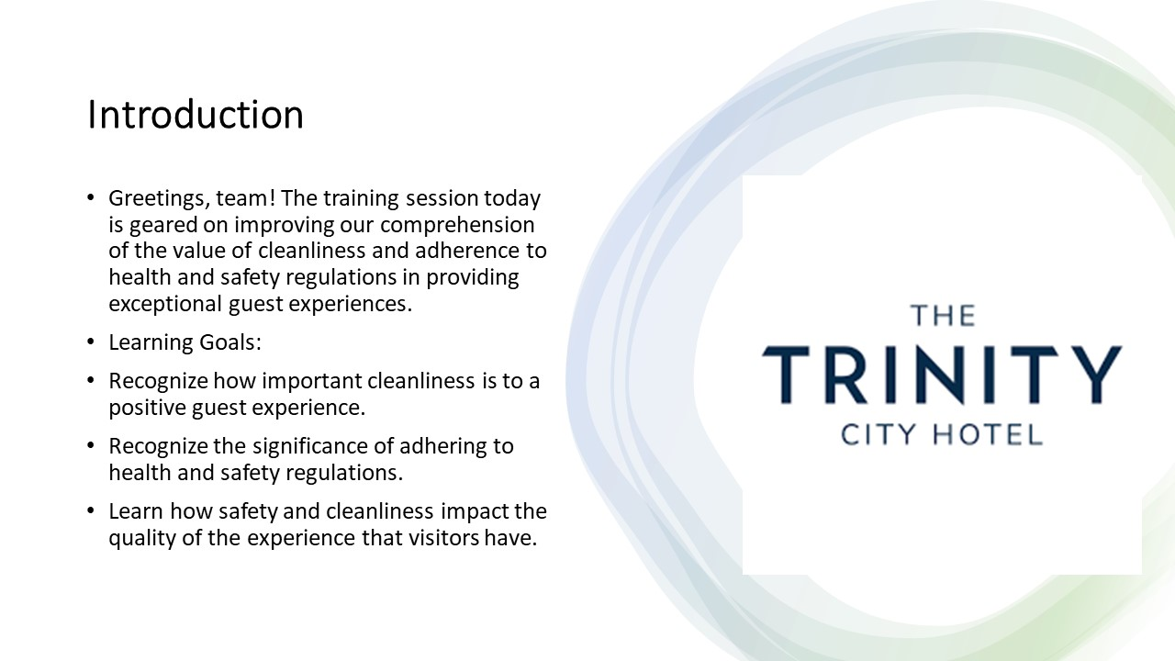

Training Notes:
- We will examine how visitor impressions and general satisfaction are impacted by cleanliness, emphasizing its direct connection to favorable evaluations and repeat business.
- To keep the workplace secure and safe, we will go through the vital function that health and safety regulations play in protecting both visitors and team members.
- We will look at examples from real-world settings to show how upholding strict health and safety regulations and lofty standards for cleanliness encourages great guest experiences and builds the reputation of our hotel.

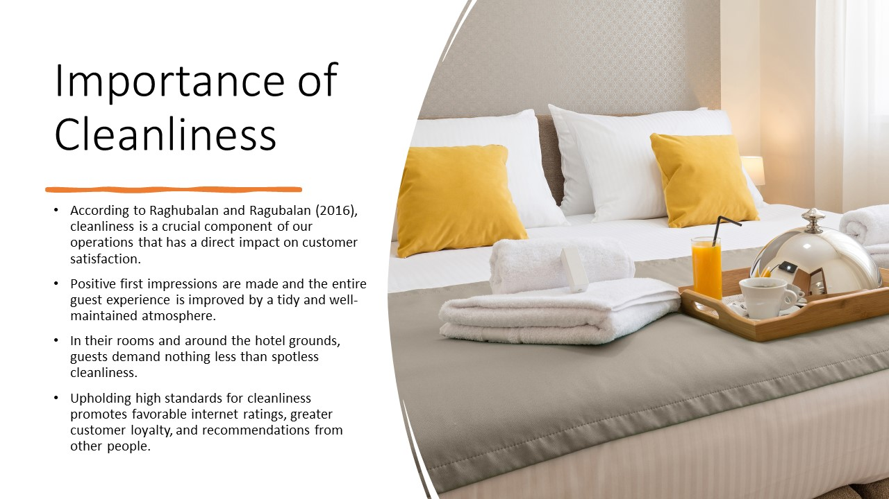

Training Notes:
- Emphasize the role that cleanliness plays in enhancing both the entire guest experience and guest satisfaction.
- Give particular instances or numbers that illustrate the link between cleanliness and visitor happiness.

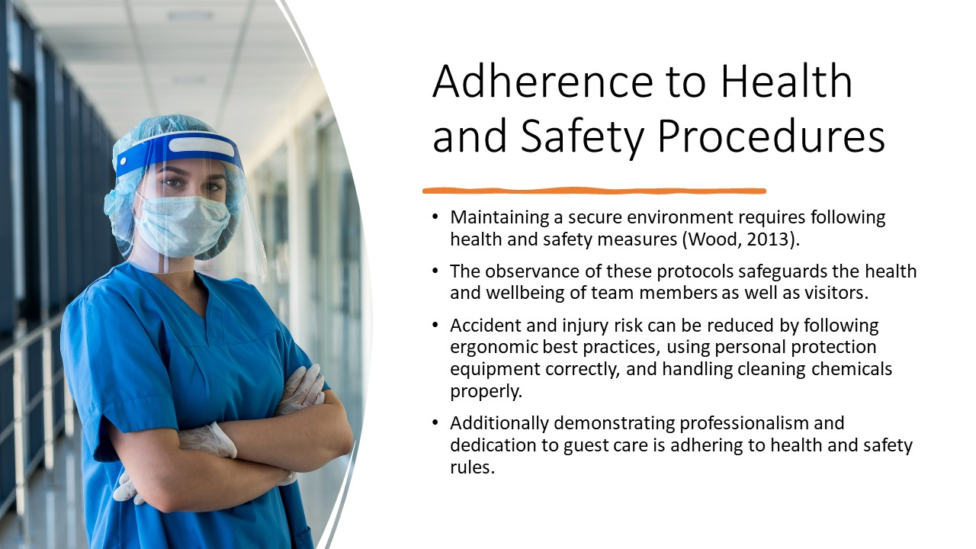

Training Notes:
- To guarantee the wellbeing of both visitors and team members, emphasize the value of adhering to health and safety regulations.
- Give concrete instances or hypothetical situations to demonstrate the effects of disregarding health and safety regulations.

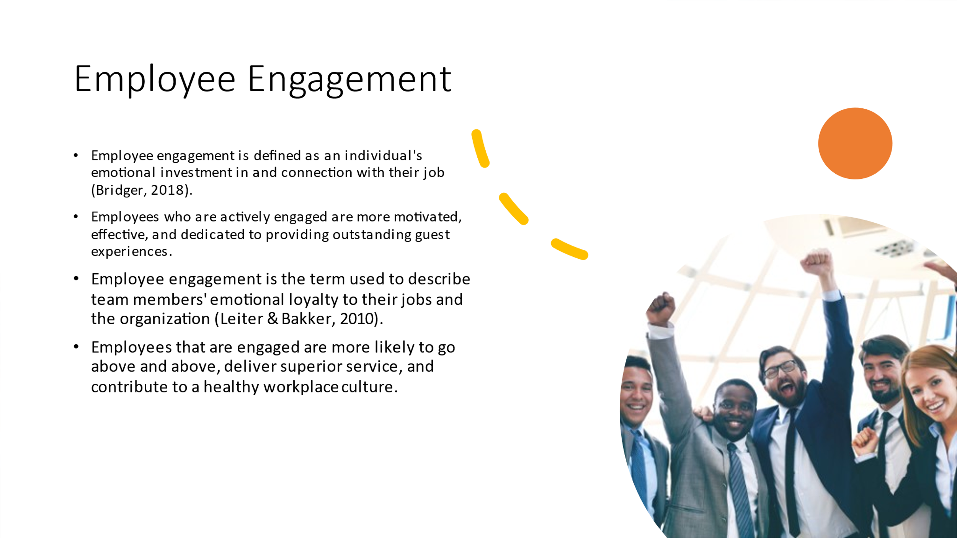

Training Notes:
- Introduce the idea of employee engagement and how it affects the effectiveness of the team and the satisfaction of the guests.
- Discuss how our team's strategy for providing exceptional guest experiences can be inspired and guided by Marriott International's employee engagement initiatives.

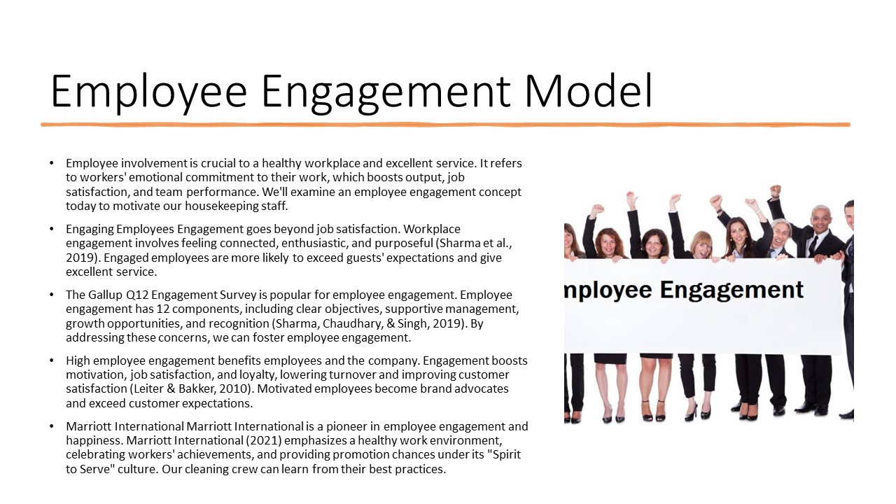

Training Notes:
- Delivering outstanding service and fostering a positive work environment both depend on engaged employees.
- Employees should be emotionally invested in and dedicated to their jobs.
- As a well-known employee engagement methodology, introduce the Gallup Q12 Engagement Survey.
- Describe the 12 survey's defining characteristics, such as clear expectations, encouraging management, opportunity for advancement, and recognition.
- Talk about the advantages of employee engagement, such as improved drive, satisfaction, and loyalty.
- Mention Marriott International as an illustration of a company with a strong culture of employee engagement.
- Draw attention to their "Spirit to Serve" culture and top practices that we might adopt.
- Stress the value of putting an employee engagement approach in place to improve performance and customer satisfaction.

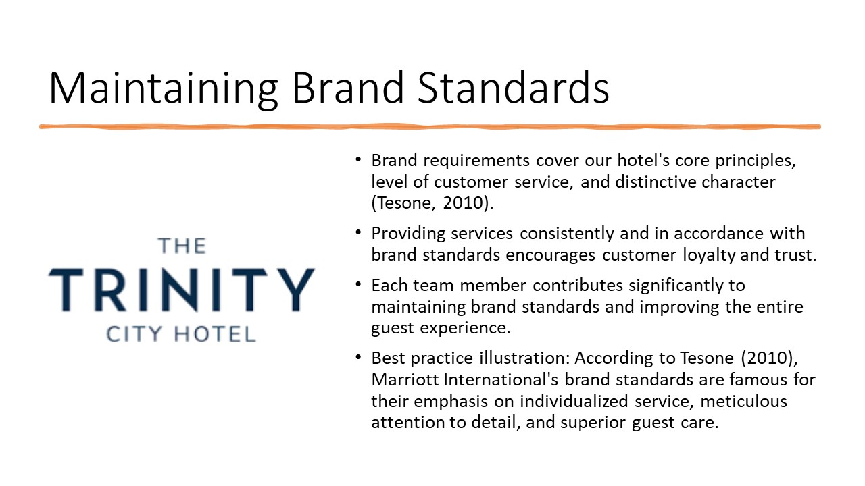

Training Notes:
- Emphasize how crucial it is to uphold brand standards to maintain consistency and satisfy customer demands.
- Give real examples or tales of how upholding brand standards enhances customer loyalty and happiness.

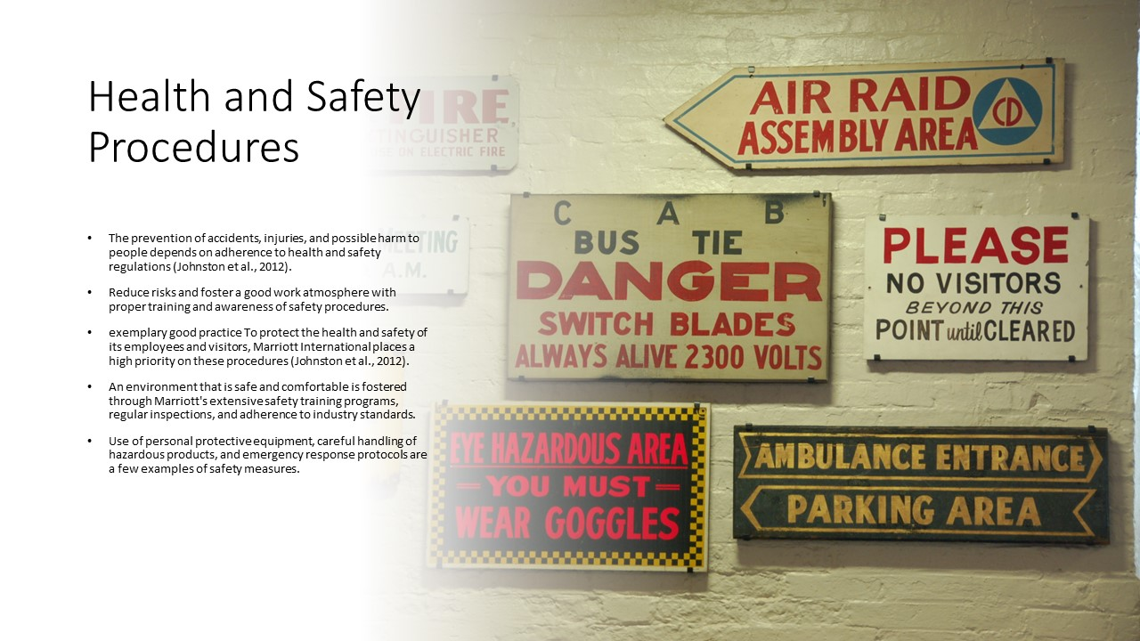

Training Notes:

- To provide a secure environment for both guests and team members, emphasize the necessity of following health and safety standards.
- Highlight the unique health and safety procedures that apply to our hotel and give examples of how they help create a secure environment in practice.

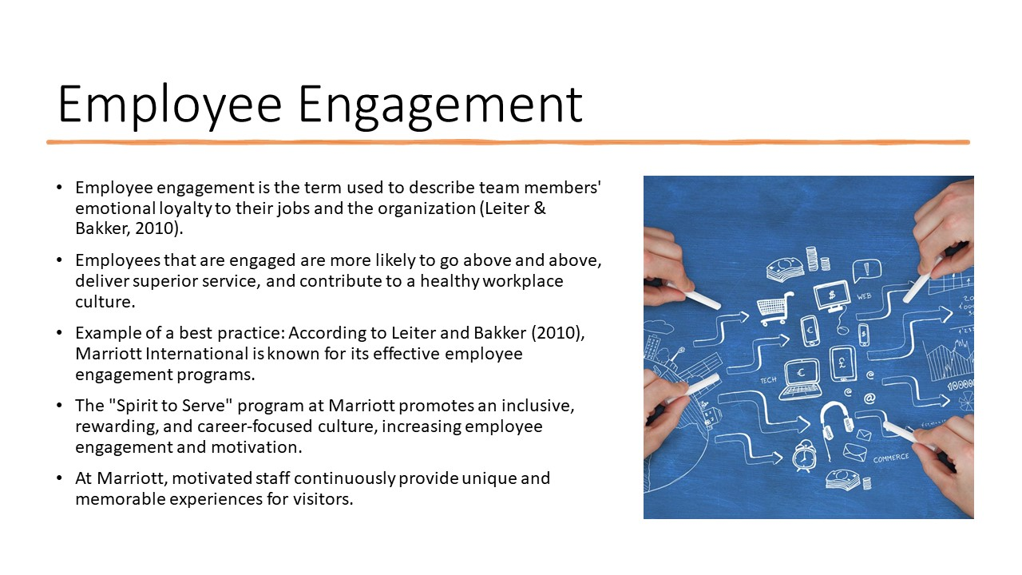

Training Notes:
- Talk about how crucial employee engagement is to achieving high performance and providing remarkable visitor experiences.
- Talk about the various tactics and initiatives that the housekeeping team can utilize to encourage employee engagement, such as reward systems, frequent feedback meetings, and chances for professional advancement.

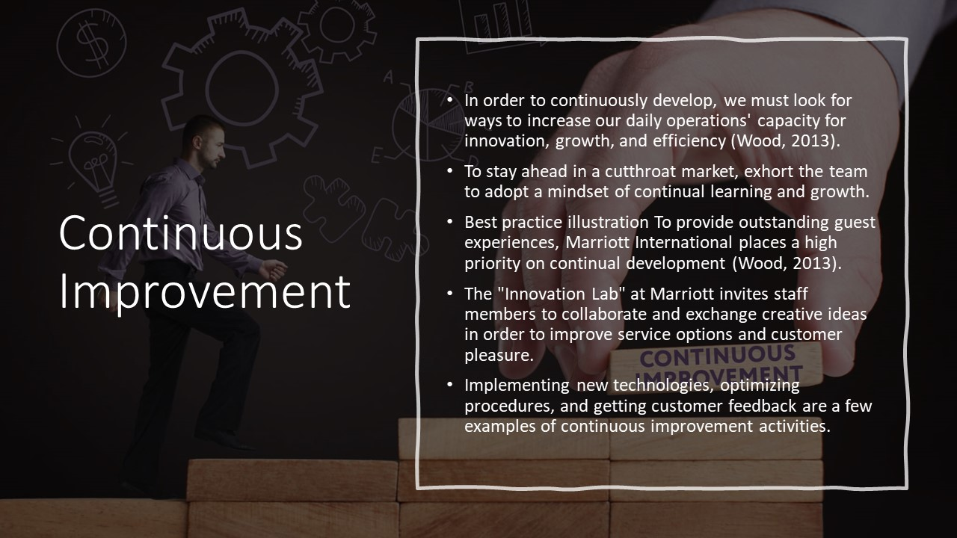

Training Notes:
- Introduce the idea of continuous improvement and explain how it helps teams perform better and provide outstanding customer service.
- Discuss with the team how we may actively contribute to the continual improvement of our housekeeping operations, such as by exchanging ideas, taking part in training sessions, and remaining current with market trends.

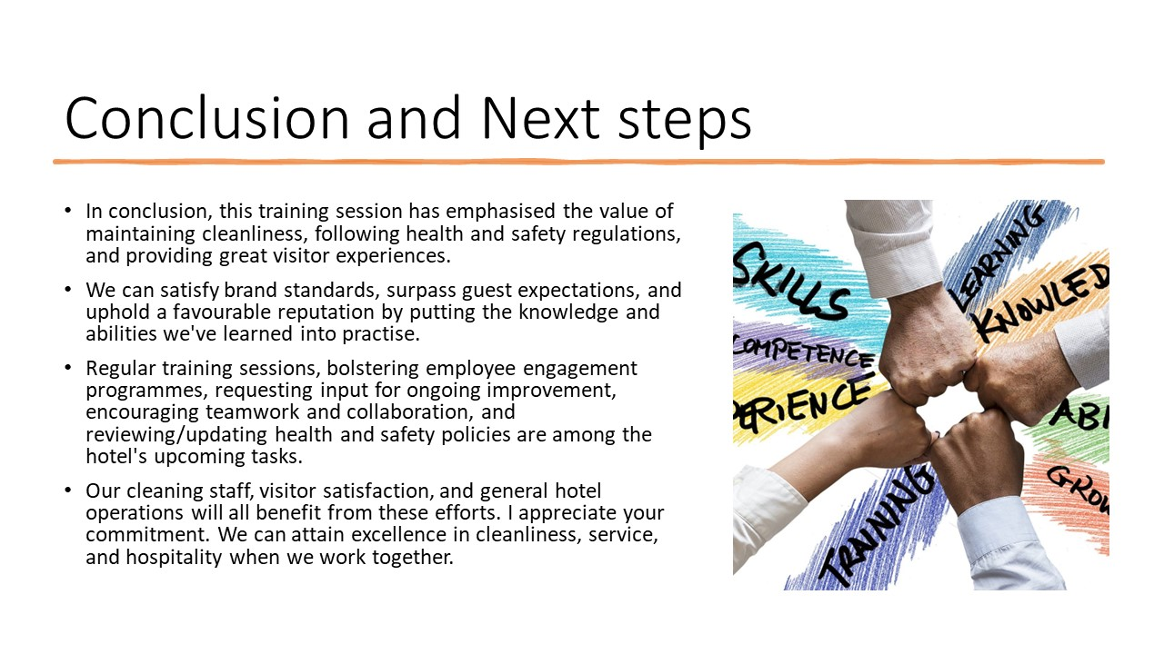

Training Notes:
- Write a summary of the main ideas discussed during the training.
- Reiterate the value of maintaining cleanliness, following health and safety regulations, and providing superb guest experiences.
- Stress the important part that each of us plays in maintaining the hotel's brand standards.
- Stress the need of continued training and constant improvement.
- Promote open communication, cooperation, and teamwork among team members.
- Discuss the value of getting input from visitors and coworkers to find areas that can be improved.
- Mention how frequent performance reviews and rewards schemes are implemented to encourage and honor excellent achievement.
- Share the next actions, such as planning further training sessions, putting new practices into place, or giving team members particular tasks.
- Thank them for their involvement and commitment to providing exceptional service as you wrap up the presentation.

References
Bridger, E. (2018) Employee engagement: a practical introduction. 2nd ed. HR Fundamentals. London: CIPD and Kogan Page.
Cottrell, S. (2019) The Study Skills Handbook. 5th ed. London: Red Globe Press.
Fallon, M. & Rutherford, D. (2010) Hotel Management and Operations. London: Pearson.
Gallup. (2021). Q12 Engagement Survey. Retrieved from [https://www.gallup.com/workplace/356063/gallup-q12-employee-engagement-survey.aspx]
Jones, T. (2010) Professional Management of Housekeeping Operations. London: Wiley.
Leiter, M. P., & Bakker, A. B. (2010). Work Engagement: A Handbook of Essential Theory and Research. Psychology Press.
Marriott International. (2021). Our Culture. Retrieved from [https://www.marriott.com/default.mi?scid=104b20e0-89a2-4bc7-92da-d28a0eb2536a&gclid=CjwKCAjwpayjBhAnEiwA-7ena-22-nnZ35fbL4tANnUmUhwnpqX7J3xsOFy5AMnj8ZC6bHclwNhp2hoCHDsQAvD_BwE&gclsrc=aw.ds|
Mullins, L. and Dossor, P. (2013) Hospitality Management and Organizational Behaviour. 5th ed. Harlow: Pearson.
Raghubalan, G. and Raghubalan, S. (2016) Hotel Housekeeping - Operations and Management. 3rd ed. India: Oxford University Press.
Sharma, N., Chaudhary, N., & Singh, V. (2019). Management Techniques for Employee Engagement in Contemporary Organizations. IGI Global.
Wood, R. (2013) Key Concepts in Hospitality Management. London: Sage.

