A child’s experience between the ages of 0 – 5 years will affect the
Rest of their lives

Lifespan

Introduction: From embryo throughout childhood, the human mind undergoes different changes. Erickson and Piaget have two different theories relating to lifespan development that will be examined among all other theories.A child’s experience in the first years of their life will have an impact on the rest of their life as there is increase brain development at this age. Childhood is a period in one's life that is very important. We do not know the causes of mental health problems, but it is known that many mental health problems occur as a result of exposure to harmful and stressful events in childhood. These adverse childhood events cause severe harmful changes to the brain's chemical composition. Due to this, these children experience problems in their adulthood that have a negative impact on their lives.
According to Ericson, Children between the ages of 3 and 6 begin to explore their surroundings and gain more control over their choices. Children can develop a sense of purpose by successfully completing this stage. Research shows that the mother's interactions with their child during and after a stressful experience can have a lasting impact on whether the experience was a positive, negative, or neutral long-term effect. (An & Cooney, 2006). The results support previous studies suggesting that early life factors can play an important role in promoting resilient health outcomes over the life course. A parent has a great influence on the life of a child as they are usually the first role model and children look up to their parents. The parent should show a good example as every upbringing last longer in the life of the growing child. Piaget suggested that using heuristic play (discovery learning) helps children learn to find things out for themselves.

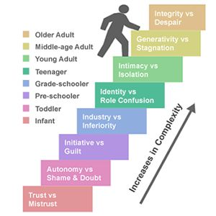
ERICSON THEORY
Ericson identifies eight stages of development throughout the life span. According to (An & Cooney, 2006), Each stage has its own developmental obstacle that must be addressed in order to attain optimal growth at that and later stages of life.
- Trust versus Mistrust (0 -1 1/2years): Children in this category rely on parents for their needs. If their needs are met, they establish trust but failure will result in the Mistrust of the parents and can equally exist throughout life.
- Autonomy versus shame: stages of development between ages( 18months – 3years). The child develops shame when their actions are met with negative emotions and thus lacking autonomy.
- Initiative Versus Guilt: A child between ages (4-5) shows signs of initiative and taking actions of their own and felt a sense of guilt when action is not appreciated. This can go a long way to affect a child sense of initiative in similar situations.
- Industry Versus Inferiority: The period that occurs between the ages of 6 and 12 years is dedicated to building a feeling of self-pride and success.
Identity Versus Role Confusion: This is the stage where they begin to develop their own identity of whom they want to be and failure in this stage can result in confusion.
Intimacy Verus Isolation: It is all about developing good relationships with others in early life. Success enables you to build dedicated, long-lasting, and supportive. Generativity Versus Stagnation: An adult in this stage will want their impacts to be felt and want to contribute, lack of success brings the feelings of stagnation,
Integrity Versus Despair Those who fail during the last phase of life will feel as though their lives have been wasted and will have several regrets. The individual will experience bitterness and sadness as a result of their actions.

- old age and is characterised by a desire to reflect on one's life.

Thi to
This Photo by Unknown Author is licensed under CC BY-NC

This Photo by Unknown Author is licensed under CC BY-SA

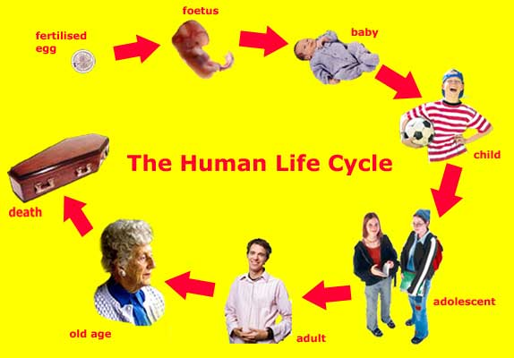
Piaget suggested that using heuristic play (discovery learning) helps children learn to find things out for themselves. (MacLeod-Brudenell 2004)
Piaget felt, however, that children should discover their world themselves 'each time we educate the kid we hinder the child from finding it' self-control and independence. Children can acquire willpower and determination by succeeding in this stage.
Piaget suggests that children in the Preoperational stage will start to think but are constrained by their view of the world because the child can not reason logically though they can pretend at this stage. According to Erikson (1968), young kid spends the first developmental stage absorbing and accepting what is given to them and required from the caregiver, which builds trust or distrust in others and the world. As the newborn develops a sense of trust and distrust, the emphasis shifts to caring and interpersonal relationships with others.
Ericson believed that a child who has developed autonomy in toilet training will develop control over their body whereby if they are unsuccessful, they develop Shame and guilt. There is a link between childhood interactions with parents and adult adjustment, according to both clinical and non-clinical studies.
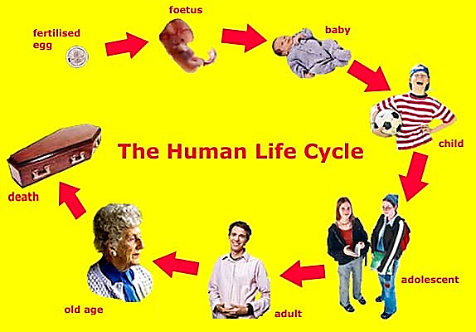
PIAGET THEORY OF COGNNITIVE BEHAVIOUR DEVELOPMENT
Schemas (building blocks of knowledge)
Processes that enable the transition from one stage to another (assimilation and accommodation equilibrium)
Stages of Development:
Sensorimotor(0-2years) - children simply behave - they do not think.
Preoperational (2-6years)- children start to think, but they are constrained by their own views of the world.
Concrete operational(7-12years) - children start to use logical rules to come to views of the world.
Concrete operational(12years-Adult) - children start to use logical rules to come to conclusions, but they are restricted to the here and now - to the concrete.
Formal operational - transition to a full, abstract, adult-like way of thinking.
Piaget said that using heuristic play (discovery learning) helps children learn to find things out for themselves. (MacLeod-Brudenell 2004) .

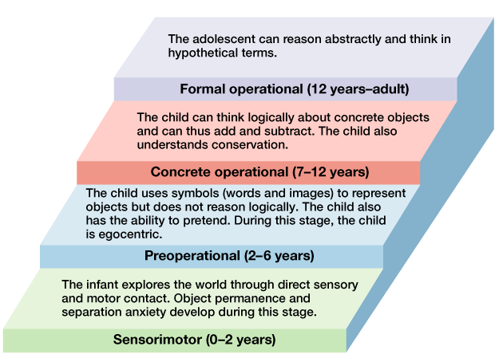
Omeneke Yusuf
(2009232)

ANOTATED BIBLIOGRAPHY

ANON., (2017). 8 Stages of Development by Erik Erikson. [Online]
Available at: https://www.youtube.com/watch?v=aYCBdZLCDBQ
[Accessed 12 November 2021].
This video reference was used to understand the Ericson theory of child development.It is a simple way of explaining the eight stages of child development, and how a child develop through the stages into adulthood and interact with their environment.

ANON., (2018). Piaget's Theory of Cognitive Development. [Online]
Available at: https://www.youtube.com/watch?v=IhcgYgx7aAA
[Accessed 20 November 2021].
This video explained Piaget’s cognitive development and all the stages that take place in the life of a child till late adulthood.Piaget felt, however, that children should discover their world themselves 'each time we educate the kid we hinder the child from finding it'
AN, J.S. and COONEY, T.M., (2006). Psychological well-being in mid to late life: The role of generativity development and parent–child relationships across the lifespan. International journal of behavioral development, 30(5), pp. 410-421.
The findings back up prior research that suggests that early life influences can play an essential role in maintaining robust health outcomes throughout one's life. The experience of a child will have an influence on their later life even if they donot act it directly . it will have an indirect influence on the life of that child and it thus imortantant the early states of life be treated with care and understanding.
ARMSTRONG M. I., BIRNIE-LEFCOVITCH S., & UNGAR M. T (2005). Pathways between social support, family well being, quality of parenting, and child resilience: What we know. Journal of Child and Family Studies, 14, 269–281. doi:10.1007/s10826-005-5054-4 - DOI
This journal studies the theory of child development and helps to understand the psychological, emotional, and physiological changes that occur in people from childbirth through puberty. It focuses on how an individual progresses from reliance to autonomy.This is also in support Erickson ‘s stages of autonomy versus shame and Piaget’s preoperational stage of development.

ERIKSON, E. (1968). Identity: Youth and crisis. New York: W. W. Norton & Company.
Erik H. Erikson's amazing discoveries on the link between life history and history began with observations on a critical stage of life: adolescent identity development and the crisis associated with the stages.Explained the stages of development
ERIK ERIKSON'S THEORY OF PSYCHOSOCIAL DEVELOPMENT.( 2014). Shimla: Shimla: Athena Information Solutions Pvt. Ltd.
This book explains about Erik Erikson ‘s proposed his own psychosocial development theory, which he called "stages of personality development." This eight-stage psychosocial development theory is arguably the most well-known of the personality phases theories. It outlines how people grow, develop, change, and face conflicts as they progress through various stages of development. This theory focuses on social interactions and the conflicts that arise as a result, which have an impact on a person's life.
HECKHAUSEN, J., WROSCH, C. and SCHULZ, R.,( 2010). A Motivational Theory of Life-Span Development. Psychological review; Psychol Rev, 117(1), pp. 32-60.
This article points out that The majority of people believe they are actively moulding their lives. They take consistent developmental routes in terms of choosing and actively pursuing long-term goals, as well as withdrawing from goals that are no longer feasible. Even in the face of setbacks, disappointments, and failures, humans have an amazing ability to keep on track and maintain a sense of personal responsibility.
LINDENBERGER, U., (2001). Lifespan Theories of Cognitive Development. In: N.J. SMELSER and P.B. BALTES, eds, International Encyclopedia of the Social & Behavioral Sciences. Oxford: Pergamon, pp. 8848-8854.
It examines modern studies on human intelligence and intellectual growth, as well as the effects of culture and other social variables on both. It also draws on new research on how education might help to promote intellectual development.
LI, X.,( 2021). An effective analyzing of direct and indirect adversity for child depressive syndromes. Aggression and Violent Behavior, , pp. 101682.
Li stated that Childhood exposure to damaging and stressful experiences leads to a severe problem in maturity. This is due to the fact that these traumatic childhood events alter the chemical makeup of the brain in a negative way. As a result, many youngsters face serious issues as adults.
MACLEOD-BRUDENELL, I. (2004). Advanced Early Years Care and Education. United Kingdom: Heinemann Educational.This is a very important book about early years and how care givers can understand and interact with children .When caregivers show affection and dependability to children, they establish trust and security. Caregiving that is inconsistent, rejecting, or emotionally unstable can cause dread and insecurity in the kid.
HALPENNY, A-M AND PETTERSEN, J. (2014) Introducing Piaget: A guide for practitioners and students in the early years education. London: Routledge
Jean Piaget is one of the contributor of psychological development of a child from childhood Adolescence and this book pointed out the different understanding of how children think and learn and through object performance.
SEIFERT, K.ET AL.( 2000). Lifespan development. 2nd edn. Boston: Boston : Houghton Mifflin.
Knowledge of changes that take place throughout life span,Self-esteem is high in childhood, lowers during adolescence (especially for girls), progressively rises throughout maturity, and then diminishes drastically in old age.
WESTERHOF, G.J. and KEYES, C.L.M., (2010). Mental illness and mental health: The two continua model across the lifespan. Journal of adult development; J Adult Dev, 17(2), pp. 110-119.
This model across life span help to underspan the differences between the mental healthand mental illness across life span.Self-acceptance is a favourable and accepting attitude toward features of one's own history and present ,Goals and beliefs that provide a feeling of purpose and significance in life;The development of Autonomy as self-direction guided by one's own socially accepted internal criteria with Positive interpersonal connection and having pleasant personal interactions in which empathy and tenderness are communicated;
WHITBOURNE, S., (2001b). Differential Aging. In: N.J. SMELSER and P.B. BALTES, eds, International Encyclopedia of the Social & Behavioral Sciences. Oxford: Pergamon, pp. 3654-3658. The individual develops as a system, with a unique set of these functions (e.g., abilities, dispositions, values), with coherence across developmental periods or stages.
In conclusion , there are researches and various theories stating the importance of early child hood development .This can interfare with the children’s ability to adapt as they grow.Every stages missed can have a negative impact on the child and the success of each stages help shape the life of that child.
Nature and Nurture is a Basic Concepts in Developmental Psychology Nature - A theory that claims physical and mental development is genetically determined. Physical and cognitive development is influenced by environmental influences, according to the theory of nurture. A helpful adult must be taught in a certain manner, such as learning via entertaining games and songs, in order for a kid to improve his or her learning capacity.A child at the at of 0 -5 explores the world around them to know if they are loved or not and observes what will happen when they sought for attention, if they need to cry or not and if anyone notice their way of communication or not.
Vygotsky believed that children should explore their environment, but that adults may contribute via social interaction. Erickson states that stage 2 entails regaining a sense of Autonomy.

