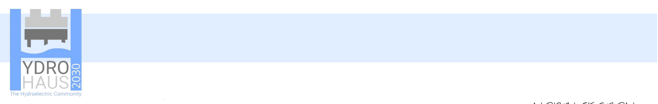
ACTIVE HOUSE
TECHNOLOGY AND ENVIROMENT 1

AMY FROHWEIN
1900811

TECHNOLOGY AND ENVIRONMENT 1
ACTIVE HOUSE

PROJECT BREIF
Our task for this project was to design a house for the House of 2030 Young Persons Design Challenge. To fit this brief, we followed Active House principles. Active House creates comfortable, healthy conditions for occupants to live in, is energy efficient through the use of renewable energies and thus has a positive impact on the environment.
During the first week, we visited the Active Classroom by Specific on the Swansea Bay Campus and met with Joanna Clarke, who helped us throughout the project.
ISSUES FACING THE UK TODAY
Over the past few weeks, flooding has devastated hundreds of homes across South Wales. With climate change resulting in more extreme weather, its clear that flooding will continue to increase across the country. Creating a solution to this problem was the main aim for our team, in this project.
CONCEPT
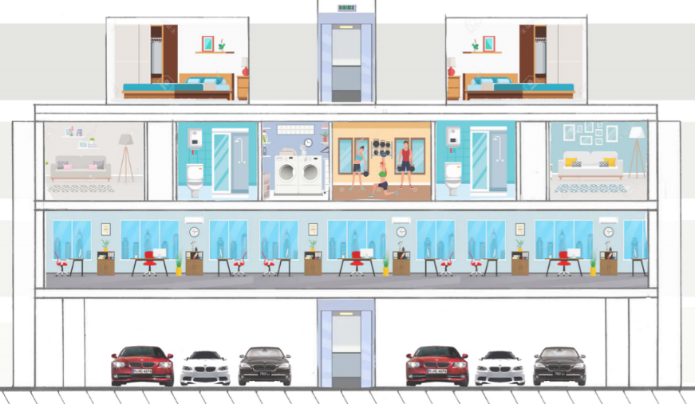
Our concept was to create a multi-use communal apartment block built upon concrete stilts, as seen above. Our aim was to design a building that is independent of the national grid through hydro and solar power.
FIGURE 1
(AUTHOR, 2020)
Section through proposed house
These stilts would allow water to flow freely beneath the building should flooding occur, preventing damage to the living space above. This would also create space for carparking, which would include electric car charging facilities. A lift will provide access for all through each floor of the building.
The first floor will consist of multi-functional spaces, which can be occupied for offices, shops to sell home grown food, etc. This enables residents of the building to work from home, and thus reducing CO2 levels being emitted from travelling to work. We left the plan for this floor very open, so businesses who rent the offices can adapt them to their needs.
FIGURE 2
(Ben Howells, 2020)
4 floor layouts
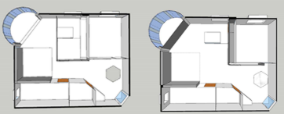
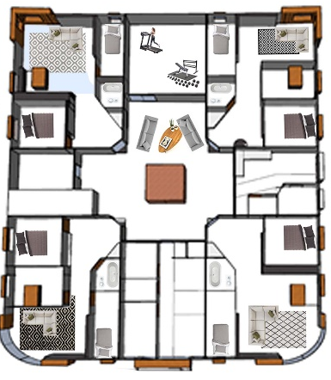
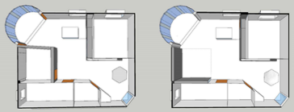
The second floors contain the main living quarters. This floor will consist of 6 private flats with moveable walls, to accommodate to each tenant needs, creating long term flexibility for future tenants. This concept is key for growing families. The flats have 4 configurations, this is demonstrated in the plans to the right. There is also a gym, sitting areas and a laundry area to promote the sense of community. The floorplan is shown on the left.
We designed the building to meet the Welsh Assembly Sustainable Development goals of encouraging health and wellbeing and independent living whilst encouraging social interaction (Assembly.Wales, 2008).
FIGURE 3 (AUTHOR, 2020)
2nd floor layout
The 3rd floor creates garden space for residents, including private and communal areas. Shared allotments provide an area for residents to grow their own food, which can be sold in the shop on the first floor. This floor also has the opportunity for extra upstairs bedrooms to be built so families can expand their homes when they need to.
MATERIALS
The structure will be constructed upon pile foundations. This type of foundation works well with weak soil conditions, as the load is transferred to the layer of stronger soil or rock below. Pile foundations are capable of taking heavy loads because of this. Pile foundations should be used when the structure is situated close to a canal or river. (TheArchitectureDesigns.com, 2019). Pile foundations are also suitable to be used on flood plains, which will help us to utilize previously undeveloped land.
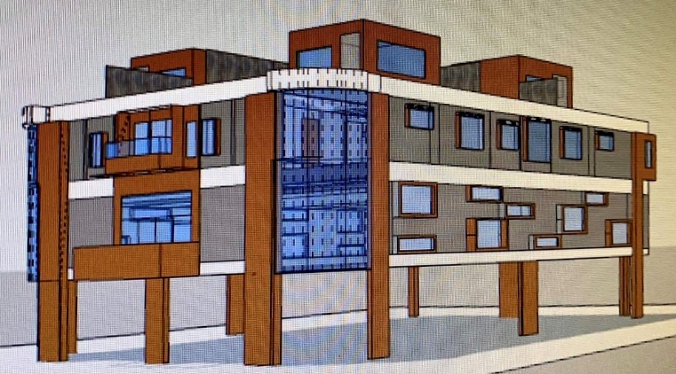
A timber framed building will be raised upon concrete columns. The exterior is cladded with timber and transpire solar collector. TSC is a solar air heating system consisting of perforated steel skins fitted to the side of building creating a cavity for warm air to travel through, helping to insulate the building. (Shbed.cardiff.ac.uk, n.d).
FIGURE 4 (Ben Howells, 2020)
1st model of building on sketchup

The building will have stone wool insulation due to it being fire resistant and nontoxic.

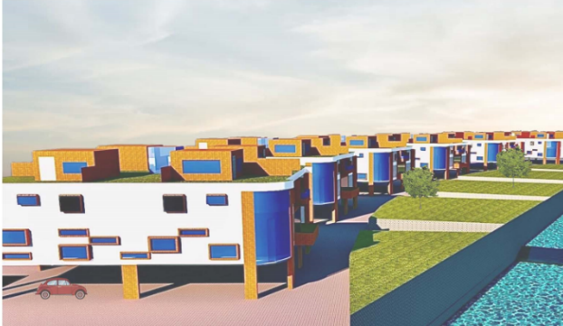
TECHNOLOGIES
FIGURE 5 (Ben Howells, 2020)
View of housing complex

CANAL SYSTEM
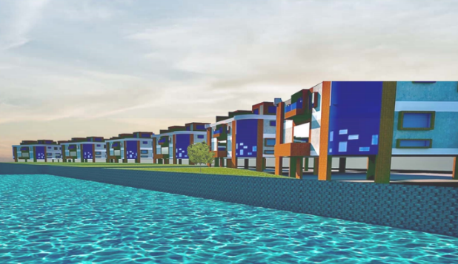
Next to each complex of 6 buildings will be a man-made water course, which will be connected to local rivers. Small level changes in the canal system, create a drop of water, this can be seen in the photos on the right. A hydropower system will capture the energy of this falling water to generate electricity where a turbine will convert this energy into electricity (Wvic.com, n.d).
FIGURE 6 (Ben Howells, 2020)
View from canal
This renewable source of electricity will be the main power source for the housing complex, which we hope will allow it to be independent from the national grid. Energy will be stored in large batteries and any excess energy can be exported back to the national grid.
WINDOWS
In passivhaus architecture, windows are situated mainly on the south side of the building in order to obtain maximum solar gain. Following this idea, we placed tall curved bay windows in the south facing flats. The north facing flats were designed with smaller windows, to prevent heat loss. All windows will be fitted with triple glazed glass to improve energy efficiency. Insulated roller shutters will be installed to the exterior of the windows. This provides an extra layer of insulation during the night-time which doubles up as a security measure also.
GREEN ROOF
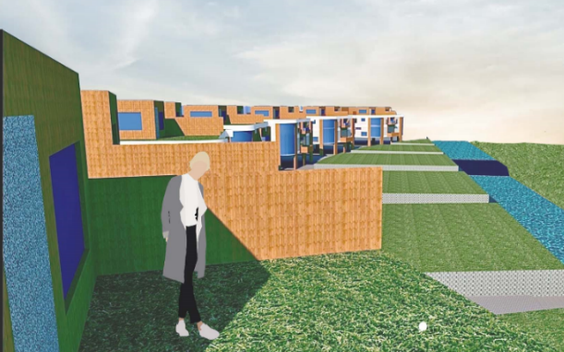
While the green roof provides extra living place for residents, it also has advantages in terms of insolation helping to regulate indoor temperatures and, hence save energy. Green roofs also have the ability to act as a rainwater buffer and slow down runoff in urban environments by absorbing great amounts of water. This helps to regulate the groundwater levels and therefore reducing the risk of flooding (Sempergreen.com, n.d).
FIGURE 7 (Ben Howells, 2020)
Garden view from house, created on sketchup

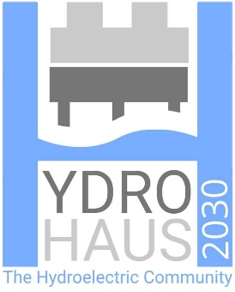
It is from these ideas that we created our team name ‘HydroHaus’. ‘Hydro’ coming from the hydro electric energy source and ‘haus’ derived from ‘Passivhaus’, the standard in which we hope to achieve in energy efficiency. From this our logo was created, as seen on the left.
FIGURE 8 (Reuben Dutch, 2020)
HYDROHAUS LOGO

GROUP WORK REFLECTION
I feel that Ben, Iestyn, Reuben and I worked very well as a group. Roles were assigned to each member in areas that suited their skills though we all collectively worked together on the design. Ben has great skills on sketch up, so had the role of creating the complex using digital software. Reuben hand drew the building. I put the presentation together using photoshop for the competition entry. While Iestyn researched the different technologies that would best suit our building.
However, time management issues in our group need to be focused on, so different aspects of the project are completed by certain deadlines.
I believe we created an excellent concept for our project focusing on adaptability, community and a solution to floods, however the overall aesthetic of the building could have been improved and technical issues such as how the stilts would support such a heavy structure need to be addressed.

REFERENCE LIST
Assembly.Wales. (2008) Sustainable Development,[online] Available at: https://www.assembly.wales/tb-08-013.pdf [Accessed 6 Mar. 2020]
The Architecture Designs. (2019). Advantages and Disadvantages of Pile Foundation [Complete guide] - The Architecture Designs. [online] Available at: https://thearchitecturedesigns.com/advantages-and-disadvantages-of-pile-foundation-complete-guide/ [Accessed 4 Mar. 2020]
Sbed.cardiff.ac.uk. (n.d.). Transpired Solar Collectors | SBED. [online] Available at: http://sbed.cardiff.ac.uk/transpired-solar-collectors/ [Accessed 4 Mar. 2020]
Wvic.com. (n.d.). How Hydropower Works. [online] Available at: http://www.wvic.com/Content/How_Hydropower_Works.cfm [Accessed 6 Mar. 2020]
Sempergreen.com. (n.d.). Benefits of a green roof - Sempergreen. [online] Available at: https://www.sempergreen.com/en/solutions/green-roofs/green-roof-benefits [Accessed 4 Mar. 2020]

FIGURE 1, AUTHOR, 2020, section through proposed house
FIGURE 2, Ben Howells, 2020, 4 floor layouts
FIGURE 3 AUTHOR, 2020, 2nd floor layout
FIGURE 4 Ben Howells, 2020, 1st model of building on Sketchup
FIGURE 5 Ben Howells, 2020, View of housing complex on Sketchup
FIGURE 6 Ben Howells, 2020, View from canal on Sketchup
FIGURE 7 Ben Howells, 2020, Garden view from house, created on Sketchup
FIGURE 8 Reuben Dutch, 2020, HYDROHAUS LOGO

