

University of Wales Trinity Saint David
School of Engineering
Can FEA replace physical testing?
Yan Li
1904638
Level 6
27/04/2020
Advanced Stress Analysis & FEA
M6X00420
Kelvin Lake

Contents
1 Introduction 1
2 Background 2
3 Company’s Research 3
4 Correlation 7
5 Discussion 9
6 Conclusion 10
7 Reference 11

Introduction
In this report, author will research the role FEA plays in product development. Finite element analysis, also called FEA, is becoming the industry standard tool to design and optimize the product. What’s more, FEA is always carried out with physical testing under same load conditions. The correlation between FE model and physical testing makes FEA a realistic research tool and been widely used. Not only the literature research, this study is also carried out based on a real case of the lightweight work of a chassis. Both FEA and physical testing are used to test the torsional stiffness to validate the CAD model, which is shown in Figure 1-1.
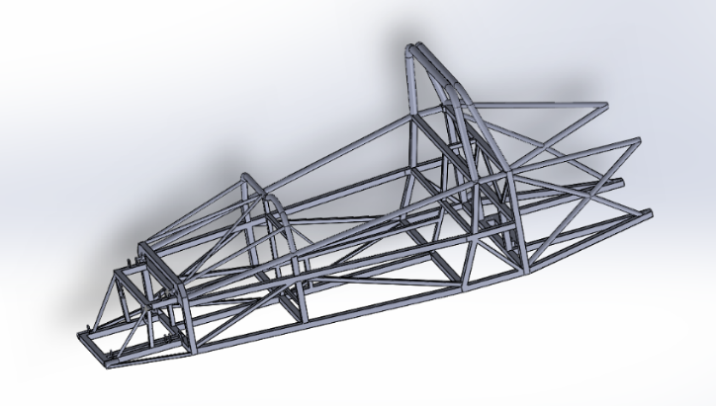
Figure 1-1 Chassis CAD model
Papers about company’s product development work using FEA and physical testing in different industries are used to find the reason of this common tool. Through the study process, the characteristics of this tool can be found by comparing various company’s researches. In addition, the role physical testing played can also be found. Based on chassis’ work, author is going to explain why companies typically carryout FE analysis alongside physical testing.
According to previous research, how the physical test correlated to the FE model can be explained. How they work together to help the development process in various industries is the core parts of this tool. Work about chassis also provides a powerful argument to explain how the correlation is built.
Finally, author will discuss whether the FE model can ever replace physical testing. Analysis about the importance of the physical testing in product development gives some advice to this question. According to the work in papers and author’s case, from author’s perspectives, physical testing is the basis of FE model. It provides basic data, limitation and can validate and verify the FEA results. Therefore, it can’t be replaced.

Background
Finite element analysis is a tool using finite element method (FEM) to study and analysis a phenomenon. FEA is particular numerical tool of solving various equation on two or three space variables and is widely used to solve problems in typical areas including structural analysis, heat transfer, fluid flow, electromagnetic potential and mass transport (Elements, 2020). In order to solve problems, FEM subdivides a large system into simpler and smaller parts, called finite elements, which is realized by meshing the target object. Then, the problem will be converted into a lager system of equations of the whole problem. Finally, FEM takes use of variational methods to approximate a solution (Logan, 2011). Engineers apply the finite element method (FEM) through using FEA computer software which provides critical insight into a design’s performance prior to physical testing. (ASR, 2020)
The real case carried out by author is an optimization work based on a race car chassis. First of all, author measures the dimensions of chassis then create a same CAD model in SolidWorks. Torsional stiffness of chassis is test in SolidWorks Simulation module, and measuring the displacements under a torque of specific magnitude to calculate the torsional stiffness. In addition, the stiffness is also been calculated. Then optimize the model in terms of the difference between FEA and physical test results.

Company’s Research
FEA has been used by many companies to develop the product.
Fatih KARPAT design a Rollover Protective Structure (ROPS) for agricultural tractors. FEA is carried out in RADIOSS software. Difference of displacement results of simulation and physical testing is compared to maintain the strength and validition of the structure. There is a strong correlation between FEA and physical test, which makes it possible to predict the behaviour of the structure in design process, reducing the prototype and test cost. (Fatih KARPAT, 2018)
As an important vehicle interior trim, door trims can reduce external noise and provide objects storage, also accord with ergonomic concepts. Because of its structural function, heat stakes are widely used as connectors. FEA combing with physical testing is an economic and efficient method to develop a structural component. For the heat stakes, through numerical simulation, loads put on the heat stakes under different conditions shows the maximum load. Therefore, the best heat stakes location layout can be determined, which gurantees the high quality and satisfies customers’ requirements. Tiago use Kratos KE 2000 MP to test two types heat stakes’ maximum retention force, which is set as the upper limit of load heat stakes can provide when the pull handle under 600N loads in FEA (shown in Figure 3-1). Finally, this tool is proved to be practical in the door trim development process (Tiago Sartor, 2015).
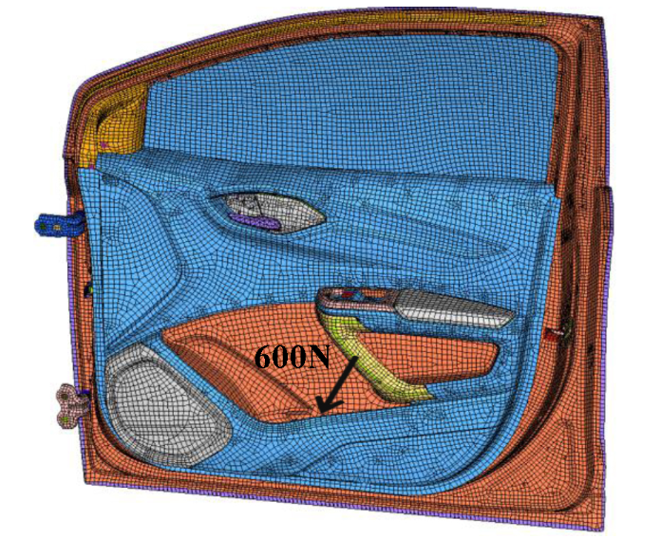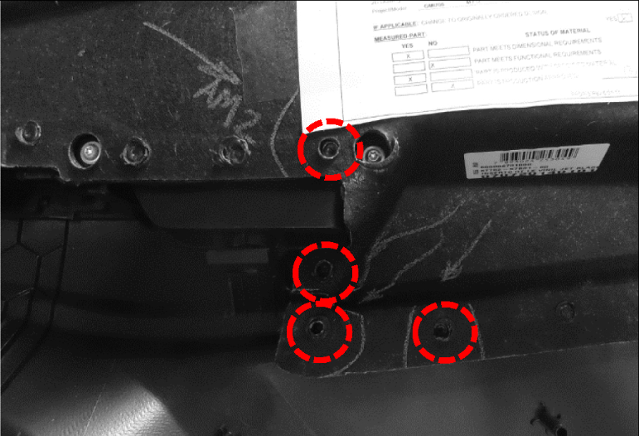
Figure 3-1 FEA and Physical Test Diagram
According to the new vehicle specifications, when the vehicle striked by a fully loaded oncoming vehicles, the rear bumper of new E-Z-GO golf vehicle must withstand certain corner impacts without visual damage. In order to meet new specifications, redesign work including retooling, physical protype and crash testing must be carried in lowest cost and as short a period of time as possible. Jingheng Wen takes use of correlating FEA with test to design a new bumper. There are 3 testing and 2 FEA models: field crash testing and lab quasi-static testing for original reinforced rear bumper, validation test for final redesigned bumper, crash simulation models relevant with test data involoving original reinforced rear bumper FEA model and new designed FEA model, one implict analysis model in ANSYS Workbench and one explicit analysis in LS-Dyna. The critical point of FEA model is accuracy. Correlating FEA with test can help simplify model by applying the proper boundary condition and material properties. It’s a relatively easy and fast tool, which is especially suitable for products produced by complex material. Figure 3-2 below shows the simplify FEA model and physical testing (Jingheng Wen, 2011).
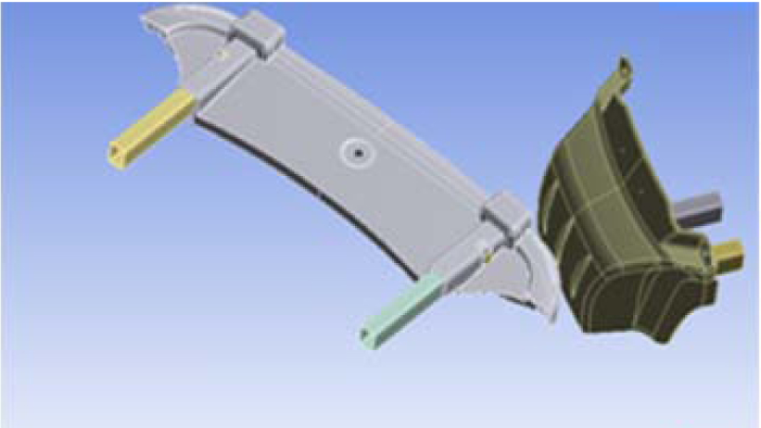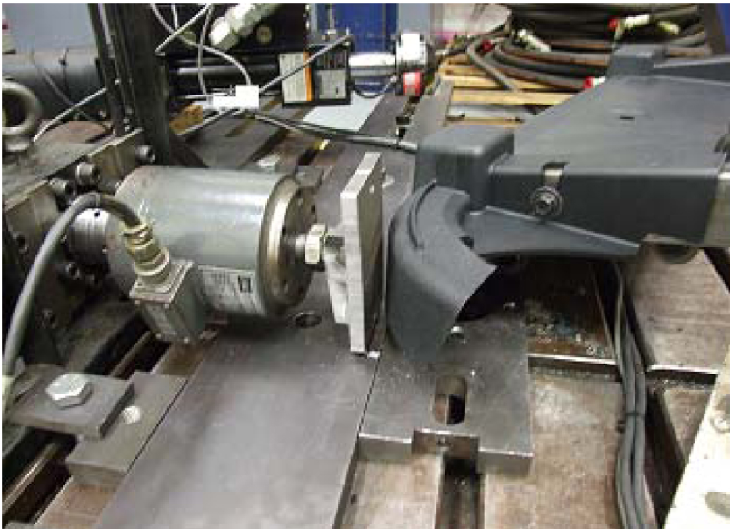
Figure 3-2 Simplify FEA model and physical testing
The durability performance of vehicle hood components should be good enough to support the vehicle hood works normally. With the highly competitive and rapidly evolving automotive industry, companies have to put the highly quality products to maket as fast as possible at a lower cost. Shailesh and his teams plan to use CAE methodology to replace the physical test, relying on FE model to optimize the component. Therefore, there is no need to manufact the expensive propotypes and do the time consuming physical testing. And the physical testing is required only to validate the final design layout. Figure 3-3 shows the final physical test (Bayani, 2011).
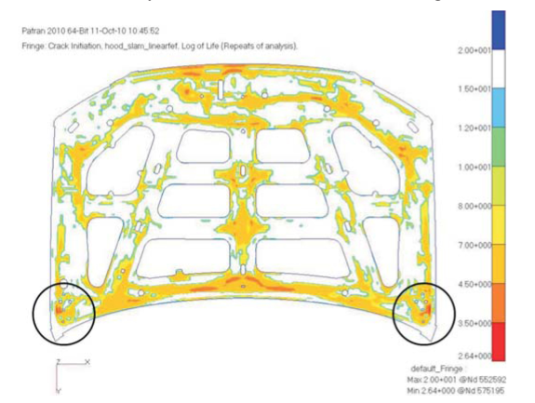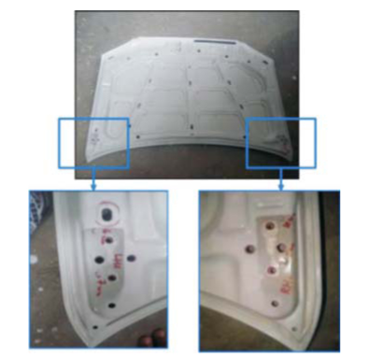
Figure 3-3 FEA and physical tetsing results
Joint technology plays an important role in transmitting structural loads, and mechanical fastener joints including blind rivets is widely used in industries. Generally, two types failures are observed in mechanical fasteners: tensile and shear failure, also other failure models like tension, shear-out, cleavage, pull-out and bearing are observed. In order to understand the failure mechanisms, Billy takes use of FE methods to model the failure mechanisms of fasteners in tesnisle and shear failure. What’s more, it’s necessary to validate the FE modelling process in order to put the software package to market. Comparation between FEA results and physical testing results is widely used to validate the package. In this research, FEA results output from MSC.MARC/Mentat FEA package are compared with results output from 6.4mm diameter blind rivet in terms of BS EN ISO 14589:2001. And the process is validated can work perfectly, Figure 3–4 below shows the FE and physical testing model (Costello, 2004).
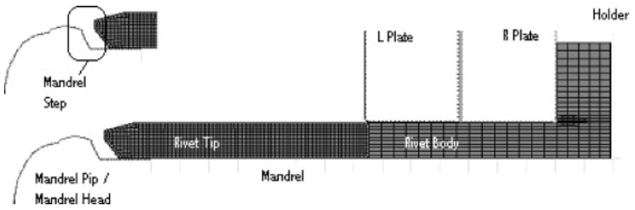
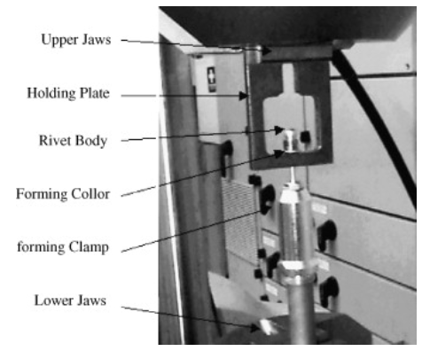
Figure 3-4 FEA and physical testing model
In automotive industrues, it’s the industry standard of optimizing structural design to use FEA to do computatinal prediction. Naga is going to build an accurate FE model to predict the roof crush strength and the timing of strucutre intrusion. Based on FMVSS216 testing conditions, correlate the peak roof crush strength as well as body stiffness and the peak intrusion strength output from FEA with physical test to determine the best combination of physical and computational parameters (Narayana, 2011).
Not only in industries, like in MEMS and medical’s research, FEA also plays an important role. According to FDA-testing requirements, it will cost $1.2 million of the company to finish entire line tests. To solve the finance problem, company has to use FEA tools to pass testing (Mraz, 2009). In order to research influence additional drilled suction holes on femur strength and faigue life, Melanie takes use of the FE model. Complete model is generated based on the FEA results output from ABAQUS and Hyper works software package and physical test results output from Instron 4505 universal testing machine. In addition, physical test results also play a role of validation (Fox1, 2013).
Obviously, FEA is widely accepted because of its advantages. Analysing company’s work mentioned above, its merits are shown in Table 3-1.
Table 3-1 FEA’s merits
Researcher | Merit
Faith | Reduce prototype and cost
Tiago | Reduce prototype and cost
Wen | Low cost and time saving
Bayani | Low cost and time saving
Costello | Display the complex failure mechanisms
Narayana | Product prediction
Foxl | Reduce cost
The main advantage of the FEA is that it produces a much more detailed results than physical testing investigations, also always quicker and lower cost. Fundamentally, it benefits from its mechanisms, subdividing a big problem into smaller and more easy solvable problems are much more efficient than solving it directly (The product research & engineering company, 2020). What’s more, FEA can provide more performance insight and more detailed information about design’s performance. The advantages of FEA being widely accepted are as follows (Newswire, 2006) (Helmut Dannbauer, 2006) (Wilde, 2020) (ASR, 2020):
Analysis complicated loading layouts, environments and designs.
Access to more performance information to improve design layouts.
Reduce the number of prototype and time.
Cheaper than expensive physical testing.
Obtain a better understanding of a design’s performance.
Solve non-linear analysis problems.
In chassis’ lightweight work, FEA is used to test whether the torsional stiffness of different lightweight model meet the industry standards. If using physical testing to realize the lightweight design process, too much prototype and time are needed, or it’s impossible to finish the work at low cost and time personally.

Correlation
It’s important to build a good correlation between FEA and physical testing. If the FE results are correlate well with the physical testing results, the FE model will be very powerful. Hence, it’s feasible to change the model parameters to obtain an optimal design for the product. Up to now, comparing the FE results with results got from physical testing is the best way to verify and validate the FE model (Donald). And in the modelling process, all physical variables should be taken into consideration, or the simulation results disconnect with the physical testing results. Correlating the model is an important part in the process of build the FE model. Generally, 10 to 15% difference in FEA and experimental results is considered a good correlation (Lake, 2020). All in all, physical testing results are beneficial to simulation improvement and giving feedback to decrease the distance between the real and virtual world (Tiago Sartor, 2015). Conditions and parameters in FE model will be improved in terms of the difference between these two, it’s also the process of building the correlation.
According to company’s work, many researchers use physical testing results to verify the FE model, and suitable adjustments are put on the model to make the model more accurate. Then, the model can be put into further design work or in the industry as a standard to develop it advantages. Absolutely, the correlation is the basis that makes the FEA’s work reliable. Of course, it’s also important in author’s lightweight work.
In author’s work, the optimization direction of the chassis is using different material. Therefore, some steel bars in the original model will be replaced with aluminium bars. In addition, all the lightweight design and analysis process are carried out in the FEA. Most importantly, it needs to be confirmed that the original model used for lightweight must be precise enough, or the further work is useless. In other words, there need to be a strong correlation between the CAD model and the real chassis. The method accepted to test the correlation is the torsional stiffness. Torque of same value is put on both CAD and real chassis, shown in Figure 4-1. Then the torsional stiffness of different positions can be calculated based on the displacements, results shown in Figure 4-2.
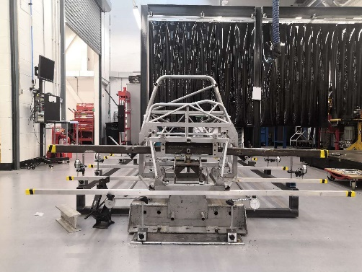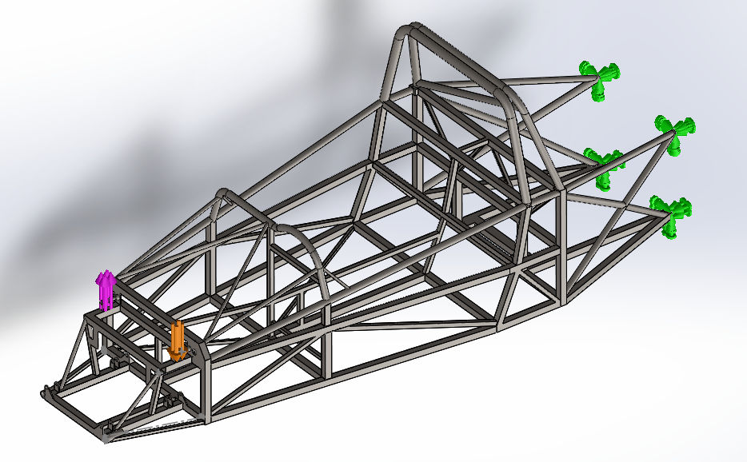
Figure 4-1 Physical (left) and FEA testing (right) (SolidWorks2019)
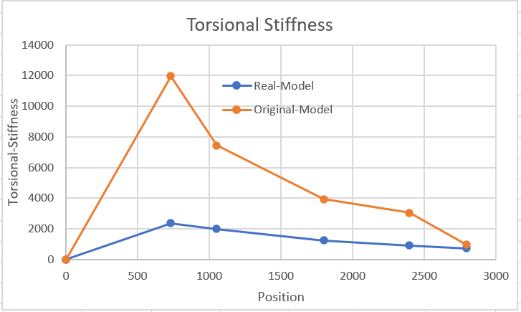
Figure 4-2 Torsional stiffness of real and CAD model (EXCEL2016)
From the curves, there is a big difference between the physical testing and FEA results. In other words, the correlation between theses two is not enough. Hence, there must be something wrong in the FE model. After analysing the FE model, some details are not shown in the FE model. In the physical testing, some bars are connected on the front and rear part to apply the load and fix the chassis, not drew in FE model. The influence carried by those bars maybe impact the results, the displacements on the bar or other connectors should be taken into consideration. Hence, the FE model is optimized shown in Figure 4-3.
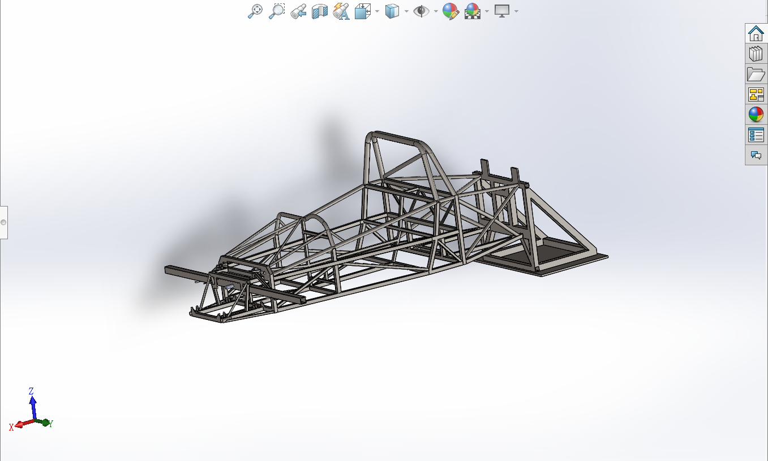
Figure 4-3 Optimal Model (SolidWorks2019)
All in all, the best way to build the correlation is comparing the physical testing and FEA results. In terms of the difference, analyse whether the parameters and conditions in the FE model is correct or not, then optimize the model. What’s more, the physical testing results can give FEA some reference about the material or the mechanisms. If there is no correlation, it makes no sense to do the FEA work.

Discussion
Many companies make FEA as a tool to end physical testing forever, also many customers expectation when using FEA to analyse. Though FEA does reduce the need for physical testing, it absolutely has not eliminated the need for physical testing (Donald). In author’s opinion, FEA can’t replace the physical testing forever.
Firstly, physical testing is the basis of the FEA. Dr. Parnell, an expert in the development and application of FEA techniques and the use of computational analysis to solve real-world problems, thinks that FEA can’t totally replace the physical testing. FEA is not enough, physical testing is need to understand the variability in geometry, load, conditions and loads (Wong, 2010). There are many material parameters, models and formulas got from physical testing in professional software like Solidowrks, Adams etc. Though the software can solve several present issues, the information needs to be updated. Technologies will become more advanced, environments will become more complex, new material and new approaches to problems will appears, the simulation software need to keep in line with the forefront of the industry to satisfy customers’ demands. Therefore, the physical testing is forever needed.
In addition, it’s necessary to verify and validate the FEA results by physical testing results. In FEA software, the working condition and some details can’t be fully restored, because there is more randomness in real production but the software is well-regulated. Therefore, the FEA results also can’t restore the physical testing results. If the difference between FEA model and testing is too big, the further analysis is meaningless and unfounded. For example, if physical testing is not carried out on the chassis, the lightweight work will be based on a wrong model. And the chassis produced in terms of its optimization layout must can’t satisfy the races’ standards. As mentioned before, 10 to 15% difference in FEA and experimental results is considered a good correlation. Physical testing is the tool to achieve this goal.
What’s more, more high-value of the product comes more requirements about life and safety. Therefore, there is more work to do besides basic FEA. (Wong, 2010). As an extreme sport, the safety is also a crucial parameter of the race car. If the chassis’s lightweight work only finished in software, it must be an unqualified product. What if one plane or one car is just designed in FEA software, maybe no one dares to be on it. Therefore, physical testing is the guarantee of product safety.

Conclusion
Finite element analysis is becoming a common tool of product design and optimization. With the development of industries, FEA tales up more and more percentage than physical testing in product development. However, FEA is always carried out alongside the physical testing. The topic of this report is the role FEA played in product development. More subdivided, this topic is explored in three aspects: why company’s FE work is always carried out with physical testing, how the correlation between FE model and physical testing is built, whether physical testing can be replaced by FEA forever. What’s more, a case is accepted to provide example for the whole analysis. The target of the case is doing the lightweight work on a race car chassis by FEA. Before optimizing the chassis, it is necessary to do FEA and physical testing on the virtual and real model to guarantee the validation.
Companies in several industries, including agricultural tractors, automotive, medical and MEMS, take use of FEA alongside physical testing in production because of FEA’s practical advantages. Comparing with traditional experiments, FEA can reduce the cost, time, number of prototypes and improve the quality in some way.
Correlation between FE model and physical testing is the basis of the research work. Physical testing results are always used to verify the FEA results, and provide some material variables, experimental data, based on which FE model is perfected. The correlation is built through this process.
Though FEA plays a very important role in industries, it can’t replace the physical testing forever. Physical testing can provide basic but important information to FEA software. In addition, FE model must be fixed and verified by the physical testing. The Physical testing can also guarantee the safety of some products.

7 Reference
ASR. (2020, 4 4). FEA vs Hand Calculations | Predicting Performance Before Prototyping. Retrieved from asrengineering.com.
Bayani, S. (2011, 1 19). Virtual Simulation of Hood Slam Test.
Costello, B. K. (2004, 11 10). FEA modelling of setting and mechanical testing of aluminum blind rivets. Journal of Materials Processing Technology.
Donald, B. J. (n.d.). Practical Stress Analysis with Finite Elements.
Elements. (2020, 4 4). Finite Element Analysis (FEA) Services. Retrieved from www.element.com.
EXCEL2016. (n.d.).
Fatih KARPAT, M. Y. (2018). Finite Element Analyses and Correlation with Physical Tests of a Rollover Protective Structure (ROPS) Performance. International Research Journal of Advanced Engineering and Science, pp. 88-92.
Fox1, M. J. (2013). Lateral drill holes decrease strength of the femur:. Journal of orthopaedic surgery and research.
Helmut Dannbauer, M. M. (2006, 10 31). Integrating Virtual Test Methods and Physical Testing to Assure Accuracy and to Reduce Effort and Time. SAE INTERNATIONAL.
Jingheng Wen, M. N. (2011, 9 13). Strength Prediction of Bumper by Correlating FEA with Test. SAE INTERNATIONAL.
Lake, K. (2020, 3 10). Creating a CAE FE model.
Logan, D. L. (2011). A first course in the finite element method.
Mraz, S. J. (2009, 11 19). FEA for the FDA. SPECIAL SECTION: MEDICAL.
Narayana, N. A. (2011, 4 12). Accurate FEA Predictions for Roof Crush. SAE International.
Newswire, P. (2006, 9 26). CoMeT Solutions Launches Breakthrough Product for Multi-Solver Mechanical Assembly Simulations; CoMeT/StructuralDynamics enables multiple rigid/flexible body dynamic simulations and structural FEA with full CAD associativity in a single user environment. New York.
SolidWorks2019. (n.d.).
The product research & engineering company. (2020, 3 24). Advantages of finite element analysis (FEA).
Tiago Sartor, B. D. (2015, 9 22). Structural Integrity Evaluation of Plastic Welding (Heat Stake) Tower in Door Trim Panels of Vehicles Using Finite Element Method. SAE INTRNATIONAL.
Wilde. (2020, 4 4). Structural Analysis (FEA). Retrieved from wildeanalysis.co.uk.
Wong, K. (2010). Is Digital Simulation Good Enough to Replace Physical Tests? Digital Engineering.

